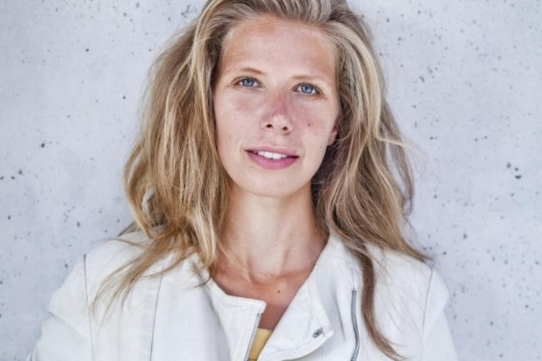**Name:** Annika Bachmann

**Age:** 36

**Nationality:** German

**Place of living:** Denmark, Aarhus C

**Family life:** Engaged

**Occupation:** Architect

**Income:** 40 000 dkk/month

**Motto:** “It is the sweet, simple things of life which are the real ones after all.”

**Personal profile:**

Annika moved to Aarhus 5 years ago to work on an important project at a big office. She planned to go back to Germany, but she fell in love with a Polish colleague from work and 5 months ago they got engaged. She wants to marry in Aarhus, because this is where they met and their love story begun. She has already started planning the wedding and is trying to find a photographer who can be open to her and her fiancee’s wishes.

Annika doesn’t like to be in the spotlight because she’s a little bit shy. Also, she is not into fancy things, that’s why she is planning a simple wedding, only with family and friends, where everyone can be relaxed, natural and just enjoying the moment. She would like to find a photographer willing to take some time before the wedding to get to know them as a couple and to understand their plans and desires to ensure that they don’t have to think about it during the wedding.

She is looking for a photographer who has a personal approach and can capture the big day just the way it will be; someone who is careful in the most important moments, because her wedding photos must not show them looking perfect, but their emotions and compatibility.

Annika discussed with her fiancée and they agreed to spend as much as it takes for their wedding photographer, because they understand that a high price comes with high quality services. And Annika believes that in the end, life is about memories and the wedding photos are one of the most important lasting memories of that day.

Annika is asking for recommendations among her friends. After she will have some, she will search online for those photographers to see how they work, their style, values and what’s their story, in order to choose the one she empathizes the most with.

|  |  |
| --- | --- |
| **User goals**  **Annika visits our webdoc:** | **Business goals**  **We want Annika to visit our webdoc:** |
| * To look for pictures that capture the way she would like to remember her wedding * To find out how the photographer works * To explore the approach and perspective of the photographer * To get an insight of the photographer’s universe to see if she can empathize with the emotions it displays | * To connect with Greg’s story and his wedding photography concept * To remember Greg’s values and unique style * To empathize with Greg’s work * To get an emotional impact, so she can recommend Greg to other couples * To want to have Greg as the one who will capture her wedding story |