Research Collaboration Seed Funding

**Proposal Cover Page**

Please complete the information in the shaded areas below.

Submit this cover page with your proposal and supporting documents as one document in MS Word or PDF format to: swilmoth@uark.edu

|  |
| --- |
| A Spatial Look at Healthcare Spillovers |

**Proposal Title:**

**Submitting Principal Investigator Information:**

|  |  |  |
| --- | --- | --- |
| Aranyak Goswami | Phone: Department: |  |
| garanyak@uark.edu | Department of Agriculture |

Name:

Email:

**Collaborator Information:**

|  |  |  |
| --- | --- | --- |
| Role | Name | Department |
| Co-PI | Abhijith Anand | Walton College of Business |
| Key Personnel | Shakil Rafi | Department of Agriculture |
|  |  |  |
|  |  |  |
|  |  |  |
|  |  |  |
|  |  |  |
|  |  |  |

**Key Words (5): Budget Amount Requested:**

|  |  |  |
| --- | --- | --- |
| Econometrics |  | $30,000 |
| Spatial Analysis | **Research Area(s) Addressed:** |
| Deep Learning |
| Health Outcomes Research | Health Outcomes, Deep Learning, Spatial  Modeling | |
| Spatial Modeling |

1.

2.

3.

4.

5.

**Synopsis** (1,000 character max):

Healthcare outcomes spread through institutional networks, yet current models fail to capture nonlinear, dynamic spillover effects. We address this gap by combining spatial econometrics with spatio-temporal graph attention networks (ST-GATs) to model hospital quality diffusion. Activities include spatial lag model estimation and ST-GAT implementation on proprietary data. The team— experts in policy, econometrics, and AI—offers a rare interdisciplinary synergy. In one year, we expect validated models, influence maps for Arkansas, and identification of high-impact intervention hubs. Long-term, this will inform scalable healthcare policy and funding prioritization. The project is positioned for follow-on support from NSF Smart Health, NIH NLM, and PCORI.

6

# Introduction

Healthcare outcomes and operational efficiency are not isolated,they spread through networks of institutional influence. When flagship university hospitals adopt new metrics or regulatory frameworks, nearby outpatient centers often follow suit. This asymmetric diffusion of practices, known as spillover in econometrics, suggests that healthcare performance is shaped by both spatial proximity and institutional hierarchy.

These dynamics are not static: outcomes evolve over time, influenced by regulatory updates e.g. the HI-TECH Act [1], disease emergence e.g. the COVID-19 pandemic [8], and shifts in local hospital administration [4]. To capture this complexity, econometricians have developed models that integrate both spatial and temporal variations such as spatial panel models [5] and instrumental variable frameworks [3].

Yet, current approaches often fall short when data is high-dimensional, irregularly spaced, or exhibit nonlinear interactions, indicating a highly fruitful research gap [11].

To address this critical gap, our proposal offers five key innovations:

1. *Proprietary, high-resolution data*: Unlike most studies that rely on coarse-grained public datasets, we leverage privately acquired, high-fidelity data from commercial brokers, enabling unprecedented spatial and temporal granularity in hospital performance metrics.
2. *Cutting-edge and novel modeling techniques*: In addition to classical spatial methods (e.g., spatial autocorrelation and spatial lag models), we will implement spatio-temporal graph attention networks (ST-GATs)[10] models ideally suited to our dense dataset and capable of capturing nonlinear, directional spillover effects across both space and time. These models have seen use in traffic modeling and are ideal for spatial and temporal modeling [7] but have yet to be used in health metrics spillover, presenting a high-risk/high-reward scenario.
3. *Interdisciplinary high-skilled team*: This project integrates policy and management science (Dr. Abhijith Anand) with advanced machine learning and econometric modeling (Dr. Aranyak Goswami and Dr. Shakil Rafi), offering a rare and synergistic approach to a complex systems problem.
4. *Compelling preliminary evidence*: Early analysis reveals statistically significant spatial spillover effects among facilities, underscoring the need for deeper, more sophisticated modeling to capture both the extent and mechanisms of influence.
5. *Precedent and promising follow-up*: This project is intentionally designed as a launchpad for competitive external funding from major agencies that support research on spatial modeling, healthcare analytics, and decision-making systems. For instance, the NIH (NIDDK) recently funded research employing spatiotemporal modeling to assess healthcare outcomes (e.g., Project #1R01DK136515-01A1). The NSF Smart Health and Biomedical Research in the Era of Artificial Intelligence and Advanced Data Science (NSF 23-614) program actively supports projects integrating machine learning, health policy, and systems-level optimization. Additionally, organizations like the National Institute for Health Care Management (NIHCM) have funded applied research on geographic disparities and healthcare performance. Our work aligns with these priorities and is well-positioned to compete for follow-on funding from the National Institutes of Health NIH, National Science Foundation NSF, Patient-centered Outcomes Research Institute PCORI, and the Agency for Health Research and Quality AHRQ in subsequent stages.

# Preliminary Results

To establish proof of concept, we conducted a preliminary analysis using two representative hospital quality metrics that are reported to the Center for Medicaid and Medicare Services:

1. COMP HIP KNEE: the complication rate following elective primary total hip and/or total knee arthroplasty
2. MORT 30 HF: the 30-day mortality rate following heart failure hospitalization

These metrics were selected based on their clinical relevance, availability in our dataset, and their historical use in policy evaluation and hospital benchmarking. Together, they reflect both surgical outcomes and chronic care performance, offering a robust testbed for our modeling approach.

Initial spatial analysis revealed clear patterns of regional clustering and performance diffusion, particularly among outpatient centers in proximity to major hospital hubs. These patterns are consistent with spillover effects consistent with previous literature [6], [2], [9]. Early runs of our spatio-temporal models show promise in capturing both directionality and intensity of influence between facilities—laying a strong foundation for the expanded analysis proposed in this grant.

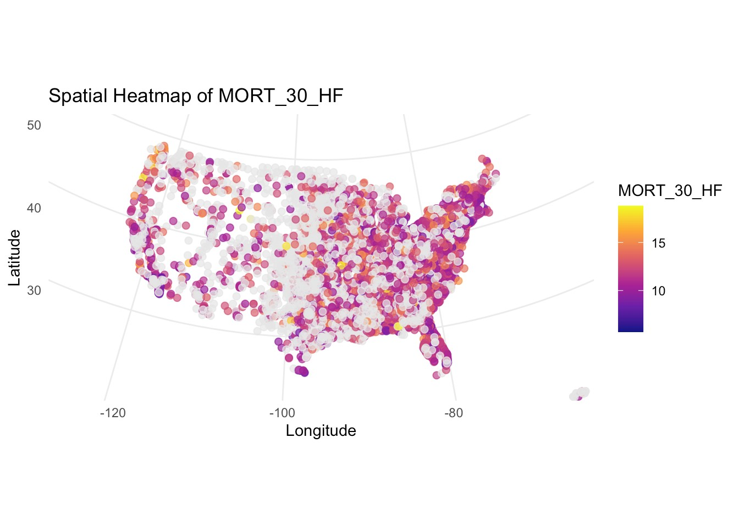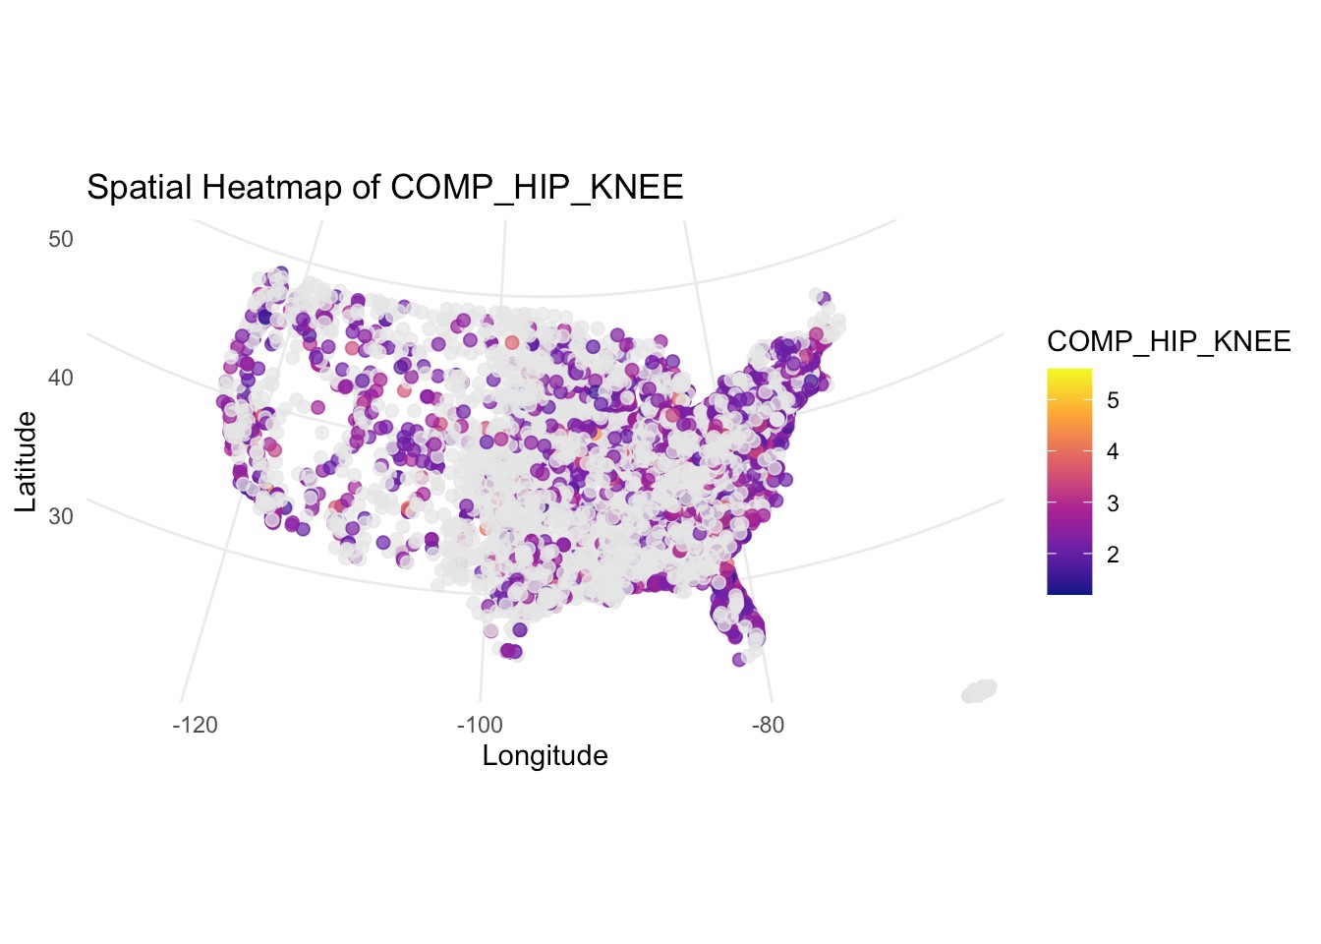

Figure 1: Side-by-side visualizations of complications and deaths metrics across hospitals

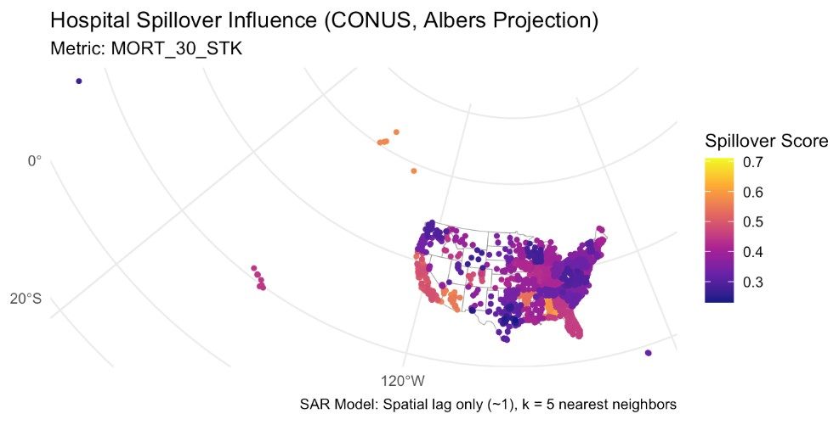

Figure 2: Hospital Spillover effects showing strong spillover in Arkansas, Georgia and southern Nevada.

The clustering results are backed up by spatial autoregression *ρ* values indicating spillover effects for MORT 30 HF but not for COMP HIP KNEE. More concretely, every one unit increase in in MORT 30 HF tends to increase the same metric of nearby hospitals by approximately 0*.*293 with a high degree of statistical certainty, all things being equal.

Introducing endogenous shocks to our preliminary

|  |  |
| --- | --- |
| **Metric** | *ρ* |
| MORT 30 HF | 0.293 |
| COMP HIP KNEE | 0.029 |

models—simulating improvements in specific hospital Table 1: Spillover coefficient (*ρ*) for selected hospital metrics metrics—allows us to estimate the spillover impact of targeted interventions. This enables us to identify which hospitals act as *influence hubs*, where localized improvements could lead to *system-wide gains*. For example, preliminary simulations using MORT 30 STK (30-day mortality rate following stroke hospitalization) suggest that a one-unit improvement in a high-impact facility can lead to average gains of up to 0.6 units in regions like Arkansas, Alabama and southern Nevada. Please see Figure 2.

As illustrated in Figure 2, several facilities in Arkansas exhibit disproportionately high spillover scores, suggesting that targeted quality improvements in this region could yield broad regional and potentially national benefits. These results underscore the relevance of this work not just for national policy modeling, but also for state-level strategic planning in Arkansas and the broader southern U.S. healthcare system.

# The Proposed Method

With our robust dataset, we will begin by estimating spatial lag models across all 143 available hospital quality metrics to quantify the direction and magnitude of spatial dependencies. Each model requires the inversion of a 4085×4085 spatial weight matrix demanding significant computational resources and careful tuning for stability and interpretability.

We will then implement a spatio-temporal graph attention network (ST-GAT), initially focusing on healthcare facilities within the state of Arkansas before scaling to a nationwide model. The ST-GAT architecture is specifically designed to capture nonlinear relationships across both space and time and has been successfully applied in domains such as traffic flow forecasting and urban mobility modeling. To the best of our knowledge this has yet to be applied to model health outcomes spillover effects, presenting a high-risk/high-reward scenario.

After initial implementation, we will iteratively refine and train our models, validating their performance against classical spatial econometric models to establish robust benchmarks.

This pipeline represents a substantial technical undertaking, well-suited to the scope of a Masters thesis or PhD dissertation and offers valuable training opportunities in applied machine learning, network science, and spatial econometrics.

# Outcomes and Actionable Deliverables

We propose to have the following timeline for our deliverables.

**Month 1—2**: Data acquisition and preprocessing;

**Month 3—4**: Spatial lag model estimation across selected hospital metrics;

**Month 5—7**: Development and training of ST-GAT models for Arkansas facilities;

**Month 8—9**: Nationwide model scaling and benchmarking against traditional methods;

**Month 10—11**: Analysis of influence hubs and policy simulations;

**Month 12**: Drafting manuscripts, submitting grant applications, and preparing the final report

We intend to present our preliminary findings at the 2026 Joint Statistical Meetings (JSM), scheduled for August 2026 in Boston, Massachusetts. To meet this goal, we will prepare and submit a poster abstract by the December 2025 submission deadline. Concurrently, we aim to make a preprint of our analysis publicly available on arXiv by Spring 2026, accompanied by open-source code and data repositories hosted on GitHub to promote transparency and reproducibility. For final publication, we will target high-impact peer-reviewed journals such as *Health Economics*, *INFORMS Journal on Healthcare*, and *Econometrica*.

# Budget Justification

This budget strategically supports the successful execution and dissemination of the proposed research over a 12-month period. A Postdoctoral Associate will be supported at $15,000 for one year (12-month appointment), providing critical expertise in data modeling, machine learning implementation, and manuscript development. Travel costs ($2,500) will support attendance at a domestic conference to present findings and foster collaborations. Materials and supplies ($2,000) cover data storage and collaboration tools necessary for secure handling and version control of high-resolution healthcare datasets.

Publication fees ($4,000) are allocated for two open-access journal articles to ensure broad visibility and rapid dissemination of results. Other direct costs ($6,500) are designated for cloud-based GPU access (e.g., AWS/GCP credits) and essential licensed software (e.g., MATLAB toolboxes, GraphML add-ons) required for implementing advanced spatiotemporal models. No institutional overhead is requested, ensuring that the entire budget directly supports research, dissemination, and project infrastructure.

# Conclusion

This project advances a bold, data-driven framework for understanding and modeling the spatial and temporal dynamics of healthcare outcomes in the United States. By integrating high-resolution proprietary data with cutting-edge spatiotemporal machine learning models, we address a critical gap in how performance metrics propagate across institutional networks. Our preliminary results not only confirm the existence of measurable spillover effects, but also identify highleverage intervention points, particularly within Arkansas, that hold promise for scalable policy impact.

This work exemplifies the type of interdisciplinary, high-risk/high-reward research this seed grant is designed to support. With strong potential for external funding, multiple publication outputs, and opportunities for graduate student training, this proposal represents a strategic investment in building capacity for translational healthcare modeling across business, engineering, and health sciences. We are confident that this project will generate insights of national significance, serve as a model for regional health planning, and lay the foundation for a new class of decision-support tools capable of improving healthcare delivery at scale.

# References

1. THE HITECH ACT—an overview. *AMA Journal of Ethics*, 13(3):172–175.
2. Badi H. Baltagi and Yin-Fang Yen. Hospital treatment rates and spillover effects: Does ownership matter? *Regional Science and Urban Economics*, 49:193–202.
3. Andrew Chesher and Adam M Rosen. What do instrumental variable models deliver with discrete dependent variables? *American Economic Review*, 103(3):557–562.
4. Brandon M. Di Paolo Harrison, Charles Braymen, and Matthew L. Hoag. The influence of regulatory change on hospital medicare cost reporting. *Journal of Governmental & Nonprofit Accounting*, 11(1):20–50.
5. J. Paul Elhorst. Spatial panel data models. In Manfred M. Fischer and Arthur Getis, editors, *Handbook of Applied Spatial Analysis*, pages 377–407. Springer Berlin Heidelberg.
6. Igor Francetic, Rachel Meacock, Jack Elliott, Sren R. Kristensen, Phillip Britteon, David G. Lugo-Palacios, Paul Wilson, and Matt Sutton. Framework for identification and measurement of spillover effects in policy implementation: intended non-intended targeted non-targeted spillovers (INTENTS). *Implement Sci Commun*, 3(1):30.
7. Xiangyuan Kong, Weiwei Xing, Xiang Wei, Peng Bao, Jian Zhang, and Wei Lu. Stgat: Spatial-temporal graph attention networks for traffic flow forecasting. *IEEE Access*, 8:134363–134372, 2020.
8. Yalini Senathirajah, David R Kaufman, Kenrick Cato, Kenrick Cato, Pia Daniel, Bonnie Arquilla, Patricia Roblin, Andre Kushniruk, Elizabeth M. Borycki, Emanuel Feld, and Poli Debi. The impact of COVID-19 regulatory reporting burden: A comparative study of a small independent hospital and a large network hospital (preprint). *Online Journal of Public Health Informatics*.
9. Olga Yakusheva. Health spillovers among hospital patients: Evidence from roommate assignments. *American Journal of Health Economics*, 3(1):76–107.
10. Chenhan Zhang, James J. Q. Yu, and Yi Liu. Spatial-temporal graph attention networks: A deep learning approach for traffic forecasting. *IEEE Access*, 7:166246–166256.
11. Xiaoyu Zhou. Essays on estimation for nonlinear spatial models.

OMB No. 0925-0001 and 0925-0002 (Rev. 10/2021 Approved Through 01/31/2026)

## BIOGRAPHICAL SKETCH

Provide the following information for the Senior/key personnel and other significant contributors. Follow this format for each person. **DO NOT EXCEED FIVE PAGES.**

NAME: ABHIJITH ANAND

eRA COMMONS USER NAME (credential, e.g., agency login): -NA-

POSITION TITLE: Assistant Professor of Information Systems, Department of Information Systems, Walton College of Business, University of Arkansas

EDUCATION/TRAINING *(Begin with baccalaureate or other initial professional education, such as nursing, include postdoctoral training and residency training if applicable. Add/delete rows as necessary.)*

|  |  |  |  |
| --- | --- | --- | --- |
| INSTITUTION AND LOCATION | DEGREE  *(if*  *applicable)* | Completion  Date  MM/YYYY | FIELD OF STUDY |
| KSIT, Visvesvaraya Technological University Bangalore, India | Bachelors | 05/2009 | Engineering, Electronics and  Communications |
| University of Wollongong (UoW) Wollongong, Australia | Masters | 10/2011 | Information and Communication  Technology |
| University of Wollongong Wollongong, Australia | Masters – Research | 06/2013 | Information Systems and Technology |
| University of Waikato,  Waikato School of Management, New Zealand  *Note: Parts of my PhD research were conducted at the*  *University of Wollongong, McGill University and University of Technology Sydney* | PhD | 11/2017 | Information Systems |
| University of Wollongong  Wollongong, Australia  *Note: I have held multiple positions during my PhD, hence dates overlap.* | Global  Challenges  Scholar | 04/2016 | Engineering and  Information Sciences |
| University of Wollongong  Wollongong, Australia  *Note: I have held multiple positions during my PhD, hence dates overlap.* | Associate  Research Fellow | 08/2017 | Management Science |

## A. Personal Statement

I am an Assistant Professor in the Department of Information Systems at the Walton College of Business, University of Arkansas. My research focuses on the intersection of IS value, healthcare information systems, IS strategy, and mathematical modeling. A core theme of my work is understanding how artificial intelligence and data analytics transform organizational strategies and competitive actions, with a particular emphasis on healthcare institutions.

My PhD in Information Systems, along with fellowships and roles on several externally funded grants in Australia, has equipped me with deep expertise in healthcare IT, analytics, and AI. Methodologically, I employ a range of advanced techniques—including statistical and econometric analysis, causal inference, computational modeling, machine learning, and mathematical modeling tailored to theoretical testing.

My research has also had significant industry reach. I have presented findings at practitioner-oriented forums such as SIM Connect, MIS Quarterly Executive, SAS Inc., Westpac, Ports Australia, and the Australian Tax Office. My work has informed whitepapers, business reports, and industry blogs, and has been featured in outlets including Science Magazine, Technology Networks, EurekAlert!, Medical Xpress, and Newswise. Notably, SAS Inc. incorporated insights from my research into their corporate training materials, with a publicfacing report receiving over 12,000 downloads - demonstrating strong practitioner engagement and realworld impact.

In summary, I bring the expertise, leadership experience, training, and motivation not only to successfully collaborate on and execute the proposed research projects, but also to generate high-impact publications suitable for top-tier academic journals and actionable outputs for practitioners.

**B. Positions, Scientific Appointments, and Honors**

## Positions and Employment

Jan 2018 – Present: Assistant Professor, Department of Information Systems, Walton College of Business, University of Arkansas

Aug 2017 – Dec 2017, Research Instructor, Department of Information Systems, Walton College of Business, University of Arkansas

## Scientific Appointments

*Associate Editor Appointments*

1. CTO Division, Academy of Management Annual Meeting *(****AOM****)* 2025, *Copenhagen, Denmark*
2. Governance, Digital Strategy, and Value, *International Conference on Information Systems (****ICIS****) 2024, Bangkok, Thailand*
3. Special Issue on Digital Organization (2023), Information Systems Frontier *(****ISF****)*
4. Governance, Digital Strategy, and Value, *International Conference on Information Systems (****ICIS****) 2023, Hyderabad, India*
5. HCI and Robotics, *Pacific Asia Conference on Information Systems (****PACIS****) 2023, Nanchang, China*
6. General IS Topics, *International Conference on Information Systems (****ICIS****) 2022, Copenhagen, Denmark*
7. General IS Topics, *International Conference on Information Systems (****ICIS****) 2021, Austin, USA*
8. IT Strategy, Leadership and Governance, *Pacific Asia Conference on Information Systems (****PACIS****) 2021, Dubai, UAE.*
9. Special Issue on Interpretable AI-enabled Online Behavior Analytics (2020), *Internet Research* Journal (**IRJ**)*.*
10. General IS Topics, *International Conference on Information Systems (****ICIS****) 2020, Hyderabad, India.*
11. Advances in Research Methods, *International Conference on Information Systems (****ICIS****) 2020, Hyderabad, India*
12. Transforming Society with Digital Innovation Track, *Pacific Asia Conference on Information Systems (****PACIS****) 2019, Xi’an, China*

## Honors

2024 EJIS Outstanding Reviewer Contributions

2022 Pandemic Research Recovery Grant

2022 Honors College Teaching Recognition

2018 AIS/ACM Best Doctoral Dissertation Award in the Field

2018 PHIS-NZ Best Doctoral Dissertation Award for IS Research, New Zealand

2018 New Faculty Commendation for Teaching Commitment, (UArk)

2017 Ports Australia Fellowship, (UoW)

2016 – 2017 UTS FEIT PhD Scholarship

2016 – 2017 UTS - FEIT Special PhD Scholarship

2013 – 2017 SAS Inc. Australia Research Fellowship, (UoW)

2016 ICIS Doctorial Consortium Fellow, Dublin, Ireland

2016 FEIT Higher Degree Research Publication Award

2016 UTS - FEIT Special Scholarship – Travel Grant

2016 UTS - Vice Chancellors Travel Grant (University Wide Competitive Grant)

1. – 2016 Global Challenges Fellowship
2. – 2016 Elected Higher Degree Research Student Representative (UoW)

2013 – 2015 University Postgraduate Award, For PhD, UoW

2013 – 2015 International Postgraduate Tuition Award, For PhD, UoW

2013 - 2015 SCIT Research Conference Grant, Competitive Grant, UoW

2015 Big Data Analytics Summer Camp, Harbin Institute of Technology, China

2012-2013 International Postgraduate Tuition Award

## Scientific Memberships

2014 – Present: Association of Information Systems

2022 – Present: Informs

**C. Contributions to Science**

## 1. Hospitals, Technology, Policy and Performance

One stream of my research work examines the behaviors between healthcare practitioners and healthcare analytics platforms – aligned with the key objective of the HITECH Act. A significant strand of my research investigates how hospitals use analytics systems to respond to performance pressures in the complex and resource-constrained clinical environment. This work addresses a critical gap in our understanding of when and why healthcare practitioners turn to analytics to guide clinical decision-making. While analytics are often cited as enablers of improved clinical and financial performance, there has been limited theoretical clarity on how different types of performance failures in hospitals activate their use. I developed the Theory of Performance-Driven Search (TPS), which explains how healthcare practitioners engage in analytics-enabled search in response to financial and clinical performance failures, shaped by historical and social aspiration levels. We collaborated with more than 15 U.S. hospitals over a five-year period to systematically collect proprietary healthcare performance markers. These publications provides potential reasons regarding the concerns on why hospitals have been failing to adopt emerging technologies despite incentives structures established under HITECH Act. Our findings are highly relevant to clinical practitioners and hospital administrators. Collectively, insights from this body of work offer a more grounded understanding of how analytics are used in high-pressure healthcare settings and provide practical guidance for improving the targeted use of health IT systems in line with HITECH goals. This work not only contributes to IT literature but also informs clinical practice by showing how performance data and analytics can be better integrated into real-world decision-making processes in hospitals.

1. Anand, A., Sharma, R. & Kohli, R. (2020). What Influences Managerial Use of Business Analytic Systems? A Theory of Performance-Driven Search. *Information Systems Research*, 31(4).
2. Vasist, P., Anand, A., & Krishnan, S., (2023) “The Role of CIOs and Board’s IT Competence on HIT Investments”. *Proceedings of International Conference on Information Systems* (ICIS), Hyderabad, India.
3. Anand, A., Sharma, R. & Kohli, R., (2016). “How Organizational Performance Influences Managerial Search? – Towards ‘Informating Search’ Theory”. *Proceedings of International Conference on Information Systems (ICIS) 2016, Dublin, Ireland.*
4. Anand, A., Sharma, R. & Kohli, R., (2015). “Who Kicks Whom? Temporal and Contextual Effects in the IT Use – Performance Relationship”. Proceedings of *International Conference on Information Systems (ICIS), Ft Fort Worth, Texas, US.*

Ongoing and recently completed projects that I would like to highlight include:

1. Anand, A., Magno, Q. & Kohli, R., “Unpacking the Impacts of Healthcare Analytics Investments on Clinical Process Performance”. *MIS Quarterly, Ongoing.*
2. Anand A, Queiroz M and Sambhara C, “Performance Shortfalls, Policy Uncertainties, and Digital Advantage in U.S. Hospitals”, *Production and Operations Management Journal (POM),* Ongoing.
3. Anand, A., & Magno, Q. “Differential Impacts of IT Investment: How Type of Investment in Analytics Affects Healthcare Performance Value Chain” *Journal of Association of Information Systems (JAIS), Ongoing.*

## 2. Vaccine Efficacy and Public Health Decision-Making

Another critical strand of my research focuses on the role of contextual factors in shaping the clinical and public health interpretation of vaccine efficacy, particularly in high-stakes pandemic environments. In one of my studies, we conducted a meta-regression analysis of Phase 3 SARS-CoV-2 vaccine trials and found a significant, previously underexplored relationship: *vaccine efficacy tends to be lower in regions experiencing higher levels of pandemic prevalence at the time of the trial.*

Insights from this work challenges the conventional assumption that vaccine efficacy is a static attribute of a biomedical product and instead positions efficacy as partially endogenous to the epidemiological and environmental context. The implication is that public health institutions and clinical practitioners must interpret efficacy data in light of real-time pandemic dynamics when shaping vaccination strategies, allocating resources, and communicating risk to the public. My work carries implications for drug and vaccine manufacturers by challenging the longstanding assumption that efficacy is a fixed, product-level attribute. Instead, it demonstrates that observed efficacy is context-dependent - specifically, that higher pandemic prevalence during Phase 3 trials is associated with lower reported vaccine efficacy. Insight from my work raises questions on the traditional approaches to trial design and marketing by revealing that where and when a vaccine is tested can materially affect its perceived effectiveness. As a result, oversight institutions need to increase scrutiny over trial site selection, particularly if it appears intended to boost headline efficacy rates. Furthermore, comparative efficacy claims between vaccines may be misleading if they ignore contextual factors, prompting a need for more nuanced and standardized efficacy reporting. The findings also elevate the importance of real-world evidence and post-market surveillance, especially for vaccines tested under more severe conditions that may outperform their trial results in lower-prevalence environments. Overall, this research urges pharmaceutical firms to rethink how they design trials, interpret results, and communicate efficacy to regulators, clinicians, and the public in a more context-aware and transparent manner.

This line of inquiry aligns with national priorities on pandemic preparedness, health equity, and evidencebased policymaking. It also informs how we evaluate, deploy, and scale vaccines and other interventions in the face of future public health crises, particularly when facing uneven pandemic waves across geographic regions. By identifying pandemic prevalence as a moderator of observed efficacy, this research contributes to more context-aware clinical trial interpretation and provides a foundation for adapting regulatory and deployment strategies in dynamic settings.

a. Sharma, R., & Anand, A. (2022). The effect of pandemic prevalence on the reported efficacy of SARS CoV-2 vaccines. PLOS ONE, 17(4),

## 3. Navigating Emerging Technologies – Organizational and Societal Implications

Lastly, another distinct strand of my research centers on how organizations and societies can strategically invest in and derive value from emerging technologies such as analytics and AI. I have made significant contributions to IS research. In addition to my proposed theory of performance-driven search, my contributions include the development of a two-stage investment pattern critical for generating value from analytics. To support this, I have developed a decision-making framework for analytics investments that provides practical guidance for managers seeking to optimize returns from their infrastructure spending. I have introduced the Performance Attainment Index, a novel methodological instrument designed to measure performance variations in a more dynamic and context-sensitive manner. Extending this focus to AI, I have proposed a theoretical model for evaluating AI investments that helps managers prioritize different AI capabilities based on organizational needs and temporally situated decision agency. Further, I am currently developing a framework to guide organizations on reconfiguring organizational attentional frameworks.

In my research on societal implications, a central focus has been the role of digital technology networks in addressing critical global challenges such as poverty alleviation, disaster recovery and health economics. In an ongoing study, we show that addressing poverty through technology requires moving beyond simplistic measures of ICT adoption to consider the readiness and structure of national technology networks that enable inclusive access and sustained benefits. This research highlights how countries with robust technology network readiness - characterized by connectivity, institutional support, and localized innovation are better positioned to translate digital investments into long-term social and economic gains for underserved populations. In related work, we examine how technology networks contribute to disaster recovery and healthcare economic resilience, especially in the aftermath of large-scale crises. Together, these studies underscore the transformative potential of technology networks not only for organizational efficiency but also for building societal resilience, reducing inequalities, and improving public health outcomes—central goals for policymakers and development organizations worldwide.

1. Queiroz, Q., Tallon, P., Coltman, T., Anand, A. & Sharma, R “IT Resource Relatedness and The Search for Business Unit Agility”. *European Journal of Information Systems (EJIS), Forthcoming.*
2. Queiroz, M., Anand, A. & Baird, A., (2024) “Manager Appraisal of Artificial Intelligence Investments”.

*Journal of Management Information Systems (JMIS),* 41(3)

1. Queiroz, M., Anand, A., & Baird, A. (2024). Leveraging Artificial Intelligence to Enable Competitive Actions. *Proceedings of Americas Conference on Information Systems (AMCIS), Salt Lake City, Utah, United States.*
2. Queiroz, M, and **Anand, A**., (2022) "Theorizing Agency and Temporality in IT-Enabled Competitive Actions." (2022). *Proceedings of Americas Conference on Information Systems (AMCIS), Minnesota, United States.*
3. Anand, A., Sharma, R. & Coltman, T., (2016) “Four Steps to Realizing Business Value from Digital Data Streams”, *Management Information Systems Quarterly – Executive (MISQ-E),* 15(4)

Ongoing and recently completed projects that I would like to highlight include:

1. Sambhara, C., Anand, A., Goudarzi, K., “IT-Related Deficiencies in Internal Controls and Product Market

Threats: Impact on Firms’ Vertical Boundaries”, *Information Systems Research (ISR), Ongoing*

1. Baird, A., Queiroz, M., & Anand, A. “Theorizing Human-AI Distributed Attention: Rethinking the Future of

Firm’s Attentional Architecture”, Ongoing

1. Anand, A., Kohli, R., Atanasov, V & Dutta, S., “Alleviating Poverty Through Technology Network Readiness: Going Beyond ICT Adoption”.

## Publication List: https://scholar.google.com/citations?user=4QxVNC8AAAAJ&hl=en

OMB No. 0925-0001 and 0925-0002 (Rev. 10/2021 Approved Through 01/31/2026)

## BIOGRAPHICAL SKETCH

Provide the following information for the Senior/key personnel and other significant contributors. Follow this format for each person. **DO NOT EXCEED FIVE PAGES.**

NAME: ARANYAK GOSWAMI

eRA COMMONS USER NAME (credential, e.g., agency login): GOSWAMIA

POSITION TITLE: Tenure Track Assistant Professor in Bioinformatics and Computational Biology, Department of Animal Sciences, University of Arkansas

EDUCATION/TRAINING *(Begin with baccalaureate or other initial professional education, such as nursing, include postdoctoral training and residency training if applicable. Add/delete rows as necessary.)*

|  |  |  |  |
| --- | --- | --- | --- |
| INSTITUTION AND LOCATION | DEGREE  *(if*  *applicable)* | Completion  Date  MM/YYYY | FIELD OF STUDY |
|  | MS | 05/2007 | Genetics |
| University of Calcutta | PhD | 07/2018 | Bioinformatics,  Computational Biology, and Genetics |
| Indian Institute of Chemical Biology      Bose Institute, Kolkata      Yale University        Stanford University | National PostDoctoral  Fellow    PostDoctoral  Associate    PostDoctoral Scholar | 11/2019      04/2022        03/2024 | Bioinformatics,  Computational Biology, and Genetics      Bioinformatics,  Computational Biology, and Genetics    Bioinformatics,  Computational Biology, and Genetics |

## A. Personal Statement

I am an Assistant Professor in the Department of Animal Sciences at the University of Arkansas, specializing in computational biology and bioinformatics, with a focus on integrating host genetics and microbiome data. My Ph.D. in Bioinformatics and Microbial Genomics, along with postdoctoral research at Yale and Bose Institute, has equipped me with expertise in GWAS, microbial genetics, and advanced computational techniques such as Variational Autoencoders (VAEs) and machine learning models. Currently, my research involves analyzing large genomic datasets to uncover genetic and microbial interactions that contribute to psychiatric disorders. My experience with advanced computational methods, causal inference techniques, and high-dimensional data analysis provides a solid foundation for identifying novel biomarkers and therapeutic targets for neuropsychiatric conditions, which is the primary goal of this R21 proposal.

## B. Positions, Scientific Appointments, and Honors • Positions and Employment

• 2024–present: Tenure Track Assistant Professor, Bioinformatics and Computational Biology, Department of Animal Sciences, University of Arkansas

## • Honors

* 2005: UGC Junior Research Fellowship, Govt of India
* 2007: Senior Research Fellowship, Govt of India
* 2018: National Postdoctoral Fellowship, Govt of India

## • Scientific Memberships

* 2019–2020: Psychiatric Genomics Consortium
* 2022–2024: American Society of Gene and Cell Therapy
* 2024–2025: American Society for Microbiology

**C. Contributions to Science**

## 1. Role of Microbes in the Pathogenesis of Neuropsychiatric Disorders

My expertise makes me exceptionally well-suited for this proposal. My extensive research has significantly advanced the fields of microbial evolution, human genetics, and host-virus interactions. My work, combining computational, mathematical, and statistical methodologies, has addressed critical scientific questions. I hold a master’s degree in human Genetics, where my research focused on the genetic effects of the TLR-9 gene in Indian populations, and a Ph.D. in Bioinformatics and microbial genomics, investigating the adaptive strategies of *Bacillus* species. During my postdoctoral research at Yale University, I employed genome-wide association studies (GWAS) to explore psychiatric disorders and genetic compensation in zebrafish models, further demonstrating my proficiency in computational human genetics. Currently, as an Assistant Professor at the University of Arkansas, I apply my expertise in computational biology and bioinformatics to analyze large genomic datasets in animals. This background positions me well to lead the proposed project, which aims to integrate host genetics and microbiome data using advanced computational techniques to uncover significant associations between genetic variants, microbial species, and psychiatric disorders. My experience ensures a comprehensive approach to identifying biomarkers and therapeutic targets, enhancing diagnostic precision and treatment strategies for psychiatric conditions.

**Relevant Publication**- Goswami, A., Wendt, F. R., Pathak, G. A., Tylee, D. S., De Angelis, F., De Lillo, A., & Polimanti, R. (2021). Role of microbes in the pathogenesis of neuropsychiatric disorders. Frontiers in Neuroendocrinology, 62, 100917. Impact Factor-8.333

## 2. Genetic Architecture and Polygenicity of Psychiatric Disorders

* I have significantly contributed to understanding the complex genetic underpinnings of psychiatric disorders through genome-wide association studies (GWAS) and machine learning techniques. My research has focused on the polygenicity and heterogeneity of psychiatric disorders, demonstrating the diverse genetic risk factors contributing to conditions like schizophrenia, PTSD, and suicidality. In particular, my study "Heterogeneity and Polygenicity in Psychiatric Disorders: A Genome-Wide Perspective" (*Chronic Stress*, 2020) highlighted the importance of considering sex and diagnostic complexity in identifying genetic risk loci, providing new insights into how these factors interact at the genome level. Building on this, the study "Sex-stratified Gene-by-Environment Genome-Wide Interaction Study of Trauma, Posttraumatic Stress, and Suicidality" (*Neurobiology of Stress*, 2021) further explored how genetic interactions with environmental factors contribute to psychiatric conditions, such as suicidality, emphasizing the need for personalized approaches in psychiatric genetics. Additionally, my work on "Epigenomic Profiles of African American Transthyretin Val122Ile Carriers" (*Circulation: Genomic and Precision Medicine*, 2021) revealed dysregulated amyloid mechanisms, advancing our understanding of the molecular basis of cardiac amyloidosis in vulnerable populations. Moreover, I contributed to research examining the polygenic risk for drinking and smoking behaviors and their association with psychiatric traits in children and young adults, independent of substance use and psychiatric risk, as shown in "Drinking and Smoking Polygenic Risk" (*Translational Psychiatry*, 2021). Furthermore, my work on the ACE2 gene network and its role in COVID-19 susceptibility (*Frontiers in Genetics*, 2021) provided functional insights and potential drug-gene interactions, showcasing the broader relevance of genetic research across multiple domains of health. Collectively, these studies underscore the importance of integrating genetic and environmental factors to inform targeted therapeutic interventions and improve the precision of psychiatric treatment approaches.
* **Reference**: Wendt, F. R., Pathak, G. A., Tylee, D. S., Goswami, A., et al. (2020). *Heterogeneity and Polygenicity in Psychiatric Disorders: A Genome-Wide Perspective*. Chronic Stress, 4, 2470547020924844. Impact Factor: 4.18.

Wendt, F. R., Pathak, G. A., Levey, D. F., Nuñez, Y. Z., Overstreet, C., Goswami, A., et al. (2021). *Sexstratified Gene-by-Environment Genome-Wide Interaction Study of Trauma, Posttraumatic Stress, and Suicidality*. Neurobiology of Stress, 14, 100309. Impact Factor: 7.142.

Pathak, G. A., Wendt, F. R., De Lillo, A., Nunez, Y. Z., Goswami, A., et al. (2021). *Epigenomic Profiles of African American Transthyretin Val122Ile Carriers Reveal Putatively Dysregulated Amyloid Mechanisms*. Circulation: Genomic and Precision Medicine, 14(1), e003011. Impact Factor: 7.465.

De Angelis, F., Wendt, F. R., Pathak, G. A., Tylee, D. S., Goswami, A., et al. (2021). *Drinking and*

*Smoking Polygenic Risk is Associated with Childhood and Early-Adulthood Psychiatric and Behavioral Traits Independently of Substance Use and Psychiatric Genetic Risk*. Translational Psychiatry, 11(1), 112. Impact Factor: 7.989.

Pathak, G. A., Wendt, F. R., Goswami, A., Koller, D., De Angelis, F., Polimanti, R., & COVID-19 Host

Genetics Initiative. (2021). *ACE2 Netlas: In Silico Functional Characterization and Drug-Gene Interactions of ACE2 Gene Network to Understand Its Potential Involvement in COVID-19 Susceptibility*. Frontiers in Genetics, 1523. Impact Factor: 4.772.

## 3. Microbial Evolution and Gene Distribution in Bacterial Genomes

* My research on microbial evolution has focused on the molecular mechanisms influencing gene distribution and evolution in bacterial genomes, particularly in *Firmicutes* and *Bacillus* species. In the study "Strand-biased Gene Distribution, Purine Asymmetry, and Environmental Factors Influence Protein Evolution in *Bacillus*" (*FEBS Letters*, 2015), we explored how compositional and environmental factors impact protein evolution and gene expression. This work provided deeper insights into how purine asymmetry and gene strand bias shape the evolution of microbial proteins, especially in response to environmental pressures. These findings are critical for understanding microbial adaptation and the evolution of essential biological functions. Additionally, in "Association of Purine Asymmetry, Strandbiased Gene Distribution, and PolC within *Firmicutes* and Beyond: A New Appraisal" (*BMC Genomics*, 2014), we further examined how purine asymmetry and strand bias are associated with the distribution of essential genes, contributing to a broader understanding of genome organization in bacterial phyla. Together, these studies enhance our knowledge of the genetic and environmental factors driving microbial evolution.
* **Reference**: Goswami, A., Chowdhury, A. R., Sarkar, M., et al. (2015). *Strand-biased Gene Distribution, Purine Asymmetry and Environmental Factors Influence Protein Evolution in Bacillus*. FEBS Letters, 589(5), 629-638. Impact Factor: 3.864.

Saha, S. K., Goswami, A., & Dutta, C. (2014). *Association of Purine Asymmetry, Strand-biased Gene Distribution and PolC within Firmicutes and Beyond: A New Appraisal*. BMC Genomics, 15(1), 1-26. Impact Factor: 4.558. **Complete Publication List** https://scholar.google.co.in/citations?user=j3y004gAAAAJ&hl=en

OMB No. 0925-0001 and 0925-0002 (Rev. 10/2021 Approved Through 01/31/2026)

## BIOGRAPHICAL SKETCH

Provide the following information for the Senior/key personnel and other significant contributors. Follow this format for each person. **DO NOT EXCEED FIVE PAGES.**

NAME: SHAKIL RAFI

eRA COMMONS USER NAME (credential, e.g., agency login): SARAFI

POSITION TITLE: POST-DOCTORAL FELLOW

EDUCATION/TRAINING *(Begin with baccalaureate or other initial professional education, such as nursing, include postdoctoral training and residency training if applicable. Add/delete rows as necessary.)*

|  |  |  |  |  |
| --- | --- | --- | --- | --- |
| INSTITUTION AND LOCATION | DEGREE  *(if applicable)* | Start Date  MM/YYYY | Completion  Date  MM/YYYY | FIELD OF STUDY |
| UNIVERSITY OF ARKANSAS, DALE  BUMPERS COLLEGE OF  AGRICULTURAL, FOOD, AND LIFE  SCIENCES, FAYETTEVILLE, AR | POSTDOCTORAL FELLOW | 08/2024 | PRESENT | BIOINFORMATICS AND  COMPUTATIONAL  BIOLOGY |
| UNIVERSITY OF ARKANSAS, FAYETTEVILLE, AR | PHD | 01/2020 | 05/2024 | APPLIED  MATHEMATICS |
| UNIVERSITY OF ARKANSAS,  FAYETTEVILLE, AR | MSC | 08/2016 | 12/2019 | PURE  MATHEMATICS |
| TROY UNIVERSITY, TROY, AL | BSC | 01/2011 | 05/2015 | PURE  MATHEMATICS,  PHILOSOPHY |

## A. Personal Statement

I am a Post-Doctoral Fellow at the Department of Agriculture at the University of Arkansas. My PhD was in Applied Mathematics where I focused on developing an algebraic framework for understanding feed-forward neural networks and gave strict upper bounds on the complexity of these neural networks in order to approximate certain solutions to differential equations. I am therefore also an expert in advanced machine learning techniques such as variational autoencoders and attentive transformers, which are necessary for this R21 proposal. In addition to my theoretical underpinnings, I have extensive knowledge and experience applying machine learning to real-world problems, for example in modeling the maternity cycle of clients at Arkansas Blue Cross and Blue Shield, investigating the inequality of ride-sharing access in Chicago during the pandemic, and revealing discrepancies in loan access during the pandemic of women and black owned businesses during the pandemic. My strong background in mathematics, and my years of experience translating theoretical concepts to real-world applications make me an ideal computational lead for this project.

**B. Positions, Scientific Appointments and Honors**

## Positions and Employment

**2024-Present** Post-doctoral Fellow, Dale Bumpers College of Agriculture.

**2023-2024** Lecturer, Department of Data Science, Sam M. Walton College of Business, University of Arkansas.

**2023-2023** Intern, Health Economics Team, Arkansas Blue Cross and Blue Shield **2015-2016** Asst. Business Analyst. R.S.S. Wears Ltd.

## Scientific Memberships

**2022-2024** Treasurer, Graduate Student Colloquium, Department of Mathematics

**2023, 2024** Lead Judge, Computer Science Category, Senior, Northwest Arkansas Regional Science and Engineering Fair.

**2016-Present** American Mathematical Society

**2022-Present** Society for Industrial and Applied Mathematics

**2014-Present** Alabama Eta Chapter of Pi Mu Epsilon, the national mathematics honor society.

## Honors

**2024:** The SIAM travel grants award, Fayetteville, AR

**2023:** Selected by my department to attend the Summer Graduate School in Machine Learning at the Simons Laufer Mathematical Sciences Institute (formerly Mathematical Sciences Research Institute) at UC San Diego.

San Diego, CA.

**2022:** Privileged to attend the Arkansas Summer Research Institute in Machine Learning, an NSF EPSCOR funded project. Fayetteville, AR

**2021:** The Lawrence Jesser Toll, Jr. Endowed Fellowship, Fayetteville, AR

**2017:** The Bangladesh-Sweden Travel Fund, Dhaka, Bangladesh

**2011:** The Millenium Scholar’s Award, Troy University, Troy, AL

## C. Contributions to Science

**i.** **Using machine learning to understanding social inequality.**

I have always been a big believer in using the power of machine learning to understand social inequality. One of my primary aims in life has been to use mathematics for good. To this end I have undertaken a handful of projects over the years. One was to look at ride-share use in the City of Chicago over the pandemic using advanced clustering techniques and come to the conclusion that over the pandemic richer neighborhoods tended to use ride-sharing infrastructure (Uber, Lyft, etc.) much more differently than poorer neighborhoods. The other was to look at loans access during the pandemic. Using advanced regression techniques such as gradient boosted decision trees I was able to show that adjusting for business size and population in a census tract, black and women owned businesses tended to receive smaller loans compared to others.

Rafi, S. *Gender Disparities in Arkansas, and Income Disparities in the US for the PPP Loan Program*. Preprints 2023, 2023090654. [Preprint]. Available from: https://doi.org/10.20944/preprints202309.0654.v1

Shakil Rafi , Arna Nishita Nithila . *Who rides Uber anyway? A census-tract level analysis and clustering of rideshares for the city of Chicago during the era of the pandemic.* [Preprint]. TechRxiv*.* 2022. DOI:

10.36227/techrxiv.21076042.v2

Shakil Rafi. *A Clustering Look at Chicago Rideshares.* Poster session presented at: SIAM Mathematics of Data Science Conference ‘22. 2022. San Diego, CA.

**ii.** **Mathematical framework for understanding neural networks.**

During the course of my PhD I also contributed to a certain neural network calculus. This calculus was first proposed by Arnulf Jentzen, Martin Hutzenthaler, Benno Kuckuck and others out of the University of Münster. This framework sees neural networks as an ordered tuple of ordered pairs of weights and biases. To this framework not only did I add new neural network operations such as raising to a power, but also introduced the concept of neural network polynomials, neural network cosines, neural network sines, and neural network exponentials. This then led to a complete neural network characterization of Monte Carlo methods and on top of that I also added upper bounds for parameter, depth, and 1-norm accuracy. In addition to this I also authored an R package *nnR*, to implement these techniques and methods.

Rafi S, Padgett J (2024). *nnR: Neural Networks Made Algebraic*. R package version 0.1.0, <https://CRAN.R-project.org/package=nnR>.

Rafi S., Padgett J., Nakarmi U. *Towards an Algebraic Framework For Approximating Functions Using Neural Network Polynomials*. arXiv. 2024. DOI: https://doi.org/10.48550/arXiv.2402.01058

Rafi S. *Maximal Parameter Estimates for Neural Networks and Uncertainties in Approximation*. Poster session presented at: SIAM Conference on Uncertainty Quantification ’24. Trieste, Italy.

Rafi S. *Analysis and Construction of Artifcial Neural Networks for the Heat Equations, and Their Associated Parameters, Depths, and Accuracies.* [dissertation]; University of Arkansas. 2024, 303p.

Full list of publications and preprints can be found in Google Scholar:

https://scholar.google.com/citations?user=xbb3YbIAAAAJ&hl=en

## D. Scholastic Performance

|  |  |  |
| --- | --- | --- |
| YEAR    2022  2022  2022  2020  2020  2020  2019 | COURSE TITLE    INTRODUCTION TO DEEP LEARNING  INTRODUCTION TO MACHINE LEARNING  FINITE ELEMENT METHODS  NUMERICAL LINEAR ALGEBRA II  SCIENTIFIC COMPUTING  NUMERICAL ANALYSIS  NUMERICAL LINEAR ALGEBRA I | GRADE    A  A  A  A  A  A  A |

|  |  |  |  |  |  |  |  |  |  |
| --- | --- | --- | --- | --- | --- | --- | --- | --- | --- |
| **BUDGET - University of Arkansas** | | | **Date:** | |  | |  | Select project type: |  |
| **Proposed to (Sponsor):**  **Proposed Start & End Dates:**  **UA Lead Investigator:**  **UA Lead Dept/College:** | Collaborative Research Program | | | | | |  |
| 2025-07-01 | | to | 2026-06-30 | | |  | On-campus research |
|  | | | | | |  |  |
|  | | | | | |  |
| SALARIES & WAGES | Base Salary | Type Appointment | | | Person-Months  CAL/AY SMR | | Cost Share | **Year 1** | **Total** |
| PI 1 PI 2 | PI 3 UA |
| Postdoctoral Associate |  | 12 mo. NonCL | | |  |  | 0% | 0 0 0 0  0 0  5,400 0 0 0 0 0  0 0 | 0 0 0 0  0 0  0 5,400 0 0 0 0  0 0 |
| Research Associate (staff) |  | 12 mo. NonCL | | |  |  | 0% |
| Research Assistant or Tech |  | 12 mo. NonCL | | |  |  | 0% |
| Graduate Assistant (Ph.D.) |  | | 1 | 3 | mo. @ | 1800 | 0% |
| Graduate Assistant (Masters) |  |  | mo. @ |  | 0% |
| Hourly, non-student(s) |  |  | hrs @ |  | 0% |
| Hourly, enrolled student |  |  | hrs @ |  | 0% |

|  |  |  |  |  |  |
| --- | --- | --- | --- | --- | --- |
| *Total S&W* |  | *5,400* | *0* | *0* | 5,400 |
| FRINGE BENEFITS | Institutional Rate: |  |  |  |  |

GA salary308 0 0 308

5.70

%

6.70

%

0.70

%

Hourly wages0 0 0 0

|  |  |  |  |  |
| --- | --- | --- | --- | --- |
| TRAVEL - Domestic |  |  |  | 0 |
| MATERIALS & SUPPLIES (not *fees or services, which are "Other"*)  JOURNAL PUBLICATION FEES  OTHER DIRECT COSTS *(Itemize by type; insert extra rows if needed.)*  GPU, Hosting, Service Fees  ***Subtotal Other Direct Costs*** | 9,500  1,500  6,500  **6,500** | **0** | 6,500 0  0  0  0  0 **6,500** | 9,500  1,500  0  0  0  0  0  0  **0** |

Enrolled student wages0 0 0 0

|  |  |  |  |  |
| --- | --- | --- | --- | --- |
| *Total FB* | *308* | *0* | *0* | 308 |
| ***Total Salaries + Benefits*** | **5,708** | **0** | **0** | **5,708** |

|  |
| --- |
| **0.0%** |
| **0.0%** |
| **0.0%** |

*Modified Total Direct Costs (above subtotal costs subject to F&A Cost) 23,208 0 23,208 0* **F & A COST (MTDC x RATE):0 0**

**F & A COST (UNRECOVERED):0 0**

**F & A COST (COST-SHARE):0 0**

*Modified Total Direct Costs (first $25K of each subaward)* **F & A COST (MTDC x RATE)SUB(S):**

*0*

*0*

**0**

**0**

15

$446

6,690

6,690

Rate:

*(*

*Direct Costs not subject to F&A Cost, with the exception that the first $25K of each subaward is subject to F&A*

*):*

# Credit Hours:

**0.0**

**%**

GRA TUITION 0

|  |  |  |
| --- | --- | --- |
| PARTICIPANT (TRAINEE) STIPEND  PARTICIPANT (TRAINEE) TRAVEL  PARTICIPANT (TRAINEE) SUBSISTENCE  PARTICIPANT (TRAINEE) OTHER | 0  0  0  0 | 0  0  0  0 |

|  |
| --- |
|  |
|  |
|  |
|  |

SUBAWARD #1, total (Institution):0 0

SUBAWARD #2, total (Institution):0 0

SUBAWARD #3, total (Institution):0 0

SUBAWARD #4, total (Institution):0 0

|  |  |  |  |  |
| --- | --- | --- | --- | --- |
| **TOTAL DIRECT COST** | **29,898** | **0** | **29,898** | **0** |
| ***TOTAL PROJECT COST*** | **$29,898** | **$0** | **$29,898** | **$0** |