1. 실전 시각화

# 비교 그룹간 분포 비교와 회귀 방정식 표기

1. 목표 : 비교의 대상이 되는 두 개의 그룹에 대한 산점도와 추세선을 각각 그리고 추세선의 선형회귀 방정식을 표현하여 각각의 그룹의 분포를 서로 비교하고 통계적 유의성을 전달  
   활용 시각화 : 산점도, 회귀선, 클러스터 산점도, 러그 플롯, 선형회귀

library(grid)  
library(ggalt)  
  
df_의약 <- df_취업통계 |> filter(대계열 == '의약계열')  
df_인문 <- df_취업통계 |> filter(대계열 == '인문계열')  
  
model_lm_의약 <- lm(df_의약$취업자_합계_계 ~ df_의약$졸업자_계)  
model_lm_인문 <- lm(df_인문$취업자_합계_계 ~ df_인문$졸업자_계)  
  
glance_의약 <- broom::glance(model_lm_의약)  
glance_인문 <- broom::glance(model_lm_인문)  
  
tidy_의약 <- broom::tidy(model_lm_의약)  
tidy_인문 <- broom::tidy(model_lm_인문)  
  
equ_의약 <- paste0('의약계열 : y = ', round(tidy_의약$estimate[2], 2), 'x + ', round(tidy_의약$estimate[1], 2), ', R\u00B2', ' = ',round(glance_의약$r.squared, 3))  
  
equ_인문 <- paste0('인문계열 : y = ', round(tidy_인문$estimate[2], 2), 'x + ', round(tidy_인문$estimate[1], 2), ', R\u00B2', ' = ',round(glance_인문$r.squared, 3))  
  
df_취업통계 |>   
 ggplot() +  
 ## X축이 졸업자_계, Y축이 취업자_합계_계에 매핑된 geom_point 레이어 생성  
 geom_point(aes(x = 졸업자_계, y = 취업자_합계_계), color = 'grey75', alpha = 0.5) +   
 geom_smooth(aes(x = 졸업자_계, y = 취업자_합계_계), color = 'grey75', se = F, method = 'lm') +   
 geom_point(data = df_인문,  
 aes(x = 졸업자_계, y = 취업자_합계_계, color = '인문계열'), alpha = 0.5) +   
 geom_smooth(data = df_인문,  
 aes(x = 졸업자_계, y = 취업자_합계_계, color = '인문계열'), se = F, method = 'lm') +   
 geom_point(data = df_의약,  
 aes(x = 졸업자_계, y = 취업자_합계_계, color = '의약계열'), alpha = 0.5) +   
 geom_smooth(data = df_의약,  
 aes(x = 졸업자_계, y = 취업자_합계_계, color = '의약계열'), se = F, method = 'lm') +   
 geom_encircle(data = df_의약,   
 aes(x = 졸업자_계, y = 취업자_합계_계, color='의약계열')) +   
 geom_rug(data = df_의약,  
 aes(x = 졸업자_계, y = 취업자_합계_계), col= "steelblue", alpha=0.5) +   
 ## X축과 Y축의 범위를 설정  
 labs(title = '의약계열 졸업현황', x = '졸업자수', y = '취업자수', subtitle = '졸업자수 대비 취업자수', caption = '출처 : 실전에서 바로쓰는 데이터 시각화 in R') +  
 scale_x_continuous(breaks = c(100, 300, 500), labels = c(100, 300, 500), limits = c(0, 500)) +   
 scale_y_continuous(breaks = c(100, 300, 500), labels = c(100, 300, 500), limits = c(0, 500)) +   
 scale_color_manual(name = NULL, values = c('의약계열' = '#4169E1', '인문계열' = '#FA8072'),   
 labels = c(equ_의약, equ_인문)) +  
 theme(strip.text.x = element_blank(),  
 strip.background = element_rect(colour="white", fill="white"),  
 legend.position=c(.2,.9),   
 legend.background = element_rect(fill = NA),   
 legend.key = element_rect(fill = NA),   
 plot.title = element_text(size = 20, family = 'NanumBarunGothicBold'),  
 plot.subtitle = element_text(vjust = 0.5, size = 12, family = 'NanumBarunGothic'),  
 axis.line = element_blank(),   
 plot.background = element_rect(fill = '#FFFAFA'),   
 panel.background = element_rect(fill = '#FFFAFA'),   
 plot.margin = margin(0.025, 0.01, 0.01, 0.01, "npc")  
 )  
  
grid.lines(  
 x = c(0, 1),  
 y = 1,  
 gp = gpar(col = "#e5001c", lwd = 4)  
)  
  
grid.rect(  
 x = 0,  
 y = 1,  
 width = 0.1,  
 height = 0.025,  
 just = c("left", "top"),  
 gp = gpar(fill = "#e5001c", col = "#e5001c", lwd = 0)  
)

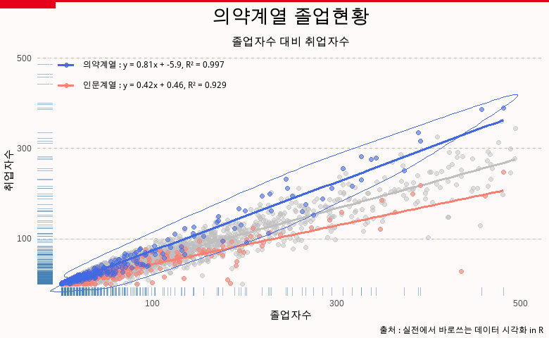

# 전체 그룹의 비교 시각화와 설명문 삽입

1. 목표 : 전체 데이터의 그룹별 분포와 기술 통계를 시각화하여 전달하고 시각화를 통해 전달하고자 하는 인사이트를 삽입 활용 시각화 : 박스 플롯, 바이올린 플롯, 산점도(jitter)

library(ggtext)  
font_add('NanumBarunGothicBold', 'c:/windows/fonts/NanumBarunGothicBold.ttf')  
  
font_add('NanumBarunGothic', 'c:/windows/fonts/NanumBarunGothic.ttf')  
  
df_전체_요약 <- df_취업통계 |>  
 summarise(mean = mean(취업률_계), median = median(취업률_계), n = n())  
  
subtitle <- paste0('전체 사례수 : ', scales::comma(df_전체_요약$n, accuracy = 1))  
  
df_계열_요약 <- df_취업통계 |>  
 group_by(대계열) |>  
 summarise(median = median(취업률_계), n = n())  
  
labels <- paste0('<span style= "font-family: NanumBarunGothicBold;font-size: 12pt" >', df_계열_요약$대계열, '</span> <br>', '중앙값 : ', scales::percent(df_계열_요약$median, scale = 1), '<br>', '사례수 : ', scales::comma(df_계열_요약$n, accuracy = 1))  
  
labels_name <- pull(df_계열_요약, 대계열)  
  
title <- "<b><span style= 'font-family: NanumBarunGothicBold;font-size: 15pt'>대학의 계열별 학과 취업률 분포</b>"  
  
subtitle <- "<span style = 'font-size:10pt'>전체 대학의 취업률 평균은 11.11%인데 <span style = 'color:red;'>의약계열</span>의 평균이 <span style = 'color:red;'> 75.8%</span> 중앙값이 <span style = 'color:red;'> 81.4%</span>로 가장 높게 나타나고 전체적인 분포도 높게 분포함.</span>"  
  
df_취업통계$대계열 = reorder(df_취업통계$대계열, df_취업통계$취업률_계, mean)  
  
df_취업통계 |>  
 ggplot(aes(x = 대계열, y = 취업률_계)) +  
 geom_jitter(aes(color = 대계열), width = 0.1, alpha = 0.1, show.legend = F) +  
 geom_boxplot(fill = NA, width = 0.4) +  
 geom_violin(fill = NA, width = 0.4) +  
 geom_point(aes(x = 대계열, y = 취업률_계), stat = 'summary', fun.y = 'mean', color = 'tomato3', size = 4) +  
 geom_label(aes(x = 대계열, y = 취업률_계, label = paste0('평균 : ', round(..y.., 1))), stat = 'summary', fun.y = 'mean', color = 'tomato3', size = 4, nudge_y = -7) +   
 labs(title = title, x = NULL, y = NULL, subtitle = subtitle) +  
 scale_x_discrete(expand = expansion(add = c(0.5, 0.5)), labels = setNames(labels, labels_name), limits = rev) +  
 theme(strip.text.x = element_blank(),  
 strip.background = element_rect(colour="white", fill="white"),  
 legend.position=c(.2,.9),   
 legend.background = element_rect(fill = NA),   
 legend.key = element_rect(fill = NA),   
 plot.title = element_textbox_simple(halign = 0.5),  
 plot.subtitle = element_textbox_simple(width = unit(0.95, "npc"), size = 13,  
 lineheight = 1,  
 padding = margin(5.5, 0.5, 5.5, 5.5),  
 margin = margin(10, 0, 5.5, 0),  
 halign = 0.5,   
 box.color = 'red',  
 r = grid::unit(8, "pt"),  
 linetype = 1),  
 axis.line = element_blank(),   
 plot.background = element_rect(fill = 'lemonchiffon'),   
 panel.background = element_rect(fill = 'lemonchiffon'),   
 axis.text.x = element_markdown(),   
 plot.margin = margin(0.025, 0, 0.075, 0, "npc"),  
 )  
  
  
grid.text(  
 '출처: 실전에서 바로쓰는 데이터 시각화 in R',   
 x = 0.005,   
 y = 0.03,   
 just = c("left", "bottom"),  
 gp = gpar(  
 col = "grey50",  
 fontsize = 10,  
 fontfamily = "Econ Sans Cnd"  
 )  
)  
  
# Add third caption  
grid.text(  
 "참조 : https://www.r-graph-gallery.com/",   
 x = 0.995,   
 y = 0.03,   
 just = c("right", "bottom"),  
 gp = gpar(  
 col = "grey50",  
 fontsize = 10,  
 fontfamily = "Econ Sans Cnd"  
 )  
)

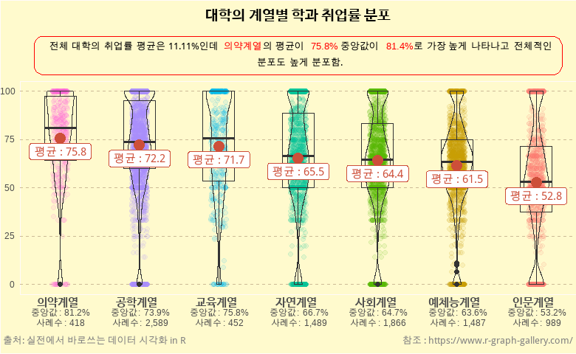

# 종합

1. 목표 : 비교의 대상이 되는 두 개의 그룹에 대한 산점도와 추세선을 각각 그리고 추세선의 선형회귀 방정식을 표현하여 각각의 그룹의 분포를 서로 비교하고 통계적 유의성을 전달 활용 시각화 : 박스 플롯, 바이올린 플롯, 산점도

library(ggtext)  
library(grid)  
library(tidyverse)  
  
theme_set(  
 theme_grey()  
)  
  
df_total_line <- df_입학자_long |> filter(지역 == '전체', lubridate::year(연도) %in% c(seq(from = 2001, to = 2021, by = 5)), 학교종류 %in% c('전문대학', '일반대학', '석사', '박사'))   
  
data_labels <- bind_rows(df_total_line |> filter(lubridate::year(연도) == 2001, 학교종류 %in% c('일반대학', '석사', '박사')), df_total_line |> filter(lubridate::year(연도) == 2006, 학교종류 %in% c('전문대학')))  
  
df_total_line |>  
 ggplot(aes(x = 연도, y = (입학생수)/1000)) +   
 ## geom_line 레이어를 생성  
 geom_line(aes(group = 학교종류, color = 학교종류), size = 2.4) +  
 geom_point(aes(fill = 학교종류), size = 5,   
 shape = 21, # Type of point that allows us to have both color (border) and fill.  
 color = "white",   
 stroke = 1 # The width of the border, i.e. stroke.  
 ) +   
 scale_x_date(  
 expand = c(0, 0), # The horizontal axis does not extend to either side  
 limits = c(as.Date('2000-01-01'), as.Date('2022-12-01')),   
 breaks = seq(from = as.Date("2001-01-01"), to = as.Date("2021-01-01"),  
 by = "5 years"),   
 labels = lubridate::year(seq(from = as.Date("2001-01-01"), to = as.Date("2021-01-01"),  
 by = "5 years")) # Set custom break locations  
 # Set custom break locations  
# labels = c("2008", "12", "16", "20") # And custom labels on those breaks!  
 ) +   
 scale_y_continuous(  
 limits = c(0, 380),  
 expand = c(0, 0)  
 ) -> line_ch7_1  
  
line_ch7_1 +  
 theme(  
 # Set background color to white  
 panel.background = element_rect(fill = "white"),  
 # Remove all grid lines  
 panel.grid = element_blank(),  
 # But add grid lines for the vertical axis, customizing color and size   
 panel.grid.major.y = element_line(color = "#A8BAC4", size = 0.3),  
 # Remove tick marks on the vertical axis by setting their length to 0  
 axis.ticks.length.y = unit(0, "mm"),   
 # But keep tick marks on horizontal axis  
 axis.ticks.length.x = unit(2, "mm"),  
 # Remove the title for both axes  
 axis.title = element_blank(),  
 # Only the bottom line of the vertical axis is painted in black  
 axis.line.x.bottom = element_line(color = "black"),  
 # Remove labels from the vertical axis  
 axis.text.y = element_blank(),  
 # But customize labels for the horizontal axis  
 axis.text.x = element_text(family = "Econ Sans Cnd", size = 16)  
 ) -> line_ch7_2  
  
  
  
line_ch7_2 +   
 geom_text(data = data_labels, aes(x = 연도, y = (입학생수/1000) + 20, label = 학교종류, color = 학교종류), show.legend = F) +   
 geom_text(  
 data = data.frame(x = as.Date('2022-09-01'), y = seq(0, 300, by = 100)),  
 aes(x, y, label = y),  
 hjust = 1, # Align to the right  
 vjust = -0.5, # Align to the bottom  
 family = "Econ Sans Cnd",  
 size = 3,   
 color = 'grey50'  
 ) +   
 theme(legend.position = 'none') +  
 labs(  
 title = "**교육과정별 졸업생수(k)**",  
 ) +   
 theme(  
 # theme_markdown() is provided by ggtext and means the title contains   
 # Markdown that should be parsed as such (the '**' symbols)  
 plot.title = element_markdown(  
 family = "Econ Sans Cnd",   
 size = 12  
 )  
 ) -> line_ch7_3  
  
  
ggplot(df_total_line) +  
 # color = "white" indicates the color of the lines between the areas  
 geom_area(aes(x = 연도, y = (입학생수)/1000, group = 학교종류, fill = 학교종류), color = "white") +  
# scale_fill_manual(values = c('grey', 'brown', 'green', 'blue')) +  
 theme(legend.position = "None") + # no legend +  
 scale_x_date(  
 expand = c(0, 0), # The horizontal axis does not extend to either side  
 limits = c(as.Date('2000-01-01'), as.Date('2022-12-01')),   
 breaks = seq(from = as.Date("2001-01-01"), to = as.Date("2021-01-01"),  
 by = "5 years"),   
 labels = lubridate::year(seq(from = as.Date("2001-01-01"), to = as.Date("2021-01-01"),  
 by = "5 years")) # Set custom break locations  
 # Set custom break locations  
 # labels = c("2008", "12", "16", "20") # And custom labels on those breaks!  
 ) +   
 scale_y_continuous(  
 limits = c(0, 790),  
 expand = c(0, 0)  
 ) -> area_ch7_1  
  
area_ch7_1 +   
 theme(  
 # Set background color to white  
 panel.background = element_rect(fill = "white"),  
 # Remove all grid lines  
 panel.grid = element_blank(),  
 # But add grid lines for the vertical axis, customizing color and size   
 panel.grid.major.y = element_line(color = "#A8BAC4", size = 0.3),  
 # Remove tick marks on the vertical axis by setting their length to 0  
 axis.ticks.length.y = unit(0, "mm"),   
 # But keep tick marks on horizontal axis  
 axis.ticks.length.x = unit(2, "mm"),  
 # Remove the title for both axes  
 axis.title = element_blank(),  
 # Only the bottom line of the vertical axis is painted in black  
 axis.line.x.bottom = element_line(color = "black"),  
 # Remove labels from the vertical axis  
 axis.text.y = element_blank(),  
 # But customize labels for the horizontal axis  
 axis.text.x = element_text(family = "Econ Sans Cnd", size = 16)  
 ) -> area_ch7_2  
  
area_ch7_2 +   
 geom_text(aes(x = as.Date('2011-01-01'), y = 600), label = '전문대학', color = 'white') +   
 geom_text(aes(x = as.Date('2011-01-01'), y = 300), label = '일반대학', color = 'white') +   
 geom_text(aes(x = as.Date('2011-01-01'), y = 80), label = '석사', color = 'white') +   
 geom_text(aes(x = as.Date('2014-01-01'), y = 80), label = '박사', color = 'white') +   
 geom_segment(aes(x = as.Date('2014-01-01'), xend = as.Date('2014-01-01'), y = 12, yend = 60), color = 'white', arrow = arrow(angle = 30, length = unit(0.1, "inches"))) +   
 geom_text(  
 data = data.frame(x = as.Date('2022-09-01'), y = seq(0, 800, by = 200)),  
 aes(x, y, label = y),  
 hjust = 1, # Align to the right  
 vjust = -0.5, # Align to the bottom  
 family = "Econ Sans Cnd",  
 size = 3,   
 color = 'grey50'  
 ) +   
 theme(legend.position = 'none') +   
 labs(  
 title = "고등교육기관 졸업생 수(k)",  
 ) +   
 theme(  
 plot.title = element_markdown(  
 family = "Econ Sans Cnd",   
 size = 12  
 )  
 ) -> area_ch7_3  
  
  
plt1 <- line_ch7_3 + theme(plot.margin = margin(0, 0.05, 0, 0, "npc"))  
plt2 <- area_ch7_3 + theme(plot.margin = margin(0, 0, 0.05, 0, "npc"))  
plt <- plt1 | plt2  
  
title_theme <- theme(  
 plot.title = element_text(  
 hjust = 0.02,  
 size = 15,  
 margin = margin(0.8, 0, 0.3, 0, "npc")  
 ),  
 plot.subtitle = element_text(  
 hjust = 0.02,  
 size = 12,  
 margin = margin(0.4, 0, 0.5, 0, "npc")  
 )  
)  
  
plt <- plt + plot_annotation(  
 title = "전문대학의 위기",  
 subtitle = "전문대학 학생수 감소 추세",  
 theme = title_theme  
) +  
 theme(  
 plot.margin = margin(0.075, 0, 0.1, 0, "npc"),  
 )  
   
plt  
  
# Add line on top of the chart  
grid.lines(  
 x = c(0, 1),  
 y = 1,  
 gp = gpar(col = "#e5001c", lwd = 4)  
)  
  
# Add rectangle on top-left  
# lwd = 0 means the rectangle does not have an outer line  
# 'just' gives the horizontal and vertical justification  
grid.rect(  
 x = 0,  
 y = 1,  
 width = 0.05,  
 height = 0.025,  
 just = c("left", "top"),  
 gp = gpar(fill = "#e5001c", col = "#e5001c", lwd = 0)  
)  
# Add first caption  
grid.text(  
 '출처: 실전에서 바로쓰는 데이터 시각화 in R',   
 x = 0.005,   
 y = 0.06,   
 just = c("left", "bottom"),  
 gp = gpar(  
 col = "grey50",  
 fontsize = 10,  
 fontfamily = "Econ Sans Cnd"  
 )  
)  
  
# Add third caption  
grid.text(  
 "참조 : https://www.r-graph-gallery.com/",   
 x = 0.995,   
 y = 0.06,   
 just = c("right", "bottom"),  
 gp = gpar(  
 col = "grey50",  
 fontsize = 10,  
 fontfamily = "Econ Sans Cnd"  
 )  
)

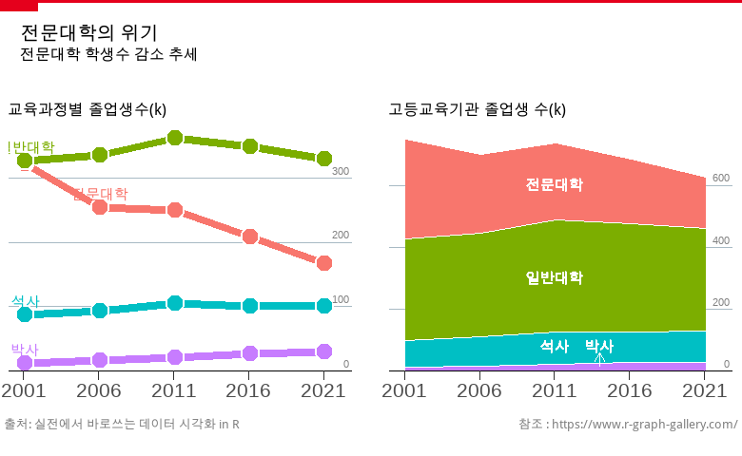

library(tidyverse)  
library(patchwork)  
showtext_auto()  
  
font_add('NanumBarunGothic', 'c:/windows/fonts/NanumBarunGothic.ttf')  
  
df_취업통계$대계열 = fct_relevel(df_취업통계$대계열, '인문계열', '사회계열', '교육계열', '자연계열', '공학계열', '의약계열', '예체능계열')  
  
df_취업통계$과정구분 = fct_relevel(df_취업통계$과정구분, '전문대학과정', '대학과정', '대학원과정')  
  
  
df_취업통계_계열별 <- df_취업통계 |>  
 group_by(과정구분, 대계열) |>   
 summarise(졸업자 = sum(졸업자_계),   
 취업자 = sum(취업자_합계_계),   
 진학자 = sum(진학자_계),   
 입대자 = sum(입대자),  
 취업불가능자 = sum(취업불가능자_계),   
 외국인유학생 = sum(외국인유학생_계),   
 제외인정자 = sum(제외인정자_계),  
 ## 백분률인 취업률은 그 자체로 합계나 평균을 낼 수 없으니 각 그룹별로 재계산  
 취업률 = 취업자 / (졸업자 - (진학자+입대자+취업불가능자+외국인유학생+제외인정자))) |>  
 ## 계열의 표시 순서를 설정하기 위해 레벨을 재조정  
 arrange(과정구분, 대계열) |>  
 ungroup() |>  
 mutate(id = seq(1:n())) |>  
 mutate(angle = 90 - (id-0.5)/n() * 360) |>  
 mutate(angle1 = case_when(  
 id > n()/2 ~ angle + 180,   
 id <= n()/2 ~ angle  
 ))  
  
  
df_취업통계_과정별 <- df_취업통계 |>   
 group_by(과정구분) |>   
 summarise(졸업자 = sum(졸업자_계),   
 취업자 = sum(취업자_합계_계),   
 진학자 = sum(진학자_계),   
 입대자 = sum(입대자),  
 취업불가능자 = sum(취업불가능자_계),   
 외국인유학생 = sum(외국인유학생_계),   
 제외인정자 = sum(제외인정자_계),  
 ## 백분률인 취업률은 그 자체로 합계나 평균을 낼 수 없으니 각 그룹별로 재계산  
 취업률 = 취업자 / (졸업자 - (진학자+입대자+취업불가능자+외국인유학생+제외인정자))) |>  
 ## 계열의 표시 순서를 설정하기 위해 레벨을 재조정  
 arrange(과정구분) |>  
 ungroup() |>  
 mutate(id = seq(1:n())) |>  
 mutate(angle = 90 - (id-0.5)/n() * 360) |>  
 mutate(angle1 = case_when(  
 id >= n()/2 ~ angle + 270,   
 id < n()/2 ~ angle -90,   
 ))  
  
df_취업통계_전체 <- df_취업통계 |>   
 summarise(## 백분률인 취업률은 그 자체로 합계나 평균을 낼 수 없으니 각 그룹별로 재계산  
 취업률 = sum(취업자_합계_계) / (sum(졸업자_계) - (sum(진학자_계)+sum(입대자)+sum(취업불가능자_계)+sum(외국인유학생_계)+sum(제외인정자_계)))) |>  
 select(취업률) |>  
 pull()  
  
#View(df_취업통계_계열별)  
# angle <- 90 - (df_취업통계_계열별$id-0.5)/nrow(df_취업통계_계열별) * 360  
# calculate the ANGLE of the labels  
# I substract 0.5 because the letter must have the angle of the center of the bars. Not extreme right(1) or extreme left (0)  
  
# calculate the alignment of labels: right or left  
# If I am on the left part of the plot, my labels have currently an angle < -90  
#label_data$hjust<-ifelse( angle < -90, 1, 0)  
  
# flip angle BY to make them readable  
#label_data$angle<-ifelse(angle < -90, angle+180, angle)  
library(geomtextpath)  
  
df_취업통계_계열별 |>  
 ggplot(aes(x = id, y = 취업률, fill = 대계열)) +   
 geom_col(position = 'dodge', show.legend = F)+   
 scale_y_continuous(labels = scales::percent, limits = c(-0.5, 1.2)) +  
 scale_x_continuous(limits = c(0.5, 21.5)) +  
 annotate(xmin = 0.5, xmax = 7.5, ymin = -0.1, ymax = 1, alpha = 0.1, geom = 'rect', fill = 'red') +  
 annotate(xmin = 7.5, xmax = 14.5, ymin = -0.1, ymax = 1, alpha = 0.1, geom = 'rect', fill = 'green') +  
 annotate(xmin = 14.5, xmax = 21.5, ymin = -0.1, ymax = 1, alpha = 0.1, geom = 'rect', fill = 'blue') +  
 geom_textpath(data = df_취업통계_과정별,aes(x = 4+((id-1)*7), y = 1.0, label = paste0(과정구분, ', ', round(취업률*100, 1), '%'), color = as.factor(id)), inherit.aes = F, show.legend = F, rich = TRUE, family = 'NanumBarunGothic') +  
 geom_text(data = df_취업통계_계열별, aes(x=id, y=0.5, label=paste0(대계열, ', ', round(취업률*100, 1), '%'), angle= angle1), color="black", inherit.aes = FALSE, size = rel(3), hjust = 0.5) +  
 geom_segment(data = df_취업통계_과정별, aes(x = 0.5+((id-1)*7), xend = 7.5+((id-1)*7), y = 취업률, yend = 취업률, color = as.factor(id)), inherit.aes = F, show.legend = F) +   
 scale_fill_brewer(palette = 'Set3') +   
 coord_curvedpolar() +  
 theme_void() +   
 theme(plot.title = element_text(hjust = 0.5, size = 20),   
 plot.margin = margin(0.25, 0, 0, 0),   
 text = element_text(family = 'NanumBarunGothic')) +   
 annotate(x = 0.5, y = -0.35, geom = 'text', label = '전체취업률') +   
 geom_text(aes(x = 0.5, y = -0.5, label = paste0(round(df_취업통계_전체, 3)*100, '%')), size = rel(4))

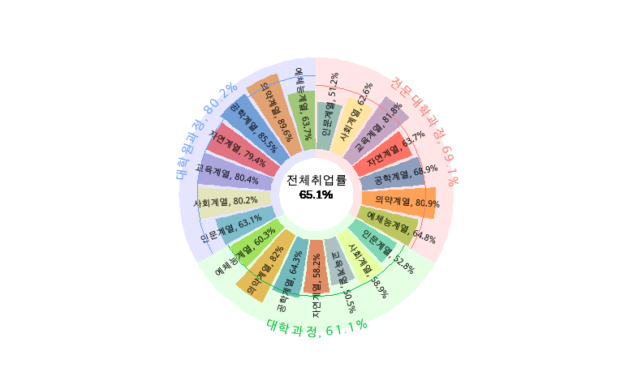

## Lists

Amet nunc eros curabitur tellus massa, eros maximus porttitor sociosqu, pellentesque.

* Erat mauris egestas finibus tincidunt sed in rhoncus a tellus etiam.
  + A adipiscing per ultricies justo tellus lorem.
    - Imperdiet ut dui primis, sed gravida, at sed nulla.
    - Sem posuere lacus consequat inceptos dapibus duis malesuada finibus.
  + Urna sed dui, ornare, eu turpis mus pellentesque amet amet bibendum.
* Himenaeos tincidunt, auctor dapibus scelerisque, montes nunc faucibus sodales malesuada ridiculus sed cubilia ligula.

1. Erat mauris egestas finibus tincidunt sed in rhoncus a tellus etiam.
   1. A adipiscing per ultricies justo tellus lorem.
      1. Imperdiet ut dui primis, sed gravida, at sed nulla.
      2. Sem posuere lacus consequat inceptos dapibus duis malesuada finibus.
   2. Urna sed dui, ornare, eu turpis mus pellentesque amet amet bibendum.
2. Himenaeos tincidunt, auctor dapibus scelerisque, montes nunc faucibus sodales malesuada ridiculus sed cubilia ligula.

Lorem dolor interdum orci eros pellentesque semper tristique, sodales, et sed ut! Porta mattis natoque et. Ac facilisi ipsum viverra elementum vestibulum ligula amet enim magnis luctus ullamcorper. Rhoncus rhoncus elit in at nisl. Tincidunt habitant sit.

* Aptent conubia quam montes id sagittis.
  + Mattis nisi nascetur, aliquam duis ex, tristique.
    - Imperdiet ut dui primis, sed gravida, at sed nulla.
    - Donec ligula nulla ac. Nisl ac at accumsan sagittis eros felis lobortis amet nec phasellus urna bibendum sapien.
  + Eu dui ac id, dictum proin consectetur convallis.
* Facilisi eu lectus mauris lorem. Et sed sapien pellentesque sed etiam vehicula.
* In porttitor id lorem eu efficitur, nisl dis!

## Reference

see figure and table !