> t <- cpScript()

[1] ---> loading data...

[1] ...done reading data and creating data frames

[1] plotting Random Forest variable importance() metrics

[1] no clear dividing line differentiating important vs. unimportant variables

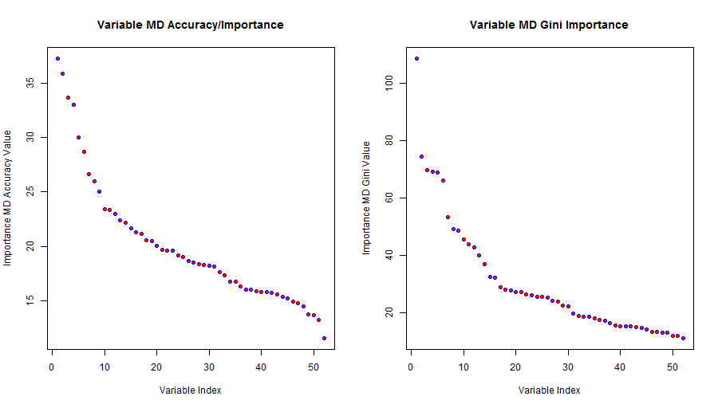

[1] ---> assessing whether Linear Model coefficients offer useful variable importance rankings...

[1] plotting Linear Model coefficients sorted in decreasing order

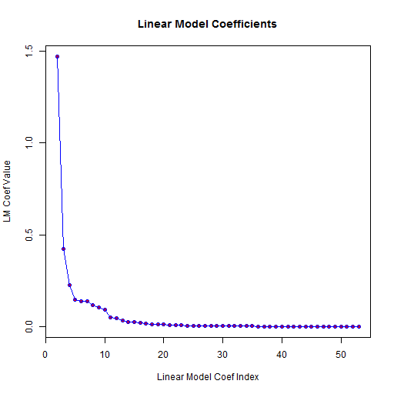

[1] ---> examining Random Forest performance for a range of 'mtry' and 'ntree' parameters...

[1] evaluating Random Forest w/ mtry=2 ntree=1

[1] evaluating Random Forest w/ mtry=2 ntree=2

[1] evaluating Random Forest w/ mtry=2 ntree=3

[1] evaluating Random Forest w/ mtry=2 ntree=5

[1] evaluating Random Forest w/ mtry=2 ntree=10

[1] evaluating Random Forest w/ mtry=2 ntree=20

[1] evaluating Random Forest w/ mtry=5 ntree=1

[1] evaluating Random Forest w/ mtry=5 ntree=2

[1] evaluating Random Forest w/ mtry=5 ntree=3

[1] evaluating Random Forest w/ mtry=5 ntree=5

[1] evaluating Random Forest w/ mtry=5 ntree=10

[1] evaluating Random Forest w/ mtry=5 ntree=20

[1] evaluating Random Forest w/ mtry=10 ntree=1

[1] evaluating Random Forest w/ mtry=10 ntree=2

[1] evaluating Random Forest w/ mtry=10 ntree=3

[1] evaluating Random Forest w/ mtry=10 ntree=5

[1] evaluating Random Forest w/ mtry=10 ntree=10

[1] evaluating Random Forest w/ mtry=10 ntree=20

[1] --> Random Forest accuracy values for evaluated (mtry, ntree) grid pairs:

[1] --> NOTE: row names are mtry values; column names are ntree values

[1] --> NOTE: matrix entries are classification accuracy on train set

1 2 3 5 10 20

2 0.9548321 0.9512009 0.9906989 0.9978977 0.9997452 1.0000000

5 0.9720966 0.9693572 0.9950946 0.9984710 0.9998726 1.0000000

10 0.9684016 0.9678282 0.9948398 0.9984073 0.9998726 0.9999363

[1] --->parameters from best 52-feature Random Forest:

[1] resultant rf52: train accuracy=1.000000 mtry=2 ntree=20 OOB error=0.023445

[1] ---> printing best (rf52) Random Forest for above parameters:

Call:

randomForest(formula = classe ~ ., data = df, mtry = mt, ntree = nt)

Type of random forest: classification

Number of trees: 20

No. of variables tried at each split: 2

OOB estimate of error rate: 2.34%

Confusion matrix:

A B C D E class.error

A 4394 22 9 14 2 0.01058320

B 45 2951 32 14 10 0.03309305

C 7 45 2610 30 7 0.03297518

D 12 3 63 2480 10 0.03426791

E 2 15 4 22 2893 0.01464578

[1] ---> computing rfcv() cross-validation error - this may take several minutes...

[1] ...done computing rfcv() output

[1] rfcv() cross-validation estimates for training set vs. number variables used:

52 26 13 6 3 1

0.005542460 0.007581066 0.009683379 0.045104160 0.109320252 0.596929350

[1] accuracy of best (rf52) Random Forest on 20% TEST set: 0.991847

[1] ---> As additional exercise fit Random Forest to top-20 features from Linear Model

[1] evaluating Random Forest w/ mtry=2 ntree=10

[1] evaluating Random Forest w/ mtry=2 ntree=50

[1] evaluating Random Forest w/ mtry=2 ntree=100

[1] evaluating Random Forest w/ mtry=2 ntree=200

[1] evaluating Random Forest w/ mtry=5 ntree=10

[1] evaluating Random Forest w/ mtry=5 ntree=50

[1] evaluating Random Forest w/ mtry=5 ntree=100

[1] evaluating Random Forest w/ mtry=5 ntree=200

[1] evaluating Random Forest w/ mtry=10 ntree=10

[1] evaluating Random Forest w/ mtry=10 ntree=50

[1] evaluating Random Forest w/ mtry=10 ntree=100

[1] evaluating Random Forest w/ mtry=10 ntree=200

[1] --> Random Forest accuracy values for evaluated (mtry, ntree) grid pairs:

[1] --> NOTE: row names are mtry values; column names are ntree values

[1] --> NOTE: matrix entries are classification accuracy on train set

10 50 100 200

2 0.9997452 1 1 1

5 0.9998726 1 1 1

10 0.9998726 1 1 1

[1] --->parameters from best 20-feature Random Forest:

[1] resultant rf20: train accuracy=1.000000 mtry=2 ntree=50 OOB error=0.009110

[1] ---> printing best Random Forest for above parameters:

Call:

randomForest(formula = classe ~ ., data = df, mtry = mt, ntree = nt)

Type of random forest: classification

Number of trees: 50

No. of variables tried at each split: 2

OOB estimate of error rate: 0.91%

Confusion matrix:

A B C D E class.error

A 4430 7 0 3 1 0.002476920

B 21 3020 8 1 2 0.010484928

C 3 28 2663 5 1 0.013703704

D 3 0 42 2519 4 0.019080997

E 0 3 1 10 2922 0.004768392

[1] ---> evalute top-20 feature Random Forest:

[1] accuracy of best (rf20) Random Forest on 20% TEST set: 0.994395

[1] ---> use rf52 to predict labels for course project 20-row data set (pml-testing.csv

1 2 3 4 5 6 7 8 9 10 11 12 13 14 15 16 17 18 19 20

B A B A A E D B A A B C B A E E A B B B

Levels: A B C D E

[1] ---> use rf20 to predict labels for course project 20-row data set (pml-testing.csv

1 2 3 4 5 6 7 8 9 10 11 12 13 14 15 16 17 18 19 20

B A B A A E D B A A B C B A E E A B B B

Levels: A B C D E