Cardiac Risk Prediction Using Machine Learning: Mid-Semester Progress Report
Dhanush Annoji  [dannoji1] | Harry Ahsan  [tahsan1] | Neha Kushnapalli  [nkushnapalli1]

Heart disease is a leading cause of death worldwide, and early detection from routine clinical measurements is an important screening problem. This project develops and compares six supervised classifier: Logistic Regression, Support Vector Machine, k-Nearest Neighbors, Random Forest, XGBoost, and an Artificial Neural Network.
We predict the presence of heart disease from 13 clinical and demographic attributes of 270 patients. At the midpoint of the project, preprocessing, exploratory analysis, and initial training and evaluation of all six models are complete. Logistic Regression currently achieves the strongest test-set performance with 88.9% accuracy and 0.918 ROC-AUC. Remaining work shall include cross-validated eval, hyperparameter tuning on the basic baselines, feature selection and interpretability analysis.
I. Introduction and Goals
Beyond raw predictive performance, we aim to answer a practical question: which model offers the best balance between accuracy and interpretability for a clinical screening setting? To that end we compare three baseline classifiers (Logistic Regression, SVM, k-NN) against three more complex models (Random Forest, XGBoost, and a neural network) under a common evaluation protocol emphasizing recall, since failing to flag a diseased patient is costlier than a false alarm.
II. Dataset
We use a Heart Disease Prediction dataset from Kaggle [1], containing 270 patient records with 13 attributes: age, sex, chest pain type, resting blood pressure, serum cholesterol, fasting blood sugar, resting electrocardiogram results, maximum heart rate achieved, exercise-induced angina, ST depression, ST slope, number of major vessels visible under fluoroscopy, and thallium stress test result. The binary target indicates presence (44.4%) or absence (55.6%) of heart disease, so the classes are approximately balanced. Validation found no missing values and no duplicate records.
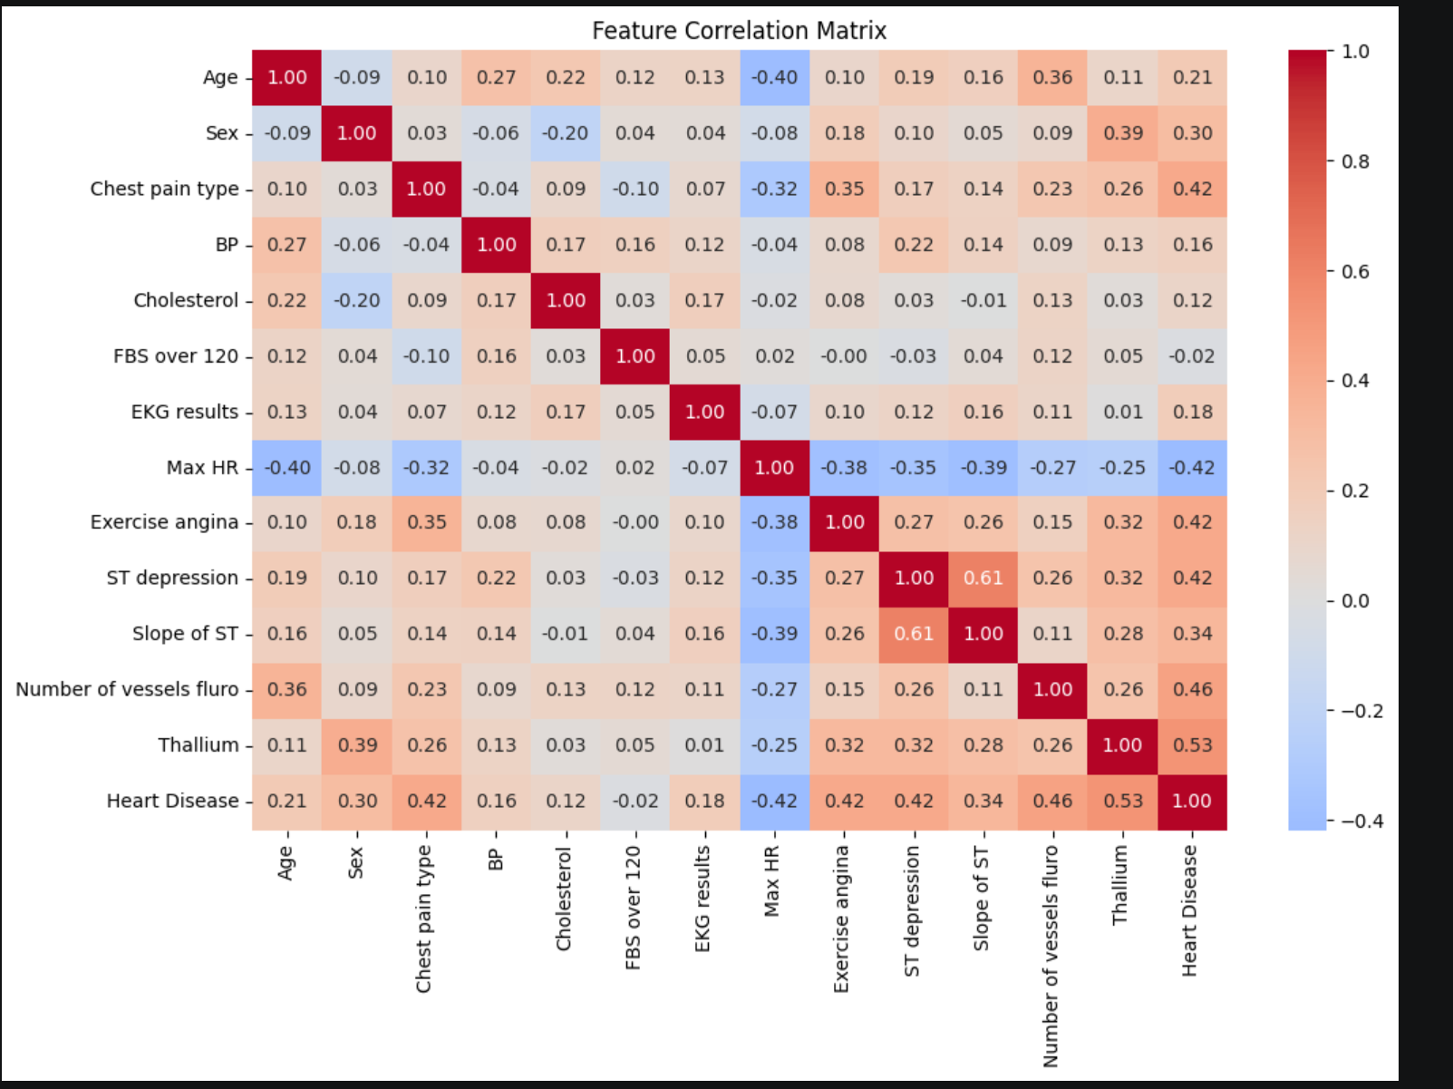
Fig. 1. Feature correlation matrix. Thallium result, chest pain type, number of fluoroscopy vessels, maximum heart rate, and exercise-induced angina correlate most strongly with the target.
III. Methodology
A. Preprocessing
The target was encoded as Presence = 1, Absence = 0. Three nominal categorical features: chest pain type, EKG results, thallium result.
These were one-hot encoded with the first level dropped, expanding the feature matrix from 13 to 17 columns; binary and ordinal features were kept as-is.
The data was split 80/20 with stratification (216 training / 54 test patients). Continuous features were standardized with a scaler fit on the training set only, to avoid leakage; scaled features are used by the distance and gradient-based models, while tree ensembles use the unscaled features.
B. Models
We train six classifiers:
- Logistic Regression (L2)
- SVM with RBF kernel
- k-NN (k selected by 5-fold cross-validation on the training set; best k = 9)
- Random Forest (300 trees)
- XGBoost (300 trees, depth 3, learning rate 0.1)
- Artificial Neural Network implemented as a multilayer perceptron with two hidden layers (32, 16) and ReLU activations.
All stochastic models use a fixed random seed for reproducibility.
C. Evaluation
Models are compared on the held-out test set using accuracy, precision, recall, F1-score, and ROC-AUC, with confusion matrices and ROC curves for qualitative comparison.
IV. Progress and Intermediate Results
Per the proposal schedule, Weeks 1–3 (EDA, preprocessing, baseline models, and advanced models) are complete: two notebooks implement the full pipeline, and all six classifiers have been trained and evaluated. Table I summarizes current test-set performance.
TABLE I. Test-Set Performance of the Six Classifiers (n = 54)
Model | Acc. | Prec. | Rec. | F1 | AUC
Logistic Regression | 0.889 | 0.846 | 0.917 | 0.880 | 0.918
SVM (RBF) | 0.870 | 0.840 | 0.875 | 0.857 | 0.893
k-NN (k = 9) | 0.852 | 0.808 | 0.875 | 0.840 | 0.897
ANN (MLP) | 0.833 | 0.800 | 0.833 | 0.816 | 0.846
Random Forest | 0.815 | 0.769 | 0.833 | 0.800 | 0.892
XGBoost | 0.815 | 0.769 | 0.833 | 0.800 | 0.861

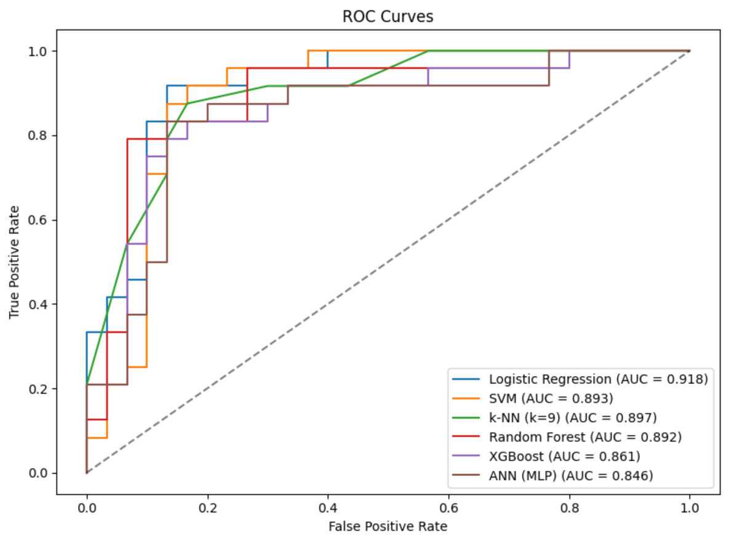Fig. 2. ROC curves on the held-out test set. Logistic Regression attains the highest AUC (0.918).
Three preliminary observations stand out:
- First, Logistic Regression: the simplest and most interpretable model currently leads on every metric, including recall (0.917; only 2 of 24 diseased patients missed).
- Second, the neural network and tree ensembles do not outperform the linear baseline, which is consistent with the modest training set size (216 samples): complex models have insufficient data to exploit their capacity.
- Third, these differences must be interpreted cautiously as the test set contains 54 patients, so the gap between the best and worst model corresponds to roughly three patients. Confirming the ranking with cross-validation is the first item of remaining work.
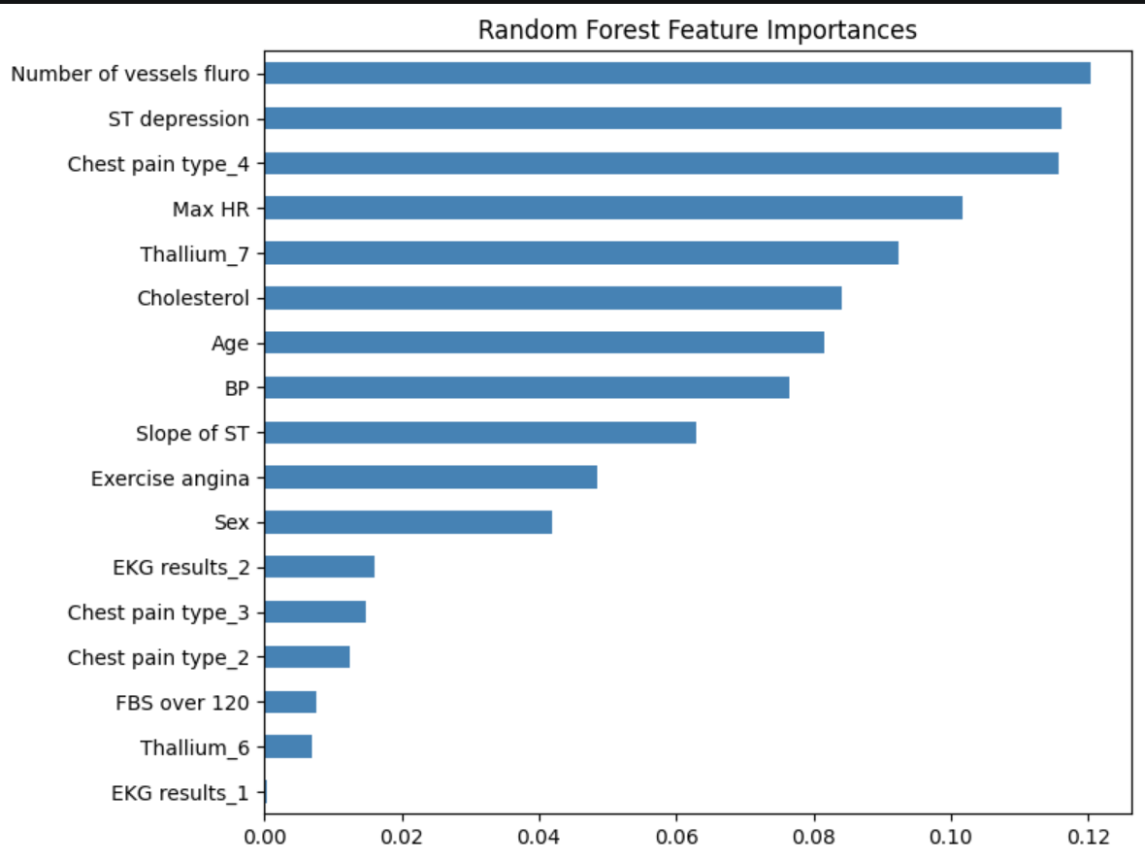Fig. 3. Random Forest feature importances. Thallium result, chest pain type, maximum heart rate, and fluoroscopy vessel count dominate, agreeing with the correlation analysis.
V. Remaining Work Plan
The following steps are planned for the remainder of the project (July 17–30):
- July 17th – 24th : Strengthen the evaluation. Cross-validate all six models, tune hyperparameters, and experiment with feature selection.
- Repeated stratified k-fold cross-validation over the full dataset to obtain mean and standard deviation for every metric, replacing the single-split estimates and confirming the model ranking. Submit this mid-report.
- Hyperparameter tuning of SVM, Random Forest, XGBoost, and the ANN via grid search within the cross-validation folds.
- Feature selection experiments (univariate ranking and recursive feature elimination with cross-validation); retrain all models on the reduced feature set and compare.

- July 24th – 30th: Interpretability analysis, consolidation of results and visualizations, and completion of the final report (IEEE format) and presentation.
- Interpretability analysis: logistic regression coefficients and odds ratios, and ensemble feature importances, to answer the performance-versus-interpretability question posed in the proposal.
- Final report with consolidated results and visualizations; presentation slides and rehearsal.
References
[1] N. Alisha, “Heart Disease Prediction Dataset,” Kaggle. [Online]. Available: https://www.kaggle.com/datasets/nalisha/heart-disease-prediction-dataset

