Kerala Finance KIP — Knowledge Intelligence Platform
Finance Policy and Government Order Knowledge Intelligence Platform

Technical Project Documentation
Client: Finance Department, Government of Kerala
Project: Finance Policy and Government Order Knowledge Intelligence Platform
Project Type: Enterprise Document Intelligence and Policy Assistance Platform
Architecture: Local, Modular, Microservice-Based Architecture
Deployment: Docker Compose
AI Approach: Local LLM and Local Embeddings
Frontend: React + Vite
Backend: FastAPI / Python
Document Intelligence: OCR, semantic chunking, hybrid retrieval and extraction
Table of Contents
1. Finance Policy and Government Order Knowledge Intelligence Platform 7
2. Abstract / Executive Summary 8
3. Introduction 10
3.1 Background 10
3.2 Problem Statement 10
3.3 Motivation 11
3.4 Aim 12
3.5 Objectives 12
3.6 Scope 12
4. Requirements Analysis 14
4.1 Functional Requirements 14
4.2 Non-Functional Requirements 16
4.3 User Requirements 17
4.4 System Requirements 18
5. System Analysis and Design 19
5.1 System Architecture 19
5.2 System Workflow 21
5.3 Use-Case Diagram 23
5.4 Data Flow Diagram 24
5.5 UML Design 25
5.6 ER Diagram / Database Design 27
6. Technology Stack 28
6.1 Programming Languages 28
6.2 Frameworks and Libraries 29
6.3 Database and Storage 30
6.4 Development and Deployment Tools 31
7. System Implementation 31
7.1 Repository Structure 31
7.2 API Gateway 33
7.3 Ingestion Service 33
7.4 Semantic Chunking 34
7.5 Embedding Generation 34
7.6 Hybrid Search 34
7.7 Document Lineage 35
7.8 Source Review Labels 36
7.9 Clause and Financial Figure Extraction 36
7.10 GST Assistant 36
7.11 Policy Agent 37
7.12 Local LLM Implementation 37
7.13 Frontend Implementation 38
8. Testing and Validation 38
8.1 Test Strategy 38
8.2 Test Cases 39
8.3 Functional Testing 41
8.4 Error Handling 41
8.5 Performance Testing 42
9. Results and Evaluation 42
9.1 System Demonstration 42
9.2 Document Ingestion Results 43
9.3 Search Results 44
9.4 Source-Aware AI Results 44
9.5 Policy-Agent Results 44
9.6 Security Results 45
9.7 Overall Evaluation 45
10. Security, Privacy and Ethical Considerations 47
10.1 Data Isolation 47
10.2 Local AI Processing 47
10.3 Authentication 47
10.4 Role-Based Access Control 48
10.5 Auditability 48
10.6 AI Reliability and Hallucination 48
10.7 Ethical Considerations 49
11. Limitations 49
1. OCR Accuracy 49
2. Local LLM Resource Requirements 49
3. Processing Time 49
4. AI Accuracy 49
5. Search Evaluation Dataset 50
6. Scalability 50
7. Document Diversity 50
8. Lineage Quality 50
12. Future Enhancements 50
12.1 Advanced OCR 50
12.2 Table Understanding 50
12.3 Advanced Reranking 51
12.4 Improved Evaluation Framework 51
12.5 Multilingual Support 51
12.6 Version-Aware Knowledge Graph 51
12.7 Advanced Policy Agent 51
12.8 Production Deployment 52
13. Conclusion 52
14. References 54
15. Appendices 54
Appendix A — Code Snippets 54
Appendix B — Additional Screenshots 56
Appendix C — Configuration Details 57
Appendix D — Sample Input and Output 58
Appendix E — User Role Matrix 60
Appendix F — Main Platform Endpoints 61

1. Finance Policy and Government Order Knowledge Intelligence Platform
Prepared for:
Finance Department, Government of Kerala
Project Objective:
To develop a secure, locally deployable enterprise knowledge intelligence platform for managing, searching, analysing and assisting with Government Orders, circulars, notifications, budget documents and GST policy documents.
Core Technologies:
Python, FastAPI, React, ChromaDB, PostgreSQL, MinIO, Redis, Celery, Ollama, Llama 3.2, sentence-transformers, Tesseract OCR and Docker Compose.

2. Abstract / Executive Summary
The Kerala Finance Knowledge Intelligence Platform (KIP) is an enterprise document-intelligence and policy-assistance platform designed for the Finance Department, Government of Kerala. Government departments manage large volumes of Government Orders (GOs), circulars, notifications, office memoranda, budget documents and GST policy materials. These documents may exist in both machine-readable and scanned formats, making efficient retrieval, interpretation, version identification and policy research challenging.
The proposed platform addresses these challenges through a modular, locally deployable architecture combining document ingestion, OCR, semantic processing, hybrid search, document lineage, clause extraction, GST assistance, policy-note generation and analytics. The platform uses a hybrid retrieval approach combining semantic vector search through ChromaDB with BM25 keyword search. The results are combined using Reciprocal Rank Fusion (RRF), allowing the system to retrieve documents based on both conceptual similarity and exact terminology. Document lineage is used to identify superseded Government Orders and prevent obsolete sources from being used incorrectly.
A local Ollama-based Llama 3.2 language model is used for AI-assisted question answering and policy-note generation. Embeddings are generated locally using sentence-transformers. Consequently, sensitive government documents and prompts do not need to leave the local deployment environment.
Security is implemented through JWT authentication, role-based access control, restricted document collections and audit logging. The system provides separate permissions for Administrator, Analyst and Viewer users. Restricted documents are isolated in a dedicated ChromaDB collection, while audit information is maintained using PostgreSQL and SQLite-based mechanisms. The system is containerized using Docker Compose and is organized into independent services for ingestion, search, lineage, extraction, GST assistance, policy assistance and analytics. This architecture provides clear service boundaries and supports maintainability, scalability and controlled deployment.
The resulting proof of concept demonstrates the key capabilities required by the project specification, including ingestion, OCR, indexing, search, source-aware answers, document lineage, GST assistance, policy-agent functionality, analytics, containerized deployment and automated testing.

3. Introduction

3.1 Background
Government finance departments manage extensive collections of official documents that influence financial administration, taxation, budgeting and policy implementation. These documents are continuously updated through new Government Orders, amendments, circulars, notifications and policy instructions.
Traditional document-management approaches generally depend on folders, filenames and manual keyword searches. Such approaches become increasingly inefficient when the document collection grows and when users need to understand relationships between different versions of Government Orders.
The challenge becomes more significant when documents are available as scanned PDFs. A normal text-search system cannot effectively search image-based content without an OCR stage (Arslan, 2022). The Kerala Finance KIP addresses this problem by creating a centralized knowledge-intelligence layer capable of processing both scanned and native documents and making their content searchable through natural-language queries. The platform combines conventional information retrieval with modern artificial intelligence techniques while maintaining local processing and source traceability.

3.2 Problem Statement
The Finance Department needs to retrieve authoritative information from large collections of Government Orders, circulars, notifications, budget documents and GST policy materials.
The main problems include:
- Large volumes of documents accumulated over multiple years.
- Documents available in different formats.
- Scanned PDFs requiring OCR.
- Difficulty identifying the latest or active version of an order.
- Risk of relying on superseded Government Orders.
- Difficulty locating specific clauses and financial figures.
- Time-consuming manual policy research.
- Difficulty connecting information across related documents.
- Need for secure access to restricted documents.
- Need for traceable and evidence-based AI responses.
- Privacy concerns associated with sending government documents to external AI services.
Therefore, a secure knowledge platform is required that can ingest, process, index and retrieve documents while preserving document lineage and providing controlled AI-assisted policy research.

3.3 Motivation
The primary motivation is to reduce the time and effort required for government officials to locate and interpret relevant financial and policy information.
The system is particularly motivated by the following needs:
- Faster information retrieval
Officials should be able to ask natural-language questions instead of manually searching large document collections.
- Improved information accuracy
Search results should identify relevant source documents and provide page-level provenance.
- Version awareness
Superseded Government Orders should be identified and excluded when appropriate.
- Support for scanned documents
OCR allows image-based government documents to become searchable.
- Secure AI assistance
A local LLM avoids unnecessary transmission of sensitive information to external AI providers.
- Policy research automation
The policy agent can retrieve relevant documents, verify their status and support policy-note preparation.
- Auditability
Important platform activities can be recorded for accountability and review.

3.4 Aim
The aim of the project is to develop a secure, locally deployable knowledge intelligence platform that enables the Finance Department to ingest, search, analyse and interact with Government finance and policy documents using hybrid information retrieval and locally hosted artificial intelligence.

3.5 Objectives
The main objectives are:
- Develop an automated document ingestion pipeline.
- Support native and scanned PDF documents.
- Implement OCR for scanned documents.
- Extract and structure document content.
- Divide documents into semantically meaningful chunks.
- Generate local embeddings for semantic search.
- Implement keyword-based BM25 search.
- Combine semantic and keyword retrieval using RRF.
- Implement document lineage and version tracking.
- Prevent superseded documents from being incorrectly cited.
- Provide source-aware AI question answering.
- Implement clause and financial-figure extraction.
- Provide GST policy research assistance.
- Develop an agent-based policy-note drafting workflow.
- Implement authentication and RBAC.
- Isolate restricted documents.
- Maintain an audit trail.
- Provide usage analytics.
- Containerize the entire solution.
- Provide automated testing and measurable search evaluation.

3.6 Scope
In Scope
The project includes:
- PDF document ingestion.
- Scanned PDF detection.
- Tesseract-based OCR.
- Native PDF text extraction.
- Document parsing.
- Semantic chunking.
- Local embedding generation.
- ChromaDB vector indexing.
- BM25 keyword indexing.
- Hybrid search.
- RRF reranking.
- Document lineage tracking.
- Source citations.
- Clause extraction.
- Financial figure extraction.
- GST policy assistance.
- Policy-note agent.
- Local LLM question answering.
- User authentication.
- Role-based access control.
- Restricted document isolation.
- Audit logging.
- Analytics.
- React-based user interface.
- REST/WebSocket communication.
- Docker Compose deployment.
- Automated tests.
Out of Scope
The POC does not attempt to replace official government decision-making systems (Chen et al., 2024). AI-generated outputs are intended to assist users with research and drafting rather than independently make legally binding policy decisions.

4. Requirements Analysis

4.1 Functional Requirements
FR1 — Document Upload
The system shall allow authorized users to upload finance and policy documents.
FR2 — Document Detection
The system shall determine whether a PDF is native text-based or requires OCR processing.
FR3 — OCR
The system shall process scanned documents using Tesseract OCR.
FR4 — Document Parsing
The system shall extract text and relevant structural information from native PDFs.
FR5 — Semantic Chunking
Documents shall be divided into meaningful content chunks while maintaining page-level provenance.
FR6 — Embedding Generation
The system shall generate embeddings using a local sentence-transformers model.
FR7 — Vector Search
The system shall store document embeddings in ChromaDB and support semantic retrieval.
FR8 — Keyword Search
The system shall support BM25 keyword-based retrieval.
FR9 — Hybrid Search
The system shall combine semantic and keyword search results.
FR10 — Reranking
The system shall apply Reciprocal Rank Fusion to combine retrieval rankings.
FR11 — Document Lineage
The system shall maintain relationships between Government Orders, including supersession relationships.
FR12 — Source Verification
Search and AI responses shall provide source review information, including document, page, confidence and status.
FR13 — AI Question Answering
The system shall provide AI-assisted responses using the local Ollama LLM.
FR14 — Clause Extraction
Authorized users shall be able to extract relevant clauses from documents.
FR15 — Financial Figure Extraction
The system shall support extraction of financial figures from relevant documents.
FR16 — GST Assistant
The platform shall provide GST policy research and rate lookup capabilities.
FR17 — Policy Agent
The system shall provide multi-step assistance for policy-note drafting.
FR18 — Authentication
Users shall authenticate before accessing protected functionality.
FR19 — Role-Based Access Control
The platform shall enforce different permissions for Admin, Analyst and Viewer users.
FR20 — Audit Logging
Important system actions shall be recorded for audit purposes.
FR21 — Analytics
The platform shall provide usage and system metrics.

4.2 Non-Functional Requirements
Security
- The system must protect restricted documents and prevent unauthorized access.
Privacy
- Sensitive documents and AI prompts should remain within the local deployment environment.
Performance
- Search operations should provide useful results within an acceptable response time for an enterprise POC.
Reliability
- The system should handle invalid documents, failed OCR operations and service failures without crashing the entire platform.
Maintainability
- Services should have clear boundaries and independently maintainable code.
Scalability
- The microservice structure should allow individual services to scale independently.
Auditability
- Important actions should be traceable through audit records.
Usability
- Users should be able to search and interact with the platform through a clear web interface.
Portability
- The application should be deployable using Docker Compose.
Explainability
- AI-generated information should be associated with source documents and review labels.

4.3 User Requirements
Administrator
The Administrator requires:
- Access to all documents, including restricted documents.
- Search access.
- Extraction capabilities.
- Policy-agent access.
- GST functionality.
- User and system administration.
- Audit visibility.
Analyst
The Analyst requires:
- Access to non-restricted documents.
- Search.
- Document extraction.
- GST assistance.
- Policy-agent functionality.
- Research and analysis features.
Viewer
The Viewer requires:
- Access to non-restricted documents.
- Search functionality.
- Read-only access to knowledge resources.
The Viewer does not have extraction, agent or administration privileges.

4.4 System Requirements
Hardware
Recommended minimum configuration:
- RAM: 8 GB minimum.
- RAM: 16 GB recommended when running the local LLM.
- Disk space: at least 20 GB.
- Modern multi-core CPU.
- Additional resources may be required depending on document volume and LLM workload.
Software
- Docker Desktop 24+
- Docker Compose v2
- Git
- Python 3.11 where local development is required.
- Modern web browser.

5. System Analysis and Design

5.1 System Architecture
The system follows a four-tier architecture.
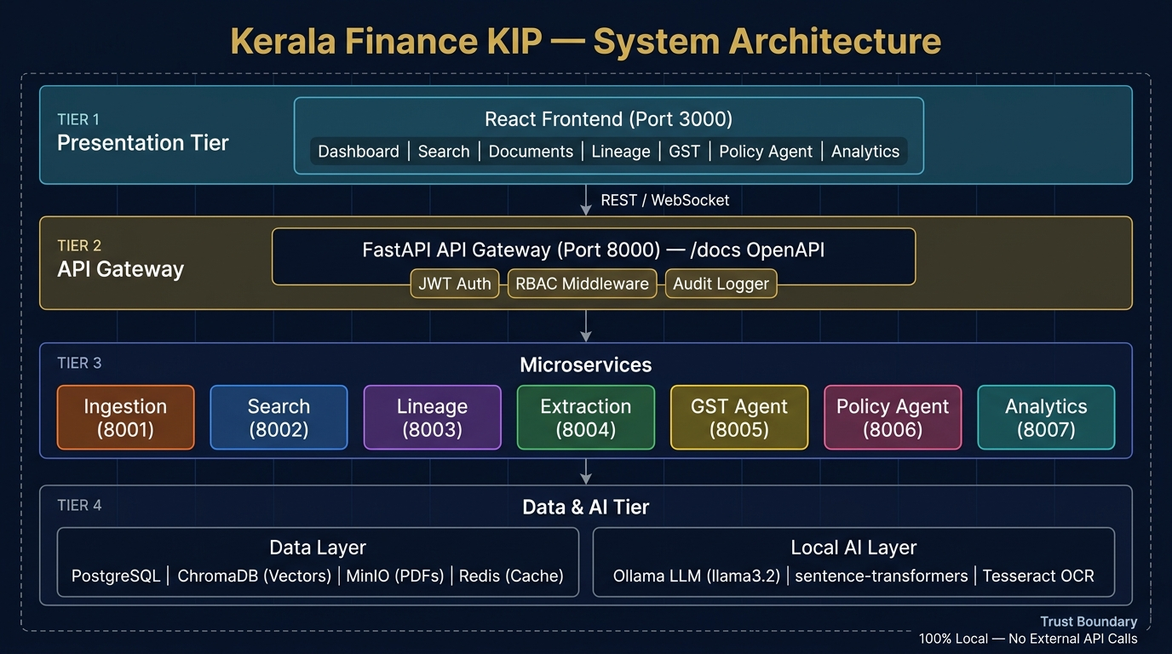
Figure 1: System Architecture
(Source: Self-created)
Tier 1 — Presentation Layer
The presentation layer is implemented using React and Vite.
It provides:
- Dashboard.
- Search.
- Documents.
- Lineage.
- GST assistant.
- Policy agent.
- Analytics.
The frontend communicates with the backend through REST and WebSocket interfaces.
Tier 2 — API Gateway
FastAPI acts as the central API gateway.
The gateway provides:
- API routing.
- JWT authentication.
- RBAC middleware.
- Audit middleware.
- Rate limiting.
- OpenAPI documentation.
The API gateway prevents direct uncontrolled access to internal services.
Tier 3 — Microservice Layer
The application contains separate services:
Service | Purpose
Ingestion Service | Document processing and OCR
Search Service | Hybrid retrieval and answer generation
Lineage Service | Version and supersession tracking
Extraction Service | Clause and figure extraction
GST Agent | GST research assistance
Policy Agent | Policy-note drafting
Analytics Service | Metrics and audit-related analytics
Tier 4 — Data and AI Layer
The data and AI layer contain:
- PostgreSQL — metadata and audit-related information.
- ChromaDB — vector storage.
- MinIO — document storage.
- Redis — caching and task coordination.
- Ollama — local LLM execution.
- sentence-transformers — local embeddings.
- Tesseract — OCR.
This architecture provides clear separation between the user interface, security boundary, application services and data/AI components.

5.2 System Workflow
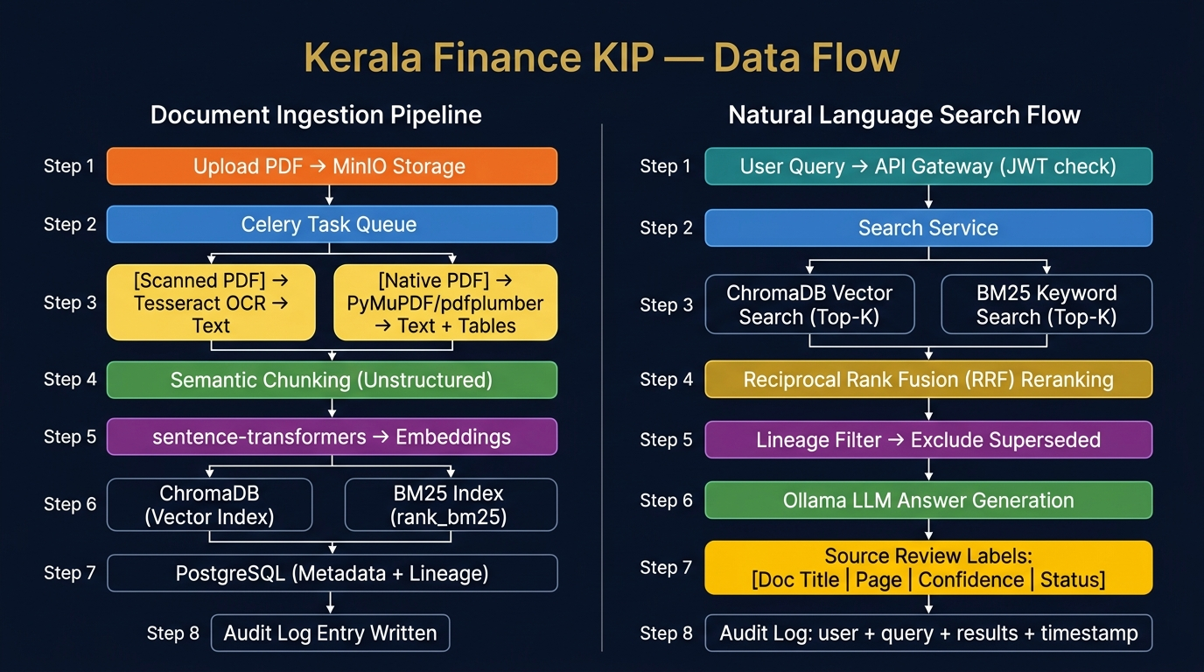
Figure 2: Data Flow Diagram
(Source: Self-created)
Document Ingestion Workflow
- The user uploads a PDF.
- The document is stored in MinIO.
- A Celery task is created.
- The system determines whether the PDF is scanned or native.
- Scanned PDFs are processed through Tesseract OCR.
- Native PDFs are processed through PyMuPDF/pdfplumber.
- Extracted content is processed using document parsing.
- The document is semantically chunked.
- Page-level provenance is maintained.
- Local embeddings are generated.
- Embeddings are stored in ChromaDB.
- Keyword-search information is indexed using BM25.
- Metadata and lineage information are stored in PostgreSQL.
- An audit entry is created.
Search Workflow
- The user submits a natural-language query.
- API Gateway validates the user's JWT.
- RBAC determines accessible documents.
- Search service performs semantic search.
- BM25 performs keyword search.
- Results are combined through RRF.
- Lineage filtering identifies superseded sources.
- Relevant sources are passed to the local LLM.
- The LLM generates an answer.
- Source review labels are attached.
- Search and audit information is recorded.

5.3 Use-Case Diagram
The principal actors are:
- Administrator.
- Analyst.
- Viewer.
Administrator Use Cases
- Login.
- Search documents.
- Upload documents.
- Extract clauses.
- Extract financial figures.
- View document lineage.
- Use a GST assistant.
- Use a policy agent.
- View analytics.
- Access restricted documents.
- Manage system functionality.
Analyst Use Cases
- Login.
- Search documents.
- View documents.
- Extract information.
- View lineage.
- Use a GST assistant.
- Use a policy agent.
- Review source citations.
Viewer Use Cases
- Login.
- Search documents.
- View permitted documents.
- Review source information.
The authorization layer ensures that each actor can access only the functionality assigned to the relevant role.

5.4 Data Flow Diagram
The platform has two major data flows.
A. Document Ingestion Data Flow
PDF Upload
↓
MinIO Storage
↓
Celery Task Queue
↓
Scanned PDF → Tesseract OCR
or
Native PDF → PyMuPDF/pdfplumber
↓
Semantic Chunking
↓
Local Embeddings
↓
ChromaDB + BM25
↓
PostgreSQL Metadata and Lineage
↓
Audit Log
B. Natural Language Search Flow
User Query
↓
API Gateway / JWT Check
↓
Search Service
↓
ChromaDB Semantic Search + BM25 Keyword Search
↓
Reciprocal Rank Fusion
↓
Lineage Filter
↓
Ollama Local LLM
↓
Source Review Labels
↓
Audit Log

5.5 UML Design
The main UML relationships can be represented through the following components.
Component Relationships
User → React Frontend → FastAPI Gateway → Microservice → Data/AI Layer
The API Gateway acts as the controlled entry point.
Sequence — Document Search
- The user enters a query.
- React sends requests to FastAPI.
- FastAPI authenticates the user.
- RBAC determines access.
- Search service receives the query.
- ChromaDB and BM25 retrieve candidate results.
- RRF combines rankings.
- Lineage service checks document status.
- Search service passes validated context to Ollama.
- Ollama generates an answer.
- Source metadata is returned.
- The audit service records the operation.
- React displays the answer and sources.
Sequence — Document Ingestion
- Administrator uploads a PDF.
- API Gateway validates permissions.
- The document is stored in MinIO.
- Celery schedules processing.
- OCR or native parser extracts content.
- Content is chunked.
- Embeddings are generated.
- ChromaDB receives vector records.
- BM25 index is updated.
- PostgreSQL stores metadata and lineage.
- An audit record is created.

5.6 ER Diagram / Database Design
PostgreSQL is used as the primary metadata database.
Important logical entities include:
User
- user_id
- username
- password/security information
- role
- status
Document
- document_id
- title
- document_type
- file_path/reference
- upload_date
- status
- access classification
Document Version / Lineage
- lineage_id
- document_id
- supersedes_document_id
- relationship_type
- effective status
Document Chunk
- chunk_id
- document_id
- page_number
- chunk_text
- embedding reference
Audit Log
- audit_id
- user_id
- action
- IP information
- timestamp
- status
- query/result information where applicable
Search / Interaction Record
- interaction_id
- user_id
- query
- timestamp
- retrieved sources
- response status
ChromaDB stores the vector representations required for semantic retrieval, while MinIO stores source documents.

6. Technology Stack

6.1 Programming Languages
Python 3.11
Python is the primary backend language and is used for:
- FastAPI services.
- OCR pipeline.
- Document processing.
- Search.
- Embedding generation.
- AI integration.
- Agents.
- Analytics.
- Testing.
JavaScript
JavaScript is used for the React frontend and user interaction.
CSS
CSS is used for frontend styling.

6.2 Frameworks and Libraries
Technology | Purpose
FastAPI | Backend API framework
React | Frontend UI
Vite | Frontend build tooling
Ollama | Local LLM execution
Llama 3.2 | Local language model
LangChain | Agent orchestration
sentence-transformers | Embeddings
ChromaDB | Vector database
rank_bm25 | Keyword retrieval
Tesseract | OCR
PyMuPDF | PDF processing
pdfplumber | PDF extraction
Unstructured | Document parsing
Celery | Asynchronous task processing
Redis | Cache/task coordination
Chart.js | Analytics visualisation

6.3 Database and Storage
PostgreSQL
Used for:
- Metadata.
- User-related information.
- Document relationships.
- Audit information.
- Lineage.
ChromaDB
Used for:
- Vector embeddings.
- Semantic retrieval.
- Restricted-document collection isolation.
MinIO
Used as a local S3-compatible document store for PDF files.
Redis
Used for caching and task coordination.

6.4 Development and Deployment Tools
- Git/GitHub.
- Docker.
- Docker Compose.
- Makefile.
- Pytest.
- OpenAPI/Swagger.
- Nginx.
- VS Code or equivalent development environment.

7. System Implementation

7.1 Repository Structure
The implementation follows a modular repository structure:
kerala-finance-kip/
├── docker-compose.yml
├── Makefile
├──. env.example
├── services/
│ ├── api-gateway/
│ ├── ingestion-service/
│ ├── search-service/
│ ├── lineage-service/
│ ├── extraction-service/
│ ├── gst-agent-service/
│ ├── policy-agent-service/
│ └── analytics-service/
├── frontend/
├── data/sample_documents/
├── scripts/
├── tests/
├── nginx/
└── docs/

This structure separates the platform into logical service boundaries.

7.2 API Gateway
The API Gateway is implemented using FastAPI.
Its main responsibilities are:
- Routing.
- Authentication.
- Authorization.
- RBAC.
- Audit middleware.
- Rate limiting.
- API documentation.
The gateway exposes an OpenAPI interface, allowing developers and administrators to inspect available endpoints.

7.3 Ingestion Service
The ingestion service handles document upload and processing.
The pipeline automatically determines whether a document requires OCR.
Native PDF
Native PDFs are processed using:
- PyMuPDF.
- pdfplumber.
Scanned PDF
Scanned PDFs are processed through:
- Image preprocessing.
- Tesseract OCR.
The extracted content is then passed to semantic chunking.

7.4 Semantic Chunking
Large documents are divided into smaller meaningful sections.
Chunk metadata preserves information such as:
- Document ID.
- Page number.
- Source document.
- Content type.
- Lineage information.
This enables the search system to retrieve specific sections instead of returning entire documents.

7.5 Embedding Generation
The system uses a local sentence-transformer model to generate vector representations. The purpose of embeddings is to represent semantic meaning rather than relying only on exact words (Aceves and Evans, 2023).
For example, a query about:
"financial assistance for government employees"
may retrieve relevant content even when the exact phrase does not appear in the source document.

7.6 Hybrid Search
The platform combines two retrieval methods.
Semantic Search
ChromaDB retrieves documents based on embedding similarity.
Keyword Search
BM25 retrieves documents based on lexical relevance.
Reciprocal Rank Fusion
The two ranked lists are combined using Reciprocal Rank Fusion.
Conceptually:
RRF(d) = Σ 1 / (k + rank_i(d))
where:
- d is a document.
- rank_i(d) is the document's rank in retrieval system i.
- k is a ranking constant.
This allows the system to benefit from both semantic similarity and exact keyword matching.

7.7 Document Lineage
Document lineage is one of the most important features of the platform.
Government Orders may be superseded by newer orders. The platform maintains these relationships.
Example:
GO(Ms) No.45/2023/Fin [SUPERSEDED]
↓
superseded by
↓
GO(Ms) No.112/2023/Fin [ACTIVE]
During search and policy assistance, lineage information is used to prevent obsolete documents from being incorrectly presented as the current authority.

7.8 Source Review Labels
Search results contain source review information such as:
{
"Source_label": "GO(Ms)No.112/2023/Fin | Page 3",
"Status_label": "ACTIVE",
"confidence": "HIGH",
"Match_type": "hybrid",
"Lineage_warning": false
}

This improves transparency by showing the user where information originated and whether the source is considered active.

7.9 Clause and Financial Figure Extraction
The extraction service identifies relevant clauses and financial figures from documents.
This supports use cases such as:
- Finding a specific policy clause.
- Identifying monetary limits.
- Extracting rates.
- Identifying percentages.
- Finding dates and conditions.
- Supporting financial policy research.

7.10 GST Assistant
The GST assistant provides targeted assistance for GST-related research.
It can support:
- GST policy queries.
- Rate lookup.
- Retrieval of relevant GST documents.
- Source-based responses.
The assistant operates within the platform's local AI architecture.

7.11 Policy Agent
The policy-note agent follows a three-stage workflow:
Step 1 — Retrieve
Search for relevant Government Orders and policy documents.
Step 2 — Verify
Check document lineage and reject superseded citations where appropriate.
Step 3 — Draft
Generate a policy-note draft based on verified sources.
This approach creates a controlled workflow instead of directly asking an LLM to generate a policy note without retrieval and verification.

7.12 Local LLM Implementation
Ollama is used to run the Llama 3.2 model locally.
The architecture is intentionally designed so that:
Government Document
↓
Local Processing
↓
Local Retrieval
↓
Local LLM
↓
Source-Aware Response
No external LLM API is required.
This is particularly important for sensitive government information.

7.13 Frontend Implementation
The React frontend provides separate areas for:
- Dashboard.
- Search.
- Documents.
- Lineage.
- GST.
- Policy Agent.
- Analytics.
The frontend communicates with the API Gateway rather than directly accessing internal databases or AI components.
This keeps security and service boundaries centralized.

8. Testing and Validation

8.1 Test Strategy
Testing is performed at multiple levels:
- Authentication testing.
- Authorization testing.
- Search testing.
- Lineage testing.
- AI response testing.
- Analytics testing.
- Error handling.
- Integration testing.
- Deployment testing.
The repository provides a test suite that can be executed using:
make test
or through the API gateway container using Pytest.

8.2 Test Cases
Test ID | Test | Expected Result
TC01 | Valid login | User successfully authenticated
TC02 | Invalid credentials | Authentication rejected
TC03 | Viewer accesses restricted document | Access denied
TC04 | Admin accesses restricted document | Access permitted
TC05 | Analyst accesses permitted document | Access permitted
TC06 | Search query submitted | Relevant results returned
TC07 | Search result source citation | Source label displayed
TC08 | Superseded document found | Lineage status identified
TC09 | Superseded citation used | System prevents inappropriate citation
TC10 | Analytics request | Metrics returned
TC11 | Scanned PDF uploaded | OCR pipeline invoked
TC12 | Native PDF uploaded | Native parser invoked
TC13 | Policy-agent request | Retrieve → Verify → Draft workflow executed
TC14 | Unauthorized administrative operation | Operation rejected
TC15 | Audit event generated | Action recorded

8.3 Functional Testing
The README/test coverage identifies testing for:
- Authentication.
- Invalid credentials.
- RBAC.
- Viewer/Analyst/Admin permissions.
- Search quality.
- Source citations.
- Generated answers.
- Document lineage.
- Superseded status.
- Analytics coverage.
These tests verify that the core POC capabilities operate together rather than only testing individual components.

8.4 Error Handling
The platform should handle:
- Invalid credentials.
- Unauthorized requests.
- Unsupported documents.
- OCR failures.
- Document parsing errors.
- Missing documents.
- Search failures.
- LLM service failures.
- Database connection failures.
- Invalid API requests.
Errors should be returned through controlled API responses rather than exposing internal implementation details to users.

8.5 Performance Testing
Performance evaluation should consider:
- Document ingestion time.
- OCR processing time.
- Embedding generation time.
- Search latency.
- Hybrid retrieval latency.
- RRF reranking latency.
- LLM response time.
- API response time.
- Concurrent request behaviour.
Search/retrieval evaluation is particularly important because the project specification explicitly requires measured search/retrieval evaluation.
Recommended evaluation measures include:
- Precision@K.
- Recall@K.
- Hit Rate@K.
- Mean Reciprocal Rank (MRR).
- Response latency.
A representative evaluation dataset should contain known queries and expected relevant documents.

9. Results and Evaluation

9.1 System Demonstration
The implemented POC demonstrates an end-to-end knowledge workflow:
Document Upload
↓
OCR / Native Parsing
↓
Chunking
↓
Embedding + BM25 Indexing
↓
Hybrid Search
↓
Lineage Validation
↓
Local LLM
↓
Source-Aware Answer
This demonstrates that the project is not limited to a chatbot interface and instead provides an integrated enterprise document-intelligence platform.

9.2 Document Ingestion Results
The system supports both:
- Native machine-readable PDFs.
- Scanned image-based PDFs.
Scanned PDFs can be processed through Tesseract OCR before entering the indexing pipeline.
This allows older or scanned government records to participate in search.

9.3 Search Results
The hybrid search architecture combines:
- ChromaDB semantic search.
- BM25 keyword search.
- RRF reranking.
- Lineage filtering.
This approach improves retrieval robustness because semantic search can identify conceptually similar content while BM25 provides strong performance for exact terms such as Government Order numbers, policy terms, dates and financial terminology.

9.4 Source-Aware AI Results
AI-generated responses are accompanied by source information.
A response can identify:
- Source document.
- Page number.
- Document status.
- Confidence.
- Match type.
- Lineage warning.
This creates a traceability layer between generated output and source evidence.

9.5 Policy-Agent Results
The policy agent demonstrates controlled policy-note assistance through:
Retrieve → Verify → Draft
The verification stage is particularly important because the system checks document lineage before using retrieved material for policy drafting.

9.6 Security Results
The implementation demonstrates:
- JWT authentication.
- Role-based access control.
- Restricted ChromaDB collections.
- Local LLM inference.
- Local embedding generation.
- Audit logging.
- Controlled API access.
These features directly support the enterprise architecture and data-isolation requirements.

9.7 Overall Evaluation
The system addresses the major requirements of the project specification:
Requirement | Implementation
Ingestion | Implemented
OCR | Tesseract
Indexing | ChromaDB + BM25
Hybrid search | Implemented
RRF | Implemented
Source citations | Implemented
Document lineage | Implemented
Clause extraction | Implemented
GST assistance | Implemented
Policy agent | Implemented
Local AI | Ollama
RBAC | Implemented
Restricted data isolation | Implemented
Audit logging | Implemented
Containerization | Docker Compose
API specification | FastAPI/OpenAPI
Automated testing | Pytest
Architecture diagrams | Provided
Data-flow diagrams | Provided

10. Security, Privacy and Ethical Considerations

10.1 Data Isolation
Restricted documents are maintained separately from general document collections.
A dedicated ChromaDB collection is used for restricted documents.
This reduces the possibility of unrestricted users retrieving protected information.

10.2 Local AI Processing
The platform uses Ollama for local LLM inference.
This means:
- Documents do not need to be sent to external LLM providers.
- User prompts remain within the local environment.
- Embeddings are generated locally.
- Sensitive government information remains under deployment control.

10.3 Authentication
JWT-based authentication is implemented at the API Gateway.
Only authenticated users can access protected platform functionality.

10.4 Role-Based Access Control
The system supports three principal roles:
- Admin.
- Analyst.
- Viewer.
RBAC prevents users from accessing functionality outside their assigned permissions.

10.5 Auditability
The platform records important actions such as:
- User activity.
- Queries.
- IP information.
- Timestamps.
- Actions.
- Status information.
An audit trail provides accountability and supports security investigations.

10.6 AI Reliability and Hallucination
AI-generated answers can contain incorrect information if the underlying retrieval process is incorrect or incomplete.
The platform therefore uses:
- Retrieval before generation.
- Source citations.
- Confidence labels.
- Document status.
- Lineage filtering.
AI output should remain an assistance mechanism and should be reviewed by authorized officials before being used for formal government decisions.

10.7 Ethical Considerations
The platform should not allow AI-generated recommendations to automatically become official government policy.
Human review remains important for:
- Legal interpretation.
- Financial decisions.
- Policy approval.
- Official communications.
- Sensitive government actions.

11. Limitations
Several limitations remain in the current proof of concept.

1. OCR Accuracy
OCR performance may decline for poor-quality scans, handwritten content, unusual fonts or heavily degraded documents.

2. Local LLM Resource Requirements
Running Llama 3.2 locally requires substantial RAM and computational resources.

3. Processing Time
Large scanned documents can require more time because OCR must process individual pages.

4. AI Accuracy
The local LLM can still produce inaccurate interpretations. Source retrieval and human validation remain necessary.

5. Search Evaluation Dataset
A larger production-scale evaluation dataset would be required to establish statistically robust retrieval performance.

6. Scalability
The POC architecture is designed to be scalable, but production deployment would require additional infrastructure planning for high concurrency and very large document collections.

7. Document Diversity
Different government documents may have different layouts, tables and formatting structures, which may require specialized extraction techniques.

8. Lineage Quality
Lineage accuracy depends on the correctness and completeness of supersession relationships stored in the metadata.

12. Future Enhancements
Future versions could include:

12.1 Advanced OCR
Integration of more advanced OCR and document-vision models could improve extraction from complex documents.

12.2 Table Understanding
Specialized table extraction could improve the handling of:
- Budget tables.
- GST tables.
- Financial schedules.
- Rate tables.

12.3 Advanced Reranking
A dedicated cross-encoder reranker could be added after RRF to further improve retrieval quality.

12.4 Improved Evaluation Framework
A larger benchmark dataset could be created with:
- Query.
- Expected document.
- Expected page.
- Expected clause.
- Expected answer.
This would enable systematic evaluation of Precision@K, Recall@K, MRR and latency.

12.5 Multilingual Support
Support for Malayalam documents and queries could make the platform more useful for a wider range of government records.

12.6 Version-Aware Knowledge Graph
A graph-based representation of Government Orders could provide deeper relationships between:
- Orders.
- Amendments.
- Departments.
- Policies.
- Dates.
- Subjects.

12.7 Advanced Policy Agent
The policy agent could be extended with:
- Structured policy-note templates.
- Approval workflows.
- Document comparison.
- Automatic change summaries.
- Citation verification.

12.8 Production Deployment
Future production deployment could introduce:
- Kubernetes.
- Horizontal service scaling.
- High-availability databases.
- Distributed storage.
- Centralized monitoring.
- Secrets management.
- Backup and disaster recovery.

13. Conclusion
The Kerala Finance KIP provides a locally deployable knowledge intelligence platform for managing and interacting with government finance and policy documents. The platform addresses the core challenges of document discovery, scanned-document processing, semantic retrieval, keyword retrieval, document versioning and policy research through an integrated architecture. Its hybrid search architecture combines ChromaDB semantic retrieval with BM25 keyword retrieval and Reciprocal Rank Fusion. Document lineage further improves the reliability of retrieved information by identifying superseded Government Orders.
The use of Ollama and local sentence-transformers provides an important privacy boundary because document content and AI processing can remain within the local environment. Security is further strengthened through JWT authentication, RBAC, restricted document collections and audit logging.
The modular microservice architecture separates ingestion, search, lineage, extraction, GST assistance, policy assistance and analytics. Docker Compose provides a reproducible deployment mechanism, while FastAPI exposes clear API contracts through OpenAPI.
Overall, the POC demonstrates the key technical capabilities required by the project specification and provides a strong foundation for a future production-grade government document intelligence platform.

14. References
Aceves, P. and Evans, J.A. (2023). Mobilizing conceptual spaces: How word embedding models can inform measurement and theory within organization science. Organization Science. doi:10.1287/orsc.2023.1686.
Arslan, H. (2022). End to end invoice processing application based on key fields extraction. IEEE Access, 10, pp.78398–78413. doi:10.1109/access.2022.3192828.
Chen, M., Tao, Z., Tang, W., Qin, T., Yang, R. and Zhu, C. (2024). Enhancing emergency decision-making with knowledge graphs and large language models. International Journal of Disaster Risk Reduction, 113, p.104804. doi:10.1016/j.ijdrr.2024.104804.

15. Appendices

Appendix A — Code Snippets
Important implementation snippets should be included in the final submission rather than the complete source code.
Recommended snippets include:
A.1 FastAPI Gateway
from fastapi import FastAPI
app = FastAPI (
title="Kerala Finance KIP API"
)

@app.get("/health")
def health():
return {"status": "healthy"}
A.2 Hybrid Search
semantic_results = vector_search(query)
keyword_results = bm25_search(query)

results = reciprocal_rank_fusion(
semantic_results,
keyword_results
)
A.3 Lineage Filtering
active_results = [
result
for result in results
if result.status != "SUPERSEDED"
]
A.4 Source Review Information
source = {
"document": document.title,
"page": chunk.page_number,
"status": document.status,
"confidence": confidence,
"match_type": "hybrid"
}
The final appendix should use the actual implementation code from the repository wherever possible.

Appendix B — Additional Screenshots
B.1 GitHub Repository
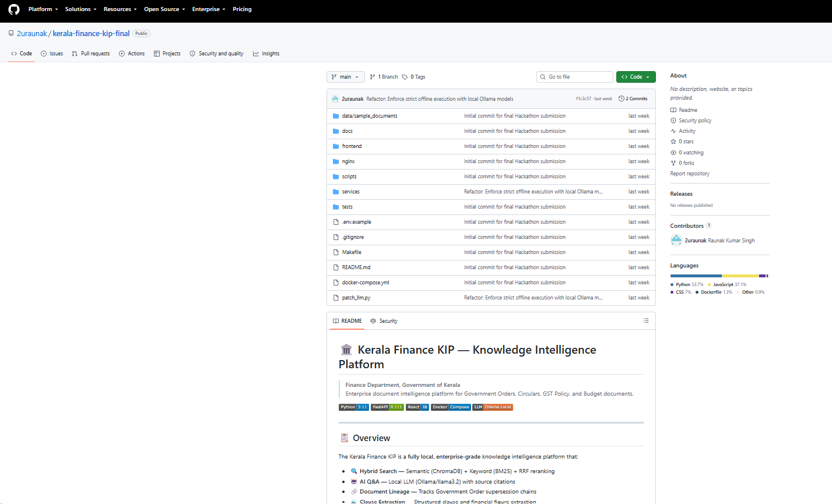
B.2 Application Dashboard
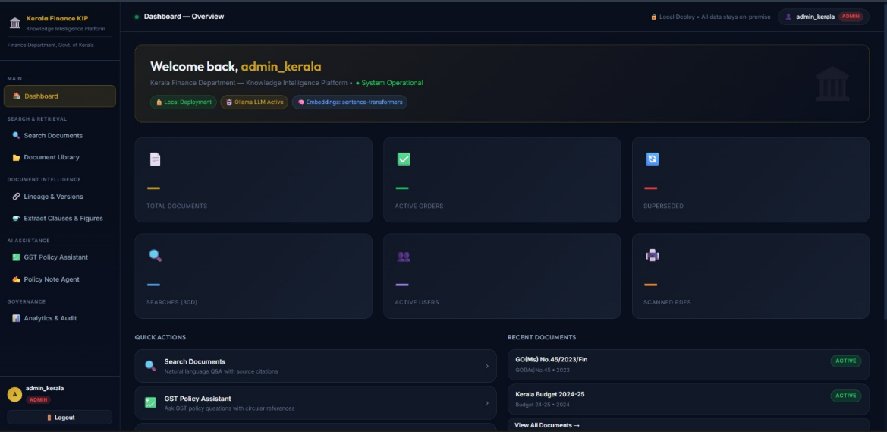
B.3 Sign in Page
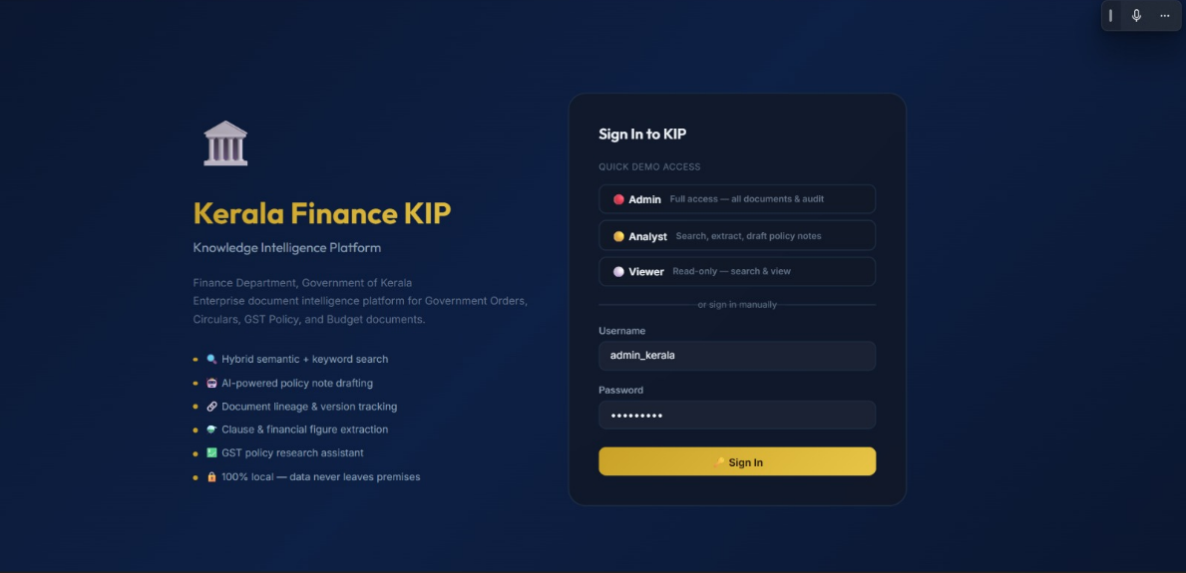
B.4 GST Assistant
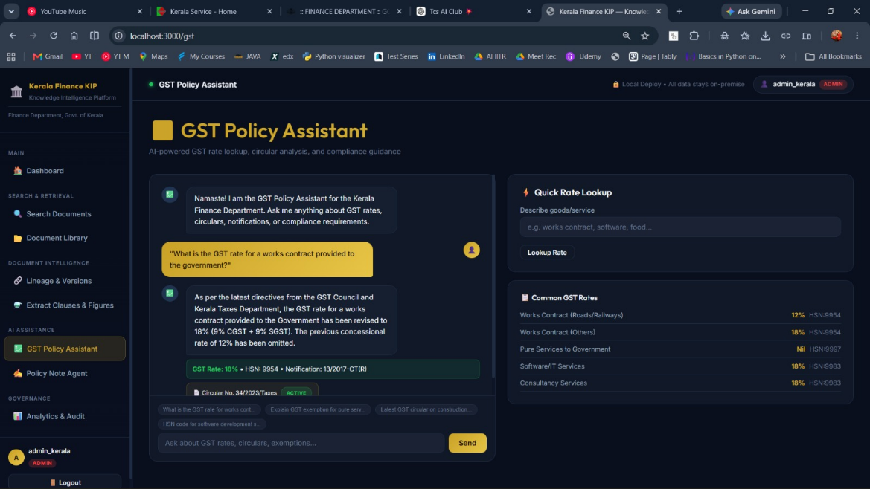

Appendix C — Configuration Details
C.1 Environment Configuration
The project provides an .env.example file.
Typical configuration categories include:
DATABASE_URL
REDIS_URL
MINIO_ENDPOINT
MINIO_ACCESS_KEY
MINIO_SECRET_KEY
CHROMA_HOST
OLLAMA_HOST
JWT_SECRET
Actual production secrets should never be committed to the repository.
C.2 Docker Deployment
The complete platform can be started using Docker Compose:
docker-compose up -d --build
The stack includes the major infrastructure components and application services.
C.3 LLM Setup
The local Llama model can be pulled through the configured Ollama service.
The project README specifies the model setup through the Makefile.
C.4 Sample Data
The repository includes sample Kerala Finance documents covering areas such as:
- Government Orders.
- Budget documents.
- GST documents.
- Office memoranda.
These documents can be used to demonstrate ingestion, indexing and search functionality.

Appendix D — Sample Input and Output
D.1 Sample Search Input
What is the current Government Order regarding the applicable financial provision?
D.2 Sample Search Output
Answer: The current applicable provision is identified from the active
Government Order retrieved by the system.
Source: GO(Ms)No.112/2023/Fin

Page: 3
Status: ACTIVE
Confidence: HIGH
Match Type: HYBRID
Lineage Warning: FALSE
D.3 Sample Lineage Output
GO(Ms) No.45/2023/Fin
|
| SUPERSEDED BY
↓
GO(Ms) No.112/2023/Fin
|
↓
ACTIVE
D.4 Sample Policy-Agent Workflow
User Request
↓
Retrieve relevant Government Orders
↓
Verify document status
↓
Reject superseded sources
↓
Collect authoritative evidence
↓
Generate policy-note draft
↓
Attach source citations
↓
Human review

Appendix E — User Role Matrix
Function | Admin | Analyst | Viewer
Login | ✓ | ✓ | ✓
Search | ✓ | ✓ | ✓
View non-restricted documents | ✓ | ✓ | ✓
Access restricted documents | ✓ | ✗ | ✗
Extract information | ✓ | ✓ | ✗
GST Assistant | ✓ | ✓ | ✗
Policy Agent | ✓ | ✓ | ✗
Analytics | ✓ | Limited/controlled | ✗
Administration | ✓ | ✗ | ✗

Appendix F — Main Platform Endpoints
The API Gateway is exposed through the FastAPI application.
The development environment provides API documentation through the OpenAPI/Swagger interface.
The main service structure includes:
API Gateway → 8000
Ingestion → 8001
Search → 8002
Lineage → 8003
Extraction → 8004
GST Agent → 8005
Policy Agent → 8006
Analytics → 8007
The React frontend operates on port 3000 in the documented development configuration.

