Heuristic Analysis

# Optimal plan

The length of optimal plan for problem 1, 2 and 3 are 6, 9 and 12 respectively. And the solutions are

|  |  |  |
| --- | --- | --- |
| Problem1 | Problem2 | Problem3 |
| $$Load\left(C_{1}, P_{1}, SFO\right)$$ $$Load(C_{2}, P_{2}, JFK)$$ $$Fly\left(P_{1}, SFO, JFK\right)$$ $$Fly\left(P_{2}, JFK, SFO\right)$$ $$Unload\left(C_{1}, P_{1}, JFK\right)$$ $$Unload(C_{2}, P_{2}, SFO)$$ | $$Load\left(C_{1}, P_{1}, SFO\right)$$ $$Load(C_{2}, P_{2}, JFK)$$ $$Load(C_{3}, P_{3}, ATL)$$ $$Fly\left(P_{1}, SFO, JFK\right)$$ $$Fly\left(P_{2}, JFK, SFO\right)$$ $$Fly(P_{3}, ATL, SFO)$$ $$Unload\left(C_{1}, P_{1}, JFK\right)$$ $$Unload(C_{2}, P_{2}, SFO)$$ $$Unload(C_{3}, P_{3}, SFO)$$ | $$Load\left(C_{1}, P_{1}, SFO\right)$$ $$Load(C_{2}, P_{2}, JFK)$$ $$Fly\left(P_{1}, SFO, ATL\right)$$ $$Load(C_{3}, P_{1}, ATL)$$ $$Fly\left(P_{2}, JFK, ORD\right)$$ $$Load(C_{4}, P_{2}, ORD)$$ $$Fly\left(P_{1}, ATL, JFK\right)$$ $$Fly\left(P_{2}, ORD, SFO\right)$$ $$Unload\left(C_{1}, P_{1}, JFK\right)$$ $$Unload(C_{2}, P_{2}, SFO)$$ $$Unload(C_{3}, P_{1}, JFK)$$ $$Unload(C_{4}, P_{2}, SFO)$$ |

# Uninformed search

Problem 1

|  |  |  |  |  |  |
| --- | --- | --- | --- | --- | --- |
| Search strategy | Optimal | Plan length | Node expansions | Number of goal tests | Time elapsed(s) |
| Breadth first | Y | 6 | 43 | 56 | 0.032 |
| Depth first | N | 20 | 21 | 22 | 0.015 |
| Uniform cost | Y | 6 | 55 | 57 | 0.041 |
| Greedy best first | Y | 6 | 7 | 9 | 0.005 |

Problem 2

|  |  |  |  |  |  |
| --- | --- | --- | --- | --- | --- |
| Search strategy | Optimal | Plan length | Node expansions | Number of goal tests | Time elapsed(s) |
| Breadth-first | Y | 9 | 3346 | 4612 | 9.331 |
| Depth-first | N | 105 | 107 | 108 | 0.336 |
| Uniform cost | Y | 9 | 4853 | 4855 | 12.975 |
| Greedy best first | N | 21 | 998 | 1000 | 2.501 |

Problem 3

|  |  |  |  |  |  |
| --- | --- | --- | --- | --- | --- |
| Search strategy | Optimal | Plan length | Node expansions | Number of goal tests | Time elapsed(s) |
| Breadth-first | Y | 12 | 14120 | 17673 | 42.903 |
| Depth-first | N | 288 | 292 | 293 | 1.193 |
| Uniform cost | Y | 12 | 18223 | 18225 | 55.916 |
| Greedy best first | N | 22 | 5578 | 5580 | 17.776 |

In all the uninformed search cases, only breadth-first and uniform cost search can yield optimality. Between them, Breadth-first search performs better than uniform cost search on node expansions, number of goal tests and search time. The result is expected since when all step costs are equal, the cost of uniform search is $O(b^{1+d})$, which is larger than breadth-first search.

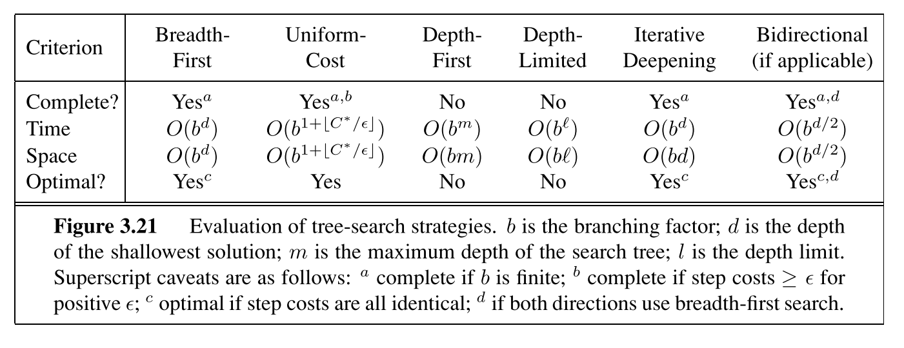

# Informed search

Problem 1

|  |  |  |  |  |  |
| --- | --- | --- | --- | --- | --- |
| Search strategy | Optimal | Plan length | Node expansions | Number of goal tests | Time elapsed(s) |
| A* with h1 | Y | 6 | 55 | 57 | 0.045 |
| A* with ignore | Y | 6 | 41 | 43 | 0.037 |
| A* with level sum | Y | 6 | 11 | 13 | 1.567 |

Problem 2

|  |  |  |  |  |  |
| --- | --- | --- | --- | --- | --- |
| Search strategy | Optimal | Plan length | Node expansions | Number of goal tests | Time elapsed(s) |
| A* with h1 | Y | 9 | 4853 | 4855 | 12.240 |
| A* with ignore | Y | 9 | 1450 | 1452 | 4.340 |
| A* with level sum | Y | 9 | 86 | 88 | 204.522 |

Problem 3

|  |  |  |  |  |  |
| --- | --- | --- | --- | --- | --- |
| Search strategy | Optimal | Plan length | Node expansions | Number of goal tests | Time elapsed(s) |
| A* with h1 | Y | 12 | 18223 | 18225 | 56.071 |
| A* with ignore | Y | 12 | 5040 | 5042 | 17.543 |
| A* with level sum | Y | 12 | 325 | 327 | 1089.815 |

For informed search, all three strategies yield optimality, the best strategy for search time is A* with ignore preconditions; for node expansions and number of goal tests, A* with level sum outperforms other strategies, this shows planning graph can better guide the A*. However, it does have a drawback, that is, it takes too much time, and the reason is the program needs $O(n{\left(a+l\right)}^{2})$ time to construct planning graph. Without further optimizing the algorithm, the clear choice for our planning problems is A* with ignore precondition.