# Manual for Web-based MultiCook

We provide a web-based imputation platform built with Python Flask to simplify the usage of MultiCook. MultiCook supports two primary scenarios:

1. Server-driven execution: Similar to Jupyter notebook, a user can run the application on the remote server and connect to the server by running the UI app on the local computer. The communication goes through a specified port. Both of the imputation and merge steps can be run.

2. Local execution: Without a remote server, all procedures are performed on a local computer. Both the imputation and merge steps can be run on the Mac/Linux platforms. On Windows platform, only the merge step can be run with pre-existing imputation results (as CookHLA and HIBAG have difficulties in running in Windows).

## Instructions

After cloning the github page(‘https://github.com/2w21234/MultiCook/’) and setting the dependencies, you should follow one of the scenarios.

### Scenario 1: Running on a Linux Server from a Local Computer

1. Connect to the Linux server:

ssh -p [port number] -L localhost:5000:127.0.0.1:5000 [server user ID]@[server IP address]

2. Activate the Anaconda environment and start Flask:

conda activate MultiCook  
flask run



### Scenario 2: Running on Mac/Linux or Windows

1. Activate the Anaconda environment and run Flask:

conda activate MultiCook  
flask run



2. Copy http://127.0.0.1:5000 and paste it into your browser to open the MultiCook interface.

Then copy the link and paste it on the browser, which leads to the following image: 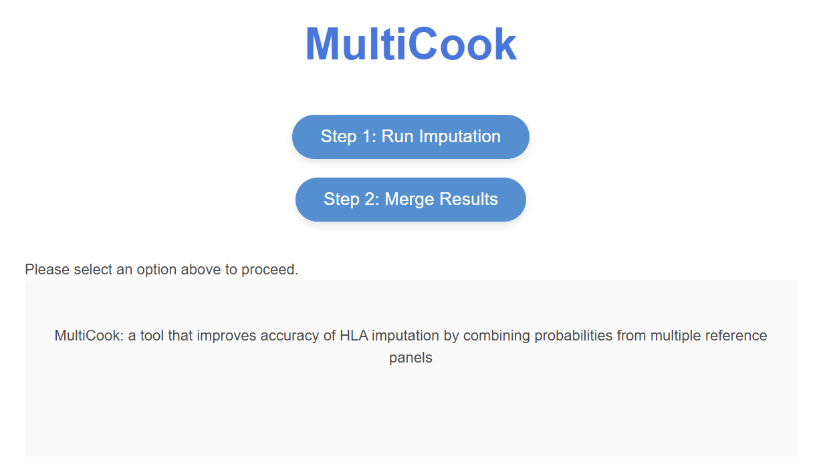

## Step 1: Single-Reference-Panel Based Imputation

1. Required Input Files:

- target data file format both for CookHLA and HIBAG : bed, bim, fam

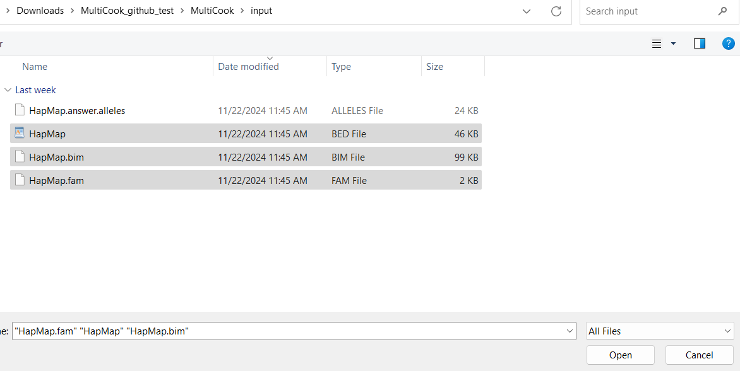- Reference file format for CookHLA: Upload six files simultaneously as the reference panel: bed, bim, fam, FRQ.frq, bgl.phased, markers.

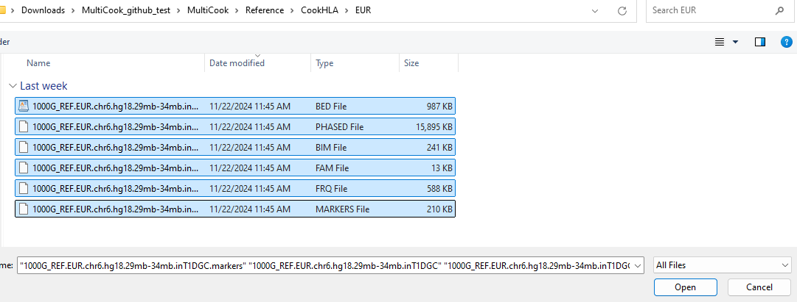  
- Reference file format for HIBAG: Upload one file: .RData.

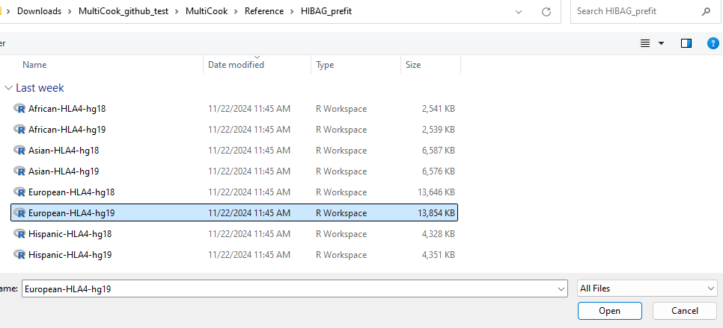

Uploaded files are saved in **./MultiCook/uploads/{working directory name}**.

2. Running Imputation:

Fill in all required fields on the first web page and click **Run Single Imputation**. The imputation process will begin sequentially.

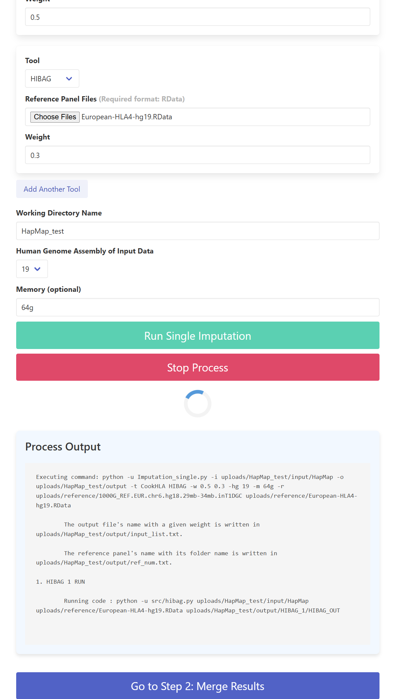

## Step 2: Merging Results

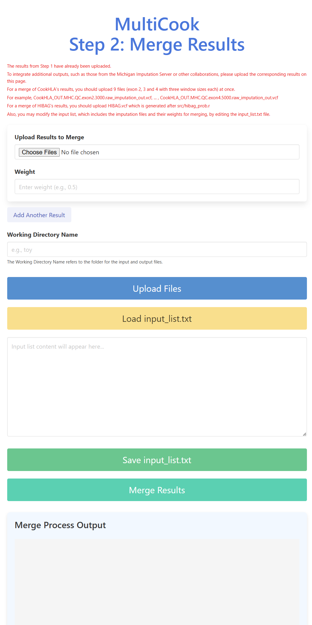

1. If Step 1 Has Been Completed:

Results are automatically loaded for merging. Enter the same working directory name and click **Merge Results**.

2. Additional File Integration:

For merging results from other tools like the Michigan Imputation Server, upload files (e.g., chr6.dose.vcf.gz) and specify their weights. Enter the same working directory name as in Step 1.

3. Editing Input List (**input_list.txt**):

The **input_list.txt** file specifies files to merge and their weights. Click **Load input_list.txt** to edit and **Save input_list.txt** to update changes. Ensure no extra lines are added to the file.

4. Merging Additional Outputs:

- CookHLA Results: Upload nine .vcf files simultaneously, e.g., CookHLA_OUT.MHC.QC.exon2.3000.raw_imputation_out.vcf, …, CookHLA_OUT.MHC.QC.exon4.5000.raw_imputation_out.vcf.

Note: For CookHLA, only the vcf file corresponding to exon2.3000 should be listed in input_list.txt.

- HIBAG Results: Upload HIBAG.vcf, generated after running **src/hibag_prob.r**.

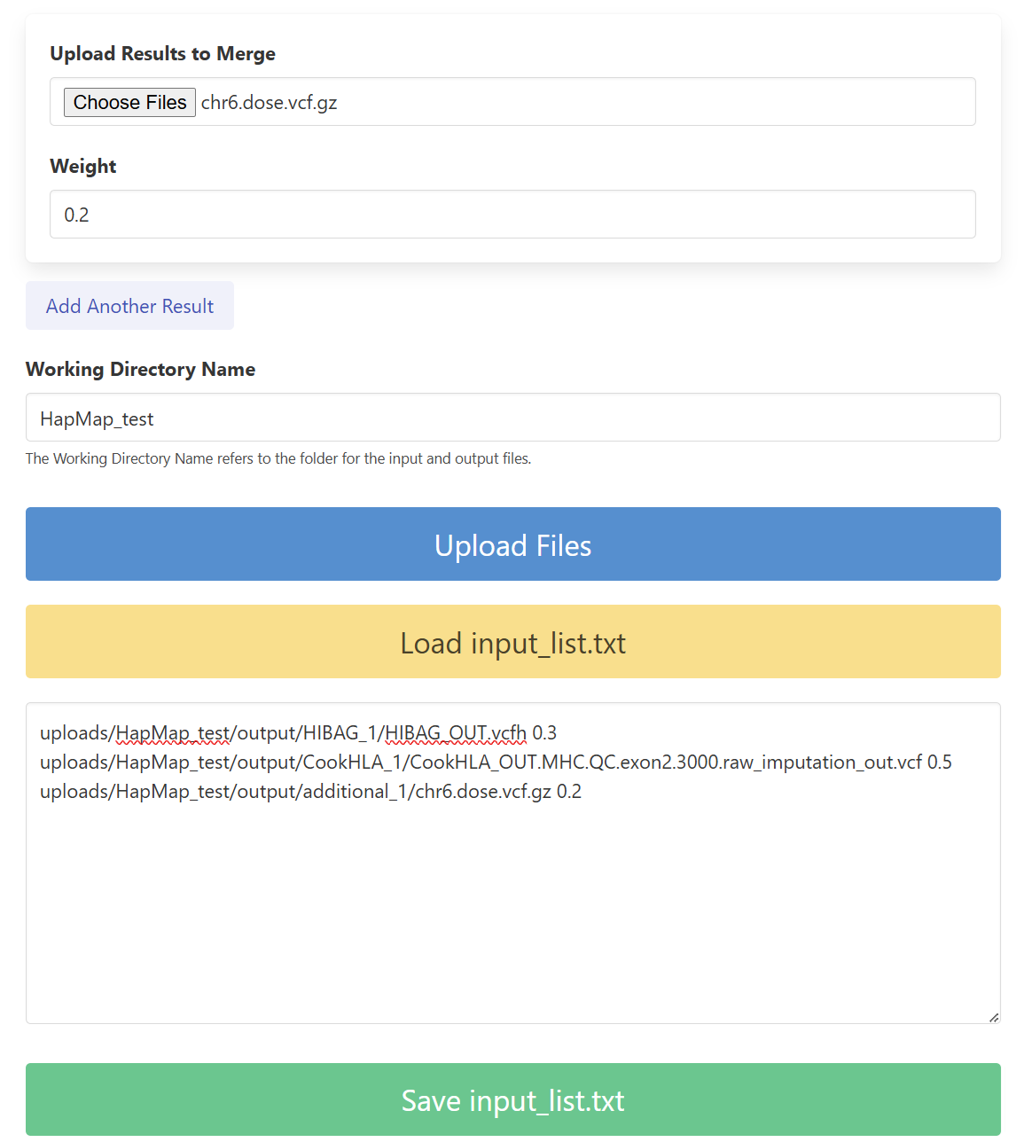

After uploading all files and editing configurations, click **Merge Results**.

5. Downloading Merged Results

Once merging is complete, click **Download Merged Results** to download the final output file (**result.all.alleles**) to your computer.

