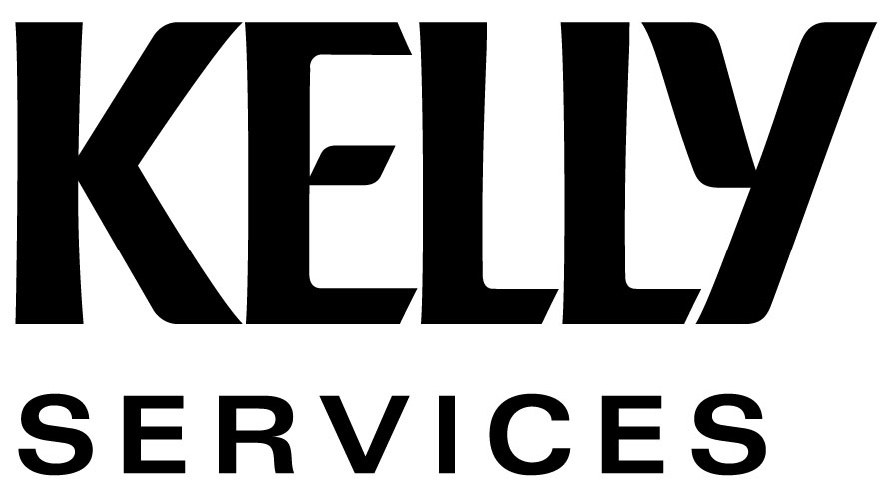
EMPLOYMENT APPLICATION
BACKGROUND INFORMATION AND AGREEMENT
Background Information (Applicants in Connecticut [only if applying for state of Connecticut positions, including Kelly Educational Staffing assignments]: Do not complete this section unless instructed to do so. Applicants applying to work in Hawaii, Massachusetts and City of Philadelphia: Do not complete this section.)

When completing this section, do not disclose information regarding convictions that have been judicially sealed, expunged, eradicated, impounded, pardoned, dismissed, or nulled. Do not disclose information regarding juvenile court convictions or minor traffic violations. A conviction record does not automatically bar you from employment. All of the job-related circumstances surrounding convictions will be considered.
- In the last 7 years, have you been convicted of, pled guilty or no contest to,
been imprisoned, or been on probation or parole for any felony? Yes No or No Record
Applicants in Alaska: Do not disclose information regarding felony convictions that are more than 10 years old.
2. In the last 7 years, have you been convicted of, pled guilty or no contest to,
been imprisoned, or been on probation or parole for any misdemeanor? Yes No or No Record
Applicants in California: Do not disclose information regarding any referral to or participation in a pre or post-trial diversion program and do not disclose information regarding any marijuana-related convictions under California Health and Safety Code sections 11357(b)-(e) or 11360(b) that are more than 2 years old.
Applicants in Georgia: Do not disclose any first offender discharge as described under Georgia Law.
Applicants in Nevada: Do not disclose misdemeanor convictions that did not result in imprisonment.
- If you answered Yes to any of the questions above, please explain completely:

Agreement
General Information  I understand I may be offered employment with Kelly Services, Inc. (“Kelly”), subject to my availability for work, Kelly’s ability to find suitable assignments for me, and results of reference checking or other screening procedures. I understand background and/or drug screening may be a condition of my employment or assignment.  For the purposes of this Agreement, “customer(s)” and “potential customer(s)” of Kelly shall mean any entity to which I have been assigned by Kelly, or have been exposed through Kelly-arranged interviews, meetings or recruiting efforts.  My employment term with Kelly is not guaranteed and is considered to be “at will.” Kelly or I may end the relationship at any time, with or without cause, subject to applicable laws. The duration of any assignment I accept depends on the needs of Kelly’s customer and may be canceled at any time by Kelly or the customer.  Kelly will provide me with the details of any assignment I accept. If the customer significantly changes the responsibilities of my assignment, I will promptly notify Kelly.  Kelly will pay me for my work while assigned to Kelly’s customer. If Kelly overpays me, Kelly may deduct such overpayment from any proper compensation it owes me. | Employment Relationships  I understand I am not an employee of any customer to which Kelly assigns me, regardless of any customer statement, conduct, or belief. I will not be eligible to participate in or to receive benefits from any customer’s benefits plans or policies. I waive and reject all rights to receive, apply for, or participate in any customer’s benefits plans or policies.  Confidentiality and Non-Disclosure  During my employment, I may be exposed to confidential and proprietary information and trade secrets of Kelly and/or Kelly's customer (“Confidential Information”). This Confidential Information includes, but is not limited to, Kelly's and/or Kelly's customer’s existing or prospective customer or employee lists, operational procedures, marketing and sales strategies and practices, pricing information, customer and prospect needs and preferences information, and employee training information and practices.  I agree that all Confidential Information, whether originals, copies, or in electronic media or other forms, is the exclusive property of Kelly and/or Kelly's customer. Without Kelly’s or its customer’s written permission, I will not publish, use, copy, retain possession of, or disclose (directly or indirectly) in any way to anyone any Confidential Information. I will not improperly make use of Confidential Information, both during my employment with Kelly and at any time after my employment with Kelly terminates. Upon completion of any assignment and/or termination of my employment with Kelly, I will return to Kelly or Kelly's customer all Confidential Information and property of Kelly and/or its customer.

Agreement (Continued)
Authorization and Release for Reference Checks  and Verification of Information  I authorize Kelly to conduct work-related reference checks and verify all information using all sources provided on this Employment Application and all related documents (in any form) (“Application”) and I release all parties from all liability resulting from the use of information that can be lawfully obtained.  Release of Personal Information  I authorize Kelly to collect, use, store, transfer, and purge the personal information I have provided exclusively for employment-related purposes. (Note: Kelly’s Privacy Statement is available upon request.)  Non-Solicitation  I acknowledge Kelly’s need to protect its existing and potential customer and employee relationships, protect its Confidential Information, and protect itself against improper or unfair competition. I agree I will not (directly or indirectly) during my employment and for 12 months from the date my last assignment ends, for any reason: (a) Solicit or attempt to solicit any Kelly employee; and (b) Solicit or attempt to solicit from Kelly any work or business from any customer or potential customer of Kelly.  I acknowledge these restrictions are reasonable and necessary to protect Kelly’s operations, legitimate competitive interests, and Confidential Information. I recognize the highly competitive nature of Kelly’s business and the irreparable harm that my violation of these restrictions would cause.  Communication and Information Systems  User Agreement  I understand communication and information systems belonging to Kelly and/or Kelly’s customer (such as e-mail, Internet, intranet, voicemail, fax machines, and the like) are intended for legitimate business purposes and I have no privacy when using these systems. Any personal use is at the sole discretion of Kelly and/or Kelly’s customer. Access to and use of these systems may be terminated at any time without notice. The use of communication and information systems in an inappropriate or offensive manner (including sexually explicit words or images, racial epithets or slurs, and/or demeaning words or images that may be considered offensive to others) is prohibited.  Notice of Assignment End  Upon completion of each assignment, I will notify Kelly of my availability for work. I understand I am responsible for maintaining weekly contact with Kelly and failure to do so will indicate I have either voluntarily quit or am not actively seeking work. Failure to contact Kelly may affect my eligibility for unemployment benefits.  Limitations on Actions  I agree to bring any claims that I may have against the Company within 300 days of the day that I knew, or should have known, of the facts giving rise to the cause of action and waive any longer, but not shorter, statutory or other limitations periods. This includes, but is not limited to, the initial filing of a charge with the Equal Employment Opportunity Commission and/or state equivalent civil rights agency. However, I understand that I will thereafter have the right to pursue any federal claim in the manner prescribed in any right to sue letter that is issued by an agency.  Assignment of Intellectual Property Rights  I understand I acquire no property rights or claim to the Confidential Information or any other property of Kelly and/or its customer and that ownership of any work I create while on any assignment with Kelly will belong to Kelly and/or its customer. My work while on any Kelly assignment shall be considered "work for hire." I will assign any intellectual property rights that arise from my work to Kelly and/or its customer. | Choice of Law and Jurisdiction and Forum  I understand any disputes related to this Application, Agreement, and/or my employment relationship with Kelly shall be governed by the laws of the State of Michigan (the location of Kelly’s world headquarters), regardless of conflicts of law principles. Any action arising out of this Application, Agreement, or relationship between me and Kelly established herein shall be brought only in the State of Michigan Courts of appropriate venue, or the United States District Court sitting in Michigan, and I consent to and submit myself to the jurisdiction of such Courts.  Release for Consent to Contact  I authorize Kelly to notify me of employment opportunities and other Kelly-related information using any method of contact I provided (including, but not limited to, e-mail, text messages, and/or telephone). I further authorize Kelly to send these notifications using any method of transmission (automated or otherwise). I understand that normal carrier/transaction fees may occur based on my individual service provider.  Successors and Assigns and Entire Application  The provisions contained in this Application and Agreement shall be binding upon Kelly and its respective successors and/or assigns, and upon me and any of my heirs, personal representatives, and/or assigns (except that my duties under the terms of this Application and Agreement may not be delegated). This Application and Agreement represent the entire understanding between Kelly and me regarding its contents. Any alteration or modification of this Application or Agreement shall not be valid unless in writing and signed by Kelly and me. Kelly and I agree that if any portion of this Application and/or Agreement is held invalid or unenforceable, the remaining portions shall remain in full force and effect.  I understand my violation of any of the provisions contained in this Application and/or Agreement may result in ineligibility for hire, discipline, or termination of assignment or employment. Additionally, if I violate any of these provisions in this Application and/or Agreement, Kelly has the right to seek any and all legal remedies and damages, including monetary damages. I agree to pay any and all legal fees, including, without limitation, all reasonable attorneys’ fees, court costs, and any other related fees and/or costs incurred by Kelly in enforcing the provisions of this Application and/or Agreement.  Truthfulness of Information  All of the information provided by me in support of my application for employment is true and complete. Any false, misrepresented, or omitted information may result in ineligibility for hire, discipline, or termination of assignment or employment.  I have read this Application and Agreement, I understand it, and I agree to its terms.  Jianying Li  Employee Name (Printed)  03 /08 /2012  Signature Date  Jianying Li 03 /08 /2012  Electronic Signature* Date  / /  Kelly Representative Signature Date
  *If you are submitting this form electronically, type your name on the Electronic Signature line and check the box to the right next to “I agree.” This is your electronic signature. By electronically signing this form, you agree that you have reviewed this entire form and agree to all the terms contained in it. | I agree.

