Guide for using MGene program

Purpose:
Program MGene was written to detect a major gene in a parent-diallel progeny population using a mixed inheritance model (MIM). The MIM model assumes that the genetic structure of the trait of interest is controlled by both a major gene and polygenic random effects. The matrix form of the model is as follows.
Y=Xβ + Zu + WLm + e
Where β, X are the fixed effects and its design matrix;
u, Z are the random effects and its design matrix;
Wnx3 is the unknown major genotype design matrix;

L3x2 is the indicator matrix;
m=(a, d)’, so Lm = (a, d, -a)’ are the major genetic effects of 3 genotypes A₁A₁, A₁A₂ and A₂A₂

This model has the same components i.e. fixed effects Xβ, random effects Zu, error term e as the polygenic model, plus the major gene effect term WLm.
MGene program works under Bayesian framework and assumes priors for each parameter. It utilizes blocking Gibbs sampling algorithm to construct Markov chains, i.e. iteratively draw sample points of each parameter based on their full conditional distributions, given current values of all other parameters. The blocking scheme updates several parameters together, here the genotype of each parent and its progenies. Markov chain reaches to a stationary distribution after burn-in cycles so that samples are drawn as if from the true joint posterior distribution, thus effectively marginalize joint posterior distribution of all model parameters and data. Independent samples can be extracted from chains and inferences can be made for each parameter.
Reversion history
Program MGene was originally written in C++ by Wen Zeng (2000) on Unix platform and was later modified in MS Visual C++ and moved to windows platform by Bin Xiang for more convenient data analysis and manipulation. It has since gone through several reversions and bug fixing. Here is a list of changes:
- Modified by Bin Xiang, Mar 8, 2002. Re-organized program. Added data management functions. K_{i}² is set as 0.5sigmaE for u, a, d normal priors. The full conditionals for a and d are set to their priors when all genotypes are of the same homozygate. Changed the number of parents to be configurable for users.
- Modified by Bin Xiang, Feb 1, 2002. Corrected a bug in updateW function. Significantly improved efficiency by rewriting several core functions and avoided unnecessary loops and updating in the MCMC iterations.
- Modified by Bin Xiang, May 1, 2001. Added arrays for buffering sampling record from each iteration run. Buffers are flashed out to external physical files every 1,000 run. The efficiency is slightly improved, as the program doesn’t have to write results out for each iteration run. Changed the main program into function with call parameters so that program can be run in batch file mode, i.e. it can be called sequentially in a batch file. The name of input files, number of iteration runs can be specified for each data set. Changes are made to compile program using VC++ in windows. Changed MAXOBS to varible type. Changed static arrays to dynamic arrays. Program automatically check file size to get MAXOBS. Changed function to tranfer data via pointer for arrays.
- Modified by Wen Zeng May. 6, 2000 to analyze real data by changing MAXOBS number and using different design matrix named incidicr.dat instead incidic.dat.
- Modified by Wen Zeng Mar. 24, 00.
- Original code by Wen Zeng, Mar. 12, 2000.

Running mode of MGene program
MGene program is a windows console mode program and it can be run in two modes: simple mode or argument mode. Regardless of the running mode, all three input files should be in the same physical folder as the program MGene.
In the simple mode no argument is supplied. The input files must be named as the following: the data file as org.dat, the design-matrix file as incidcr.dat and the initial values file initial.dat (see next section for the meaning and required format of input files). The program can be run as any usual executable file, i.e. by double clicking or type the program name MGxx at command prompt mode, where xx is the version number. The user will be prompted to input the total number of iterations at running time. Thinning parameter and the number of parents is fixed at default value (lag=5, NP=6).
In the argument mode, the program can either be run by typing the program name followed by arguments in command prompt mode or be called by command lines in a batch file. The syntax of calling the program is

MGxx [file1 file2 file3 chainID iteration-number] [lag] [NP]
Examples:

MGxx 158one_org 158one_incidcr 158one_initial 158one 100000 10 5

**supply all arguments.

MGxx 158one_org 158one_incidcr 158one_initial 158one 100000

**using default lag=5, NP=6.

MGxx 20

**supply only lag, use default file1, file2, file3 names and NP. Iteration number needs to be inputted at running time.
where file1 is data file name, file2 is design matrix file name and file3 is initial values file name; chainID is the ID for identifying chains i.e. in output file names; lag is the lag distance for thinning the chains, i.e. output samples every lag iterations; NP is the number of parent.
The program prints out the iteration number every 100 iterations to give the running status. After the program finishes all iterations it output the chains into three files:
- variance and major gene effects as [chainID_]bsigma.dat,
- parental GCAs as [chainID_]btheta.dat and
- parental genotypes as [chainID_]btgeno.dat.
Tip: Since external programs can be executed within SAS using global command X ‘command‘, e.g. X ‘MGxx ...‘, a concise way of running a batch of datasets or simulated data sets is writing a micro program.

Workflow

PROC MIXED
MG Program

Diallel Data Y
Adjusted Y, initial values & design matrix

SAS summary
Output Correction in SAS
Diagnostic in BOA

The entire analysis can be summarized in the above workflow chart. Four diamonds are four steps which involve data manipulation and analysis using SAS, MGene program or Splus. These steps are explained in details in the following (a 6-parent diallel design is used in examples).
- Prepare input files for MGene program

There are three files needed as input datasets:
1). The original data file: it should include female, male and trait value columns. Female, male are coded as 1, 2, …, 6. The name should be called org.dat in the simple mode;
2). The incidence matrix file: it is the aggregated design matrix for the linear mixed model: H = (X:WL:Z) is an Nx24 matrix, where N is the number of observations and 24 is the number of parameters in the model. Parameter vector is β* = (β:m:u) = (u, a, d, g1, ..., g6, s1, ..., s15). The name should be called incidic.dat in the simple mode;
3). The initial value file: it includes all initial values for MCMC procedure. The name should be called initial.dat in the simple mode. The format of the initial value file is the following:
Line1: u (overall mean) a (additive effect of the major gene) d (dominant effect of the major gene)
Line2: g1 ... g6 (GCA effects of six parents)
Line3: s1 ... s15 (SCA effects of 15 crosses)
Line4: σ_{G}² σ_{S}² σ_{E}² f
Line5: K_{i}² U_{i} α β
where K_{i}² is the variance hyperparameter of normal prior for u a d; U_{i} is the first hyperparameter of inverse gamma prior for the variance component; the second hyperparameter V_{i} of inverse gamma prior is (U_{i} - 1)* σ_{i}², i =G, S, E; α and β are the hyperparameters of beta prior for favorable allele frequency;
Here is an example:
0.0 1.1 0.0
-.1 0 .1 -.3 -.1 .2
-.1 -.2 -.2 .6 -.3 .1 -.2 .1 .2 -.1 -.4 .1 .7 0 .2
0.034 0.017 0.595 0.5
4 2 1 1
Note: in the latest version, K_{i}² is fixed as 0.5*σ_{E}².

All three input files can be prepared in SAS macro program MG_input.sas. This macro program fits a polygenic model using Proc Mixed and use the residuals Y- Xβ as the adjusted trait values to remove fixed effects test, block. Estimates of variance and GCA, SCA parameters from polygenic model are used as initial values for MGene program.

2. Run GM program:
The details on runing the program in different ways was already discussed in section ‘Running mode of MGene program’. Here, some brief inside knowledge of MGene program will be provided instead.
Understanding the coding in the GM program.
MAXOBS - is the total number of observations.
MAXPARA: - is the number of parameters used in the MIM model, default 24 for six parent diallel design. They are indexed as the following:
Index: 0 1 2 3 ... 8 9 ... 23
Location parameter θ
Theta[MAXPARA]: u a d g1 ... g6 s1 ... s15
Variance of θ
Sigma[MAXPARA]: K₁² K₂² K₃² σ_{G}² ... σ_{G}² σ_{S}² ... σ_{S}²

HyperPar[7]: Hyperparamters K₁² U_{i} U₁ V₂ V₃ α β
SigmaE: Error variance σ_{E}²
y[MAXOBS]: Trait value Y
hMat[MAXOBS][MAXPARA]:Aggregated design matrix (X:WL:Z)
freq: frequency of the major gene allele A₁ f

After the program read in three input files, the above variables or matrices (array) were assigned values. Theta, sigma, hMat, freq are sequentially updated during MCMC loop. The updating order in each MCMC iteration is as follows:
- Update major gene genotypes W from full conditional distributions by parent blocking, i.e. update parent 1 and its offspring, …, parent 6 and its offspring;
- Update allele frequency freq from its full conditional distribution;
- Update location parameters Theta univariately from their full conditional distributions;
- Update variance parameters Sigma, and SigmaE from their full conditional distributions.
Step 1 through 4 completes one iteration cycle and repeating the above steps forms a Markov chain. For every lag iterations, parameter values are written to buffer arrays and are then flashed to output files when buffers are full. The program finishes when all iterations are complete and output files are closed after the remaining values in the buffer are written to output files.

3. Modify output files
The program will generate three files:
      - [chainID_]bsigma.dat include variance parameters and major gene parameters σ_{G}², σ_{S}², σ_{E}² , f, a, d;
      - [chainID_]btheta.dat includes parental GCA effects g1 - g6;
      - [chainID_]btgeno.dat includes parental genotypes.
In the Gibbs chain, additive major gene effect a may be positive or negative. A postive a indicate A is the favorable allele, and a negative a indicate A is the favorable allele. In our study, we are only interested in the absolute value of a and the frequency of the favorable allele. Hence we takes the value of -a and 1-f when a is negative. The corresponding changes in genotype samples are also needed. Such changes can be made through the SAS macro program change.sas. This macro program also calculated the major gene variance, additive part and non-additive part for each Gibbs sample. The output files from change.sas are
- [chainID_]bsigmac.dat based on [chainID_]bsigma.dat, modified a and f when a is negative;
- [chainID_]btgenoc.dat based on [chainID_]btgeno.dat, modified genotype values when a is negative;
- [chainID_]varm.dat includes major gene variances σ_{m}², additive major gene variance σ_{ma}² and dominance major gene variance σ_{md}².
Together with [chainID_]btheta.dat, there are four output files which need to be analyzed in BOA.

4. BOA output analysis
Bayesian Output Analysis Program (BOA) is developed by Brian J. Smith and can be used to analyze the chains from MGene program. The program files and help documentation may be downloaded from http://www.public-health.uiowa.edu/BOA
BOA.s is essentially a Splus script program thus requires installation of Splus or R software. It has two interfaces, menu-driven interface and command line. To enter the menu-driven interface, type boa.menu() at the command line. To use command line mode, type boa.start(). More details can be found in the BOA help documentation files.
To further facilitate using BOA, a short Splus script file MG_batch.ssc was written for analyzing output files produced by MGene program. The script includes three similar Splus functions MGboabs, MGboabt and MGboavm but customized for three output files [chainId_]bsigmac.dat, [chainId_]btheta.dat and [chainId_]varm.dat. In each function, the boa functions are called to obtain essential chain information such as summary statistics, highest probability density intervals, diagnostic statistics, diagnostic plots, trace plots and density plots etc.

Running from Graphical User’s Interface
In order to make this program package available for most researchers, we construct a GUI version that successfully packs up all required programs for fulfilling this project. It is a friendly graphic user’s interface and requires minimum amount of input work from researchers to finish the entire process.
1. Software and path set up
As explained in the workflow, several software packages are needed for the entire process, including SAS, S-plus and JAVA runtime environment. It is highly recommended that up-to-date version of each package is installed on the computer, and paths are required to be properly set up as the following examples:
For JAVA :C:\j2sdk1.4.0_02\bin;
For SAS :C:\Program Files\SAS Institute\SAS\V8;
For S-plus :C:\Program Files\sp2000\cmd;

For detail path setup information, please refer to instruction from the software distributors.
2. GUI set up
The software package is required to be installed under the directory, C:\MGGUI. Under this directory, all required “java.class” files and one C++ executable file are installed. These files are executable files, which are compiled from the corresponding source files, and are needed to fulfill the analysis. Any damage (such as deletion by mistake) of these files may result in malfunctioning in executing the program. So precaution is needed to protect these executable files from being impaired. (Due to the previous set up of C++ program, these files have to be stored and run from this directory. Newer version may come out to avoid the possible problem resulted from mis-conducting)
Three sub-directories are constructed under C:\MGGUI. ‘backup’ directory is used to store all source codes, including JAVA, C++, SAS, and S-plus codes; ‘executingCode’ directory holds all required executable files as a back for repairing purpose; ‘startCode’ directory holds required intermediate scripts for running this GUI, such as invoking SAS etc.
As the current set up, the actual running job will be carried out in C:\MGGUI directory as well. The user needs to load the original raw data file, such as “AIND035”, into this directory before starting to run the programs. All the output data files will be temporarily stored in this directory, it is highly recommended that the user transfer the output data files as well as original data file to other directory after finishing the whole procedure.

3. Running the GUI version
A shortcut icon will be put on the desktop, the whole procedure is invoked by double-clicking on the icon. One thing needs to be aware that the GUI is actually invoked by the following command: “C:\j2sdk1.4.0_02\bin\javaw.exe -cp C:\MGGUI\MGLinkerGUI” from the DOS command window. So it is obvious that the JAVA path set up and JAVA class files location are important for successfully running the GUI. Please follow the set up direction carefully for this GUI package.
Once the shortcut icon is activated, a GUI shows on the screen as following:
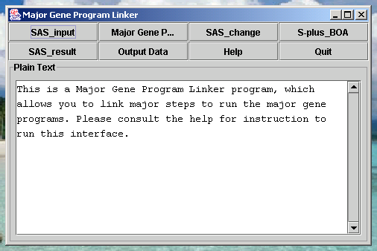
Eight buttons are lined up on the top for executing the programs, the text window shows information about which button is clicked and what is the function of that button. The first five buttons are arranged according to the order of the general workflow of the overall procedure (refer to the workflow section).
SAS_input button is clicked, SAS program will be invoked and the “MG_Input.sas” will be loaded. This SAS code is used to process raw data, please refer to previous detail explanation. Raw data will be preprocessed and ready for C++ Gibbs Sampler program.
Major Gene Program button is clicked, another interface will show on the screen as following. The user needs to input individual name, which is numerical part of raw data file name. E.G. for raw data file AIND035, individual is “035”. The default inputs are shown for chained ID, iteration number, lag number, and number of parent, which often needed to be modified by user as input, for specific parameter set-up. Once all parameters are set up properly, the user can invoke C++ by clicking the “start” button. Two text windows are lined up on the interface, the top one is for interactive information, such as what command has been issued, etc. The bottom one is the re-direct window for C++ output stream. The user could visually monitoring the running of C++ program. If C++ runs successfully, a piece of message “Process exit with rc=0” will be shown on the bottom line.
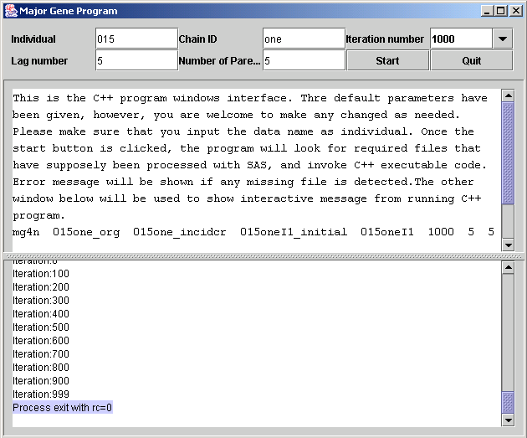
Goes back to the first GUI window.
SAS_change button is clicked, SAS program will be invoked and the “change.sas” will be loaded. This SAS code is used to modify C++ program output files for BOA diagnosis.
S-plus_BOA button is clicked, S-plus program will be invoked and two s-plus scripts “MG-batch1.ssc” and “MG-batch4.ssc” will be loaded. The s-plus scripts combing with BOA package are used to diagnose the quality of Gibbs Sampler performance. Whether the joint posterior distribution is reached, and when? Once the proper converge information is confirmed, the user can proceed to finish the statistical analysis procedure.
SAS_result button is clicked, SAS program will be invoked and the “MG_result.sas” will be loaded. This SAS code is used to perform statistical analysis for all parameter estimation as well as reporting of major gene effect.
Output Data button is clicked, an open file window will show up. By default, it only shows text-related files under C:\MGGUI directory. The user can open any output data file to monitor the behavior of the programs.
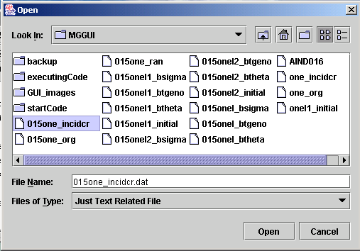
Although users could view all files under C:\MGGUI directory by choosing “all file” from the Files of Type window, it is highly recommended to use the default file type to avoid potential impairing on the executable files from any mis-conducting.
Help button is clicked, this word –format documentation file will be opened for user’s reference.
Quit button is clicked for exit the program.
4. A few suggestions for using this GUI
To finish this analysis, the user will need to run different programs. The main C++ program normally runs for two hours for the 250,000 iterations. It tends to use lots of CPU capacity, you will experience slow running of other application once you have started the C++ program.
Due to the Windows operation system set up, once the C++ program is initiated, which as a sub-thread of JAVA GUI. It will continue running until completion, no matter the GUI is on or not. In other words, once the “start” button is clicked from the Major Gene Program GUI. The C++ program will continue running even after you click “Quit” button to kill the GUI! Please do keep this in mind when you use this GUI.
Another program that takes longer time and lots of CPU is S-plus programs. Normally, it might take 10-30 minutes for one diagnosis.

