Python note

Install a package on user’s level vs. system level

Scenario: I wanted to reproduce an example from LINC1000 portal: <http://amp.pharm.mssm.edu/L1000CDS2/help/>. But, it turns out that our server does not have “requests” package. I assumed that there are two ways to get around this problem.

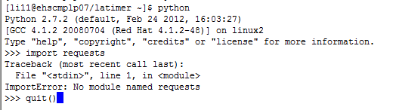

1. Install on a user’s level, so that I do not have to bother our admin,
2. Need help from the adamin

I will see how it will work out.

Okay, I did not figure it out on Linux but it is as simple as following a few steps presented by this youtube video: <https://www.youtube.com/watch?v=Ng5T18HyA-Q>