**April 9th, 2020**

**Python3 learning**

1. **Subprocess**
   1. Potential child thread needed
2. **Logging** 
   1. Taking log for analysis
   2. Check if a child process finishes
3. **Learning materials**
   1. **Learning python3 the hard way (**[**https://learncodethehardway.org/python/**](https://learncodethehardway.org/python/)**)**
   2. **Learning python=3-django course (https://www.feldroy.com/products/django-crash-course)**
4. **My first cookiecutter project (https://github.com/wdm0006/cookiecutter-pipproject)**
   1. **Installed the cookiecutter and download the wdm0006**
   2. **There was an error, and I solve it with help from:** [**https://github.com/mikeckennedy/python-for-entrepreneurs-course-demos/issues/30**](https://github.com/mikeckennedy/python-for-entrepreneurs-course-demos/issues/30)
   3. **Constructed my AccordJP– accord-Jianying-pipeline**
   4. **Installed the AccordJP**
   5. **Import myAccordJP in python console**
5. **Learning the click package and trying to make it work (**[**https://click.palletsprojects.com/en/7.x/parameters/**](https://click.palletsprojects.com/en/7.x/parameters/) **)**
6. **Keep working on myAccordJP by adding more features and functions, etc.**
7. **More on cuttiecutter**
   1. **I found out that wdm0006 has changed!! Nothing wrong, but some testing does not pass:** [**https://github.com/wdm0006/cookiecutter-pipproject**](https://github.com/wdm0006/cookiecutter-pipproject)
   2. **Somehow it works again?? (April 21st, 2020)**
   3. **I have to go back to audrey’s original post:** [**https://github.com/audreyr/cookiecutter-pypackage**](https://github.com/audreyr/cookiecutter-pypackage)
8. **Gone through my own note on pythons,**
9. **Still haven’t got a chance to test click package**

**Statistics**

I found a very helpful ROC/AUC curve tutorial <https://www.google.com/search?q=r+calculate+auc&oq=r+calculate+auc&aqs=chrome..69i57j0l7.5980j0j4&sourceid=chrome&ie=UTF-8#kpvalbx=_mRCXXqXWOfKyytMP-vOdmAk32>

**Upgrade R version in Rstudio**

1. With updateR (<https://github.com/AndreaCirilloAC/updateR> )
2. Not working as always!!
3. I have to install the R on the console and under Mac, there is no option to get the older R
4. Have to recover all the libraries from windows machine, and it takes a lot of time

**Look into click package**

In order to use the “click” package, I am spending some time to learn it (<https://click.palletsprojects.com/en/7.x/quickstart/#virtualenv> )

Setting up the basic on my macsystem

mkdir clickRelated

cd clickRelated

python3 -m virtualenv venv

. venv/bin/activate

Or, deactivate

To test installation, one can easily do the following

pip install --editable .

Very interesting youtube needs the credit: <https://www.youtube.com/watch?v=sugvnHA7ElY>

Setting up the basic on linux can be DIFFERENT!!

On BRC cluster, it is hard to get hold of pythob3, therefore, I am stuck with python2, and it also works to compile and install. Good new!

To resolve the “red underline” of importing the local library

From project 🡪 preference 🡪 mark “source”

Create two three branches for convenience (https://github.com/Kunena/Kunena-Forum/wiki/Create-a-new-branch-with-git-and-manage-branches)

git checkout -b ncsucluster

git push origin ncsubranch

Also, it is configured different

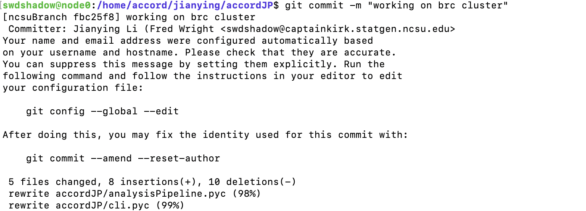

Sometimes, one has to wiggle through those intuitive adjustment

**Learning the slurm system**

Get my own wordpress note: <https://sites.duke.edu/workblog/2020/05/07/working-with-slurm-system-simple-linux-for-resource-management/>

Successfully installed smanage and make it work

By adding an alias in the bashrc:

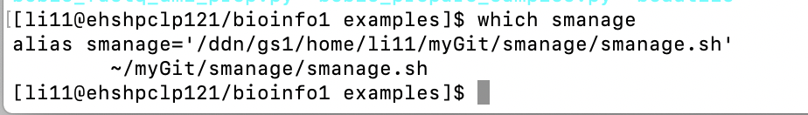

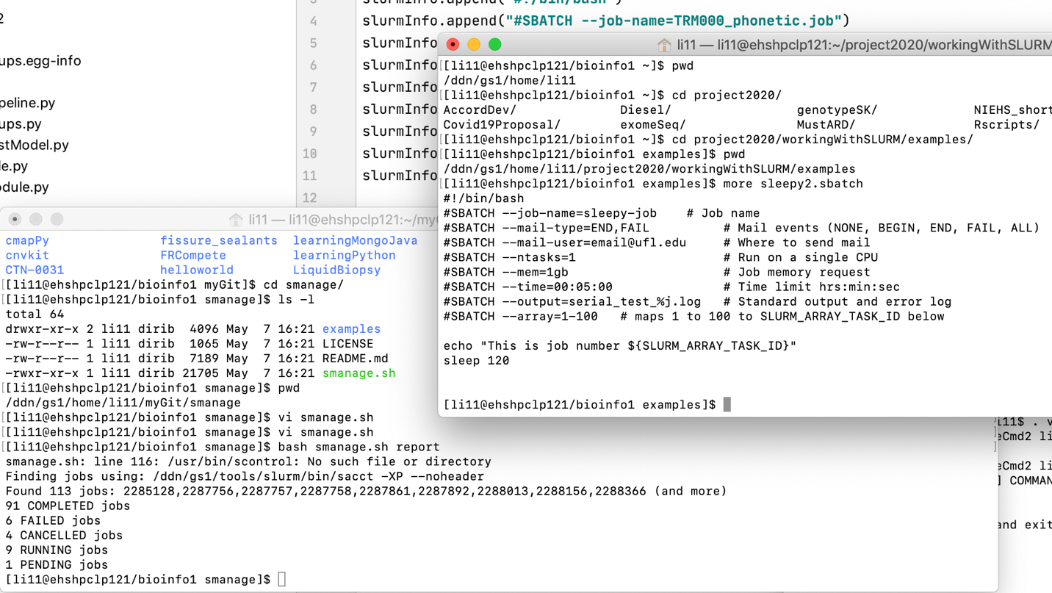

to interface with slurm

1. Create temp bash files for command and submit job
2. Collect those bash files – run clean command
3. Delete those bash files

Embed R/bash/executable scripts within python package

I followed this link: <https://realpython.com/python-application-layouts/#application-with-internal-packages>

But somehow, /bin/ directory can’t be added to github because .gitignore. I comment #/bin/, it becomes okay.

How to use the executable: <https://www.reddit.com/r/learnpython/comments/8816u8/python_package_bin_folder/>

Here is another helpdoc: <https://python-packaging.readthedocs.io/en/latest/command-line-scripts.html>

Not yet figured out!!

1. Create temp bash files for command and submit job
2. Collect those bash files – run clean command
3. Delete those bash files