I am trying to set up tunneling for my jyputer notebook on our linux server.

OS: windows

Software: putty

Problem:

My colleague provides a very good instruction, but I could not edit the “connection session”

Hi Jianying,

I worked out how to run this through the new machines. The basis I used is here:

Remote jupyter notebooks with ssh port forwarding (thedatafrog.com) (<https://thedatafrog.com/en/articles/remote-jupyter-notebooks/> )

These are the configurations I used in putty:

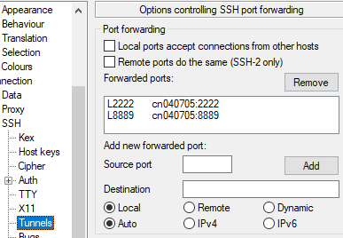

Cn040705 is the proper name for ib03, which is the one I usually log on to. If you use a different one, that name should go there instead.

The to run jupyter:

jupyter notebook --no-browser --port=8889 --ip=0.0.0.0

And finally I went to <http://localhost:8889> to open it in a browser.

======================================================

Solution:

I found another helpdoc online <https://knowledge.exlibrisgroup.com/Voyager/Knowledge_Articles/Set_Up_SSH_Port_Forwarding_in_Putty>

But, I am stuck at entering information tio the “source port panel”

I sent help note to another friend:

Hi, Adam, I am trying to configure the tunnel for our new ib servers, when I enter "cn040701.ib01:2222" in the source port panel (windows putty configuration panel), it complains about the "improper" naming. Did I enter anything wrong? Or am I allowed to perform such configuration as a "common user"? Any hint will be appreciated. thanks.

It turn out that I need to enter the information in separate windows:

Put only the port number: 2222 in the source port box

And, in the destination box put: cn040701:2222

Since I have this set up well:

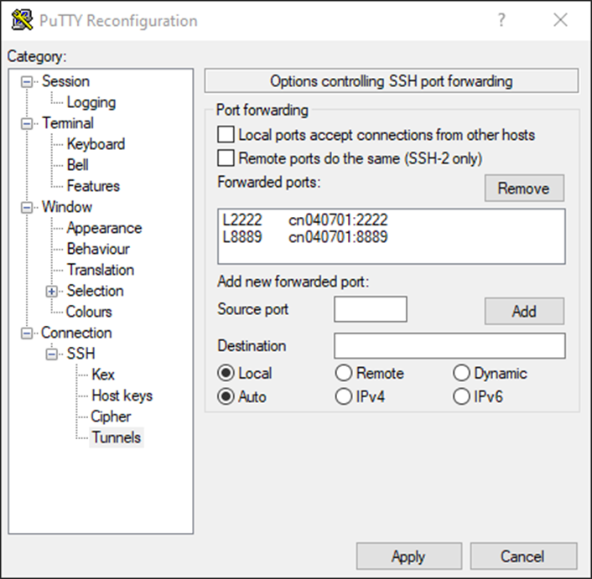

I can launch jupyter notebook, jupyter notebook --no-browser --port=8889 --ip=0.0.0.0

I got the following token to enter and I am good!!

816a19df3b25a61f9244b3623f396aac81f4905d95f90149

In my browser, I have <http://localhost:8889>, when prompted, I enter the above token!! All set!!