# Creating the Spotify Database using a DACPAC Deployment

1. **Download the file DACPAC** file from the repository named Database.dacpac:  
   <https://github.com/2wetdogs/spotify/tree/master/Database/bin/Release>
2. **Open SQL Management Studio and connect to the SQL Instance** you want to create the database in.  
   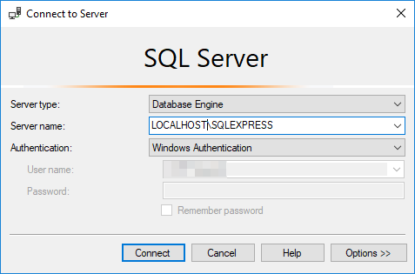
3. **Right mouse click on Databases** and choose **Deploy Data-tier Application**.  
   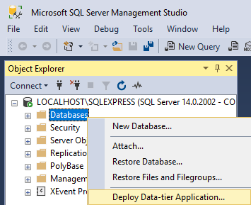
4. Choose **Next.**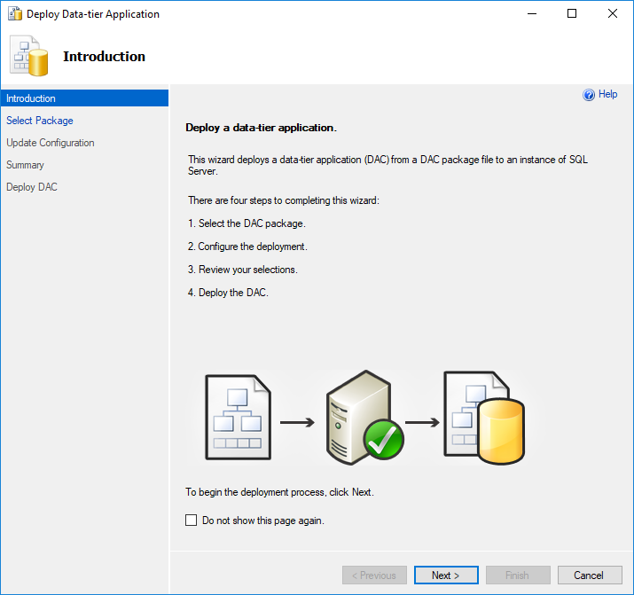
5. Choose **Browse**.  
   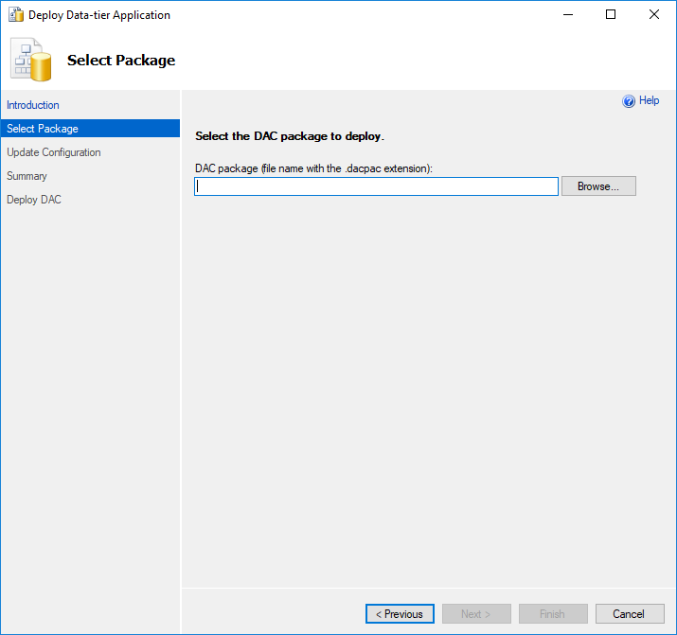
6. **Navigate to the folder** that contains the DACPAC file and **choose the DACPAC file**, then **select Open**.  
   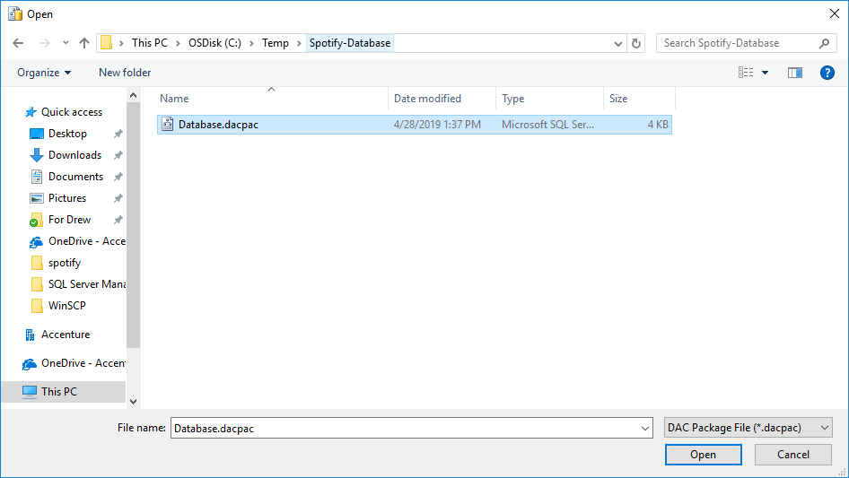
7. Select **Next.**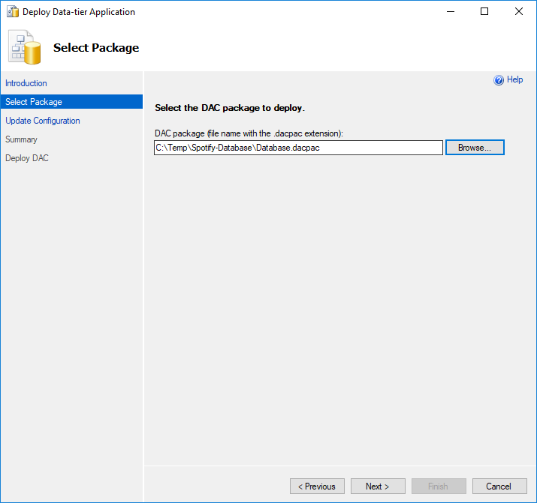
8. **Enter in the name** for your database and select **Next**.  
   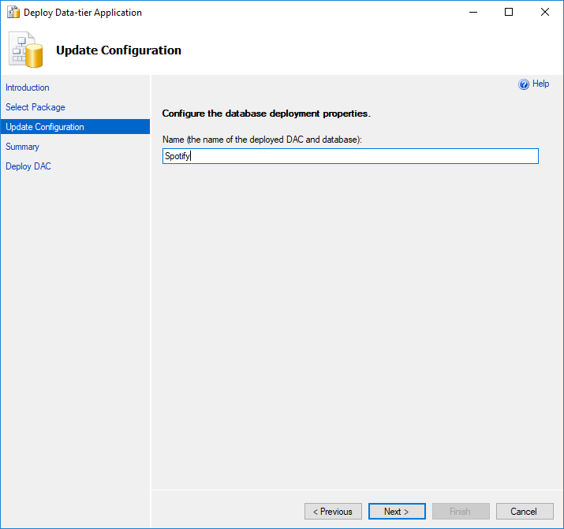
9. Review the options and select **Next.**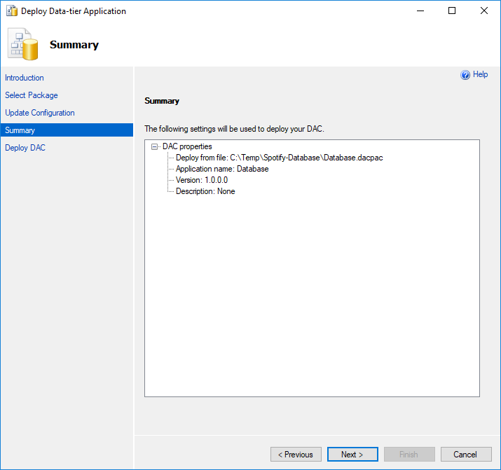
10. The deployment will begin.  
    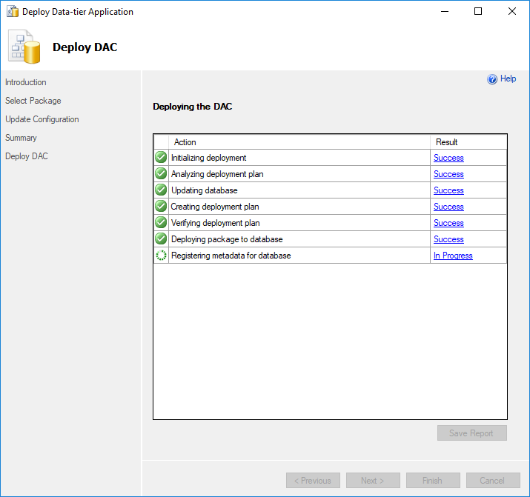
11. Once completed select **Finish**.  
    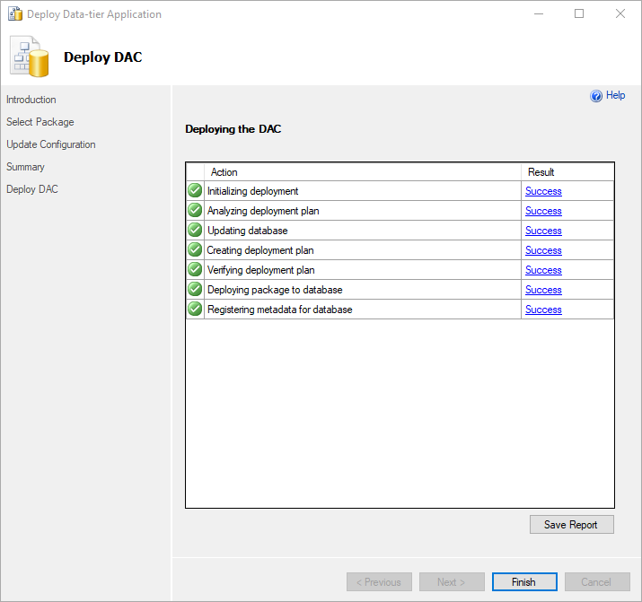
12. The database is now deployed and ready for use.