Learning Docker
Docker vs Virtualization:
- A Virtual Machine (VM) is a software-based computer that behaves like a real physical computer.
- Docker is a platform that allows you to package an application and all its dependencies into a container so it can run consistently on any machine.
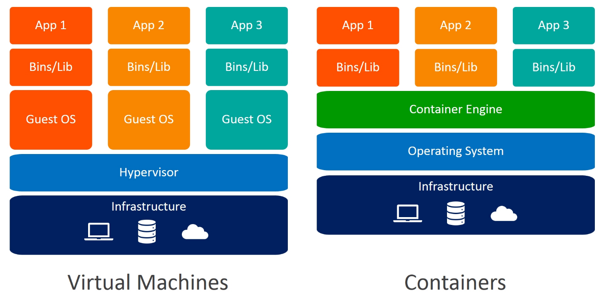
Guest os means the operating system that’s installed in the virtual machine using for example virutalbox.
Let’s explain now the difference between containers and virtual machines:
- The reason VMs and containers exist is isolation.
- Imagine you have 3 Application A, B and C and you install them on the same computer on virtual machine, what can happen is:
  - Dependency conflicts: A runs on Python 3.2 , B (Python 3.10) and C (Python 3.12)
  - One of the apps can consume all ram then the others B and C will crash
  - Security, if A gets hacked B and C may be affected too
- Containers are lightweight, they consum less RAM.
- Deployment is fast
- Not necessary to install the whole environnements in you local pc because containers contain
A container is a lightweight, isolated package that contains an application and everything it needs to run.
Image is the blueprint; Container is the running application created from that blueprint.

Commands :
- Docker run image
- Docker ps -a : show all docker containers including stopped
- Docker ps –help
- Docker search image-name
- Docker rmi image_id -f : delete image
- Docker rm container_id -f: delete container
- Docker run -p 8080:80 image-id: run on port 8080
- Docker run -tdi -p 8080:80 image-id: run it on background
- Docker run -tdi -p 8080:80 –name newname image-id : run it on background
- Docker exec -it container_id /bin/bash: enter inside container files and open bash
  - apt update
  - apt install vim
  - vim index.html
  - ESC + X -> :wq + Enter
Volume:
In Docker, a volume is a way to store data outside a container so it doesn’t disappear when the container stops or is deleted.
Containers are temporary by default:
- You run a container → it creates files/data
- You delete the container → ❌ data is lost
👉 Volumes solve this by keeping data persistently on your machine (host).
docker run -tdi -p 5000:80 -v /c/Users/aymen/Desktop/Nginx/:/usr/share/nginx/html/ --name nginx-aymen 5aca
Dockerfile:
A Dockerfile is a text file that contains a set of instructions to build a Docker image automatically.
Instead of manually running containers with long commands, you define everything once in a Dockerfile.

FROM nginx
RUN apt update && apt install vim -y
Copy index.html /usr/share/nginx/html/index.html
EXPOSE 80

Docker build -t new_nginx .
Dockerfile Commands:
COPY : copy only files
ADD : copy both files and folders
ENV PORT 80
EXPOSE ${PORT}
- RUN vs CMD
RUN | CMD
During image build (docker build) | When the container starts (docker run)
WORKDIR /app : sets the current working directory for the instructions that follow.

Example of building a react image:
FROM node:22
WORKDIR /app
COPY package.json /app
RUN npm install
COPY . .
EXPOSE 5173
CMD ["npm", "run", "dev","--","--host"]

Dockerhub:
- Login
- docker tag 874e 2ymenzitounii/react-project
- docker push 2ymenzitounii/react-project
Clone git repo using Dockerfile:
- Same setup for everyone: Every developer gets the same project and environment, so there are fewer errors.
- Saves time: Docker can download the project and prepare everything automatically.
- Keeps your computer clean: The project and its tools stay inside the container and don't affect the software installed on your computer.

FROM node:22
WORKDIR /app
COPY package*.json .
RUN apt update && apt install git -y
RUN git clone https://github.com/2ymenzitouni/hedayaQuran.git .
RUN npm i
EXPOSE 5173
CMD ["npm", "run", "dev","--","--host"]
Docker Build for a React/Vite Application Using Nginx
FROM node:22 AS builder
WORKDIR /app
RUN apt update && apt install -y git
RUN git clone https://github.com/2ymenzitouni/hedayaQuran.git .
RUN npm install
RUN npm run build
#-----------------------
FROM nginx:alpine AS production
COPY --from=builder /app/dist /usr/share/nginx/html
EXPOSE 80
CMD ["nginx", "-g", "daemon off;"]
- Multi-stage build: Separates build (Node.js) and production (Nginx) to make the final image smaller and cleaner.
- Optimized production image: Only the built static files are included, not the whole project or dependencies.
- Fast performance: Nginx serves static files very quickly and efficiently.
- Lightweight container: Removes Node.js and build tools in production, reducing size and resource usage.
- Consistent environment: Works the same on any machine (no “it works on my PC” problem).
- Easy deployment: One Docker image can be run anywhere without extra setup.
Docker Compose
Docker Compose is a tool that lets you run multiple Docker containers using one file (docker-compose.yml) instead of writing long docker run commands.
Example of running git project:
services:
react:
build: .
container_name: react-aymen-quran
ports:
- "5173:5173"
command: npm run dev -- --host
Notice: If we already have made a container then we changed the docker compose we should type: docker compose up -d --build

