**Lead2pass.1Z0-051.v12.39**

Number: 1Z0-051

Passing Score: 800

Time Limit: 120 min File Version: 12.39

**Exam A**

**QUESTION 1**

Which is the valid CREATE TABLE statement?

1. CREATE TABLE emp9$# (emp_no NUMBER (4));
2. CREATE TABLE 9emp$# (emp_no NUMBER(4));
3. CREATE TABLE emp1*23 (emp_no NUMBER(4));
4. CREATE TABLE emp9$# (emp_no NUMBER(4), date DATE);

**Correct Answer:** A

**Section: (none) Explanation**

**QUESTION 2** Which two statements are true regarding tables? (Choose two.)

1. A table name can be of any length.
2. A table can have any number of columns.
3. A column that has a DEFAULT value cannot store null values.
4. A table and a view can have the same name in the same schema.
5. A table and a synonym can have the same name in the same schema.
6. The same table name can be used in different schemas in the same database.

**Correct Answer:** EF

**Section: (none) Explanation**

**QUESTION 3** Which two statements are true regarding constraints? (Choose two.)

1. A foreign key cannot contain NULL values.
2. A column with the UNIQUE constraint can contain NULL values.
3. A constraint is enforced only for the INSERT operation on a table.
4. A constraint can be disabled even if the constraint column contains data.
5. All constraints can be defined at the column level as well as the table level.

**Correct Answer:** BD

**Section: (none) Explanation**

**QUESTION 4** Which two statements are true regarding constraints? (Choose two.)

1. A foreign key cannot contain NULL values.
2. The column with a UNIQUE constraint can store NULLS .
3. A constraint is enforced only for an INSERT operation on a table.
4. You can have more than one column in a table as part of a primary key.

**Correct Answer:** BD

**Section: (none) Explanation**

**QUESTION 5**

Evaluate the following CREATE TABLE commands:

CREATE TABLE orders

(ord_no NUMBER(2) CONSTRAINT ord_pk PRIMARY KEY,

ord_date DATE, cust_id NUMBER(4));

CREATE TABLE ord_items

(ord_no NUMBER(2), item_no NUMBER(3),

qty NUMBER(3) CHECK (qty BETWEEN 100 AND 200), expiry_date date CHECK (expiry_date > SYSDATE), CONSTRAINT it_pk PRIMARY KEY (ord_no,item_no),

CONSTRAINT ord_fk FOREIGN KEY(ord_no) REFERENCES orders(ord_no));

The above command fails when executed. What could be the reason?

1. SYSDATE cannot be used with the CHECK constraint.
2. The BETWEEN clause cannot be used for the CHECK constraint.
3. The CHECK constraint cannot be placed on columns having the DATE data type.
4. ORD_NO and ITEM_NO cannot be used as a composite primary key because ORD_NO is also theFOREIGN KEY.

**Correct Answer:** A

**Section: (none) Explanation**

**Explanation/Reference:**

**QUESTION 6** Evaluate the following SQL commands:

CREATE SEQUENCE ord_seq

INCREMENT BY 10

START WITH 120

MAXVALUE 9999

NOCYCLE;

CREATE TABLE ord_items

(ord_no NUMBER(4)DEFAULT ord_seq.NEXTVAL NOT NULL, item_no NUMBER(3),

qty NUMBER(3) CHECK (qty BETWEEN 100 AND 200), expiry_date date CHECK (expiry_date > SYSDATE), CONSTRAINT it_pk PRIMARY KEY (ord_no,item_no),

CONSTRAINT ord_fk FOREIGN KEY(ord_no) REFERENCES orders(ord_no));

The command to create a table fails. Identify the reason for the SQL statement failure? (Choose all that apply.)

1. You cannot use SYSDATE in the condition of a CHECK constraint.
2. You cannot use the BETWEEN clause in the condition of a CHECK constraint.
3. You cannot use the NEXTVAL sequence value as a DEFAULT value for a column.
4. You cannot use ORD_NO and ITEM_NO columns as a composite primary key because ORD_NO isalso the FOREIGN KEY.

**Correct Answer:** AC

**Section: (none) Explanation: Antwort C galt in dieser Form bis Oracle V. 11**

**QUESTION 7** Examine the structure and data in the PRICE_LIST table:

name Null Type

------ --------- -------

PROD_ID NOT NULL NUMBER(3)

PROD_PRICE VARCHAR2(10)

PROD_ID PROD_PRICE

---------- - -----------

1. $234.55
2. $6,509.75
3. $1,234

You plan to give a discount of 25% on the product price and need to display the discount amount in the same format as the PROD_PRICE.

Which SQL statement would give the required result?

1. SELECT TO_CHAR(prod_price* .25,'$99,999.99')FROM PRICE_LIST;
2. SELECT TO_CHAR(TO_NUMBER(prod_price)* .25,'$99,999.00') FROM PRICE_LIST;
3. SELECT TO_CHAR(TO_NUMBER(prod_price,'$99,999.99')* .25,'$99,999.00') FROM PRICE_LIST;
4. SELECT TO_NUMBER(TO_NUMBER(prod_price,'$99,999.99')* .25,'$99,999.00') FROM PRICE_LIST;

**Correct Answer:** C

**Section: (none) Explanation: Prod_Price ist char, weil $; erst mit "MASKE" zu Number convertieren**

**QUESTION 8**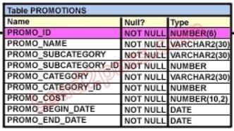

View the Exhibit and examine the structure of the PROMOTIONS table.

Which two SQL statements would execute successfully? (Choose two.)

1. UPDATE promotions

SET promo_cost = promo_cost+ 100 WHERE TO_CHAR(promo_end_date, 'yyyy') > '2000';

1. SELECT promo_begin_date FROM promotions   
   WHERE TO_CHAR(promo_begin_date,'mon dd yy')='jul 01 98';
2. UPDATE promotions   
   SET promo_cost = promo_cost + 100   
   WHERE promo_end_date > TO_DATE(SUBSTR('01-JAN-2000',8));
3. SELECT TO_CHAR(promo_begin_date,'dd/month')   
   FROM promotions WHERE promo_begin_date IN (TO_DATE('JUN 01 98'), TO_DATE('JUL 01 98'));

**Correct Answer:** AB

**Section: (none)** **Explanation Formate in A und B sind korrekt. C, Substr. Fehler; D, keine Range**

**QUESTION 9**

View the Exhibit and examine the data in the PROMO_NAME and PROMO_END_DATE columns of the PROMOTIONS table, and the required output format.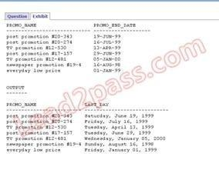

Which two queries give the correct result? (Choose two.)

1. SELECT promo_name,   
   TO_CHAR(promo_end_date,'Day') ', ' ||TO_CHAR(promo_end_date,'Month') ' ' ||TO_CHAR(promo_end_date,'DD, YYYY') AS last_day FROM promotions;
2. SELECT promo_name,TO_CHAR (promo_end_date,'fxDay') ', ' TO_CHAR(promo_end_date,'fxMonth') ' ' TO_CHAR(promo_end_date,'fxDD, YYYY') AS last_day FROM promotions;
3. SELECT promo_name, TRIM(TO_CHAR(promo_end_date,'Day')) ', ' TRIM(TO_CHAR (promo_end_date,'Month')) ' ' TRIM(TO_CHAR(promo_end_date,'DD, YYYY')) AS last_day FROM promotions;
4. SELECTpromo_name, TO_CHAR(promo_end_date,'fmDay') || ',' ||  
   TO_CHAR(promo_end_date,'fmMonth') || ' ' || TO_CHAR(promo_end_date,'fmDD, YYYY')   
   AS last_day FROM promotions;

**Correct Answer:** CD

**Section: (none) Explanation Both, FM and Trim, work fine for this Task but not "FX" or "Nothing".**

**QUESTION 10**

View the Exhibit and examine the structure of the CUSTOMERS table. Using the CUSTOMERS table, you need to generate a report that shows an increase in the credit limit by 15% for all customers.

Customers whose credit limit has not been entered should have the message " Not Available" displayed. 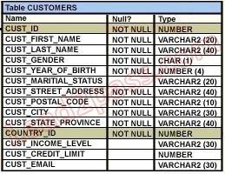

Which SQL statement would produce the required result?

1. SELECT NVL(cust_credit_limit,'Not Available')*.15 "NEW CREDIT" FROM customers;
2. SELECT NVL(cust_credit_limit*.15,'Not Available') "NEW CREDIT" FROM customers;
3. SELECT TO_CHAR(NVL(cust_credit_limit*.15,'Not Available')) "NEW CREDIT" FROM customers;
4. SELECT NVL(TO_CHAR(cust_credit_limit*.15),'Not Available') "NEW CREDIT" FROM customers;

**Correct Answer:** D

**Section: (none) Explanation: Number / Char Konflikte beachten**

**QUESTION 11**

Examine the structure of the PROGRAMS table:

name Null Type

------ --------- -------

PROG_ID NOT NULL NUMBER(3)

PROG_COST NUMBER(8,2)

START_DATE NOT NULL DATE

END_DATE DATE

Which two SQL statements would execute successfully? (Choose two.)

1. SELECT NVL(ADD_MONTHS(END_DATE,1),SYSDATE)FROM programs;
2. SELECT TO_DATE(NVL(SYSDATE-END_DATE,SYSDATE))FROM programs;
3. SELECT NVL(MONTHS_BETWEEN(start_date,end_date),'Ongoing') FROM programs;
4. SELECT NVL(TO_CHAR(MONTHS_BETWEEN(start_date,end_date)),'Ongoing') FROM programs;

**Correct Answer:** AD

**Section: (none) Explanation ! Subtraktion von DATE - DATE erzeugt NUMBER**

**QUESTION 12** The PRODUCTS table has the following structure:

Evaluate the following two SQL statements: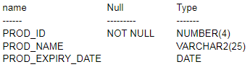

SELECT prod_id, NVL2(prod_expiry_date, prod_expiry_date + 15,'') FROM products;

SELECT prod_id, NVL(prod_expiry_date, prod_expiry_date + 15) FROM products;

Which statement is true regarding the outcome?

A. Both the statements execute and give different results.

B. Both the statements execute and give the same result.

1. Only the first SQL statement executes successfully.
2. Only the second SQL statement executes successfully.

**Correct Answer:** A

**Section: (none) Explanation NVL2 gibt "niemals" den 1. Parameter zurück !**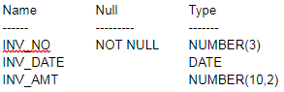

**QUESTION 13** Examine the structure of the INVOICE table.

Which two SQL statements would execute successfully? (Choose two.)

1. SELECT inv_no,NVL2(inv_date,'Pending','Incomplete')FROM invoice;
2. SELECT inv_no,NVL2(inv_amt,inv_date,'Not Available')FROM invoice;
3. SELECT inv_no,NVL2(inv_date,sysdate-inv_date,sysdate)FROM invoice;
4. SELECT inv_no,NVL2(inv_amt,inv_amt*.25,'Not Available') FROM invoice;

**Correct Answer:** AC

**Section: (none) Explanation: Number / Char Konflikt bei B und D !**

**QUESTION 14**

View the Exhibit and evaluate the structure and data in the CUST_STATUS table. You issue the following SQL statement:

SQL> SELECT custno, NVL2(NULLIF(amt_spent, credit_limit), 0, 1000)"BONUS" FROM cust_status;

Which statement is true regarding the execution of the above query?

1. It produces an error because the AMT_SPENT column contains a null value.
2. It displays a bonus of 1000 for all customers whose AMT_SPENT is less than CREDIT_LIMIT.
3. It displays a bonus of 1000 for all customers whose AMT_SPENT equals CREDIT_LIMIT, orAMT_SPENT is null .
4. It produces an error because the TO_NUMBER function must be used to convert the result of "FirstTest, First Pass" - www.lead2pass.com 9 the NULLIF function before it can be used by the NVL2 function.

**Correct Answer:** C

**Section: (none) Explanation: Nullif gibt bei a equals b NULL zurück; NVL2 nimmt dann 1000**

**QUESTION 15** Which statement is true regarding the COALESCE function?

1. It can have a maximum of five expressions in a list.
2. It returns the highest NOT NULL value in the list for all rows.
3. It requires that all expressions in the list must be of the same data type.
4. It requires that at least one of the expressions in the list must have a NOT NULL value.

**Correct Answer:** C

**Section: (none) Explanation: ...oder können implizit in gleiche Typen umgewandelt werden!**

**QUESTION 16**

View the Exhibit and examine the structure of the PROMOTIONS table. Using the PROMOTIONS table, you need to find out the average cost for all promos in the ranges $0-2000 and $2000-5000 in category A You issue the following SQL statement:

SELECT AVG(CASE  
WHEN promo_cost BETWEEN 0 AND 2000 AND promo_category = 'A' then promo_cost  
ELSE null END) "CAT_2000A",

AVG(CASE

WHEN promo_cost BETWEEN 2001 AND 5000 AND promo_category='A' THEN promo_cost  
ELSE null END) "CAT_5000A" FROM promotions;

What would be the outcome?

1. It executes successfully and gives the required result.
2. It generates an error because NULL cannot be specified as a return value.
3. It generates an error because CASE cannot be used with group functions.
4. It generates an error because multiple conditions cannot be specified for the WHEN clause.

**Correct Answer:** A **Explanation: Das SQL Statement ist OK**



**QUESTION 17**

View the Exhibit and examine the structure of the PROMOTIONS table.

Which SQL statements are valid? (Choose all that apply.)

1. SELECT promo_id, DECODE(NVL(promo_cost,0), promo_cost, promo_cost * 0.25, 100) "Discount"FROM promotions;
2. SELECT promo_id, DECODE(promo_cost, 10000,DECODE(promo_category, 'G1', promo_cost *.25, NULL), NULL) "Catcost" FROM promotions;
3. SELECT promo_id, DECODE(NULLIF(promo_cost, 10000), NULL, promo_cost*.25, 'N/A') "Catcost" FROM promotions;
4. SELECT promo_id, DECODE(promo_cost, >10000, 'High', <10000, 'Low') "Range" FROM promotions;

**Correct Answer:** AB

**Explanation: Typ-Konflikt bei C. und ungültige Operatoren bei D.**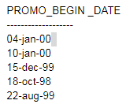

**QUESTION 18**

Examine the data in the PROMO_BEGIN_DATE column of the PROMOTIONS table:

You want to display the number of promotions started in 1999 and 2000.

Which query gives the correct output?

1. SELECT SUM(DECODE(SUBSTR(promo_begin_date,8),'00',1,0)) "2000", SUM(DECODE(SUBSTR(promo_begin_date,8),'99',1,0)) "1999" FROM promotions;
2. SELECT SUM(CASE TO_CHAR(promo_begin_date,'yyyy') WHEN '99' THEN 1 ELSE 0 END) "1999",SUM(CASE TO_CHAR(promo_begin_date,'yyyy') WHEN '00' THEN 1 ELSE 0 END) "2000" FROM promotions;
3. SELECT COUNT(CASE TO_CHAR(promo_begin_date,'yyyy') WHEN '99' THEN 1 ELSE 0 END) "1999", COUNT(CASE TO_CHAR(promo_begin_date,'yyyy') WHEN '00' THEN 1 ELSE 0 END) "2000" FROM promotions;
4. SELECT COUNT(DECODE(SUBSTR(TO_CHAR(promo_begin_date,'yyyy'), 8), '1999', 1, 0)) "1999", COUNT(DECODE(SUBSTR(TO_CHAR(promo_begin_date,'yyyy'), 8),'2000', 1, 0)) "2000"   
   FROM promotions;

**Correct Answer:** A

**Explanation: Vorsicht mit dem Offset; das hängt von den NLS Setting der DB ab.**

**QUESTION 19**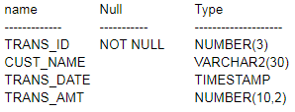

Examine the structure of the TRANSACTIONS table:

You want to display the date, time, and transaction amount of transactions that where done before 12 noon. The value zero should be displayed for transactions where the transaction amount has not been entered.

Which query gives the required result?

1. SELECT TO_CHAR(trans_date,'dd-mon-yyyy hh24:mi:ss'), TO_CHAR(trans_amt,'$99999999D99') FROM transactions   
   WHERE TO_NUMBER(TO_DATE(trans_date,'hh24')) < 12   
   AND COALESCE(trans_amt,NULL) <>NULL;
2. SELECT TO_CHAR(trans_date,'dd-mon-yyyy hh24:mi:ss'), NVL(TO_CHAR(trans_amt,'$99999999D99'),0)   
   FROM transactions   
   WHERE TO_CHAR(trans_date,'hh24') < 12;
3. SELECT TO_CHAR(trans_date,'dd-mon-yyyy hh24:mi:ss'), COALESCE(TO_NUMBER(trans_amt,'$99999999.99'),0)   
   FROM transactions   
   WHERE TO_DATE(trans_date,'hh24') < 12;
4. SELECT TO_DATE (trans_date,'dd-mon-yyyy hh24:mi:ss'), NVL2(trans_amt,TO_NUMBER(trans_amt,'$99999999.99'), 0)   
   FROM transactions WHERE TO_DATE(trans_date,'hh24') < 12;

**Correct Answer:** B

**Section: (none) Explanation**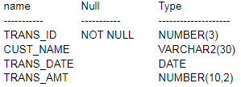

**QUESTION 20**

Examine the structure of the TRANSACTIONS table:

You want to display the transaction date and specify whether it is a weekday or weekend. Evaluate the following two queries:

SELECT TRANS_DATE, CASE

WHEN TRIM(TO_CHAR(trans_date,'DAY')) IN ('SATURDAY','SUNDAY') THEN 'weekend'

ELSE 'weekday' END "Day Type" FROM transactions;

SELECT TRANS_DATE, CASE

WHEN TO_CHAR(trans_date,'DAY') BETWEEN 'MONDAY' AND 'FRIDAY' THEN 'weekday'

ELSE 'weekend' END "Day Type" FROM transactions;

Which statement is true regarding the above queries?

1. Both give wrong results.
2. Both give the correct result.
3. Only the first query gives the correct result.
4. Only the second query gives the correct result.

**Correct Answer:** C

**Section: (none) Explanation**

**QUESTION 21**

View the Exhibit for the structure of the STUDENT and FACULTY tables.

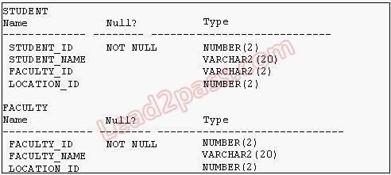

You need to display the faculty name followed by the number of students handled by the faculty at the base location.

Examine the following two SQL statements: Statement 1

SQL>SELECT faculty_name,COUNT(student_id)

FROM student JOIN faculty

USING (faculty_id, location_id)

GROUP BY faculty_name;

Statement 2

SQL>SELECT faculty_name,COUNT(student_id)

FROM student NATURAL JOIN faculty GROUP BY faculty_name;

Which statement is true regarding the outcome?

1. Only s tatement 1 executes successfully and gives the required result.
2. Only statement 2 executes successfully and gives the required result.
3. Both statements 1 and 2 execute successfully and give different results.
4. Both statements 1 and 2 execute successfully and give the same required result.

**Correct Answer:** D

**Section: (none) Explanation**

**QUESTION 22** Which two statements are true regarding the USING clause in table joins? (Choose two.)

1. It can be used to join a maximum of three tables.
2. It can be used to restrict the number of columns used in a NATURAL join.
3. It can be used to access data from tables through equijoins as well as nonequijoins.
4. It can be used to join tables that have columns with the same name and compatible data types.

**Correct Answer:** BD

**Section: (none) Explanation**

**QUESTION 23**

Examine the structure of the CUSTOMERS table:

name Null Type

----------- ----------- --------------------

CUSTNO NOT NULL NUMBER(3)

CUSTNAME NOT NULL VARCHAR2(25)

CUSTADDRESS VARCHAR2(35)

CUST_CREDIT_LIMIT NUMBER(5)

CUSTNO is the PRIMARY KEY in the table. You want to find out if any customers' details have been entered more than once using different CUSTNO, by listing all the duplicate names. Which two methods can you use to get the required result? (Choose two.)

1. self-join
2. subquery
3. full outer-join with self-join
4. left outer-join with self-join
5. right outer-join with self-join

**Correct Answer:** AB

**Section: (none) Explanation**

**QUESTION 24**

View the Exhibits and examine the structures of the PRODUCTS, SALES, and CUSTOMERS tables.

14

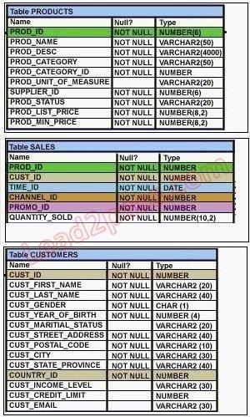

You issue the following query:

SQL>SELECT p.prod_id,prod_name,prod_list_price, quantity_sold,cust_last_name

FROM products p NATURAL JOIN sales s NATURAL JOIN customers c WHERE prod_id =148;

Which statement is true regarding the outcome of this query?

1. It executes successfully.
2. It produces an error because the NATURAL join can be used only with two tables.
3. It produces an error because a column used in the NATURAL join cannot have a qualifier.
4. It produces an error because all columns used in the NATURAL join should have a qualifier.

**Correct Answer:** C

**Section: (none) Explanation**

**QUESTION 25**

View the Exhibits and examine the structures of the PRODUCTS, SALES, and CUSTOMERS tables. You need to generate a report that gives details of the customer's last name, name of the product, and the quantity sold for all customers in 'Tokyo' .

Which two queries give the required result? (Choose two.)

1. SELECT c.cust_last_name,p.prod_name, s.quantity_sold FROM sales s JOIN products p

USING(prod_id) JOIN customers c USING(cust_id) WHERE c.cust_city='Tokyo';

1. SELECT c.cust_last_name, p.prod_name, s.quantity_sold FROM products p JOIN sales s JOIN customers c ON(p.prod_id=s.prod_id) ON(s.cust_id=c.cust_id) WHERE c.cust_city='Tokyo';
2. SELECT c.cust_last_name, p.prod_name, s.quantity_sold FROM products p JOIN sales s

ON(p.prod_id=s.prod_id) JOIN customers c ON(s.cust_id=c.cust_id) AND c.cust_city='Tokyo';

1. SELECT c.cust_id,c.cust_last_name,p.prod_id, p.prod_name, s.quantity_sold FROM products p JOINsales s USING(prod_id) JOIN customers c USING(cust_id) WHERE c.cust_city='Tokyo';

**Correct Answer:** AC

**Section: (none)**

**Explanation**

**QUESTION 26**

View the Exhibit and examine the structure of the PROMOTIONS, SALES, and CUSTOMER tables. You need to generate a report showing the promo name along with the customer name for all products that were sold during their promo campaign and before 30th October 2007. You issue the following query:

SQL> SELECT promo_name,cust_name  
FROM promotions p   
JOIN sales s ON(time_id   
BETWEEN promo_begin_date   
AND promo_end_date)   
JOIN customer c ON (s.cust_id = c.cust_id) AND time_id < '30-oct-2007'; 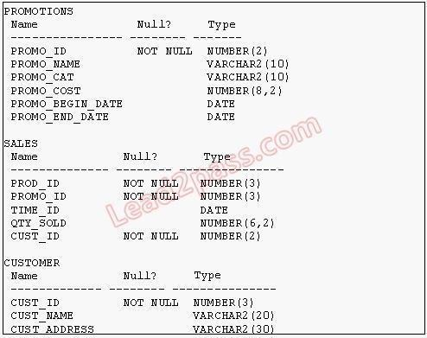

Which statement is true regarding the above query?

1. It executes successfully and gives the required result.
2. It executes successfully but does not give the required result.
3. It produces an error because the join order of the tables is incorrect.
4. It produces an error because equijoin and nonequijoin conditions cannot be used in the same SELECTstatement.

**Correct Answer:** B

**Section: (none) Explanation**

**QUESTION 27**

View the Exhibit and examine the data in the PROJ_TASK_DETAILS table.

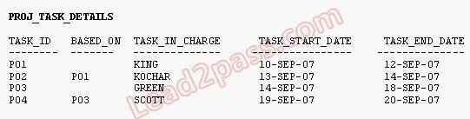

The PROJ_TASK_DETAILS table stores information about tasks involved in a project and the relation between them.

The BASED_ON column indicates dependencies between tasks. Some tasks do not depend on the completion of any other tasks.

You need to generate a report showing all task IDs, the corresponding task ID they are dependent on, and the name of the employee in charge of the task it depends on. Which query would give the required result?

1. SELECT p.task_id, p.based_on, d.task_in_chargeFROM proj_task_details p JOIN proj_task_details d

ON (p.based_on = d.task_id);

1. SELECT p.task_id, p.based_on, d.task_in_charge

FROM proj_task_details p LEFT OUTER JOIN proj_task_details d ON (p.based_on = d.task_id);

1. SELECT p.task_id, p.based_on, d.task_in_charge

FROM proj_task_details p FULL OUTER JOIN proj_task_details d ON (p.based_on = d.task_id);

1. SELECT p.task_id, p.based_on, d.task_in_chargeFROM proj_task_details p JOIN proj_task_details d ON (p.task_id = d.task_id);

**Correct Answer:** B

**Section: (none) Explanation**

**QUESTION 28**

Examine the data in the CUSTOMERS table:

CUSTNO CUSTNAME CITY

--------- --------- ----------

1. KING SEATTLE
2. GREEN BOSTON
3. KOCHAR SEATTLE4 SMITH NEW YORK

You want to list all cities that have more than one customer along with the customer details. Evaluate the following query:

SQL>SELECT c1.custname, c1.city

FROM Customers c1 __________________ Customers c2

ON (c1.city=c2.city AND c1.custname<>c2.custname);

Which two JOIN options can be used in the blank in the above query to give the correct output? (Choose two.)

1. JOIN
2. NATURAL JOIN
3. LEFT OUTER JOIN
4. FULL OUTER JOIN
5. RIGHT OUTER JOIN

**Correct Answer:** AE

**Section: (none) Explanation**

**QUESTION 29**

View the Exhibits and examine the structures of the CUSTOMERS, SALES, and COUNTRIES tables. You need to generate a report that shows all country names, with corresponding customers (if any) and sales details (if any), for all customers.

Which FROM clause gives the required result?

1. FROM sales JOIN customers USING (cust_id)FULL OUTER JOIN countries USING (country_id);
2. FROM sales JOIN customers USING (cust_id)

RIGHT OUTER JOIN countries USING (country_id);

1. FROM customers LEFT OUTER JOIN sales USING (cust_id)RIGHT OUTER JOIN countries USING (country_id);
2. FROM customers LEFT OUTER JOIN sales USING (cust_id)LEFT OUTER JOIN countries USING (country_id);

**Correct Answer:** C

**Section: (none) Explanation**

**QUESTION 30**

View the Exhibits and examine the structures of the PROMOTIONS and SALES tables.

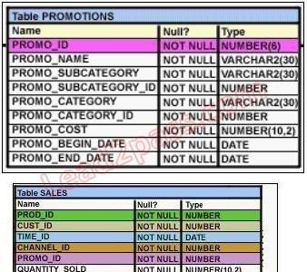

Evaluate the following SQL statement:

SQL>SELECT p.promo_id, p.promo_name, s.prod_id

FROM sales s RIGHT OUTER JOIN promotions p ON (s.promo_id = p.promo_id);

19

Which statement is true regarding the output of the above query?

1. It gives the details of promos for which there have been sales.
2. It gives the details of promos for which there have been no sales.
3. It gives details of all promos irrespective of whether they have resulted in a sale or not.
4. It gives details of product ID s that have been sold irrespective of whether they had a promo or not.

**Correct Answer:** C

**Section: (none) Explanation**

**QUESTION 31**

View the Exhibit and examine the data in the EMPLOYEES table:

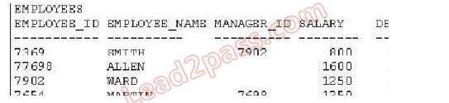

You want to display all the employee names and their corresponding manager names. Evaluate the following query:

SQL> SELECT e.employee_name "EMP NAME", m.employee_name "MGR NAME" FROM employees e

______________ employees m

ON e.manager_id = m.employee_id;

Which JOIN option can be used in the blank in the above query to get the required output?

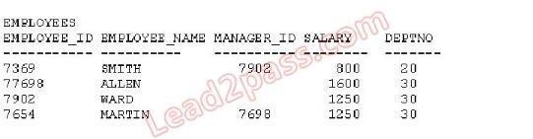

1. only inner JOIN
2. only FULL OUTER JOINC. only LEFT OUTER JOIN

D. only RIGHT OUTER JOIN

**Correct Answer:** C

**Section: (none) Explanation**

**QUESTION 32**

View the Exhibit and examine the structure of the PRODUCT, COMPONENT, and PDT_COMP tables.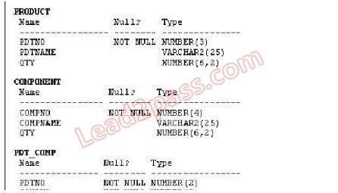

In PRODUCT table, PDTNO is the primary key.

In COMPONENT table, COMPNO is the primary key.

In PDT_COMP table, (PDTNO,COMPNO) is the primary key, PDTNO is the foreign key referencing PDTNO in PRODUCT table and COMPNO is the foreign key referencing the COMPNO in COMPONENT table.

You want to generate a report listing the product names and their corresponding component names, if the component names and product names exist. Evaluate the following query:

SELECT pdtno,pdtname, compno,compname

FROM product _____________ pdt_comp

USING (pdtno) ____________ component USING(compno) WHERE compname IS NOT NULL;

Which combination of joins used in the blanks in the above query gives the correct output?

1. JOIN; JOIN
2. FULL OUTER JOIN; FULL OUTER JOIN
3. RIGHT OUTER JOIN; LEFT OUTER JOIN
4. LEFT OUTER JOIN; RIGHT OUTER JOIN

**Correct Answer:** D oder A

**Section: (none) Explanation**

**QUESTION 33**

View the Exhibit and examine the structure of the SALES and PRODUCTS tables. In the SALES table, PROD_ID is the foreign key referencing PROD_ID in the PRODUCTS table, You want to list each product ID and the number of times it has been sold. Evaluate the following query: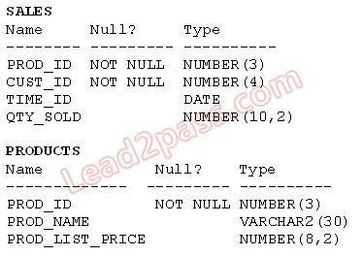

SQL>SELECT p.prod_id, COUNT(s.prod_id)

FROM products p _____________ sales s

ON p.prod_id = s.prod_id GROUP BY p.prod_id;

Which two JOIN options can be used in the blank in the above query to get the required output?  
(Choose two.)

1. JOIN
2. FULL OUTER JOIN
3. LEFT OUTER JOIN

D. RIGHT OUTER JOIN

**Correct Answer:** BC

**Section: (none) Explanation**

**QUESTION 34** Which two statements are true regarding subqueries? (Choose two.)

1. A subquery can retrieve zero or more rows.
2. Only two subqueries can be placed at one level.
3. A subquery can be used only in SQL query statements.
4. A subquery can appear on either side of a comparison operator.
5. There is no limit on the number of subquery levels in the WHERE clause of a SELECT statement.

**Correct Answer:** AD

**Section: (none) Explanation**

**QUESTION 35**

Where can subqueries be used? (Choose all that apply.)

1. field names in the SELECT statement
2. the FROM clause in the SELECT statement
3. the HAVING clause in the SELECT statement
4. the GROUP BY clause in the SELECT statement
5. the WHERE clause in only the SELECT statement
6. the WHERE clause in SELECT as well as all DML statements

**Correct Answer:** ABCF

**Section: (none) Explanation**

**Explanation/Reference:**

22

**QUESTION 36** Which three statements are true regarding subqueries? (Choose three.)

1. Subqueries can contain GROUP BY and ORDER BY clauses.
2. Main query and subquery can get data from different tables.
3. Main query and subquery must get data from the same tables.
4. Subqueries can contain ORDER BY but not the GROUP BY clause.
5. Only one column or expression can be compared between the main query and subquery.
6. Multiple columns or expressions can be compared between the main query and subquery.

**Correct Answer:** ABF

**Section: (none) Explanation**

**QUESTION 37**

View the Exhibits and examine PRODUCTS and SALES tables.

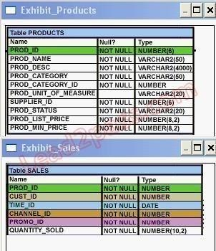

You issue the following query to display product name and the number of times the product has been sold:

SQL>SELECT p.prod_name, i.item_cnt

FROM (SELECT prod_id, COUNT(*) item_cnt

FROM sales

GROUP BY prod_id) i RIGHT OUTER JOIN products p ON i.prod_id = p.prod_id;

What happens when the above statement is executed?

1. The statement executes successfully and produces the required output.
2. The statement produces an error because ITEM_CNT cannot be displayed in the outer query.
3. The statement produces an error because a subquery in the FROM clause and outer-joins cannot beused together.
4. The statement produces an error because the GROUP BY clause cannot be used in a subquery in the FROM clause.

**Correct Answer:** A

**Section: (none) Explanation**

**QUESTION 38**

View the Exhibit and examine the structure of the PRODUCTS table. Which two tasks would require subqueries? (Choose two.)

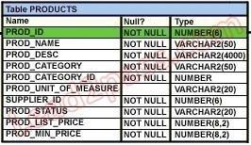

1. Display the minimum list price for each product status.
2. Display all suppliers whose list price is less than 1000.
3. Display the number of products whose list price is more than the average list price.
4. Display the total number of products supplied by supplier 102 and have product status as 'obsolete'.
5. Display all products whose minimum list price is more than the average list price of products and have the status 'orderable'.

**Correct Answer:** CE

**Section: (none) Explanation**

**QUESTION 39** Which statement is true regarding subqueries?

1. The LIKE operator cannot be used with single- row subqueries.
2. The NOT IN operator is equivalent to IS NULL with single- row subqueries.
3. =ANY and =ALL operators have the same functionality in multiple- row subqueries.
4. The NOT operator can be used with IN, ANY, and ALL operators in multiple- row subqueries.

**Correct Answer:** D

**Section: (none) Explanation**

**QUESTION 40** Which three statements are true about multiple-row subqueries? (Choose three.)

1. They can contain a subquery within a subquery.
2. They can return multiple columns as well as rows.
3. They cannot contain a subquery within a subquery.
4. They can return only one column but multiple rows.
5. They can contain group functions and GROUP BY and HAVING clauses.
6. They can contain group functions and the GROUP BY clause, but not the HAVING clause.

**Correct Answer:** ABE

**Section: (none)**

**Explanation**

**Explanation/Reference:**

24

**QUESTION 41**

View the Exhibit and examine the structure of CUSTOMERS and GRADES tables.

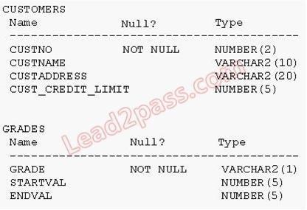

You need to display names and grades of customers who have the highest credit limit. Which two SQL statements would accomplish the task? (Choose two.)

1. SELECT custname, gradeFROM customers, grades

WHERE (SELECT MAX(cust_credit_limit)

FROM customers) BETWEEN startval and endval;

1. SELECT custname, gradeFROM customers, grades

WHERE (SELECT MAX(cust_credit_limit)

FROM customers) BETWEEN startval and endval

AND cust_credit_limit BETWEEN startval AND endval;

1. SELECT custname, grade

FROM customers, grades

WHERE cust_credit_limit = (SELECT MAX(cust_credit_limit) FROM customers) AND cust_credit_limit BETWEEN startval AND endval;

1. SELECT custname, grade

FROM customers , grades

WHERE cust_credit_limit IN (SELECT MAX(cust_credit_limit) FROM customers)

AND MAX(cust_credit_limit) BETWEEN startval AND endval;

**Correct Answer:** BC

**Section: (none) Explanation**

**QUESTION 42** Examine the structure of the PRODUCTS table:

name Null Type

--------- --------- ----------

PROD_ID NOT NULL NUMBER(4)

PROD_NAME VARCHAR2(20)

25

PROD_STATUS VARCHAR2(6)

QTY_IN_HAND NUMBER(8,2)

UNIT_PRICE NUMBER(10,2)

You want to display the names of the products that have the highest total value for UNIT_PRICE *

QTY_IN_HAND.

Which SQL statement gives the required output?

1. SELECT prod_name

FROM products

WHERE (unit_price * qty_in_hand) = (SELECT MAX(unit_price * qty_in_hand) FROM products);

1. SELECT prod_nameFROM products

WHERE (unit_price * qty_in_hand) = (SELECT MAX(unit_price * qty_in_hand) FROM products GROUP BY prod_name);

1. SELECT prod_name

FROM products

GROUP BY prod_name

HAVING MAX(unit_price * qty_in_hand) = (SELECT MAX(unit_price * qty_in_hand) FROM products GROUP BY prod_name);

1. SELECT prod_name

FROM products

WHERE (unit_price * qty_in_hand) = (SELECT MAX(SUM(unit_price * qty_in_hand)) FROM products) GROUP BY prod_name;

**Correct Answer:** A

**Section: (none) Explanation**

**QUESTION 43**

View the Exhibit and examine the structure of the PRODUCTS table. Evaluate the following query:

SQL> SELECT prod_name

FROM products

WHERE prod_id IN (SELECT prod_id FROM products

WHERE prod_list_price =

(SELECT MAX(prod_list_price)FROM products

WHERE prod_list_price <

(SELECT MAX(prod_list_price)FROM products)));

What would be the outcome of executing the above SQL statement?



1. It produces an error.
2. It shows the names of all products in the table.

26

1. It shows the names of products whose list price is the second highest in the table.
2. It shows the names of all products whose list price is less than the maximum list price.

**Correct Answer:** C

**Section: (none) Explanation**

**QUESTION 44**

View the Exhibit and examine the structure of the PROMOTIONS table. You have to generate a report that displays the promo name and start date for all promos that started after the last promo in the 'INTERNET' category.

Which query would give you the required output?

1. SELECT promo_name, promo_begin_date FROM promotions WHERE promo_begin_date > ALL (SELECT MAX(promo_begin_date) FROM promotions )AND promo_category = 'INTERNET';
2. SELECT promo_name, promo_begin_date FROM promotions WHERE promo_begin_date IN (SELECT promo_begin_date FROM promotions WHERE promo_category='INTERNET');
3. SELECT promo_name, promo_begin_date FROM promotions WHERE promo_begin_date > ALL (SELECT promo_begin_date FROM promotions WHERE promo_category = 'INTERNET');
4. SELECT promo_name, promo_begin_date FROM promotions WHERE promo_begin_date > ANY (SELECT promo_begin_date FROM promotions WHERE promo_category = 'INTERNET');

**Correct Answer:** C

**Section: (none) Explanation**

**QUESTION 45**

View the Exhibit and examine the structure of the PRODUCTS table. You want to display the category with the maximum number of items. You issue the following query:

SQL>SELECT COUNT(*),prod_category_id

FROM products

GROUP BY prod_category_id

HAVING COUNT(*) = (SELECT MAX(COUNT(*)) FROM products);

What is the outcome?

1. It executes successfully and gives the correct output.
2. It executes successfully but does not give the correct output.
3. It generates an error because the subquery does not have a GROUP BY clause.
4. It generates an error because = is not valid and should be replaced by the IN operator.

**Correct Answer:** C

**Section: (none) Explanation**

**QUESTION 46**

View the Exhibit and examine the structure of the CUSTOMERS table. You issue the following SQL statement on the CUSTOMERS table to display the customers who are in the same country as customers with the last name 'KING' and whose credit limit is less than the maximum credit limit in countries that have customers with the last name 'KING':

SQL> SELECT cust_id,cust_last_name  
FROM customers  
WHERE country_id IN(  
 SELECT country_id FROM customers   
 WHERE cust_last_name ='King')

AND cust_credit_limit < (SELECT MAX(cust_credit_limit)   
FROM customers  
WHERE country_id IN(SELECT country_id  
FROM customers  
WHERE cust_last_name='King'));

Which statement is true regarding the outcome of the above query?

1. It executes and shows the required result.
2. It produces an error and the < operator should be replaced by < ALL to get the required output.
3. It produces an error and the < operator should be replaced by < ANY to get the required output. 28
4. It produces an error and the IN operator should be replaced by = in the WHERE clause of the mainquery to get the required output.

**Correct Answer:** A

**Section: (none) Explanation**

**QUESTION 47** Evaluate the following SQL statement:

SQL> SELECT cust_id, cust_last_name FROM customers WHERE cust_credit_limit IN   
(select cust_credit_limit FROM customers WHERE cust_city ='Singapore');

Which statement is true regarding the above query if one of the values generated by the subquery is NULL?

1. It produces an error.
2. It executes but returns no rows.
3. It generates output for NULL as well as the other values produced by the subquery.
4. It ignores the NULL value and generates output for the other values produced by the subquery.

**Correct Answer:** C D

**Section: (none) Explanation**

**QUESTION 48**

View the Exhibit and examine the structure of the PROMOTIONS table. Evaluate the following SQL statement:

SELECT promo_name,CASE   
WHEN promo_cost >=(  
 SELECT AVG(promo_cost)  
 FROM promotions WHERE   
 promo_category='TV')   
 then 'HIGH' else 'LOW' END COST_REMARK   
FROM promotions;

Which statement is true regarding the outcome of the above query?

1. It shows COST_REMARK for all the promos in the table.
2. It produces an error because the subquery gives an error.
3. It shows COST_REMARK for all the promos in the promo category 'TV'.
4. It produces an error because subqueries cannot be used with the CASE expression.

**Correct Answer:** A

**Section: (none) Explanation**

**QUESTION 49**

View the Exhibit and examine the structure of the PRODUCTS tables. You want to generate a report that displays the average list price of product categories where the average list price is less than half the maximum in each category.

Which query would give the correct output?  


1. SELECT prod_category,avg(prod_list_price) FROM products  
   GROUP BY prod_category HAVING avg(prod_list_price) < ALL (SELECT max(prod_list_price)/2 FROM products GROUP BY prod_category);
2. SELECT prod_category,avg(prod_list_price) FROM products GROUP BY prod_category HAVING avg(prod_list_price) > ANY (SELECT max(prod_list_price)/2 FROM products GROUP BY prod_category);
3. SELECT prod_category,avg(prod_list_price) FROM products HAVING avg(prod_list_price) < ALL (SELECT max(prod_list_price)/2 FROM products GROUP BY prod_category);
4. SELECT prod_category,avg(prod_list_price) FROM products GROUP BY prod_category HAVING avg(prod_list_price) > ANY (SELECT max(prod_list_price)/2 FROM products);

**Correct Answer:** A ???

**Section: (none) Explanation**

**Explanation/Reference:**

**QUESTION 50**

View the Exhibits and examine the structures of the COSTS and PROMOTIONS tables. Evaluate the following SQL statement:

SELECT prod_id FROM costs WHERE promo_id IN

(SELECT promo_id FROM promotions WHERE promo_cost < ALL

(SELECT MAX(promo_cost) FROM promotions

GROUP BY (promo_end_datepromo_begin_date)));

What would be the outcome of the above SQL statement?

1. It displays prod IDs in the promo with the lowest cost.
2. It displays prod IDs in the promos with the lowest cost in the same time interval.
3. It displays prod IDs in the promos with the highest cost in the same time interval.
4. It displays prod IDs in the promos with cost less than the highest cost in the same time interval.

**Correct Answer:** D ...das stimmt auch nicht, klingt aber so ähnlich !

**Section: (none) Explanation**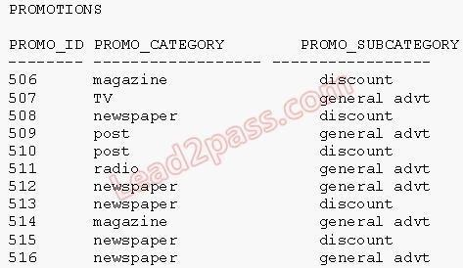

**QUESTION 51**

View the Exhibit and examine the data in the PROMOTIONS table.

You need to display all promo categories that do not have 'discount' in their subcategory. Which two SQL statements give the required result? (Choose two.)

1. SELECT promo_category FROM promotions

MINUS

SELECT promo_category FROM promotions WHERE promo_subcategory = 'discount';

1. SELECT promo_category FROM promotions

INTERSECT

SELECT promo_category FROM promotions WHERE promo_subcategory = 'discount';

1. SELECT promo_category FROM promotions

MINUS

SELECT promo_category FROM promotions WHERE promo_subcategory <> 'discount';

1. SELECT promo_category FROM promotions

INTERSECT

SELECT promo_category FROM promotions WHERE promo_subcategory <> 'discount';

**Correct Answer:** AD

**Section: (none) Explanation**

**QUESTION 52**

View the Exhibit and examine the structure of the CUSTOMERS and CUST_HISTORY tables.

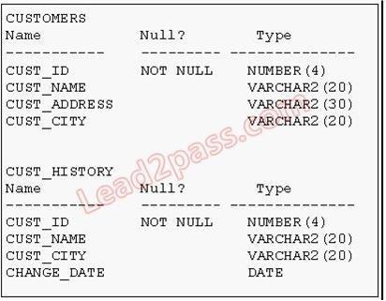

The CUSTOMERS table contains the current location of all currently active customers. The

CUST_HISTORY table stores historical details relating to any changes in the location of all current as well as previous customers who are no longer active with the company. You need to find those customers who have never changed their address. Which SET operator would you use to get the required output?

1. MINUS
2. UNION
3. INTERSECT
4. UNION ALL

**Correct Answer:** A

**Section: (none) Explanation**

**Explanation/Reference:**

**QUESTION 53**

Which statement is true regarding the UNION operator?

1. By default, the output is not sorted.
2. NULL values are not ignored during duplicate checking.
3. Names of all columns must be identical across all SELECT statements.
4. The number of columns selected in all SELECT statements need not be the same.

**Correct Answer:** B

**Section: (none) Explanation**

**QUESTION 54**

View the Exhibits and examine the structures of the PRODUCTS and SALES tables.

Which two SQL statements would give the same output?   
(Choose two.)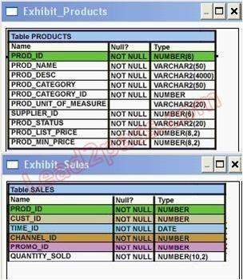

1. SELECT prod_id FROM products INTERSECT

SELECT prod_id FROM sales;

1. SELECT prod_id FROM productsMINUS

SELECT prod_id FROM sales;

1. SELECT DISTINCT p.prod_id

FROM products p JOIN sales s

ON p.prod_id=s.prod_id;

1. SELECT DISTINCT p.prod_id

FROM products p JOIN sales s

ON p.prod_id <> s.prod_id;

**Correct Answer:** AC

**Section: (none) Explanation**

**QUESTION 55**

View the Exhibit and evaluate structures of the SALES, PRODUCTS, and COSTS tables.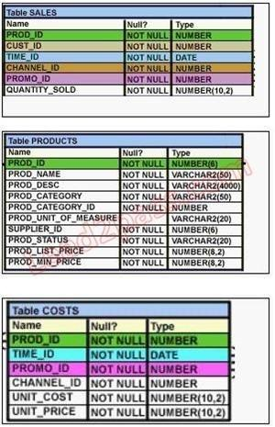

Evaluate the following SQL statement:

SQL>SELECT prod_id FROM products

INTERSECT

SELECT prod_id FROM sales

MINUS

SELECT prod_id FROM costs;

Which statement is true regarding the above compound query?

1. It produces an error.
2. It shows products that were sold and have a cost recorded.
3. It shows products that were sold but have no cost recorded.
4. It shows products that have a cost recorded irrespective of sales.

**Correct Answer:** C

**Section: (none) Explanation**

**QUESTION 56** Evaluate the following SQL statement:

SQL> SELECT promo_id, promo_category FROM promotions WHERE promo_category = 'Internet' ORDER BY 2 DESC

UNION

SELECT promo_id, promo_category FROM promotions WHERE promo_category = 'TV'

UNION

SELECT promo_id, promo_category FROM promotions WHERE promo_category ='Radio';

Which statement is true regarding the outcome of the above query?

1. It executes successfully and displays rows in the descending order of PROMO_CATEGORY.
2. It produces an error because positional notation cannot be used in the ORDER BY clause with SEToperators.
3. It executes successfully but ignores the ORDER BY clause because it is not located at the end of thecompound statement.
4. It produces an error because the ORDER BY clause should appear only at the end of a compoundquery-that is, with the last SELECT statement.

**Correct Answer:** D

**Section: (none) Explanation**

**QUESTION 57** Evaluate the following SQL statement:

SELECT cust_id, cust_last_name "Last Name" FROM customers WHERE country_id = 10

UNION

SELECT cust_id CUST_NO, cust_last_name FROM customers WHERE country_id = 30;

Which ORDER BY clauses are valid for the above query? (Choose all that apply.)

1. ORDER BY 2,1
2. ORDER BY CUST_NO ...kommt nicht im 1. Select vor
3. ORDER BY 2,cust_id
4. ORDER BY "CUST_NO" ...dito
5. ORDER BY "Last Name"

**Correct Answer:** ACE

**Section: (none) Explanation**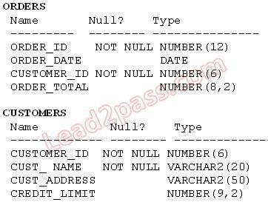

**QUESTION 58**

View the Exhibit and examine the structure of the ORDERS and CUSTOMERS tables. Evaluate the following SQL command:

SELECT o.order_id, c.cust_name, o.order_total, c.credit_limit FROM orders o JOIN customers c

USING (customer_id) WHERE o.order_total > c.credit_limit  
FOR UPDATE --setzt Record Locks  
ORDER BY o.order_id;

Which two statements are true regarding the outcome of the above query? (Choose two.)

1. It locks all the rows that satisfy the condition in the statement.
2. It locks only the columns that satisfy the condition in both the tables.
3. The locks are released only when a COMMIT or ROLLBACK is issued.
4. The locks are released after a DML statement is executed on the locked rows.

**Correct Answer:** AC

**Section: (none) Explanation: FOR UPDATE sperrt alle Zeilen, die die Bedingung erfüllen**

**QUESTION 59**

Which statements are true regarding the FOR UPDATE clause in a SELECT statement? (Choose all that apply.)

1. It locks only the columns specified in the SELECT list.
2. It locks the rows that satisfy the condition in the SELECT statement.
3. It can be used only in SELECT statements that are based on a single table.
4. It can be used in SELECT statements that are based on a single or multiple tables.
5. After it is enforced by a SELECT statement, no other query can access the same rows until a COMMIT or ROLLBACK is issued.

**Correct Answer:** BD

**Section: (none) Explanation**

**QUESTION 60**

View the Exhibit and examine the structure of the CUSTOMERS table. NEW_CUSTOMERS is a new table with the columns CUST_ID, CUST_NAME and CUST_CITY that have the same data types and size as the corresponding columns in the CUSTOMERS table. Evaluate the following INSERT statement:

INSERT INTO new_customers (cust_id, cust_name, cust_city) VALUES(SELECT cust_id,cust_first_name||' '||cust_last_name,cust_city FROM customers WHERE cust_id > 23004);

The INSERT statement fails when executed. What could be the reason?

1. The VALUES clause cannot be used in an INSERT with a subquery.
2. Column names in the NEW_CUSTOMERS and CUSTOMERS tables do not match.
3. The WHERE clause cannot be used in a subquery embedded in an INSERT statement.
4. The total number of columns in the NEW_CUSTOMERS table does not match the total number ofcolumns in the CUSTOMERS table.

**Correct Answer:** A

**Section: (none) Explanation**

**QUESTION 61**

View the Exhibit and examine the structure of ORDERS and CUSTOMERS tables. There is only one customer with the cust_last_name column having value Roberts. Which INSERT statement should be used to add a row into the ORDERS table for the customer whose CUST_LAST_NAME is Roberts and CREDIT_LIMIT is 600?

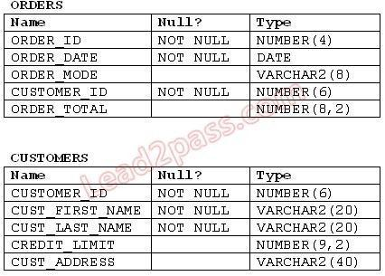

1. INSERT INTO orders

VALUES (1,'10-mar-2007', 'direct',

(SELECT customer_id

FROM customers

WHERE cust_last_name='Roberts' AND credit_limit=600), 1000);

1. INSERT INTO orders (order_id,order_date,order_mode, (SELECT customer_id

FROM customers WHERE cust_last_name='Roberts' AND credit_limit=600),order_total)

VALUES(1,'10-mar-2007', 'direct', &&customer_id, 1000);

1. INSERT INTO(SELECT o.order_id, o.order_date,o.order_mode,c.customer_id, o.order_total FROMorders o, customers c WHERE o.customer_id = c.customer_id AND c.cust_last_name='Roberts' ANDc.credit_limit=600 ) VALUES (1,'10-mar-2007', 'direct',(SELECT customer_id ROM customers WHERE cust_last_name='Roberts' AND credit_limit=600), 1000);
2. INSERT INTO orders (order_id,order_date,order_mode,

(SELECT customer_id

FROM customers

WHERE cust_last_name='Roberts' AND credit_limit=600),order_total)

VALUES(1,'10-mar-2007', 'direct', &customer_id, 1000);

**Correct Answer:** A

**Section: (none) Explanation**

**QUESTION 62**

View the Exhibit and examine the structure of the PRODUCTS, SALES, and SALE_SUMMARY tables. SALE_VW is a view created using the following command :

SQL>CREATE VIEW sale_vw AS

SELECT prod_id, SUM(quantity_sold) QTY_SOLD FROM sales GROUP BY prod_id;

You issue the following command to add a row to the SALE_SUMMARY table :

SQL>INSERT INTO sale_summary

SELECT prod_id, prod_name, qty_sold FROM sale_vw JOIN products

USING (prod_id) WHERE prod_id = 16;

What is the outcome?

1. It executes successfully.
2. It gives an error because a complex view cannot be used to add data into the SALE_SUMMARY table.C. It gives an error because the column names in the subquery and the SALE_SUMMARY table do not match.

D. It gives an error because the number of columns to be inserted does not match with the number of columns in the SALE_SUMMARY table.

**Correct Answer:** D

**Section: (none) Explanation**

**Explanation/Reference:**

**QUESTION 63**

View the exhibit and examine the description for the SALES and CHANNELS tables. You issued the following SQL statement to insert a row in the SALES table:

INSERT INTO sales VALUES

(23, 2300, SYSDATE, (SELECT channel_id

FROM channels WHERE channel_desc='Direct Sales'), 12, 1, 500);

Which statement is true regarding the execution of the above statement?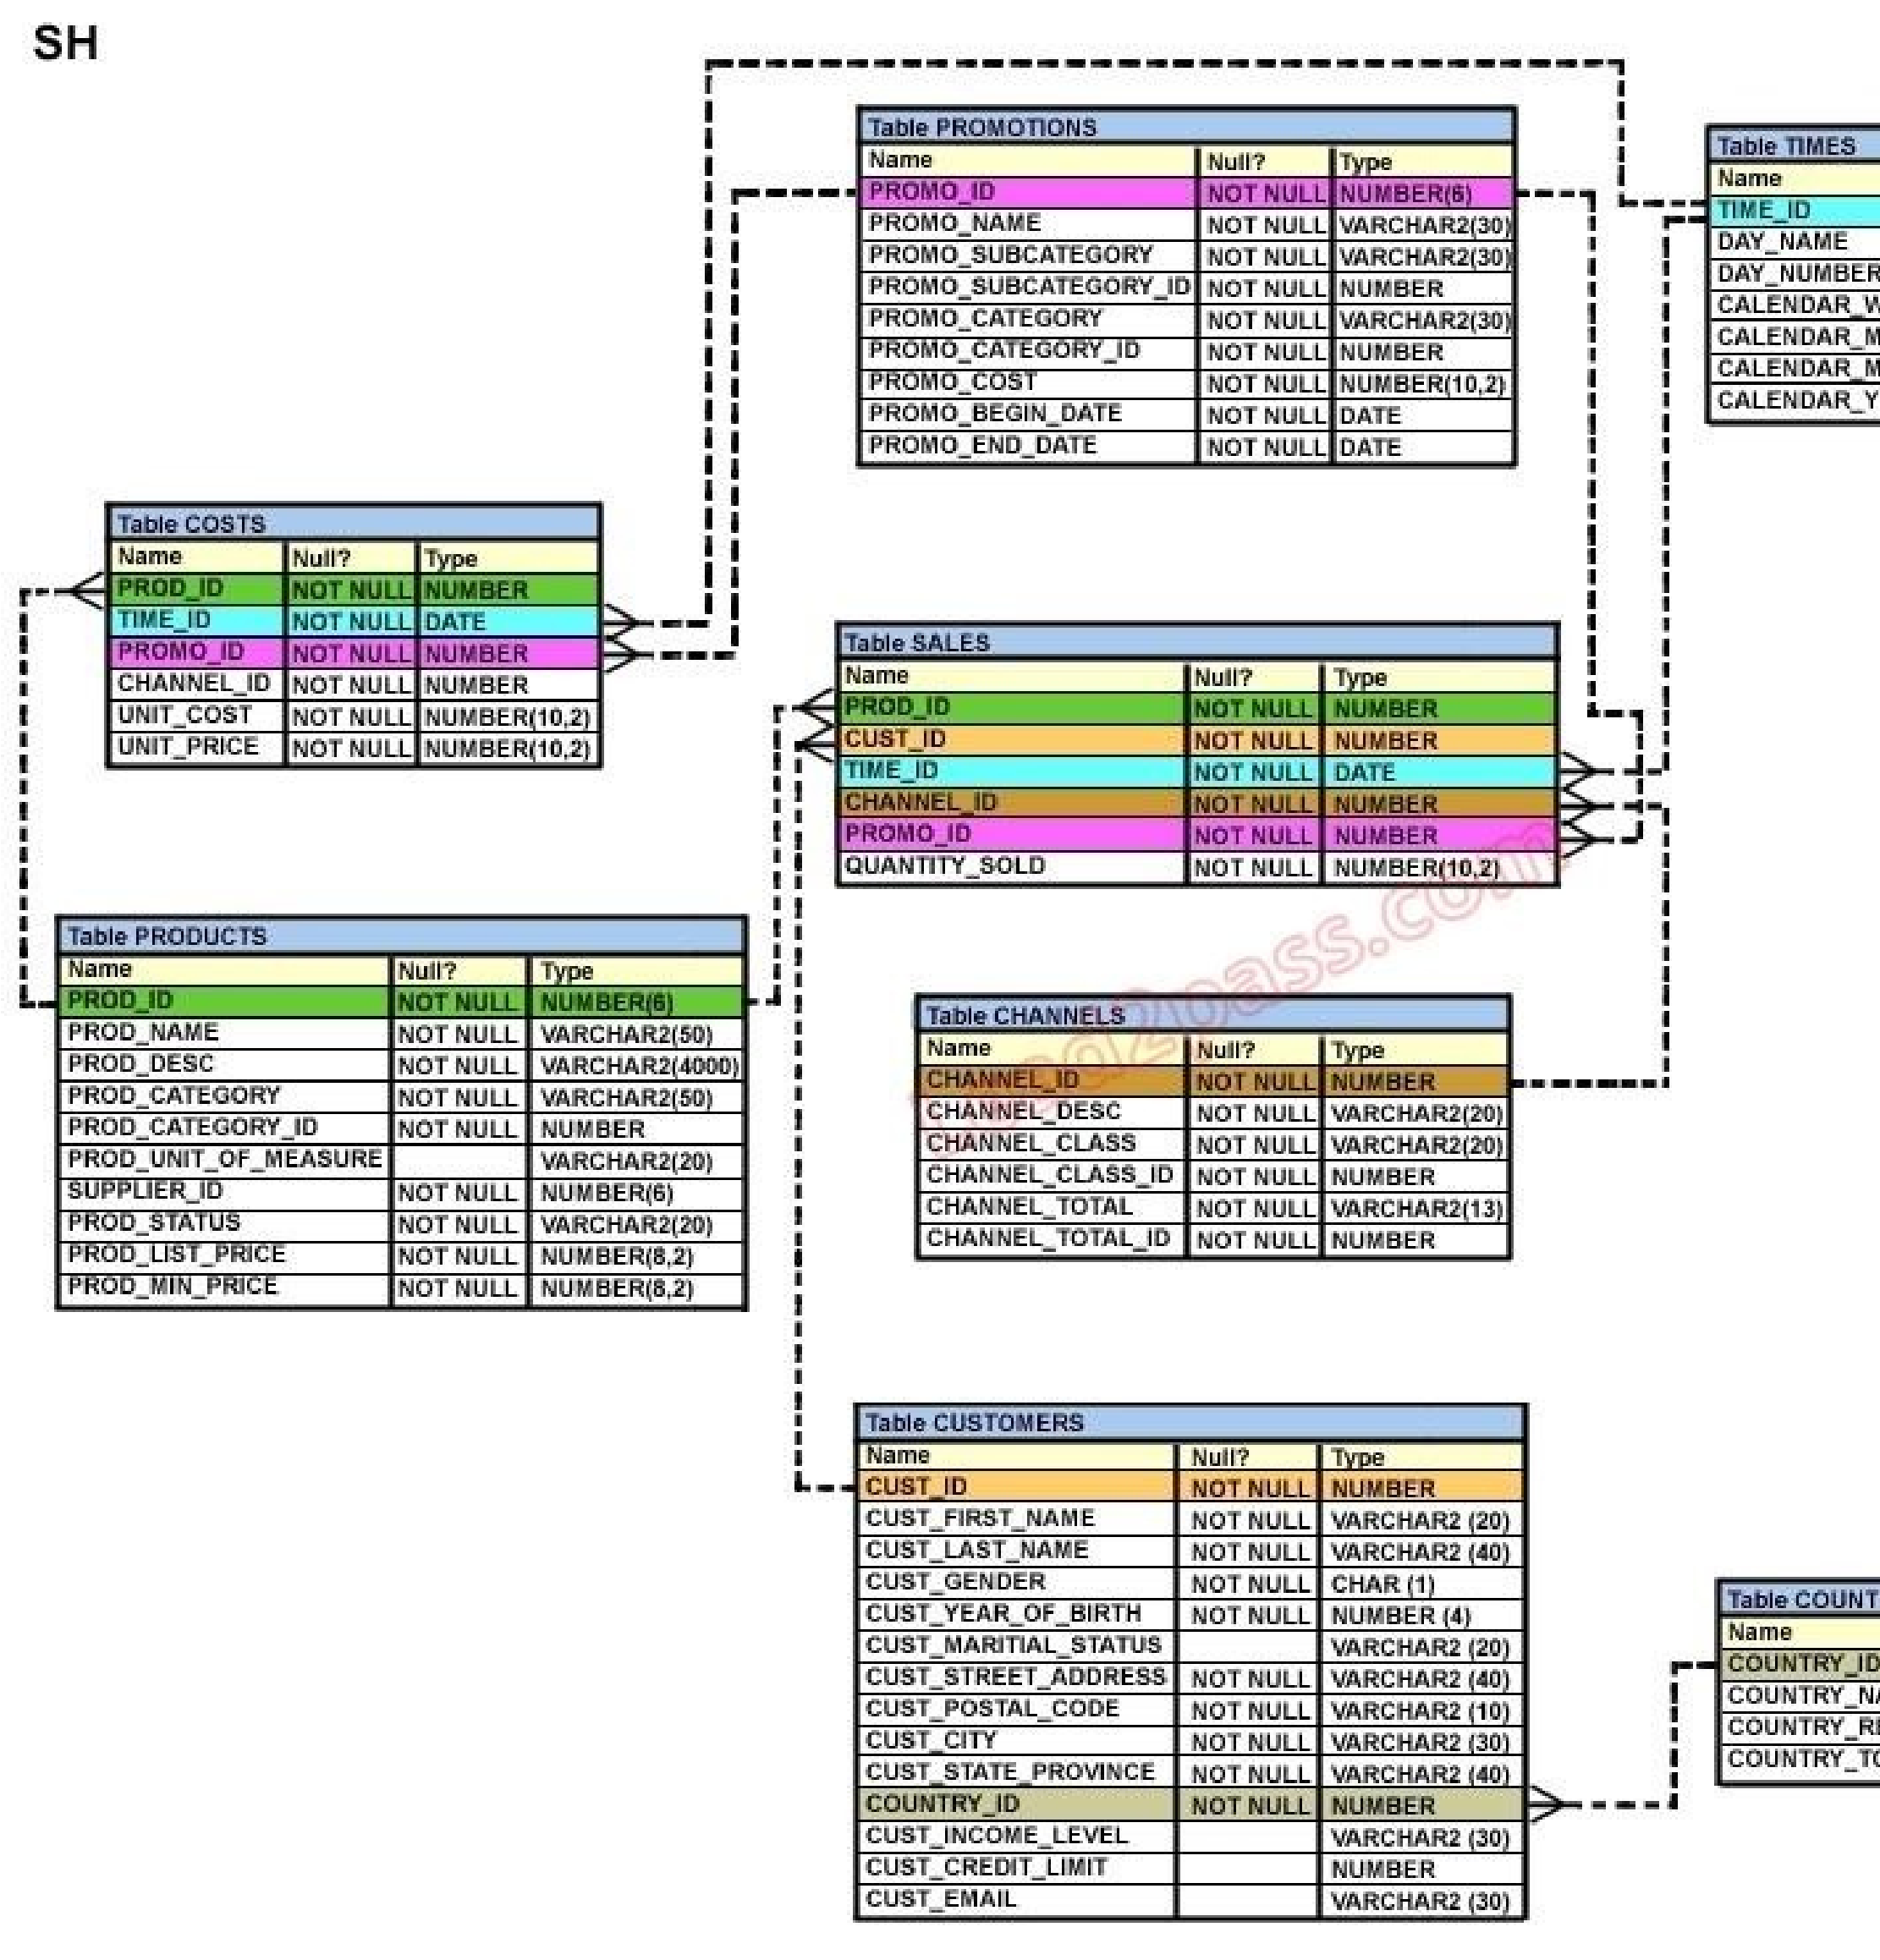

1. The statement will execute and the new row will be inserted in the SALES table.
2. The statement will fail because subquery cannot be used in the VALUES clause.
3. The statement will fail because the VALUES clause is not required with subquery.
4. The statement will fail because subquery in the VALUES clause is not enclosed with in single quotationmarks .

**Correct Answer:** A

**Section: (none) Explanation**

**QUESTION 64**

View the Exhibit and examine the description for the CUSTOMERS table. You want to update the CUST_CREDIT_LIMIT column to NULL for all the customers, where CUST_INCOME_LEVEL has NULL in the CUSTOMERS table.

Which SQL statement will accomplish the task?



1. UPDATE customers

SET cust_credit_limit = NULL

WHERE CUST_INCOME_LEVEL = NULL;

1. UPDATE customers

SET cust_credit_limit = NULL

WHERE cust_income_level IS NULL;

1. UPDATE customers

SET cust_credit_limit = TO_NUMBER(NULL)

WHERE cust_income_level = TO_NUMBER(NULL);

1. UPDATE customers

SET cust_credit_limit = TO_NUMBER(' ',9999)

WHERE cust_income_level IS NULL;

**Correct Answer:** B

**Section: (none) Explanation**

**QUESTION 65**

View the Exhibit and examine the description for the CUSTOMERS table. You want to update the

CUST_INCOME_LEVEL and CUST_CREDIT_LIMIT columns for the customer with the CUST_ID 2360.

You want the value for the CUST_INCOME_LEVEL to have the same value as that of the customer with the CUST_ID 2560 and the CUST_CREDIT_LIMIT to have the same value as that of the customer with CUST_ID 2566.

Which UPDATE statement will accomplish the task?



1. UPDATE customers

SET cust_income_level = (SELECT cust_income_level

FROM customers

WHERE cust_id = 2560),

cust_credit_limit = (SELECT cust_credit_limit

FROM customers

WHERE cust_id = 2566)

WHERE cust_id=2360;

1. UPDATE customers

SET (cust_income_level,cust_credit_limit) = (SELECT cust_income_level, cust_credit_limit

FROM customers

WHERE cust_id=2560 OR cust_id=2566)

WHERE cust_id=2360;

1. UPDATE customers

SET (cust_income_level,cust_credit_limit) = (SELECT cust_income_level, cust_credit_limit

FROM customers

WHERE cust_id IN(2560, 2566)

WHERE cust_id=2360;

1. UPDATE customers

SET (cust_income_level,cust_credit_limit) = (SELECT cust_income_level, cust_credit_limit

FROM customers

WHERE cust_id=2560 AND cust_id=2566)

WHERE cust_id=2360;

**Correct Answer:** A

**Section: (none) Explanation**

**QUESTION 66**

View the Exhibit and examine the structures of the EMPLOYEES and DEPARTMENTS tables. You want to update the EMPLOYEES table as follows:4 ? 4;

-Update only those employees who work in Boston or Seattle (locations 2900 and 2700). -Set department_id for these employees to the department_id corresponding to London (location_id 2100). -Set the employees' salary in location_id 2100 to 1.1 times the average salary of their department. -Set the employees' commission in location_id 2100 to 1.5 times the average commission of their department.

You issue the following command:

SQL>UPDATE employees

SET department_id =

(SELECT department_id

FROM departments

WHERE location_id = 2100),

(salary, commission) =

(SELECT 1.1*AVG(salary), 1.5*AVG(commission)

FROM employees, departments

WHERE departments.location_id IN(2900,2700,2100))

WHERE department_id IN

(SELECT department_id FROM departments

WHERE location_id = 2900 OR location_id = 2700)

What is the outcome?

1. It executes successfully and gives the correct result.
2. It executes successfully but does not give the correct result.
3. It generates an error because a subquery cannot have a join condition in an UPDATE statement.
4. It generates an error because multiple columns (SALARY, COMMISION) cannot be specified togetherin an UPDATE statement.

**Correct Answer:** B

**Section: (none) Explanation**

**QUESTION 67** Evaluate the following DELETE statement:

DELETE FROM sales;

There are no other uncommitted transactions on the SALES table. Which statement is true about the DELETE statement?

1. It would not remove the rows if the table has a primary key.
2. It removes all the rows as well as the structure of the table.
3. It removes all the rows in the table and deleted rows can be rolled back.
4. It removes all the rows in the table and deleted rows cannot be rolled back.

**Correct Answer:** C

**Section: (none) Explanation**

**QUESTION 68**

Which two statements are true regarding the DELETE and TRUNCATE commands? (Choose two.)

1. DELETE can be used to remove only rows from only one table at a time.
2. DELETE can be used to remove only rows from multiple tables at a time.
3. DELETE can be used only on a table that is a parent of a referential integrity constraint.
4. DELETE can be used to remove data from specific columns as well as complete rows.
5. DELETE and TRUNCATE can be used on a table that is a parent of a referential integrity constrainthaving ON DELETE rule .

**Correct Answer:** AE

**Section: (none)**

**Explanation**

**QUESTION 69**

View the Exhibit and examine the structure of CUSTOMERS and SALES tables. Evaluate the following SQL statement:

UPDATE (SELECT prod_id, cust_id, quantity_sold, time_id FROM sales)

SET time_id = '22-MAR-2007'

WHERE cust_id = (SELECT cust_id

FROM customers WHERE cust_last_name = 'Roberts' AND credit_limit = 600);

Which statement is true regarding the execution of the above UPDATE statement?

1. It would not execute because two tables cannot be used in a single UPDATE statement.
2. It would not execute because the SELECT statement cannot be used in place of the table name.
3. It would execute and restrict modifications to only the columns specified in the SELECT statement.D. It would not execute because a subquery cannot be used in the WHERE clause of an UPDATE statement.

**Correct Answer:** C

**Section: (none) Explanation**

**QUESTION 70**

Which three statements/commands would cause a transaction to end? (Choose three.)

1. COMMIT
2. SELECT
3. CREATE
4. ROLLBACK
5. SAVEPOINT

**Correct Answer:** ACD

**Section: (none) Explanation**

**Explanation/Reference:**

**QUESTION 71**

View the Exhibit and examine the description of SALES and PROMOTIONS tables. You want to delete rows from the SALES table, where the PROMO_NAME column in the PROMOTIONS table has either blowout sale or everyday low price as values. Which DELETE statements are valid? (Choose all that apply.)

1. DELETE

FROM sales

WHERE promo_id = (SELECT promo_id

FROM promotions

WHERE promo_name = 'blowout sale')

AND promo_id = (SELECT promo_id

FROM promotions

WHERE promo_name = 'everyday low price');

1. DELETE

FROM sales

WHERE promo_id = (SELECT promo_id

FROM promotions

WHERE promo_name = 'blowout sale')

OR promo_id = (SELECT promo_id FROM promotions

WHERE promo_name = 'everyday low price');

1. DELETE

FROM sales

WHERE promo_id IN (SELECT promo_id

FROM promotions

WHERE promo_name = 'blowout sale'

OR promo_name = 'everyday low price');

1. D DELETE

FROM sales

WHERE promo_id IN (SELECT promo_id

FROM promotions

WHERE promo_name IN ('blowout sale','everyday low price'));

**Correct Answer:** BCD

**Section: (none) Explanation**

**QUESTION 72**

View the Exhibit and examine the description for the PRODUCTS and SALES table. PROD_ID is a primary key in the PRODUCTS table and foreign key in the SALES table. You want to remove all the rows from the PRODUCTS table for which no sale was done for the last three years. Which is the valid DELETE statement?

1. DELETE

FROM products

WHERE prod_id = (SELECT prod_id

FROM sales

WHERE time_id - 3*365 = SYSDATE );

1. DELETE

FROM products

WHERE prod_id = (SELECT prod_id

FROM sales

WHERE SYSDATE >= time_id - 3*365 );

1. DELETE

FROM products

WHERE prod_id IN (SELECT prod_id FROM sales

WHERE SYSDATE - 3*365 >= time_id);

1. DELETE

FROM products

WHERE prod_id IN (SELECT prod_id

FROM sales

WHERE time_id >= SYSDATE - 3*365 );

**Correct Answer:** C

**Section: (none) Explanation**

**QUESTION 73**

View the Exhibit and examine the structure and data in the INVOICE table.

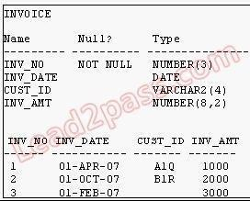

Which two SQL statements would execute successfully? (Choose two.)

1. SELECT AVG(inv_date )FROM invoice;
2. SELECT MAX(inv_date),MIN(cust_id)FROM invoice;
3. SELECT MAX(AVG(SYSDATE - inv_date))FROM invoice;
4. SELECT AVG( inv_date - SYSDATE), AVG(inv_amt)FROM invoice;

**Correct Answer:** BD

**Section: (none) Explanation**

**QUESTION 74** Which two statements are true regarding the COUNT function? (Choose two.)

1. The COUNT function can be used only for CHAR, VARCHAR2, and NUMBER data types.
2. COUNT(*) returns the number of rows including duplicate rows and rows containing NULL value in anyof the columns.
3. COUNT(cust_id) returns the number of rows including rows with duplicate customer IDs and NULLvalue in the CUST_ID column.
4. COUNT(DISTINCT inv_amt)returns the number of rows excluding rows containing duplicates and NULL

values in the INV_AMT column.

1. A SELECT statement using the COUNT function with a DISTINCT keyword cannot have a WHEREclause.

**Correct Answer:** BD

**Section: (none) Explanation**

**QUESTION 75**

View the Exhibit and examine the structure of the CUSTOMERS table. Using the CUSTOMERS table, you need to generate a report that shows the average credit limit for customers in WASHINGTON and NEW YORK.

Which SQL statement would produce the required result?

1. SELECT cust_city, AVG(cust_credit_limit)

FROM customers

WHERE cust_city IN ('WASHINGTON','NEW YORK')

GROUP BY cust_credit_limit, cust_city;

1. SELECT cust_city, AVG(cust_credit_limit)

FROM customers

WHERE cust_city IN ('WASHINGTON','NEW YORK')

GROUP BY cust_city,cust_credit_limit;

1. SELECT cust_city, AVG(cust_credit_limit)

FROM customers

WHERE cust_city IN ('WASHINGTON','NEW YORK') GROUP BY cust_city;

1. SELECT cust_city, AVG(NVL(cust_credit_limit,0))

FROM customers

WHERE cust_city IN ('WASHINGTON','NEW YORK');

**Correct Answer:** C

**Section: (none) Explanation**

**QUESTION 76** Examine the structure of the MARKS table:

name Null Type

--------------- ------------ -----------------

STUDENT_ID NOT NULL VARCHAR2(4)

STUDENT_NAME VARCHAR2(25)

SUBJECT1 NUMBER(3)

SUBJECT2 NUMBER(3)

SUBJECT3 NUMBER(3)

Which two statements would execute successfully? (Choose two.)

1. SELECT student_name,subject1 FROM marks WHERE subject1 > AVG(subject1);
2. SELECT student_name,SUM(subject1) FROM marks WHERE student_name LIKE 'R%';
3. SELECT SUM(subject1+subject2+subject3) FROM marks WHERE student_name IS NULL;
4. SELECT SUM(DISTINCT NVL(subject1,0)), MAX(subject1) FROM marks   
   WHERE subject1 > subject2;

**Correct Answer:** CD

**Section: (none) Explanation**

**QUESTION 77**

View the Exhibit and examine the structure of the CUSTOMERS table. Which statement would display the highest credit limit available in each income level in each city in the CUSTOMERS table?

1. SELECT cust_city, cust_income_level, MAX(cust_credit_limit ) FROM customers GROUP BY cust_city,cust_income_level, cust_credit_limit;
2. SELECT cust_city, cust_income_level, MAX(cust_credit_limit) FROM customers GROUP BY cust_city,cust_income_level;
3. SELECT cust_city, cust_income_level, MAX(cust_credit_limit) FROM customers GROUP BYcust_credit_limit, cust_income_level, cust_city ;
4. SELECT cust_city, cust_income_level, MAX(cust_credit_limit) FROM customers GROUP BY cust_city,cust_income_level, MAX(cust_credit_limit);

**Correct Answer:** B

**Section: (none) Explanation**

**Explanation/Reference:**

**QUESTION 78**

View the Exhibit and examine the structure of the PROMOTIONS table. Evaluate the following SQL statement:

SQL>SELECT promo_category, AVG(promo_cost) Avg_Cost,

AVG(promo_cost)*.25 Avg_Overhead

FROM promotions

WHERE UPPER(promo_category) IN ('TV', 'INTERNET','POST') GROUP BY Avg_Cost ORDER BY Avg_Overhead;

The above query generates an error on execution.

Which clause in the above SQL statement causes the error?

1. WHERE
2. SELECT
3. GROUP BY
4. ORDER BY

**Correct Answer:** C

**Section: (none) Explanation**

**QUESTION 79** Examine the structure of the ORDERS table:

Name Null Type

--------- ---------- --------------------

ORDER_ID NOT NULL NUMBER(12)

ORDER_DATE NOT NULL TIMESTAMP(6)

CUSTOMER_ID NOT NULL NUMBER(6)

ORDER_STATUS NUMBER(2)

ORDER_TOTAL NUMBER(8,2)

You want to find the total value of all the orders for each year and issue the following command:

SQL>SELECT TO_CHAR(order_date,'rr'), SUM(order_total)

FROM orders

GROUP BY TO_CHAR(order_date,'yyyy');

Which statement is true regarding the outcome?

1. It executes successfully and gives the correct output.
2. It gives an error because the TO_CHAR function is not valid.
3. It executes successfully but does not give the correct output.
4. It gives an error because the data type conversion in the SELECT list does not match the data type conversion in the GROUP BY clause.

**Correct Answer:** D

**Section: (none) Explanation**

**QUESTION 80**

View the Exhibit and examine the structure of the SALES table. The following query is written to retrieve all those product ID s from the SALES table that have more than 55000 sold and have been ordered more than 10 times.

SQL> SELECT prod_id

FROM sales

WHERE quantity_sold > 55000 AND COUNT(*)>10

GROUP BY prod_id

HAVING COUNT(*)>10;

Which statement is true regarding this SQL statement?

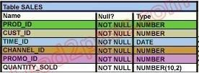

1. It executes successfully and generates the required result.
2. It produces an error because COUNT(*) should be specified in the SELECT clause also.
3. It produces an error because COUNT(*) should be only in the HAVING clause and not in the WHEREclause.
4. It executes successfully but produces no result because COUNT(prod_id) should be used instead ofCOUNT(*).

**Correct Answer:** C

**Section: (none) Explanation**

**QUESTION 81** You issue the following query:

SQL> SELECT AVG(MAX(qty))

FROM ord_items

GROUP BY item_no

HAVING AVG(MAX(qty))>50;

Which statement is true regarding the outcome of this query?

1. It executes successfully and gives the correct output.
2. It gives an error because the HAVING clause is not valid.
3. It executes successfully but does not give the correct output.
4. It gives an error because the GROUP BY expression is not valid.

**Correct Answer:** B

**Section: (none) Explanation**

**QUESTION 82**

View the Exhibit and examine the structure of the CUSTOMERS table. Evaluate the following SQL statement:

SQL> SELECT cust_city, COUNT(cust_last_name)

FROM customers

WHERE cust_credit_limit > 1000

GROUP BY cust_city

HAVING AVG(cust_credit_limit) BETWEEN 5000 AND 6000; Which statement is true regarding the outcome of the above query?



1. It executes successfully.
2. It returns an error because the BETWEEN operator cannot be used in the HAVING clause.
3. It returns an error because WHERE and HAVING clauses cannot be used in the same SELECTstatement.
4. It returns an error because WHERE and HAVING clauses cannot be used to apply conditions on thesame column.

**Correct Answer:** A

**Section: (none) Explanation**

**QUESTION 83**

Which statements are true regarding the WHERE and HAVING clauses in a SELECT statement? (Choose

all that apply.)

1. The HAVING clause can be used with aggregate functions in subqueries.
2. The WHERE clause can be used to exclude rows after dividing them into groups.
3. The WHERE clause can be used to exclude rows before dividing them into groups.
4. The aggregate functions and columns used in the HAVING clause must be specified in the SELECT listof the query.
5. The WHERE and HAVING clauses can be used in the same statement only if they are applied todifferent columns in the table.

**Correct Answer:** AC

**Section: (none) Explanation**

**Explanation/Reference:**

**QUESTION 84**

View the Exhibit and examine the structure of the PROMOTIONS table.

Examine the following two SQL statements: Statement 1

SQL>SELECT promo_category,SUM(promo_cost)

FROM promotions

WHERE promo_end_date-promo_begin_date > 30

GROUP BY promo_category;

Statement 2

SQL>SELECT promo_category,sum(promo_cost)

FROM promotions

GROUP BY promo_category

HAVING MIN(promo_end_date-promo_begin_date)>30;

Which statement is true regarding the above two SQL statements?



1. statement 1 gives an error, statement 2 executes successfully
2. statement 2 gives an error, statement 1 executes successfully
3. statement 1 and statement 2 execute successfully and give the same output
4. statement 1 and statement 2 execute successfully and give a different output

**Correct Answer:** D

**Section: (none) Explanation**

**QUESTION 85** Examine the data in the ORD_ITEMS table:

ORD_NO ITEM_NO QTY

-------- -------- ---------

1 111 10

1 222 20

1. 333 30
2. 333 30
3. 444 40
4. 111 40

Evaluate the following query:

SQL>SELECT item_no, AVG(qty)

FROM ord_items

HAVING AVG(qty) > MIN(qty) * 2 GROUP BY item_no;

Which statement is true regarding the outcome of the above query?

1. It gives an error because the HAVING clause should be specified after the GROUP BY clause.
2. It gives an error because all the aggregate functions used in the HAVING clause must be specified in

the SELECT list.

1. It displays the item nos with their average quantity where the average quantity is more than double theminimum quantity of that item in the table.
2. It displays the item nos with their average quantity where the average quantity is more than double theoverall minimum quantity of all the items in the table.

**Correct Answer:** C

**Section: (none) Explanation**

**QUESTION 86**

Which CREATE TABLE statement is valid?

A. CREATE TABLE ord_details (ord_no NUMBER(2) PRIMARY KEY, item_no NUMBER(3) PRIMARY KEY, ord_date DATE NOT NULL); B. CREATE TABLE ord_details

(ord_no NUMBER(2) UNIQUE, NOT NULL, item_no NUMBER(3),

ord_date DATE DEFAULT SYSDATE NOT NULL); C. CREATE TABLE ord_details (ord_no NUMBER(2) , item_no NUMBER(3),

ord_date DATE DEFAULT NOT NULL, CONSTRAINT ord_uq UNIQUE (ord_no),

CONSTRAINT ord_pk PRIMARY KEY (ord_no));

D. CREATE TABLE ord_details (ord_no NUMBER(2), item_no NUMBER(3),

ord_date DATE DEFAULT SYSDATE NOT NULL, CONSTRAINT ord_pk PRIMARY KEY (ord_no, item_no));

**Correct Answer:** D

**Section: (none) Explanation**

**QUESTION 87**

You want to create an ORD_DETAIL table to store details for an order placed having the following business requirement:

1. The order ID will be unique and cannot have null values.
2. The order date cannot have null values and the default should be the current date.
3. The order amount should not be less than 50.
4. The order status will have values either shipped or not shipped.
5. The order payment mode should be cheque, credit card, or cash on delivery (COD).

Which is the valid DDL statement for creating the ORD_DETAIL table?

1. CREATE TABLE ord_details

(ord_id NUMBER(2) CONSTRAINT ord_id_nn NOT NULL, ord_date DATE DEFAULT SYSDATE NOT NULL, ord_amount NUMBER(5, 2) CONSTRAINT ord_amount_min CHECK (ord_amount > 50),

ord_status VARCHAR2(15) CONSTRAINT ord_status_chk CHECK (ord_status IN ('Shipped', 'Not Shipped')), ord_pay_mode VARCHAR2(15) CONSTRAINT ord_pay_chk CHECK (ord_pay_mode IN ('Cheque', 'Credit Card',

'Cash On Delivery')));

1. CREATE TABLE ord_details

(ord_id NUMBER(2) CONSTRAINT ord_id_uk UNIQUE NOT NULL, ord_date DATE DEFAULT

SYSDATE NOT NULL,

ord_amount NUMBER(5, 2) CONSTRAINT ord_amount_min CHECK (ord_amount > 50),

ord_status VARCHAR2(15) CONSTRAINT ord_status_chk CHECK (ord_status IN ('Shipped', 'Not Shipped')), ord_pay_mode VARCHAR2(15) CONSTRAINT ord_pay_chk

CHECK (ord_pay_mode IN ('Cheque', 'Credit Card',

'Cash On Delivery')));

1. CREATE TABLE ord_details

(ord_id NUMBER(2) CONSTRAINT ord_id_pk PRIMARY KEY, ord_date DATE DEFAULT SYSDATE NOT NULL, ord_amount NUMBER(5, 2) CONSTRAINT ord_amount_min CHECK (ord_amount >= 50),

ord_status VARCHAR2(15) CONSTRAINT ord_status_chk CHECK (ord_status IN ('Shipped', 'Not Shipped')), ord_pay_mode VARCHAR2(15) CONSTRAINT ord_pay_chk

CHECK (ord_pay_mode IN ('Cheque', 'Credit Card',

'Cash On Delivery')));

1. CREATE TABLE ord_details(ord_id NUMBER(2),

ord_date DATE NOT NULL DEFAULT SYSDATE, ord_amount NUMBER(5, 2) CONSTRAINT ord_amount_min CHECK (ord_amount >= 50),

ord_status VARCHAR2(15) CONSTRAINT ord_status_chk CHECK (ord_status IN ('Shipped', 'Not Shipped')), ord_pay_mode VARCHAR2(15) CONSTRAINT ord_pay_chk

CHECK (ord_pay_mode IN ('Cheque', 'Credit Card',

'Cash On Delivery')));

**Correct Answer:** C

**Section: (none) Explanation**

**QUESTION 88** You created an ORDERS table with the following description:

name Null Type

ORD_ID NOT NULL NUMBER(2)

CUST_ID NOT NULL NUMBER(3)

ORD_DATE NOT NULL DATE

ORD_AMOUNT NOT NULL NUMBER (10,2)

You inserted some rows in the table. After some time, you want to alter the table by creating the PRIMARY KEY constraint on the ORD_ID column. Which statement is true in this scenario?

1. You cannot have two constraints on one column.
2. You cannot add a primary key constraint if data exists in the column.
3. The primary key constraint can be created only at the time of table creation .
4. You can add the primary key constraint even if data exists, provided that there are no duplicate values.

**Correct Answer:** D

**Section: (none)**

**Explanation**

**QUESTION 89** Which two statements are true regarding constraints? (Choose two.)

1. A table can have only one primary key and one foreign key.
2. A table can have only one primary key but multiple foreign keys.
3. Only the primary key can be defined at the column and table levels.
4. The foreign key and parent table primary key must have the same name.
5. Both primary key and foreign key constraints can be defined at both column and table levels.

**Correct Answer:** BE

**Section: (none) Explanation**

**QUESTION 90**

Examine the following SQL commands:

SQL>CREATE TABLE products (

prod_id NUMBER(3) CONSTRAINT p_ck CHECK (prod_id > 0), prod_name CHAR(30), prod_qty NUMBER(6),

CONSTRAINT p_name NOT NULL,

CONSTRAINT prod_pk PRIMARY KEY (prod_id));

SQL>CREATE TABLE warehouse ( warehouse_id NUMBER(4),

roomno NUMBER(10) CONSTRAINT r_id CHECK(roomno BETWEEN 101 AND 200), location VARCHAR2(25), prod_id NUMBER(3),

CONSTRAINT wr_pr_pk PRIMARY KEY (warehouse_id,prod_id), CONSTRAINT prod_fk FOREIGN KEY (prod_id) REFERENCES products(prod_id));

Which statement is true regarding the execution of the above SQL commands?

1. Both commands execute successfully.
2. The first CREATE TABLE command generates an error because the NULL constraint is not valid.
3. The second CREATE TABLE command generates an error because the CHECK constraint is not valid.D. The first CREATE TABLE command generates an error because CHECK and PRIMARY KEY constraints cannot be used for the same column.

E. The first CREATE TABLE command generates an error because the column PROD_ID cannot be used in the PRIMARY KEY and FOREIGN KEY constraints.

**Correct Answer:** B

**Section: (none) Explanation**

**Explanation/Reference:**

**QUESTION 91**

You issued the following command to drop the PRODUCTS table:

SQL> DROP TABLE products;

What is the implication of this command? (Choose all that apply.)

1. All data along with the table structure is deleted.
2. The pending transaction in the session is committed.
3. All indexes on the table will remain but they are invalidated.
4. All views and synonyms will remain but they are invalidated.
5. All data in the table are deleted but the table structure will remain.

**Correct Answer:** ABD

**Section: (none) Explanation**

**QUESTION 92** Which two statements are true regarding views? (Choose two.)

1. A simple view in which column aliases have been used cannot be updated.
2. Rows cannot be deleted through a view if the view definition contains the DISTINCT keyword.
3. Rows added through a view are deleted from the table automatically when the view is dropped.
4. The OR REPLACE option is used to change the definition of an existing view without dropping and re-creating it.
5. The WITH CHECK OPTION constraint can be used in a view definition to restrict the columns displayedthrough the view.

**Correct Answer:** BD

**Section: (none) Explanation**

**QUESTION 93** Evaluate the following command:

CREATE TABLE employees

(employee_id NUMBER(2) PRIMARY KEY, last_name VARCHAR2(25) NOT NULL, department_id NUMBER(2)NOT NULL, job_id VARCHAR2(8), salary NUMBER(10,2));

You issue the following command to create a view that displays the IDs and last names of the sales staff in the organization:

CREATE OR REPLACE VIEW sales_staff_vu

SELECT employee_id, last_name,job_id

FROM employees

WHERE job_id LIKE 'SA_%'

WITH CHECK OPTION;

Which two statements are true regarding the above view? (Choose two.)

1. It allows you to insert rows into the EMPLOYEES table .
2. It allows you to delete details of the existing sales staff from the EMPLOYEES table.
3. It allows you to update job IDs of the existing sales staff to any other job ID in the EMPLOYEES table. 56
4. It allows you to insert IDs, last names, and job IDs of the sales staff from the view if it is used inmultitable INSERT statements.

**Correct Answer:** BD

**Section: (none) Explanation**

**QUESTION 94**

View the Exhibit to examine the description for the SALES and PRODUCTS tables. You want to create a SALE_PROD view by executing the following SQL statement:

CREATE VIEW sale_prod

AS SELECT p.prod_id, cust_id, SUM(quantity_sold) "Quantity" , SUM(prod_list_price) "Price"

FROM products p, sales s

WHERE p.prod_id=s.prod_id

GROUP BY p.prod_id, cust_id;

Which statement is true regarding the execution of the above statement?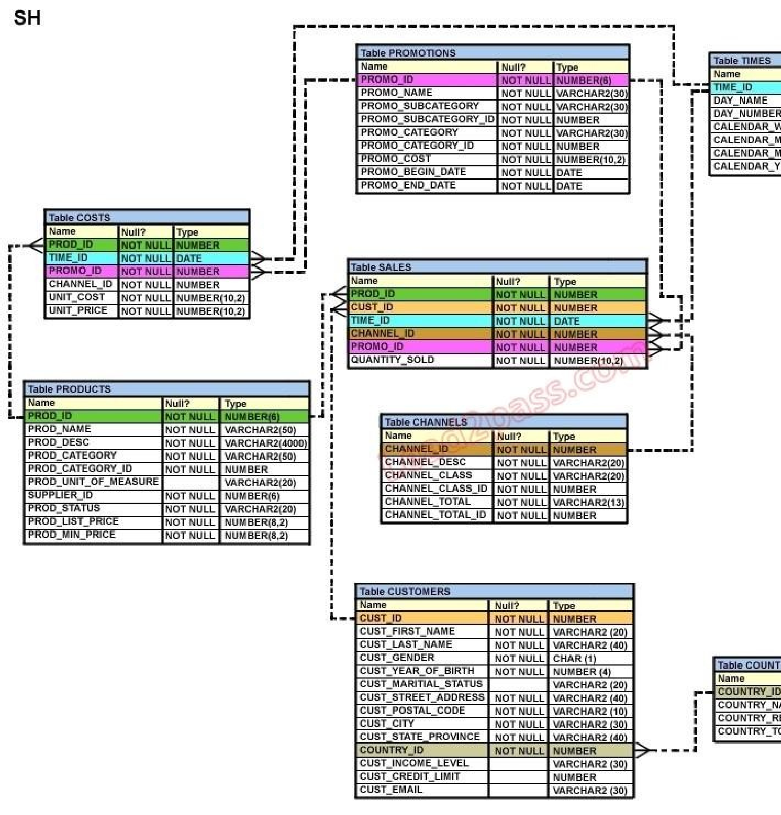

1. The view will be created and you can perform DML operations on the view.
2. The view will be created but no DML operations will be allowed on the view.
3. The view will not be created because the join statements are not allowed for creating a view.
4. The view will not be created because the GROUP BY clause is not allowed for creating a view. 57

**Correct Answer:** B

**Section: (none) Explanation**

**QUESTION 95** Which two statements are true regarding views? (Choose two.)

1. A subquery that defines a view cannot include the GROUP BY clause.
2. A view that is created with the subquery having the DISTINCT keyword can be updated.
3. A view that is created with the subquery having the pseudo column ROWNUM keyword cannot beupdated.
4. A data manipulation language ( DML) operation can be performed on a view that is created with thesubquery having all the NOT NULL columns of a table.

**Correct Answer:** CD

**Section: (none) Explanation**

**QUESTION 96** Which three statements are true regarding views? (Choose three.)

1. Views can be created only from tables.
2. Views can be created from tables or other views.
3. Only simple views can use indexes existing on the underlying tables.
4. Both simple and complex views can use indexes existing on the underlying tables.
5. Complex views can be created only on multiple tables that exist in the same schema.
6. Complex views can be created on multiple tables that exist in the same or different schemas.

**Correct Answer:** BDF

**Section: (none) Explanation**

**QUESTION 97**

Evaluate the following CREATE SEQUENCE statement:

CREATE SEQUENCE seq1

START WITH 100

INCREMENT BY 10

MAXVALUE 200

CYCLE

NOCACHE;

The SEQ1 sequence has generated numbers up to the maximum limit of 200. You issue the following SQL statement:

SELECT seq1.nextval FROM dual;

What is displayed by the SELECT statement?

1. 1
2. 10
3. 100
4. an error

**Correct Answer:** A

**Section: (none) Explanation**

**Explanation/Reference:**

**QUESTION 98**

View the Exhibit and examine the structure of the ORD table. Evaluate the following SQL statements that are executed in a user session in the specified order:

CREATE SEQUENCE ord_seq;

SELECT ord_seq.nextval

FROM dual;

INSERT INTO ord

VALUES (ord_seq.CURRVAL, '25-jan-2007',101);

UPDATE ord

SET ord_no= ord_seq.NEXTVAL WHERE cust_id =101;

What would be the outcome of the above statements?

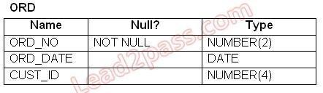

1. All the statements would execute successfully and the ORD_NO column would contain the value 2 forthe CUST_ID 101.
2. The CREATE SEQUENCE command would not execute because the minimum value and maximumvalue for the sequence have not been specified.
3. The CREATE SEQUENCE command would not execute because the starting value of the sequenceand the increment value have not been specified.
4. All the statements would execute successfully and the ORD_NO column would have the value 20 forthe CUST_ID 101 because the default CACHE value is 20.

**Correct Answer:** A

**Section: (none) Explanation**

**QUESTION 99**

When executing a SQL workload, you choose to generate execution plans only, without collecting execution statistics. Which two statements describe the implications of this? (Choose two.)

1. It produces less accurate results of the comparison analysis.
2. It automatically calls the SQL Tuning Advisor for recommendations.
3. It shortens the time of execution and reduces the impact on system resources.
4. Only the changes in the execution plan, and not performance regression, are detected.

**Correct Answer:** AC

**Section: (none)**

**Explanation**

**QUESTION 100** Which statements are correct regarding indexes? (Choose all that apply.)

1. When a table is dropped, the corresponding indexes are automatically dropped.
2. A FOREIGN KEY constraint on a column in a table automatically creates a nonunique index.
3. A nondeferrable PRIMARY KEY or UNIQUE KEY constraint in a table automatically creates a uniqueindex.

59

1. For each data manipulation language (DML) operation performed, the corresponding indexes areautomatically updated.

**Correct Answer:** ACD

**Section: (none) Explanation**

**QUESTION 101**

View the Exhibit and examine the structure of ORD and ORD_ITEMS tables. The ORD_NO column is PRIMARY KEY in the ORD table and the ORD_NO and ITEM_NO columns are composite PRIMARY KEY in the ORD_ITEMS table. Which two CREATE INDEX statements are valid? (Choose two.)

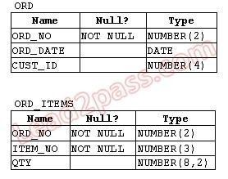

1. CREATE INDEX ord_idx1ON ord(ord_no);
2. CREATE INDEX ord_idx2ON ord_items(ord_no);
3. CREATE INDEX ord_idx3ON ord_items(item_no);
4. CREATE INDEX ord_idx4

ON ord,ord_items(ord_no, ord_date,qty);

**Correct Answer:** BC

**Section: (none) Explanation**

**QUESTION 102** Which two statements are true regarding indexes? (Choose two.)

1. They can be created on tables and clusters.
2. They can be created on tables and simple views.
3. You can create only one index by using the same columns.
4. You can create more than one index by using the same columns if you specify distinctly differentcombinations of the columns.

**Correct Answer:** AD

**Section: (none) Explanation**

**QUESTION 103**

The ORDERS table belongs to the user OE. OE has granted the SELECT privilege on the ORDERS table to the user HR.

60

Which statement would create a synonym ORD so that HR can execute the following query successfully?

SELECT * FROM ord;

1. CREATE SYNONYM ord FOR orders; This command is issued by OE.
2. CREATE PUBLIC SYNONYM ord FOR orders; This command is issued by OE.
3. CREATE SYNONYM ord FOR oe.orders; This command is issued by the database administrator.D. CREATE PUBLIC SYNONYM ord FOR oe.orders; This command is issued by the database administrator.

**Correct Answer:** D

**Section: (none) Explanation**

**QUESTION 104**

SLS is a private synonym for the SH.SALES table. The user SH issues the following command:

DROP SYNONYM sls;

Which statement is true regarding the above SQL statement?

1. Only the synonym would be dropped.
2. The synonym would be dropped and the corresponding table would become invalid.
3. The synonym would be dropped and the packages referring to the synonym would be dropped.
4. The synonym would be dropped and any PUBLIC synonym with the same name becomes invalid.

**Correct Answer:** A

**Section: (none) Explanation**

**QUESTION 105** Which statement is true regarding synonyms?

1. Synonyms can be created only for a table.
2. Synonyms are used to reference only those tables that are owned by another user.
3. A public synonym and a private synonym can exist with the same name for the same table.
4. The DROP SYNONYM statement removes the synonym, and the table on which the synonym has beencreated becomes invalid.

**Correct Answer:** C

**Section: (none) Explanation**

**QUESTION 106**

View the Exhibit and examine the structure of the PRODUCTS table. Using the PRODUCTS table, you issue the following query to generate the names, current list price, and discounted list price for all those products whose list price falls below $10 after a discount of 25% is applied on it.

SQL>SELECT prod_name, prod_list_price,

prod_list_price - (prod_list_price * .25) "DISCOUNTED_PRICE" FROM products WHERE discounted_price < 10;

The query generates an error.

What is the reason for the error?

61



1. The parenthesis should be added to enclose the entire expression.
2. The double quotation marks should be removed from the column alias.
3. The column alias should be replaced with the expression in the WHERE clause.
4. The column alias should be put in uppercase and enclosed with in double quotation marks in theWHERE clause.

**Correct Answer:** C

**Section: (none) Explanation**

**QUESTION 107**

View the Exhibit and examine the data in the PROMOTIONS table. PROMO_BEGIN_DATE is stored in the default date format, dd-mon-rr. You need to produce a report that provides the name, cost, and start date of all promos in the POST category that were launched before January 1, 2000. Which SQL statement would you use?

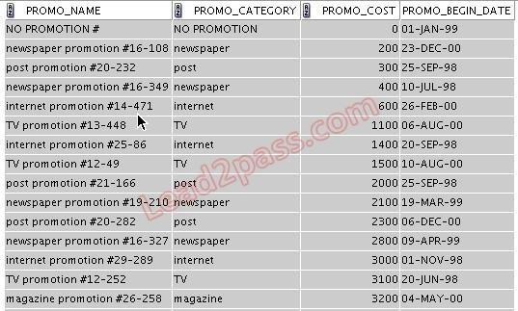

1. SELECT promo_name, promo_cost, promo_begin_date

FROM promotions

WHERE promo_category = 'post' AND promo_begin_date < '01-01-00';

1. SELECT promo_name, promo_cost, promo_begin_date

FROM promotions

62

WHERE promo_cost LIKE 'post%' AND promo_begin_date < '01-01-2000';

1. SELECT promo_name, promo_cost, promo_begin_date

FROM promotions

WHERE promo_category LIKE 'P%' AND promo_begin_date < '1-JANUARY-00';

1. SELECT promo_name, promo_cost, promo_begin_date

FROM promotions

WHERE promo_category LIKE '%post%' AND promo_begin_date < '1-JAN-00';

**Correct Answer:** D

**Section: (none) Explanation**

**QUESTION 108**

View the Exhibit and examine the structure of the CUSTOMERS table. Evaluate the query statement:

SQL> SELECT cust_last_name, cust_city, cust_credit_limit FROM customers

WHERE cust_last_name BETWEEN 'A' AND 'C' AND cust_credit_limit BETWEEN 1000 AND 3000; What would be the outcome of the above statement?



1. It executes successfully.
2. It produces an error because the condition on CUST_LAST_NAME is invalid.
3. It executes successfully only if the CUST_CREDIT_LIMIT column does not contain any null values.D. It produces an error because the AND operator cannot be used to combine multiple BETWEEN clauses.

**Correct Answer:** A

**Section: (none) Explanation**

**QUESTION 109** Evaluate the following two queries:

SQL> SELECT cust_last_name, cust_city

FROM customers

WHERE cust_credit_limit IN (1000, 2000, 3000);

SQL> SELECT cust_last_name, cust_city

FROM customers

WHERE cust_credit_limit = 1000 OR cust_credit_limit = 2000 OR cust_credit_limit = 3000;

63

Which statement is true regarding the above two queries?

1. Performance would improve in query 2.
2. Performance would degrade in query 2.
3. There would be no change in performance.
4. Performance would improve in query 2 only if there are null values in the CUST_CREDIT_LIMITcolumn.

**Correct Answer:** C

**Section: (none) Explanation**

**QUESTION 110**

View the Exhibit and examine the structure of the PROMOTIONS table. Using the PROMOTIONS table, you need to find out the names and cost of all the promos done on 'TV' and 'internet' that ended in the time interval 15th March '00 to 15th October '00. Which two queries would give the required result? (Choose two.)



1. SELECT promo_name, promo_cost

FROM promotions

WHERE promo_category IN ('TV', 'internet') AND promo_end_date BETWEEN '15-MAR-00' AND '15-OCT-00';

1. SELECT promo_name, promo_cost

FROM promotions

WHERE promo_category = 'TV' OR promo_category ='internet' AND promo_end_date >='15-MAR-00' OR promo_end_date <='15-OCT-00';

1. SELECT promo_name, promo_cost

FROM promotions

WHERE (promo_category BETWEEN 'TV' AND 'internet') AND (promo_end_date IN ('15-MAR-00','15OCT-00'));

1. SELECT promo_name, promo_cost

FROM promotions

WHERE (promo_category = 'TV' OR promo_category ='internet') AND (promo_end_date >='15-MAR-

00' AND promo_end_date <='15-OCT-00');

**Correct Answer:** AD

**Section: (none)**

**Explanation**

**QUESTION 111** The CUSTOMERS table has the following structure:

Name Null Type

64

-------------- ----------- ----------- ----------

CUST_ID NOT NULL NUMBER

CUST_FIRST_NAME NOT NULL VARCHAR2(20)

CUST_LAST_NAME NOT NULL VARCHAR2(30)

CUST_INCOME_LEVEL VARCHAR2(30) CUST_CREDIT_LIMIT NUMBER

You need to write a query that does the following tasks:

1. Display the first name and tax amount of the customers. Tax is 5% of their credit limit.
2. Only those customers whose income level has a value should be considered.
3. Customers whose tax amount is null should not be considered.

Which statement accomplishes all the required tasks?

Which statement accomplishes all the required tasks?

1. SELECT cust_first_name, cust_credit_limit * .05 AS TAX_AMOUNT FROM customers WHEREcust_income_level IS NOT NULL AND tax_amount IS NOT NULL;
2. SELECT cust_first_name, cust_credit_limit * .05 AS TAX_AMOUNT FROM customers WHEREcust_income_level IS NOT NULL AND cust_credit_limit IS NOT NULL;
3. SELECT cust_first_name, cust_credit_limit * .05 AS TAX_AMOUNT FROM customers WHEREcust_income_level <> NULL AND tax_amount <> NULL;
4. SELECT cust_first_name, cust_credit_limit * .05 AS TAX_AMOUNT FROM customers WHERE(cust_income_level,tax_amount) IS NOT NULL;

**Correct Answer:** B

**Section: (none) Explanation**

**QUESTION 112** The PART_CODE column in the SPARES table contains the following list of values:

PART_CODE

----------

A%_WQ123

A%BWQ123 AB_WQ123

Evaluate the following query:

SQL> SELECT part_code

FROM spares

WHERE part_code LIKE '%\%_WQ12%' ESCAPE '\';

Which statement is true regarding the outcome of the above query?

1. It produces an error.
2. It displays all values.
3. It displays only the values A%_WQ123 and AB_WQ123 .
4. It displays only the values A%_WQ123 and A%BWQ123 . E. It displays only the values A%BWQ123 and AB_WQ123.

65

**Correct Answer:** D

**Section: (none) Explanation**

**QUESTION 113**

View the Exhibit and examine the data in the PRODUCTS table. You need to display product names from the PRODUCTS table that belong to the 'Software/Other ' category with minimum prices as either $2000 or $4000 and no unit of measure. You issue the following query:

SQL>SELECT prod_name, prod_category, prod_min_price

FROM products

WHERE prod_category LIKE '%Other%' AND (prod_min_price = 2000 OR prod_min_price = 4000) AND prod_unit_of_measure <> '';

Which statement is true regarding the above query?

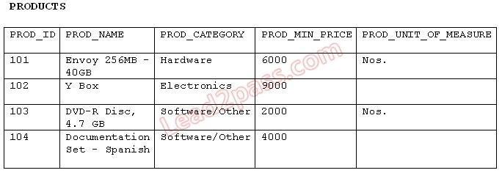

1. It executes successfully but returns no result.
2. It executes successfully and returns the required result.
3. It generates an error because the condition specified for PROD_UNIT_OF_MEASURE is not valid.
4. It generates an error because the condition specified for the PROD_CATEGORY column is not valid.

**Correct Answer:** A

**Section: (none) Explanation**

**QUESTION 114**

View the Exhibit and examine the structure of CUSTOMERS table. Evaluate the following query:

SQL>SELECT cust_id, cust_city

FROM customers

WHERE cust_first_name NOT LIKE 'A_%g_%' AND cust_credit_limit BETWEEN 5000 AND 15000 AND cust_credit_limit NOT IN (7000, 11000) AND cust_city NOT BETWEEN 'A' AND 'B';

Which statement is true regarding the above query?

66



1. It executes successfully.
2. It produces an error because the condition on the CUST_CITY column is not valid.
3. It produces an error because the condition on the CUST_FIRST_NAME column is not valid.
4. It produces an error because conditions on the CUST_CREDIT_LIMIT column are not valid.

**Correct Answer:** A

**Section: (none) Explanation**

**QUESTION 115**

View the Exhibit and examine the structure of the PROMOTIONS table. You need to generate a report of all promos from the PROMOTIONS table based on the following conditions:

1. The promo name should not begin with 'T' or 'N'.
2. The promo should cost more than $20000.
3. The promo should have ended after 1st January 2001.

Which WHERE clause would give the required result?



1. WHERE promo_name NOT LIKE 'T%' OR promo_name NOT LIKE 'N%' AND promo_cost > 20000AND promo_end_date > '1-JAN-01'
2. WHERE (promo_name NOT LIKE 'T%' AND promo_name NOT LIKE 'N%')OR promo_cost > 20000OR promo_end_date > '1-JAN-01'
3. WHERE promo_name NOT LIKE 'T%' AND promo_name NOT LIKE 'N%' AND promo_cost > 20000AND promo_end_date > '1-JAN-01'
4. WHERE (promo_name NOT LIKE '%T%' OR promo_name NOT LIKE '%N%') AND(promo_cost >

20000 AND promo_end_date > '1-JAN-01')

67

**Correct Answer:** C

**Section: (none) Explanation**

**QUESTION 116**

View the E xhibit and examine the structure of the CUSTOMERS table. You want to generate a report showing the last names and credit limits of all customers whose last names start with A, B, or C, and credit limit is below 10, 000.

Evaluate the following two queries:

SQL> SELECT cust_last_name, cust_credit_limit FROM customers WHERE (UPPER(cust_last_name)

LIKE 'A%' OR

UPPER(cust_last_name) LIKE 'B%' OR UPPER(cust_last_name) LIKE 'C%') AND cust_credit_limit <

10000;

SQL>SELECT cust_last_name, cust_credit_limit FROM customers WHERE UPPER(cust_last_name)

BETWEEN 'A' AND 'C'

AND cust_credit_limit < 10000;

Which statement is true regarding the execution of the above queries?

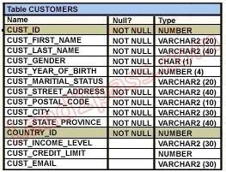

1. Only the first query gives the correct result.
2. Only the second query gives the correct result.
3. Both execute successfully and give the same result.
4. Both execute successfully but do not give the required result.

**Correct Answer:** A

**Section: (none) Explanation**

**QUESTION 117**

View the Exhibit and examine the structure of the PRODUCTS table. You want to display only those product names with their list prices where the list price is at least double the minimum price.

The report should start with the product name having the maximum list price satisfying this condition. Evaluate the following SQL statement:

SQL>SELECT prod_name,prod_list_price

FROM products

WHERE prod_list_price >= 2 * prod_min_price

Which ORDER BY clauses can be added to the above SQL statement to get

68

the correct output?

(Choose all that apply.)



1. ORDER BY prod_list_price DESC, prod_name;
2. ORDER BY (2*prod_min_price)DESC, prod_name;C. ORDER BY prod_name, (2*prod_min_price)DESC;

D. ORDER BY prod_name DESC, prod_list_price DESC; E. ORDER BY prod_list_price DESC, prod_name DESC;

**Correct Answer:** AE

**Section: (none) Explanation**

**QUESTION 118**

View the Exhibit and examine the structure of the CUSTOMERS table. You have been asked to produce a report on the CUSTOMERS table showing the customers details sorted in descending order of the city and in the descending order of their income level in each city. Which query would accomplish this task?



1. SELECT cust_city, cust_income_level, cust_last_name

FROM customers

ORDER BY cust_city desc, cust_income_level DESC ;

1. SELECT cust_city, cust_income_level, cust_last_name

FROM customers

ORDER BY cust_income_level desc, cust_city DESC;

1. SELECT cust_city, cust_income_level, cust_last_name

FROM customers

ORDER BY (cust_city, cust_income_level) DESC;

69

1. SELECT cust_city, cust_income_level, cust_last_name

FROM customers

ORDER BY cust_city, cust_income_level DESC;

**Correct Answer:** A

**Section: (none)**

**Explanation**

**QUESTION 119**

View the Exhibit and examine the data in the PROMO_CATEGORY and PROMO_COST columns of the PROMOTIONS table.

Evaluate the following two queries:

SQL>SELECT DISTINCT promo_category to_char(promo_cost)"code" FROM promotions ORDER BY code;

SQL>SELECT DISTINCT promo_category promo_cost "code"

FROM promotions ORDER BY 1;

Which statement is true regarding the execution of the above queries?

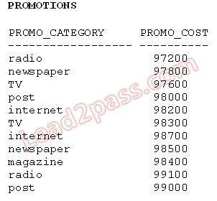

1. Only the first query executes successfully.
2. Only the second query executes successfully.
3. Both queries execute successfully but give different results.
4. Both queries execute successfully and give the same result.

**Correct Answer:** B

**Section: (none) Explanation**

**QUESTION 120**

View the Exhibit and examine the data in the COSTS table. You need to generate a report that displays the IDs of all products in the COSTS table whose unit price is at least 25% more than the unit cost. The details should be displayed in the descending order of 25% of the unit cost. You issue the following query:

70

SQL>SELECT prod_id

FROM costs

WHERE unit_price >= unit_cost * 1.25 ORDER BY unit_cost * 0.25 DESC;

Which statement is true regarding the above query?

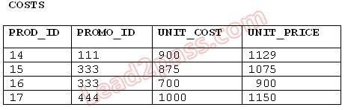

1. It executes and produces the required result.
2. It produces an error because an expression cannot be used in the ORDER BY clause.
3. It produces an error because the DESC option cannot be used with an expression in the ORDER BYclause.
4. It produces an error because the expression in the ORDER BY clause should also be specified in theSELECT clause.

**Correct Answer:** A

**Section: (none) Explanation**

**QUESTION 121** Which two statements are true regarding the ORDER BY clause? (Choose two.)

1. It is executed first in the query execution.
2. It must be the last clause in the SELECT statement.
3. It cannot be used in a SELECT statement containin g a HAVING clause.
4. You cannot specify a column name followed by an expression in this clause.
5. You can specify a combination of numeric positions and column names in this clause.

**Correct Answer:** BE

**Section: (none) Explanation**

**QUESTION 122**

Which statement is true regarding the default behavior of the ORDER BY clause?

1. In a character sort, the values are case- sensitive.
2. NULL values are not considered at all by the sort operation.
3. Only those columns that are specified in the SELECT list can be used in the ORDER BY clause.
4. Numeric values are displayed from the maximum to the minimum value if they have decimal positions.

**Correct Answer:** A

**Section: (none) Explanation**

**QUESTION 123**

You need to generate a list of all customer last names with their credit limits from the CUSTOMERS table. Those customers who do not have a credit limit should appear last in the list. Which two queries would achieve the required result? (Choose two.)

71

1. SELECT cust_last_name, cust_credit_limit

FROM customers

ORDER BY cust_credit_limit DESC ;

1. SELECT cust_last_name, cust_credit_limit

FROM customers

ORDER BY cust_credit_limit;

1. SELECT cust_last_name, cust_credit_limit

FROM customers

ORDER BY cust_credit_limit NULLS LAST;

1. SELECT cust_last_name, cust_credit_limit

FROM customers

ORDER BY cust_last_name, cust_credit_limit NULLS LAST;

**Correct Answer:** BC

**Section: (none) Explanation**

**QUESTION 124**

View the Exhibit and examine the structure of the PRODUCTS table. You want to display only those product names with their list prices where the list price is at least double the minimum price.

The report should start with the product name having the maximum list price satisfying this condition. Evaluate the following SQL statement:

SQL>SELECT prod_name,prod_list_price

FROM products

WHERE prod_list_price >= 2 * prod_min_price

Which ORDER BY clauses can be added to the above SQL statement to get the correct output?

(Choose all that apply.)



1. ORDER BY prod_list_price DESC, prod_name;
2. ORDER BY (2*prod_min_price)DESC, prod_name;C. ORDER BY prod_name, (2*prod_min_price)DESC;

D. ORDER BY prod_name DESC, prod_list_price DESC; E. ORDER BY prod_list_price DESC, prod_name DESC;

**Correct Answer:** AE

**Section: (none) Explanation**

**QUESTION 125** Which arithmetic operations can be performed on a column by using a SQL function that is built

72

into Oracle database ? (Choose three .)

1. addition
2. subtraction
3. raising to a power
4. finding the quotient
5. finding the lowest value

**Correct Answer:** ACE

**Section: (none) Explanation**

**QUESTION 126** Which tasks can be performed using SQL functions built into Oracle Database ? (Choose three.)

1. displaying a date in a nondefault format
2. finding the number of characters in an expression
3. substituting a character string in a text expression with a specified string
4. combining more than two columns or expressions into a single column in the output

**Correct Answer:** ABC

**Section: (none) Explanation**

**QUESTION 127** Which tasks can be performed using SQL functions that are built into Oracle database ? (Choose three .)

1. finding the remainder of a division
2. adding a number to a date for a resultant date value
3. comparing two expressions to check whether they are equal
4. checking whether a specified character exists in a given string
5. removing trailing, leading, and embedded characters from a character string

**Correct Answer:** ACD

**Section: (none) Explanation**

**QUESTION 128**

Which statements are true regarding single row functions? (Choose all that apply.)

1. MOD : returns the quotient of a division
2. TRUNC : can be used with NUMBER and DATE values
3. CONCAT : can be used to combine any number of values
4. SYSDATE : returns the database server current date and time
5. INSTR : can be used to find only the first occurrence of a character in a string
6. TRIM : can be used to remove all the occurrences of a character from a string

**Correct Answer:** BD

**Section: (none) Explanation**

**QUESTION 129** The following data exists in the PRODUCTS table:

PROD_ID PROD_LIST_PRICE -------- ------------------------------

73

123456 152525.99

You issue the following query:

SQL> SELECT RPAD(( ROUND(prod_list_price)), 10,'*')

FROM products

WHERE prod_id = 123456;

What would be the outcome?

1. 152526 ****
2. **152525.99
3. 152525** **
4. an error message

**Correct Answer:** A

**Section: (none) Explanation**

**QUESTION 130**

You need to display the first names of all customers from the CUSTOMERS table that contain the character 'e' and have the character 'a' in the second last position. Which query would give the required output?

1. SELECT cust_first_name

FROM customers

WHERE INSTR(cust_first_name, 'e')<>0 AND

SUBSTR(cust_first_name, -2, 1)='a';

1. SELECT cust_first_name

FROM customers

WHERE INSTR(cust_first_name, 'e')<>'' AND

SUBSTR(cust_first_name, -2, 1)='a';

1. SELECT cust_first_name

FROM customers

WHERE INSTR(cust_first_name, 'e')IS NOT NULL AND

SUBSTR(cust_first_name, 1,-2)='a';

1. SELECT cust_first_name

FROM customers

WHERE INSTR(cust_first_name, 'e')<>0 AND

SUBSTR(cust_first_name, LENGTH(cust_first_name),-2)='a';

**Correct Answer:** A

**Section: (none) Explanation**

**QUESTION 131**

In the CUSTOMERS table, the CUST_CITY column contains the value 'Paris' for the CUST_FIRST_NAME 'ABIGAIL'.

Evaluate the following query:

SQL> SELECT INITCAP(cust_first_name || ' ' ||

UPPER(SUBSTR(cust_city,-LENGTH(cust_city),2)))

FROM customers

WHERE cust_first_name = 'ABIGAIL';

What would be the outcome?

74

1. Abigail PA
2. Abigail Pa
3. Abigail IS
4. an error message

**Correct Answer:** B

**Section: (none) Explanation**

**QUESTION 132** Evaluate the following query:

SQL> SELECT TRUNC(ROUND(156.00,-1),-1) FROM DUAL;

What would be the outcome?

1. 16
2. 100C. 160 D. 200 E. 150

**Correct Answer:** C

**Section: (none) Explanation**

**QUESTION 133**

View the Exhibit and examine the structure of the CUSTOMERS table. In the CUSTOMERS table, the CUST_LAST_NAME column contains the values 'Anderson' and 'Ausson'. You issue the following query:

SQL> SELECT LOWER(REPLACE(TRIM('son' FROM cust_last_name),'An','O')) FROM CUSTOMERS WHERE LOWER(cust_last_name) LIKE 'a%n'; What would be the outcome?



1. 'Oder' and 'Aus'
2. an error because the TRIM function specified is not valid
3. an error because the LOWER function specified is not valid
4. an error because the REPLACE function specified is not valid "First Test, First Pass" -www.lead2pass.com 75

**Correct Answer:** B

**Section: (none) Explanation**

**QUESTION 134** Which two statements are true regarding working with dates? (Choose two.)

1. The default internal storage of dates is in the numeric format.
2. The default internal storage of dates is in the character format.
3. The RR date format automatically calculates the century from the SYSDATE function and does notallow the user to enter the century.
4. The RR date format automatically calculates the century from the SYSDATE function but allows theuser to enter the century if required.

**Correct Answer:** AD

**Section: (none) Explanation**

**QUESTION 135**

You are currently located in Singapore and have connected to a remote database in Chicago. You issue the following command:

SQL> SELECT ROUND(SYSDATE-promo_begin_date,0)

FROM promotions

WHERE (SYSDATE-promo_begin_date)/365 > 2;

PROMOTIONS is the public synonym for the public database link for the PROMOTIONS table. What is the outcome?

1. an error because the ROUND function specified is invalid
2. an error because the WHERE condition specified is invalid
3. number of days since the promo started based on the current Chicago date and time
4. number of days since the promo started based on the current Singapore date and time

**Correct Answer:** C

**Section: (none) Explanation**

**QUESTION 136**

Examine the data in the CUST_NAME column of the CUSTOMERS table.

CUST_NAME

----------------

Renske Ladwig

Jason Mallin

Samuel McCain

Allan MCEwen

Irene Mikkilineni

Julia Nayer

You need to display customers' second names where the second name starts with "Mc" or "MC." Which query gives the required output?

1. SELECT SUBSTR(cust_name, INSTR(cust_name,' ')+1)

FROM customers

WHERE INITCAP(SUBSTR(cust_name, INSTR(cust_name,' ')+1))='Mc'; "First Test, First Pass" www.lead2pass.com 76

1. SELECT SUBSTR(cust_name, INSTR(cust_name,' ')+1)FROM customers

WHERE INITCAP(SUBSTR(cust_name, INSTR(cust_name,' ')+1)) LIKE 'Mc%';

1. SELECT SUBSTR(cust_name, INSTR(cust_name,' ')+1)

FROM customers

WHERE SUBSTR(cust_name, INSTR(cust_name,' ')+1) LIKE INITCAP('MC%');

1. SELECT SUBSTR(cust_name, INSTR(cust_name,' ')+1)

FROM customers

WHERE INITCAP(SUBSTR(cust_name, INSTR(cust_name,' ')+1)) = INITCAP('MC%');

**Correct Answer:** B

**Section: (none) Explanation**

**QUESTION 137**

Examine the data in the CUST_NAME column of the CUSTOMERS table.

CUST_NAME

----------------

Lex De Haan

Renske Ladwig

Jose Manuel Urman

Jason Mallin

You want to extract only those customer names that have three names and display the * symbol in place of the first name as follows:

CUST NAME ------------------

*** De Haan

**** Manuel Urman

Which two queries give the required output? (Choose two.)

1. SELECT LPAD(SUBSTR(cust_name,INSTR(cust_name,' ')),LENGTH(cust_name),'*') "CUST NAME"

FROM customers

WHERE INSTR(cust_name, ' ',1,2)<>0;

1. SELECT LPAD(SUBSTR(cust_name,INSTR(cust_name,' ')),LENGTH(cust_name),'*') "CUST NAME"

FROM customers

WHERE INSTR(cust_name, ' ',-1,2)<>0;

1. SELECT LPAD(SUBSTR(cust_name,INSTR(cust_name,' ')),LENGTH(cust_name)- INSTR(cust_name,''), '*') "CUST NAME"

FROM customers

WHERE INSTR(cust_name, ' ',-1,-2)<>0;

1. SELECT LPAD(SUBSTR(cust_name,INSTR(cust_name,' ')),LENGTH(cust_name)- INSTR(cust_name,''), '*') "CUST NAME"

FROM customers

WHERE INSTR(cust_name, ' ',1,2)<>0 ;

**Correct Answer:** AB

**Section: (none) Explanation**

**QUESTION 138**

View the Exhibit and examine the structure of the EMPLOYEES table. Examine the data in the ENAME and HIREDATE columns of the EMPLOYEES table: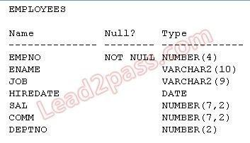

ENAME HIREDATE

-------- ----------------

SMITH 17-DEC-80

ALLEN 20-FEB-81   
WARD 22-FEB-81

You want to generate a list of user IDs as follows:

USERID

-------------

Smi17DEC80

All20FEB81

War22FEB81

You issue the following query:

SELECT CONCAT(SUBSTR(INITCAP(ename),1,3), REPLACE(hiredate,'-')) "USERID" FROM employees;

What is the outcome?

1. It executes successfully and gives the correct output.
2. It executes successfully but does not give the correct output.
3. It generates an error because the REPLACE function is not valid.
4. It generates an error because the SUBSTR function cannot be nested in the CONCAT function.

**Correct Answer:** A

**Section: (none) Explanation**

**QUESTION 139** View the Exhibit and examine the structure and data in the INVOICE table.

name Null Type

------- --------- -----------

INV_NO NOT NULL NUMBER(3)

INV_DATE DATE

INV_AMT NUMBER(10,2)

Which statements are true regarding data type conversion in expressions used in queries? (Choose all that apply.)

78

1. inv_amt ='0255982' : requires explicit conversion
2. inv_date > '01-02-2008' : uses implicit conversion
3. CONCAT(inv_amt,inv_date) : requires explicit conversion
4. inv_date = '15-february-2008' : uses implicit conversion
5. inv_no BETWEEN '101' AND '110' : uses implicit conversion

**Correct Answer:** DE

**Section: (none) Explanation**

**QUESTION 140** Examine the structure and data of the CUST_TRANS table:

CUST_TRANS

-----------------------------------

Name Null Type

CUSTNO NOT NULL CHAR(2)

TRANSDATE DATE

TRANSAMT NUMBER(6,2)

CUSTNO TRANSDATE TRANSAMT

----- -------------- --------------

11 01-JAN-07 1000

22 01-FEB-07 2000

33 01-MAR-07 3000

Dates are stored in the default date format dd-mon-rr in the CUST_TRANS table. Which SQL statements would execute successfully? (Choose three .)

1. SELECT transdate + '10' FROM cust_trans;
2. SELECT * FROM cust_trans WHERE transdate = '01-01-07';
3. SELECT transamt FROM cust_trans WHERE custno > '11';
4. SELECT * FROM cust_trans WHERE transdate='01-JANUARY-07';
5. SELECT custno + 'A' FROM cust_trans WHERE transamt > 2000;

**Correct Answer:** ACD

**Section: (none) Explanation**

**QUESTION 141** You want to display the date for the first Monday of the next month and issue the following command:

SQL>SELECT TO_CHAR(NEXT_DAY(LAST_DAY(SYSDATE),'MON'), 'dd "is the first Monday for" fmmonth rrrr') FROM DUAL;

What is the outcome?

1. It executes successfully and returns the correct result.
2. It executes successfully but does not return the correct result.
3. It generates an error because TO_CHAR should be replaced with TO_DATE.
4. It generates an error because rrrr should be replaced by rr in the format string.
5. It generates an error because fm and double quotation marks should not be used in the format string.

**Correct Answer:** A

**Section: (none) Explanation**

**Explanation/Reference:**

79

**QUESTION 142**

You need to calculate the number of days from 1st January 2007 till date.

Dates are stored in the default format of dd-mon-rr.

Which SQL statements would give the required output? (Choose two .)

1. SELECT SYSDATE - '01-JAN-2007' FROM DUAL;
2. SELECT SYSDATE - TO_DATE('01/JANUARY/2007') FROM DUAL;
3. SELECT SYSDATE - TO_DATE('01-JANUARY-2007') FROM DUAL;
4. SELECT TO_CHAR(SYSDATE, 'DD-MON-YYYY') - '01-JAN-2007' FROM DUAL;
5. SELECT TO_DATE(SYSDATE, 'DD/MONTH/YYYY') - '01/JANUARY/2007' FROM DUAL;

**Correct Answer:** BC

**Section: (none) Explanation**

**QUESTION 143**

You need to display the date 11-oct-2007 in words as 'Eleventh of October, Two Thousand Seven'. Which SQL statement would give the required result?

1. SELECT TO_CHAR('11-oct-2007', 'fmDdspth "of" Month, Year') FROM DUAL;
2. SELECT TO_CHAR(TO_DATE('11-oct-2007'), 'fmDdspth of month, year') FROM DUAL;
3. SELECT TO_CHAR(TO_DATE('11-oct-2007'), 'fmDdthsp "of" Month, Year') FROM DUAL;
4. SELECT TO_DATE(TO_CHAR('11-oct-2007','fmDdspth ''of'' Month, Year')) FROM DUAL;

**Correct Answer:** C

**Section: (none) Explanation**

**QUESTION 144** The SQL statements executed in a user session are as follows:

SQL> CREATE TABLE product (pcode NUMBER(2), pname VARCHAR2(10));

SQL> INSERT INTO product VALUES (1, 'pen');

SQL> INSERT INTO product VALUES (2,'pencil');

SQL> SAVEPOINT a;

SQL> UPDATE product SET pcode = 10 WHERE pcode = 1;

SQL> SAVEPOINT b;

SQL> DELETE FROM product WHERE pcode = 2;

SQL> COMMIT; The Commit deletes all the savepoints!

SQL> DELETE FROM product WHERE pcode=10;

Which two statements describe the consequences of issuing the ROLLBACK TO SAVE POINT a command in the session? (Choose two.)

1. The rollback generates an error.
2. No SQL statements are rolled back.
3. Only the DELETE statements are rolled back.
4. Only the second DELETE statement is rolled back.
5. Both the DELETE statements and the UPDATE statement are rolled back.

**Correct Answer:** AB

**Section: (none) Explanation**

**QUESTION 145** When does a transaction complete? (Choose all that apply.)

1. when a DELETE statement is executed
2. when a ROLLBACK command is executed
3. when a PL/SQL anonymous block is executed
4. when a data definition language ( DDL) statement is executed
5. when a TRUNCATE statement is executed after the pending transaction

**Correct Answer:** BDE

**Section: (none) Explanation**

**QUESTION 146** Which statement is true regarding transactions? (Choose all that apply.)

1. A transaction can consist only of a set of DML and DDL statements. (!only)
2. A part or an entire transaction can be undone by using ROLLBACK command .
3. A transaction consists of a set of DML or DCL statements. (eventuell)
4. A part or an entire transaction can be made permanent with a COMMIT. (immer alles)
5. A transaction can consist of only a set of queries or DML or DDL statements. (!only)

**Correct Answer:** BC

**Section: (none) Explanation**

**QUESTION 147**

View the Exhibit; e xamine the structure of the PROMOTIONS table. Each promotion has a duration of at least seven days . Your manager has asked you to generate a report, which provides the weekly cost for each promotion done to l date.

Which query would achieve the required result?



1. SELECT promo_name, promo_cost/promo_end_date-promo_begin_date/7 FROM promotions;
2. SELECT promo_name,(promo_cost/promo_end_date-promo_begin_date)/7 FROM promotions;
3. SELECT promo_name, promo_cost/(promo_end_date-promo_begin_date/7) FROM promotions;
4. SELECT promo_name, promo_cost/((promo_end_date-promo_begin_date)/7) FROM promotions;

**Correct Answer:** D

**Section: (none) Explanation**

**Explanation/Reference:**

**QUESTION 148**

Which two statements are true regarding the starting of the database instance using the following command? (Choose two.)

SQL>STARTUP UPGRADE

1. It enables all system triggers.
2. It allows only SYSDBA connections.
3. It ensures that all job queues remain active during the upgrade process.
4. It sets system initialization parameters to specific values that are required to enable database upgradescripts to be run.

**Correct Answer:** BD

**Section: (none) Explanation**

**QUESTION 149**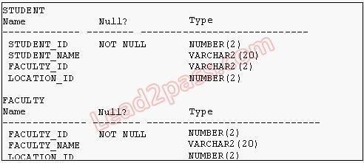

View the Exhibit for the structure of the STUDENT and FACULTY tables. You need to display the faculty name followed by the number of students handled by the faculty at the base location.

Examine the following two SQL statements:

Statement 1

SQL>SELECT faculty_name,COUNT(student_id)

FROM student JOIN faculty

USING (faculty_id, location_id)

GROUP BY faculty_name;

Statement 2

SQL>SELECT faculty_name,COUNT(student_id) FROM student NATURAL JOIN faculty GROUP BY faculty_name;

Which statement is true regarding the outcome?

1. Only statement 1 executes successfully and gives the required result.
2. Only statement 2 executes successfully and gives the required result.
3. Both statements 1 and 2 execute successfully and give different results.
4. Both statements 1 and 2 execute successfully and give the same required result.

**Correct Answer:** D

**Section: (none)**

**Explanation**

**Explanation/Reference:**

82

**QUESTION 150**

View the Exhibits and examine the structures of the PRODUCTS, SALES, and CUSTOMERS tables.



You need to generate a report that gives details of the customer's last name, name of the product, and the quantity sold for all customers in ' Tokyo' .

Which two queries give the required result? (Choose two.)

1. SELECT c.cust_last_name,p.prod_name, s.quantity_sold

FROM sales s JOIN products p

USING(prod_id)

JOIN customers c

USING(cust_id)

WHERE c.cust_city='Tokyo';

1. SELECT c.cust_last_name, p.prod_name, s.quantity_sold

FROM products p JOIN sales s JOIN customers c

ON(p.prod_id=s.prod_id)

ON(s.cust_id=c.cust_id)

WHERE c.cust_city='Tokyo';

1. SELECT c.cust_last_name, p.prod_name, s.quantity_sold

FROM products p JOIN sales s

ON(p.prod_id=s.prod_id)

83

JOIN customers c

ON(s.cust_id=c.cust_id)

AND c.cust_city='Tokyo';

1. SELECT c.cust_id,c.cust_last_name,p.prod_id, p.prod_name, s.quantity_sold FROM products p JOINsales s USING(prod_id)

JOIN customers c

USING(cust_id)

WHERE c.cust_city='Tokyo';

**Correct Answer:** AC

**Section: (none) Explanation**

**QUESTION 151**

View the Exhibit and examine the data in the



The PROJ_TASK_DETAILS table stores information about tasks involved in a project and the relation between them.

The BASED_ON column indicates dependencies between tasks. Some tasks do not depend on the completion of any other tasks.

You need to generate a report showing all task IDs, the corresponding task ID they are dependent on, and the name of the employee in charge of the task it depends on. Which query would give the required result?

1. SELECT p.task_id, p.based_on, d.task_in_chargeFROM proj_task_details p JOIN proj_task_details d

ON (p.based_on = d.task_id);

1. SELECT p.task_id, p.based_on, d.task_in_charge

FROM proj_task_details p LEFT OUTER JOIN proj_task_details d ON (p.based_on = d.task_id);

1. SELECT p.task_id, p.based_on, d.task_in_charge

FROM proj_task_details p FULL OUTER JOIN proj_task_details d ON (p.based_on = d.task_id);

1. SELECT p.task_id, p.based_on, d.task_in_chargeFROM proj_task_details p JOIN proj_task_details d ON (p.task_id = d.task_id);

**Correct Answer:** B

**Section: (none) Explanation**

**QUESTION 152** Which two statements are true regarding subqueries? (Choose two.)

1. A subquery can retrieve zero or more rows.
2. Only two subqueries can be placed at one level.
3. A subquery can be used only in SQL query statements.
4. A subquery can appear on either side of a comparison operator.
5. There is no limit on the number of subquery levels in the WHERE clause of a SELECT statement. 84

**Correct Answer:** AD

**Section: (none) Explanation**

**QUESTION 153**

View the Exhibit and examine the structure of the SALES, CUSTOMERS, PRODUCTS, and TIMES tables. The PROD_ID column is the foreign key in the SALES table, which references the PRODUCTS table. Similarly, the CUST_ID and TIME_ID columns are also foreign keys in the SALES table referencing the CUSTOMERS and TIMES tables, respectively.

Evaluate the following CREATE TABLE command:

CREATE TABLE new_sales(prod_id, cust_id, order_date DEFAULT SYSDATE) AS

SELECT prod_id, cust_id, time_id FROM sales;

Which statement is true regarding the above command?

1. The NEW_SALES table would not get created because the DEFAULT value cannot be specified in thecolumn definition.
2. The NEW_SALES table would get created and all the NOT NULL constraints defined on the specifiedcolumns would be passed to the new table.
3. The NEW_SALES table would not get created because the column names in the CREATE TABLEcommand and the SELECT clause do not match.

85

1. The NEW_SALES table would get created and all the FOREIGN KEY constraints defined on thespecified columns would be passed to the new table.

**Correct Answer:** B

**Section: (none) Explanation**

**QUESTION 154**

View the Exhibit to examine the description for the SALES table. Which views can have all DML operations performed on it? (Choose all that apply.)



1. CREATE VIEW v3

AS SELECT * FROM SALES

WHERE cust_id = 2034

WITH CHECK OPTION;

1. CREATE VIEW v1

AS SELECT * FROM SALES

WHERE time_id <= SYSDATE - 2*365

WITH CHECK OPTION;

1. CREATE VIEW v2

AS SELECT prod_id, cust_id, time_id FROM SALES

WHERE time_id <= SYSDATE - 2*365

WITH CHECK OPTION;

1. CREATE VIEW v4

AS SELECT prod_id, cust_id, SUM(quantity_sold) FROM SALES WHERE time_id <= SYSDATE -

2*365

GROUP BY prod_id, cust_id

WITH CHECK OPTION;

**Correct Answer:** AB

**Section: (none) Explanation**

**QUESTION 155**

You need to extract details of those products in the SALES table where the PROD_ID column contains the string '_D123'.

Which WHERE clause could be used in the SELECT statement to get the required output?

A. WHERE prod_id LIKE '%_D123%' ESCAPE '_' B. WHERE prod_id LIKE '%\_D123%' ESCAPE '\'

1. WHERE prod_id LIKE '%_D123%' ESCAPE '%_'
2. WHERE prod_id LIKE '%\_D123%' ESCAPE '\_'

**Correct Answer:** B

**Section: (none) Explanation**

**QUESTION 156** Which two statements are true regarding single row functions? (Choose two.)

86

1. They accept only a single argument.
2. They can be nested only to two levels.
3. Arguments can only be column values or constants.
4. They always return a single result row for every row of a queried table.
5. They can return a data type value different from the one that is referenced.

**Correct Answer:** DE

**Section: (none) Explanation**

**QUESTION 157** Which SQL statements would display the value 1890.55 as $1,890.55? (Choose three .)

1. SELECT TO_CHAR(1890.55,'$0G000D00')FROM DUAL;
2. SELECT TO_CHAR(1890.55,'$9,999V99')FROM DUAL;
3. SELECT TO_CHAR(1890.55,'$99,999D99')FROM DUAL;
4. SELECT TO_CHAR(1890.55,'$99G999D00')FROM DUAL;
5. SELECT TO_CHAR(1890.55,'$99G999D99')FROM DUAL;

**Correct Answer:** ADE

**Section: (none) Explanation**

**QUESTION 158** Examine the structure of the SHIPMENTS table:

name Null Type

----- -------------- --------------

PO_ID NOT NULL NUMBER(3)

PO_DATE NOT NULL DATE

SHIPMENT_DATE NOT NULL DATE

SHIPMENT_MODE VARCHAR2(30)

SHIPMENT_COST NUMBER(8,2)

You want to generate a report that displays the PO_ID and the penalty amount to be paid if the SHIPMENT_DATE is later than one month from the PO_DATE. The penalty is $20 per day. Evaluate the following two queries:

SQL> SELECT po_id, CASE

WHEN MONTHS_BETWEEN (shipment_date,po_date)>1 THEN

TO_CHAR((shipment_date - po_date) * 20) ELSE 'No Penalty' END PENALTY FROM shipments;

SQL>SELECT po_id, DECODE

(MONTHS_BETWEEN (po_date,shipment_date)>1,

TO_CHAR((shipment_date - po_date) * 20), 'No Penalty') PENALTY FROM shipments;

Which statement is true regarding the above commands?

1. Both execute successfully and give correct results.

87

1. Only the first query executes successfully but gives a wrong result.
2. Only the first query executes successfully and gives the correct result.
3. Only the second query executes successfully but gives a wrong result.
4. Only the second query executes successfully and gives the correct result.

**Correct Answer:** C

**Section: (none) Explanation**

**QUESTION 159** Which two statements are true regarding the USING and ON clauses in table joins? (Choose two.)

1. Both USING and ON clauses can be used for equijoins and nonequijoins.
2. A maximum of one pair of columns can be joined between two tables using the ON clause.
3. The ON clause can be used to join tables on columns that have different names but compatible datatypes.
4. The WHERE clause can be used to apply additional conditions in SELECT statements containing theON or the USING clause.

**Correct Answer:** CD

**Section: (none) Explanation**

**QUESTION 160**

View the Exhibit and examine the structure of the CUSTOMERS table. Which two tasks would require subqueries or joins to be executed in a single statement? (Choose two.)



1. listing of customers who do not have a credit limit and were born before 1980
2. finding the number of customers, in each city, whose marital status is 'married'
3. finding the average credit limit of male customers residing in 'Tokyo' or 'Sydney'
4. listing of those customers whose credit limit is the same as the credit limit of customers residing in thecity 'Tokyo'
5. finding the number of customers, in each city, whose credit limit is more than the average credit limit ofall the customers

**Correct Answer:** DE

**Section: (none) Explanation**

**QUESTION 161** Which statement is true regarding the INTERSECT operator?

88

1. It ignores NULL values.
2. Reversing the order of the intersected tables alters the result.
3. The names of columns in all SELECT statements must be identical.
4. The number of columns and data types must be identical for all SELECT statements in the query.

**Correct Answer:** D

**Section: (none) Explanation**

**QUESTION 162**

View the Exhibit; e xamine the structure of the PROMOTIONS table. Each promotion has a duration of at least seven days . Your manager has asked you to generate a report, which provides the weekly cost for each promotion done to l date.

Which query would achieve the required result?



1. SELECT promo_name, promo_cost/promo_end_date-promo_begin_date/7 FROM promotions;
2. SELECT promo_name,(promo_cost/promo_end_date-promo_begin_date)/7 FROM promotions;
3. SELECT promo_name, promo_cost/(promo_end_date-promo_begin_date/7) FROM promotions;
4. SELECT promo_name, promo_cost/((promo_end_date-promo_begin_date)/7) FROM promotions;

**Correct Answer:** D

**Section: (none) Explanation**

**QUESTION 163**

You need to produce a report where each customer's credit limit has been incremented by $1000. In the output, the customer's last name should have the heading Name and the incremented credit limit should be labeled New Credit Limit.

The column headings should have only the first letter of each word in uppercase . Which statement would accomplish this requirement?

1. SELECT cust_last_name Name, cust_credit_limit + 1000

"New Credit Limit"

FROM customers;

1. SELECT cust_last_name AS Name, cust_credit_limit + 1000 AS New Credit LimitFROM customers;
2. SELECT cust_last_name AS "Name", cust_credit_limit + 1000 AS "New Credit Limit"FROM customers;
3. SELECT INITCAP(cust_last_name) "Name", cust_credit_limit + 1000 INITCAP("NEW CREDIT LIMIT")

FROM customers;

89

**Correct Answer:** C

**Section: (none) Explanation**

**QUESTION 164**

View the Exhibit and examine the structure of the PRODUCTS table.

All products have a list price.

You issue the following command to display the total price of each product after a discount of 25% and a tax of 15% are applied on it. Freight charges of $100 have to be applied to all the products.

SQL>SELECT prod_name, prod_list_price -(prod_list_price*(25/100)) +(prod_list_price -(prod_list_price* (25/100))*(15/100))+100 AS "TOTAL PRICE" FROM products;

What would be the outcome if all the parenthese s are removed from the above statement?

1. It produces a syntax error.
2. The result remains unchanged. Punkt- vor Strichrechnung
3. The total price value would be lower than the correct value.
4. The total price value would be higher than the correct value.

**Correct Answer:** B

**Section: (none) Explanation**

**QUESTION 165**

Using the CUSTOMERS table, you need to generate a report that shows 50% of each credit amount in each income level.

The report should NOT show any repeated credit amounts in each income level. Which query would give the required result?

1. SELECT cust_income_level, DISTINCT cust_credit_limit * 0.50 AS "50% Credit Limit" FROMcustomers;
2. SELECT DISTINCT cust_income_level, DISTINCT cust_credit_limit * 0.50 AS "50% Credit Limit" FROMcustomers;
3. SELECT DISTINCT cust_income_level ' ' cust_credit_limit * 0.50 AS "50% Credit Limit" FROMcustomers;
4. SELECT cust_income_level ' ' cust_credit_limit * 0.50 AS "50% Credit Limit" FROM customers;

**Correct Answer:** C

**Section: (none) Explanation**

**QUESTION 166** View the Exhibit and examine the structure of the PRODUCTS table.

You need to generate a report in the following format:

CATEGORIES

5MP Digital Photo Camera's category is Photo

Y Box's category is Electronics

Envoy Ambassador's category is Hardware

Which two queries would give the required output? (Choose two.)

1. SELECT prod_name || q'''s category is ' || prod_category CATEGORIES FROM products;
2. SELECT prod_name || q'['s ]'category is ' || prod_category CATEGORIES FROM products;
3. SELECT prod_name || q'\'s\' || ' category is ' || prod_category CATEGORIES FROM products;
4. SELECT prod_name || q'<'s >' || 'category is ' || prod_category CATEGORIES FROM products;

**Correct Answer:** CD

**Section: (none) Explanation**

**QUESTION 167**

View the Exhibit and examine the data in the CUSTOMERS table. Evaluate the following query:

SQL> SELECT cust_name AS "NAME", cust_credit_limit/2 AS MIDPOINT,MIDPOINT+100 AS "MAX

LOWER LIMIT"

FROM customers;

The above query produces an error on execution. What is the reason for the error?

1. An alias cannot be used in an expression.
2. The a lias NAME should not be enclosed with in double quotation marks .
3. The MIDPOINT+100 expression gives an error because CUST_CREDIT_LIMIT contains NULL values.
4. The a lias MIDPOINT should be enclosed with in double quotation marks for theCUST_CREDIT_LIMIT/2 expression .

**Correct Answer:** A

**Section: (none) Explanation**

**QUESTION 168** Evaluate the following query:

SQL> SELECT promo_name || q'{'s start date was }' || promo_begin_date AS "Promotion Launches" FROM promotions;

91

What would be the outcome of the above query?

1. It produces an error because flower braces have been used.
2. It produces an error because the data types are not matching.
3. It executes successfully and introduces an 's at the end of each promo_name in the output.
4. It executes successfully and displays the literal " {'s start date was } " for each row in the output.

**Correct Answer:** C

**Section: (none) Explanation**

**QUESTION 169**

View the Exhibit and examine the data in the EMPLOYEES table. You want to generate a report showing the total compensation paid to each employee to date. You issue the following query:

SELECT ename ' joined on ' hiredate ', the total compensation paid is '

TO_CHAR(ROUND(ROUND(SYSDATE-hiredate)/365) * sal + comm) "COMPENSATION UNTIL DATE" FROM employees;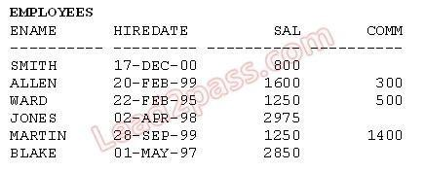

What is the outcome?

1. It generates an error because the alias is not valid.
2. It executes successfully and gives the correct output.
3. It executes successfully but does not give the correct output.
4. It generates an error because the usage of the ROUND function in the expression is not valid.
5. It generates an error because the concatenation operator can be used to combine only two items.

**Correct Answer:** C

**Section: (none) Explanation**

**QUESTION 170**

Examine the structure of the PROMOTIONS table:

name Null Type

----- -------------- --------------

PROMO_ID NOT NULL NUMBER(6)

PROMO_NAME NOT NULL VARCHAR2(30)

PROMO_CATEGORY NOT NULL VARCHAR2(30) PROMO_COST NOT NULL NUMBER(10,2)

The management wants to see a report of unique promotion costs in each promotion category.

Which query would achieve the required result?

A. SELECT DISTINCT promo_cost, promo_category FROM promotions; B. SELECT promo_category, DISTINCT promo_cost FROM promotions;

1. SELECT DISTINCT promo_cost, DISTINCT promo_category FROM promotions;
2. SELECT DISTINCT promo_category, promo_cost FROM promotions ORDER BY 1;

**Correct Answer:** D

**Section: (none) Explanation**

**QUESTION 171** Evaluate the following query:

SELECT INTERVAL '300' MONTH,

INTERVAL '54-2' YEAR TO MONTH,

INTERVAL '11:12:10.1234567' HOUR TO SECOND FROM dual;

What is the correct output of the above query?

1. +25-00 , +54-02, +00 11:12:10.123457
2. +00-300, +54-02, +00 11:12:10.123457
3. +25-00 , +00-650, +00 11:12:10.123457
4. +00-300 , +00-650, +00 11:12:10.123457

**Correct Answer:** A

**Section: (none) Explanation**

**QUESTION 172** Which three statements are true regarding the data types in Oracle Database 10g/11g? (Choose three.)

1. Only one LONG column can be used per table.
2. A TIMESTAMP data type column stores only time values with fractional seconds.
3. The BLOB data type column is used to store binary data in an operating system file.
4. The minimum column width that can be specified for a VARCHAR2 data type column is one.
5. The value for a CHAR data type column is blank-padded to the maximum defined column width.

**Correct Answer:** ADE

**Section: (none) Explanation**

**QUESTION 173** Examine the description of the EMP_DETAILS table given below:

name NULL TYPE

----- -------------- --------------

EMP_ID NOT NULL NUMBER

EMP_NAME NOT NULL VARCHAR2 (40)

EMP_IMAGE LONG

Which two statements are true regarding SQL statements that can be executed on the EMP_DETAIL table? (Choose two.)

1. An EMP_IMAGE column can be included in the GROUP BY clause.
2. An EMP_IMAGE column cannot be included in the ORDER BY clause.

93

1. You cannot add a new column to the table with LONG as the data type.
2. You can alter the table to include the NOT NULL constraint on the EMP_IMAGE column.

**Correct Answer:** BC

**Section: (none) Explanation**

**QUESTION 174**

You need to create a table for a banking application. One of the columns in the table has the following requirements:

1. You want a column in the table to store the duration of the credit period.
2. The data in the column should be stored in a format such that it can be easily added and subtracted withDATE data type without using conversion functions.
3. The maximum period of the credit provision in the application is 30 days.
4. The interest has to be calculated for the number of days an individual has taken a credit for.

Which data type would you use for such a column in the table?

1. DATE
2. NUMBER
3. TIMESTAMP
4. INTERVAL DAY TO SECOND
5. INTERVAL YEAR TO MONTH

**Correct Answer:** D

**Section: (none) Explanation**

**QUESTION 175**

Examine the structure proposed for the TRANSACTIONS table:

name Null Type

----- -------------- --------------

TRANS_ID NOT NULL NUMBER(6)

CUST_NAME NOT NULL VARCHAR2(20)

CUST_STATUS NOT NULL CHAR

TRANS_DATE NOT NULL DATE

TRANS_VALIDITY VARCHAR2

CUST_CREDIT_LIMIT NUMBER

Which statements are true regarding the creation and storage of data in the above table structure? (Choose all that apply.)

1. The CUST_STATUS column would give an error.
2. The TRANS_VALIDITY column would give an error.
3. The CUST_STATUS column would store exactly one character.
4. The CUST_CREDIT_LIMIT column would not be able to store decimal values.E. The TRANS_VALIDITY column would have a maximum size of one character.

F. The TRANS_DATE column would be able to store day, month, century, year, hour, minutes, seconds, and fractions of seconds.

**Correct Answer:** BC

**Section: (none) Explanation**

**QUESTION 176**

Examine the structure proposed for the TRANSACTIONS table:

name Null Type

----- -------------- --------------

TRANS_ID NOT NULL NUMBER(6)

CUST_NAME NOT NULL VARCHAR2(20)

CUST_STATUS NOT NULL VARCHAR2

TRANS_DATE NOT NULL DATE

TRANS_VALIDITY INTERVAL DAY TO SECOND

CUST_CREDIT_VALUE NUMBER(10)

Which two statements are true regarding the storage of data in the above table structure? (Choose two.)

1. The TRANS_DATE column would allow storage of dates only in the dd-mon-yyyy format.
2. The CUST_CREDIT_VALUE column would allow storage of positive and negative integers.
3. The TRANS_VALIDITY column would allow storage of a time interval in days, hours, minutes, andseconds.
4. The CUST_STATUS column would allow storage of data up to the maximum VARCHAR2 size of 4,000characters.

**Correct Answer:** BC

**Section: (none) Explanation**

**QUESTION 177**

Resume (character large object [CLOB] data type), which contains the resume submitted by the employee. Which is the correct syntax to create this table?

1. CREATE TABLE EMP_1(emp_id NUMBER(4), emp_name VARCHAR2(25), start_date DATE,

e_status VARCHAR2(10) DEFAULT 'ACTIVE', resume CLOB(200));

1. CREATE TABLE 1_EMP(emp_id NUMBER(4), emp_name VARCHAR2(25), start_date DATE,

emp_status VARCHAR2(10) DEFAULT 'ACTIVE', resume CLOB);

1. CREATE TABLE EMP_1(emp_id NUMBER(4), emp_name VARCHAR2(25), start_date DATE,

emp_status VARCHAR2(10) DEFAULT "ACTIVE",

resume CLOB);

1. CREATE TABLE EMP_1

(emp_id NUMBER, emp_name VARCHAR2(25), start_date DATE,

emp_status VARCHAR2(10) DEFAULT 'ACTIVE', resume CLOB);

**Correct Answer:** D

**Section: (none) Explanation**

**Explanation/Reference:**

**QUESTION 178** Examine the structure of the PROMOS table:

name Null Type

----- ------------ --------------

PROMO_ID NOT NULL NUMBER(3)

PROMO_NAME VARCHAR2(30)

PROMO_START_DATE NOT NULL DATE

PROMO_END_DATE DATE

You want to generate a report showing promo names and their duration (number of days). If the

PROMO_END_DATE has not been entered, the message 'ONGOING' should be displayed. Which queries give the correct output? (Choose all that apply.)

1. SELECT promo_name, TO_CHAR(NVL(promo_end_date -promo_start_date,'ONGOING')) FROMpromos;
2. SELECT promo_name,COALESCE(TO_CHAR(promo_end_date - promo_start_date),'ONGOING')FROM promos;
3. SELECT promo_name, NVL(TO_CHAR(promo_end_date -promo_start_date),'ONGOING') FROMpromos;
4. SELECT promo_name, DECODE(promo_end_date

-promo_start_date,NULL,'ONGOING',promo_end_date - promo_start_date) FROM promos;

1. SELECT promo_name, decode(coalesce(promo_end_date,promo_start_date),null,'ONGOING',promo_end_date - promo_start_date) FROM promos;

**Correct Answer:** BCD

**Section: (none) Explanation**

**QUESTION 179** Examine the structure of the PROMOS table:

name Null Type

----------------- ------------ -------------------

PROMO_ID NOT NULL NUMBER(3)

PROMO_NAME VARCHAR2(30)

PROMO_START_DATE NOT NULL DATE

PROMO_END_DATE NOT NULL DATE

You want to display the list of promo names with the message 'Same Day' for promos that started and ended on the same day.

Which query gives the correct output?

1. SELECT promo_name, NVL(NULLIF(promo_start_date, promo_end_date), 'Same Day') FROMpromos;
2. SELECT promo_name, NVL(TRUNC(promo_end_date - promo_start_date), 'Same Day') FROMpromos;
3. SELECT promo_name, NVL2(TO_CHAR(TRUNC(promo_end_date-promo_start_date)), NULL,'SameDay') FROM promos;
4. SELECT promo_name, DECODE((NULLIF(promo_start_date, promo_end_date)), NULL,'Same day')FROM promos;

**Correct Answer:** D

**Section: (none) Explanation**

**Explanation/Reference:**

**QUESTION 180**

Examine the data in the LIST_PRICE and MIN_PRICE columns of the PRODUCTS table:

LIST_PRICE MIN_PRICE

---------- --------------

10000 8000

20000

30000 30000

Which two expressions give the same output? (Choose two.)

1. NVL(NULLIF(list_price, min_price), 0)
2. NVL(COALESCE(list_price, min_price), 0)
3. NVL2(COALESCE(list_price, min_price), min_price, 0)
4. COALESCE(NVL2(list_price, list_price, min_price), 0)

**Correct Answer:** BD

**Section: (none) Explanation**

**QUESTION 181** Which two statements are true about sequences created in a single instance database? (Choose two.)

1. The numbers generated by a sequence can be used only for one table.
2. DELETE <sequencename> would remove a sequence from the database.
3. CURRVAL is used to refer to the last sequence number that has been generated.
4. When the MAXVALUE limit for a sequence is reached, you can increase the MAXVALUE limit by usingthe ALTER SEQUENCE statement.
5. When a database instance shuts down abnormally, the sequence numbers that have been cached butnot used would be available once again when the database instance is restarted.

**Correct Answer:** CD

**Section: (none) Explanation**

**QUESTION 182** Examine the following PL/SQL block:

SET SERVEROUTPUT ON

SET LONG 10000

ECLARE report clob;

BEGIN

report := DBMS_SPM.EVOLVE_SQL_PLAN_BASELINE();

DBMS_OUTPUT.PUT_LINE(report); END;

Which statement describes the effect of the execution of the above PL/SQL block?

1. The plan baselines are verified with the SQL profiles.
2. All fixed plan baselines are converted into nonfixed plan baselines.
3. All the nonaccepted SQL profiles are accepted into the plan baseline.
4. The nonaccepted plans in the SQL Management Base are verified with the existing plan baselines.

**Correct Answer:** D

**Section: (none) Explanation**

**Explanation/Reference:**

**QUESTION 183** Which two statements are true regarding savepoints? (Choose two.)

1. Savepoints are effective only for COMMIT.
2. Savepoints may be used to ROLLBACK.
3. Savepoints can be used for only DML statements.
4. Savepoints are effective for both COMMIT and ROLLBACK.
5. Savepoints can be used for both DML and DDL statements.

**Correct Answer:** BC

**Section: (none) Explanation**

**Explanation/Reference:**