Survival Probability
Survival probability at temperature (t) = exp[-m(t)*d(t)]
Where m=stage-specific mortality & d = stage-specific development duration.
Poletti et al. 2011
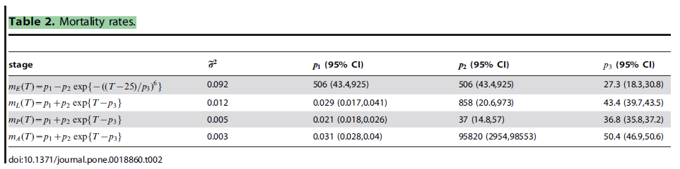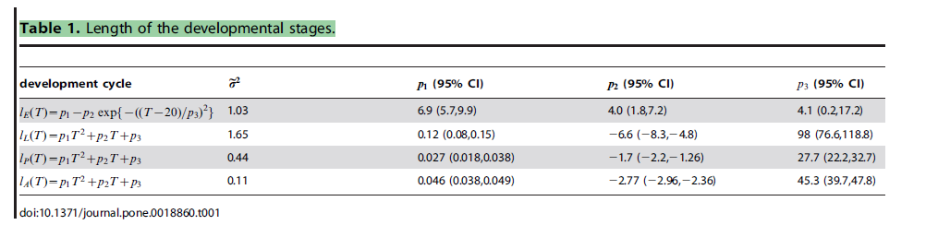
Egg:exp⁡[-506-+506e-T-2527.36×6.9-4.0eT-204.12]
$$Larvea:exp⁡[-(0.029+858e^{T-43.4})×\left(0.12T^{2}-6.6T+98\right)]$$
$$Pupea:exp⁡[-(0.021+37e^{T-36.8})×(0.027T^{2}-1.7T+27.7)]$$
pEA=Egg*+Larvea*+Pupea
pEA=exp-506-+506e-T-2527.36×6.9-4.0eT-204.12*+exp-0.029+858eT-43.4×0.12T2-6.6T+98*+exp-0.021+37eT-36.8×0.027T2-1.7T+27.7]

Yang et al. 2009
$$Maturation duration = 1/(0.131-0.05723T+0.01164T^{2}-0.001341T^{3}+8.723×{10}^{-5}T^{4}-3.017×{10}^{-6}T^{5}+5.153×{10}^{-8}T^{6}-3.42×{10}^{-10}T^{7})$$
$$Mortality=(2.13-0.3787T + 0.02457T^{2}- 6.778 × {10}^{-4}{ T}^{3} + 6.794 × {10}^{-6}T^{4}).$$
$$pEA=exp[-\frac{(2.13-0.3787T + 0.02457T^{2}- 6.778 × {10}^{-4}{ T}^{3} + 6.794 × {10}^{-6}T^{4})}{(0.131-0.05723T+0.01164T^{2}-0.001341T^{3}+8.723×{10}^{-5}T^{4}-3.017×{10}^{-6}T^{5}+5.153×{10}^{-8}T^{6}-3.42×{10}^{-10}T^{7}) }]$$

MDR
To calculate the MDR using the Poletti data, sum the durations of each phase, then convert it to a rate.
$$Egg:\left(6.9-4.0e^{{\left(\frac{T-20}{4.1}\right)}^{2}}\right)$$
$$Larvea:\left(0.12T^{2}-6.6T+98\right)$$
$$Pupea:(0.027T^{2}-1.7T+27.7)$$
Adult:(0.046T2-2.77T+45.3)

Duration=Egg+Larvea+Pupea+Adults
6.9-4.0eT-204.12+0.12T2-6.6T+98+ 0.027T2-1.7T+27.7+(0.046T2-2.77T+45.3)
Duration=0.14793T2-8.311.07T+13277.69-4eT-204.12

MDR=1/0.14693T2-8.311.07T+132.677.9-4eT-204.12

