Plan

Impact of Thermal response functions on estimating the Transmission risk of Chikungunya

Objective
How does the thermal response functional form of temperature-dependent parameters influence the estimated R₀ value of chikungunya over a range of temperatures? We will consider two R0 formula: 1- Mordecai et al 2017, and 2- Mokhtar et al 2024
- Is there a difference in R₀ estimates when using different thermal response functions? Organize the thermal response functions for each parameter into data-calibrated functions (single vs multiple datasets, field vs lab data) and expert opinion-driven functions.
- Consider Mordecai et al as the baseline R0 estimate, and set a systematic approach to vary the parameters' functional forms to evaluate how R0 value changes across a range of temperature values (like in Mordecai et al).
- For each combination, regenerate Mordecai’s Fig 2 and Fig 3B, and find a way to compare and present the results on differences across the created combinations of temperature-dependent parameters.

Literature
Modeling Paper

CHIKV SR Paperlinks

Project Components

R₀ Formulations
Plan is to test 2
  - Mordecai 2017 (INCLUDE)
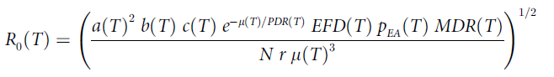

- R0 formula from our 2024 Dengue paper (the formula applies to Chikungunya as well)

Will need to go through to unify parameter names & determine any differences in parameters

Common
Parameter name: Mordecai symbol, Mokhtar symbol
Biting rate: $a, b_{v}$
Transmission rate:$b, β_{hv}$
Infection rate: $c, β_{vh}$
Extrinsic incubation period (EIP): $PDR (this is inverse of EIP), θ_{v}$
# eggs per female: $EFD, θ_{T}$
Egg-Adult survival probability: $p_{ea}, ν_{v}$
Mosquito development rate: $MDR, ϕ$
Adult mosquito mortality: $μ, μ$
Human recovery rate: $r, γ$

Differences
Mordecai:
- N: human density

Mohktar:
- Risk of exposure to Ae. aegypti
- Probability of Ae. aegypti occurenc: $P_{ea}$
- Baseline mosquito-human ratio: $D$
- Carrying capacity related to precipitation: $f(R)$
- Water temperature: $T_{w}$

Thermal parameter functions
Spreadsheet of formatted equations
*To fix due to incompatibilities in the previous formatting for the first 22 equations.*
- Key Features:
  - Some of the equations are piecewise
  - Dana will go through and identify duplicate functions
  - Also identify if functions are parameterized through fitting to single dataset, multiple dataset, lab vs field-based mosquito data, or parameters values from expert opinion (including unrelated literature)

In the supplementary, there should be plots to show the shape of the thermal parameters. This way the readers can see the difference in thermal optimums for each function

Figures/Visualization
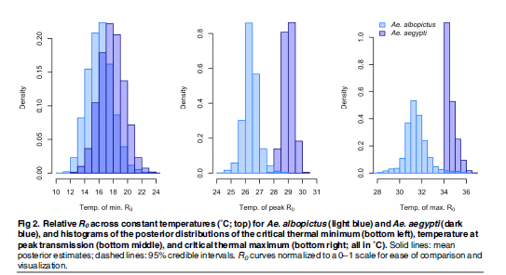
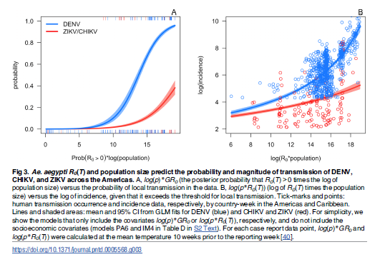

Scripts
Dana’s Wishlist:
- Developed in R.
- Data output in a way that it can be plotted with temperature on the x-axis and R₀ on the y-axis.
- A systematic way of turning on and off temperature-dependent functions for each parameter.

Meeting Notes

06/02/2026

Notes
- Similarities to the previous dengue project, the thermal functional equations
- What happens to the relative R0 when you change these thermal response functions
- Use Mordecai’s Model as the baseline
  - What will happen if you replace one or more of the functional forms with one that has been reported in the literature, to see how that changes the R0 estimate

To-do
- Finalize the table with equations and post to Drive
  - Seperate by Ae. albopitus and Ae. aegypti
- Convert to rates and make sure they are in the same units (duration v. rate)
- Set up an individual meeting with Sina

Things to think about
- How do we quantify the difference between the R0 when we change the thermal response function?
  - Is this change statistically significant?
  - We are comparing the change over temperature, similar to a change over time style o

