## Community COVID-19 risk level consistency rates over time

#### 2 weeks interval

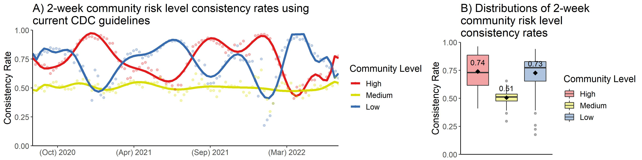

#### 3 weeks interval

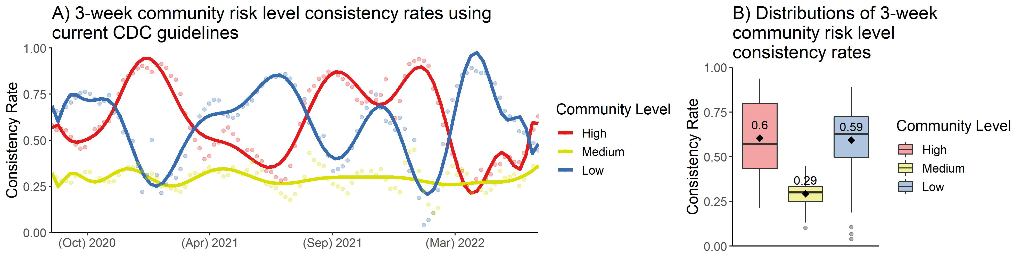

#### 4 weeks interval

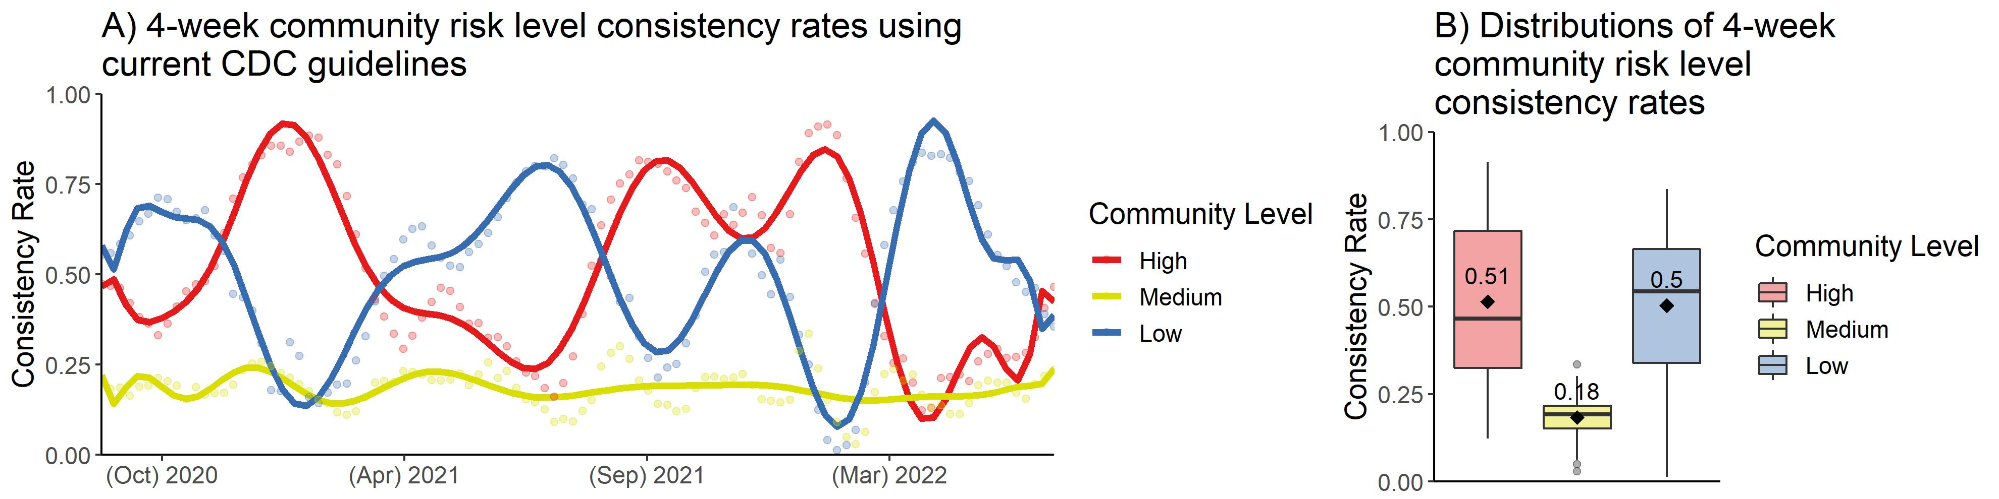

## Community risk level consistency rates with alternative threshold for low risk level

#### 2 weeks interval

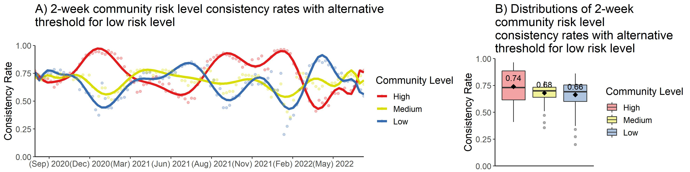

#### 3 weeks interval

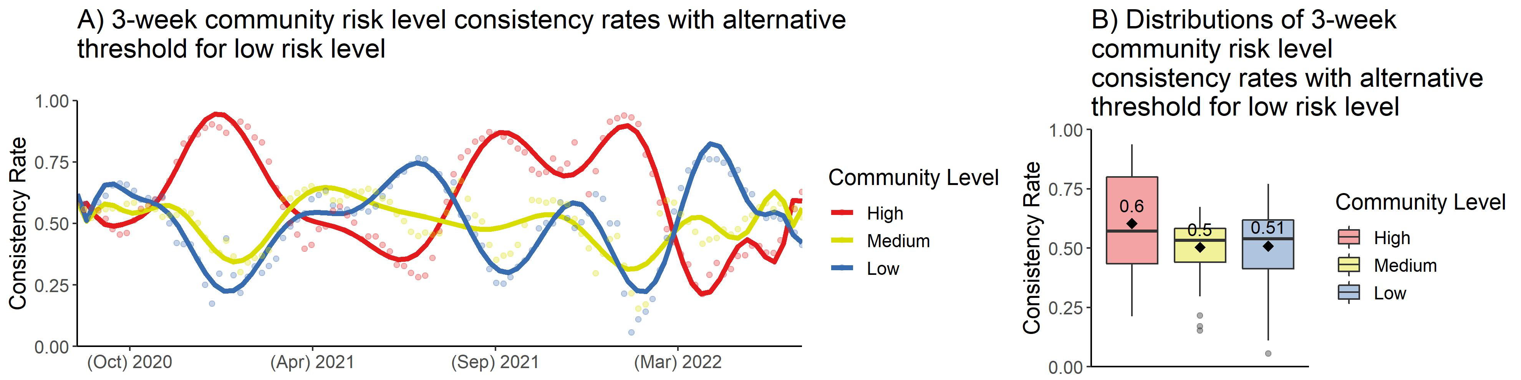

#### 4 weeks interval

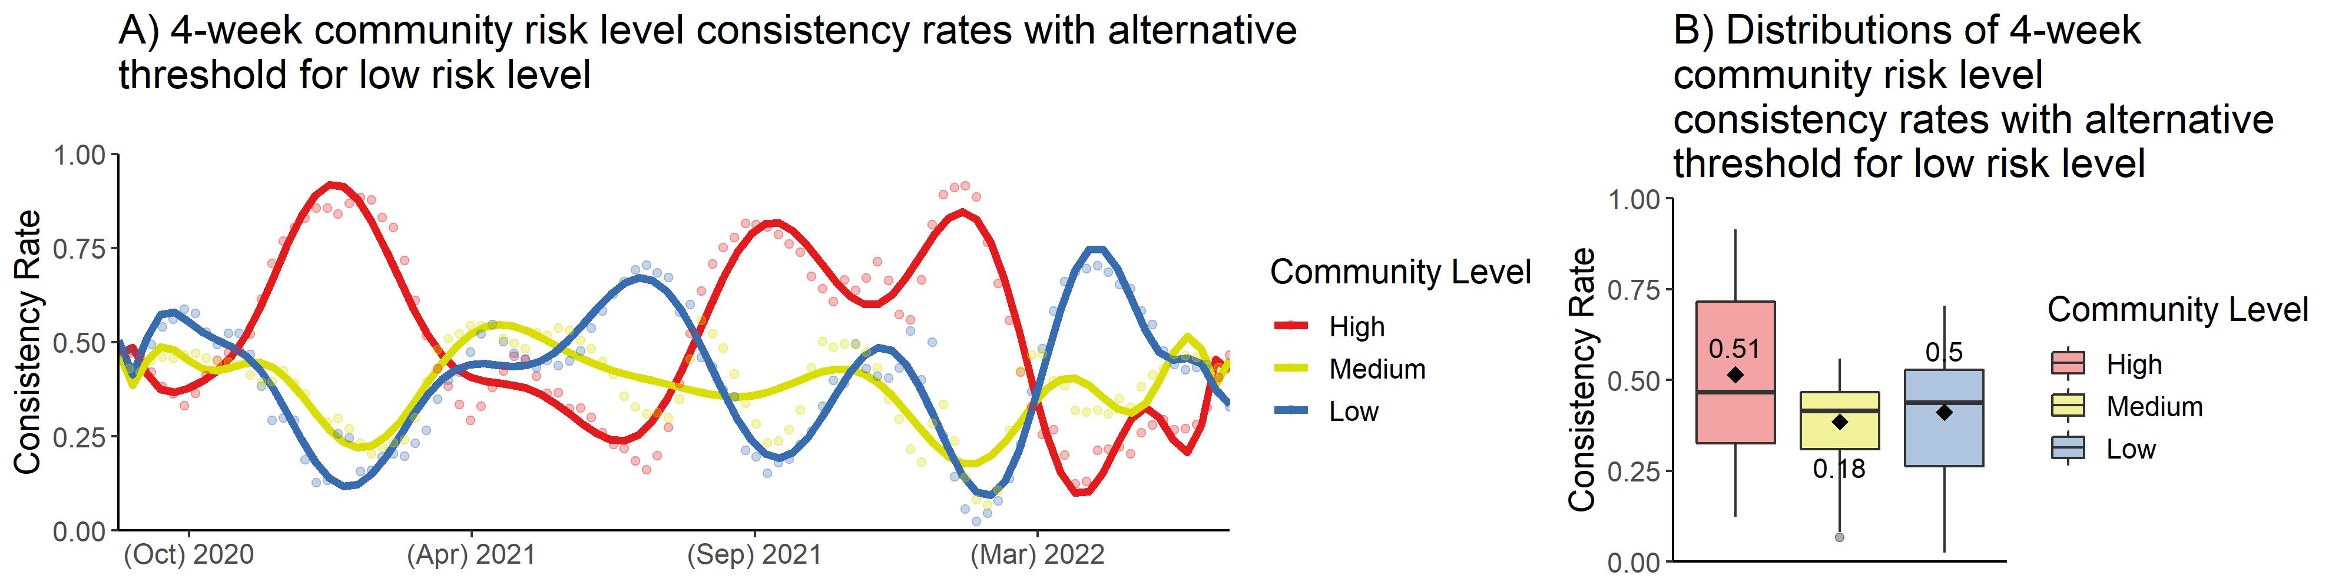

## Weekly variation in county COVID-19 community risk level

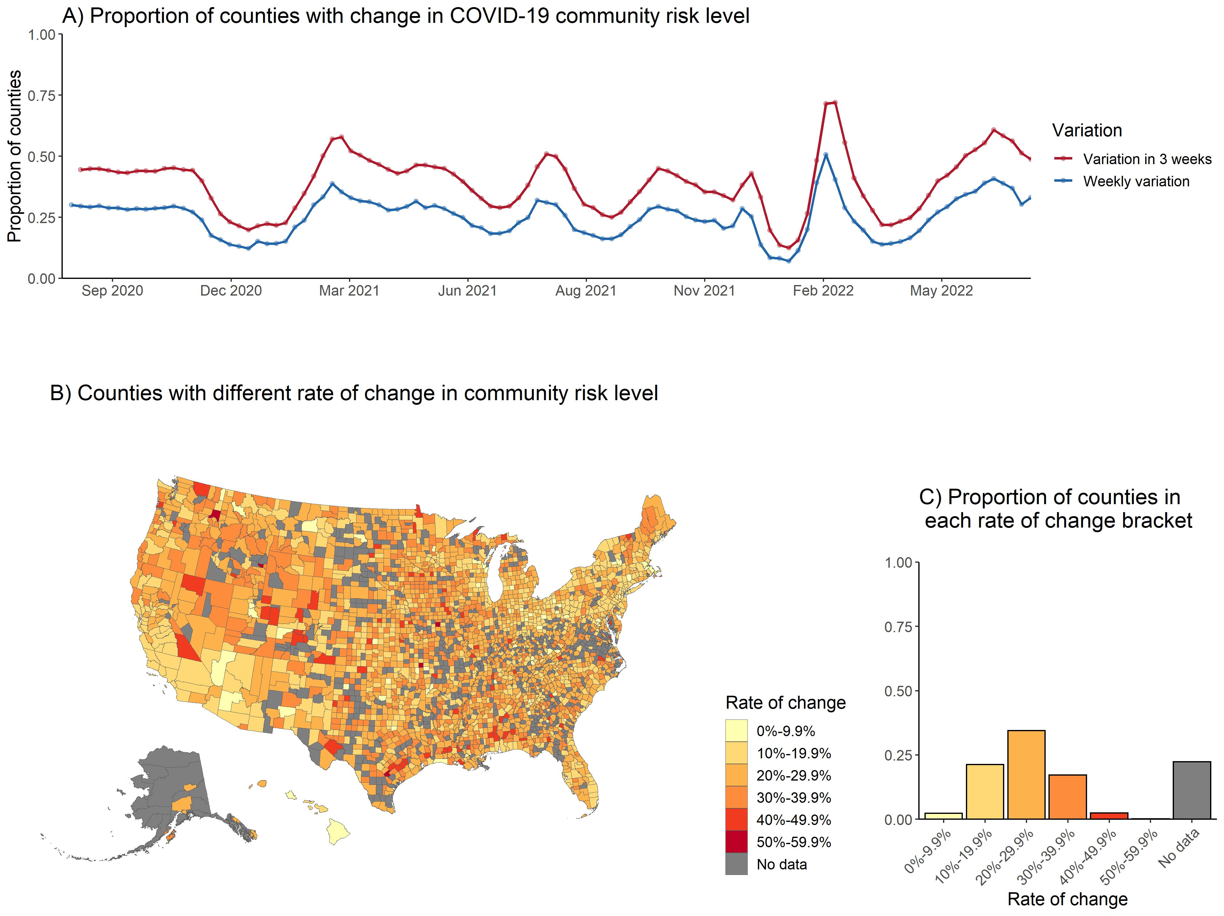

## Community risk level consistency rates for each NCHS Urban-Rural Category

