**Brief:** Write a brief for your project, stating the purpose of the site, key requirements of the client and any key messages they want the site to convey. (150 words max)

The site is for a Masseuse who run’s their own business at home, the clients name is Sharon Jensen. What she wants for the website is a simple webpage that provides sufficient information to the customers who wish to know what kind of treatments that she offers.

Key requirements that the client insists on having in the website is only that there is information about what she does as a masseuse, what her prices are, and where people can contact her.

**Research *:** Once you have found your client you need to complete research to answer the following questions.

What examples of similar web sites exist?

<http://www.mvmassage.nz/>

<https://clinic25.co.nz/>

<https://thaitouch.co.nz/#1>

<https://www.leelawadee-thaimassage.nz/>

<http://www.handstoheal.com/>

What are the key items to include in such a site?

* Logo
* Business Name
* Contact Information
* Basic Information
* Accessible Webpages
* Easy viewing
* Welcome message
* Photos
* List of treatments
* Acceptable colouring

What special requirements does your client have?

* Supply sufficient information that tells customers about what the client does in terms of treatment

What current web design trends apply to this kind of site?

* Gradients & Duotones
* Vibrant Colours

The evidence of this research will be included in your site documentation as a markdown file. Links to sites can be included, (400 words max), copied text needs to be referenced correctly.

**Specifications:** Write a specification list for your site. This should be based on your research findings and your discussions with your client. (5 – 15 items)

* Logo
* Navbar
* Home Page
* Contact Page
* Headings
* Descriptions
* Supporting Images
* Social Media Links
* Background Images
* Footer
* Google Maps Location
* Theme based colouring

**3 High Fidelity Wireframes:** Based on the findings of your research you are to produce three high fidelity wireframes from which your client will select one for the site. The wireframes should give an idea of layout, navigation, colours, fonts types and sizes, and types and size of images used.

High Fidelity Wireframe 1:

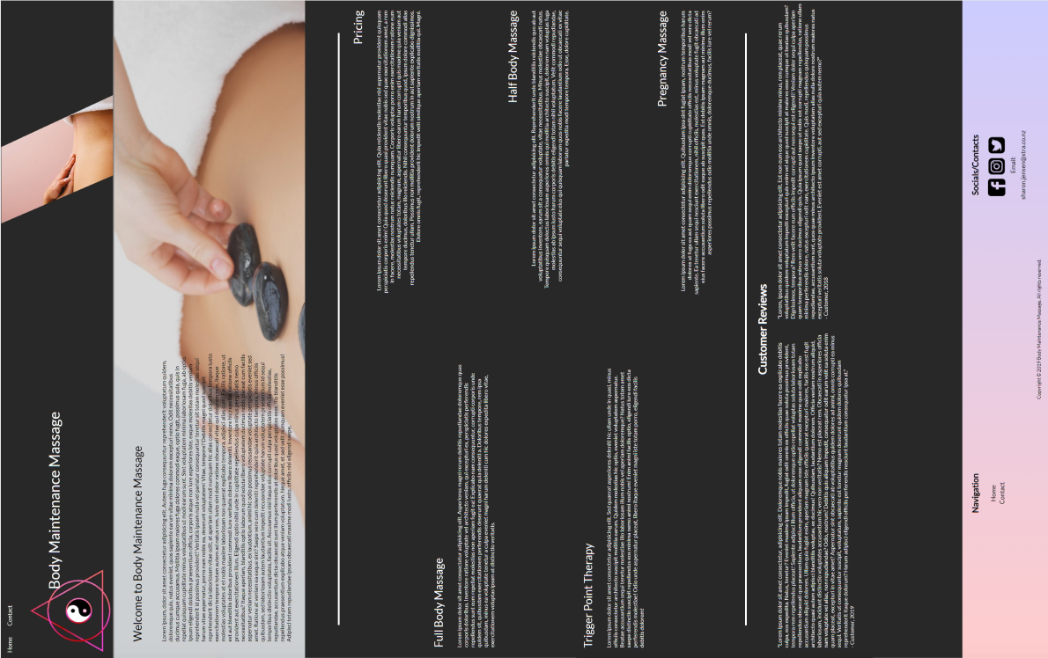

High Fidelity Wireframe 2:

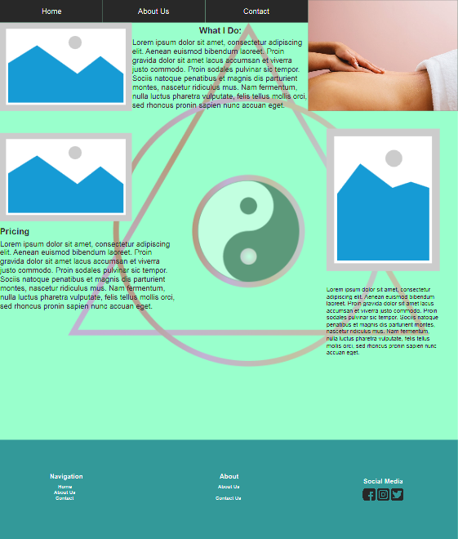

High Fidelity Wireframe 3:

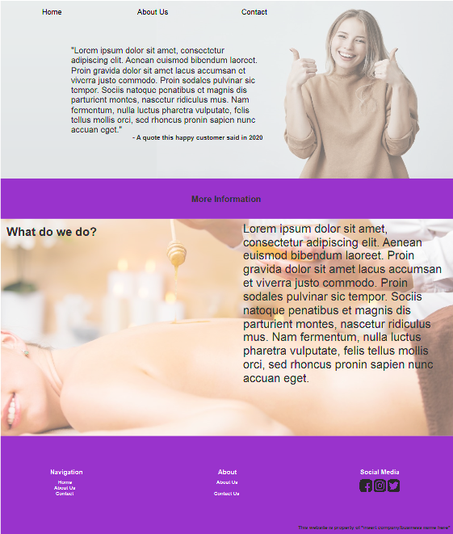

**Product Backlog:** Create a list of all tasks required to complete to meet the specifications above. (User stories?). Estimate and allocate the time required for each task. Record this in the format of your choice and include with your documentation, possible templates to use will be discussed in class. If you are unable to estimate the time for a task, break the task down further.

**Progress Log:** Work through your product backlog, noting any major issues as you go. Use a format of your choice to record this. Templates will be discussed with your tutor

|  |  |  |  |
| --- | --- | --- | --- |
| Task No. | Primary Task | Time Allocated for Task | Notes |
| 1 | Make Navbar consisting of 2 tabs | 5 Minutes |  |
| 2 | Create Grid Layout | 30 Minutes – 1 Hour | Used on the home page, proved to be very useful in terms of allowing the rows to use multiple amounts of text |
| 3 | Add Headings | 45 Minutes – 1 Hour | Both Headings and Subheadings were formatted correctly with appropriate font sizing. |
| 4 | Add Subheadings | 10 Minutes |
| 5 | Add Page Breaks | 1 Hour | Webpage was formatted to have multiple sections. Layout came out great in my opinion |
| 6 | Add Images | 10 Minutes | Finding appropriate images was a difficult task considering the internets “massage hehe” ideals.  However the images found came out great and useful for the website. |
| 7 | Format Images | 10 Minutes |  |
| 8 | Format Sections | 1 Hour – 2 Hours | Tinkering with the height of certain aspects was needed to allow the website to have no breaks in the page |
| 9 | Create Footer | 1 Hour 30 Mins – 2 Hours | Found an issue where the footer wouldn’t stay at the bottom of the page |
| 10 | Format Footer layout | 20 Minutes | Columns of the footer wouldn’t respond after having certain parts of the columns being deleted |
| 11 | Add Links to Social Media in Footer | 5 Minutes | Resizing of the social media icons was easy with the use of display: inline-block |
| 12 | Link Navigation links to pages in footer | 5 Minutes | Relatively easy, took a bit of mucking around with the code to make sure that the text on the footer was linked to the pages. |
| 13 | Add Columns | 10 Minutes | Used at the bottom of the page for *“Customer Reviews”* |
| 14 | Add Rows | 10 Minutes |
| 15 | Format Colouring | 30 Minutes |  |
| 16 | Use Container div for text formatting | 10 Minutes | Container div is primarily used for the welcome message of the homepage. The subcontainer uses grid’s for the text to be in 2 evenly spaced paragraphs. |
| 17 | Use Sub Container div for text formatting | 10 Minutes |
| 18 | Add Website business name on banner | 5 Minutes |  |
| 19 | Format headings for text alignment | 30 Minutes | Padding & margins were used to keep the text in the desired space. |
| 20 | Format subheadings for text alignment | 30 Minutes |

**Execution:**

**Testing:** Create and carry out a basic test plan for your site. You are advised to test as you go and keep a record of this. Test templates will also be discussed with your tutor.

|  |  |  |
| --- | --- | --- |
| Test Plan | | Pass/Fail |
| 1 | Is the webpage responsive on a smartphone | Fail |
| 2 | Is webpage responsive on a tablet | Pass |
| 3 | Do the navbar buttons work | Pass |
| 4 | Do the navigation links on the footer work | Pass |
| 5 | Do the social media icons have the correct websites linked to them | Pass |
| 6 | Do the social media icons when clicked take you to the website that is linked to that specific icon | Pass |
| 7 | Are the Sections of the webpage formatted correctly | Pass |
| 8 | Does the footer stay at the bottom of the page | Pass |
| 9 | Do images scale correctly | Pass |
| 10 | Is the contact page accessible from both the navbar and the footer navigation column | Pass |
| 11 | Does the contact page have correctly formatted headings, subheadings, supporting text | Pass |
| 12 | Is the contact page responsive | Fail |

|  |  |
| --- | --- |
| **Assignment 1: Deliverables** | |
| **1** | Client identified |
| **2** | Research document included in repo as md file, repo link supplied **\*** |
| **3** | Brief included in site documentation |
| **4** | Specification included in site documentation |
| **5** | 3 High Fidelity Wireframes included in site documentation |
| **6** | Product Backlog included in site documentation |
| **7** | Testing plan included in site documentation |
| **8** | Notes made against product backlog recording progress |
| **9** | Site including 2 pages, text, images and formatting included. |