

**Date: - 24/06/2020**

**COMP.6210**

**Web Services and Design Methodologies**

Assignment 1

**Kiran Shrestha**

Student No: - 30011956

Date: - 03/09/2020

Toi Ohomai Institute of Technology

Table of Contents

**Screenshot**

**PC ---------------------------------------------------------------------------------------------------3**

**Mobile ---------------------------------------------------------------------------------------------5**

|  |  |
| --- | --- |
| **Name** | **Kiran Shrestha** |
| **Student ID** | **30011956** |
| **cPanel**  **Username** | **a30011956** |
| **cPanel**  **password** | **toiohomai1234** |
| **cPanel**  **URL** | <https://cpanel.labnet.nz/cpsess6084934719/frontend/paper_lantern/index.html> |
| **GitHub**  **URL** | <https://github.com/30011956KiranShrestha/COMP.6210> |

**Screenshot: -s**

**PC**

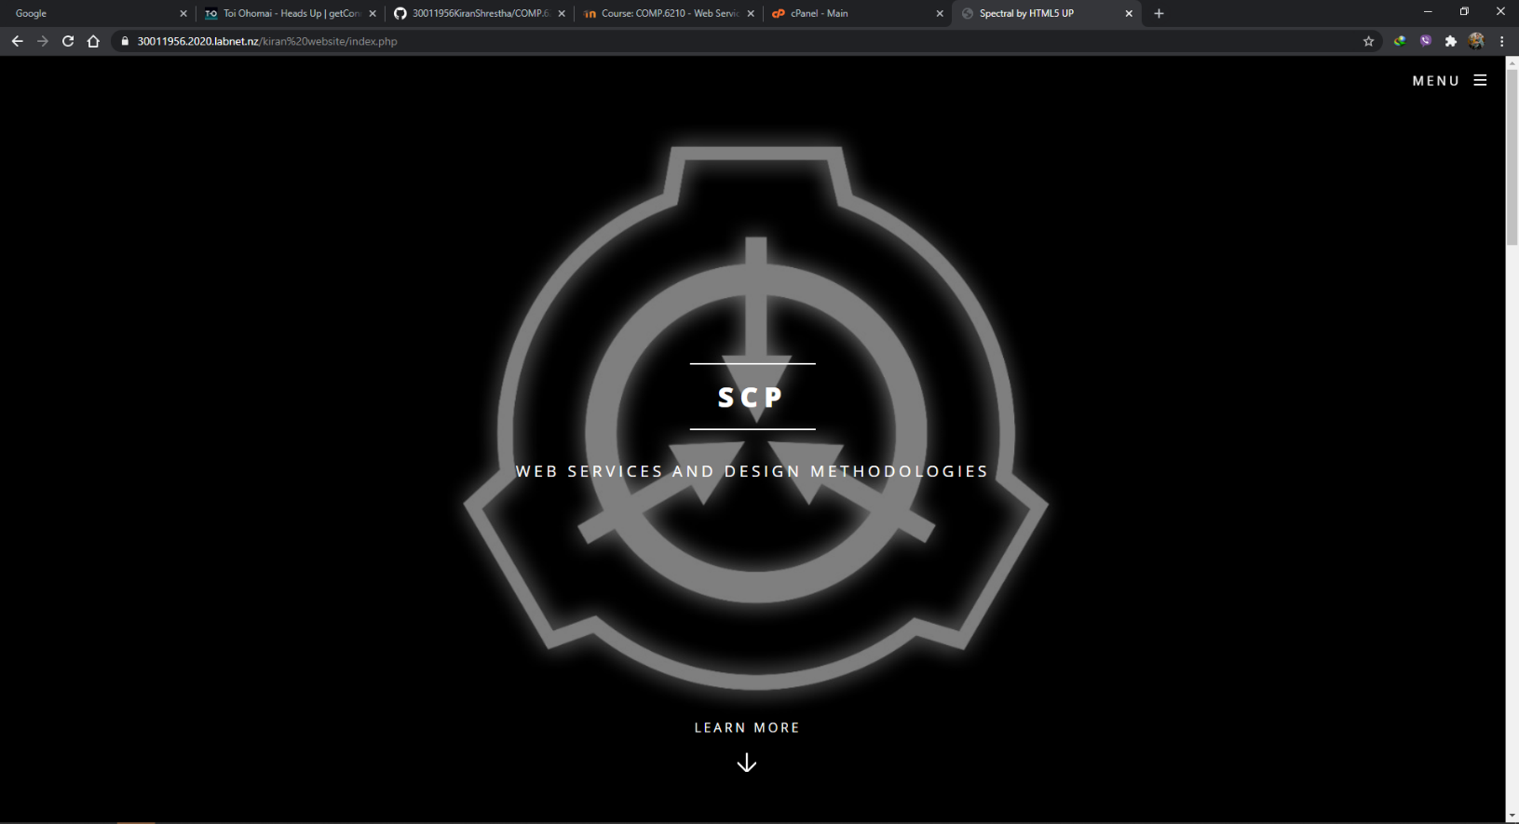

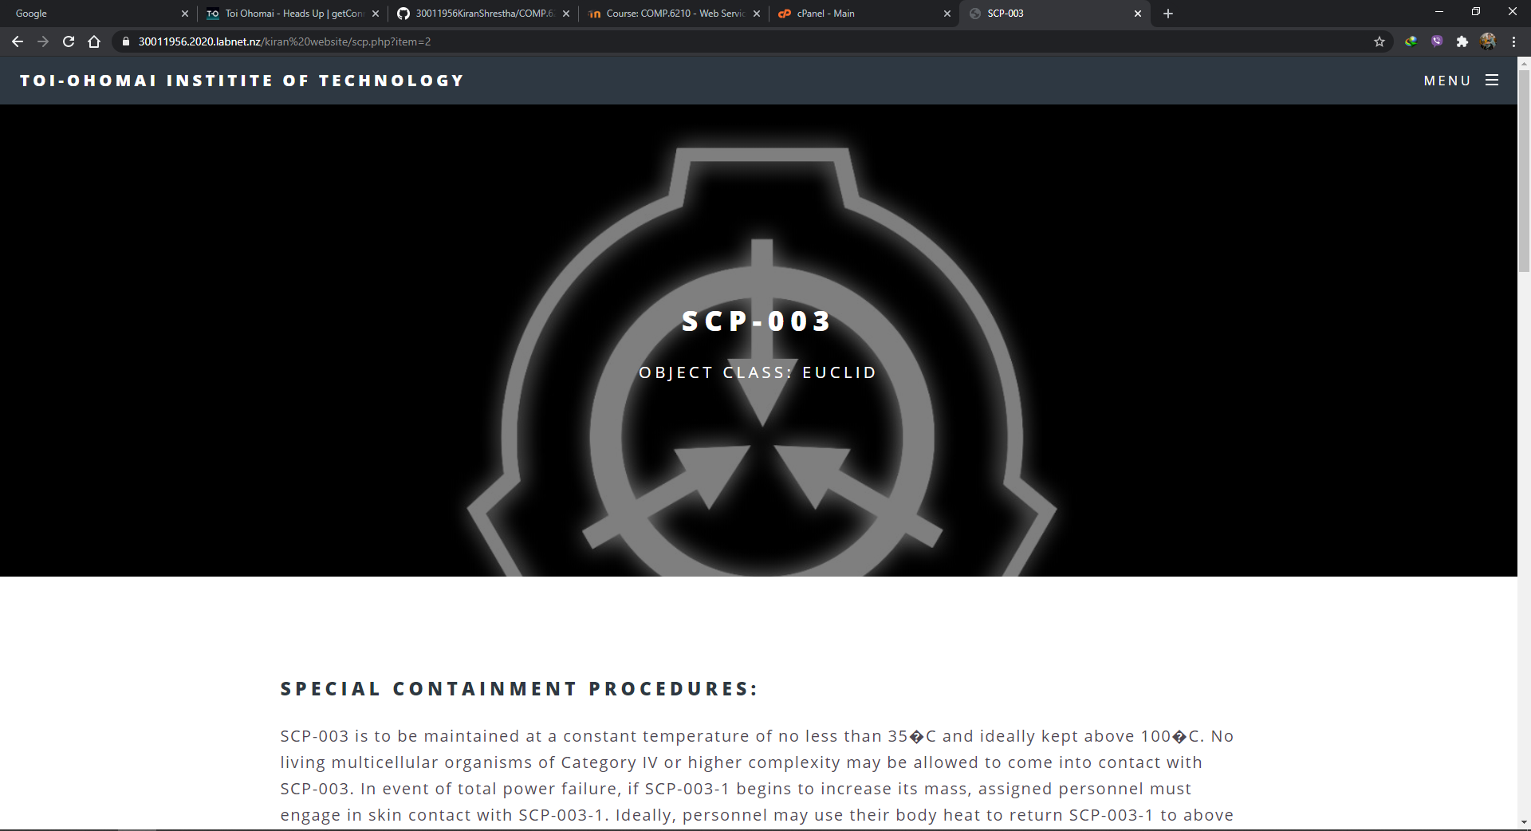

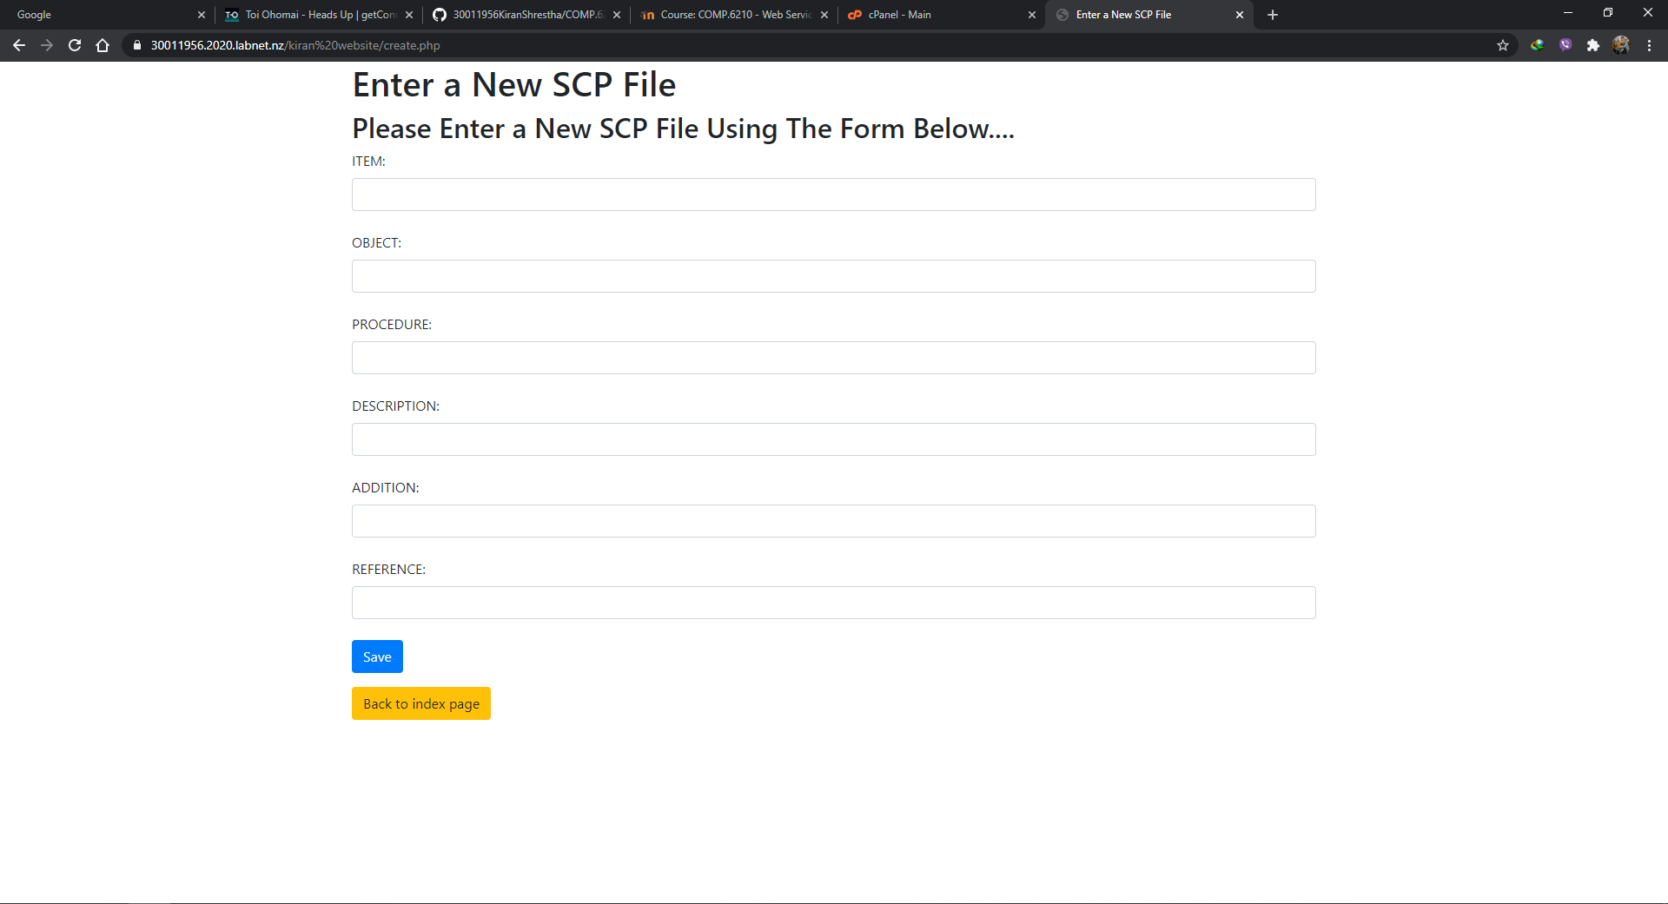

**Mobile: -**

