**Brief**

This website is for an eSports organization with a CSGO team. The purpose of the site is to advertise their team, organization, sponsors and to give their fans somewhere to see game times, whos currently on the team and a place to buy team merch. The key requirements are to have a home page showing match times, a page about the team, a page for sponsors and shop to sell team jerseys.

**Research**

In order to meet the clients need i did some research here are some relevant sites.

[**http://www.nrg.gg**](http://www.nrg.gg) **,** [**http://www.nrg.gg/csgo**](http://www.nrg.gg/csgo)

[**https://www.teamliquid.com/**](https://www.teamliquid.com/) **,** [**https://www.teamliquid.com/players#csgo**](https://www.teamliquid.com/players#csgo)

[**https://www.cloud9.gg/**](https://www.cloud9.gg/) **,** [**https://www.cloud9.gg/pages/cs-go**](https://www.cloud9.gg/pages/cs-go)

[**https://astralis.gg/**](https://astralis.gg/)

[**https://www.fnatic.com/**](https://www.fnatic.com/) **,** [**https://www.fnatic.com/teams/csgo**](https://www.fnatic.com/teams/csgo)

**Specifications**

1. Match times
2. Sponsors
3. Player profiles
4. Shop
5. Links to social media

**High Fidelity Wireframes**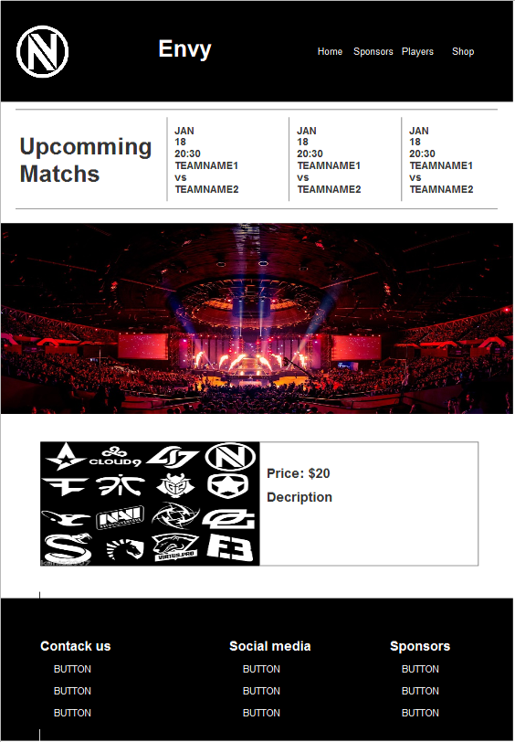

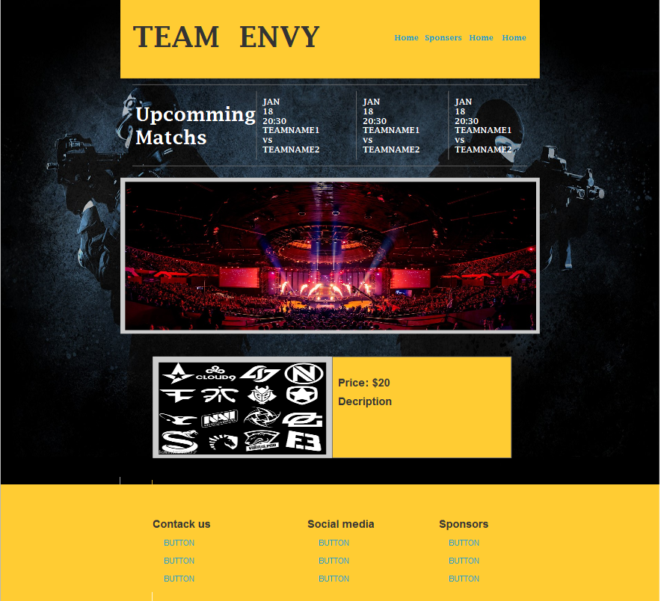

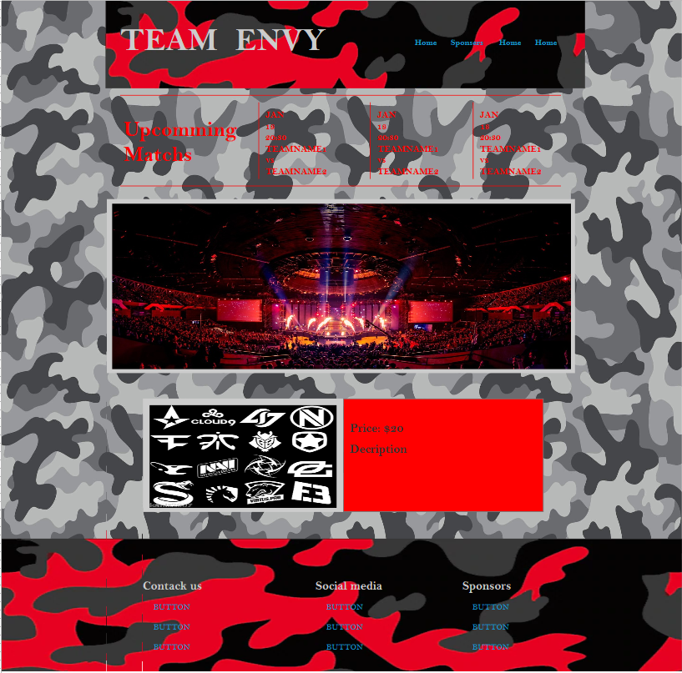

**Product Backlog**

|  |  |  |
| --- | --- | --- |
| TaskN.O | Task | Sub Tasks |
| 1. | Page Grid For Home Page | Header, Navbar, Upcoming Events, Slideshow, Footer |
| 2 | Style Navbar | Logo, Team Name, Links |
| 3 | Upcoming Events Bar | Style Lines, Style Text, |
| 4 | Slideshow | Get Images, Code Script |
| 5 | Footer | Style Footer, Style Heading, Style Links, |
| 6 | Page Grid For Team Page | Header, Navbar, Player Cards, Footer |
| 7 | Make Player Cards | Images, Description, Social Media Links |
| 8 | Embedded Tweets | Make Grid, Style, |
| 9 | Page Grid For Sponsors Page | Header, Navbar, Content, Footer |
| 10 | Page Grid For Shop Page | Header, Navbar, Content, Footer |
| 11 | Complete Test Plan | Browser Support, Styled correct, Links |
| 12 |  |  |
| 13 |  |  |
| 14 |  |  |

**Testing**

|  |  |
| --- | --- |
| **Assignment 1: Deliverables** | |
| **1** | Client identified |
| **2** | Research document included in repo as md file, repo link supplied **\*** |
| **3** | Brief included in site documentation |
| **4** | Specification included in site documentation |
| **5** | 3 High Fidelity Wireframes included in site documentation |
| **6** | Product Backlog included in site documentation |
| **7** | Testing plan included in site documentation |
| **8** | Notes made against product backlog recording progress |
| **9** | Site including 2 pages, text, images and formatting included. |

|  |  |  |  |  |
| --- | --- | --- | --- | --- |
| N.O | Test | Expected Result | Actual Result | Pass/Fail |
| 1 | Load website on Chrome | It Loads with no errors | It Loads with no errors | Pass |
| 2 | Load website on FireFox | It Loads with no errors | It Loads with no errors | Pass |
| 3 | Load website on Opera | It Loads with no errors | It Loads with no errors | Pass |
| 4 | Load website on Edge | It Loads with no errors | It Loads with no errors | Pass |
| 5 | Is Navbar styled correctly | Navbar is correctly styled on all pages | Navbar is correctly styled on all pages | Pass |
| 6 | Do Navbar Links Link correctly other Pages | All Navbar links work on all pages | All Navbar links work on all pages | Pass |
| 7 | Does Slideshow Work | All images load a cycle automatically | All images load a cycle automatically | Pass |
| 8 | Footer is styled Correctly | Footer is correctly styled on all pages | Footer is correctly styled on all pages | Pass |
| 9 | Footer links work | All Footer links work on all pages | All Footer links work on all pages | Pass |
| 10 | Contact form Loads | Contact form loads when you click contact us | Contact form loads when you click contact us | Pass |
| 11 | Contact form is styled correctly | Contact form is styled correctly on all pages | Contact form is styled correctly on all pages | Pass |
| 12 | Contact Form Submit Button | Sends you back to index.html without breaking website | Sends you back to index.html without breaking website | Pass |
| 13 | Player Card links | Social Media links should work | Social Media links should work | Pass |
| 14 |  |  |  |  |
| 15 |  |  |  |  |