COMP.5210

Web Application Implementation

Project

Assignment 2 – Semester 1 2019

**Jacques Rockell (30013256)**

**Task 1 : Responsive Design**

Desktop



Tablet



Mobile



## 

## 

## 

**Task 3: Data Collection and Display**

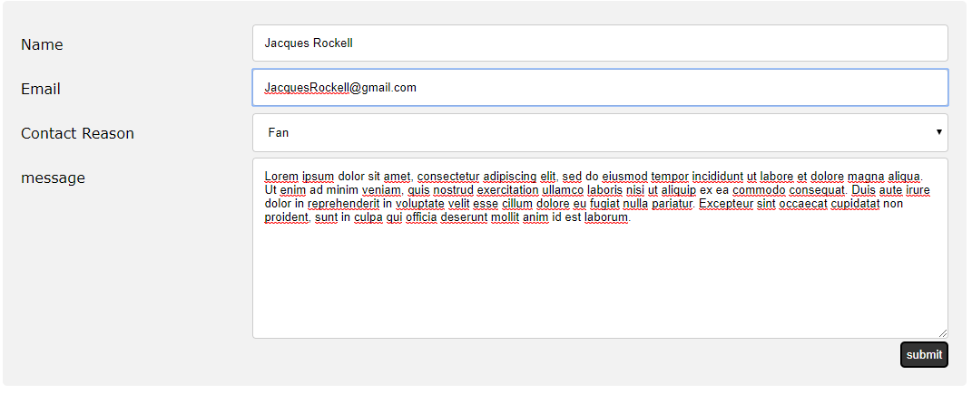

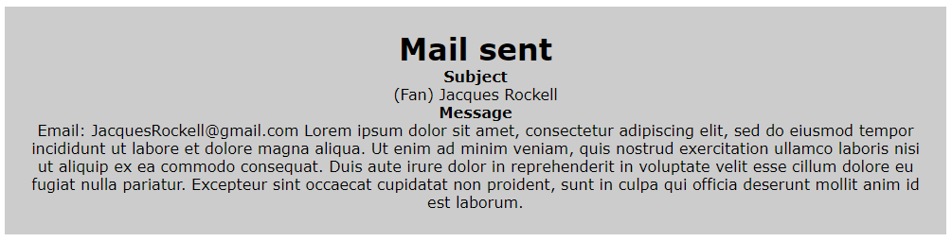

## **Task 4: Code Validation and Content**



 

 

 

 

 

 

 

 

 