5210 Assignment 1

Client Website

Kris Boyte

30016677

Contents

Brief 2

Specifications 2

Research 2

Hi Fidelity Wireframes 4

Backlog 7

Testing 8

# Brief

PF Automotive is a Tauranga based auto mechanic specialising in Subaru vehicles. They provide wofs, repairs, performance installs, pre-purchase inspections, and general maintenance services. PF Automotive have been operating in the bay for 35 years, and have no dedicated website, relying on word of mouth and very minimal advertising.

A dedicated website would increase their reach and expand their customer base. The website needs to be informative, practical, and enticing. In the auto mechanic market, trust and reliability need to be established with customers. A personal connection to the customer is a technique I have noticed through research to establish trust and reliability. A personal connection can be established on the website using friendly faces and personal messages from the owner and workers of the shop.

# Specifications

Based on my research of PF Automotive, their competitors and other similar sites, the requirements of PF Automotive’s new website would be:

* A simple to use contact form, and clearly displayed store details (phone, location, hours). Store contact details need to be quick for the user to find.
* A list of services provided - to inform user.
* About section, with information about the owner - to establish a connection with the customer

When it comes to styling, my interaction with the owner of PF Automotive gave me the impression that a more traditional website would be preferred, with clear links and details.

# Research

Bay Automotive. <https://bayautomotive.co.nz/>

General automotive services. Wide coverage of. Also European specialists.

Targets a wide audience - family, enthusiast. Establishes a personal connection. With lots of faces in pictures.

Design: Modern. Large pictures that take up full width. Black and white with one accent. Text is broken up into small chunks.

Sub Tech <https://www.subtech.co.nz/>

Independent Subaru service centre. Subaru specialist

Targets the enthusiast audience. Focus on performance.

Way too many nav links. Most of them can be combined.

Design: Modern. Large pictures that take up full width, but content takes up less than full width. Content is broken up into small chunks separate by images. Black and white with one accent.

Oil Changers <https://www.oilchangers.co.nz/>

General automotive services centred around transmission and oil changes.

Wide target audience.

Design: Traditional. Lots of information. Takes too much time to navigate. Simple white background with black text.

# Hi Fidelity Wireframes

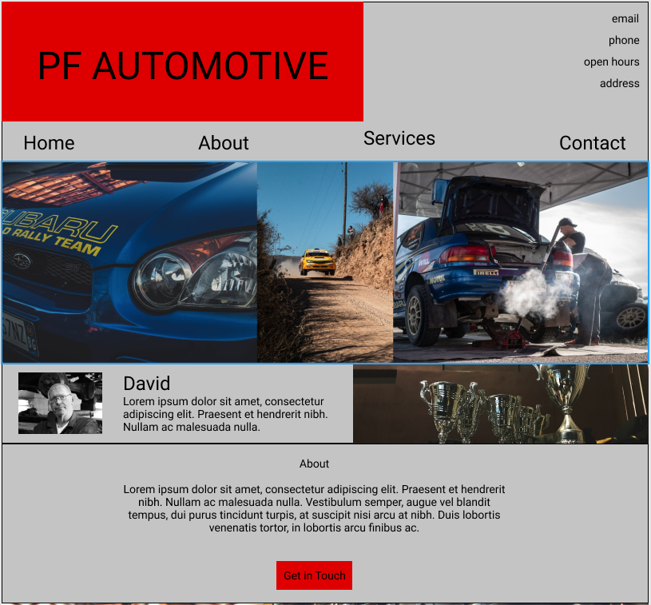

This is a one-page design. The navigation links scroll to the sections on the page rather than loading a new page.

This design keeps with the theme of a straightforward website, while still presenting itself as modern.

This was the design that the client and I agreed on moving forward.

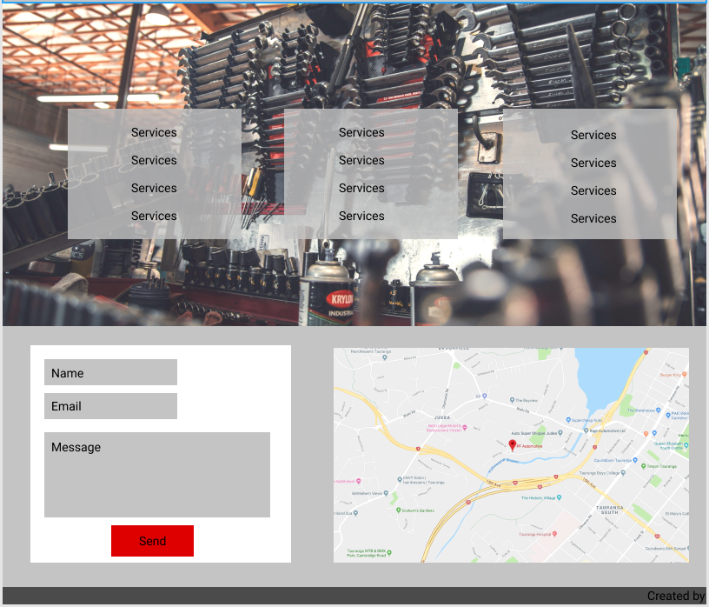

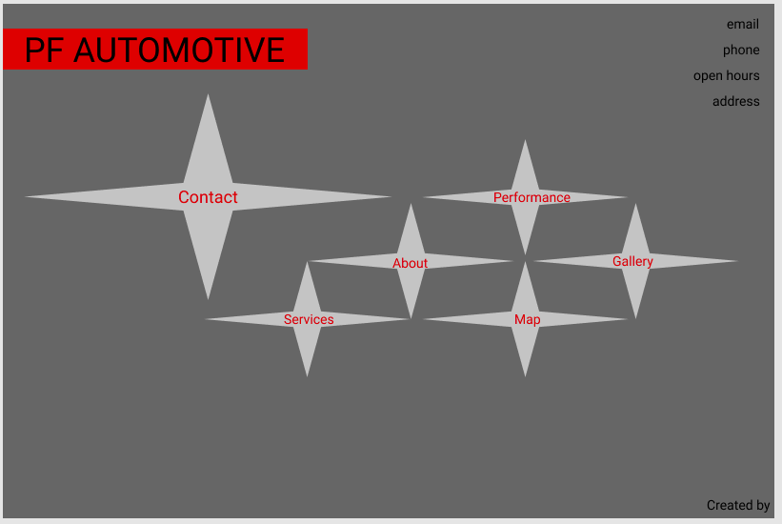

This design fills the page. The stars represent the Subaru badge. When clicked, they expand, and the content appears in the middle depending on what star is selected.

This is a more conceptual idea that relies heavily on JavaScript for animations and other features. After talking to my client, it was clear that this was not within the scope of a clear, simple website.

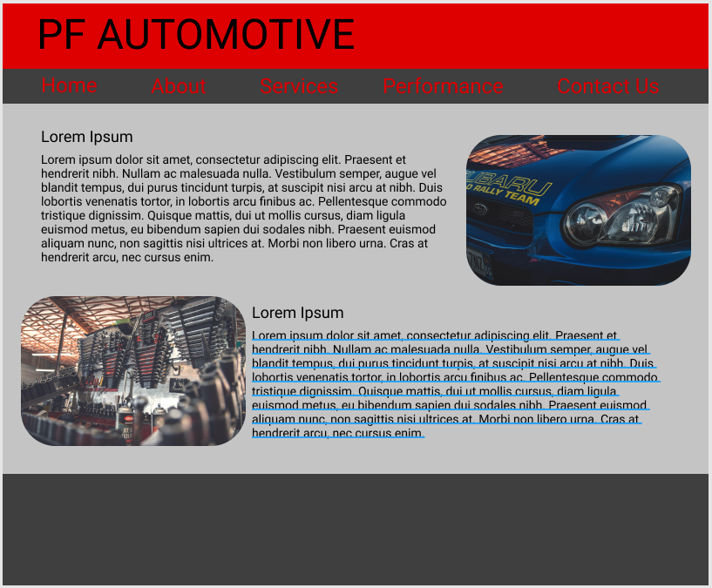

This design was the most traditional. It is similar in design to many of my client’s competitors’ existing websites. Lots of information and pictures.

Between my client and I, it was decided that this design was not concise enough and appears dated.

# Backlog

|  |  |  |  |
| --- | --- | --- | --- |
| **Task** | **Difficulty** | **Time (mins)** | **Notes** |
| **Outline Sections** | | | |
| Frame and section spacing | 1 | 20 |  |
| Banner and nav | 1 | 15 |  |
| Image | 1 | 30 | While this step was relatively easy, it took some time to source and format the images |
| About | 2 | 20 |  |
| services | 2 | 20 |  |
| contact | 3 | 40 | Had to learn how to use and style html forms |
| footer | 1 | 5 | Very basic footer |
| **Visual Design Sections** | | | |
| banner and nav | 2 | 30 | Used the <polygon> tag to create the banner image, which was new to me. |
| image | 2 | 20 |  |
| about | 2 | 30 |  |
| services | 2 | 30 |  |
| contact | 2 | 30 |  |
| footer | 1 | 5 |  |
| Fonts | 1 | 10 | Had to learn how to import custom fonts. Didn't turn out to be very difficult |

|  |  |
| --- | --- |
| **Task category** | **Time** |
| Outline | 2hr 30min |
| Design | 2hr 35min |
| Total | 5hr 5min |

# Testing

|  |  |  |  |
| --- | --- | --- | --- |
| Test case 1: Navigation Links | | | |
| Test Data | Expected result | Actual Result | Pass/Fail |
| Contact link | Should scroll to the contact section | Scrolls to contact section | Pass |
| Services link | Should scroll to the services section | Scrolls to services section | Pass |
| About link | Should scroll to the about section | Scrolls to about section | Pass |
| Home link | Should scroll to the home section | Scrolls to the top of the page | Pass |

|  |  |  |  |
| --- | --- | --- | --- |
| Test case 2: Different browsers | | | |
| Test Data | Expected result | Actual Result | Pass/Fail |
| Google Chrome version 76.0.3809.132 | All elements should load and work as intended. Images, fonts, links | All elements load and work as intended. | Pass |
| Firefox version 68.0.2 | All elements should load and work as intended. Images, fonts, links | Most elements work. Links that don’t use custom anchors don't scroll smoothly | Fail |
| Opera version 63.0.3368.71 | All elements should load and work as intended. Images, fonts, links | All elements load and work as intended. | Pass |
| Edge version 44.18362.267.0 | All elements should load and work as intended. Images, fonts, links | Most elements work. Edge does not support smooth scroll | Fail |

|  |  |  |  |
| --- | --- | --- | --- |
| Test case 3: Responsive design | | | |
| Test Data | Expected result | Actual Result | Pass/Fail |
| Desktop view | All elements should display as intended. | All elements display as intended. | Pass |
| Large tablet view | All elements should display as intended. | All elements display as intended. | Pass |
| Small tablet or large phone view | All elements should display as intended. | Some elements break out of their containers. | Fail |
| Small phone view | All elements should display as intended. | Most elements break out of their containers. | Fail |