

[Document title]

[Document subtitle]



November 3, 2019

Lukas jeremias roessner

30021032

Table of Contents

Introduction 2

Physical Design 3

Data Volume Map 3

Tables SQL Commands 4

Data Insert Commands 4

Database Diagram 4

Index Files 4

Possible De-Normalization 4

Reports 4

List of Clients 4

List of Scheduled Vets 4

Data Dictionary 4

EMPLOYEE 4

ROOM 4

TIMESLOT 4

VET 4

SPECIALITY 4

SITE 5

VS 5

CLIENT 5

ANIMAL 5

SCHEDULE 5

CALL_SCHEDULE 5

TREATMENT 6

# Introduction

The intro

# Physical Design

## Data Volume Map

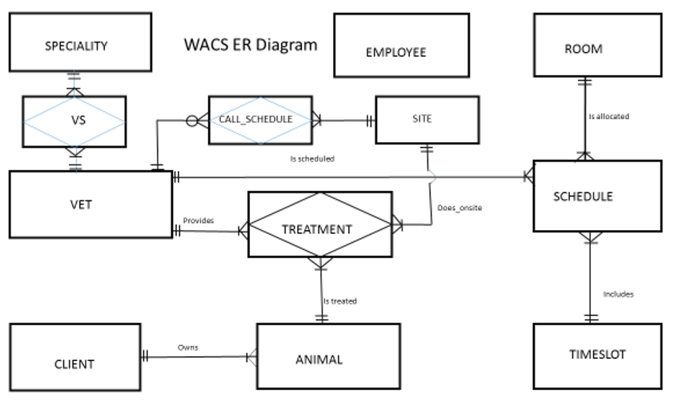

Employee: 10  
Client: 15,000  
Animal: 12,000  
Vet: 8  
Room: 4  
Specialty: 12  
Timeslot: 8  
Schedule: 240 (30 days ahead)  
Site: 200  
Call Schedule: 800 (4 per site)  
VS: 36 (each vet has 3 specialties)  
Treatment: 22,800

## Tables SQL Commands

## Data Insert Commands

## Database Diagram

## Index Files

## Possible De-Normalization

## Reports

### List of Clients

### List of Scheduled Vets

## Data Dictionary

### EMPLOYEE

|  |  |  |  |  |
| --- | --- | --- | --- | --- |
| Column | Data Type | References | Default | Not Null |
| E# | int |  | identity |  |
| E_Firstname | varchar(40) |  |  |  |
| E_Surname | varchar(40) |  |  |  |
| StreetNo | varchar(10) |  |  |  |
| StreetName | varchar(50) |  |  |  |
| Suburb | varchar(50) |  |  |  |

### ROOM

|  |  |  |  |  |
| --- | --- | --- | --- | --- |
| Column | Data Type | References | Default | Not Null |
| R# | int |  | identity |  |
| RoomName | varchar(30) |  |  |  |

### TIMESLOT

|  |  |  |  |  |
| --- | --- | --- | --- | --- |
| Column | Data Type | References | Default | Not Null |
| Slot# | int |  | identity |  |
| Fromm | TIME(0) |  |  |  |
| Too | TIME(0) |  |  |  |

### VET

|  |  |  |  |  |
| --- | --- | --- | --- | --- |
| Column | Data Type | References | Default | Not Null |
| V# | int |  | identity |  |
| V_Firstname | varchar(40) |  |  |  |
| V_Surname | varchar(40) |  |  |  |
| StreetNo | varchar(10) |  |  |  |
| StreetName | varchar(50) |  |  |  |
| Suburb | varchar(50) |  |  |  |
| ContactNo | varchar(35) |  |  |  |

### SPECIALITY

|  |  |  |  |  |
| --- | --- | --- | --- | --- |
| Column | Data Type | References | Default | Not Null |
| SP# | int |  | identity |  |
| Description | varchar(200) |  |  |  |

### SITE

|  |  |  |  |  |
| --- | --- | --- | --- | --- |
| Column | Data Type | References | Default | Not Null |
| Site# | int |  | identity |  |
| SiteType | varchar(25) |  |  |  |
| StreetNo | varchar(10) |  |  |  |
| StreetName | varchar(50) |  |  |  |
| Suburb | varchar(50) |  |  |  |

### VS

|  |  |  |  |  |
| --- | --- | --- | --- | --- |
| Column | Data Type | References | Default | Not Null |
| V# | int | VET |  |  |
| SP# | int | SPECIALITY |  |  |

### CLIENT

|  |  |  |  |  |
| --- | --- | --- | --- | --- |
| Column | Data Type | References | Default | Not Null |
| C# | int |  | identity |  |
| C_Firstname | varchar(40) |  |  |  |
| C_Surname | varchar(40) |  |  |  |
| StreetNo | varchar(10) |  |  |  |
| StreetName | varchar(50) |  |  |  |
| Suburb | varchar(50) |  |  |  |
| ContactNo | varchar(35) |  |  |  |

### ANIMAL

|  |  |  |  |  |
| --- | --- | --- | --- | --- |
| Column | Data Type | References | Default | Not Null |
| A# | int |  | identity |  |
| AName | varchar(60) |  |  |  |
| C# | int | CLIENT |  |  |

### SCHEDULE

|  |  |  |  |  |
| --- | --- | --- | --- | --- |
| Column | Data Type | References | Default | Not Null |
| Sch# | int |  | identity |  |
| V# | int | VET |  | Y |
| Slot# | int | TIMESLOT |  | Y |
| R# | int | ROOM |  | Y |
| Oncall | ?? |  |  |  |

### CALL_SCHEDULE

|  |  |  |  |  |
| --- | --- | --- | --- | --- |
| Column | Data Type | References | Default | Not Null |
| V# | int | VET |  |  |
| Site# | int | SITE |  |  |
| Fromm | TIME(0) |  |  |  |
| Too | TIME(0) |  |  |  |

### TREATMENT

|  |  |  |  |  |
| --- | --- | --- | --- | --- |
| Column | Data Type | References | Default | Not Null |
| T# | int |  | identity |  |
| Date_of_Treatment | date |  |  |  |
| V# | int | VET |  |  |
| A# | int | ANIMAL |  |  |
| Site | int | SITE |  |  |
| Treatment_Given | Varchar(200) |  |  |  |