

WACS database physical design

Comp6212 Assignment 2



November 3, 2019

Lukas jeremias roessner

30021032

Table of Contents

Introduction 2

Assumptions 2

Physical Design 2

Data Volume Map 2

Tables SQL Commands 3

Data Insert Commands 5

Database Diagram 11

Index Files 12

Possible De-Normalization 12

Reports (Database Name: Lukas) 12

List of Clients, Animals and Treatments 12

List of Scheduled Vets 13

Data Dictionary 13

EMPLOYEE 13

ROOM 13

TIMESLOT 13

VET 13

SPECIALITY 14

SITE 14

VS 14

CLIENT 14

ANIMAL 14

SCHEDULE 14

CALL_SCHEDULE 15

TREATMENT 15

# Introduction

This Report goes in-depth about the Physical design of a database designed for Wopwop Animal Care Service to keep track of vets, clients, employees, animals, treatments etc.

Database Name: Lukas

# Assumptions

The assumption that a Date_of_Schedule and Date_of_Call_Schedule were needed was made. This assumption has been made to record the date of when a client is scheduled to come in or a vet is scheduled to do a call out.

# Physical Design

## Data Volume Map

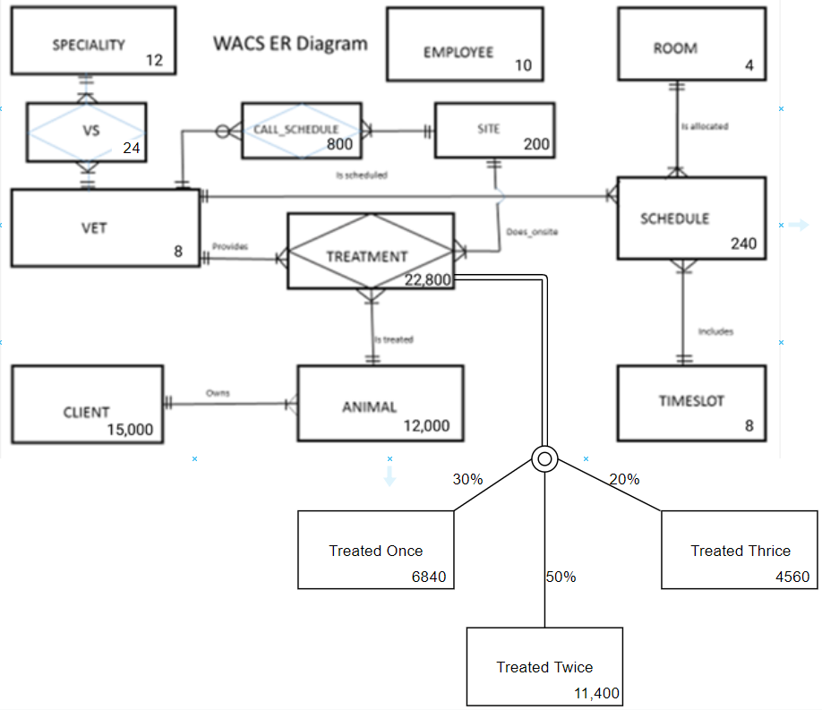

|  |  |
| --- | --- |
| Employee: 10 Client: 15,000 Animal: 12,000 Vet: 8 Room: 4 Specialty: 12 | Timeslot: 8 Schedule: 240 Site: 200 Call Schedule: 800 VS: 24 Treatment: 22,800 |

## Tables SQL Commands

--EMPLOYEE(E#, E_Firstname, E_Surname, StreetNo, StreetName, Suburb)

--PK- E#

CREATE TABLE EMPLOYEE(

E# int IDENTITY(1,1),

E_Firstname varchar(40) NOT NULL,

E_Surname varchar(40) NOT NULL,

StreetNo varchar(10) NOT NULL,

StreetName varchar(50) NOT NULL,

Suburb varchar(50) NOT NULL,

CONSTRAINT PK_E PRIMARY KEY(E#));

--ROOM(R#, RoomName)

--PK- R#

CREATE TABLE ROOM(

R# int IDENTITY(1,1),

RoomName varchar(30) NOT NULL,

CONSTRAINT PK_R PRIMARY KEY(R#));

--TIMESLOT(Slot#, From, To)

--PK- Slot#

CREATE TABLE TIMESLOT(

Slot# int IDENTITY(1,1),

Fromm TIME(0) NOT NULL,

Too TIME(0) NOT NULL,

CONSTRAINT PK_Slot# PRIMARY KEY(Slot#));

--VET (V#, V_Firstname, V_Surname, StreetNo, StreetName, Suburb, ContactNo)

--PK- V#

CREATE TABLE VET(

V# int IDENTITY(1,1),

V_Firstname varchar(40) NOT NULL,

V_Surname varchar(40) NOT NULL,

StreetNo varchar(10) NOT NULL,

StreetName varchar(50) NOT NULL,

Suburb varchar(50) NOT NULL,

ContactNo varchar(35) NOT NULL,

CONSTRAINT PK_V PRIMARY KEY(V#));

--SPECIALITY(SP#, Description)

--PK- SP#

CREATE TABLE SPECIALITY(

SP# int IDENTITY(1,1),

Description varchar(200) NOT NULL,

CONSTRAINT PK_SP PRIMARY KEY(SP#));

--SITE(Site#, SiteType, StreetNo, StreetName, Suburb)

--PK- Site#

CREATE TABLE SITE(

Site# int IDENTITY(1,1),

SiteType varchar(25) NOT NULL,

StreetNo varchar(10) NOT NULL,

StreetName varchar(50) NOT NULL,

Suburb varchar(50) NOT NULL,

CONSTRAINT PK_Site PRIMARY KEY(Site#));

--VS (V#, SP#)

--PK � (V#, SP#) � composite key

--FK � V#, and SP#

CREATE TABLE VS (

V# int NOT NULL,

SP# int NOT NULL,

CONSTRAINT PK_VSP PRIMARY KEY(V#,SP#),

CONSTRAINT FK_V_VSP FOREIGN KEY(V#) REFERENCES VET(V#) ON DELETE CASCADE ON UPDATE CASCADE,

CONSTRAINT FK_SP_VSP FOREIGN KEY(SP#) REFERENCES SPECIALITY(SP#) ON DELETE CASCADE ON UPDATE CASCADE);

--CLIENT(C#, C_Firstname, C_Surname, StreetNo, StreetName, Suburb, ContactNo)

--PK- C#

CREATE TABLE CLIENT(

C# int IDENTITY(1,1),

C_Firstname varchar(40) NOT NULL,

C_Surname varchar(40) NOT NULL,

StreetNo varchar(10) NOT NULL,

StreetName varchar(50) NOT NULL,

Suburb varchar(50) NOT NULL,

ContactNo varchar(35) NOT NULL,

CONSTRAINT PK_C PRIMARY KEY(C#));

--ANIMAL(A#, AName, C#)

--PK- A#

--FK � C#

CREATE TABLE ANIMAL (

A# int IDENTITY(1,1),

AName# varchar(60) NOT NULL,

C# int,

CONSTRAINT PK_A PRIMARY KEY(A#),

CONSTRAINT FK_C_A FOREIGN KEY(C#) REFERENCES CLIENT(C#) ON DELETE CASCADE ON UPDATE CASCADE);

--SCHEDULE(Sch#, V#, Slot#, R#,Oncall)

--R#, V# and Slot# nulls should be allowed

--PK - Sch#

--FK � V#, Slot# and R#

CREATE TABLE SCHEDULE (

Sch# int IDENTITY(1,1),

V# int,

Slot# int,

R# int,

Date_of_Schedule date NOT NULL,

Oncall BIT NOT NULL,

CONSTRAINT PK_Sch PRIMARY KEY(Sch#),

CONSTRAINT FK_V_Sch FOREIGN KEY(V#) REFERENCES VET(V#) ON DELETE CASCADE ON UPDATE CASCADE,

CONSTRAINT FK_Slot_Sch FOREIGN KEY(Slot#) REFERENCES TIMESLOT(Slot#) ON DELETE CASCADE ON UPDATE CASCADE,

CONSTRAINT FK_R_Sch FOREIGN KEY(R#) REFERENCES ROOM(R#) ON DELETE CASCADE ON UPDATE CASCADE);

--CALL_SCHEDULE (V#, Site#, From, To)

--PK � (V#, Site#) � composite key

--FK � V#, and Site#

CREATE TABLE CALL_SCHEDULE (

V# int NOT NULL,

Site# int NOT NULL,

Fromm TIME(0) NOT NULL,

Too TIME(0) NOT NULL,

Date_of_Call_Schedule date NOT NULL,

CONSTRAINT PK_VSite PRIMARY KEY(V#, Site#),

CONSTRAINT FK_V_VSite FOREIGN KEY(V#) REFERENCES VET(V#) ON DELETE CASCADE ON UPDATE CASCADE,

CONSTRAINT FK_Site_VSite FOREIGN KEY(Site#) REFERENCES SITE(Site#) ON DELETE CASCADE ON UPDATE CASCADE);

--TREATMENT(T#, Date_of_Treatment, V#, A#, Site#, Treatment_Given)

--Site# - nulls should be allowed

--PK - T#

--FK � V#, A# and Site#

CREATE TABLE TREATMENT (

T# int IDENTITY(1,1),

Date_of_Treatment date NOT NULL,

V# int NOT NULL,

A# int NOT NULL,

Site# int,

Treatment_Given varchar(200) NOT NULL,

CONSTRAINT PK_T PRIMARY KEY(T#),

CONSTRAINT FK_V_T FOREIGN KEY(V#) REFERENCES VET(V#) ON DELETE CASCADE ON UPDATE CASCADE,

CONSTRAINT FK_A_T FOREIGN KEY(A#) REFERENCES ANIMAL(A#) ON DELETE CASCADE ON UPDATE CASCADE,

CONSTRAINT FK_Site_T FOREIGN KEY(Site#) REFERENCES SITE(Site#) ON DELETE CASCADE ON UPDATE CASCADE);

## Data Insert Commands

--EMPLOYEE data insert

INSERT INTO EMPLOYEE([E_Firstname],[E_Surname],[StreetNo],[StreetName],[Suburb]) VALUES('Arthur','Goff','61','Elit, St.','Austin');

INSERT INTO EMPLOYEE([E_Firstname],[E_Surname],[StreetNo],[StreetName],[Suburb]) VALUES('Acton','Silva','29','Maecenas Rd.','Aosta');

INSERT INTO EMPLOYEE([E_Firstname],[E_Surname],[StreetNo],[StreetName],[Suburb]) VALUES('Yuli','Calhoun','74','Venenatis St.','Baiso');

INSERT INTO EMPLOYEE([E_Firstname],[E_Surname],[StreetNo],[StreetName],[Suburb]) VALUES('Callie','Roth','75','Ullamcorper Street','Nashville');

INSERT INTO EMPLOYEE([E_Firstname],[E_Surname],[StreetNo],[StreetName],[Suburb]) VALUES('Tarik','Landry','100','Sed, Street','Chépica');

INSERT INTO EMPLOYEE([E_Firstname],[E_Surname],[StreetNo],[StreetName],[Suburb]) VALUES('Stacey','Salas','130','Justo Road','Llanidloes');

INSERT INTO EMPLOYEE([E_Firstname],[E_Surname],[StreetNo],[StreetName],[Suburb]) VALUES('Rahim','Yang','113','Ultrices St.','Bhusawal');

INSERT INTO EMPLOYEE([E_Firstname],[E_Surname],[StreetNo],[StreetName],[Suburb]) VALUES('Iris','Snyder','99','Ornare, Avenue','Koszalin');

INSERT INTO EMPLOYEE([E_Firstname],[E_Surname],[StreetNo],[StreetName],[Suburb]) VALUES('Rashad','Baker','54','Neque Rd.','Chimbarongo');

INSERT INTO EMPLOYEE([E_Firstname],[E_Surname],[StreetNo],[StreetName],[Suburb]) VALUES('Abra','Hinton','127','Fermentum Avenue','Chantemelle');

--ROOM data insert

INSERT INTO ROOM([RoomName]) VALUES('Red Room');

INSERT INTO ROOM([RoomName]) VALUES('X-Ray');

INSERT INTO ROOM([RoomName]) VALUES('Treatment Room 1');

INSERT INTO ROOM([RoomName]) VALUES('Treatment Room 2');

INSERT INTO ROOM([RoomName]) VALUES('Treatment Room 3');

--TIMESLOT data insert

INSERT INTO TIMESLOT([Fromm],[Too]) VALUES('07:00:00', '07:30:00');

INSERT INTO TIMESLOT([Fromm],[Too]) VALUES('07:45:00', '08:15:00');

INSERT INTO TIMESLOT([Fromm],[Too]) VALUES('08:30:00', '09:00:00');

INSERT INTO TIMESLOT([Fromm],[Too]) VALUES('09:15:00', '09:45:00');

INSERT INTO TIMESLOT([Fromm],[Too]) VALUES('10:00:00', '10:30:00');

INSERT INTO TIMESLOT([Fromm],[Too]) VALUES('10:45:00', '11:15:00');

INSERT INTO TIMESLOT([Fromm],[Too]) VALUES('11:30:00', '12:00:00');

INSERT INTO TIMESLOT([Fromm],[Too]) VALUES('12:15:00', '12:45:00');

--VET data insert

INSERT INTO VET([V_Firstname],[V_Surname],[StreetNo],[StreetName],[Suburb],[ContactNo]) VALUES('Ferdinand','Cobb','91','Venenatis Rd.','Devizes','1694111035599');

INSERT INTO VET([V_Firstname],[V_Surname],[StreetNo],[StreetName],[Suburb],[ContactNo]) VALUES('Bevis','Fields','18','Accumsan St.','Solihull','1623041589899');

INSERT INTO VET([V_Firstname],[V_Surname],[StreetNo],[StreetName],[Suburb],[ContactNo]) VALUES('Harlan','Estes','90','Ligula. Rd.','SŽlange','1685021802299');

INSERT INTO VET([V_Firstname],[V_Surname],[StreetNo],[StreetName],[Suburb],[ContactNo]) VALUES('Luke','Howard','12','Phasellus Rd.','Gaggio Montano','1674032563399');

INSERT INTO VET([V_Firstname],[V_Surname],[StreetNo],[StreetName],[Suburb],[ContactNo]) VALUES('Nero','Rutledge','122','Accumsan Rd.','Rankweil','1633031790399');

INSERT INTO VET([V_Firstname],[V_Surname],[StreetNo],[StreetName],[Suburb],[ContactNo]) VALUES('Madison','Valentine','95','Molestie Road','Thane','1617071402699');

INSERT INTO VET([V_Firstname],[V_Surname],[StreetNo],[StreetName],[Suburb],[ContactNo]) VALUES('Winter','Copeland','120','Phasellus Rd.','Ancona','1643102355199');

INSERT INTO VET([V_Firstname],[V_Surname],[StreetNo],[StreetName],[Suburb],[ContactNo]) VALUES('Cadman','Vinson','10','Parturient Rd.','Çeşme','1645060648799');

--SPECIALITY data insert

INSERT INTO SPECIALITY([Description]) VALUES('Anaesthesiology');

INSERT INTO SPECIALITY([Description]) VALUES('Cardiology');

INSERT INTO SPECIALITY([Description]) VALUES('Dentistry');

INSERT INTO SPECIALITY([Description]) VALUES('Internal medicine');

INSERT INTO SPECIALITY([Description]) VALUES('Porcine');

INSERT INTO SPECIALITY([Description]) VALUES('Preventive medicine');

--SITE data insert

INSERT INTO SITE([SiteType],[StreetNo],[StreetName],[Suburb]) VALUES('House','25','Ipsum Street','Farciennes');

INSERT INTO SITE([SiteType],[StreetNo],[StreetName],[Suburb]) VALUES('Farm','15','Mollis Ave','Diets-Heur');

INSERT INTO SITE([SiteType],[StreetNo],[StreetName],[Suburb]) VALUES('Clinic','39','Scelerisque Street','Vichy');

INSERT INTO SITE([SiteType],[StreetNo],[StreetName],[Suburb]) VALUES('House','143','Lorem St.','Aydın');

INSERT INTO SITE([SiteType],[StreetNo],[StreetName],[Suburb]) VALUES('Farm','17','Vehicula St.','Dilsen-Stokkem');

INSERT INTO SITE([SiteType],[StreetNo],[StreetName],[Suburb]) VALUES('Farm','3','Ornare St.','Roux-Miroir');

INSERT INTO SITE([SiteType],[StreetNo],[StreetName],[Suburb]) VALUES('Farm','113','Mauris Rd.','Chiny');

INSERT INTO SITE([SiteType],[StreetNo],[StreetName],[Suburb]) VALUES('Clinic','124','Sit St.','Coleville Lake');

INSERT INTO SITE([SiteType],[StreetNo],[StreetName],[Suburb]) VALUES('House','97','Iaculis St.','Olivar');

INSERT INTO SITE([SiteType],[StreetNo],[StreetName],[Suburb]) VALUES('House','49','Magna. Av.','Gresham');

INSERT INTO SITE([SiteType],[StreetNo],[StreetName],[Suburb]) VALUES('House','39','Faucibus Rd.','Coinco');

INSERT INTO SITE([SiteType],[StreetNo],[StreetName],[Suburb]) VALUES('House','118','Nam Rd.','Leffinge');

INSERT INTO SITE([SiteType],[StreetNo],[StreetName],[Suburb]) VALUES('Farm','87','Ac St.','Baie-Comeau');

INSERT INTO SITE([SiteType],[StreetNo],[StreetName],[Suburb]) VALUES('Farm','38','Tristique Rd.','Kingston-on-Thames');

INSERT INTO SITE([SiteType],[StreetNo],[StreetName],[Suburb]) VALUES('Farm','143','Ante St.','Omaha');

INSERT INTO SITE([SiteType],[StreetNo],[StreetName],[Suburb]) VALUES('House','121','Nulla Avenue','Ruddervoorde');

INSERT INTO SITE([SiteType],[StreetNo],[StreetName],[Suburb]) VALUES('Farm','53','Diam. Av.','Castelbianco');

INSERT INTO SITE([SiteType],[StreetNo],[StreetName],[Suburb]) VALUES('Clinic','24','Vestibulum, Street','Orsogna');

INSERT INTO SITE([SiteType],[StreetNo],[StreetName],[Suburb]) VALUES('Farm','112','Tristique St.','Wichita');

INSERT INTO SITE([SiteType],[StreetNo],[StreetName],[Suburb]) VALUES('House','138','Nunc Street','Osgoode');

INSERT INTO SITE([SiteType],[StreetNo],[StreetName],[Suburb]) VALUES('Farm','70','Vulputate, St.','Coquimbo');

INSERT INTO SITE([SiteType],[StreetNo],[StreetName],[Suburb]) VALUES('Farm','98','Mauris Rd.','Bonnyville Municipal District');

INSERT INTO SITE([SiteType],[StreetNo],[StreetName],[Suburb]) VALUES('Clinic','90','Non Rd.','Stalhille');

INSERT INTO SITE([SiteType],[StreetNo],[StreetName],[Suburb]) VALUES('Clinic','70','Egestas Avenue','Gdańsk');

INSERT INTO SITE([SiteType],[StreetNo],[StreetName],[Suburb]) VALUES('Clinic','67','Sit St.','Baunatal');

INSERT INTO SITE([SiteType],[StreetNo],[StreetName],[Suburb]) VALUES('House','146','At Rd.','Kilwinning');

INSERT INTO SITE([SiteType],[StreetNo],[StreetName],[Suburb]) VALUES('House','54','In Road','Salzwedel');

INSERT INTO SITE([SiteType],[StreetNo],[StreetName],[Suburb]) VALUES('Clinic','59','Nam Ave','Jerez de la Frontera');

INSERT INTO SITE([SiteType],[StreetNo],[StreetName],[Suburb]) VALUES('House','90','Pulvinar Rd.','Reutlingen');

--VS data insert

INSERT INTO VS([V#],[SP#]) VALUES(1,1);

INSERT INTO VS([V#],[SP#]) VALUES(2,4);

INSERT INTO VS([V#],[SP#]) VALUES(2,5);

INSERT INTO VS([V#],[SP#]) VALUES(3,3);

INSERT INTO VS([V#],[SP#]) VALUES(4,5);

INSERT INTO VS([V#],[SP#]) VALUES(5,6);

INSERT INTO VS([V#],[SP#]) VALUES(6,2);

INSERT INTO VS([V#],[SP#]) VALUES(7,5);

INSERT INTO VS([V#],[SP#]) VALUES(8,4);

--CLIENT data insert

INSERT INTO CLIENT([C_Firstname],[C_Surname],[StreetNo],[StreetName],[Suburb],[ContactNo]) VALUES('Ashely','Hooper','58','Nam Rd.','Zeebrugge','1659100177999');

INSERT INTO CLIENT([C_Firstname],[C_Surname],[StreetNo],[StreetName],[Suburb],[ContactNo]) VALUES('Rhona','Shepherd','51','Adipiscing Rd.','Compiano','1662121092499');

INSERT INTO CLIENT([C_Firstname],[C_Surname],[StreetNo],[StreetName],[Suburb],[ContactNo]) VALUES('Blaze','Nolan','102','Dapibus Street','Town of Yarmouth','1650100273799');

INSERT INTO CLIENT([C_Firstname],[C_Surname],[StreetNo],[StreetName],[Suburb],[ContactNo]) VALUES('Ferdinand','Oneal','132','Cursus Avenue','Heidenheim','1612112135099');

INSERT INTO CLIENT([C_Firstname],[C_Surname],[StreetNo],[StreetName],[Suburb],[ContactNo]) VALUES('Kameko','Pena','74','Euismod St.','Alto del Carmen','1664092578499');

INSERT INTO CLIENT([C_Firstname],[C_Surname],[StreetNo],[StreetName],[Suburb],[ContactNo]) VALUES('Chadwick','Ortega','95','Sapien. St.','Plainevaux','1653021115299');

INSERT INTO CLIENT([C_Firstname],[C_Surname],[StreetNo],[StreetName],[Suburb],[ContactNo]) VALUES('Davis','Flynn','140','Euismod Street','Brescia','1676071947399');

INSERT INTO CLIENT([C_Firstname],[C_Surname],[StreetNo],[StreetName],[Suburb],[ContactNo]) VALUES('Cain','Marquez','144','In Av.','Tredegar','1683012204399');

INSERT INTO CLIENT([C_Firstname],[C_Surname],[StreetNo],[StreetName],[Suburb],[ContactNo]) VALUES('Axel','Miller','33','Urna Rd.','Orsogna','1669020400199');

INSERT INTO CLIENT([C_Firstname],[C_Surname],[StreetNo],[StreetName],[Suburb],[ContactNo]) VALUES('Ramona','Munoz','88','Augue Ave','Katowice','1602122749699');

INSERT INTO CLIENT([C_Firstname],[C_Surname],[StreetNo],[StreetName],[Suburb],[ContactNo]) VALUES('Conan','Howe','139','Aliquet Av.','Kapolei','1669022610699');

INSERT INTO CLIENT([C_Firstname],[C_Surname],[StreetNo],[StreetName],[Suburb],[ContactNo]) VALUES('Keegan','Love','58','Amet Av.','Turriaco','1630080806199');

INSERT INTO CLIENT([C_Firstname],[C_Surname],[StreetNo],[StreetName],[Suburb],[ContactNo]) VALUES('Donovan','Floyd','128','Integer Road','Miami','1663011549799');

INSERT INTO CLIENT([C_Firstname],[C_Surname],[StreetNo],[StreetName],[Suburb],[ContactNo]) VALUES('Scarlett','Mcclure','27','Amet Road','Moose Jaw','1647070745699');

INSERT INTO CLIENT([C_Firstname],[C_Surname],[StreetNo],[StreetName],[Suburb],[ContactNo]) VALUES('Rylee','Mullen','46','Habitant Road','Ruisbroek','1672120518699');

INSERT INTO CLIENT([C_Firstname],[C_Surname],[StreetNo],[StreetName],[Suburb],[ContactNo]) VALUES('Montana','Fuentes','25','Dui, Rd.','Jerez de la Frontera','1685091201799');

INSERT INTO CLIENT([C_Firstname],[C_Surname],[StreetNo],[StreetName],[Suburb],[ContactNo]) VALUES('Camilla','Tillman','45','Eget, Road','Brodick','1605061184199');

INSERT INTO CLIENT([C_Firstname],[C_Surname],[StreetNo],[StreetName],[Suburb],[ContactNo]) VALUES('Perry','Walters','81','Odio. Av.','Sandy','1623102475899');

INSERT INTO CLIENT([C_Firstname],[C_Surname],[StreetNo],[StreetName],[Suburb],[ContactNo]) VALUES('Yardley','Hebert','63','Tristique Av.','Jonesboro','1642080338499');

INSERT INTO CLIENT([C_Firstname],[C_Surname],[StreetNo],[StreetName],[Suburb],[ContactNo]) VALUES('Michelle','Waters','127','Interdum. Ave','Wepion','1665061934499');

--ANIMAL data insert

INSERT INTO ANIMAL([AName#],[C#]) VALUES('Cedric',1);

INSERT INTO ANIMAL([AName#],[C#]) VALUES('Slade',7);

INSERT INTO ANIMAL([AName#],[C#]) VALUES('Carla',16);

INSERT INTO ANIMAL([AName#],[C#]) VALUES('Julie',20);

INSERT INTO ANIMAL([AName#],[C#]) VALUES('Cailin',14);

INSERT INTO ANIMAL([AName#],[C#]) VALUES('Gemma',14);

INSERT INTO ANIMAL([AName#],[C#]) VALUES('Jakeem',14);

INSERT INTO ANIMAL([AName#],[C#]) VALUES('Lillith',6);

INSERT INTO ANIMAL([AName#],[C#]) VALUES('Doris',15);

INSERT INTO ANIMAL([AName#],[C#]) VALUES('Gannon',1);

INSERT INTO ANIMAL([AName#],[C#]) VALUES('Keane',14);

INSERT INTO ANIMAL([AName#],[C#]) VALUES('Urielle',13);

INSERT INTO ANIMAL([AName#],[C#]) VALUES('Ivan',6);

INSERT INTO ANIMAL([AName#],[C#]) VALUES('Burke',18);

INSERT INTO ANIMAL([AName#],[C#]) VALUES('Eleanor',2);

INSERT INTO ANIMAL([AName#],[C#]) VALUES('Rhona',17);

INSERT INTO ANIMAL([AName#],[C#]) VALUES('Bradley',2);

INSERT INTO ANIMAL([AName#],[C#]) VALUES('Remedios',10);

--SCHEDULE data insert

INSERT INTO SCHEDULE([V#],[Slot#],[R#],[Date_of_Schedule],[Oncall]) VALUES(1,1,2,'2019-11-07',0);

INSERT INTO SCHEDULE([V#],[Slot#],[R#],[Date_of_Schedule],[Oncall]) VALUES(1,3,1,'2019-11-07',0);

INSERT INTO SCHEDULE([V#],[Slot#],[R#],[Date_of_Schedule],[Oncall]) VALUES(1,5,3,'2019-11-08',0);

INSERT INTO SCHEDULE([V#],[Slot#],[R#],[Date_of_Schedule],[Oncall]) VALUES(1,6,2,'2019-11-08',0);

INSERT INTO SCHEDULE([V#],[Slot#],[R#],[Date_of_Schedule],[Oncall]) VALUES(2,2,2,'2019-11-06',0);

INSERT INTO SCHEDULE([V#],[Slot#],[R#],[Date_of_Schedule],[Oncall]) VALUES(2,4,1,'2019-11-08',1);

INSERT INTO SCHEDULE([V#],[Slot#],[R#],[Date_of_Schedule],[Oncall]) VALUES(2,7,2,'2019-11-07',1);

INSERT INTO SCHEDULE([V#],[Slot#],[R#],[Date_of_Schedule],[Oncall]) VALUES(2,8,2,'2019-11-07',0);

--CALL_SCHEDULE data insert

INSERT INTO CALL_SCHEDULE([V#],[Site#],[Fromm],[Too],[Date_of_Call_Schedule]) VALUES(1,10,'07:00:00','09:00:00','2019-11-07');

INSERT INTO CALL_SCHEDULE([V#],[Site#],[Fromm],[Too],[Date_of_Call_Schedule]) VALUES(4,15,'12:00:00','14:00:00','2019-11-07');

INSERT INTO CALL_SCHEDULE([V#],[Site#],[Fromm],[Too],[Date_of_Call_Schedule]) VALUES(2,11,'13:00:00','16:00:00','2019-11-07');

INSERT INTO CALL_SCHEDULE([V#],[Site#],[Fromm],[Too],[Date_of_Call_Schedule]) VALUES(8,2,'08:00:00','08:30:00','2019-11-07');

INSERT INTO CALL_SCHEDULE([V#],[Site#],[Fromm],[Too],[Date_of_Call_Schedule]) VALUES(6,23,'08:00:00','09:00:00','2019-11-07');

INSERT INTO CALL_SCHEDULE([V#],[Site#],[Fromm],[Too],[Date_of_Call_Schedule]) VALUES(2,12,'11:00:00','12:00:00','2019-11-07');

INSERT INTO CALL_SCHEDULE([V#],[Site#],[Fromm],[Too],[Date_of_Call_Schedule]) VALUES(3,6,'10:00:00','13:00:00','2019-11-07')

--TREATMENT data insert

INSERT INTO TREATMENT([Date_of_Treatment],[V#],[A#],[Site#],[Treatment_Given]) VALUES('2019-10-07',5,11,19,'Antibiotics given');

INSERT INTO TREATMENT([Date_of_Treatment],[V#],[A#],[Site#],[Treatment_Given]) VALUES('2019-11-02',5,1,20,'Ambutated left rear foot');

INSERT INTO TREATMENT([Date_of_Treatment],[V#],[A#],[Site#],[Treatment_Given]) VALUES('2019-10-19',5,6,4,'Pain killers for next two weeks');

INSERT INTO TREATMENT([Date_of_Treatment],[V#],[A#],[Site#],[Treatment_Given]) VALUES('2019-10-25',5,15,15,'Therapy recommended');

INSERT INTO TREATMENT([Date_of_Treatment],[V#],[A#],[Site#],[Treatment_Given]) VALUES('2019-10-25',2,8,21,'Administered injection');

## Database Diagram

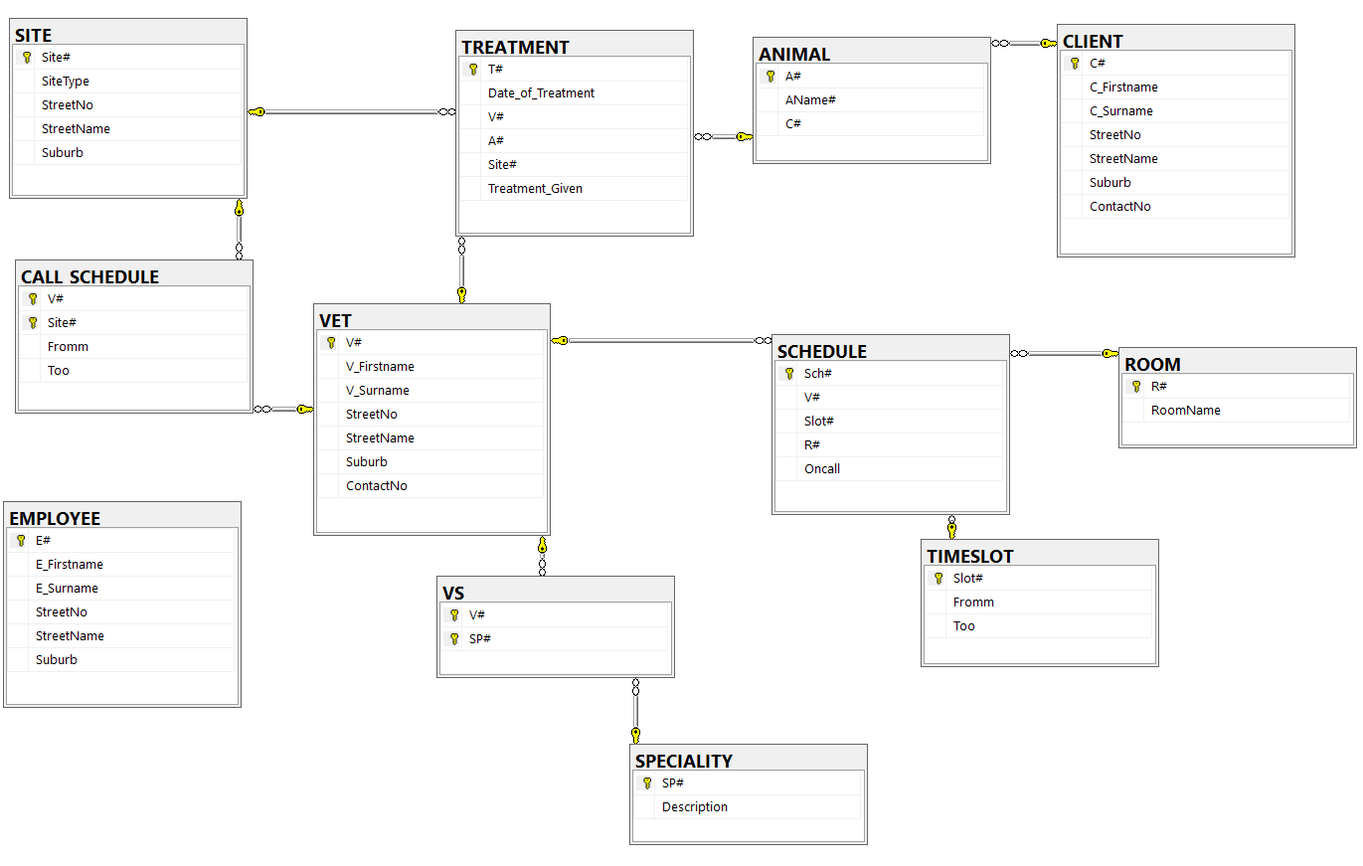

## Index Files

CREATE INDEX ind_EMP_Fn_Ln

ON EMPLOYEE (E_Firstname, E_Surname);

CREATE INDEX ind_VET_Fn_Ln

ON VET (V_Firstname, V_Surname);

CREATE INDEX ind_CLI_Fn_Ln

ON CLIENT (C_Firstname, C_Surname);

CREATE INDEX ind_ANI_A#_Nme

ON ANIMAL (A#, AName#);

## Possible De-Normalization

A suggestion for a De-Normalization would be the ROOM table with the SCHEDULE table

|  |  |  |
| --- | --- | --- |
| Column | PK/FK | Data Type |
| Sch# | PK | int |
| *V#\** | FK | int |
| *Slot#\** | FK | int |
| Date_of_Schedule |  | date |
| Oncall |  | BIT |
| RoomName |  | varchar(30) |

A positive impact of this de-normalization would be that the ROOM table has now merged with the SCHEDULE table and therefore we have one less table which decreases the storage space needed.

A negative impact of this de-normalization would be that we now have too write a long string, the room name, into every record under the RoomName column where we used to just have the foreign key of the ROOM table.

## Reports (Database Name: Lukas)

### List of Clients, Animals and Treatments

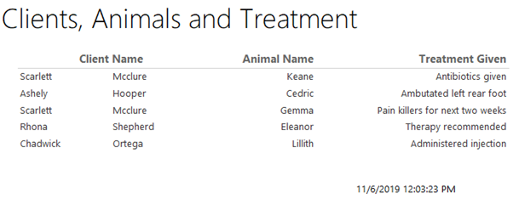

### List of Scheduled Vets

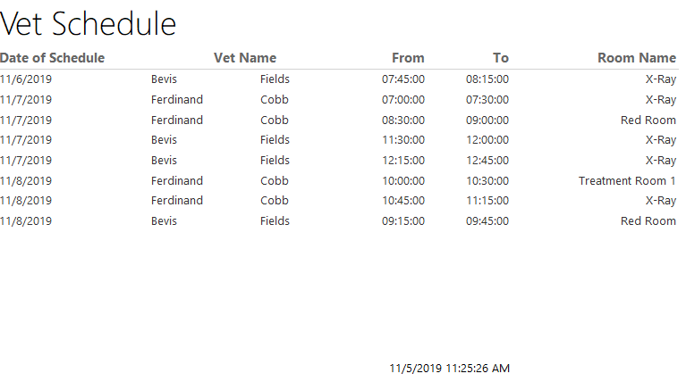

## Data Dictionary

### EMPLOYEE

|  |  |  |  |  |
| --- | --- | --- | --- | --- |
| Column | Data Type | References | Default | Not Null |
| E# | int |  | identity |  |
| E_Firstname | varchar(40) |  |  | Y |
| E_Surname | varchar(40) |  |  | Y |
| StreetNo | varchar(10) |  |  | Y |
| StreetName | varchar(50) |  |  | Y |
| Suburb | varchar(50) |  |  | Y |

### ROOM

|  |  |  |  |  |
| --- | --- | --- | --- | --- |
| Column | Data Type | References | Default | Not Null |
| R# | int |  | identity |  |
| RoomName | varchar(30) |  |  | Y |

### TIMESLOT

|  |  |  |  |  |
| --- | --- | --- | --- | --- |
| Column | Data Type | References | Default | Not Null |
| Slot# | int |  | identity |  |
| Fromm | TIME(0) |  |  | Y |
| Too | TIME(0) |  |  | Y |

### VET

|  |  |  |  |  |
| --- | --- | --- | --- | --- |
| Column | Data Type | References | Default | Not Null |
| V# | int |  | identity |  |
| V_Firstname | varchar(40) |  |  | Y |
| V_Surname | varchar(40) |  |  | Y |
| StreetNo | varchar(10) |  |  | Y |
| StreetName | varchar(50) |  |  | Y |
| Suburb | varchar(50) |  |  | Y |
| ContactNo | varchar(35) |  |  | Y |

### SPECIALITY

|  |  |  |  |  |
| --- | --- | --- | --- | --- |
| Column | Data Type | References | Default | Not Null |
| SP# | int |  | identity |  |
| Description | varchar(200) |  |  | Y |

### SITE

|  |  |  |  |  |
| --- | --- | --- | --- | --- |
| Column | Data Type | References | Default | Not Null |
| Site# | int |  | identity |  |
| SiteType | varchar(25) |  |  | Y |
| StreetNo | varchar(10) |  |  | Y |
| StreetName | varchar(50) |  |  | Y |
| Suburb | varchar(50) |  |  | Y |

### VS

|  |  |  |  |  |
| --- | --- | --- | --- | --- |
| Column | Data Type | References | Default | Not Null |
| V# | int | VET |  | Y |
| SP# | int | SPECIALITY |  | Y |

### CLIENT

|  |  |  |  |  |
| --- | --- | --- | --- | --- |
| Column | Data Type | References | Default | Not Null |
| C# | int |  | identity |  |
| C_Firstname | varchar(40) |  |  | Y |
| C_Surname | varchar(40) |  |  | Y |
| StreetNo | varchar(10) |  |  | Y |
| StreetName | varchar(50) |  |  | Y |
| Suburb | varchar(50) |  |  | Y |
| ContactNo | varchar(35) |  |  | Y |

### ANIMAL

|  |  |  |  |  |
| --- | --- | --- | --- | --- |
| Column | Data Type | References | Default | Not Null |
| A# | int |  | identity |  |
| AName | varchar(60) |  |  | Y |
| C# | int | CLIENT |  | Y |

### SCHEDULE

|  |  |  |  |  |
| --- | --- | --- | --- | --- |
| Column | Data Type | References | Default | Not Null |
| Sch# | int |  | identity | Y |
| V# | int | VET |  |  |
| Slot# | int | TIMESLOT |  |  |
| R# | int | ROOM |  |  |
| Date_of_Schedule | date |  |  | Y |
| Oncall | BIT |  |  | Y |

### CALL_SCHEDULE

|  |  |  |  |  |
| --- | --- | --- | --- | --- |
| Column | Data Type | References | Default | Not Null |
| V# | int | VET |  | Y |
| Site# | int | SITE |  | Y |
| Fromm | TIME(0) |  |  | Y |
| Too | TIME(0) |  |  | Y |
| Date_of_Call_Schedule | date |  |  | Y |

### TREATMENT

|  |  |  |  |  |
| --- | --- | --- | --- | --- |
| Column | Data Type | References | Default | Not Null |
| T# | int |  | identity |  |
| Date_of_Treatment | date |  |  | Y |
| V# | int | VET |  | Y |
| A# | int | ANIMAL |  | Y |
| Site | int | SITE |  |  |
| Treatment_Given | varchar(200) |  |  | Y |