

Learning Python

Comp 6214



Logan Tawhiri | Blake Jensen

30024380 | 30006830

# To use/view Python Code

Step 1: Download your preferred version of Python on <https://www.python.org/>. I recommend you select the latest version.

Step 2: Download visual studio code.

Step 3: Once visual studio code is installed open visual studio and select the extensions icon and search for the python extension. Download it.



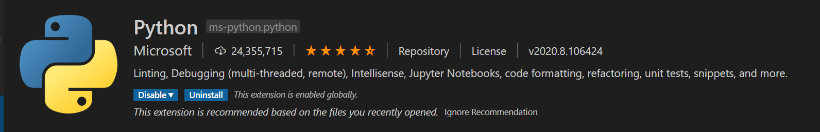

Step 4: Something will popup stating you need to select a python interpreter select it and choose the version of python that you installed.

Step 5: Create the folder structure that you would like to use for your python code.

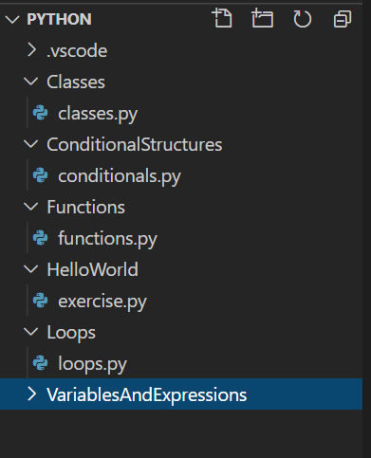

Step 6: Create a .py file of your chosen name to start creating your python code.

Step 7: Some Libraries within python require you to run a PIP install “package name” command in CMD or PowerShell to view the application working in full.

# Who was the project for? What problems or issues did the project address/solve?

The project was for each project member as each of us didn’t have very good knowledge with the coding language Python, the project's main purpose was to solve that issue by increasing our knowledge of this coding language.

# Who was involved in the project, what were their respective roles?

Logan Tawhiri: Programmer, Documentation Manager.

Blake Jensen: Programmer, Project Leader.

# What was needed in working on and completing the project?

We required software like:

* Visual studio code and the necessary extensions within the vs code application.
* Git tools
* PIP installation of libraries
* YouTube
* Google docs
* Various other websites

# What wasn’t completed

All tasks were completed without fail.

# What went well/to plan with the project

The whole project in general went along at a steady pace but it was particularly easy to research about python projects as examples are readily available all over the internet with easy-to-follow tutorials.

# What did not go well or to plan in this project

Originally, we found that the project wasn’t meeting the complexity requirements as everything we were producing was basic. So, we must select from two routes, either increasing the complexity of the project or simply producing a huge quantity of applications to meet the standards. Other than that, nothing went wrong.

# Scope

|  |  |  |  |
| --- | --- | --- | --- |
| **Scope Items** | **In Progress** | **Finished** | **Comments?** |
| Making a “Hello World” application using Python |  | **✓** | No issues occurred with this scope item as it is really basic |
| Making a basic application using loops using Python |  | **✓** | No issues occurred at this scope item as the tutorials on LinkedIn learning for loops are clear and concise |
| Making a slightly more advanced application that uses loops |  | **✓** | For this scope item it was a little more difficult as the loops were implemented into the connect four game that was created |
| Making a basic application using IF statements using Python |  | **✓** | No issues occurred at this scope item |
| Making a slightly more advanced application that uses IF statements |  | **✓** | For this scope item many of the games that were created: space invaders, pong and connect four all use IF statements consistently throughout |
| Making a basic application using dictionaries using Python |  | **✓** | For this scope item we were required to look further than linked in learning to find the information, but was easy other than that |
| Making an application using lists using Python |  | **✓** | This was easy to produce |
| Make a slightly more advanced application that uses lists |  | **✓** | A GUI with buttons was provided for interaction for this. |
| Making an application using methods using Python |  | **✓** | This was done with no complications |
| Making an application using classes using Python |  | **✓** | We produced 2 copies of applications using classes one using the oop method and one that isn’t |
| Making an application using arrays using Python |  | **✓** | This was a basic task |
| Making an application that can calculate basic math using Python |  | **✓** | This one was simple, and no problems occurred |

# Participation Report

|  |  |  |  |
| --- | --- | --- | --- |
| Participation Report | | | |
| Member Name | Objectives in Progress | Objective Completion | Date of Completion |
| Blake Jensen  Logan Tawhiri | Create a basic Hello World program | **✓** | August 18th 2020 |
| Blake Jensen  Logan Tawhiri | Create a basic application utilizing Loops | **✓** | August 18th 2020 |
| Blake Jensen Logan Tawhiri | Create a basic application utilizing IF statements | **✓** | August 18th 2020 |
| Blake Jensen Logan Tawhiri | Create a basic application utilizing Dictionaries | **✓** | August 22nd 2020 |
| Blake Jensen Logan Tawhiri | Create a basic application utilizing Lists | **✓** | August 22nd 2020 |
| Blake Jensen Logan Tawhiri | Create a basic application utilizing Methods | **✓** | August 25th 2020 |
| Blake Jensen Logan Tawhiri | Create a basic application utilizing Classes | **✓** | August 25th 2020 |
| Blake Jensen Logan Tawhiri | Create a basic application utilizing Arrays | **✓** | August 25th 2020 |
| Blake Jensen | Create an advanced application utilizing Arrays | **✓** | September 1st 2020 |
| Logan Tawhiri | Create an advanced application utilizing Loops with Python | **✓** | September 1st 2020 |
| Blake Jensen Logan Tawhiri | Create an advanced application utilizing IF Statements with Python | **✓** | September 7th 2020 |
| Blake Jensen Logan Tawhiri | Create an advanced application utilizing Dictionaries with Python | **✓** | September 14th 2020 |
| Blake Jensen Logan Tawhiri | Create a calculator that can calculate simple arithmetic (Addition, Subtraction, Multiplication, Division) | **✓** | September 1st 2020 |

# Deliverables

|  |  |
| --- | --- |
| **Deliverable** | **Delivered** |
| .py files | **✓** |
| Multiple programs showing basic Python functionality | **✓** |
| Having basic knowledge of Python | **✓** |
| Testing | **✓** |
| Participation Report | **✓** |

## 

# Milestones

|  |  |
| --- | --- |
| **Milestones** | **Completed** |
| Completed watching the first batch of tutorials. | **✓** |
| Hello world program created & executed. | **✓** |
| Create a program that uses IF statements & execute. | **✓** |
| Create a program that uses loops & execute. | **✓** |
| Create a program that utilizes arrays & execute. | **✓** |
| Create a program that uses lists & dictionaries and execute. | **✓** |
| Create a program that uses methods & classes and execute. | **✓** |
| Create a program that calculates basic arithmetic & execute. | **✓** |
| Testing of programs to ensure a finished product. | **✓** |

# Testing Plan

|  |  |  |
| --- | --- | --- |
| Testing Report | | |
| Script/Application Being Test | Outcome | Date Tested |
| Basic Hello World script | No issues occurred; the script executed successfully without error | August 20th 2020 |
| Basic script using Conditional Statements | Script performed successfully without fail, each if statement in either script worked. | August 23rd 2020 |
| Basic script using Arrays | The script executed with success, the array was retrieved and output to the console as well as any extra commands were executed and were output as well. | August 22nd 2020 |
| Basic script using Dictionaries | The script worked according to expectation; the dictionary was retrieved from the variable it was stored in with the values stored inside it. | August 22nd 2020 |
| Basic script using Lists | Execution of the script was flawless; the list was recognized and output to the console for the user to see. No errors were addressed to the console when running the script. | August 22nd 2020 |
| Basic script using Methods | No errors were addressed by the console when the script was executed | September 1st 2020 |
| Basic script using Classes | There were no errors output by the console when the scripts that had classes inside them were executed. Meaning that the creation of these scripts was a success | September 1st 2020 |
| Basic script using Loops | The loops worked perfectly without failure | September 4th 2020 |
| Advanced application using Arrays | The application had a simple GUI, accompanied by a textbox with a message, a button was also present in the application that when pressed it retrieved the array and cleared the textbox and output the array on the textbox. All of this was completed without error. | September 12th 2020 |
| Advanced application using Dictionaries | Much like the GUI for the arrays application it had a textbox with a message and a button with what the button would do. Once pressed it retrieved the dictionary without failing and no errors were reported. Test was successful. | September 12th 2020 |
| Advanced application using Lists | No problems occurred when the button was clicked. The output for the textbox showed the List that was stored in the script. | September 12th 2020 |
| Advanced application using IF Statements | This application was quite different from the other applications that showed lists, dictionaries, and arrays. This one utilized message boxes to output messages with optional choices for the user to choose from. Each option had its own unique message as well as for the third choice it allowed the user to retrieve a list/dictionary and replace the message in the textbox to the list/dictionary. If the third button was clicked again and the other optional choice was selected the textbox would clear and the original message upon execution would appear. In other words, the test was successful | September 24th 2020 |
| Advanced application that is a recreation of the game *Connect Four* | This game worked well, it allowed the user to place the tokens wherever they wanted to place them without error. Test was successful without errors | October 3rd 2020 |
| Advanced application that is a recreation of the game *Pong* | The game pong worked amazingly, the paddles for either side operated well, and the ball would rebound when they collided with them. Success. | October 6th 2020 |
| Advanced application that is a recreation of the game *Space Invaders* | Works without failure, no errors were thrown. | October 8th 2020 |
| Advanced application that is a recreation of the game hangman | The game functions in the terminal as opposed to a GUI it is functioning correctly. | October 13th 2020 |

# Screenshots

### Basic

#### Hello world

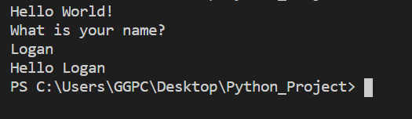

#### Variables and Expressions

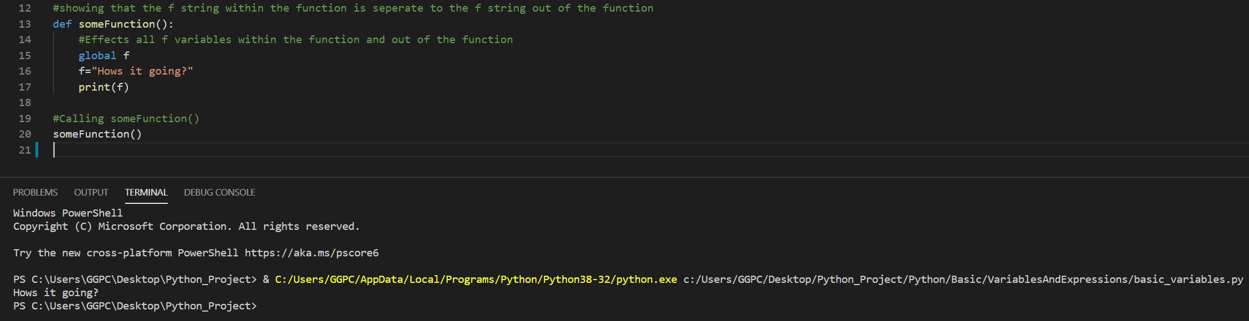

#### Loops

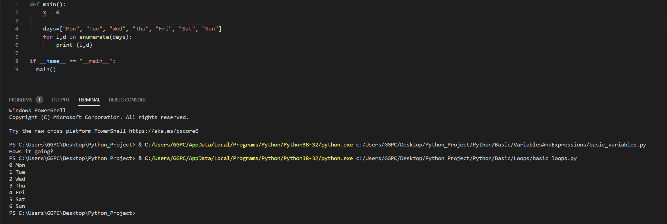

#### If Statements

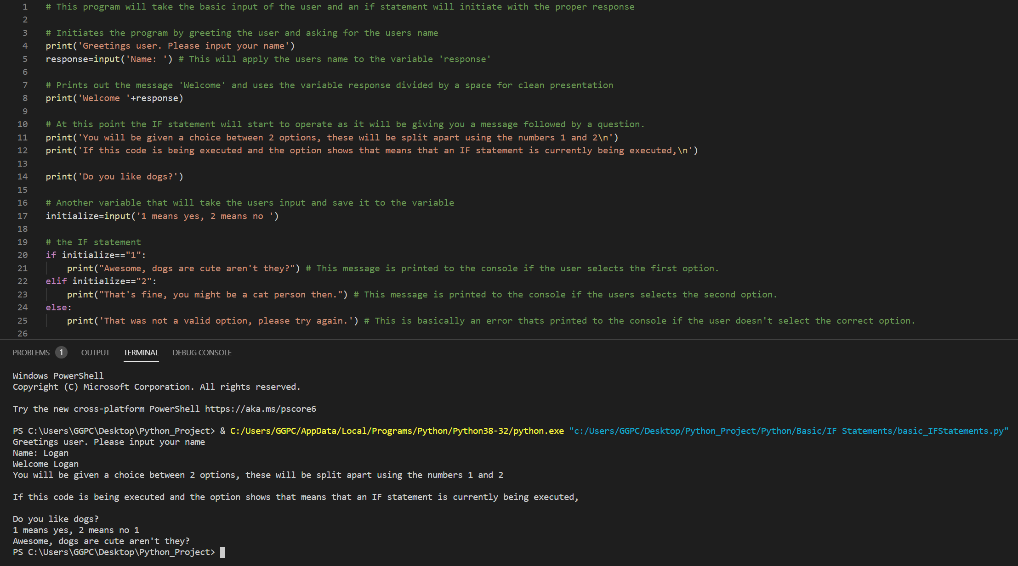

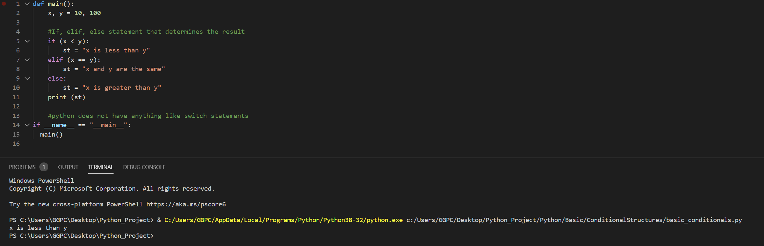

#### Classes / Methods

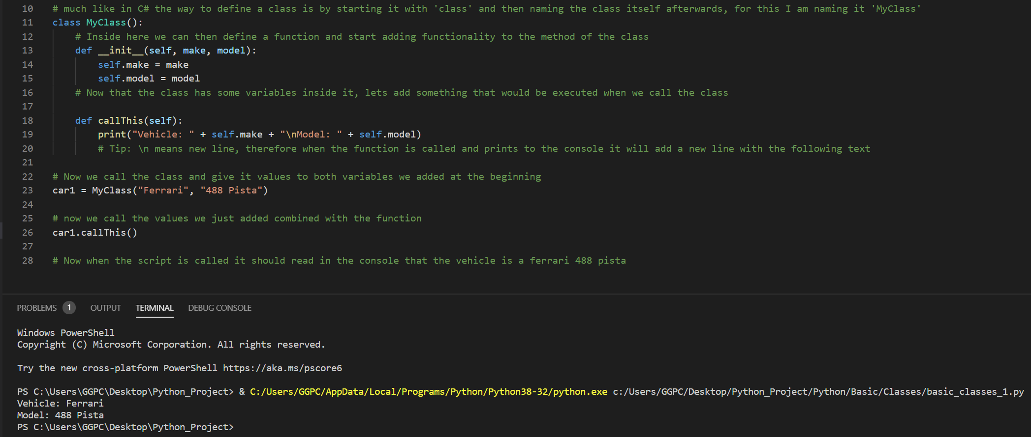

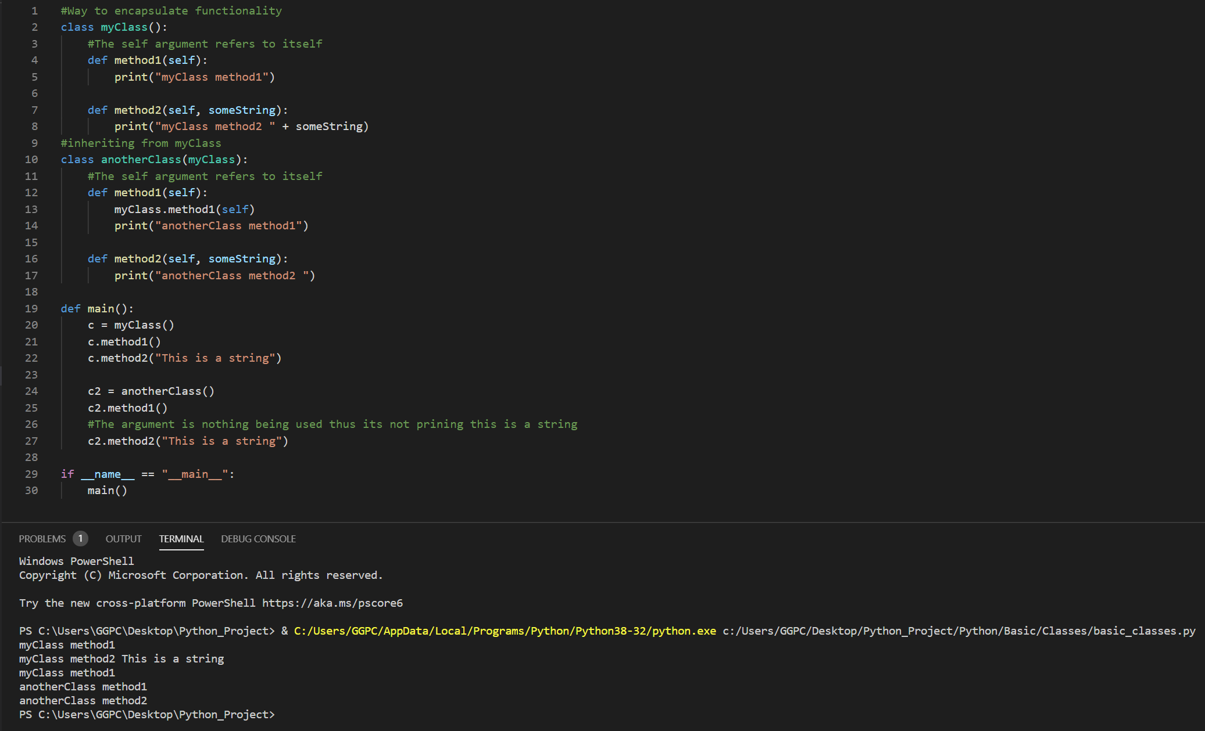

#### Lists

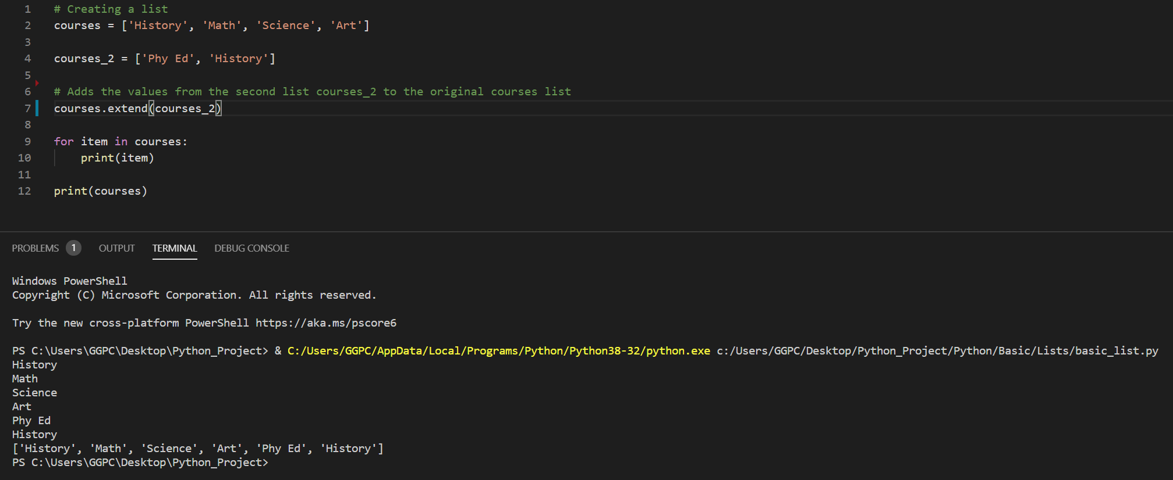

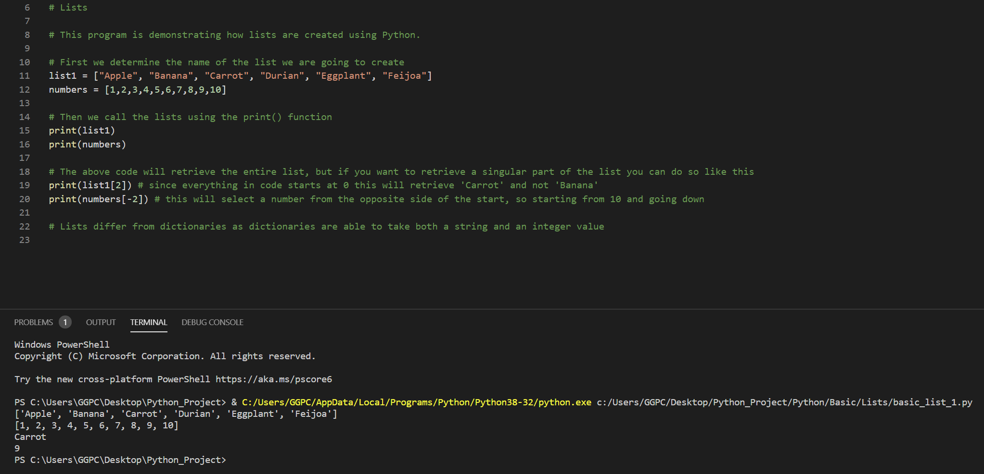

#### Dictionaries

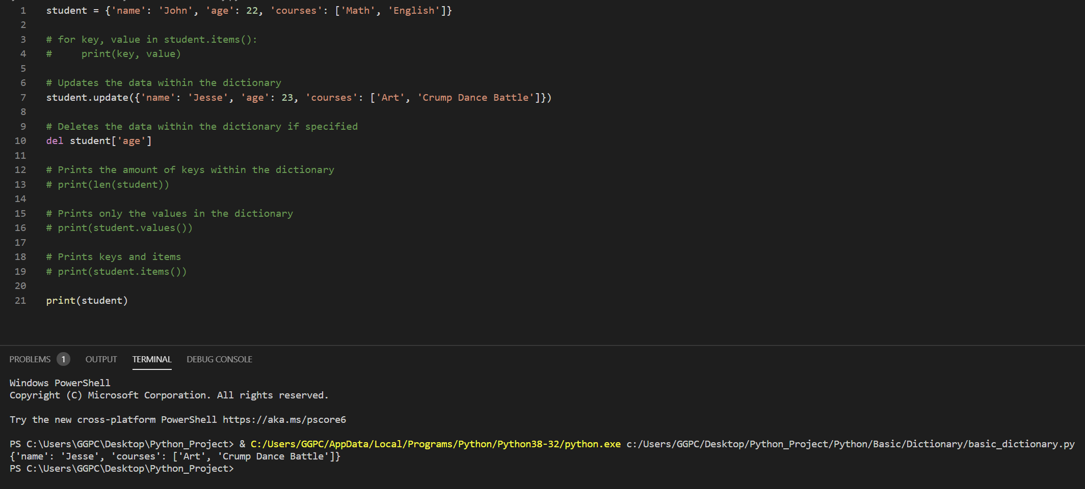

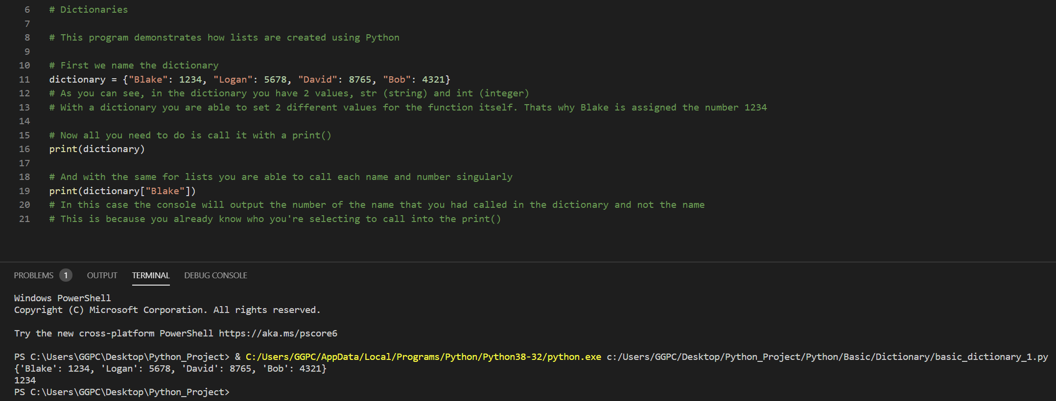

#### Arrays

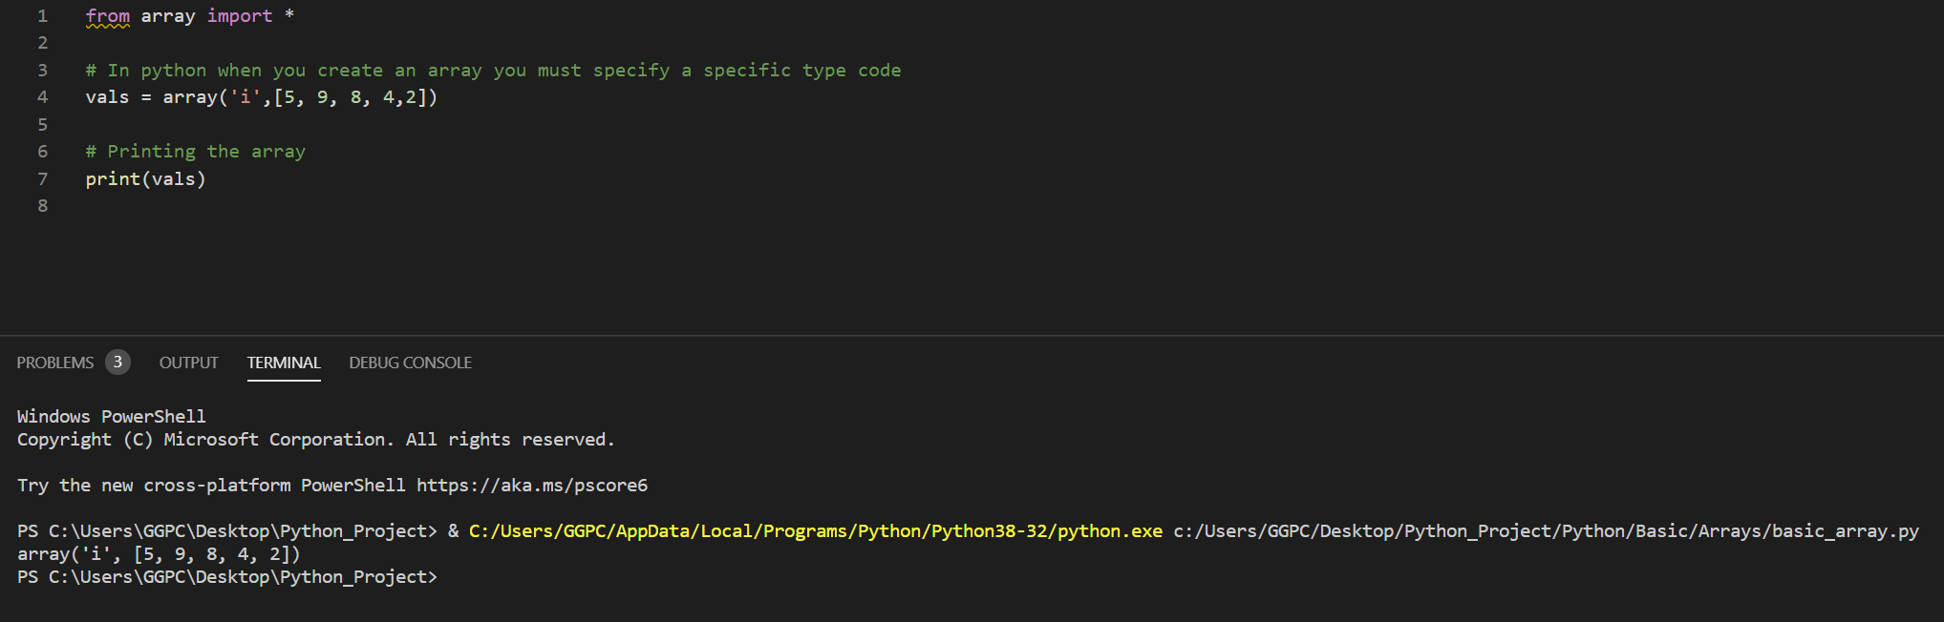

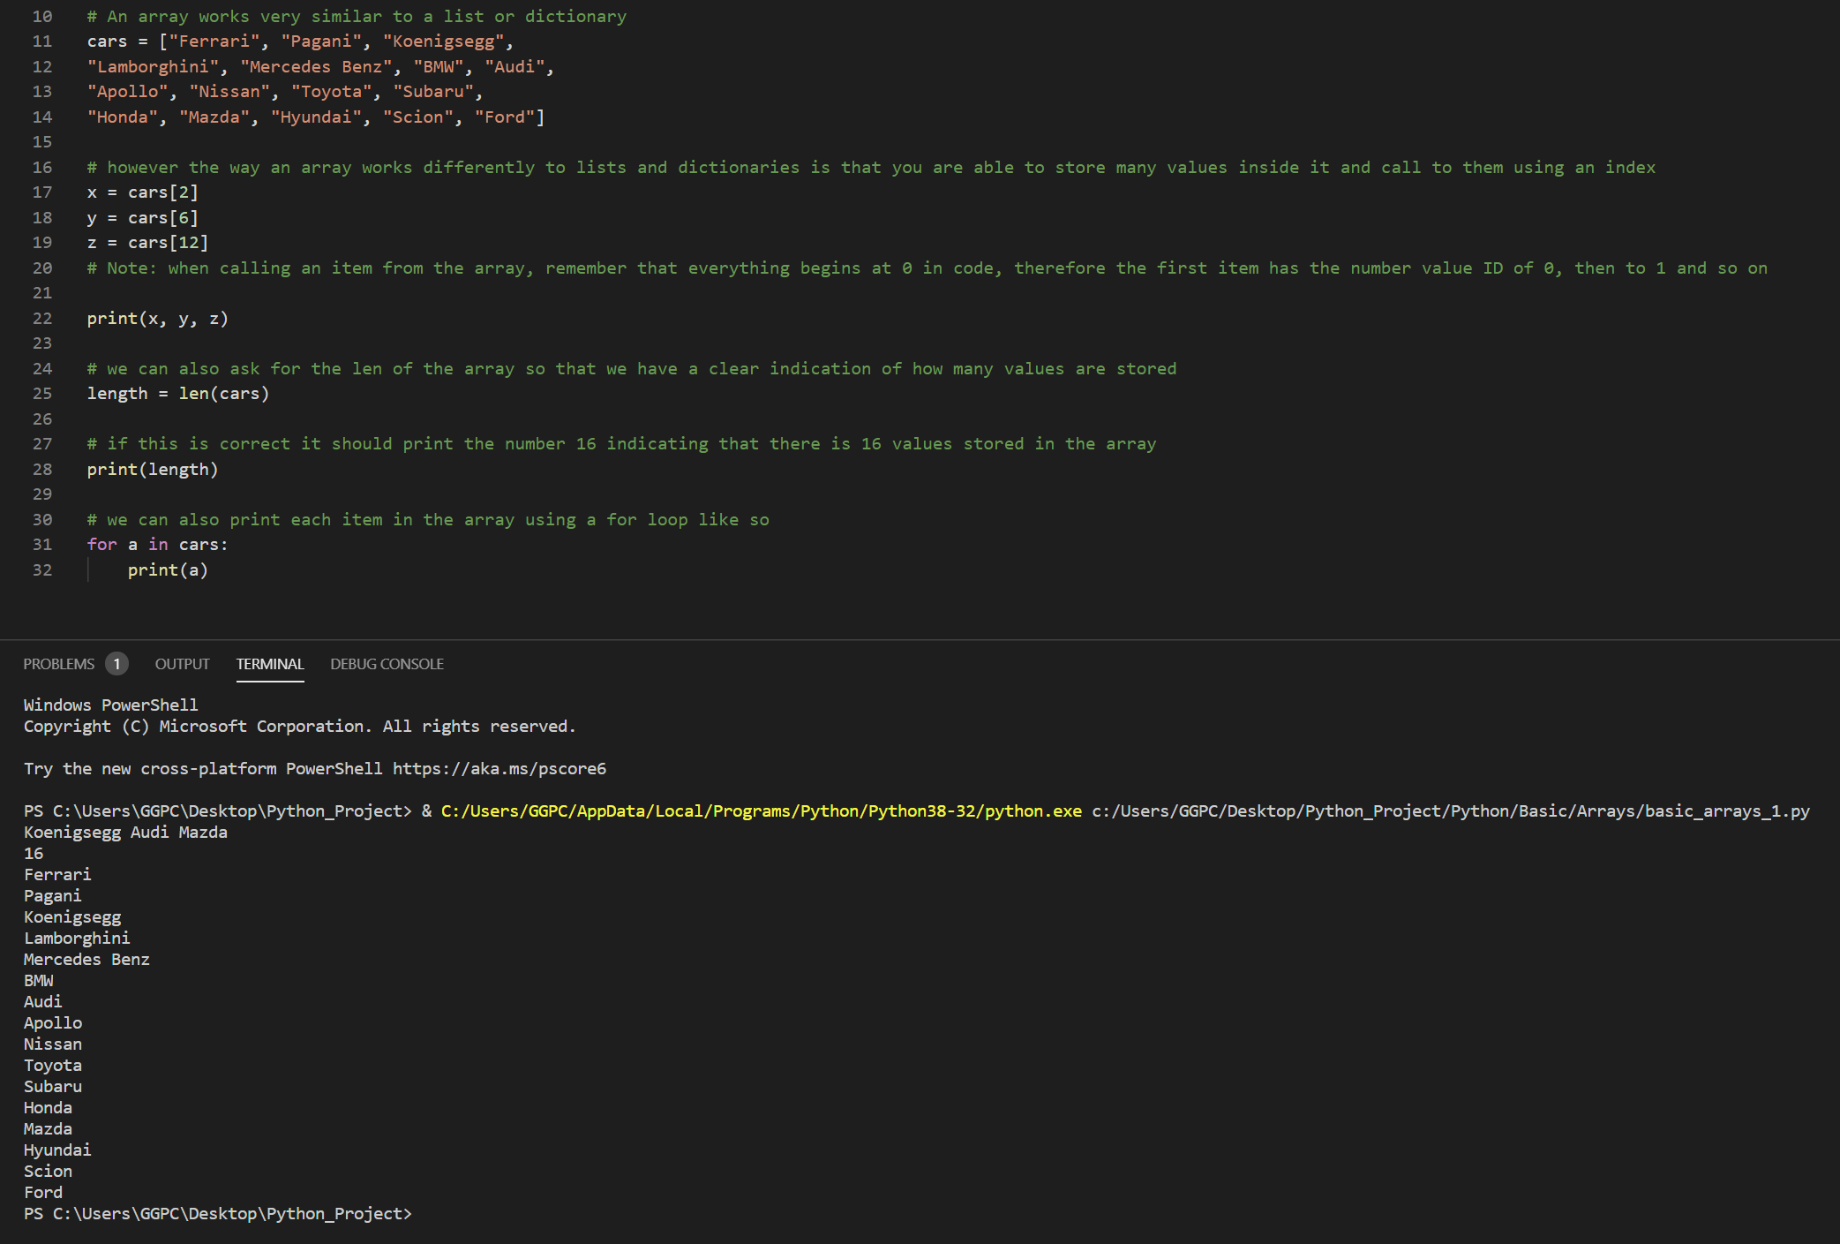

### Advanced

#### Calculator

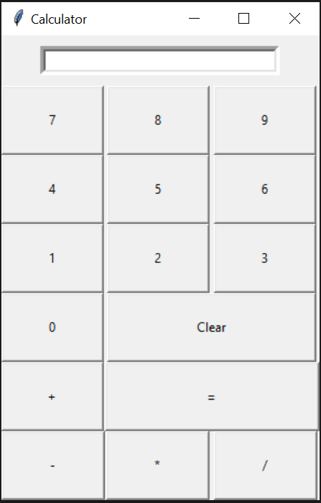

#### Connect Four

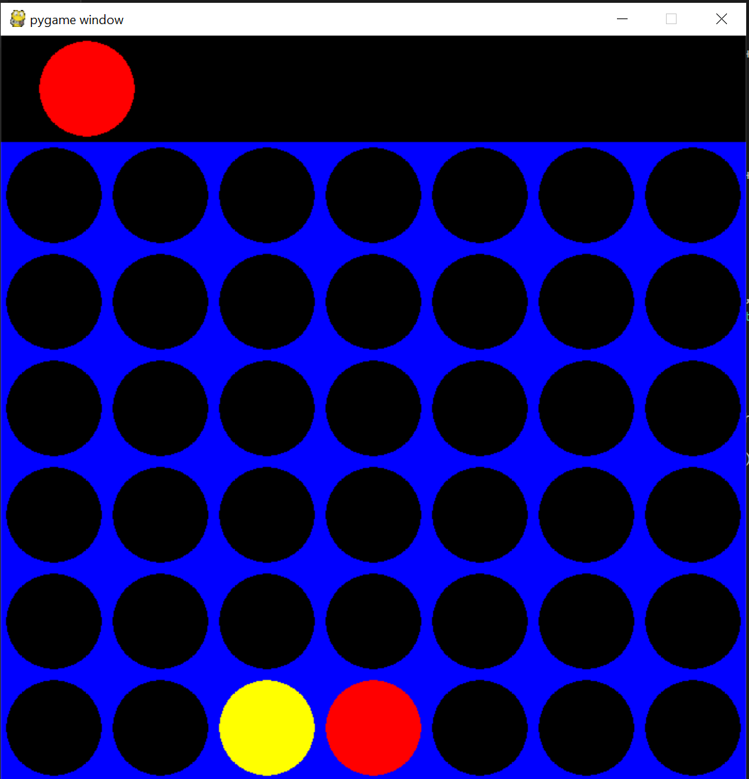

#### Hangman

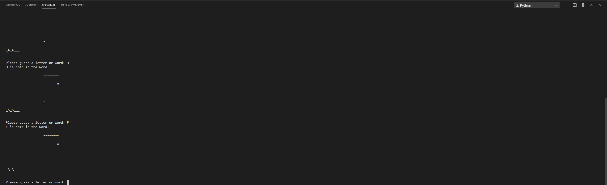

#### Pong

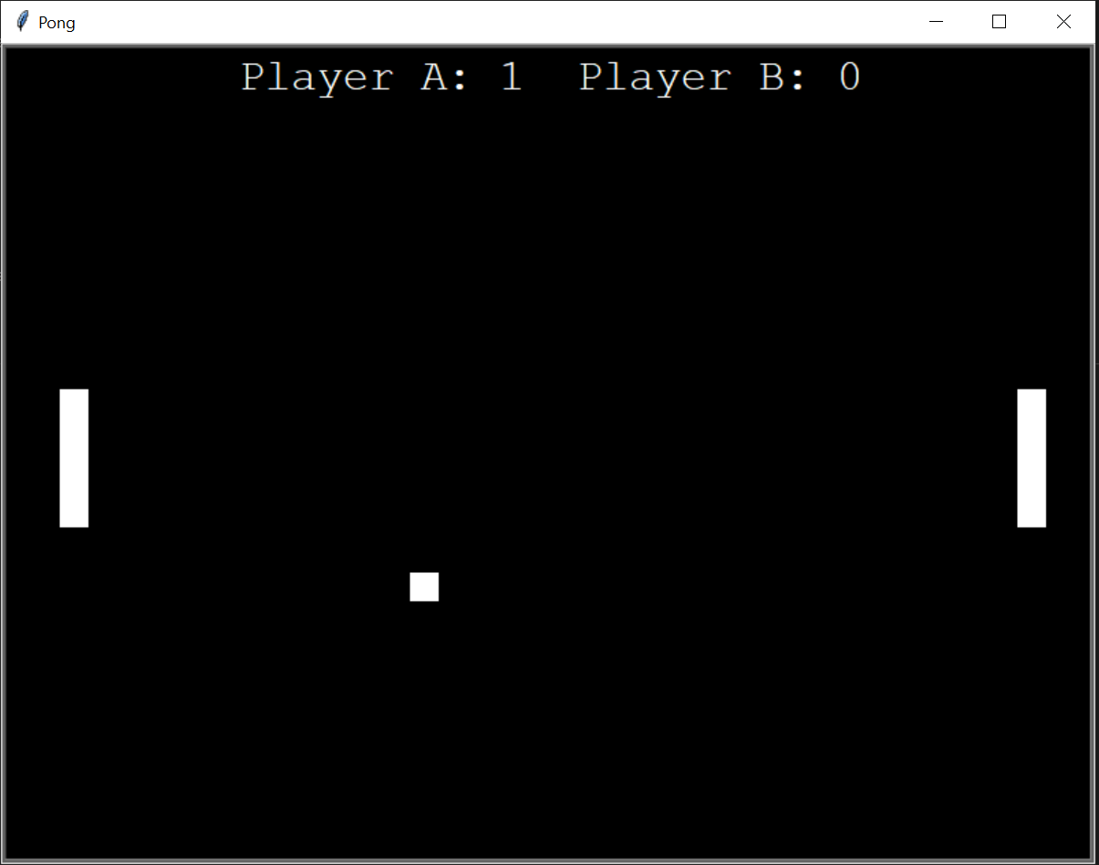

#### Space Invaders (Type Game)

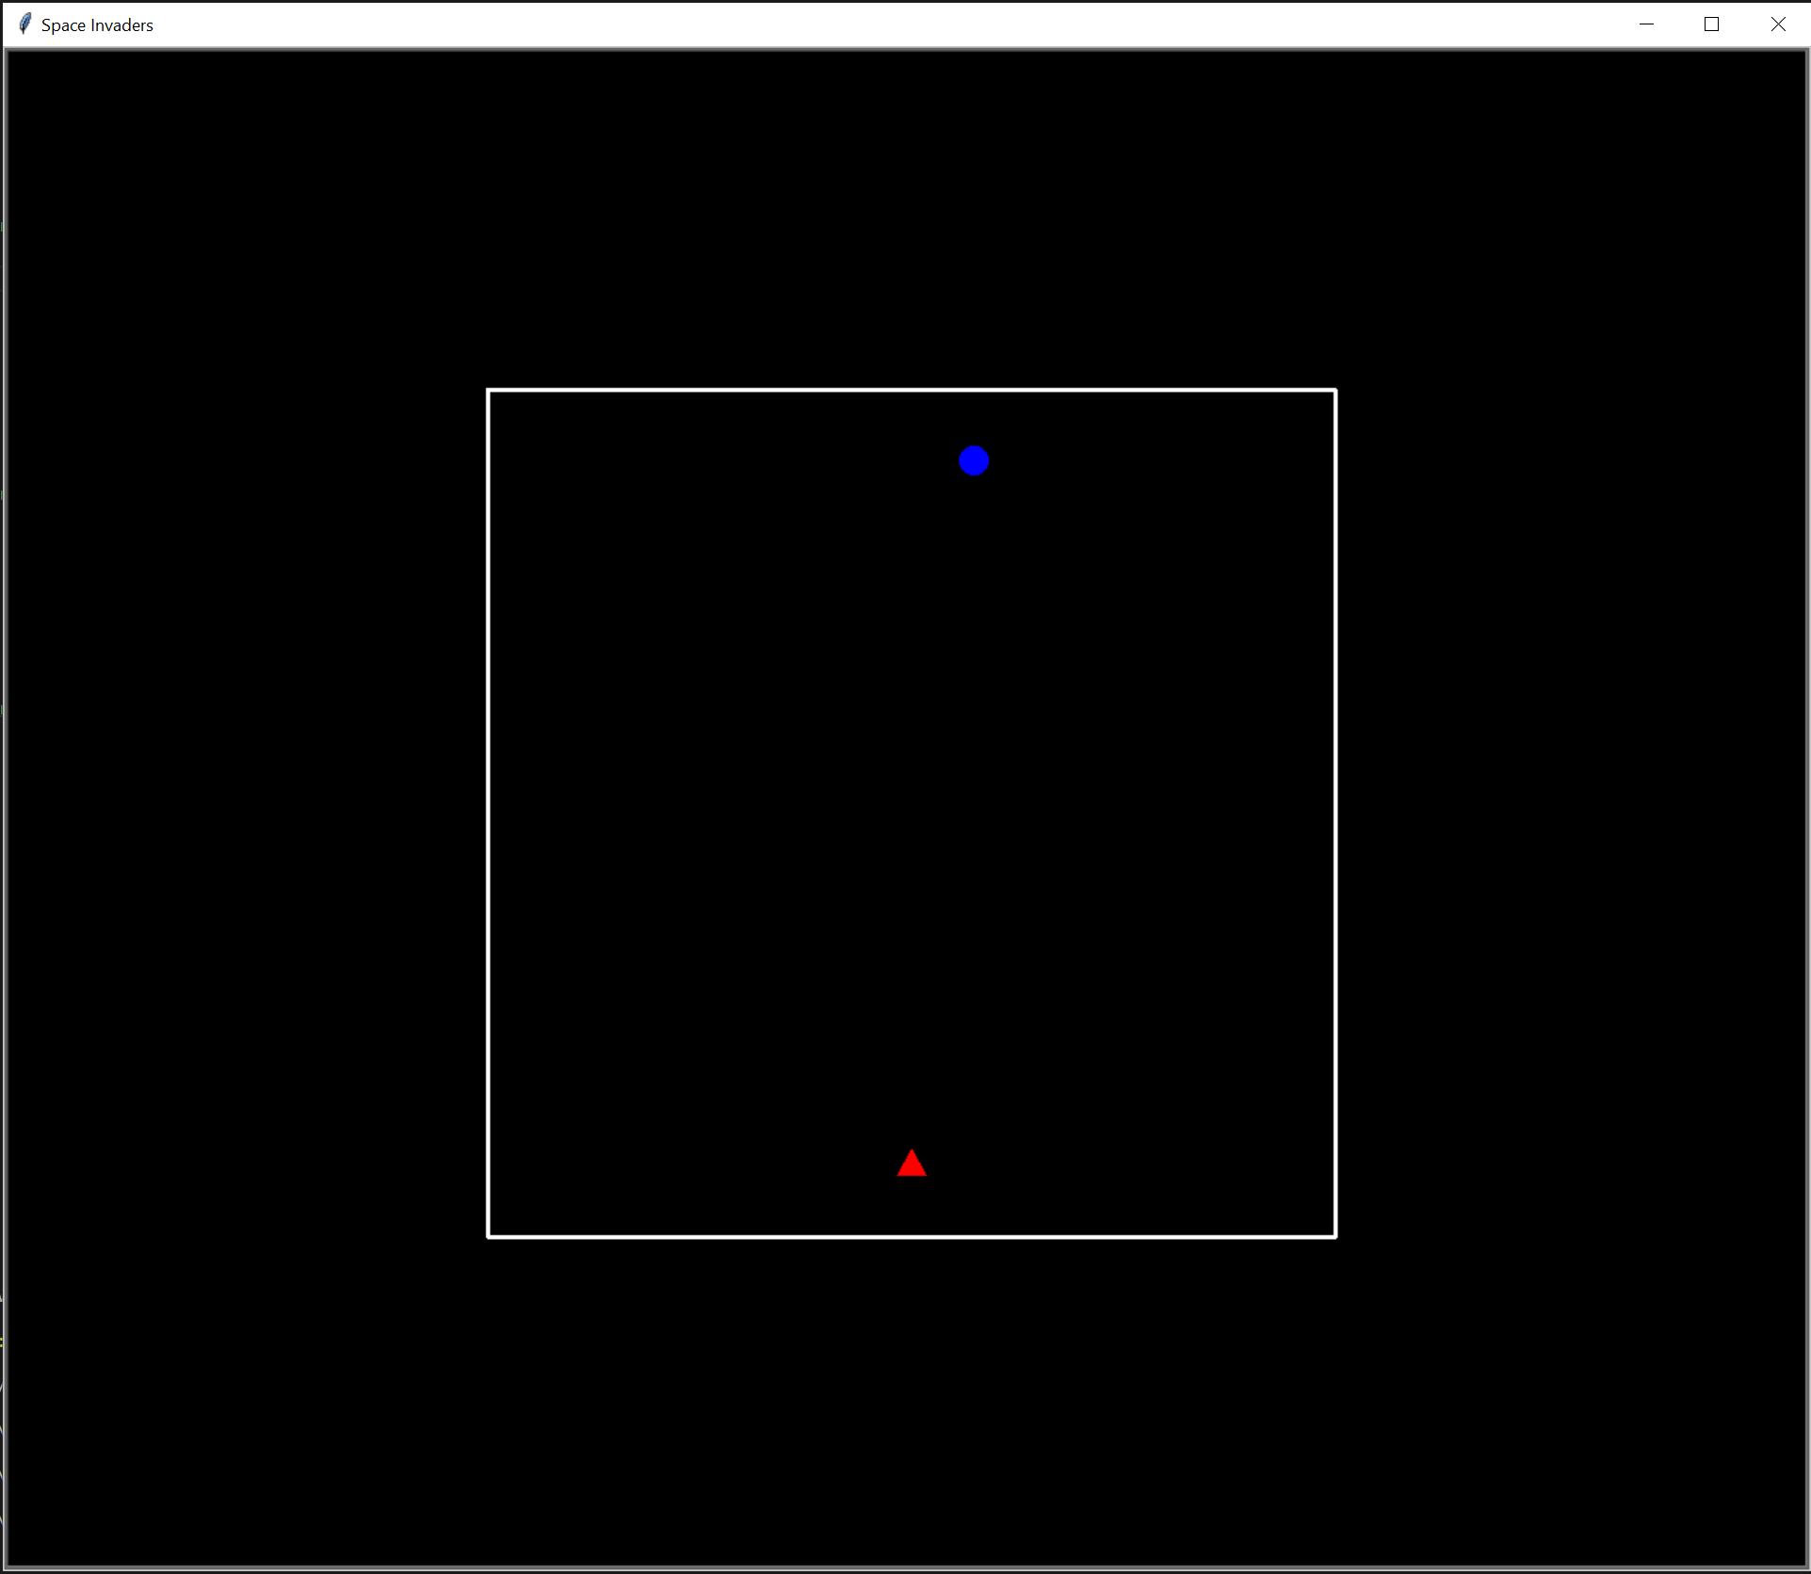

#### Dictionary with GUI

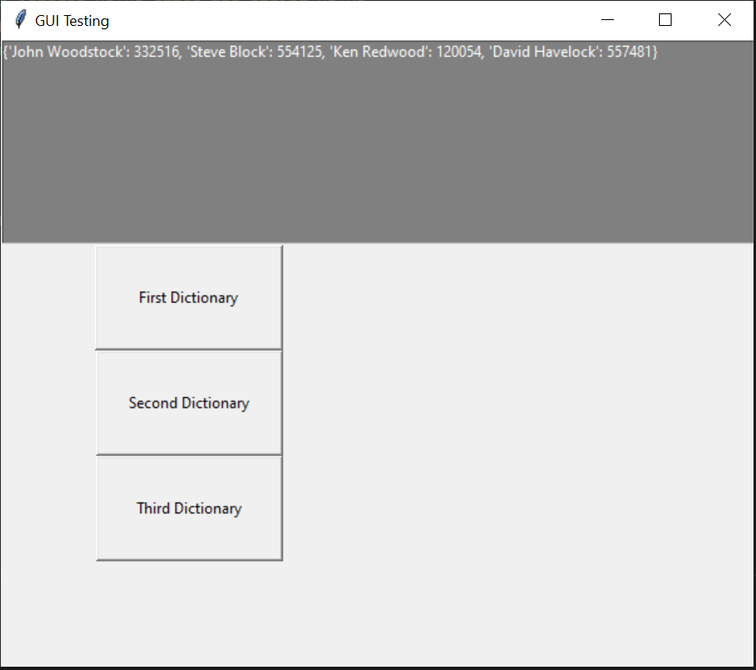

#### If Statements with GUI

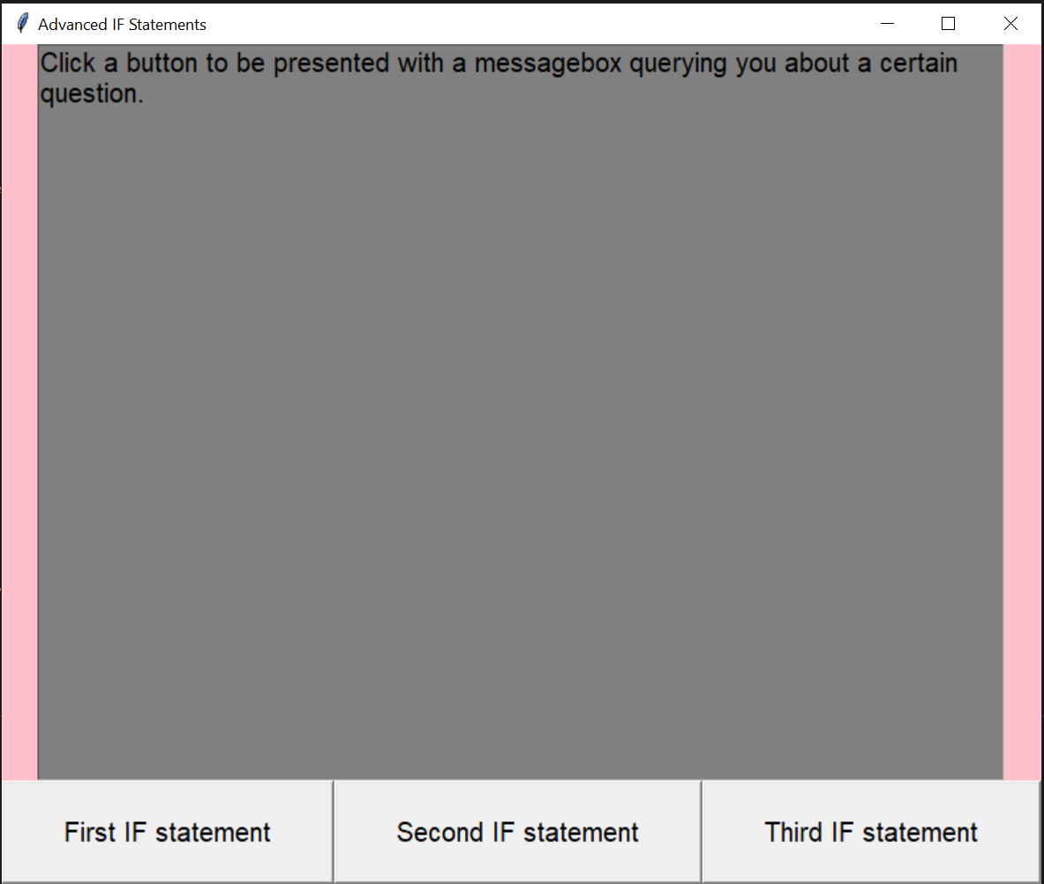

#### Lists with GUI

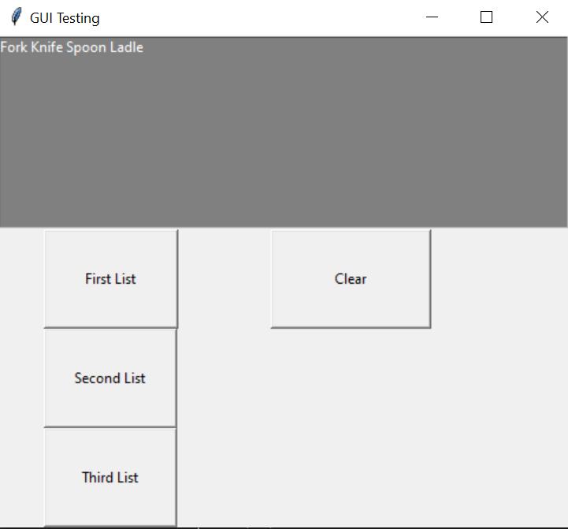

#### Arrays with GUI

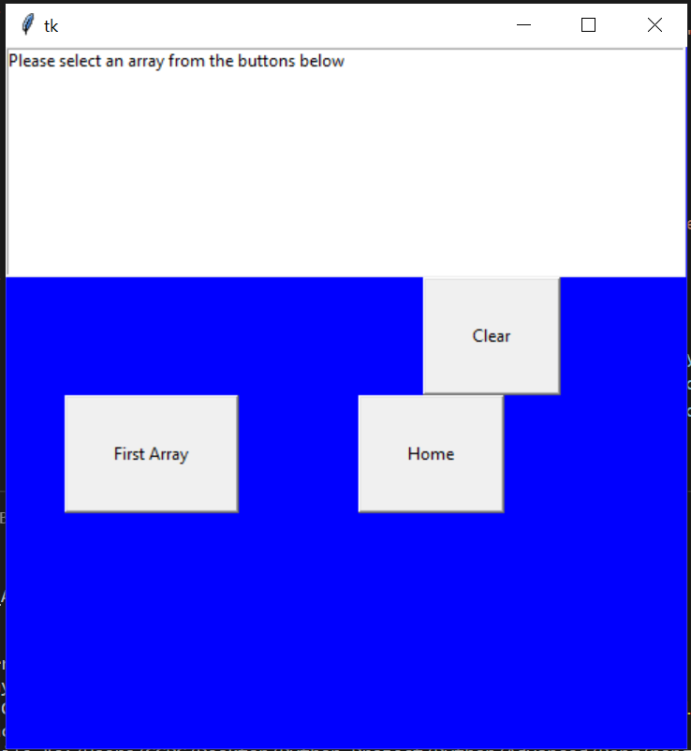

#### Discord Bot

#### 

#### 

#### 

# Repository Link

<https://github.com/30024380/Python_Project>

# Conclusion

Originally the project was to create basic applications that can do many of the basic functionalities of a program such as loops, if statements, lists, dictionaries, functions, methods, classes and a multitude of concepts. This was all and well to the team until we realized the project wouldn’t meet the needed requirements as things were too basic so we decided to dabble into coding basic GUI and games using python as this didn’t seem like a bad approach to meet the requirements. All applications reached their expected outcomes of success and were tested thoroughly before being marked off as complete.   
  
Overall, the project went along smoothly with all project members contributing to completing the tasks that were set within the project proposal.

In general, the project team learned that Python is a good language for general purpose use and has many libraries that can be imported to make a numerous number of applications. Another thing we learnt is that the language is intuitive in the way it handles variables as opposed to other coding languages. In terms of what both members think it seems to be a lot easier than C# (C Sharp) but at certain moments it also proves to be more difficult as certain libraries and packages need to be installed for different versions of Python, whereas for a programming language like C# the packages can be installed with any version that's currently available. In Python some packages that are needed to be installed via pip, and certain packages have been created for older versions of Python, meaning that utilizing these packages are difficult as users would need to have many different versions of Python to use these packages. We also had to factor in that both team members were working on Windows 10, whereas some of these packages were created for separate Operating Systems like Linux, MacOS and Windows. This did affect some of the tutorials that we watched as it made it harder to replicate the coding that was being done inside these tutorials.

# References

Galli, K. (2020). How to Program a GUI Application (with Python Tkinter)!. Retrieved 11 October 2020, from https://www.youtube.com/watch?v=D8-snVfekto&ab_channel=KeithGalli

Marini, J. (2020). Learning Python. Retrieved 5 September 2020, from https://www.linkedin.com/learning/learning-python/classes?u=56197641

Python. (2020). Retrieved 1 September 2020, from https://www.python.org/

Python Projects Ideas - 11 Awesome Games You Can Make With Python. (2020). Retrieved 17 October 2020, from https://www.youtube.com/watch?v=dXY7Tol4sRI&t=57s&ab_channel=TechWithTim

Schafer, C. (2020). Python Tutorials. Retrieved 13 September 2020, from https://www.youtube.com/playlist?list=PL-osiE80TeTt2d9bfVyTiXJA-UTHn6WwU