# To use Python Code

Step 1: Download your preferred version of Python on <https://www.python.org/>. I recommend you select the latest version.

Step 2: Download visual studio code.

Step 3: Once visual studio code is installed open visual studio and select the extensions icon and search for the python extension. Download it.

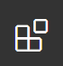

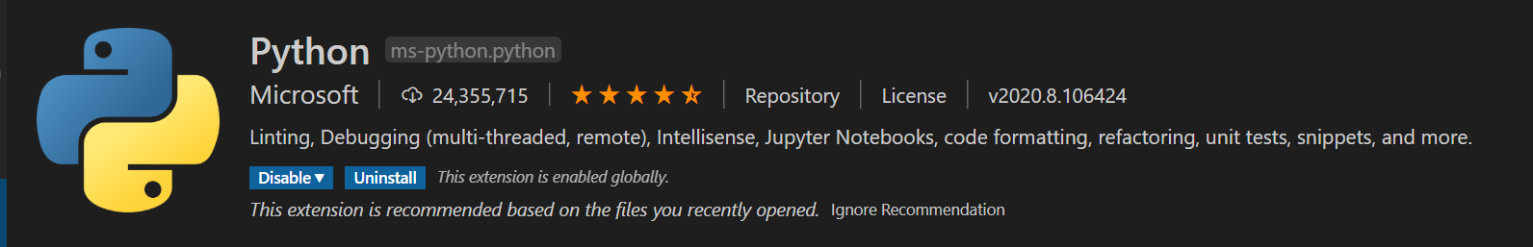

Step 4: Something will popup stating you need to select a python interpreter select it and choose the version of python that you installed.

Step 5: Create the folder structure that you would like to use for your python code.

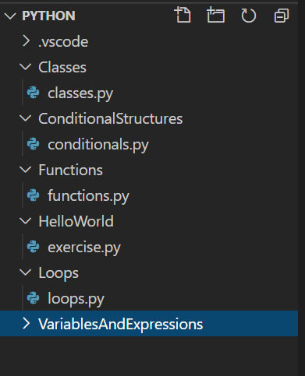

Step 6: Create a .py file of your chosen name to start creating your python code.