COMP.6215 Graphical User Interface Programming

Assignment 1: Designing Applications

Manish Twayana Student Number: 30028560

2020

Contents

1. Concept 2

1.1. Concept Idea 2

1.2. Concept Breakdown 2

1.3. Rough Mindmap: 2

1.4. Proper Mindmap 3

2. Structure 4

3. Interaction 5

3.1. Wireframe 5

3.2. Storyboard 8

4. Visual 9

4.1. Mood Board 9

4.2. Logo used 10

1. Concept
   1. Concept Idea

My application is about concept of observing disease effected area and reporting the merging disease in certain area. This idea came to me due to effect of COV-19 in recent time in 2020.

* This concept will help to analysis the current condition of a disease in certain area, which can be help for containing the disease and stop the spread into different area.
* This concept can be used in record gather data about the disease.

* 1. Concept Breakdown

Initial I just to develop an application which help to equate effect of certain disease in the world but this will limit my application to work to generate report of current period of time but I implement the idea of reporting current disease that general public are suffering from.

* 1. Rough Mindmap:

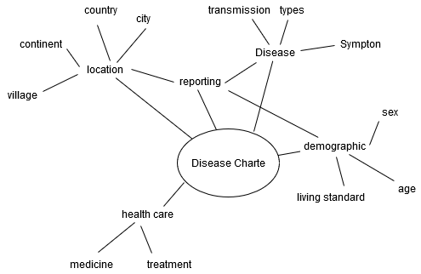

* 1. Mind map into outline

Using above rough mind map we come with this outline given below to ensure the development of applicant goes according to the concept intended to.

**View**

**Effected Area Disease effecting that area**

**Number of people effected**

**Reporting**

**Area Disease**

**People effected**

1. Structure

Structure of this concept can be described in Hierarchical diagram given below which indicated that our main page is welcome page which lead to next page having level that is Map based view, Report page and search. These would lead us to next level of this application.

1. Interaction
   1. Wireframe

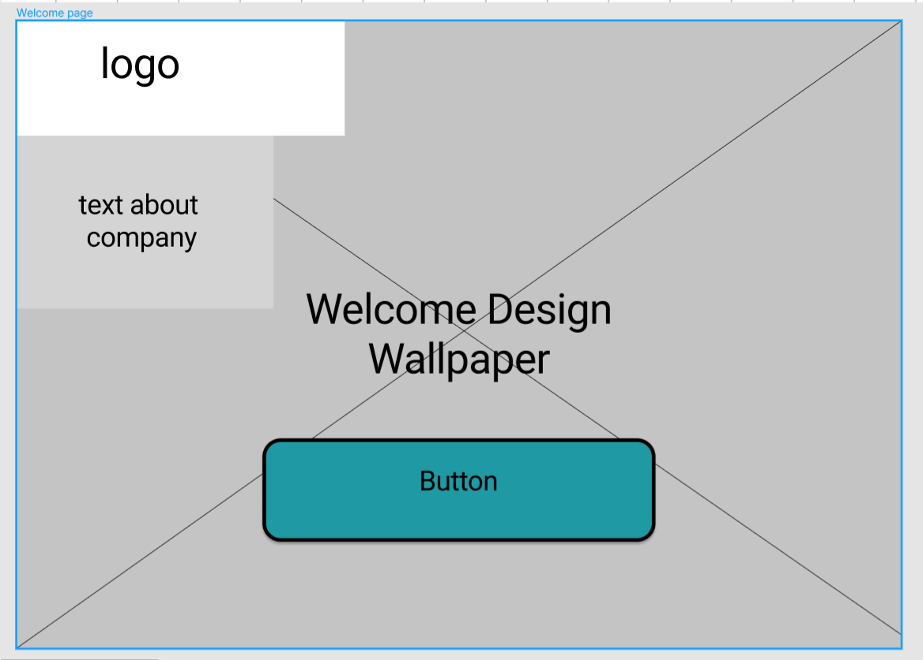

Figure 1: Welcome page

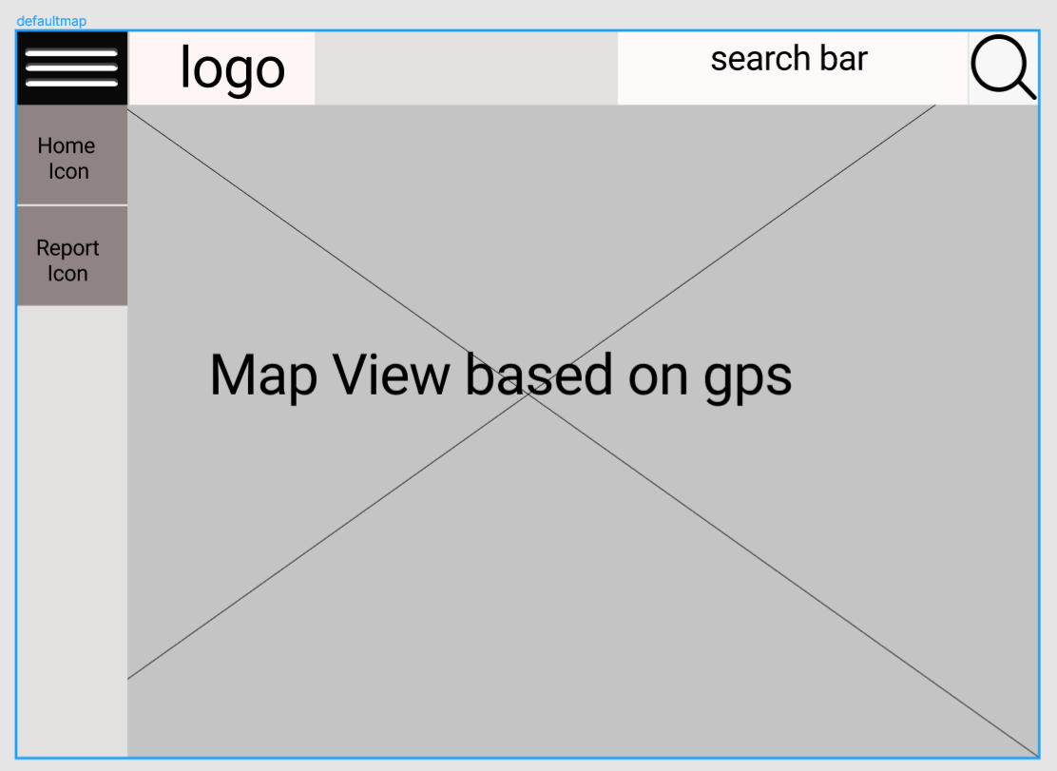

Figure 2: Web Based View

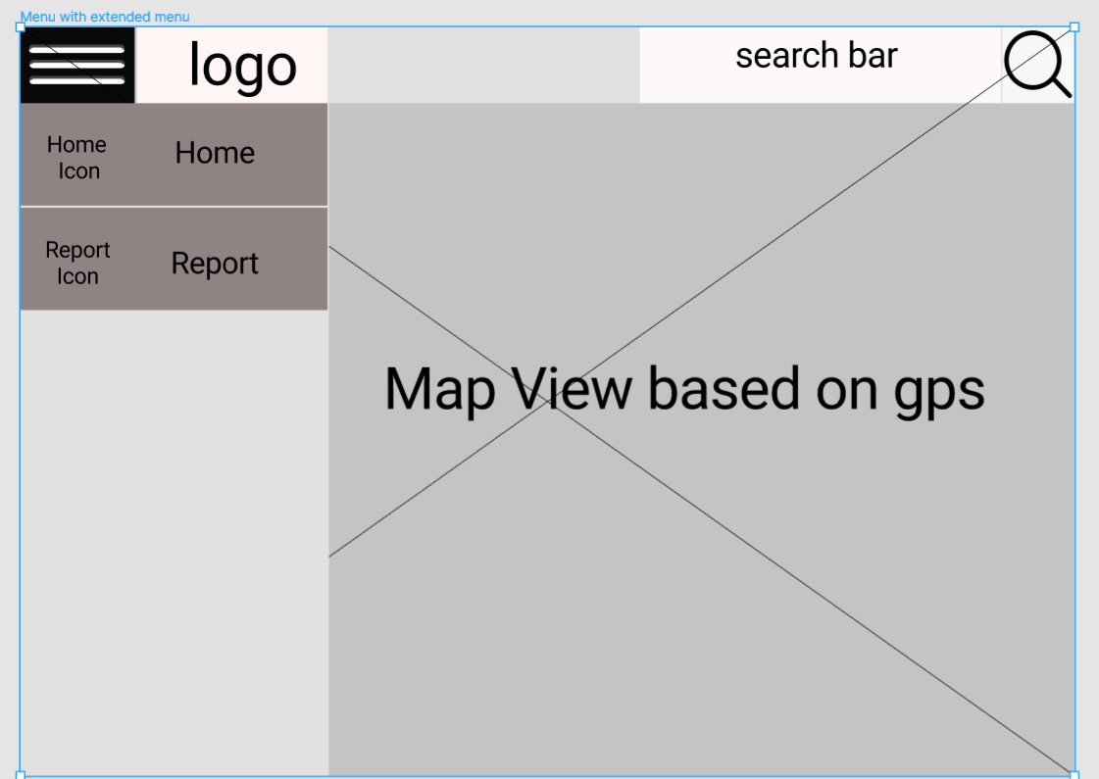

Figure 3: Map view with menu extended menu bar

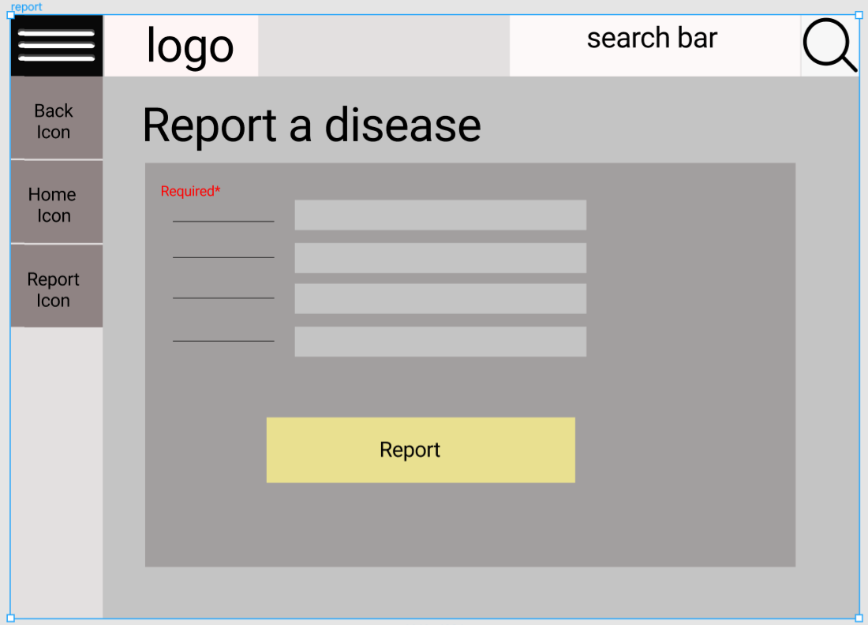

Figure 4: Report page

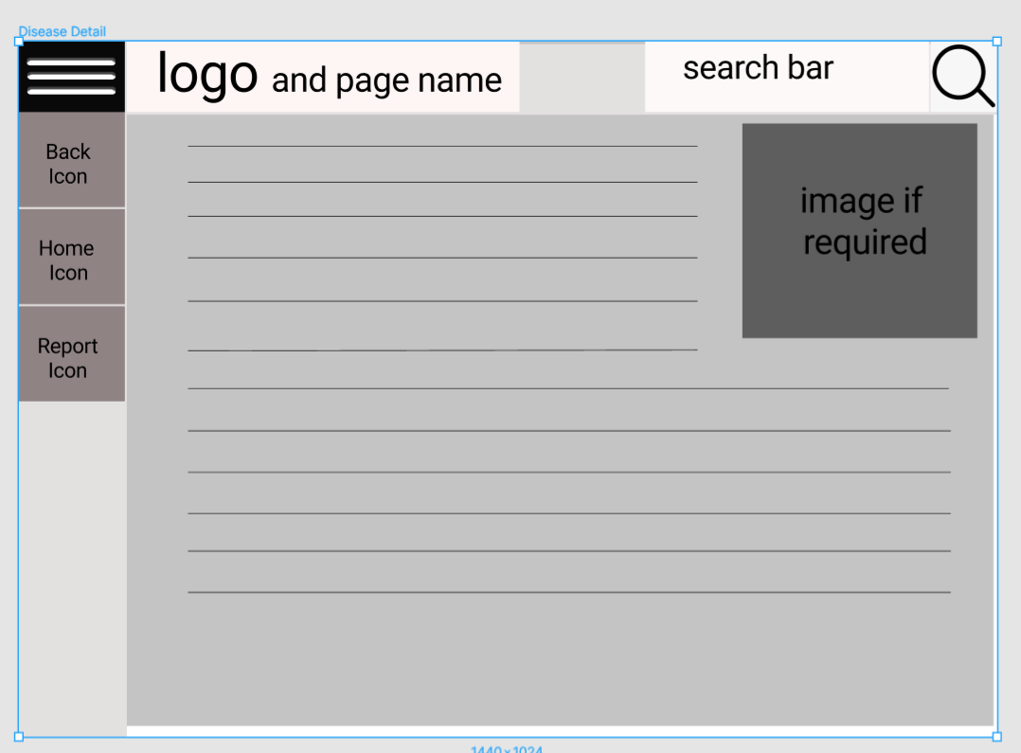

Figure 5: Disease Detail Page

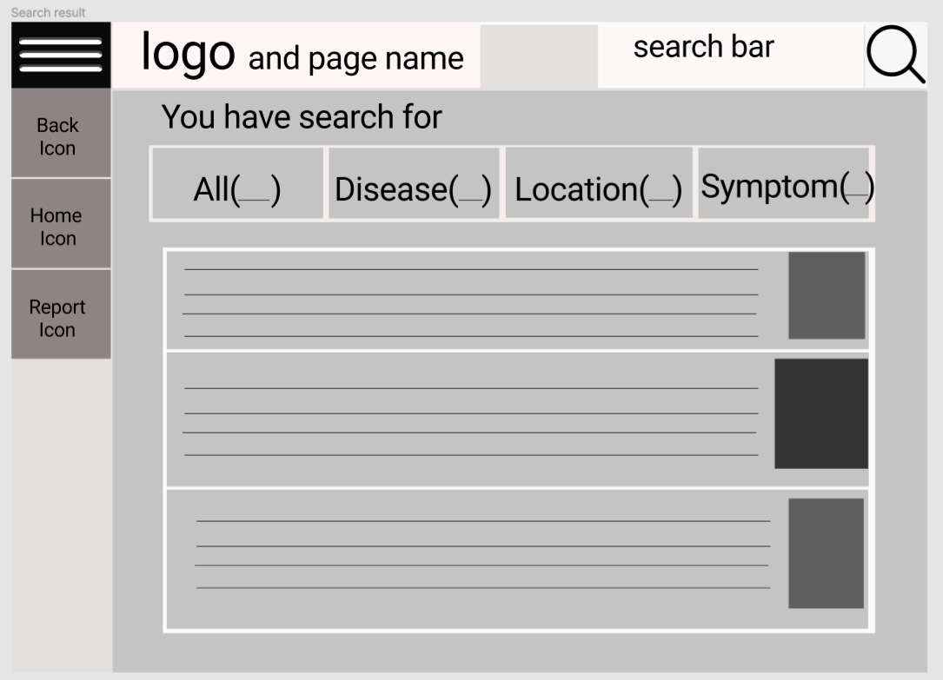

Figure 6: Search Result Page

* 1. Storyboard

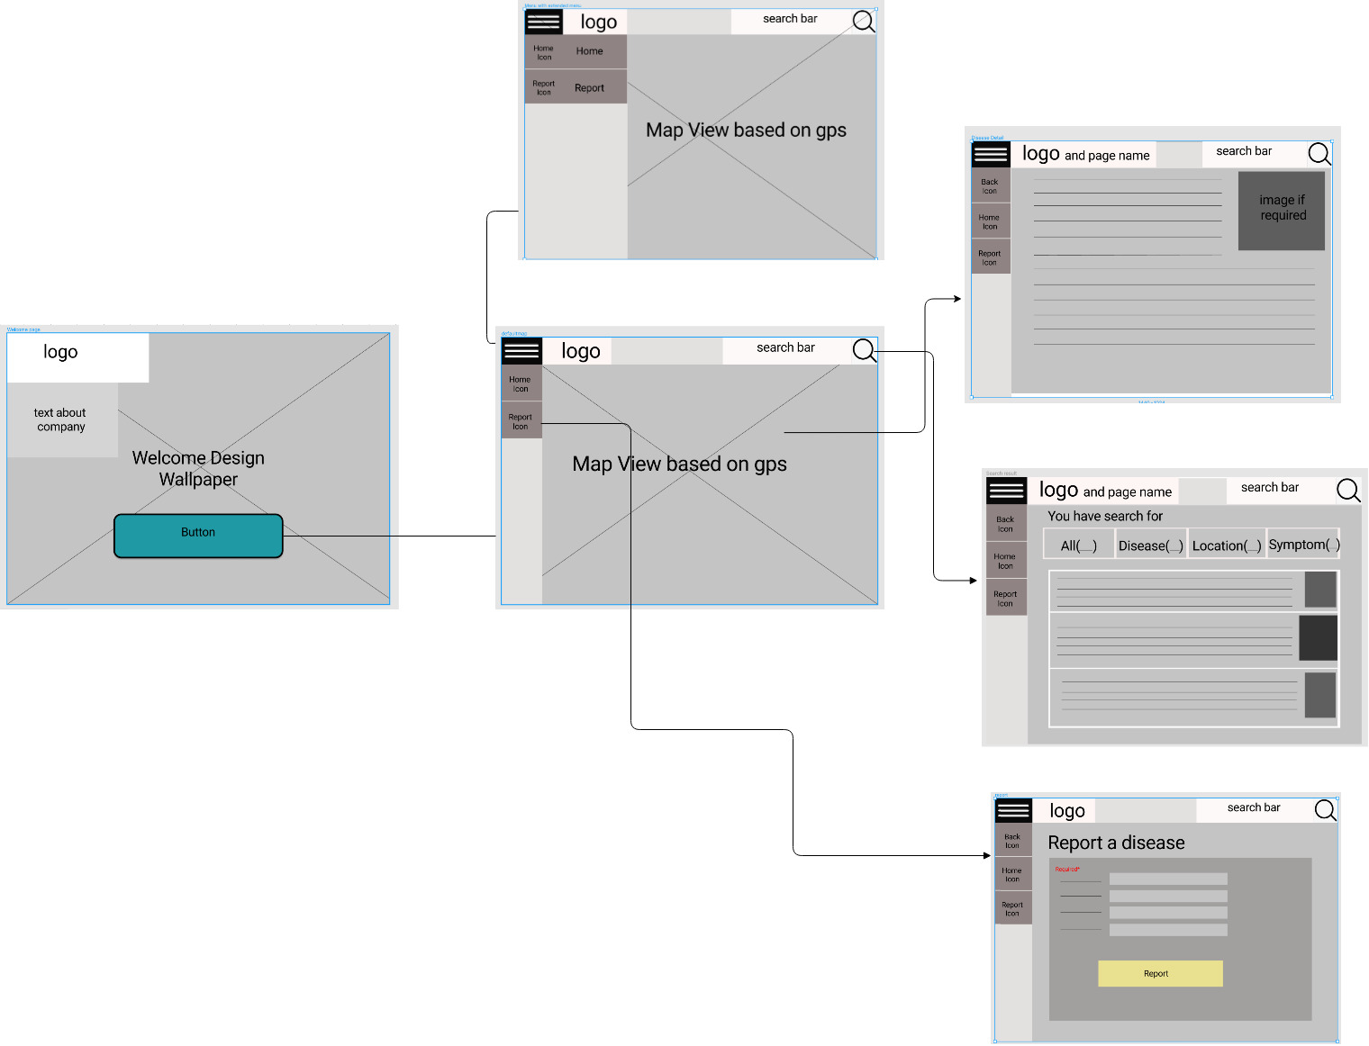

Figure 7: Story board

1. Visual
   1. Mood Board

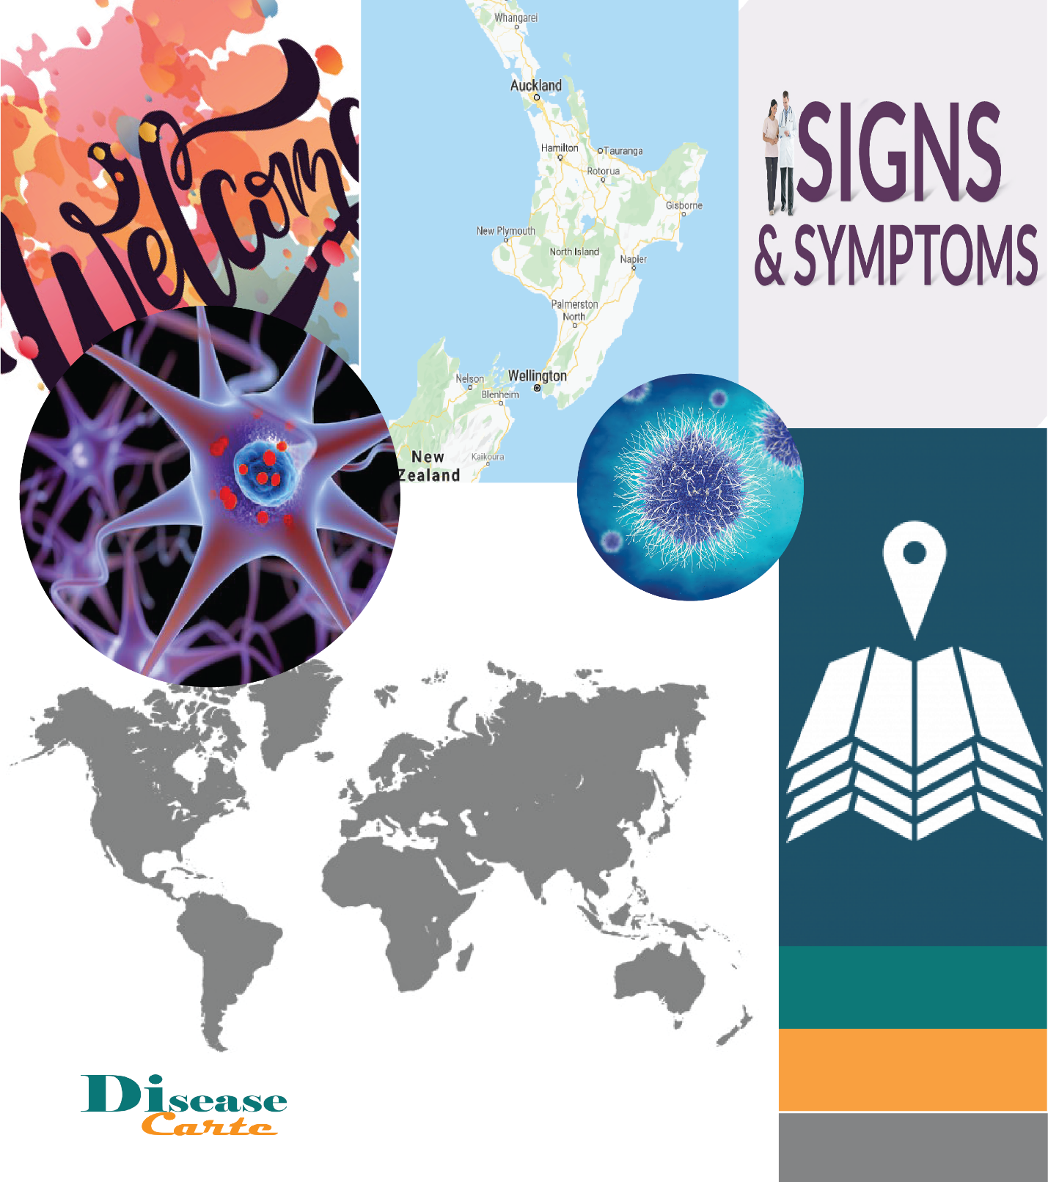

Figure 8: Mood Board

* 1. Logo used



Figure 9: Logo without background



Figure 10: Logo with black background