Movie Database – Master Document

Team Orange – Movie database project

Benjamin Wearn, Chris Chi, Jaron Rose

2021

Table of Contents

Sprint One 2

Software development testing plan 2

Analysis report 4

Purpose: 4

Problem Statement: 4

Scope and Objective: 4

Target System: 4

Project Requirements: 4

CITE Rules for Software Development 4

User Interface Development Guidelines: 4

User Control and Freedom: 4

Consistency and Standards: 4

Error Prevention: 4

Aesthetics: 4

CITE Development Methodology: 5

CITE Quality Assurance: 5

Quality Planning: 5

Quality Assurance: 6

Quality Control: 6

Quality Assurance Department: 6

Quality Assurance in Development Lifecycle: 6

1. Initiation and Planning: 6

2. First Review: 6

3. Iteration Audits: 6

4. Final Verification and Validation: 6

Test Types: 6

Multi-platform report 7

Introduction 7

Adaptive 7

Responsive 7

Side by side comparison 7

Decision: Adaptive or Responsive 7

Source Control 8

Project management 8

Sprint Two 10

Sprint Three 11

# Sprint One

## Software development testing plan

Testing for this project will take on a variety of forms, a subset of these will be undertaken throughout development, however all of them will be able to be performed on project completion to determine the overall state of the completed project. Some of the aspects of testing to be undertaken are: -

**Functionality testing** – this kind of testing determines whether or not the website actually achieves what it sets out to do, questions to be asked are such like, do the all the links function as expected? Do all the pages show the required content? This type of testing will also include Forms testing to ensure all the required forms function as expected with required inputs or inputs as required and to ensure that no erroneous data can be entered into forms as much as possible. Included also is navigation testing to ensure that all navigation tools function as expected and help the user around in a clear and user-friendly manner.

**Validation testing** – this kind of testing is to determine whether all the different types of code are free of errors and will function as expected on various browsers, this can be achieved through validate of all HTML, CSS and PHP code, being run through a code validation testing environment.

**Portability testing** – this kind of testing determines how the website looks and/or runs on various browsers and across various platforms (such as different operating systems), it is not always possible to test every browser on every platform, however, ensuring that the website functions as expected across as many environments as possible will minimise any protentional impacts upon potential users.

**Printing compatibility** – this kind of testing in an age of green initiatives could be considered a waste of time as people are attempting to minimise the amount of printing they are doing, however, ensuring your pages print correctly and look nice when printed, will minimise environmental impacts if users are to actually print your page. This means you could be saving excess paper from being wasted as the layout of your page prints poorly.

**Performance testing** – this kind of testing is important in an age where information is served at such high speed. Ensuring your platform operates as quickly as possible will minimise the amount of traffic your platform may lose due to slow loading pages, which prompt potential users to click away and find somewhere else to be served the content they were hoping to find on your page.

**Content testing** – it Is important to test your content for a couple of reasons, firstly, it is important to include key information, without overwhelming users with information, clearly labelled headings, navigation and sections, to help them find the data they are looking for without having to read too much, as this will deter some users from browsing your page. It is important to clearly help users as the primary method of web content browsing is typically using ‘scanning’ techniques commonly referred to as the ‘F Pattern’, if your content doesn’t help those users find the content they are looking for, they may get frustrated, give up and try another platform.

**Security testing** – security testing is important to carry out to ensure the safety of your users and your databases, content, etc. by ensuring that none of the systems or users can be targeted with any known flaws will mean a good reputation and encourage people to use your platform.

**User friendliness testing** – when designing a web platform, it is very important to keep the end-user in mind, these are the people who you are developing the platform for. If the platform is not easy to use, navigate and browse your content, they will simply find somewhere else to get that content.

**Design testing** – design is something to keep in mind throughout development, the overall appearance, layout and content of your platform will either encourage or discourage users from using your platform, and with a large amount of content available on the web, you want to stand out from the competition and have users, using your platform over others. The things to keep in mind have been somewhat stated already in previous sections, however, ensuring that your content looks nice, is laid out with appropriate headings and navigation to help your users around and doesn’t feel clunky or slow, will help to ensure the continued success of your platform.

## Analysis report

### Purpose:

The purpose of the movie rental database development, is for Acme Entertainment Pty Ltd. In which they require an update to the current prototype of their movie database. This database is to be reviewed and updated so it can be used across all the major digital platforms.

### Problem Statement:

Currently the system prototype does not allow multi-platform access, which limits users to be most compatible on a computer system, as other platforms are not optimized and tested for, which may result in other platforms having issues when accessing the system on a different platform. Although Acme would like the system to be updated in order to improve such accessibility to allow other platforms to be optimized.

### Scope and Objective:

The scope of the project is to update the current system that Acme has provided in order to allow multi-platform access from at least three other platforms.

### Target System:

The target system is to be changed to allow users to access the database on any system through integrating multi-platform solutions.

### Project Requirements:

* Develop the application with PHP
* generate SQL scripts to store the movie records in an appropriate database table
* Create a service to access the movies database stored in the server
* Multi-platform access

### CITE Rules for Software Development

### User Interface Development Guidelines:

### User Control and Freedom:

Allow users the control and freedom with optimal options and digital space such as backward steps, undoing and redoing previous actions.

### Consistency and Standards:

Ensure that graphic elements are maintained across similar platforms.

### Error Prevention:

Implement error catching so that potential errors are kept to a minimum.

### Aesthetics:

Remove unnecessary clutter and information that may limit user’s attentional resources.

### CITE Development Methodology:

CITE uses an agile method framework, which maintains a customer focus. This allows teams to deliver the highest priority features first for clients. Communicate accurately and unambiguously across imposed barriers such as, distance, time, culture, language. Sprint reviews ensure that the delivered features are reviewed and that feedback is shared across the team. Continuous integration allows for continual improvements on development and for problem resolutions as issues arise. CITE uses a three-sprint model:

Each sprint goes through six phases which are, planning, design, build, test, review and launch.

Planning allows the team to have clear direction, goals and understanding of requirements before, during and at the ending of development.

Design will be continuously improved on at each interval as after each interval, the design will be updated to better fit client needs and requirements if they are not met previously.

Building the project will allow teams the opportunity to have visual representation and/or to develop the actual system to be implemented. At each interval the build may be changed as errors or issues may arise.

Testing will begin once the initial build is completed to determine whether the system works as intended

The team will then review the project before going into the next sprint interval where the six phases are then revisited and improved upon the previous until the project is finished.

### CITE Quality Assurance:

CITE implements a Quality Management System (QMS) that ensures quality of software throughout every development. The tasks and objectives of this QMS are:

Elaboration and implementation of procedures and regulations for software development based on industry standards and practices. Product lifecycle monitoring which ensures compliance with all processes and guidelines at CITE. Product quality verification and validation to ensure needs and expectations of all clients are met. Establishment of effective collaboration within all project teams.

### Quality Planning:

CITE creates quality plans that govern the applicable set of standards, regulations, procedures, guidelines and during development of each project.

### Quality Assurance:

CITE has established processes that evaluate project performance and aim to assure that quality standards are being followed and that software comply with all requirements

### Quality Control:

Performance trends are measured to identify defective code, verify deliverables are of high quality and are working correctly and as intended.

### Quality Assurance Department:

CITE has an independent subdivision for quality assurance. This subdivision is responsible for:

* Full-cycle testing
* Document and Code review
* Defect tracking
* Configuration Management
* Process Monitoring
* Risk Management

### Quality Assurance in Development Lifecycle:

CITE performs quality assurance (QA) throughout the entire software development lifecycle. This QA lifecycle includes 4 phases.

### Initiation and Planning:

Project specification analysis, test plan elaboration and team assignment.

### First Review:

Initial testing of first development deliverables, refining test plan and test items.

### Iteration Audits:

Ongoing testing of intermediate iterations builds.

### Final Verification and Validation:

Final product testing to ensure best possible quality and readiness for deployment.

### Test Types:

CITE utilizes these test types on all projects to ensure quality assurance:

* Functional and Regression Testing
* GUI and Usability Testing
* Compatibility Testing
* Performance Testing
* Installation / Configuration Testing
* System/ Integration Testing
* Security Testing
* Internationalisation / Localisation Testing
* User Acceptance Testing

## Multi-platform report

### Introduction

This report has the purpose of determining which web development technology, adaptive or responsive, to be used for Team Orange’s project. To deliver a little background information of the web program, it is a website that’s connected to a database which has the purpose of user input searching for movie records as well as displaying top 10 searched movies. In brief, this report will provide the necessary information and point out which will be used.

### Adaptive

Adaptive web design practice requires the developers to create multiple versions of webpages that better fit on every different devices, which means the developers need to create one .css file for each device.

### Responsive

Responsive web design practice delivers content to the users by auto-adopting the screen sizes of the devices, and provide the best user experience by minimizing the resizing, panning and scrolling with the use of fluid grid layout.

### Side by side comparison

|  |  |
| --- | --- |
| Responsive | Adaptive |
| Same layout for all screen size | Different layouts according to the device and OS |
| One .css file fits all | Multiple version .css files for each different size |
| Hard to build as making one design for multiple devices could be complex | Easier to build as design layouts according to device |
| Works on any screen size | Work on Single screen size for each .css |
| Loads faster, only load a single layout | Loads slower, load entire possible layouts |

### Decision: Adaptive or Responsive

Due to numbers of reasons, **Responsive web design practice** will be used for the project.

1. **Responsive** requires to only create one .css file for all devices which **reduces the amount of budget** required comparing to **adaptive**, as it requires developers to create multiple .css files which **increases the amount of time and money required**.
2. Responsive method allows the web page to load quickly, increasing client satisfaction, whereas adaptive method loads slower.
3. Responsive practice fluidly fits all screen sizes whereas Adaptive practice aims to fit only one size.

## Source Control

## Project management

Project Start:

Project underway

Project completion

## Code Validation

index.php

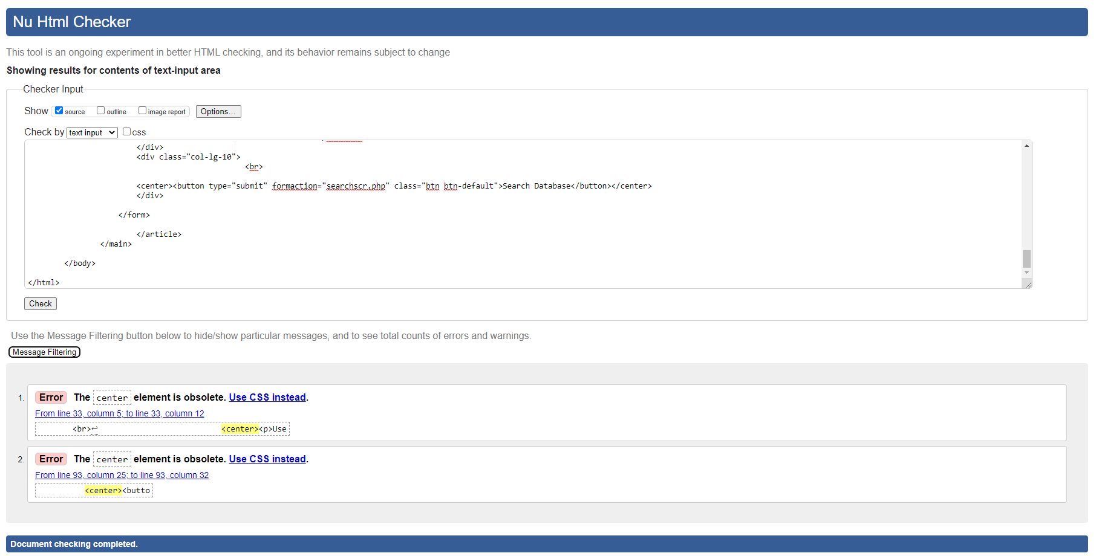

bargraph.php

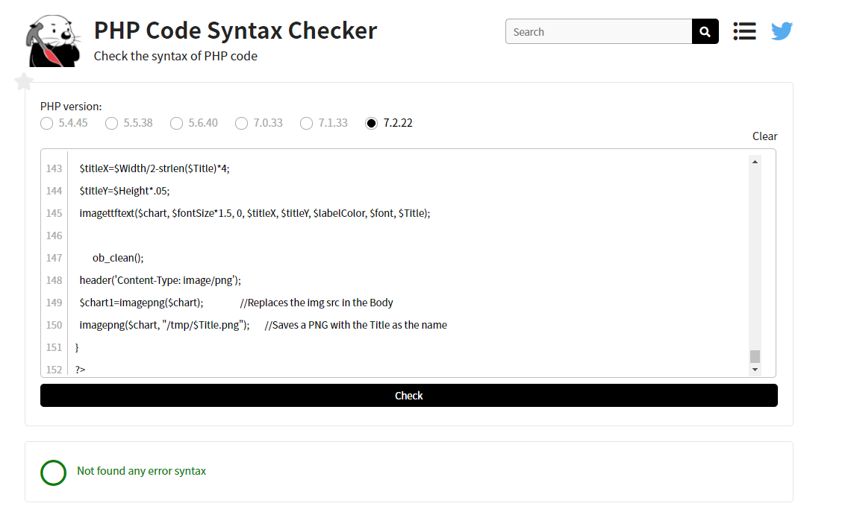

connect.php

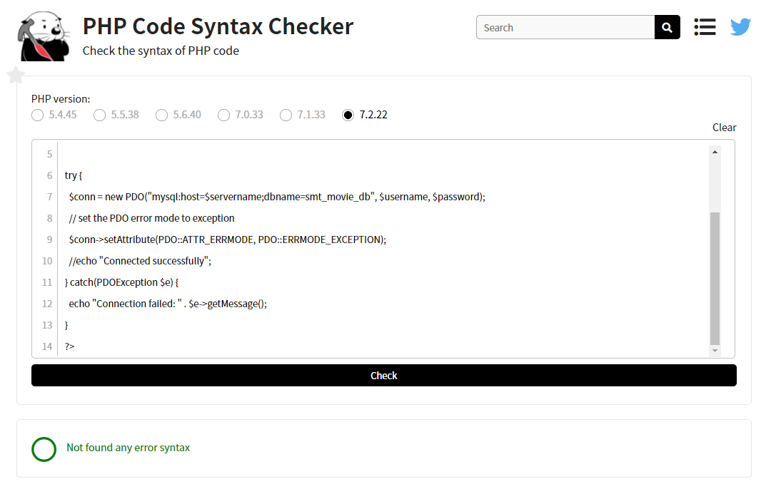

searchscr.php

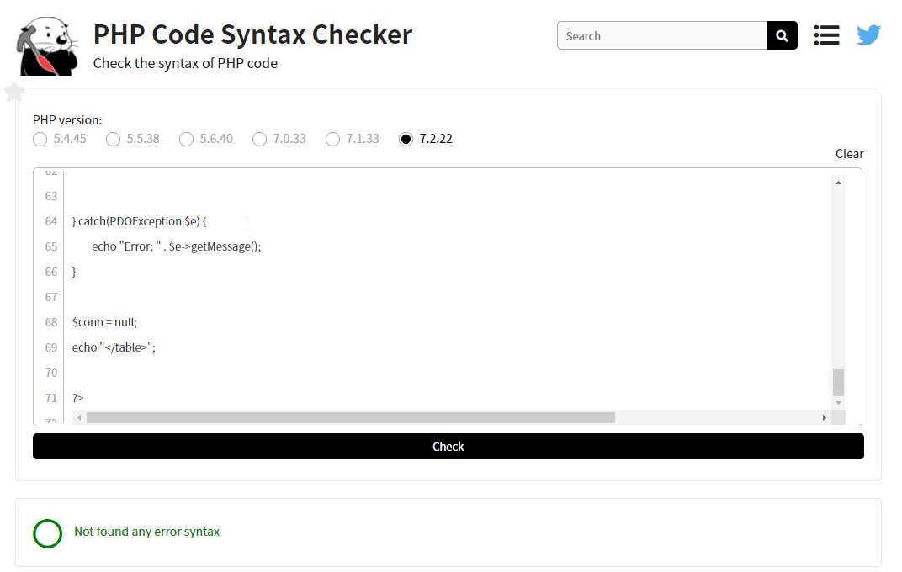

# Sprint Two - TBD

This page onwards assigned for Sprint Two.

# Sprint Three – TBD

This page onwards assigned for Sprint Three.

*End of Assessment*