Jaron Rose 30038674

Project Document

Programming III

# 1. Data Structures

The data structure being used in this project will be a Double Linked List. This data structure is a linked data structure that consists of a set of sequentially linked records or nodes. These nodes point to other nodes that are either in front of after a particular node. This data structure will be used to store a list of songs in the program.

# 2. Hashing Techniques

Password hashing will be used as the hashing technique, this will be done to change user passwords into a larger and complex string and store the password for later verification when used to login through the client-server system. For security reasons, storing passwords in hashed form guards against possible unauthorized access. Hashing performs a one way transformation on a password into another large string.

# 3. Sorting Algorithms

In development of the music player, the merge sort will be used as the sorting algorithm for sorting the music files in alphabetical order. Merge sort is one of the fastest sorting algorithms available and therefore is a reason why it will be used.

# 4. Searching Techniques

Binary search is an efficient algorithm for finding an item from a sorted list. It works by repeatedly dividing in half the portion of the list and checking halves until the item is found. The binary search algorithm will be used in the music player program to search for individual songs in the music list. If no song is found an error message will be displayed, if the song is found then the song will be displayed with an option to play the selected song.

# 5. Third Party Libraries

CSVHelper is a third library party that will be used to read and write to a CSV file. This will be used to read and write user login information and save the music player song list to a file which will then be able to be viewed upon next launch of the program.

# 6. Where can I find the documentation for this?

<https://joshclose.github.io/CsvHelper/>

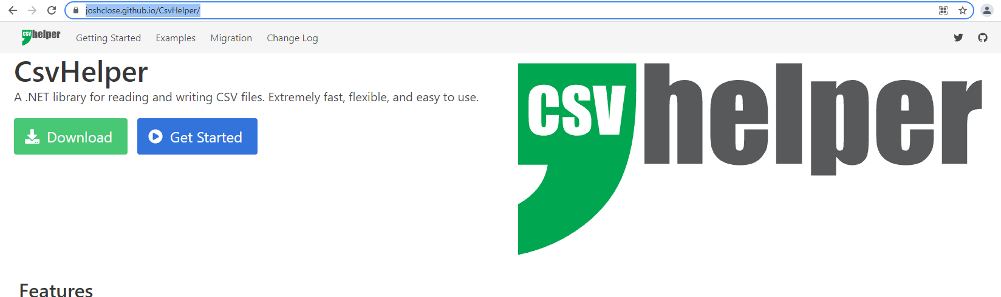

# 7. Prototype GUI

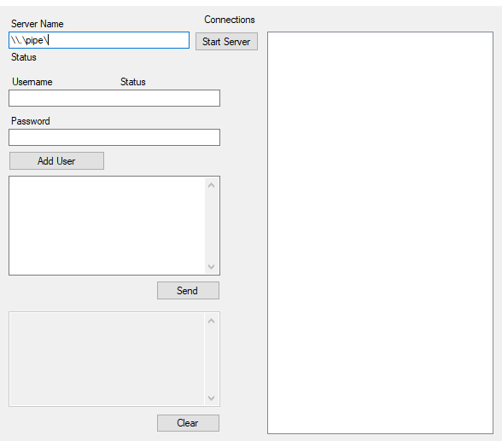

This is the prototype for the music player server, where users can be created and stored. Once a user is created, the details will be sent to the client side in which they can use the details to login to the music player. Saving the list of users into a CSV file will be implemented in further development of the project.

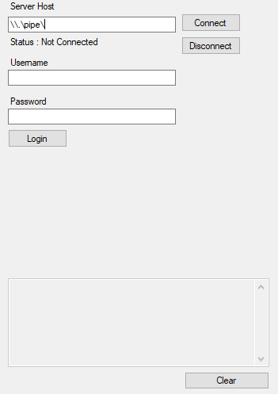

This is the prototype for the client side of the client-server, in which login credentials will be displayed in the grayed text area. Successful login will display a music player in the unused area of the program. More space for the music player and song list will be implemented.

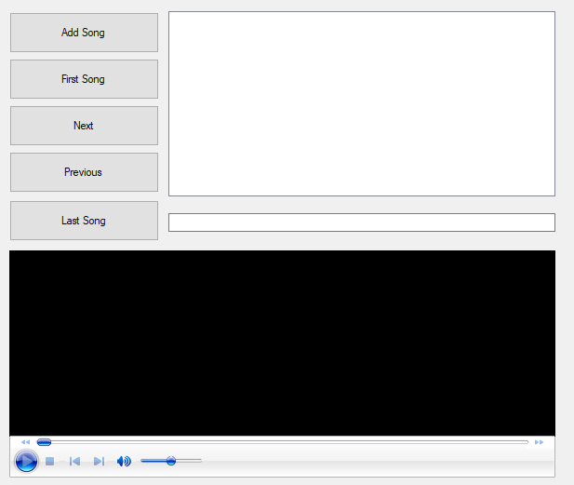

This is the prototype for the music player, which will be implemented to the client side program as seen above.

# 8. Source Control

GitHub will be used as the primary source control for the project, allowing for quick access to files through the cloud and uploading of files or documents.

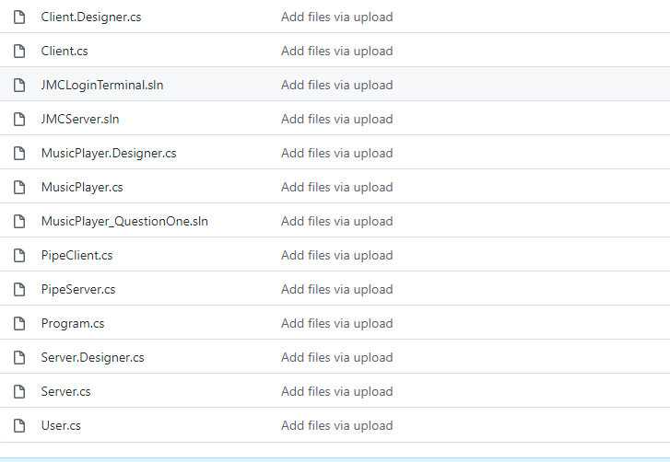

# 9. Coding Standards

The following coding standards will be used and followed:

• Naming Conventions  
• File Naming and Organization  
• Formatting and Indentation  
• Comments and Documentation  
• Classes, Functions and Interfaces  
• Pointer and Reference Usage  
• Testing

# 10. Testing

Testing will be done throughout the whole development of the project. This will be done through test cases, which will test specific scenarios and functionality of the GUI and code. Through passing or failing of tests, it will show whether the program is working as intended.

FOR EXAMPLE:

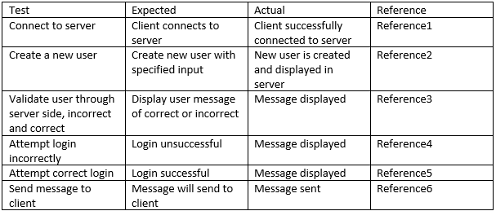

END OF DOCUMENT