NEURAL NETWORK
EXPERIMENT-1
Sakshi Shekhawat
24UADS1069

Experiment: Visualization of Perceptron Learning Algorithm
Objective
To visualize the Perceptron Learning Algorithm using NumPy and Matplotlib and evaluate its performance on NAND and XOR truth table datasets.
Description of the Model
A perceptron is a single-layer neural network used for binary classification. It computes a weighted sum of inputs and passes it through a step activation function to produce the output. During training, the perceptron updates its weights and bias using the perceptron learning rule based on the classification error. The model can correctly learn only linearly separable datasets.

Python Implementation
import numpy as np
import matplotlib.pyplot as plt
import time
# Step activation function
def step(x):
return 1 if x >= 0 else 0
# Perceptron training function
def train_perceptron(X, y, title, lr=1.0, max_epochs=20):
weights = np.zeros(X.shape[1])
bias = 0
errors_per_epoch = []
converged = False
for epoch in range(max_epochs):
total_error = 0
print(f"\nEpoch {epoch + 1}")
print("x1 x2 | target | predicted | error | weights | bias")
for i in range(len(X)):
net = np.dot(X[i], weights) + bias
pred = step(net)
error = y[i] - pred
# Update rule
weights += lr * error * X[i]
bias += lr * error
total_error += abs(error)
print(f"{X[i][0]} {X[i][1]} | {y[i]} | {pred} | {error} | {weights} | {bias}")
errors_per_epoch.append(total_error)
# Plot decision boundary
plt.clf()
for i in range(len(X)):
if y[i] == step(np.dot(X[i], weights) + bias):
plt.scatter(X[i][0], X[i][1], c='green', marker='o')
else:
plt.scatter(X[i][0], X[i][1], c='red', marker='x')
x_vals = np.array([0, 1.5])
if weights[1] != 0:
y_vals = -(weights[0] * x_vals + bias) / weights[1]
plt.plot(x_vals, y_vals)
plt.title(f"{title} - Epoch {epoch + 1}")
plt.xlabel("x1")
plt.ylabel("x2")
plt.grid(True)
plt.pause(2)
if total_error == 0:
converged = True
break
plt.close()
print("\n----------------------------------")
print(f"Training completed for {title}")
if converged:
print(f"Status: CONVERGED in {epoch + 1} epochs")
else:
print("Status: FAILED to converge (Not linearly separable)")
print("----------------------------------")
# Error vs Epoch plot
plt.figure()
plt.plot(errors_per_epoch, marker='o')
plt.title(f"Error vs Epochs ({title})")
plt.xlabel("Epoch")
plt.ylabel("Total Error")
plt.grid(True)
plt.show()
# ================= DATASETS ================= #
# NAND gate
X_nand = np.array([[0,0],[0,1],[1,0],[1,1]])
y_nand = np.array([1,1,1,0])
# XOR gate
X_xor = np.array([[0,0],[0,1],[1,0],[1,1]])
y_xor = np.array([0,1,1,0])
# ================= RUN ================= #
train_perceptron(X_nand, y_nand, "NAND Gate")
train_perceptron(X_xor, y_xor, "XOR Gate")
Description of Code
1.Required libraries such as NumPy and Matplotlib are imported.
2. A step activation function is defined to convert the net input into binary output.
3. The train_perceptron function initializes weights and bias to zero.
4. For each epoch, the algorithm calculates predicted output and error.
5. Weights and bias are updated using the perceptron learning rule.
6. Decision boundary and classification results are visualized using Matplotlib.
7. Error vs Epoch graph is plotted to observe the learning progress.

Performance Evaluation
NAND Gate: The perceptron successfully converges because the NAND dataset is linearly separable. The error decreases to zero after several epochs.
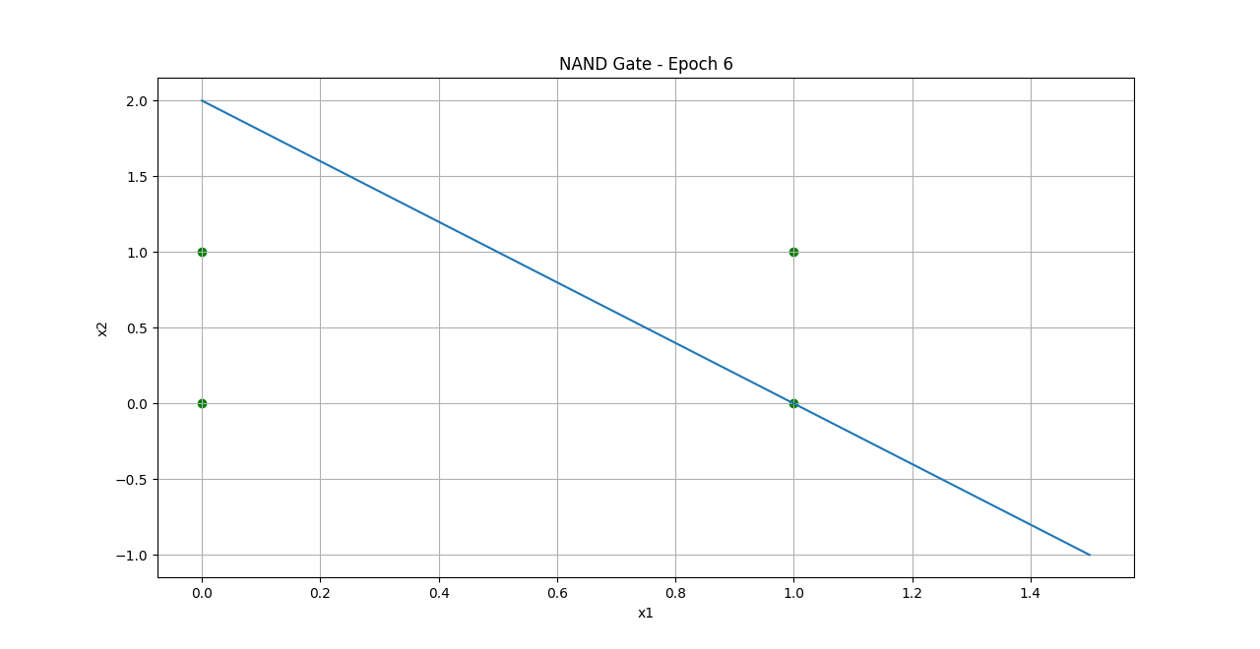

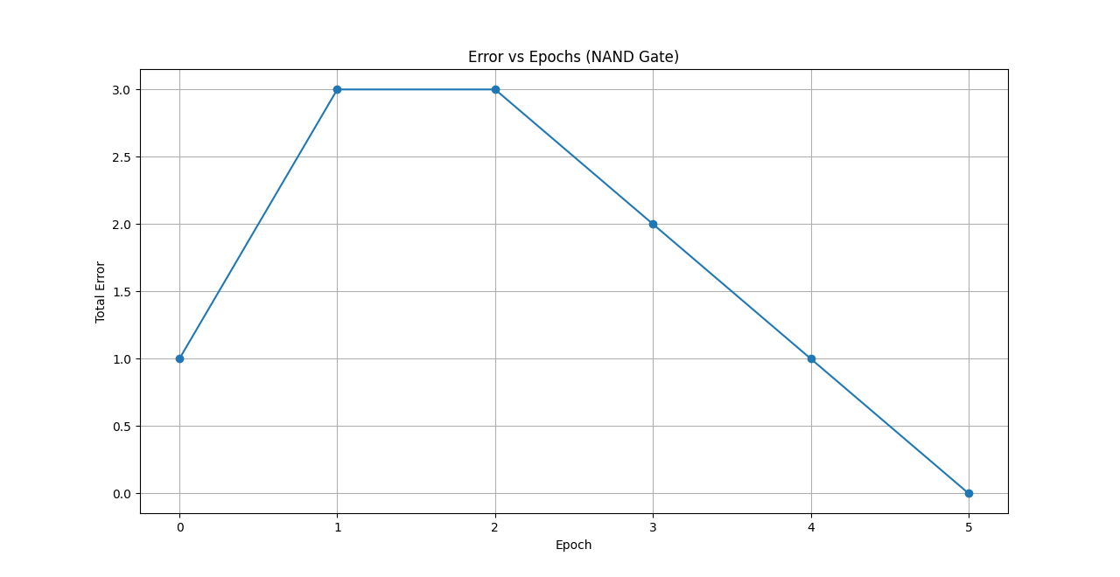

XOR Gate: The perceptron fails to converge because XOR is not linearly separable. A single-layer perceptron cannot model this dataset, which results in persistent error.
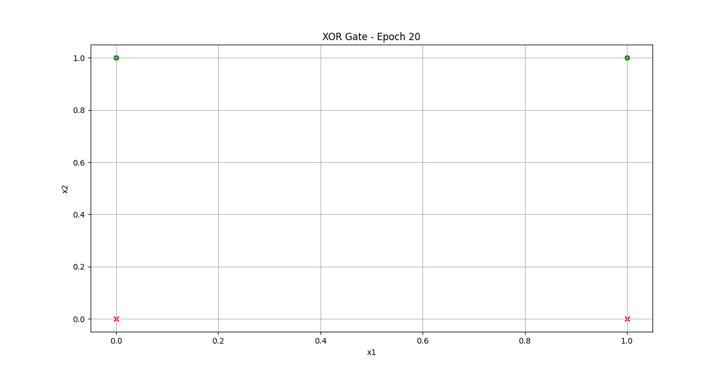

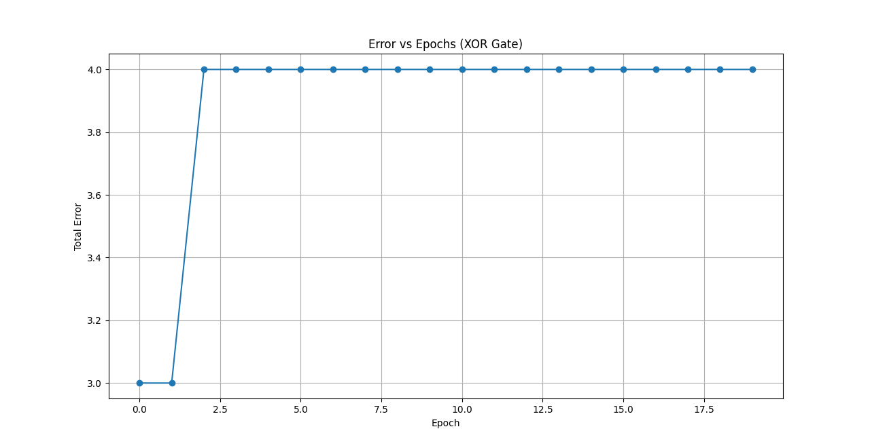

My Comments (Limitations / Scope of Improvement)
The main limitation of a single-layer perceptron is that it cannot solve non-linearly separable problems such as XOR. This limitation can be overcome by using multi-layer neural networks (MLP) with hidden layers and nonlinear activation functions. Future improvements can include implementing a multi-layer perceptron and comparing its performance with the single-layer model.

