ShafiqUrRehman_COMP228_006_Lab01
Exercise1 - two screenshots:
Negative salary entered:
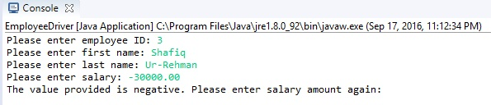

Employee information for “Bill” displayed:
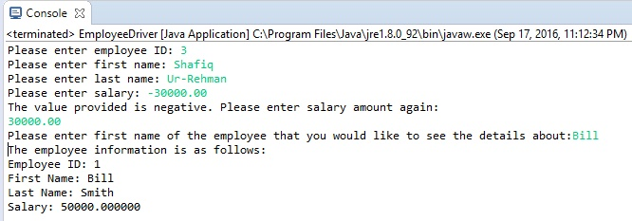

Exercise2 – four screenshots:
Account balance displayed:
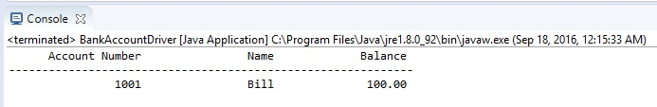

Withdrawal amount was more than balance:
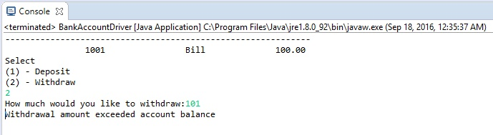
Balance after withdrawal:
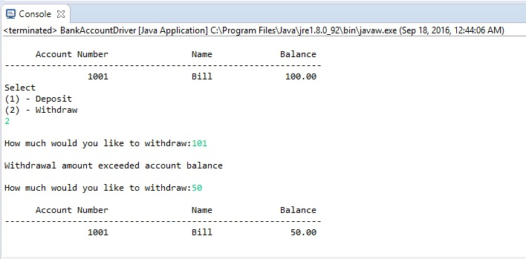
Balance after deposit:
