# **VOID JUMPER - INSTRUCTION MANUAL**

### **WARNING: READ BEFORE USING YOUR NINTENDO ENTERTAINMENT SYSTEM.**

A very small percentage of individuals may experience epileptic seizures when exposed to certain light patterns or flashing lights. Exposure to certain patterns or backgrounds on a television screen or while playing video games may induce an epileptic seizure in these individuals. If you, or anyone in your family, have an epileptic condition, consult your physician prior to playing.

### **1. STORY**

In the deepest, uncharted regions of space, a lone astronaut known only as the **Void Jumper** has become stranded. Their ship, critically low on power, has drifted into a sector of floating ruins patrolled by strange, hostile lifeforms.

The only hope for escape lies in collecting scattered fragments of crystallized energy—the shimmering relics of a long-dead civilization. With these fragments, the Void Jumper might just have enough power to restart their ship's engines and make the jump home. The journey will be treacherous, but with skill and courage, you can guide them back from the void.

### **2. OBJECTIVE**

The goal of **Void Jumper** is to guide the player through each sector of the ruins, collecting all the energy fragments (coins) to activate the final, large fragment that serves as the exit. Survive the hazards, collect the fragments, and leap to the next sector!

### **3. CONTROLS**

Use your keyboard to navigate the world of **Void Jumper**.

* **A / D KEYS:** Move the Void Jumper left and right.
* **K KEY:** Press to make the Void Jumper jump.
* **I KEY:** Press to begin the game from the title screen or to pause/unpause the game during play.

### **4. GAMEPLAY**

**The Title Screen**

This is where your adventure begins. Press the 'I' key to jump into the action.

**Void Jumper**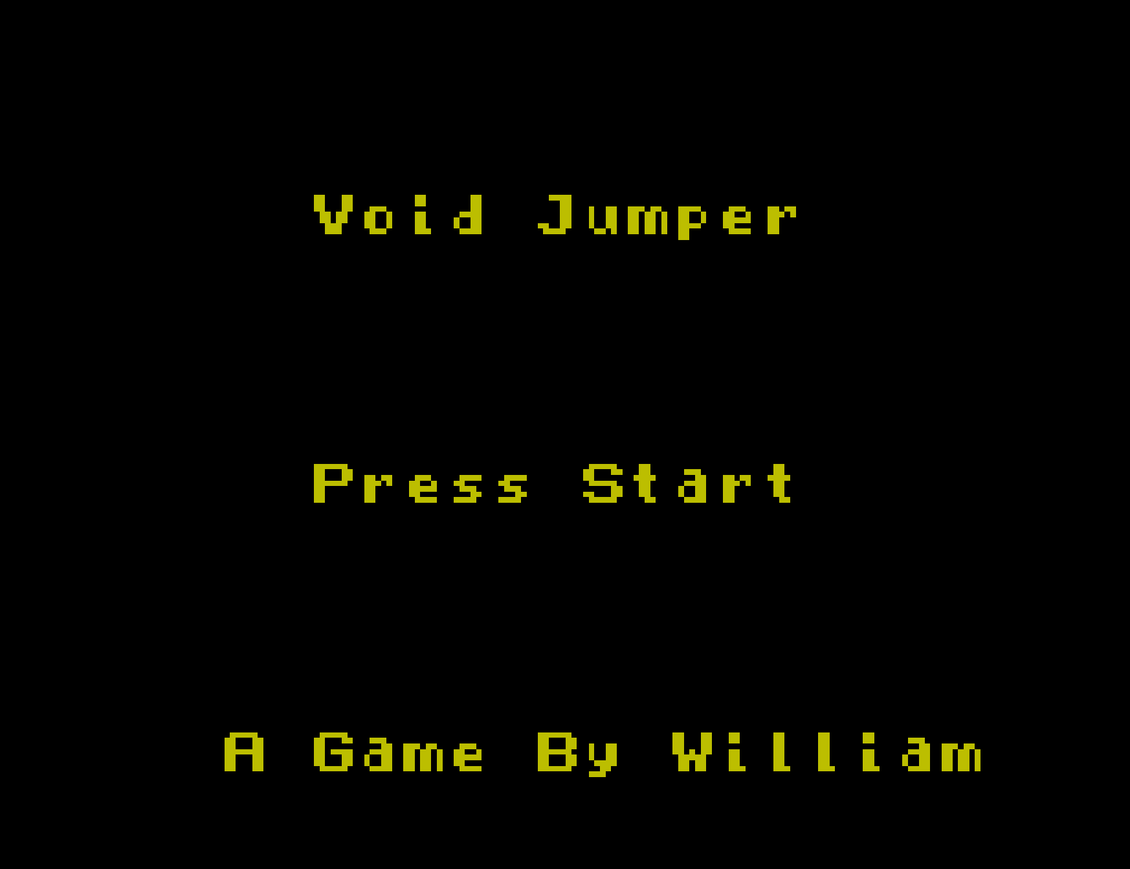

You control the Void Jumper. Master their agile movements and precise jumping to navigate the hazardous platforms suspended in space.

**Energy Fragments (Coins)**

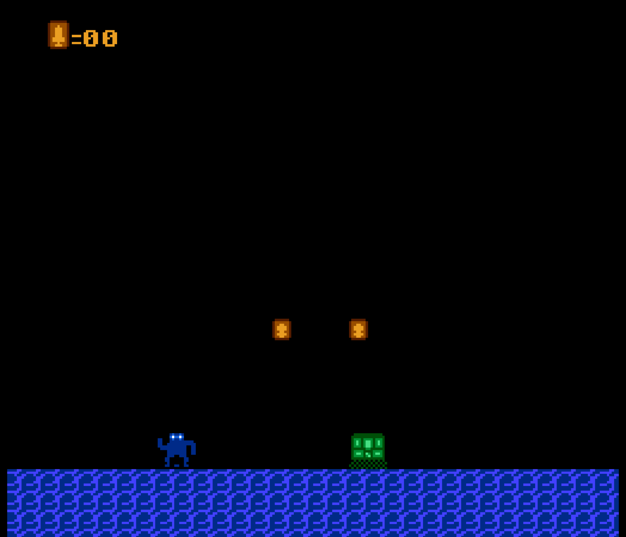

These are the main collectibles in the game. You must collect all the small, regular fragments in a level to be able to collect the final, large fragment which will complete the level.

**Hostile Lifeforms**

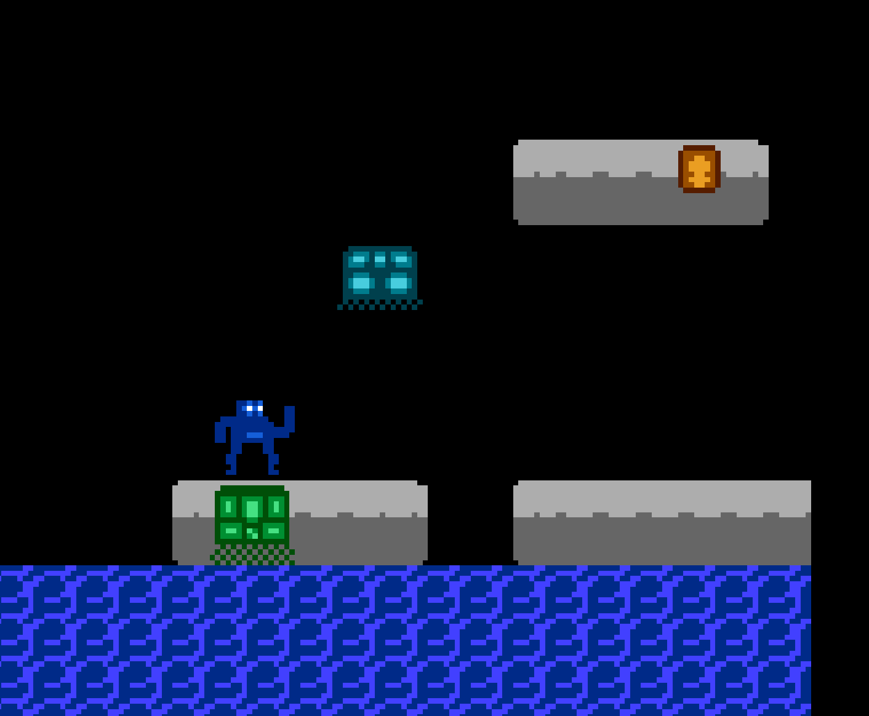

The ruins are not abandoned. Be wary of the strange creatures that inhabit them. Some will chase you relentlessly, while others bounce in predictable patterns. Contact with any of them will be detrimental to your mission!

And be careful where you jump or you might face death!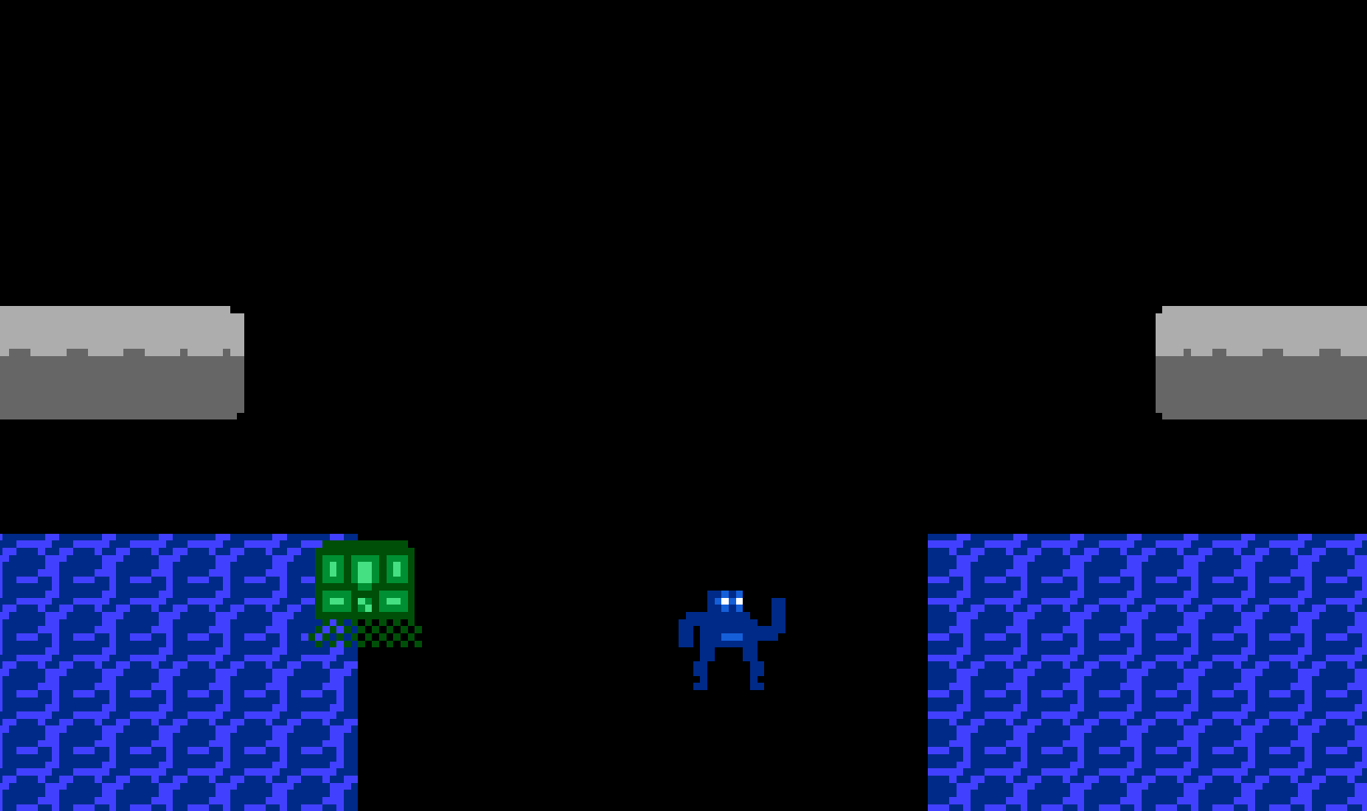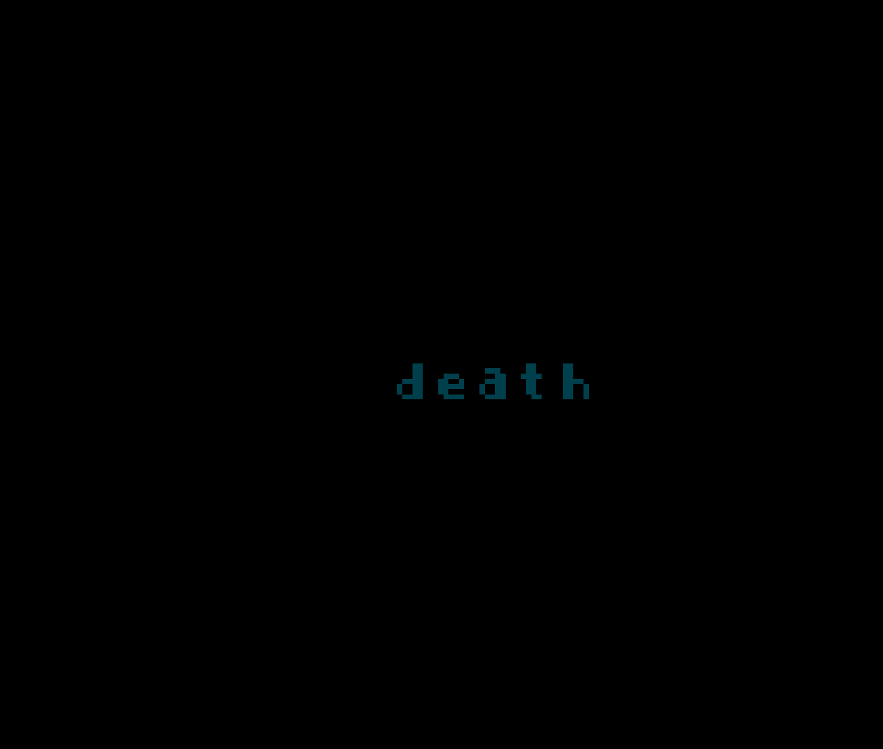

### **A GAME BY WILLIAM**

Thank you for playing!