Triangle Problem

3014218159 songxiuhuan 宋修寰

# Import the Junit and eclemma

Choose the project and right click, choose the build path and choose the Junit and hamcrest.

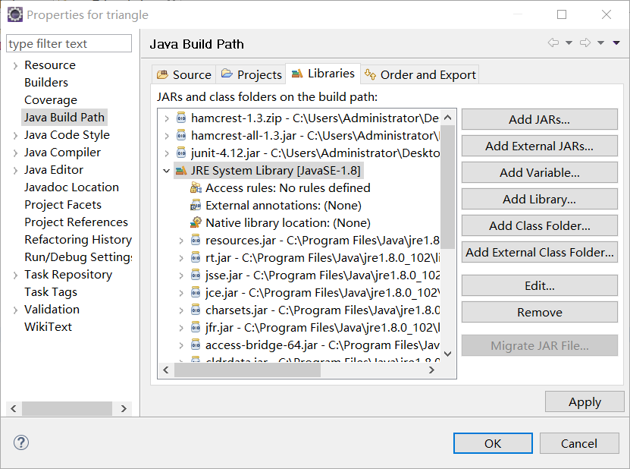

# Install eclemma

Help——install newsoftware——input the URL of the eclemma in my PC

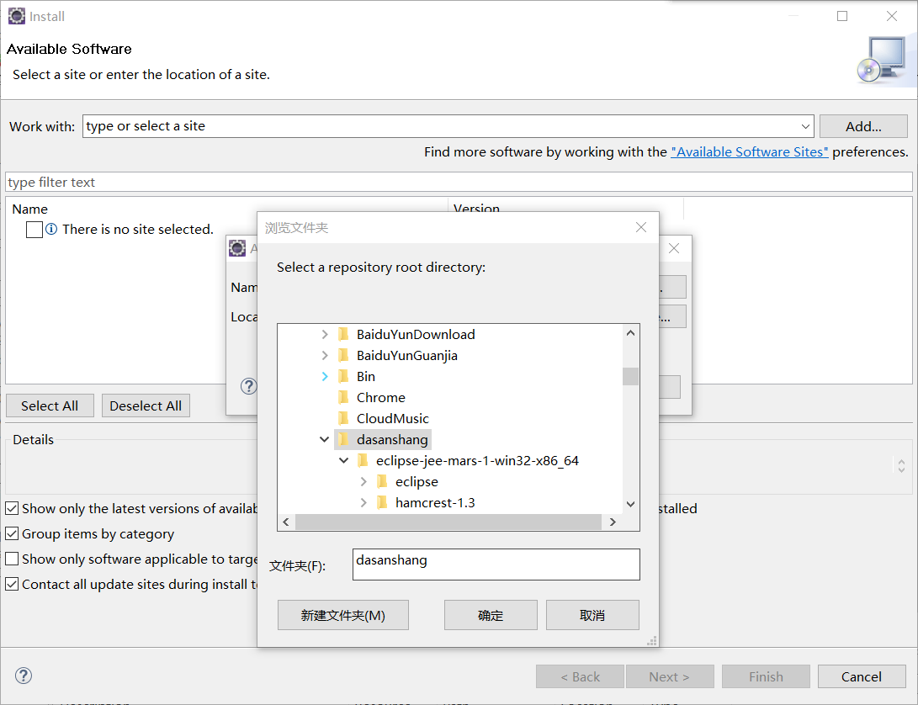

# Coding the triangle and testTriangle, to verify if it’s a triangle and equilateral, isosceles, or scalene.

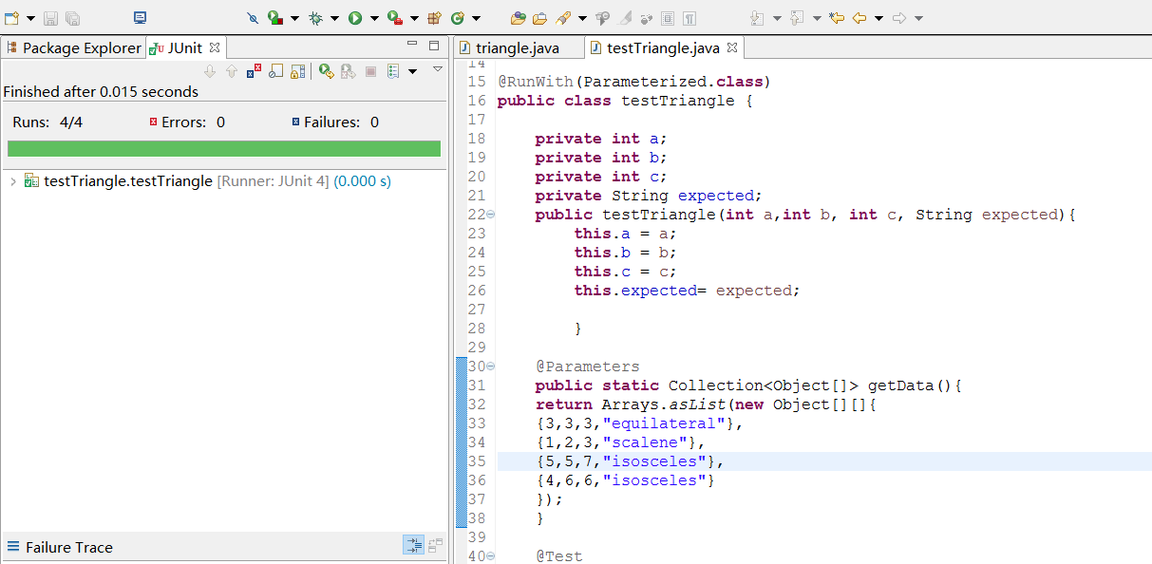

When a==b==c it’s a equilateral one.

When a==b!=c it’s a isosceles one.

Others they are scalene.

KEY: A regular triangle must obey that a+b>c and a-b<c. Or there will be a failure.