**SAFETY COVER Measuring Form**

**PHONE: (800) 288-7946 • FAX: (877) 292-5773**

**www.intheswim.com • EMAIL: customforms@intheswim.com**

320 Industrial Drive • West Chicago, IL 60185 P

Name: _ Craig Baldwin _ Email: _ cjbsmb1994@yahoo.com _

Address: _ 16 Anna Avenue _ City: _ Bear _ State: _DE_ Zip Code: _19701_

Best Phone: _ 302-562-4745 _ Best Time to Contact: _ Evening Time _

Fax: _ _ Source Code (from our catalog or website): _ _

**Did you receive an Instant Estimate online? If so, what was the number?** _ _



**IMPORTANT:** We base our Custom Safety Cover pricing solely on the measurements you provide.

**PLEASE READ ALL INSTRUCTIONS BEFORE YOU BEGIN MEASURING.**

Thank you for your interest in a quality safety cover from In The Swim! Your Custom Safety Cover will be a worthwhile investment in the life of your pool and the safety of those you love. When filling out this form, it is extremely important that you provide us with accurate measurements. This will ensure an accurate and timely quote, and a cover that fits your pool properly. Every cover fits a little bit differently, so your cover will be made to match the exact measurements you give us. Any inaccurate measurements will not only delay the quoting process, but will also result in your cover not fitting correctly.

**Once your safety cover is in production, alterations can NOT be made. Custom Safety Covers cannot be returned.**

**Tips And Tricks To Avoid Common Measuring Errors**

* Tools Needed: Masking tape, waterproof marker, and 100 ft. measuring tape.
* Make sure your Name, Address, Phone Number, and Email are on this cover page, and include your name and number on each additional page of this form. Submit ALL pages, it will speed up your quote!
* Please write neatly, using black ink. The easier it is for us to read, the easier it is for us to quote!
* If you need extra room for any measurements, please include and submit them on a plain sheet of white paper (with your name and number at the top).
* If your pool is a Rectangle, Rectangle with Step Section, or a Rectangle with either Bowed or Grecian ends, it is a type #1 Pool. Use the Type #1 measurement instructions.
* If your pool is Free Form, Oval with Step Section, Kidney, or Lazy L, it is a Type #2 Pool. Use the Type #2 measurement instructions.



**GIVE COMPLETE INFORMATION FOR FASTER QUOTING AND ORDERING, AND TO ENSURE CORRECT FIT!**

**Please Check The Cover(s) You Would Like Us To Quote For You**

**MESH SAFETY COVERS**

Mesh covers are usually lighter and easier to handle than solid covers. This means it will be easier to get the safety cover on and off your pool. Mesh covers will also allow rain water and melting snow to pass through the cover into the pool. Most of the time, covers are going to be less expensive than solid covers.

❏**In The Swim Mesh**

❏**Meyco Mesh**

❏**In The Swim Sunblock Mesh**

❏**In The Swim Commercial Grade Mesh**

**SOLID SAFETY COVERS**



The big advantage of a solid cover is that it will prevent sunlight and fine particles from entering the water. This will prevent dirt and algae from building up in the pool, keeping it cleaner over the winter. With solid covers, you must remove standing water from the top with either a drain panel (mesh built into the cover), or a cover pump.

|  |  |  |
| --- | --- | --- |
| ❏**Meyco Perma Guard Solid** | ❏**Drain** | ❏**Pump** |
| ❏**Aqua Master Solid** | ❏**Drain** | ❏**Pump** |
| ❏**In The Swim Supreme Solid** | ❏**Drain** | ❏**Pump** |
| ❏**Xtra Lite Solid** | ❏**Drain** | ❏**Pump** |

**TYPE #1 POOLS: Measuring Instructions for Rectangles, Rectangles with Step Sections, Rectangles with Bowed Ends, or Rectangles with Grecian Ends**

**STEP 1:**

Using the graph paper we’ve provided, draw an accurate diagram that shows the inside pool dimensions. Include the deck area, planters (if you have them), and any other obstructions that are within 18” of the waterline. If you have a rock structure on the waterline, a raised wall, or a waterfall, please use Type #2 instructions for A - B measurements (see next page). If you are replacing a safety cover, and the old cover is not available, please use Type #2 instructions for A-B measurements as well.

**STEP 2:**

The diagrams below show the required measurements for each type of pool shape. Select the shape that most closely matches your particular pool, and list your measurements accordingly on the diagram you created. Be sure they are inside waterline dimensions! If your pool doesn’t match a shape you see below, you may need to measure for a Type #2 pool (see next page).

**PROVIDE MEASUREMENTS AS INDICATED BY THE DOTTED LINES**

|  |  |  |  |  |  |  |  |
| --- | --- | --- | --- | --- | --- | --- | --- |
| RECTANGLE | GRECIAN | “L” SHAPE | | RECTANGLE W/STEP | | BOWED ENDS |  |
|  |  | **B** |  |  |  |  |  |
|  | **E** |  | True “L” |  |  | **E** |  |
|  |  |  | Check List |  |  |  |  |
| **B** | **B** |  | C+F=A |  | **B** | **B** |  |
| **F** | B+D=E |  |  |
|  |  |  |  |  |  |  |
|  | **D** |  | **D** |  |  | **C** |  |
|  |  |  |  | **C** |  |  |
| **A** | **A** | **A** |  | **A** | **A** |  |
|  |  |  |
|  |  |  | **C** |  | **D** |  |  |
|  |  |  |  |  |  |  |
|  | **C** | **E** |  |  |  | **D** |  |
|  |  |  |  |  |  |

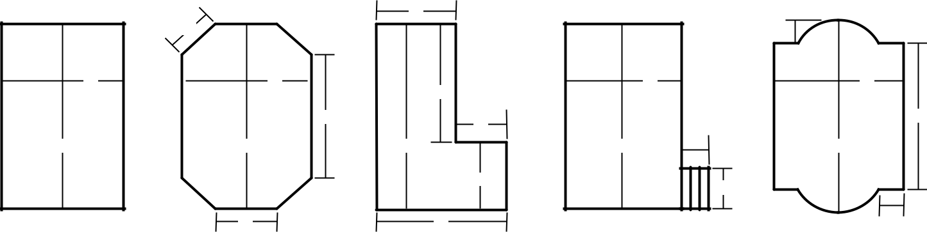

**STEP 3:**

If you have any non-removable obstructions within 18” of the waterline, locate them on your diagram. Measure the distance from the obstruction to the pool’s edge, and also measure the distance from the obstruction to the closest squared off corner of the pool.

**STEP 4:**

If you have a step section, be sure to provide step length and width, and the offset of the step if applicable.



**E**

**C**

Ladder

side view

**D**

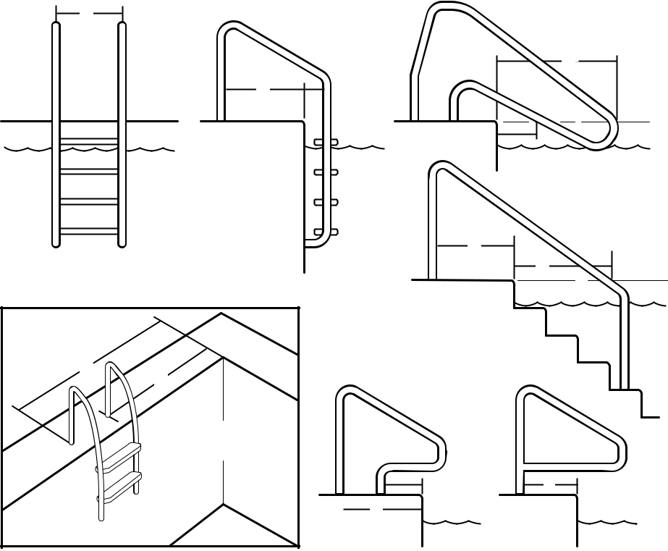

**H**

**J**

**M**

OBSTRUCTION & STEP SECTION

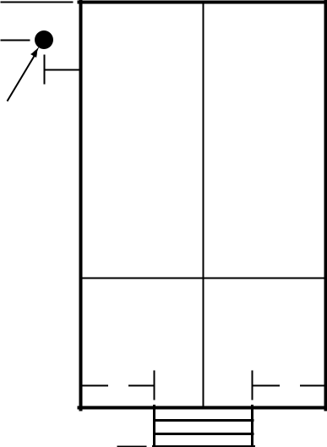

**3’** 

**9’**

Slide leg

measured

on center

**32’**

Ladder front view

**J**

COVER

**16’**

**A**

**B**

Measure from a

squared off corner

EXAMPLE:

**Non-Removable**

**Obstructions**

**G** **J**

**F**

**4’** **4’**

**3’** 



**8’**

Please provide any measurements given for obstructions on the diagram that is completed.

**TYPE #2 POOLS: “A-B Measuring” instructions for Free-Form Pools and**

**Replacement Safety Covers**

**STEP 1:**

Using the graph paper we’ve provided, draw an accurate diagram indicating the inside pool dimensions. Include the deck area, planters (if you have them), and any other obstructions that are within 18” of the waterline. **Photographs of the** **pool are required when you have rocks, waterfalls, raised walls, spas, or anything other than a simple, unbroken coping perimeter.**

**STEP 2:**

Establish two points to be called A and B, parallel to the long side of the pool (see below). These points should be at least 25 feet apart (or 2/3 the total length of the pool), and able to be easily marked with masking tape (or stakes if in the lawn). A must be to the left of B as you face the pool. Be sure to provide the distance between A and B as you face the pool (See Type #2 measuring example on the next page).

**Note:** *The A-B line must never intersect the pool and must be at least 4 feet away from any marked point (pool, anchors,**and obstructions) regardless of how far back the line needs to be extended.*

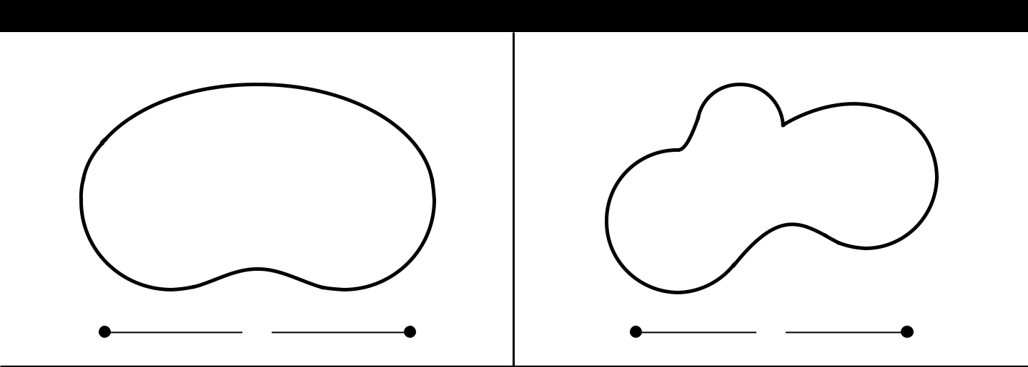

**A-B MEASUREMENT DIAGRAM *(A-B measurements are ALWAYS needed for Type #2 pools)***

|  |  |
| --- | --- |
| **KIDNEY SHAPED POOL** | **FREE FORM POOL** |

**A** **B**

**25’**

**A** **B**

**25’**

**STEP 3:**

Using masking tape and waterproof marker, mark and number points along the inside edge of the pool at a maximum of 2 foot intervals. Be sure to identify all non-removable obstruction points when filling in your measurements on the measuring chart provided. **Always number in a clockwise direction.**



*Use masking tape and waterproof marker instead of chalk. Chalk will wash away if it rains, but the tape and marker will stay put.*

Number all corner points, direction changes, ladders, handrails, grab rails, slide legs, rocks, spillways, spa walls that separate the spa and pool, fill spouts, and dive stands that are not removable. **IMPORTANT: Also number any anchors** **from a previous safety cover.** 1 foot intervals should be used in small or tight radius areas. Remember to include thetotal length of your A-B line, along with the overall length of your pool.

**STEP 4:**

Provide cross dimensions from numbered points. These are important so we can verify whether they match the A-B measurements of your pool.

**TYPE #2 MEASURING EXAMPLE: “A-B Measuring” instructions for Free-Form Pools and Replacement Safety Covers**

**STEP 1:**



Measure the distance from **Point A** to **Point B** and record the measurementin the space provided on the measur-ing form.

**STEP 2:**

Measure the distance from **Point A** to **Point 1** and record the measurementin the chart provided.

**STEP 3:**

Measure the distance from **Point A** to **Point 2** and record the measurementin the chart provided.

**STEP 4:**

Continue taking the same type of measurements for all other numbered points on the pool ( **Point A** to **Point 3,** **Point A** to **Point 4, Point A** to **Point 5,** and so on…). Now measure the dis-tance from Point B to all the numbered points, using the same process that you did for the A measurements

**(Point B to Point 1, Point B to Point 2, Point B to Point 3,** and so on…).

**See the Example A - B Measurements Chart below.**

**STEP 5:**

Measure the overall width and length of the pool by **selecting numbered** **points that represent** these distancesand record measurements in the spaces provided on the measuring form. It is also helpful if you provide at least two additional cross dimension measurements for both the width and length of the pool. **See Over**

**all Pool Measurements: “Point to Point” (right).**

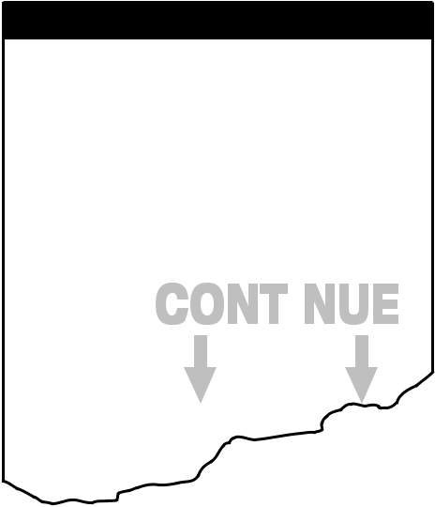

|  |  |  |  |  |  |  |  |  |  |  |  |  |
| --- | --- | --- | --- | --- | --- | --- | --- | --- | --- | --- | --- | --- |
|  |  |  |  |  |  | Outside Coping | | |  |  |  |  |
|  |  |  |  |  |  |  |  |  | 12” Coping | |  |  |
|  |  | SPA | 30 | 31 | 32 |  | 38 | 39 | 40 |  | Always number in |  |
|  |  |  |  | 35 |  | 37 |  | Inside |  | a clockwise direction. |  |
|  |  |  |  |  |  |  |  |  |  |
|  |  | 29 | 34 |  |  |  | Coping |  | 41 |  |  |
|  |  |  |  |  |  |  |  |  |
|  |  | 36 | | Spillway | |  | CROSSDIMENSION14’2” |  |  |
| Hand Rails | | |  |  | 43 |  |  |
|  | 23’ 0” |  |  |  |  |
|  |  | 28 |  |  |  |  |  |  |  |  |
|  |  | 35 | |  | Spa Wall | |  |  |  |  |  |
|  |  |  |  |  |  | 42 |  |  |
|  |  | 27 |  |  |  |  |  |  |  |  |  |
|  |  |  | CROSS DIMENSION | | | |  |  |  |  |  |
|  |  |  |  |  |  |  |  |  |
|  | 25 | 26 | 22 | CROSSDIMENSION24’7” | |  |  | OVERALLLENGTH37’9” |  |  | 44 |  |
|  | 23 |  |  | 45 |  |  |  |
|  | 24 |  |  |  |  |  |  |
|  |  |  |  |  |  |  |  |  |  |
|  |  | 21 |  |  |  |  |  | 46 |  |  |  |  |
| Slide |  | 20 |  |  |  |  |  |  |  | B |  |
|  |  |  |  |  |  |  |  |  |  |
| Legs |  |  |  |  |  |  |  |  |  |  |  |
|  |  |  |  |  |  |  |  |  | PLANTER | |  |
|  | 17 | |  |  |  |  |  | 47 |  |  |
| 19 |  |  |  |  |  |  |  |  |  |
| 18 |  |  |  |  | OVERALL WIDTH | |  |  |  |  |  |  |
|  |  | 16 |  |  |  | 17’ 0” |  | 48 | |  | B-1 = 27’ 6” |  |
|  |  |  |  |  |  |  |  | B-2 = 29’ 2” |  |
|  |  | 14 | 13 |  |  |  |  | 50 |  |
|  |  |  |  |  |  |  |  | B-3 = 32’ 6” |  |
|  |  |  |  |  |  |  |  |  |  |  |  |
|  |  | 15 |  | 12 | |  |  |  | 49 |  | B-4 = 36’ 6” |  |
|  |  |  |  |  |  |  |  | 25’ |  |
|  |  |  |  |  |  | CROSS DIMENSION | | | 51 |  |  |
|  |  |  |  |  | 11 |  | Distance between |  |
|  |  |  |  |  |  | 14’ 0” | |  |  |
|  |  |  |  |  |  |  |  | A-B line required. |  |
|  |  |  |  |  |  |  |  |  |  |  |  |
|  |  | Rocks | |  | 10 | |  |  |  |  |  |  |
|  |  |  |  |  |  |  |  |  |  |  |

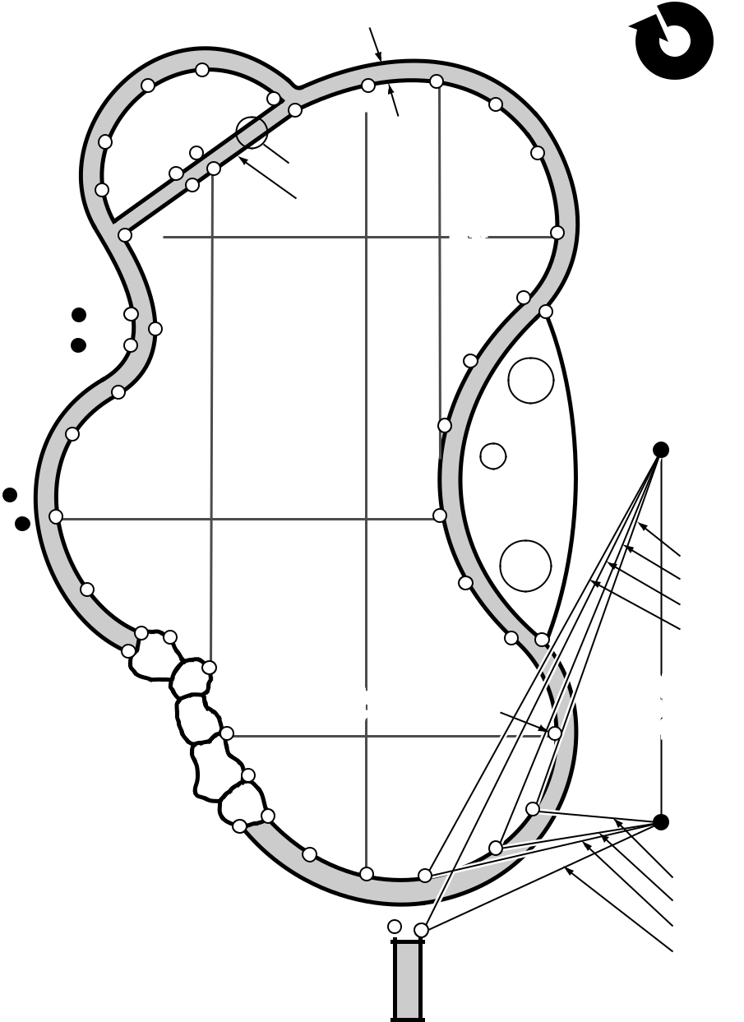

|  |  |  |  |  |
| --- | --- | --- | --- | --- |
|  | 9 |  | 1 |  |
|  |  | A |  |
| 8 | 7 | 2 |  |
|  |  |
| 6 | 3 |  |  |
|  |  |  |

|  |  |  |  |  |
| --- | --- | --- | --- | --- |
|  |  | A-1 | =5’2” |  |
| 5 |  | A-2 | =8’4” |  |
| 4 | A-3 | = 11’ 8” |  |
|  | A-4 | = 15’ 8” |  |
|  |  |  |
| Diving Board Base | |  |  |  |



EXAMPLE: A & B MEASUREMENTS

|  |  |  |  |  |  |  |  |  |  |
| --- | --- | --- | --- | --- | --- | --- | --- | --- | --- |
| **POINT** | |  | **A** | |  |  | **B** | |  |
|  |  |  |  |  |  |  |  |  |  |
| **1** | |  | **5’ 2”** | |  |  | **27’ 6”** | |  |
|  | |  |  | |  |  |  | |  |
| **2** | |  | **8’ 4”** | |  |  | **29’ 2”** | |  |
|  | |  |  | |  |  |  | |  |
| **3** | |  | **11’ 8”** | |  |  | **32’ 6”** | |  |
|  | |  |  | |  |  |  | |  |
| **4** | |  | **15’ 8”** | |  |  | **365’ 6”** | |  |
|  | |  |  |  |  |  |  |  |  |
| **5** | |  |  |  |  |  |  |  |  |
|  |  |  |  |  |  |  |  |
| **6** | |  |  |  |  |  |  |  |  |
|  |  |  |  |  |  |  |  |
|  | |  |  |  |  |  |  |  |  |
| **7** | |  |  |  |  |  |  |  |  |
|  | |  |  |  |  |  |  |  |  |
| **8** | |  |  |  |  |  |  |  |  |
|  |  |  |  |  |  |  |  |  |  |
|  | **9** |  |  |  |  |  |  |  |  |

**OVERALL POOL MEASUREMENTS: “POINT TO POINT”**

**Overall Width = 17 feet** (point 17 to point 47)

**Cross Dimension = 14 feet** (point 11 to point 51)

**Cross Dimension = 23 feet** (point 27 to point 42)

**Overall Length = 37 feet, 9 inches** (point 6 to point 38)

**Cross Dimension = 24 feet, 7 inches** (point 12 to point 36)

**Cross Dimension = 14 feet, 2 inches** (point 46 to point 39)

**Note:** *Continue taking the A and B measurements for all numbered points**that you made around your pool. The measurements from the numbered points should all touch A and B at the exact same point. (For illustration purposes, the lines above are slightly off the exact point.)*

**REQUIRED INFORMATION: TYPE #1 & TYPE #2 POOLS**

Answer ALL questions. If items are **NOT REMOVABLE** and **LESS THAN 18” FROM THE WATERLINE,** measurements must be given using the same method that was used to measure the pool. If your pool has obstructions and/or special features, please provide photos of each area.

|  |  |  |  |
| --- | --- | --- | --- |
| **CHECK ONE:** | | **YES** | **NO** |
| **1.** | **Are there skimmer covers?** | ❏ | ❏ |
|  | Are the covers flush with the deck? | ❏ | ❏ |
| **2.** | **Are there ladders?** | ❏ | ❏ |
|  | Are the ladders removable? | ❏ | ❏ |
|  | **If No:** Measure to locate ladders, and |  |  |
|  | distance ladders extend into the pool. |  |  |
| **3.** | **Are there handrails?** | ❏ | ❏ |
|  | Are the handrails removable? | ❏ | ❏ |
|  | **If No:** Measure to locate handrails, and |  |  |
|  | distance handrails extend into the pool. |  |  |
| **4.** | **Are there grab rails?** | ❏ | ❏ |
|  | Are the grab rails removable? | ❏ | ❏ |
|  | **If No:** Measure to locate grab rails, |  |  |
|  | distance rails are set back from the pool, |  |  |
|  | and to points where the rails dip below |  |  |
|  | the coping. Also indicate type of grab rail. | |  |
| **5.** | **Is there a fill spout?** | ❏ | ❏ |
|  | Is the fill spout removable? | ❏ | ❏ |
|  | **If No:** Measure from pool to front of |  |  |
|  | fill spout. |  |  |
| **6.** | **Is there a dive stand?** | ❏ | ❏ |
|  | **If Yes:** Measurements are required. |  |  |
|  | How far back is the stand from the pool? ________ | | |
| **7.** | **Is there a slide?** | ❏ | ❏ |
|  | Are slide legs within 18” of the waterline? | ❏ | ❏ |
|  | **If Yes:** Measurements are required. |  |  |
|  | Also give distance legs are set back |  |  |
|  | from pool edge. | ________ | |
| **8.** | **Are there any Grab Rocks?** | ❏ | ❏ |
|  | **If Yes:** Measure to locate placement. |  |  |
|  | How wide are the rocks? | *________* | |
| **9.** | **Is there a spa?** | ❏ | ❏ |
|  | Is the spa level with the deck and/or |  |  |
|  | coping? | ❏ | ❏ |
|  | **If No:** How much is the spa raised |  |  |
|  | above the pool? | *________* | |
| **10. Is a separate cover required for the spa?** | | ❏ | ❏ |

**CHECK ONE:** **YES NO**

**11. Does the spa wall have an open spillway?**❏ ❏

If it is an open spillway, A-B dimensions

are required to locate the spillway.

(Please provide a photo.)

**12. Is there a planter area?** ❏ ❏

**If Yes:** Give A-B dimensions at startand finish of planter area. Give width of coping between the pool and the front of

the planter. ________

**13. Do you require stakes or anchors in**

**the planter area?** ❏ ❏

**14. Is the planter raised?** ❏ ❏

**If Yes:** What type of material is the

planter made of? ____________________________

**15. Is the planter strong enough for the**

**cover to snap-hook into?** ❏ ❏

**16. Is there a raised wall or raised**

**bond beam?** ❏ ❏

**If Yes:** How high? Give A-B dimensionsat the beginning of the wall as well as points along the wall at the deck line.

**17. Are there waterfalls or rocks?** ❏ ❏

**If Yes:** Give A-B dimensions of thebeginning and at the end of the obstruction as well as points along the pool. (Please provide a photo.)

**18. Are there varying deck levels?** ❏ ❏

**If Yes:** Give A-B dimensions at levelchange. Give A-B dimensions indicating the angles where the level change cuts back from the pool.

How much of a level change is it? *________*

**19. Do you have at least 3 feet of deck**

**around the pool?** ❏ ❏

**If No:** Please show dimensions onyour sketch.

**20. Do you have a concrete deck?** ❏ ❏

**If No:** Please specify what type

(wood, brick, etc.). ____________________________

**FOR REPLACEMT OF EXISTING SAFETY COVERS ONLY**

|  |  |  |  |
| --- | --- | --- | --- |
| **CHECK ONE:** | | **YES** | **NO** |
| **1.** | **Is this a replacement safety cover?** | ❏ | ❏ |
| **2.** | **Do you need to match existing anchors?** | ❏ | ❏ |
| **3.** | **Is the old cover available?** | ❏ | ❏ |
| **4.** | **Do you know the manufacturer of your old cover?** | ❏ | ❏ |

Manufacturer *_______________________________________*

Serial No. *_________________________________________*

**Important:** If the old cover is not available, please provide A-B measurements ofthe pool perimeter as well as the anchor locations.

Submitting this measuring form indicates that you have verified your measurements, and that the information you have supplied to us is correct. Your new safety cover will be made to these specifica-tions when you place your order. If you need to make changes to your measurements and specifi-cations, please resubmit them in writing. **Custom** **Safety Covers are not returnable.**



|  |  |  |  |  |
| --- | --- | --- | --- | --- |
| **GRAPH: TYPE #1 & TYPE #2 POOLS** | | | Name: ____Craig Baldwin ______________________________ __ | |
| **Please specify inside dimensions.** | | | Phone: _(302) 562-4745______ _ |  |
|  |  |  |  |  |

**PLEASE USE BLACK INK AND ADDITIONAL PAGES IF NECESSARY**

**SAFETY COVER MEASURING FORM: TYPE #2 POOLS** IMPORTANT!

Name: ____Craig Baldwin _________________________________

Phone: _(302) 562-4745__________ _________________________

**Distance from Point A to Point B**

____25_____ ft. _____0_____ in.





|  |  |  |
| --- | --- | --- |
| **POINT** | **A** | **B** |
| **35** | 40' 3.500'' | 35' 11.000'' |
| **36** | 39' 9.625'' | 35' 5.500'' |
| **37** | 39' 3.875'' | 35' 2.250'' |
| **38** | 38' 9.750'' | 34' 9.750'' |
| **39** | 38' 4.625'' | 34' 4.125'' |
| **40** | 37' 9.750'' | 33' 4.500'' |
| **41** | 37' 0.875'' | 32' 4.750'' |
| **42** | 35' 5.250'' | 30' 5.375'' |
| **43** | 33' 9.875'' | 28' 5.000'' |
| **44** | 32' 3.000'' | 26' 5.250'' |
| **45** | 30' 9.750'' | 24' 5.250'' |
| **46** | 29' 8.000'' | 22' 5.250'' |
| **47** | 28' 7.625'' | 20' 5.250'' |
| **48** | 27' 8.250'' | 18' 5.000'' |
| **49** | 26' 10.500'' | 16' 5.125'' |
| **50** | 26' 2.000'' | 14' 5.000'' |
| **51** | 25' 6.625'' | 12' 4.875'' |
| **52** | 25' 2.750'' | 11' 5.000'' |
| **53** | 24' 8.750'' | 10' 5.500'' |
| **54** | 24' 0.500'' | 9' 7.750'' |
| **55** | 23' 3.000'' | 9' 0.250'' |
| **56** | 22' 4.250'' | 8' 7.625'' |
| **57** | 21' 4.875'' | 8' 5.750'' |
| **58** | 20' 5.500'' | 8' 5.875'' |
| **59** | 19' 6.750'' | 8' 6.000'' |
| **60** | 18' 9.250'' | 8' 5.875'' |
| **61** | 18' 0.750'' | 8' 6.000'' |
| **62** | 17' 5.625'' | 8' 6.250'' |
| **63** | 16' 8.500'' | 8' 10.250'' |
| **64** | 15' 10.375'' | 9' 5.750'' |
| **65** | 14' 11.000'' | 10' 3.750'' |
| **66** | 13' 11.000'' | 11' 3.000'' |
| **67** | 12' 11.000'' | 12' 3.000'' |
| **68** | 11' 11.500'' | 13' 3.000'' |

 A & B MEASUREMENTS A A & B MEASUREMENTS

**Overall Pool Width**

Point # ____52____ to Point # ____81____

______20______ ft. ______3_______ in.

**Overall Pool Length**

Point # ____21____ to Point # ____66____

______37______ ft. ______7.5______ in.

**Cross Dimension**

Point # ____5_____ to Point # ____43____

______14______ ft. ______5_______ in.

**Cross Dimension**

Point # ____8_____ to Point # ____34____

______15______ ft. ______11______ in.

**Cross Dimension**

Point # ____86____ to Point # ____48____

______16______ ft. ______6.25_ ___ in.

**Cross Dimension**

Point # ____79____ to Point # ____59____

______15______ ft. ______10.125 __ in.

**Obstruction 1**

Type ______________________________

A to Point # _____ = ______ ft. _______ in.

B to Point # _____ = ______ ft. _______ in.

**Obstruction 2**

Type ______________________________

A to Point # _____ = ______ ft. _______ in.

B to Point # _____ = ______ ft. _______ in.

**Obstruction 3**

Type ______________________________

A to Point # _____ = ______ ft. _______ in.

B to Point # _____ = ______ ft. _______ in.

**Note:** *Please use a separate piece of paper**if you have more than 3 obstructions.*

|  |  |  |
| --- | --- | --- |
| **POINT** | **A** | **B** |
| **1** | 20' 4.750'' | 26' 5.875'' |
| **2** | 22' 0.625'' | 28' 3.125'' |
| **3** | 23' 9.750'' | 30' 0.625'' |
| **4** | 25' 7.250'' | 31' 10.500'' |
| **5** | 27' 5.000'' | 33' 8.500'' |
| **6** | 29' 3.125'' | 35' 6.750'' |
| **7** | 31' 1.500'' | 37' 5.375'' |
| **8** | 33' 0.125'' | 39' 4.000'' |
| **9** | 33' 5.938'' | 39' 9.500'' |
| **10** | 33' 11.875'' | 40' 2.500'' |
| **11** | 34' 5.750'' | 40' 6.625'' |
| **12** | 34' 11.625'' | 40' 11.000'' |
| **13** | 35' 5.563'' | 41' 3.000'' |
| **14** | 35' 11.375'' | 41' 7.250'' |
| **15** | 36' 4.750'' | 41' 10.000'' |
| **16** | 36' 9.375'' | 41' 11.250'' |
| **17** | 37' 1.375'' | 42' 0.000'' |
| **18** | 38' 4.625'' | 42' 1.500'' |
| **19** | 38' 7.875'' | 42' 1.250'' |
| **20** | 38' 10.875'' | 42' 0.500'' |
| **21** | 39' 1.375'' | 41' 11.500'' |
| **22** | 39' 10.250'' | 41' 6.500'' |
| **23** | 40' 7.500'' | 41' 1.250'' |
| **24** | 41' 6.625'' | 40' 9.875'' |
| **25** | 41' 8.750'' | 40' 8.250'' |
| **26** | 41' 7.750'' | 40' 3.750'' |
| **27** | 41' 1.750'' | 39' 4.875'' |
| **28** | 40' 11.750'' | 38' 11.750'' |
| **29** | 41' 1.250'' | 38' 9.750'' |
| **30** | 41' 5.375'' | 38' 10.500'' |
| **31** | 41' 9.375'' | 38' 11.000'' |
| **32** | 41' 10.375'' | 38' 8.250'' |
| **33** | 41' 7.625'' | 38' 3.000'' |
| **34** | 40' 7.875'' | 36' 4.250'' |



Submitting this measuring form indicates that you have verified your measurements, and that the information you have supplied to us is correct. Your new safety cover will be made to these specifica-tions when you place your order. If you need to make changes to your measurements and specifi-cations, please resubmit them in writing. **Custom** **Safety Covers are not returnable.**

**SAFETY COVER MEASURING FORM: TYPE #2 POOLS** IMPORTANT!

Name: _____Craig Baldwin _________________________________

Phone: _(302) 562-4745__________ __________________________

A & B MEASUREMENTS

|  |  |  |
| --- | --- | --- |
| **POINT** | **A** | **B** |
| **69** | 11' 0.625'' | 26' 5.875'' |
| **70** | 10' 2.000'' | 28' 3.125'' |
| **71** | 9' 4.125'' | 30' 0.625'' |
| **72** | 8' 7.250'' | 31' 10.500'' |
| **73** | 7' 11.125'' | 33' 8.500'' |
| **74** | 7' 4.625'' | 35' 6.750'' |
| **75** | 7' 0.000'' | 37' 5.375'' |
| **76** | 6' 10.500'' | 39' 4.000'' |
| **77** | 7' 0.250'' | 39' 9.500'' |
| **78** | 7' 5.500'' | 40' 2.500'' |
| **79** | 8' 0.250'' | 40' 6.625'' |
| **80** | 8' 9.375'' | 40' 11.000'' |
| **81** | 9' 8.125'' | 41' 3.000'' |
| **82** | 10' 7.875'' | 41' 7.250'' |
| **83** | 11' 7.875'' | 41' 10.000'' |
| **84** | 12' 7.875'' | 41' 11.250'' |
| **85** | 13' 7.125'' | 42' 0.000'' |
| **86** | 15' 6.625'' | 42' 1.500'' |
| **87** | 17' 6.250'' | 42' 1.250'' |
| **88** | 18' 6.000'' | 42' 0.500'' |
| **89** | 19' 0.000'' | 41' 11.500'' |
| **90** | 19' 6.000'' | 41' 6.500'' |
| **91** | 20' 0.000'' | 41' 1.250'' |
| **92** |  |  |
| **93** |  |  |
| **94** |  |  |
| **95** |  |  |
| **96** |  |  |
| **97** |  |  |
| **98** |  |  |
| **99** |  |  |
| **100** |  |  |
| **101** |  |  |
| **102** |  |  |

A & B MEASUREMENTS

|  |  |  |
| --- | --- | --- |
| **POINT** | **A** | **B** |
| **103** |  |  |
| **104** |  |  |
| **105** |  |  |
| **106** |  |  |
| **107** |  |  |
| **108** |  |  |
| **109** |  |  |
| **110** |  |  |
| **111** |  |  |
| **112** |  |  |
| **113** |  |  |
| **114** |  |  |
| **115** |  |  |
| **116** |  |  |
| **117** |  |  |
| **118** |  |  |
| **119** |  |  |
| **120** |  |  |
| **121** |  |  |
| **122** |  |  |
| **123** |  |  |
| **124** |  |  |
| **125** |  |  |
| **126** |  |  |
| **127** |  |  |
| **128** |  |  |
| **129** |  |  |
| **130** |  |  |
| **131** |  |  |
| **132** |  |  |
| **133** |  |  |
| **134** |  |  |
| **135** |  |  |
| **136** |  |  |