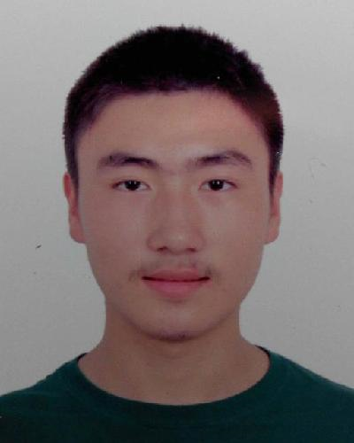‍Fan Jin (金帆)

Tel: (+86) 130-5131-2880  |  Email: jinf15@mails.tsinghua.edu.cn

EDUCATION

Undergraduate 2019 | Tsinghua University

* Major: Automation
* Minor: Applied Statistics
* Overall GPA: 3.47 / 4.0
* Rank: top 15%
* Scholarship Outstanding Academic Award (freshmen & sophomore), Zheng Geru Scholarship (sophomore)

English

* GRE: 322 + 4.0
* TOEFL iBT: 99
* CET-6: 592

Computer Programming

* C++/Java/R/C#
* https://github.com/kingium

Academic interests

* Data science
* Reinforcement learning (under guidance of Prof. Minlie Huang in Dept. of CS, Tsinghua)

Selected Courses

* Introduction to Data Science (4.0), Linear Regression Analysis
* Elementary Probability Theory (3.7), Statistical Inference (3.3)
* Linear Algebra (4.0), Calculus (3.7)
* Signals and Systems (4.0), Data Structure

EXPERIENCE

Oct 2016 – Jun 2017 Mathematical Modeling of Wind Power for Turbines under guidance of Prof. Fan Yang

(report: <http://119.28.44.116/files/SRT_report.pdf> in Chinese)

|  |  |  |
| --- | --- | --- |
| EVENTS | WHEN | AWARDS |
| Mathematical Contest of Modeling (top mathematical contest in the world) | Jan 2017 | Honorable Mention |
| Beauty of Programming by Microsoft (focused on applications of cloud computing) | May 2016 | Rank 118, Semi-final |

PROJECTS

* Data Mining with University Ranking Analysis Nov 2016 Capstone Project for Data Science
* Development of Dual-display Augmented Reality App Mar 2017 Guided by Dr. Jingtao Fan
* Implementation of a Star-rail-mix Algorithm Aug 2016 Summer Vacation Project
* A simplified version of railway ticket booking system Aug 2016 Capstone Project of Summer Courses
* Some hard-level algorithm problems on Leetcode Oct 2016 C++ implementation
* Compiler for the Jack language (<https://github.com/kingium/JackCompiler> ) Java implementation
* Analysis of Wind Speed Series at Wind Power Plant June 2016 for Time Series Analysis course