CS362

Assignment-3

Donghao Lin(lindo)

**Mutation Rate**

Original

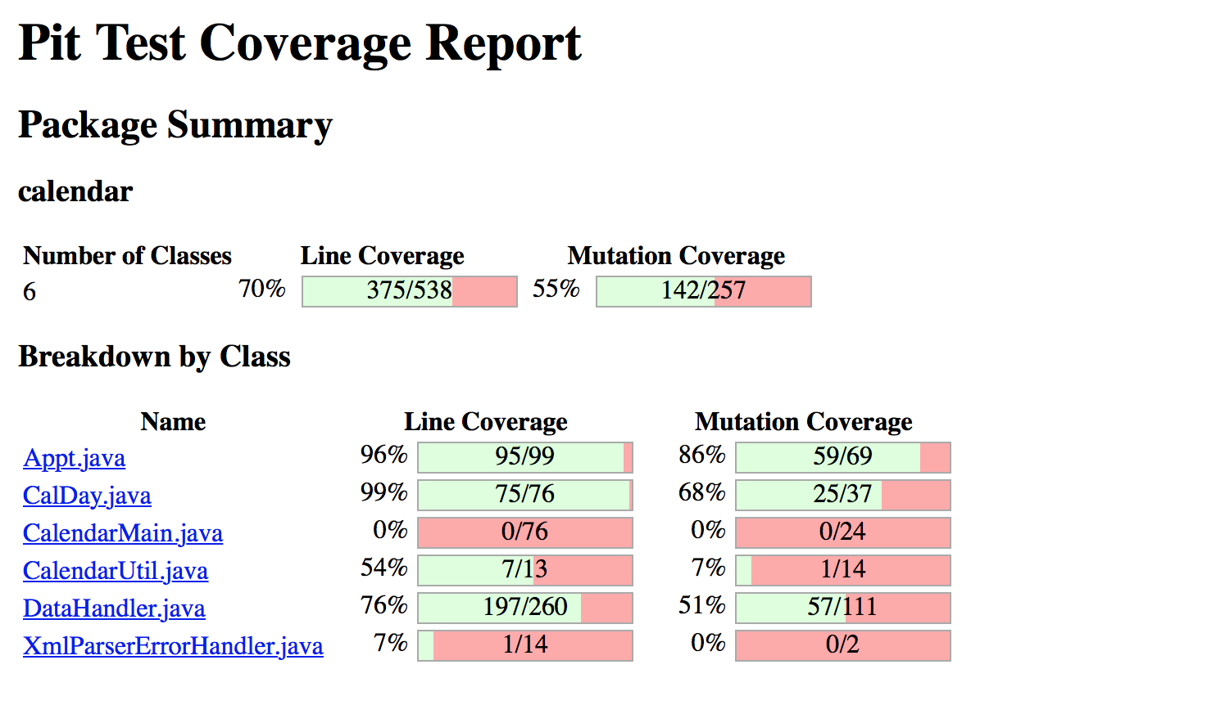

Final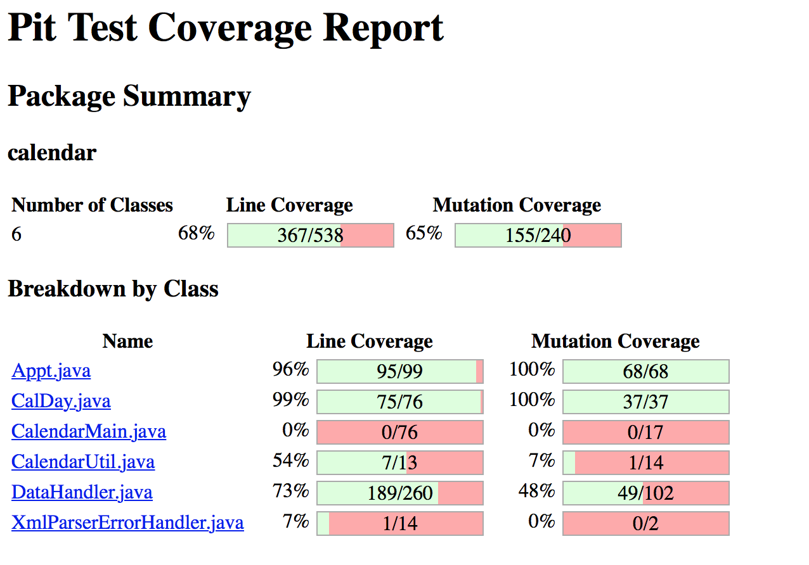

I got mutation coverage of class Datahanndler less than 90%, because I try to change a lot of test cases into my code but they did not improve the mutation coverage.

In class Datahandler, only getAppRange() was located that was not fully covered, and some other functions that were not covered were not located by the tool.

I did not find any “new” bugs, because I spend lots of time figuring out how the mutation tools work and creating a lot of test cases. My test suits were only used to fit all conditions that a function may have, so they did not detect any “new” bugs.

**Overall Experience**

Some cases were not covered or killed by my test cases, but the test report did not locate which function should be covered.

First time I was using the mutation tool, I did not know that is negated conditional and changed conditional, then I search them on the internet and fixed lots of my test cases to improve my mutation coverage.