CS362

Assignment-5

Donghao Lin

**Bug-Reports**

int NumDaysInMonth = CalendarUtil.NumDaysInMonth(startYear, startMonth);

In line 173 in Appt.java

0 is January in startMonth, but is startMonth = 12, the method should not work well.

So, change to

int NumDaysInMonth = CalendarUtil.NumDaysInMonth(startYear, startMonth - 1);

if (startDay < 0 || startDay > NumDaysInMonth)

In line 174 in Appt.java

startDay can be 0 in the condition above, so it is logically incorrect.

Appointment can be created when startDay = 0.

Change to

if (startDay < 1 || startDay > NumDaysInMonth)

**Debugging**

I ran my random test and it did not run through all cases, so I check the code where the test did not pass and fixed them.

int NumDaysInMonth = CalendarUtil.NumDaysInMonth(startYear, startMonth);

change to

int NumDaysInMonth = CalendarUtil.NumDaysInMonth(startYear, startMonth - 1);

if (startDay < 0 || startDay > NumDaysInMonth)

Change to

if (startDay < 1 || startDay > NumDaysInMonth)

I used Eclipse to debug the program. I imported the project and debugged as maven test and Junit Test. When I was debugging, I clicked all java files and it showed a lot of problems on the Markers section on the bottom of the tool. I did use Agan’s principle in debugging Calendar, I read the code and made some bugs to make the program fail then changed only one variable one time to in testing. 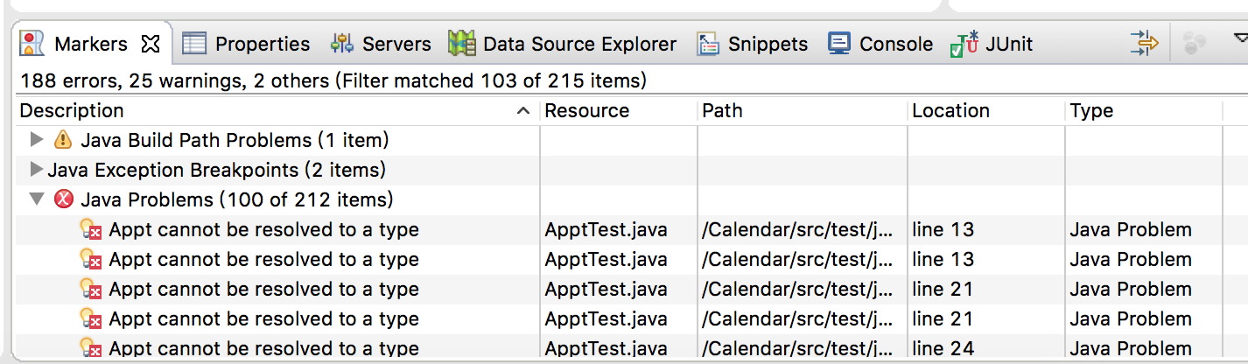

**Test-Reports**

When I was testing Calendar, it sometimes came up with an error that the last date is earlier than first date in the test cases. And I think it is unreliable that my teammate’s code has lots of bugs except the two above.

