**计算缓存切片的数目**

**地图服务的缓存切片大小由以下因素决定：**

1. 数据的地理范围
2. 比例尺的级别设置
3. 地图的内容数量
4. 地图的符号复杂度
5. 所选用的切片图片格式
6. 所选用的切片图片分辨率

**计算方法：**

参数

1. W:地图空间范围的长度，单位为米
2. H:地图空间范围的宽度，单位为米
3. S:当前级别的比例尺，例如5000代表1/5000
4. Res:图片分辨率，默认为96dpi（dot per inch）
5. P：切片的大小，例如256，代表256×256
6. R:切片的行数
7. C:切片的列数

*1 inch = 0.0254 metre

计算公式

C=(W/S)*(Res/0.0254)/P

R=(H/S)*(Res/0.0254)/P

其中(Res/0.0254)/S为缓存的分辨率（resolution）。

**示例：**

地图服务缓存分为12级比例尺，最大比例尺为5000，最小比例尺为16000000。

计算脚本见附件（EstimateTilesCount.py）。

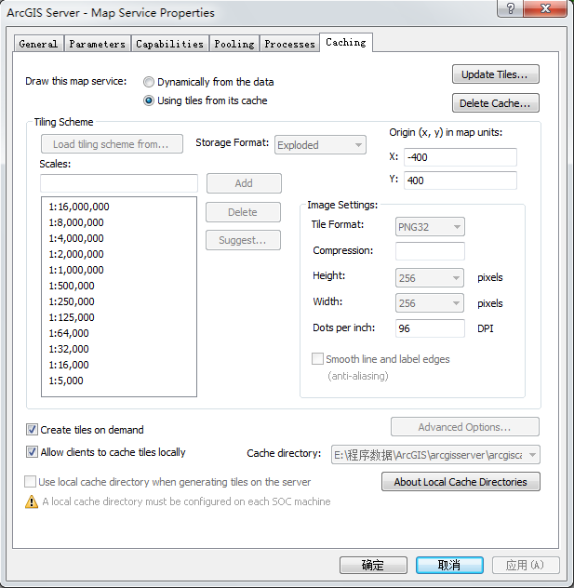

图表 1 缓存的设置

|  |  |  |
| --- | --- | --- |
| 省份 | 切片数目 | 估计大小（按平均PNG32图片大小为60KB估计） |
| 西藏 | 23246189 | 1330GB |
| 海南 | 652632 | 37GB |
| 宁夏 | 1707227 | 98GB |
| 青海 | 12988369 | 743GB |
|  |  | 2208GB |

海南

Updating envelope: 0

108.612083 18.159306 111.272363 20.162639

LevelID= 0

Scale= 16000000

Resolution= 0.0380713760933

numTilesWideFromTile = 1.0

numTilesHighFromTile = 2.0

totalTiles= 2.0

LevelID= 1

Scale= 8000000

Resolution= 0.0190356880466

numTilesWideFromTile = 1.0

numTilesHighFromTile = 2.0

totalTiles= 2.0

LevelID= 2

Scale= 4000000

Resolution= 0.00951784402332

numTilesWideFromTile = 2.0

numTilesHighFromTile = 2.0

totalTiles= 4.0

LevelID= 3

Scale= 2000000

Resolution= 0.00475892201166

numTilesWideFromTile = 3.0

numTilesHighFromTile = 3.0

totalTiles= 9.0

LevelID= 4

Scale= 1000000

Resolution= 0.00237946100583

numTilesWideFromTile = 6.0

numTilesHighFromTile = 4.0

totalTiles= 24.0

LevelID= 5

Scale= 500000

Resolution= 0.00118973050292

numTilesWideFromTile = 10.0

numTilesHighFromTile = 7.0

totalTiles= 70.0

LevelID= 6

Scale= 250000

Resolution= 0.000594865251458

numTilesWideFromTile = 19.0

numTilesHighFromTile = 14.0

totalTiles= 266.0

LevelID= 7

Scale= 125000

Resolution= 0.000297432625729

numTilesWideFromTile = 36.0

numTilesHighFromTile = 27.0

totalTiles= 972.0

LevelID= 8

Scale= 64000

Resolution= 0.000152285504373

numTilesWideFromTile = 69.0

numTilesHighFromTile = 52.0

totalTiles= 3588.0

LevelID= 9

Scale= 32000

Resolution= 7.61427521866e-05

numTilesWideFromTile = 138.0

numTilesHighFromTile = 104.0

totalTiles= 14352.0

LevelID= 10

Scale= 16000

Resolution= 3.80713760933e-05

numTilesWideFromTile = 274.0

numTilesHighFromTile = 207.0

totalTiles= 56718.0

LevelID= 11

Scale= 5000

Resolution= 1.18973050292e-05

numTilesWideFromTile = 875.0

numTilesHighFromTile = 659.0

totalTiles= 576625.0

Total tiles generated for this extent: 652632.0

Finished env update.

宁夏

Updating envelope: 1

104.279076 35.235354 107.651748 39.380879

LevelID= 0

Scale= 16000000

Resolution= 0.0380713760933

numTilesWideFromTile = 2.0

numTilesHighFromTile = 1.0

totalTiles= 2.0

LevelID= 1

Scale= 8000000

Resolution= 0.0190356880466

numTilesWideFromTile = 2.0

numTilesHighFromTile = 1.0

totalTiles= 2.0

LevelID= 2

Scale= 4000000

Resolution= 0.00951784402332

numTilesWideFromTile = 3.0

numTilesHighFromTile = 2.0

totalTiles= 6.0

LevelID= 3

Scale= 2000000

Resolution= 0.00475892201166

numTilesWideFromTile = 4.0

numTilesHighFromTile = 4.0

totalTiles= 16.0

LevelID= 4

Scale= 1000000

Resolution= 0.00237946100583

numTilesWideFromTile = 7.0

numTilesHighFromTile = 7.0

totalTiles= 49.0

LevelID= 5

Scale= 500000

Resolution= 0.00118973050292

numTilesWideFromTile = 12.0

numTilesHighFromTile = 14.0

totalTiles= 168.0

LevelID= 6

Scale= 250000

Resolution= 0.000594865251458

numTilesWideFromTile = 23.0

numTilesHighFromTile = 28.0

totalTiles= 644.0

LevelID= 7

Scale= 125000

Resolution= 0.000297432625729

numTilesWideFromTile = 46.0

numTilesHighFromTile = 55.0

totalTiles= 2530.0

LevelID= 8

Scale= 64000

Resolution= 0.000152285504373

numTilesWideFromTile = 87.0

numTilesHighFromTile = 107.0

totalTiles= 9309.0

LevelID= 9

Scale= 32000

Resolution= 7.61427521866e-05

numTilesWideFromTile = 174.0

numTilesHighFromTile = 214.0

totalTiles= 37236.0

LevelID= 10

Scale= 16000

Resolution= 3.80713760933e-05

numTilesWideFromTile = 347.0

numTilesHighFromTile = 427.0

totalTiles= 148169.0

LevelID= 11

Scale= 5000

Resolution= 1.18973050292e-05

numTilesWideFromTile = 1108.0

numTilesHighFromTile = 1362.0

totalTiles= 1509096.0

Total tiles generated for this extent: 1707227.0

Finished env update.

青海

Updating envelope: 2

89.401451 31.542525 103.061188 39.339597

LevelID= 0

Scale= 16000000

Resolution= 0.0380713760933

numTilesWideFromTile = 2.0

numTilesHighFromTile = 1.0

totalTiles= 2.0

LevelID= 1

Scale= 8000000

Resolution= 0.0190356880466

numTilesWideFromTile = 4.0

numTilesHighFromTile = 2.0

totalTiles= 8.0

LevelID= 2

Scale= 4000000

Resolution= 0.00951784402332

numTilesWideFromTile = 7.0

numTilesHighFromTile = 4.0

totalTiles= 28.0

LevelID= 3

Scale= 2000000

Resolution= 0.00475892201166

numTilesWideFromTile = 12.0

numTilesHighFromTile = 7.0

totalTiles= 84.0

LevelID= 4

Scale= 1000000

Resolution= 0.00237946100583

numTilesWideFromTile = 23.0

numTilesHighFromTile = 13.0

totalTiles= 299.0

LevelID= 5

Scale= 500000

Resolution= 0.00118973050292

numTilesWideFromTile = 46.0

numTilesHighFromTile = 26.0

totalTiles= 1196.0

LevelID= 6

Scale= 250000

Resolution= 0.000594865251458

numTilesWideFromTile = 91.0

numTilesHighFromTile = 52.0

totalTiles= 4732.0

LevelID= 7

Scale= 125000

Resolution= 0.000297432625729

numTilesWideFromTile = 180.0

numTilesHighFromTile = 104.0

totalTiles= 18720.0

LevelID= 8

Scale= 64000

Resolution= 0.000152285504373

numTilesWideFromTile = 351.0

numTilesHighFromTile = 201.0

totalTiles= 70551.0

LevelID= 9

Scale= 32000

Resolution= 7.61427521866e-05

numTilesWideFromTile = 701.0

numTilesHighFromTile = 401.0

totalTiles= 281101.0

LevelID= 10

Scale= 16000

Resolution= 3.80713760933e-05

numTilesWideFromTile = 1402.0

numTilesHighFromTile = 801.0

totalTiles= 1123002.0

LevelID= 11

Scale= 5000

Resolution= 1.18973050292e-05

numTilesWideFromTile = 4486.0

numTilesHighFromTile = 2561.0

totalTiles= 11488646.0

Total tiles generated for this extent: 12988369.0

Finished env update.

西藏

Updating envelope: 3

78.404327 27.27605 99.112312 36.483509

LevelID= 0

Scale= 16000000

Resolution= 0.0380713760933

numTilesWideFromTile = 3.0

numTilesHighFromTile = 2.0

totalTiles= 6.0

LevelID= 1

Scale= 8000000

Resolution= 0.0190356880466

numTilesWideFromTile = 5.0

numTilesHighFromTile = 3.0

totalTiles= 15.0

LevelID= 2

Scale= 4000000

Resolution= 0.00951784402332

numTilesWideFromTile = 9.0

numTilesHighFromTile = 4.0

totalTiles= 36.0

LevelID= 3

Scale= 2000000

Resolution= 0.00475892201166

numTilesWideFromTile = 18.0

numTilesHighFromTile = 8.0

totalTiles= 144.0

LevelID= 4

Scale= 1000000

Resolution= 0.00237946100583

numTilesWideFromTile = 35.0

numTilesHighFromTile = 16.0

totalTiles= 560.0

LevelID= 5

Scale= 500000

Resolution= 0.00118973050292

numTilesWideFromTile = 69.0

numTilesHighFromTile = 31.0

totalTiles= 2139.0

LevelID= 6

Scale= 250000

Resolution= 0.000594865251458

numTilesWideFromTile = 137.0

numTilesHighFromTile = 61.0

totalTiles= 8357.0

LevelID= 7

Scale= 125000

Resolution= 0.000297432625729

numTilesWideFromTile = 273.0

numTilesHighFromTile = 122.0

totalTiles= 33306.0

LevelID= 8

Scale= 64000

Resolution= 0.000152285504373

numTilesWideFromTile = 532.0

numTilesHighFromTile = 237.0

totalTiles= 126084.0

LevelID= 9

Scale= 32000

Resolution= 7.61427521866e-05

numTilesWideFromTile = 1064.0

numTilesHighFromTile = 473.0

totalTiles= 503272.0

LevelID= 10

Scale= 16000

Resolution= 3.80713760933e-05

numTilesWideFromTile = 2126.0

numTilesHighFromTile = 945.0

totalTiles= 2009070.0

LevelID= 11

Scale= 5000

Resolution= 1.18973050292e-05

numTilesWideFromTile = 6800.0

numTilesHighFromTile = 3024.0

totalTiles= 20563200.0

Total tiles generated for this extent: 23246189.0

Finished env update.