Python语言有的设计理念和哲学，称为“Python之禅”。Python之禅是Python的灵魂，理解Python之禅能帮助开发人员编写出优秀的Python程序。在Python交互式方式运行工具IDLE（也称为Python shell）中输入import this命令，如图所示，显示的内容就是Python之禅。

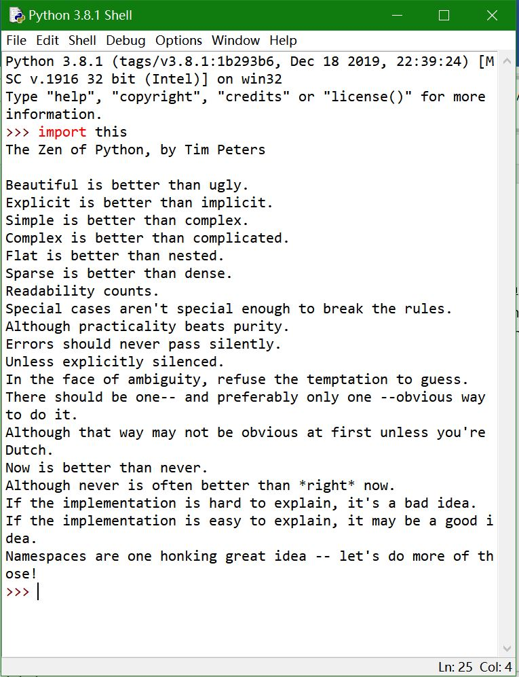

Python 3.8.1 (tags/v3.8.1:1b293b6, Dec 18 2019, 22:39:24) [MSC v.1916 32 bit (Intel)] on win32

Type "help", "copyright", "credits" or "license()" for more information.

>>> import this

The Zen of Python, by Tim Peters

Beautiful is better than ugly.

Explicit is better than implicit.

Simple is better than complex.

Complex is better than complicated.

Flat is better than nested.

Sparse is better than dense.

Readability counts.

Special cases aren't special enough to break the rules.

Although practicality beats purity.

Errors should never pass silently.

Unless explicitly silenced.

In the face of ambiguity, refuse the temptation to guess.

There should be one-- and preferably only one --obvious way to do it.

Although that way may not be obvious at first unless you're Dutch.

Now is better than never.

Although never is often better than \*right\* now.

If the implementation is hard to explain, it's a bad idea.

If the implementation is easy to explain, it may be a good idea.

Namespaces are one honking great idea -- let's do more of those!

>>>

翻译：

《Python之禅》(The Zen of Python)，蒂姆·彼得斯(Tim Peters)著

美丽总比丑陋好。

显式的比隐式的好。

简单总比复杂好。

复杂总比复杂好。

平铺总比嵌套好。

稀疏总比稠密好。

可读性。

特殊情况并不特别到足以违反规则。

尽管实用性胜过纯洁性。

错误不应该悄无声息地过去。

除非显式地沉默。

面对模棱两可的情况，拒绝猜测的诱惑。

应该有一种——最好是只有一种——显而易见的方法。

尽管这种方式一开始可能并不明显，除非你是荷兰人。

现在总比没有好。

尽管“从不”常常比“现在”更好。

如果实现很难解释，那就是个坏主意。

如果实现很容易解释，这可能是一个好主意。

名称空间是一个伟大的想法——让我们做更多这样的事情!