**Outputs:**

**Scenario-1:**

**Before Executing:**

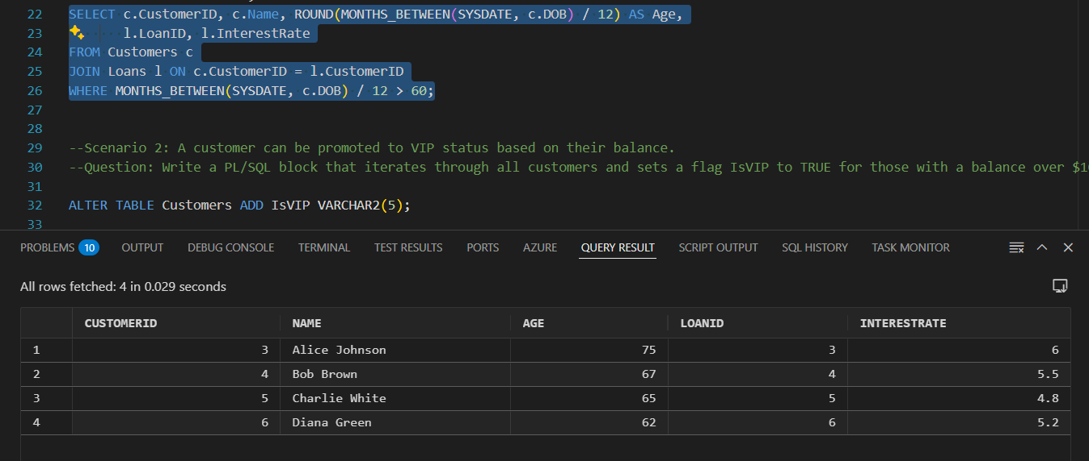

**After Executing:** The Customers whose age is above 60 ,their interest rate is increased 1%.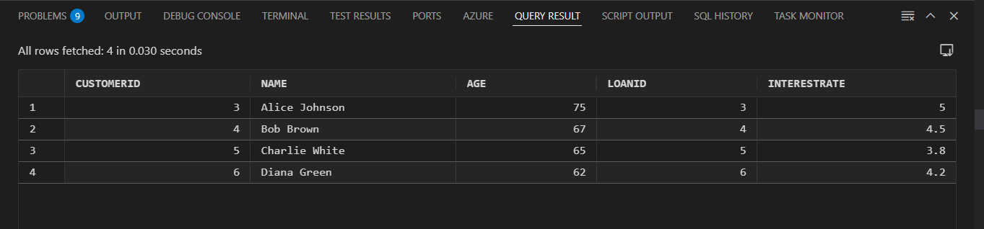

**Scenario-2**

**Before Executing:** A new Column- **ISVIP** is added to identify the customers whose balance is above $10,000

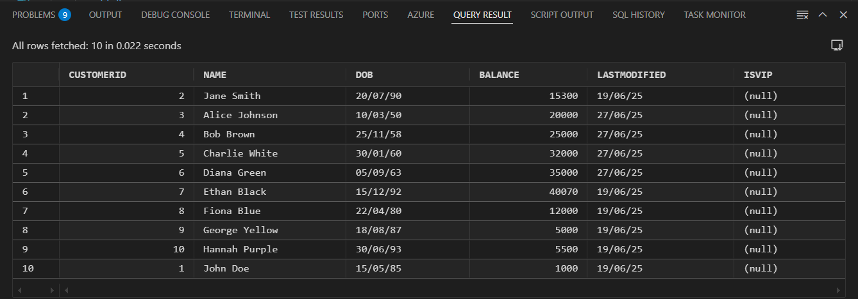

**After Executing:**

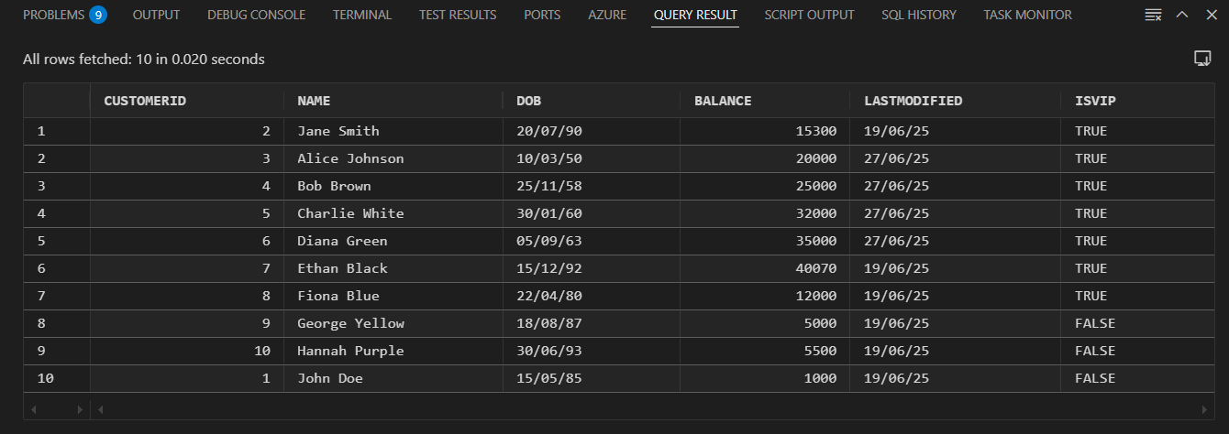

**Scenario-3:**

**Alert is generated to the Customers whose loan is due within 30 days.**

