**Outputs:**

**All scenarios procedures compiled successfully:**

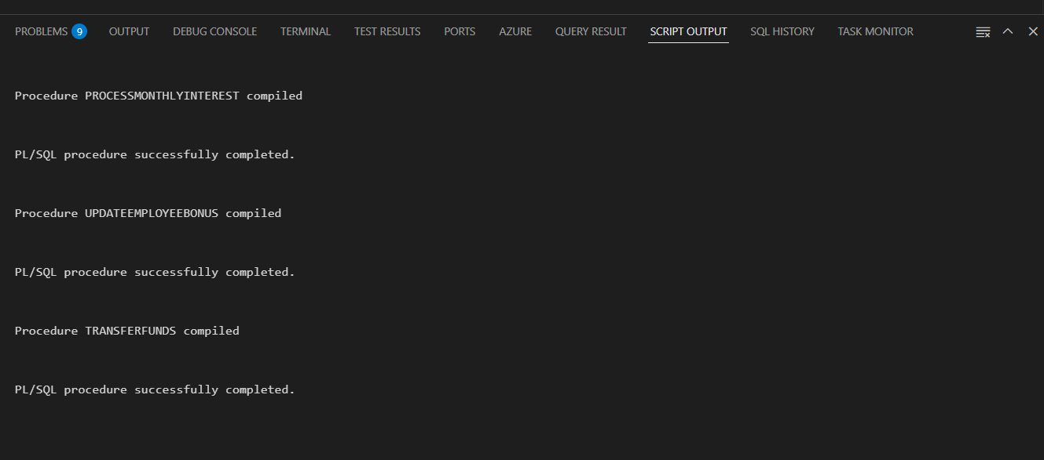

**Scenario-1:**

**Before executing the procedure:**

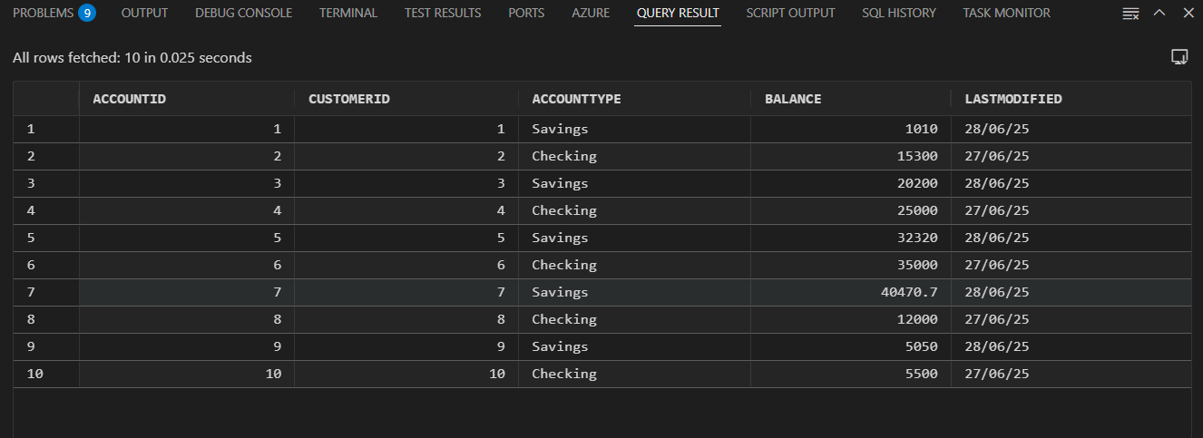

**After Executing:** All the savings accounts balance is increased to 1%

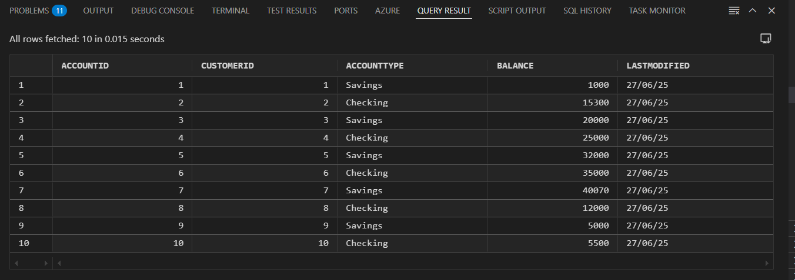

**Scenario-2:**

**Before Executing:**

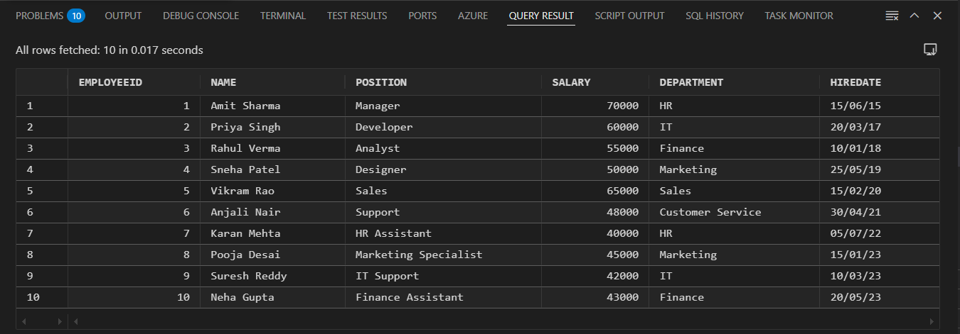

**After executing:** The salary of employees working in IT have got 10% increment.

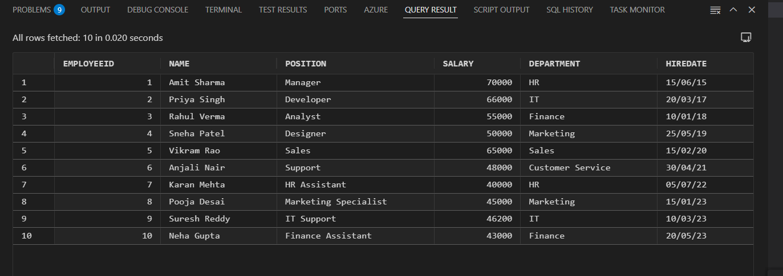

**Scenario-3:**

**Before Executing:**



**After Executing:** The transaction of amount 300 from Customer 2 to 3 :

