**Outputs:**

**Secnario-1:** Age Function to Caluclate Age of customers

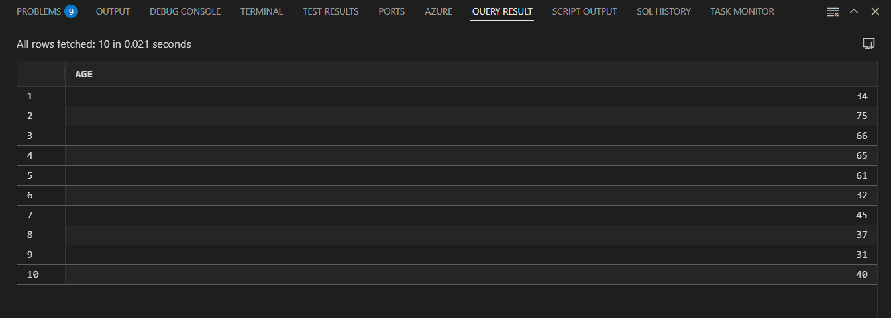

**Scenario-2:**Function to calculate monthly installment

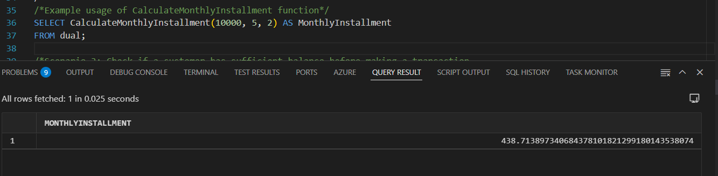

**Scenario-3:** Funtion to check the customer has the suffiecint blance

