**OUTPUTS:**

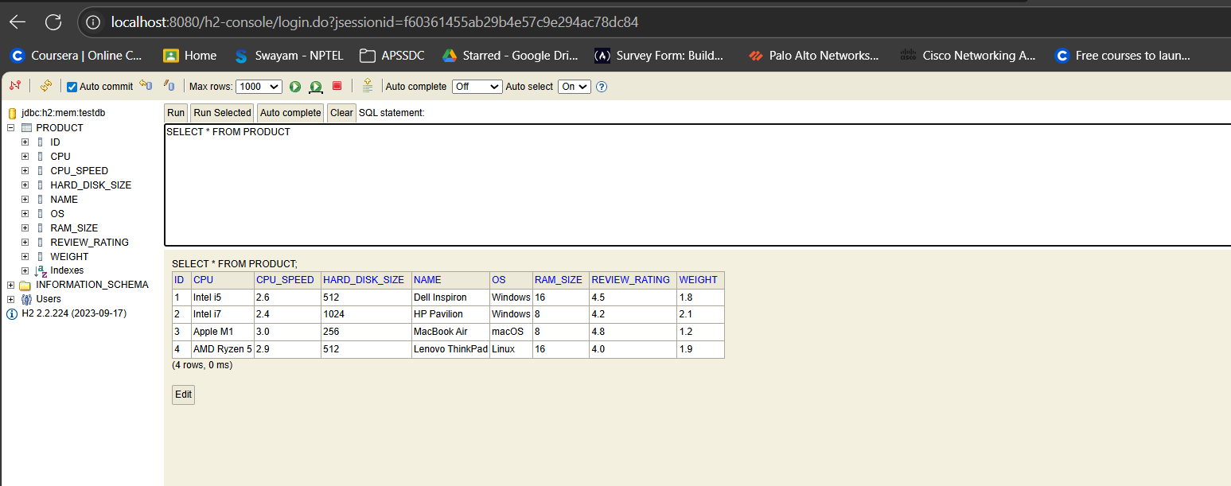

**Using Postman:**

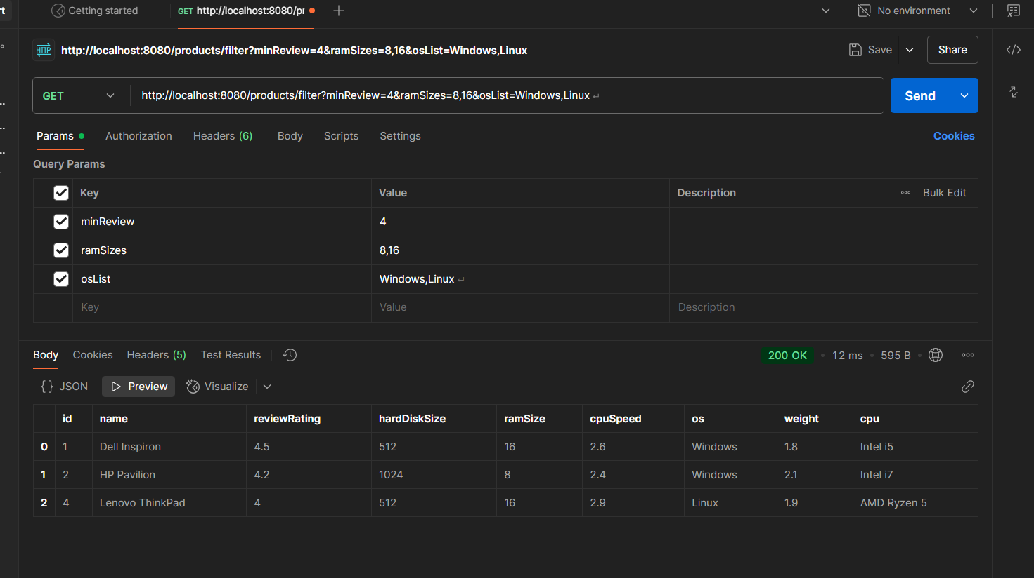

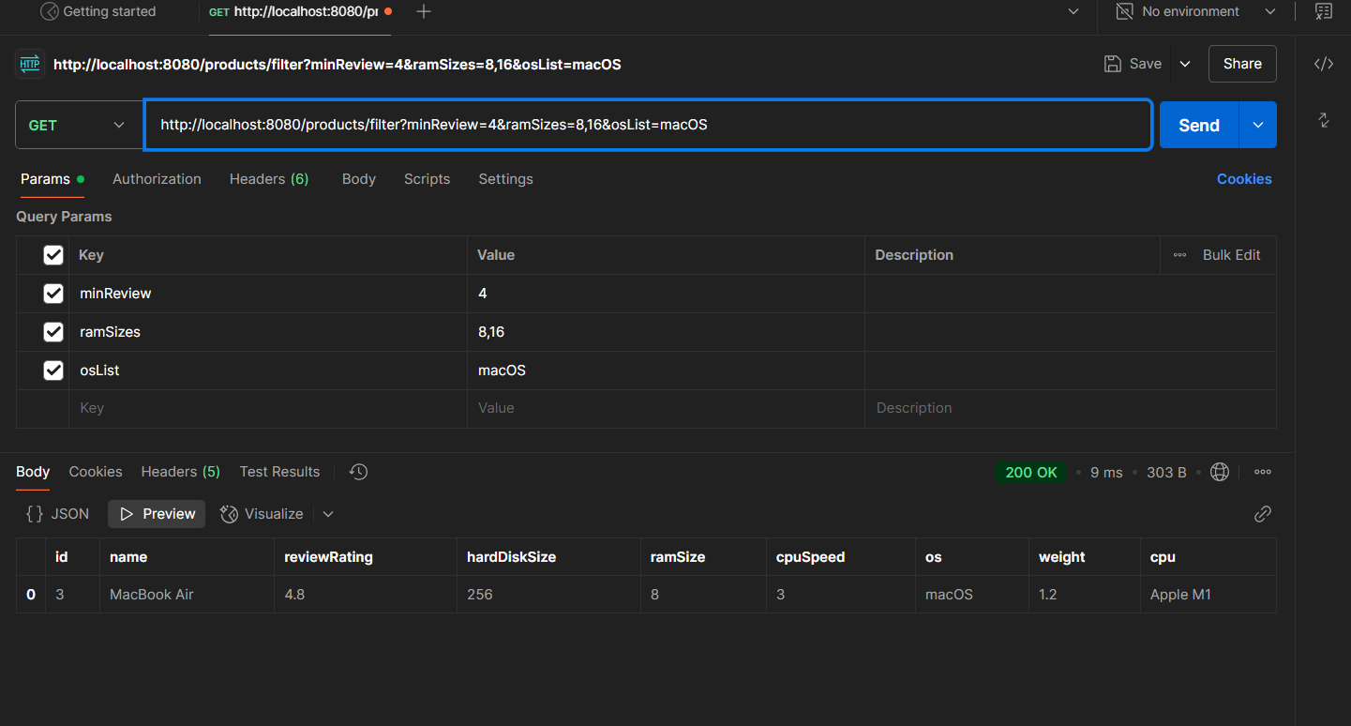

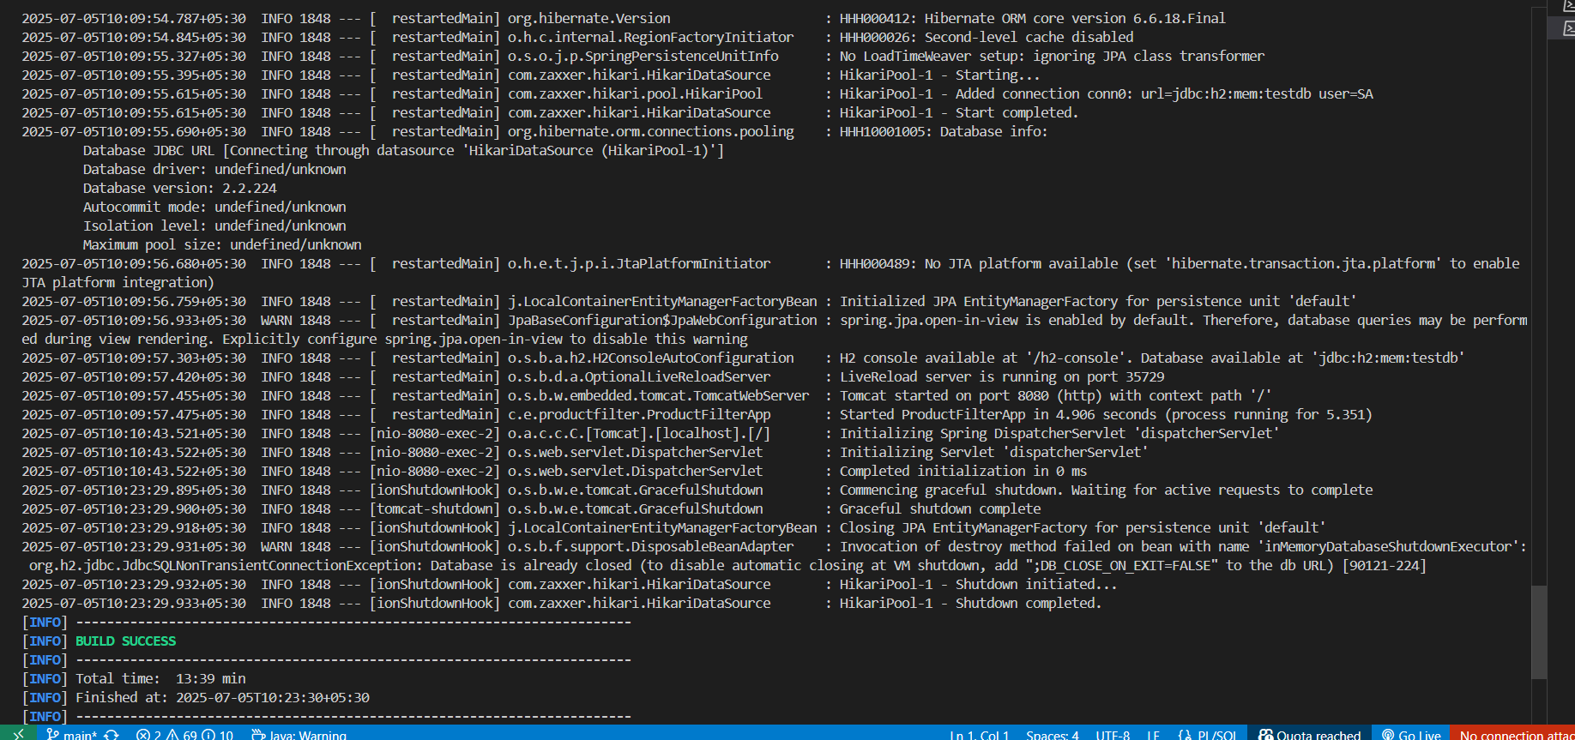

**Notes:**

* All filters are optional — only added when not null or not empty.
* We use cb.like, cb.in, cb.ge, cb.le, etc. depending on the filter type.
* This is much more maintainable than string-concatenating HQL manually.

**"What will be the WHERE clause?"**

There is **no fixed WHERE clause**, because it is **dynamically constructed** based on user-selected filters using the Criteria API.