**1.Explain branching and merging**

**Branching and Merging in Git**

**Branching** lets you create an isolated environment to work on a feature, bug fix, or experiment—without affecting the main codebase.

* You create a branch using:
* git checkout -b feature-xyz
* This gives you a sandbox to make changes safely.

**Merging** is the process of integrating changes from one branch into another—typically from a feature branch into main or master.

* You merge using:
* git checkout main
* git merge feature-xyz

This keeps your workflow clean and collaborative.

**2.Explain about creating a branch request in GitLab**

**Creating a Branch Request in GitLab**

GitLab doesn’t use the term “branch request” officially, but here’s what it typically means:

1. **Create a new branch locally**:
2. git checkout -b my-feature
3. **Push it to GitLab**:
4. git push origin my-feature
5. **GitLab detects the new branch** and offers to create a merge request from it.

**3.Explain about creating a merge request in GitLab**

**Creating a Merge Request in GitLab**

A **Merge Request (MR)** is GitLab’s version of a pull request. It’s how you propose merging your branch into another (usually main).

**Steps:**

1. Push your branch to GitLab.
2. Navigate to your project in GitLab.
3. Click **Merge Requests** → **New Merge Request**.
4. Select:
   * **Source branch**: your feature branch
   * **Target branch**: usually main or develop
5. Add a title, description, and reviewers.
6. Submit the request.

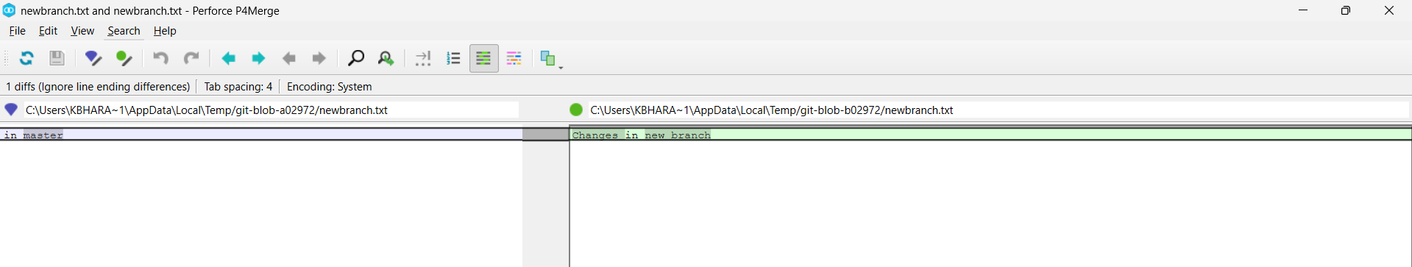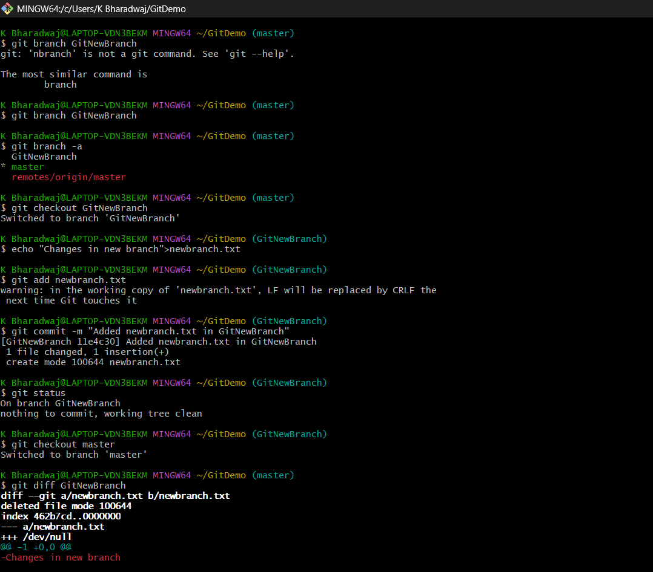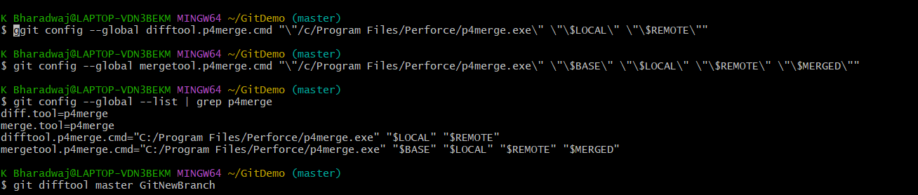

**MERGING**

