VERSION 1.0

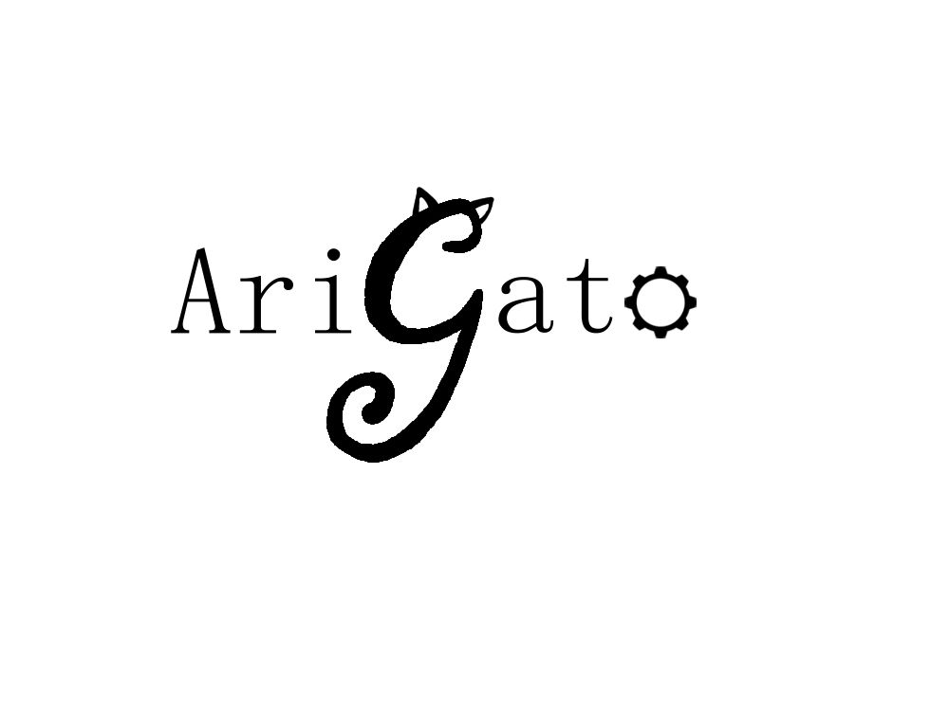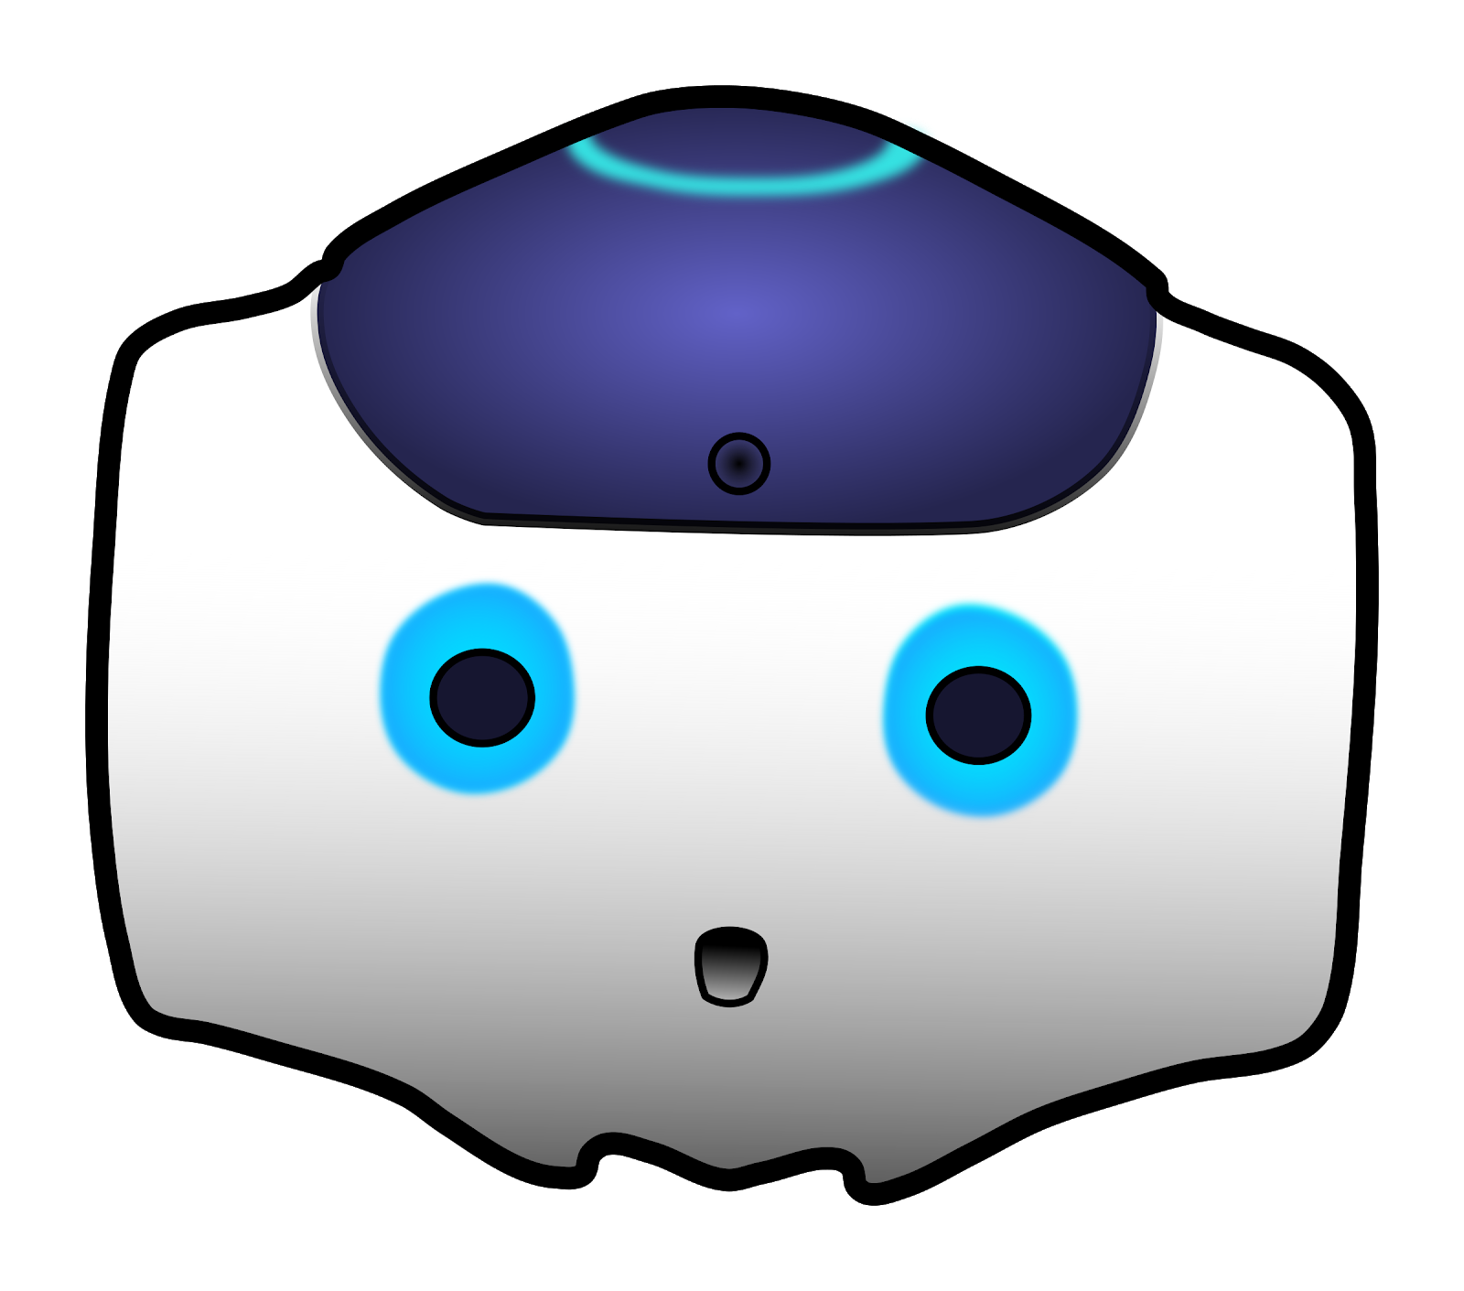

Human-Robot Interaction

NAO Documentation / User Manual

CREATED BY Casey Chen, Hailey Dhanens, Matthew Harker, Angie Quach, & Derek Vaughan

Arigato, central washington university

Ellensburg, wa

“Our mission is to create and showcase meaningful and exciting human-to-robot interaction using the Aldebaran NAO robots recently required by CWU.” – AriGato Robotics

____________________________________________________________________________

# CONTENTS

Section 1: Introduction to the NAO Robot

1.1 What is NAO?............................................................................................................................X

1.2 Who made NAO?......................................................................................................................X

1.3 Definitions, Acronyms, & Abbreviations….……………………………………………………………………………X

1.4 References……………………………………………………………………………………………………………………………X

Section 2: NAO’s Capabilities

2.1 Initial (Pre-Built) Capabilities....................................................................................................X

2.2 Verbal Responses (Q&A)……………………………............................................................................X

2.3 Internet-Based Requests & Responses…………………………………………………………………………………X

2.4 Facial Detection & Recognition Responses…………………………………………………………………………..X

2.5 Basic Movement Options……………..………………..……………………………………………………………………X

2.6 Advanced Movement Options………………………..……………………………………………………………………X

Section 3: Creating Your Own NAO Modules

3.1 Basics of Choregraphe…………………...........................................................................................X

3.2 Using the NAOqi Framework....................................................................................................X

3.3 Creating Your First Module………………….….……………………………………………………………………………X

3.4 Integrating Your Module onto NAO………………………………………………………………………………………X

Section 4: Help

4.1 General FAQs……………………………….………………………………………………………………………………………X

4.2 Troubleshooting…………………………………………………………………………………………………………………..X

# SECTION 1: INTRODUCTION TO THE NAO ROBOT

## 1.1 WHAT IS NAO?

NAO is an autonomous, humanoid, fully programmable robot. NAO robots are capable of 25 degrees of freedom, and thanks to their humanoid nature and design, are able to walk around, adapt, and interact with their surrounding environment. Furthermore, NAO has 4 directional microphones, speakers, and 2 cameras capable of filming and analyzing the robot’s environment, and human faces, for example. NAO is additionally capable of connecting to the internet by means of ethernet or Wi-Fi – this enables features such as http requests or big data analytics using the cloud.

All of these features add up to NAO’s capabilities essentially being limitless, it is truly up to the developer’s imagination to decide what the robot will eventually be capable of. Development for NAO can be conducted in either Python or C++.

Additional Specifications:

* Dimensions: 22.6 x 10.8 x 12.2 inches (574 x 311 x 275 mm)
* Weight: 12.08 pounds (5.48 kg)
* Autonomous Battery Life: 60 minutes active use, 90 minutes stationary use
* Operating System: Linux-Based NAOqi 2.8 (Linux Distro: Gentoo)
* Processor: Intel Atom E3845 @ 1.91 GHz

## 1.2 WHo made NAO?

The initial development of the NAO robot began as early as 2004. NAO was created by a French company known as Aldebaran, who was later acquired by SoftBank Robotics, a company based out of Japan, in 2015. The first public version of the NAO robot was released in 2008, however the version this project will be focusing on (NAO v6, or NAO Next Gen) was released to the public in 2014.

## 1.3 definitions, acronyms, & abbreviations

Aldebaran

French robotics company based in Japan which developed NAO in partnership with Softbank Robotics

API

Application Program Interface.

Choregraphe

A multi-platform desktop application that allows users to create animations and behaviors for the NAO and test them in both simulated and real environments. It also allows users to monitor the NAO’s visual and audio sensors.

Client

Dr. Szilard Vajda, assistant professor, of the Central Washington University Computer Science department, the requester of this project

### Ethernet

A common form of network cable. It allows a connected device to join a local area network (LAN) in order to connect to and browse the internet.

Library

A collection of well-defined resources and implementations of behavior, written for/in a particular programming language for use by other developers to simplify and speed up development for a system.

NAO

A programmable, humanoid robot designed by Aldebaran Robots.

NAOqI

A Linux-based operating system stored in the robot’s memory at all times; used for running and controlling features and programs.

See

The NAO robots cannot “see” in a physical sense but has cameras that it can use to record images to identify its surroundings.

Sensor

Measures the robot’s configurations, conditions, and its environment and sends such information to the robot for processing.

Software

A set of computer instructions used to obtain input, and then manipulate that input in order to generate relevant output in terms of function and performance as specified by the user.

SOURCE

A university-wide event in May 2019 showcasing all disciplines of research, scholarship, and creative activities by students, faculty, and staff.

User

A person who will interact with and make use of the NAO’s various capabilities.

Wi-Fi

**Placeholder text**

## 1.4 references

[1] Guide to making an SRS: http://www.cse.msu.edu/~cse870/IEEEXplore-SRS-template.pdf

[2] NAO Lab Documentation/Info: https://team.inria.fr/perception/demos/naolab/

[3] NAO, NAOqi, Choregraph Documentation: <http://doc.aldebaran.com/>

[4] NAO, Technical Guide: <http://doc.aldebaran.com/2-1/family/index.html>

[5] Engineering NYU, Intro to Robotics http://engineering.nyu.edu/mechatronics/smart/pdf/Intro2Robotics.pdf

# SECTION 2: NAO’s CAPABILITIES

## 2.1 initial (pre-built) capabilities

The original capabilities of the NAO are put on the robot by subscribing to the Aldebaran “Basic Channel.” Official documentation on this channel lists and describes its capabilities.[1] Below is a list of some of the phrases NAO can respond to in the documentation, most of which are available in English, French, and Japanese Language settings.

* “How are you?”
* “Can you say goodbye?”
* “What can you do?”
* “Tell me all you can do.”
* “How do I install an application?”
* “How do I start an application?”
* “What did I say?”
* “Can you repeat please?”
* “What is your IP address?”
* “Are you connected to Internet?”
* “What languages so you speak?
* “Speak French.”
* “Can you speak French?”
* “Speak Japanese.”
* “Speak Chinese”
* “Can you speak Chinese”
* “Speak softer”
* “Speak louder”
* “Can you stand up?”
* “Can you sit down?”
* “Crouch.”
* “Lay down”
* “Lift your arm”
* “Lay down on your back”
* “Lay down on your belly.”
* “Stop Looking at me”
* “What is your name?”
* “Introduce yourself”
* “How are you?”
* “How tall are you?”
* “How much do you weigh?”

## 2.2 verbal responses (q&a)

Developers

Verbal queues:

* Who is developing your programs?
* Who is working on you?
* Who is in the capstone project?

Description: Nao lists the team members of the Arigato capstone project

How old are you

Verbal queues:

* How old are you?
* What is your age?

Description: Nao will respond with various humorous verbal responses

Sing the anthem

Verbal queues:

Description:

What time is it?

Verbal queues:

Description:

## 2.3 internet-based requests & responses

*Movie Information*

Verbal queues:

Description:

*Temperature*

Verbal queues:

* What is the current temperature of Ellensburg?
* What’s the current temperature?
* What is the temperature?
* How hot is it outside?
* How cold is it outside?
* How hot is it?
* How cold is it?

Description: Nao will retrieve weather information from OpenWeatherMap.com and give the current temperature in Ellensburg Washington. Because this module was only intended for use in Ellensburg, if one wants to change the city, they will have to go into the code and do it manually.

## 2.4 facial detection & recognition responses

*Age Guesser*

Verbal queues:

* Can you guess how old I am?
* Guess my age.
* How old do you think I am?
* What is my age?

Description: When prompted, NAO will use the facial recognition API to attempt a guess at the user’s age.

*Do you know me?*

Verbal queues:

* Do you know me?
* Do you remember me?
* Do you know my name?
* Do you know who I am?

Description: If a recognized face is within view, if NAO can recognize the face within 6 seconds, NAO will greet the person, if not, the module will time out, and NAO will say “sorry, I do not recognize you”

## 2.5 basic movement options

*Jazz Hands*

Verbal queues:

* Jazz hands
* Do jazz hands
* Be jazzy
* Can you do jazz hands?

Description: NAO will perform jazz hands when prompted

*Move Fingers*

Verbal queues:

* NAO, wiggle your fingers
* Move fingers
* Can you wiggle your fingers
* Do your fingers move
* Move your fingers

Description: NAO will open and close his hands to demonstrate the mobility of his fingers.

*Nod Yes*

Verbal queues:

* Nod yes
* Can you nod for me?
* Nod your head
* Nod your head for me

Description: Nao will move his head up and down to demonstrate the mobility of his head

*Raise Left/Right foot*

Verbal queues:

* Raise your left/right foot
* Move your left/right foot

Description: Nao will lean to the side and lift the corresponding foot in order to demonstrate the mobility of his feet.

*Turn head left/right*

Verbal queues:

* Turn your head left/right
* Tur head left/right
* Head left/right
* Move your head to the left/right
* Look left/right

Description: NAO will turn his head to the corresponding direction in order to demonstrate the mobility of his head

*Walk backward/forward/left/right*

Verbal queues:

* Walk <direction>
* Move <direction>
* Step <direction>
* Take a step <direction>

Description: NAO will move 0.2 meters in the desired direction

## 2.6 advanced movement options

*Pushups*

Verbal queues:

* Pushups
* Do pushups
* Do some pushups
* Can you do pushups?
* Do you know how to do pushups?

Description: NAO will ask how many pushups you would like done (he can do 1 to 10 inclusive) and will proceed to do that many pushups

***WARNING***

NAO must have clear and empty space behind and in front of him to do pushups, and making NAO do excessive pushups without a break can lead to overheating motors

# SECTION 3: CREATING YOUR OWN NAO MODULES

## 3.1 basics of choregraphe

## 3.2 using the naoqi framework

## 3.3 creating your first module

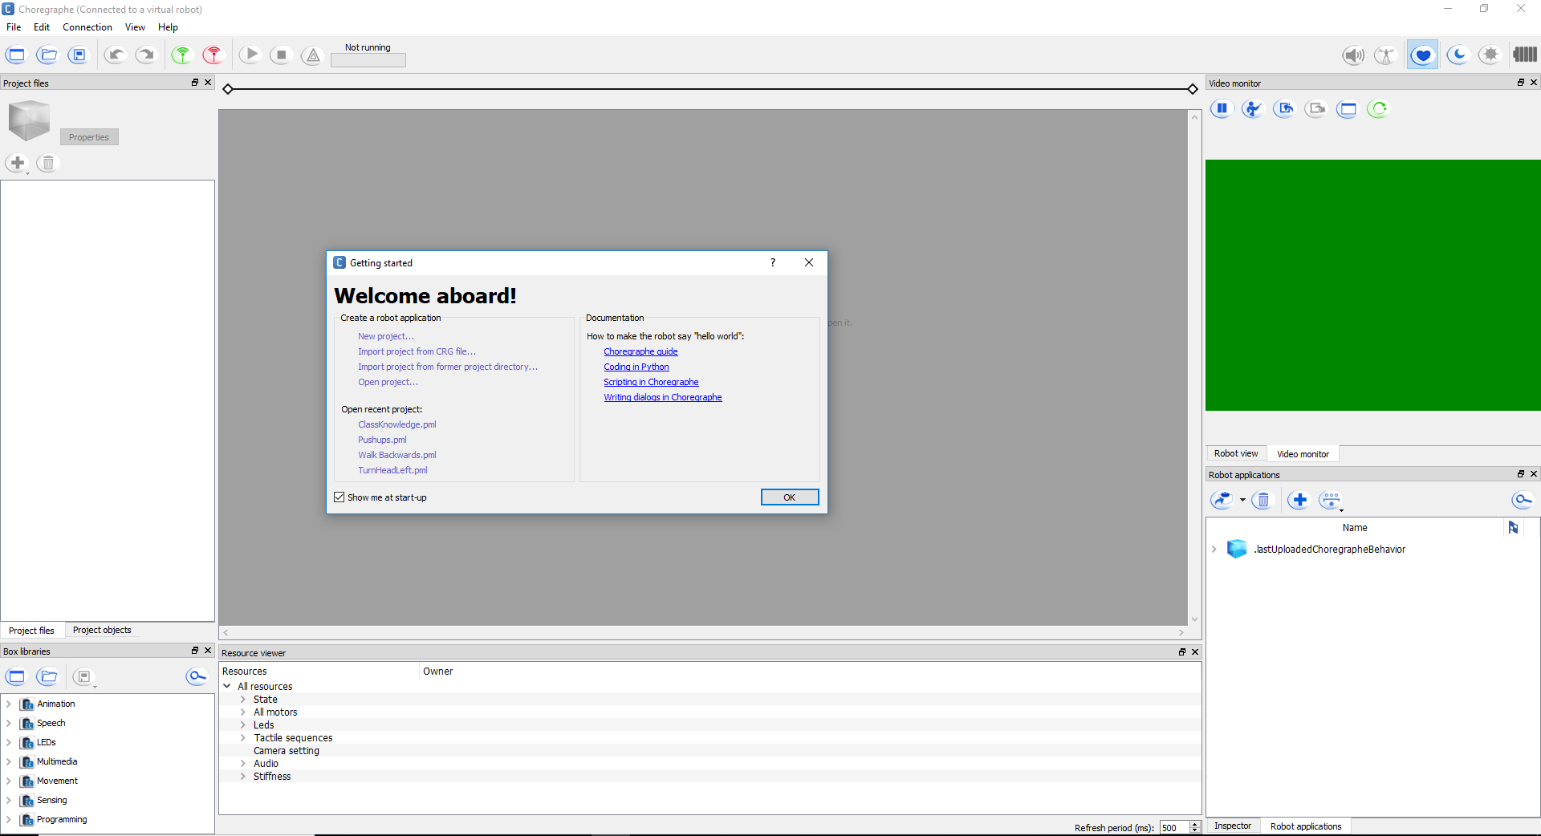

Figure 1 - First Opening Choregraphe

When first opening Choregraphe a window will pop up saying “Welcome aboard!” It will have a documentation section with a quick “Hello World” tutorial, and possibly links to recent projects. To begin, either click “New project…” or exit out of the window, which will create a new project anyway. Start by filling out the information with the properties button in the upper left corner, next to the blue square shown in the left image of figure 2

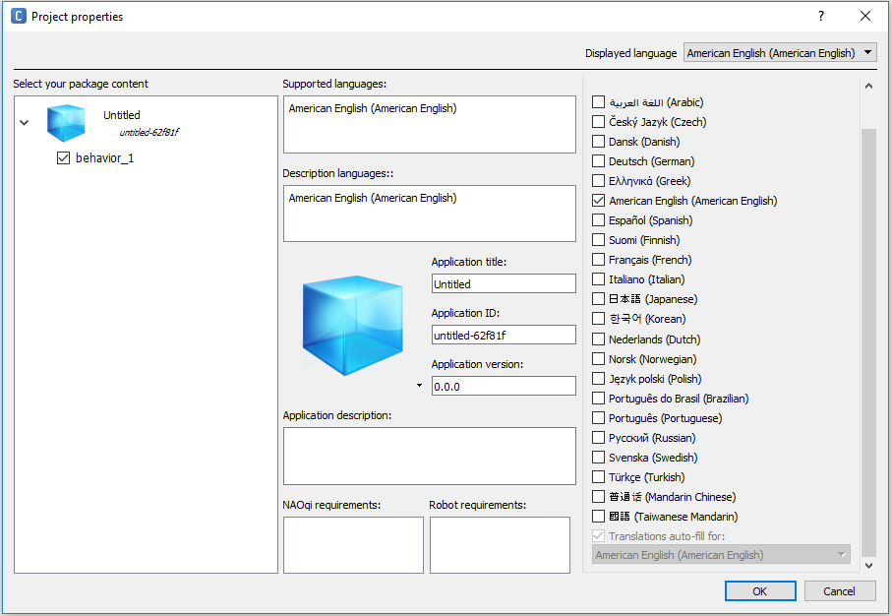

Figure 2 - Project Properties

Fill in the application title section so that when you put your module on the robot you will know which module it is. Next click on behavior_1, under the blue rectangle in the “Select your package component” section in the window shown in figure 2.

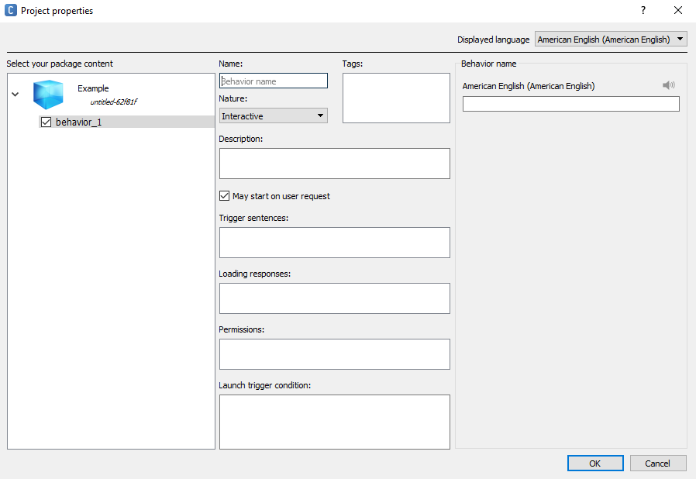

Fill out the sections shown in figure 3 after clicking behavior_1:

* **Name:** make sure the name is self-documenting (name is relevant to what the module does a good example for hello world would be “hello”, a bad example would be “module 1”
* **Description**: This documentation will let future users know what your module is supposed to do, and why
* **Nature**: Nature has three settings: Interactive, Solitary, and No Nature. Make sure the Nature is set to Interactive. This means that a user can trigger the module with trigger sentences while NAO’s autonomous life is on. Solitary means that NAO will perform the module when he is not being interacted with, and can be interrupted at any time with Interactive modules. There is no description for No Nature, so It is best not To use.
* **Trigger sentences:** trigger sentences are what the robot listens for to perform the module. Make sure they are unique, so they don’t share a phrase with another module that is already on the robot. It is also good to make a couple trigger phrases so that the module can be more general   
  (Example: for an arm raising module, instead of just saying “lift arm” also put “lift YOUR arm”, “Can your lift your arm” and “lift your arm please.
* **Loading responses:** loading responses are supposed to be what NAO says after you say the trigger phrase, and before the module is performed. In AriGato’s experience, these loading responses do not work, and the robot only uses the default phrases “okay” and “let’s go.”

## 3.4 integrating your module onto nao

# SECTION 4: HELP

## 4.1 general faqs

## 4.2 troubleshooting

1. http://doc.aldebaran.com/2-1/nao/basic_channel_conversation.html