

Requirement & Design Specification

**Global Assess Management System (GAMS)**

**Version: 1.0**

– Hanoi, August 2022 –

# Record of Changes

| **Version** | **Date** | **A* M, D** | **In charge** | **Change Description** |
| --- | --- | --- | --- | --- |
| V1.0 | 16/5 | A | tungtnhe140085, hiepcvhe180139, manhndthe181128, hieunvhe182603, quangddhe191228 | Add context diagram |
| V1.0 | 17/5 | A | tungtnhe140085, hiepcvhe180139, manhndthe181128, hieunvhe182603, quangddhe191228 | Add Actors |
| V1.0 | 20/5 | A | tungtnhe140085, hiepcvhe180139, manhndthe181128, hieunvhe182603, quangddhe191228 | Add UC |
| V1.0 | 21/5 | A | tungtnhe140085, hiepcvhe180139, manhndthe181128, hieunvhe182603, quangddhe191228 | Add description for UC |
| V1.0 | 27/5 | A | tungtnhe140085, hiepcvhe180139, manhndthe181128, hieunvhe182603, quangddhe191228 | Add database design |
|  |  |  |  |  |
|  |  |  |  |  |
|  |  |  |  |  |
|  |  |  |  |  |
|  |  |  |  |  |
|  |  |  |  |  |
|  |  |  |  |  |

Contents

Record of Changes 2

I. Overview 4

1. System Context 4

2. User Requirements 4

2.1 Actors 4

2.2 Diagrams 5

2.3 Descriptions 6

3. System Functionalities 6

3.1 Screens Flow 6

3.2 Screen Authorization 6

3.3 Non-UI Functions 7

II. Functional Requirements 8

1. Feature Name1 8

1.1 SubFeature Name1.1 8

1.2 SubFeature Name1.2 8

2. User Authentication 8

2.1 User Register 8

2.2 User Login 8

2.3 Password Reset 8

2.4 User Profile 8

3. System Administration 9

3.1 Master Data 9

3.2 User Management 10

III. System Design 10

1. Database Design 10

1.1 Database Schema 10

1.2 Table Descriptions 10

2. Code Packages 11

2.1 Package Diagram 11

2.2 Package Descriptions 11

# **I. Overview**

## 1. System Context

*The* ***Technical Store*** *is a web-based commerce system designed to provide customers with an online platform for browsing, configuring, and purchasing computer components, pre-built PCs, and full custom PC build services. The system replaces traditional offline sales models with a centralized, automated solution that supports real-time inventory updates, secure online payments, and integrated shipping services.*

*Note: Add Employee, remove notification, Shipping (shipper riêng của shop), change Supplier , add AI suggestion for building comp*

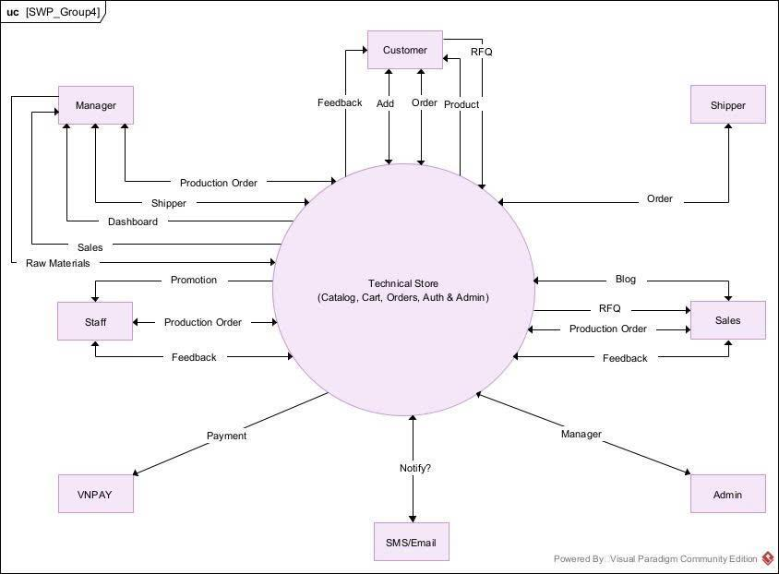

## 2. User Requirements

### 2.1 Actors

| **#** | **Actor** | **Description** |
| --- | --- | --- |
| **1** | **Customer** | **End-user who browses, adds items, places orders, and provides feedback.** |
| **2** | **Manager** | **Oversees product catalog, shipping assignments, dashboard insights, and tasks.** |
| **3** | **Staff** | **Handles promotions, processes orders, and manages customer feedback.** |
| **4** | **Shipper** | **External delivery entity that fulfills and updates shipping requests.** |
| **5** | **Marketing** | **Creates and manages blog content and marketing campaigns, monitors engagement.** |
| **6** | **Admin** | **Manages high-level administrative roles, permissions, and overall system control.** |
| **7** | **VNPay** | **External payment gateway that handles transactions securely.** |
| **8** | **SMS/Email** | **Sends notifications (e.g., order updates, marketing emails) to users.** |

### 2.2 Diagrams

*[A use case (UC) describes a sequence of interactions between a system and an external actor that results in the actor being able to achieve some outcome of value. The names of use cases are always written in the form of a verb followed by an object. Select strong, descriptive names to make it evident from the name that the use case will deliver something valuable for some user.*

*Following are some questions you might ask to help user representatives identify use cases*

* *What will the actor use the system for?*
* *Will the actor create, store, change, remove, or read data in the system?*
* *Will the actor need to inform the system about external events or changes?*
* *Will the actor need to be informed about certain occurrences in the system?*

*In this section, you need to provide the UC diagram(s) to show the actor-UCs and UC-UC relationships like the sample below. You can have multiple UC diagrams for the system, each diagram is for one actor or one workflow]*

2.2.1. UC’s for Customers

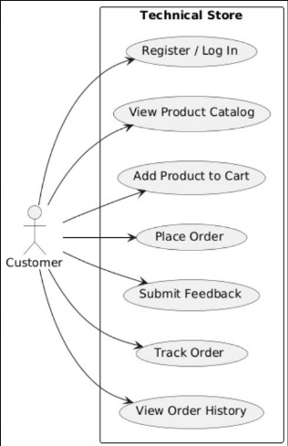

2.2.2 UC’s for Manager

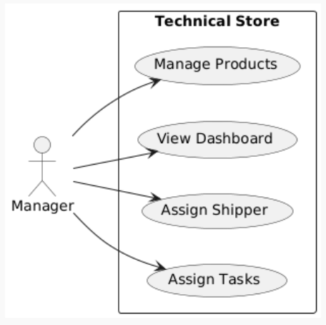

2.2.3 UC’s for Staff

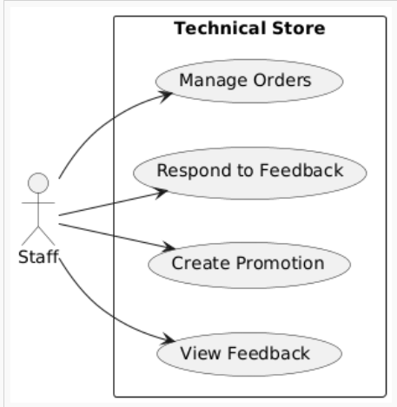

2.2.5 UC’s for Marketing  
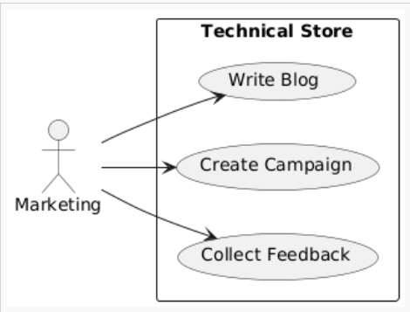

2.2.6 UC’s for Admin  
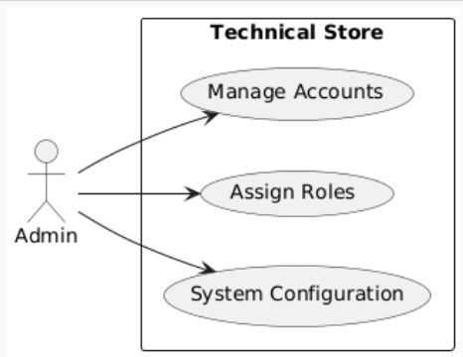

2.2.7 UC’s for Shipper  
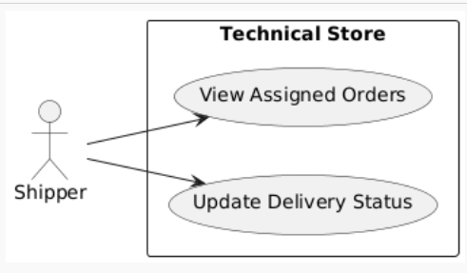

### 2.3 Descriptions

*[This part describes the use cases, you can follow the table form as below]*

| ID | Use Case | Actor(s) | Use Case Description |
| --- | --- | --- | --- |
| xx | [Use Case Name] | Actor List | [Brief description for each UC in the form of “As a <type of user>, I want <some goal> so that <some reasons>” or in other form that we can have overall understanding of the UC] |
| 01 | Sign Up | Guest | As a Guest, I want to sign up so that I can create an account and access full features. |
| 02 | Login | Customer / Staff / Manager / Admin | As a user, I want to log into the system so that I can access my personal features. |
| 03 | Browse Products | Guest / Customer | As a visitor, I want to browse products so that I can view what's available before purchasing. |
| 04 | Add to Cart | Customer | As a Customer, I want to add products to my cart so that I can purchase them later. |
| 05 | Place Order | Customer | As a Customer, I want to place an order so that I can buy the products I selected. |
| 06 | Make Payment | Customer | As a Customer, I want to make a payment so that I can complete my purchase. |
| 07 | Manage Products | Manager | As a Manager, I want to manage products so that I can keep the catalog updated. |
| 08 | Process Orders | Staff | As a Staff, I want to process orders so that customer orders can be fulfilled. |
| 09 | Update Delivery Status | Shipper | As a Shipper, I want to update the delivery status so that customers are informed. |
| 10 | Give Feedback | Customer | As a Customer, I want to give feedback so that I can share my experience with others. |
| 11 | Create Promotion | Manager | As a Manager, I want to create promotions so that we can attract more customers. |
| 12 | Assign Promotion | Manager | As a Manager, I want to assign promotions to products so that discounts apply appropriately. |
| 13 | Run Campaign | Marketing | As a Marketing staff, I want to run campaigns so that we can boost sales. |
| 14 | Manage Permissions | Admin | As an Admin, I want to manage user permissions so that roles are securely assigned. |

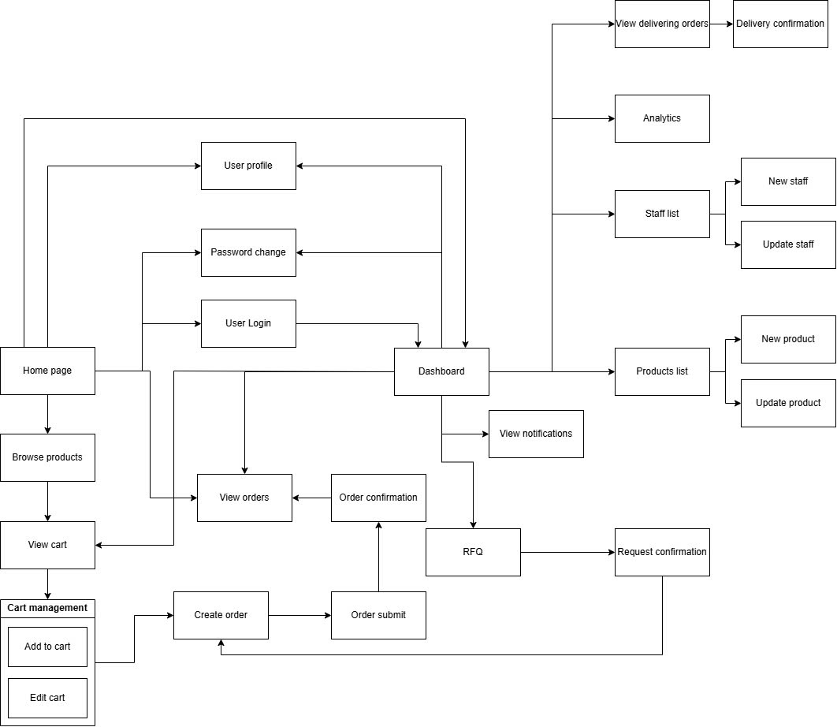

### 3.2 Screen Authorization

*[Provide the system roles authorization to the system features (down to screens, and event to the screen activities if applicable) in the table form as below – replace Role-Name1, Role-Name2,… with your specific system user role names]*

| **Screen** | **Role-Name1** | **Role-Name2** | **Role-Name3** | **…** |
| --- | --- | --- | --- | --- |
| <<Screen Name1>> | X |  | X | X |
| <<Screen Activity>> |  |  | X | X |
| <<Screen Name2>> | X |  | X |  |
| Query All Data | X |  |  |  |
| Query Own Data |  |  | X |  |
| Add New Data |  |  | X | X |
| Update All Data |  |  |  | X |
| Update Own Data |  |  |  | X |
| Delete Data |  |  |  |  |
| … |  |  |  |  |

### 3.3 Non-UI Functions

*[Provide the descriptions for the non-screen system functions, i.e batch/cron job, service, API, etc.]*

| **#** | **Feature** | **System Function** | **Description** |
| --- | --- | --- | --- |
| 1 | <<Feature Name>> | <<Function Name1>> | <<Function Name1 Description>> |
| 2 | … |  |  |

II. Functional Requirements

*[Provide descriptions about the system’s functions/screens. The functions/screens are grouped by the system features, and even sub-features if needed. For the screens, you need to provide the screen layouts (mock-up screens) and relevant specifications if needed]*

## 1. Feature Name1

### 1.1 SubFeature Name1.1

#### 1.1.1 Screen/Function Name1

*[Content #1: UI layout (Mockup screen prototype)]*

*[Content #2: brief descriptions of the screen/function, mapped to the relevant use cases]*

*[Content #3: provide further descriptions for the screen’s components/fields using table format below]*

| **Field Name** | **Description** |
| --- | --- |
| Field Name1 | Field description: data type min/max length or value, initial data, etc. |
| Field Name2 | … |
| ***Field Group-Name1*** | |
| Field Name3 | … |
| Field Name4 | … |
| ***Field Group-Name2*** | |
| … | … |

#### 1.1.2 Screen/Function Name2

…

### 1.2 SubFeature Name1.2

…

## 2. User Authentication

### 2.1 User Register

…

### 2.2 User Login

…

### 2.3 Password Reset

…

### 2.4 User Profile

…

## 3. System Administration

### 3.1 Master Data

#### 3.1.1 Setting List

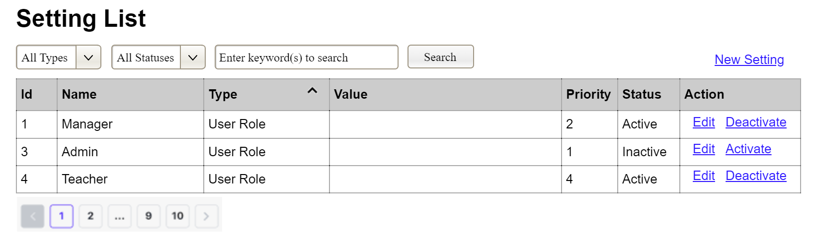

This screen allows the Administrator to:

* View Setting List: view list of current master data.
* Filter Setting List: filter master data by data types, statuses
* Search Settings: enter keyword(s) to search master data by their names or values
* Sort Setting List: sort mater data list (ascending, descending) by clicking column headers

On the screen, s/he can also

* Activate/Deactivate Setting: change status of a specific inactive/active master data
* Choose to go to the Setting Details screens for adding new or updating an existing master data by clicking the New Setting or Edit link.

**Field Description**

| **Field Name** | **Description** |
| --- | --- |
| (1) | Initial values: all the active setting names with null or blank type  Hover the mouse to show the field name: “Setting Type” |
| (2) | Initial values: All Statuses, Active, Inactive (default value “All Status”)  Hover the mouse to show the field name: “Setting Status” |
| (3) | The change-status action is Activate or Deactivate depending on the current status of the relevant setting (Inactive or Active, respectively). |

#### 3.1.2 Setting Details

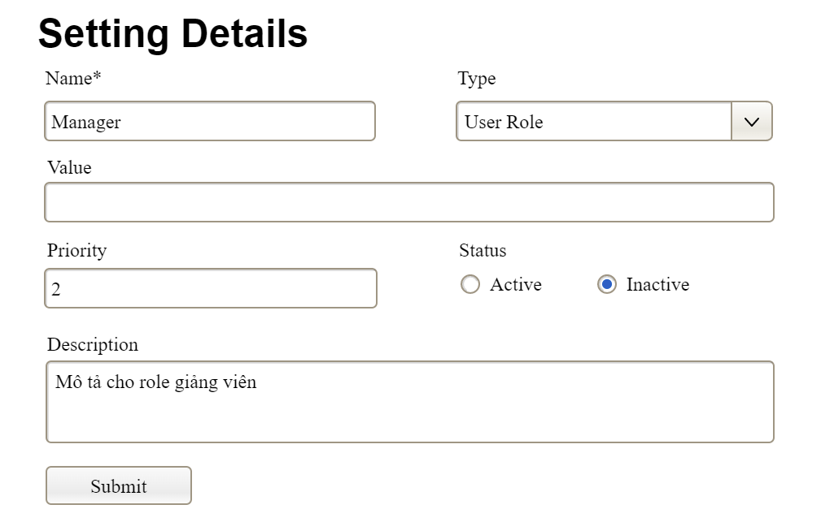

This screen allows the Administrator to:

* Add New Setting: add new master data.
* Update Setting Details: update details of a specific master data

**Field Description**

| **Field Name** | **Description** |
| --- | --- |
| Name | Data type: non-digit string, max length of 20 characters |
| Type | Initial data values: all active setting names (with null or blank type) |
| Value | Data type: any string, max length of 100 characters |
| Priority | Data type: a positive integer |
| Description | Data type: any string, max length of 200 characters |

### 3.2 User Management

#### 3.2.1 User List

…

#### 3.2.2 User Details

…

# 

# 

# 

# 

# 

# 

# 

# 

# 

# 

# 

# 

# III. System Design

## 1. Database Design

*[Provide the tables relationship like example below]*

### 1.1 Database Schema

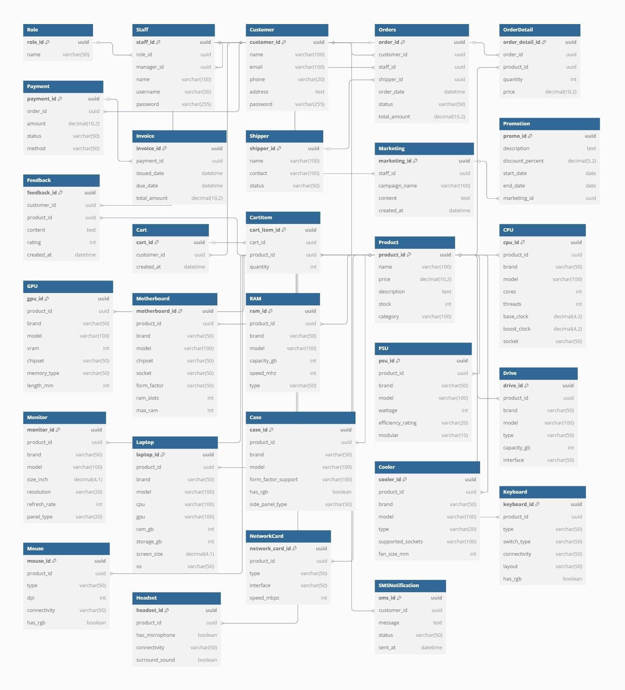

### 1.2 Table Descriptions

| **No** | **Table** | **Description** |
| --- | --- | --- |
| *01* | *<Table name>* | *<Description of the table>*  *- Primary keys: <<list of primary key fields>>*  *- Foreign keys: <<list of foreign key fields>>*  *- Unique keys:<<list of unique field or unique field set>>* |
| *02* | *<Table name2>* | *…* |

## 2. Code Packages

*[Provide the package diagram for the system (or sub systems) and package description similar to sample diagram and using description table format below]*

### 2.1 Package Diagram

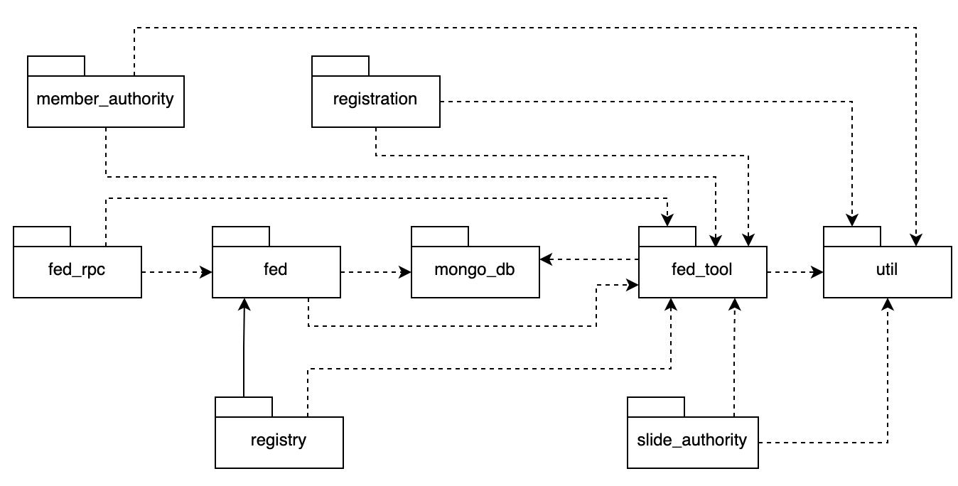

### 2.2 Package Descriptions

| **No** | **Package** | **Description** |
| --- | --- | --- |
| *01* | *member_authority* | *<Description of the package: purpose, contents,..>* |
| *02* | *registration* | *<Description of the package: purpose, contents,..>* |
| *03* | *…* |  |