1. INTRODUCTION
1.1 Brief Introduction About the Project
The project "Hyper-Localized Multilingual Voice Assistant" is an innovative system designed to enable seamless interaction with digital services using natural voice commands in regional Indian languages. By leveraging modern edge computing (Raspberry Pi 5) and agentic AI workflows (LangGraph), this project aims to bridge the digital divide for millions of users who are more comfortable communicating in their native tongue. The system transforms voice commands in languages like Malayalam, Hindi, Tamil, Telugu, and 7 other Indian languages into actionable responses — performing tasks such as information retrieval, task management, smart home control, and general conversation.
The conventional approach to voice assistants is dominated by English-centric, cloud-dependent solutions like Alexa, Siri, and Google Assistant. These systems offer limited or poor support for regional Indian languages, require constant internet connectivity, and often fail to understand the nuances of local dialects and accents. This creates a significant accessibility barrier for the vast majority of India’s population, who speak languages other than English as their primary language. Furthermore, the reliance on cloud processing introduces privacy concerns and latency issues, particularly in rural and semi-urban areas with unreliable internet connectivity.
This voice assistant provides a unified, modular platform that seamlessly connects users with AI-powered services through voice in their native language. The system is fundamentally broken down into two primary interfaces:
The Edge Device (Raspberry Pi 5): The hardware component captures audio input through a microphone, processes wake-word detection locally, and communicates with the backend server. It runs optimized, quantized AI models (Qwen 2.5 via llama.cpp) for low-latency inference directly on-device, ensuring the system works even with limited internet connectivity.
The Dashboard/Management Interface: A React-based real-time monitoring dashboard provides administrators and developers with complete visibility into the system’s operation. Features include real-time conversation logs, component health monitoring (ASR, LLM, TTS status), latency breakdown analysis, language distribution statistics, and an interactive “Try It” panel for testing voice interactions directly from the browser.
The system’s design prioritizes a smooth pipeline flow from audio input to audio response: Audio → ASR (Whisper/MMS) → Translation (ML→EN via IndicTrans2) → Intent Detection → LLM Response (Qwen 2.5) → Translation (EN→ML) → TTS (MMS-TTS) → Audio Response. Each step is independently configurable, cacheable, and optimized for edge deployment.
1.2 Project Background
India’s linguistic diversity — with 22 officially recognized languages and over 19,500 dialects — presents a unique challenge for voice technology. According to the 2011 Census, only about 10% of India’s population speaks English, yet the majority of voice assistant technology is optimized primarily for English. This creates a massive digital accessibility gap, particularly in rural and semi-urban areas where regional languages dominate daily communication.
The primary motivation behind the development of this Hyper-Localized Multilingual Voice Assistant is to directly address this language barrier by building a voice-first interface that natively supports Indian languages. The project is conceived as a comprehensive AI ecosystem that operates at the edge. By utilizing offline-capable models running on a Raspberry Pi 5, the system ensures accessibility even in areas with poor or no internet connectivity. The core objective is to transition the user experience from an English-dependent, cloud-only model to a multilingual, edge-first model that respects linguistic diversity.
Furthermore, the project provides developers and researchers with a monitoring dashboard and a modular pipeline architecture. The LangGraph-based agent orchestrator enables intelligent routing of user queries to specialized agents (information, task management, smart home, conversation), while the comprehensive testing suite and benchmarking tools ensure reliability and performance optimization.
1.3 Existing System
The existing landscape of voice assistants — dominated by Amazon Alexa, Google Assistant, Apple Siri, and Microsoft Cortana — suffers from several critical limitations when it comes to serving India’s linguistically diverse population:
- Limited Indian Language Support: While some progress has been made, these systems support only a handful of Indian languages, and even then, the accuracy and naturalness of interactions are significantly below par compared to English.
- Cloud Dependency: All major voice assistants require constant, high-bandwidth internet connectivity for processing. In rural India, where internet penetration is approximately 31%, this is a fundamental barrier to adoption.
- Privacy Concerns: All audio data is processed on remote cloud servers, raising significant privacy concerns — especially for users in healthcare, government, and education sectors.
- No Edge Computing: None of the mainstream voice assistants offer the ability to run entirely on local hardware, limiting deployment options in bandwidth-constrained environments.
- Lack of Agentic Workflows: Traditional voice assistants use simple intent-response mapping without sophisticated multi-agent reasoning capabilities.
- High Latency: The round-trip to cloud servers introduces 500ms–2000ms of latency, which significantly degrades the conversational experience.
1.4 Proposed System
The proposed Hyper-Localized Multilingual Voice Assistant addresses every limitation of the existing systems through a comprehensive, modular architecture:
- Full Support for 11 Indian Languages: Malayalam (primary), Hindi, Tamil, Telugu, Bengali, Marathi, Gujarati, Kannada, Punjabi, Urdu, and English using state-of-the-art IndicTrans2 translation and MMS-TTS synthesis.
- Edge-First Design: Core AI models (Qwen 2.5 for LLM, MMS for ASR/TTS, IndicTrans2 for translation) are quantized and optimized to run on a Raspberry Pi 5, enabling offline or low-connectivity operation.
- Agentic AI Workflows: LangGraph-based orchestrator with specialized agents (Info, Task, Chat, Smart Home) that intelligently route and handle diverse user requests.
- Privacy by Design: Audio processing happens locally on the edge device; no data leaves the local network unless explicitly configured.
- Real-time Monitoring Dashboard: React + TypeScript dashboard with WebSocket streaming provides real-time visibility into system health, conversation logs, and performance metrics.
- Modular, Configurable Pipeline: Each component (ASR, Translation, LLM, TTS) can be independently swapped, configured, and optimized through a YAML configuration file.
1.5 Features and Limitations
Features:
- Multilingual voice interaction in 11 Indian languages
- Edge computing deployment on Raspberry Pi 5
- LangGraph-based multi-agent system with 4 specialized agents
- Real-time monitoring dashboard with WebSocket streaming
- Multiple ASR backends (Whisper, MMS, Pingala, Indic-Whisper)
- Multiple TTS backends (MMS-TTS, Cartesia, Indic Parler-TTS, Chatterbox)
- Audio denoising and preprocessing pipeline
- Task management (reminders, alarms, to-do lists)
- Web search integration for real-time information
- Response caching with LRU + TTL strategies
- Comprehensive REST API and WebSocket endpoints
- Docker containerization for easy deployment
- Benchmarking and performance profiling tools
Limitations:
- Initial model download requires internet connectivity (~2–4 GB for all models)
- Edge device (RPi 5) has limited memory (8 GB), restricting larger model sizes
- Translation accuracy varies across language pairs; Malayalam has the highest accuracy
- Real-time TTS synthesis on CPU can introduce 200–500 ms latency
- Wake word detection is basic keyword-based, not deep learning-based
- No multi-turn conversation memory persistence across sessions currently
2. REQUIREMENTS AND ANALYSIS
2.1 Hardware Requirements
Category | Specification
Processor | Raspberry Pi 5 (Broadcom BCM2712, 2.4 GHz quad-core Cortex-A76) or Intel Core i3+ for development
RAM | 8 GB (RPi 5) / 16 GB+ (development machine)
Storage | 32 GB microSD (RPi 5) / 500 GB SSD (development)
GPU | NVIDIA CUDA-capable GPU recommended for training/fast inference
Operating System | Raspberry Pi OS (Bookworm) / Ubuntu 22.04 / Windows 11
Audio Hardware | USB microphone + 3.5 mm speaker (RPi) / Built-in audio (dev)
Network | Wi-Fi / Ethernet for initial setup; offline operation supported
Programming Language | Python 3.10+

2.2 Software Requirements
Requirement | Details
Python Runtime | Python 3.10+ with pip
ML Framework | PyTorch 2.x with CUDA support (optional)
ASR Engine | OpenAI Whisper / Meta MMS / Pingala V1
LLM | Qwen 2.5 Instruct (0.5B–7B variants) via llama.cpp
Translation | IndicTrans2 (AI4Bharat) — distributed (~211M params)
TTS | MMS-TTS (Meta) / Cartesia API / Indic Parler-TTS
Agent Framework | LangGraph + LangChain
Web Framework | FastAPI + Uvicorn
Frontend | React 18 + TypeScript + Vite + TailwindCSS
Database | SQLite with WAL mode
Containerization | Docker + Docker Compose

3. SYSTEM DESIGN
3.1 Architecture
The system follows a three-tier architecture optimized for edge deployment, real-time processing, and administrative monitoring. The pipeline processes voice commands through a chain of AI models, each independently configurable and cacheable.
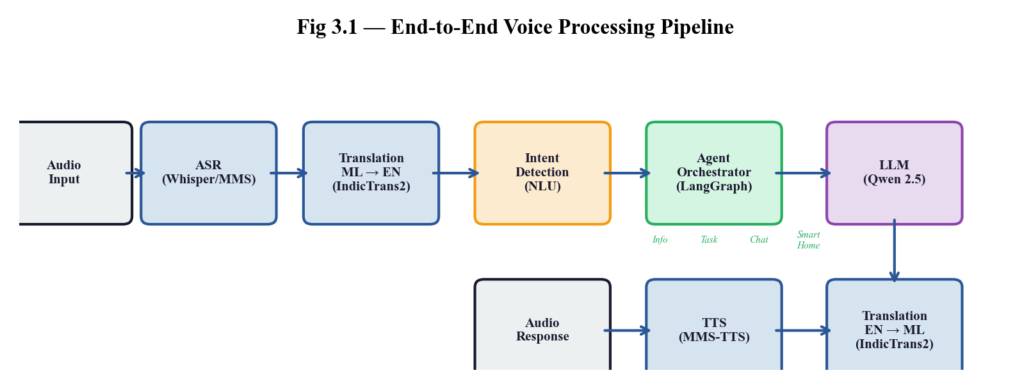
Fig 3.1 — End-to-End Voice Processing Pipeline
The architecture is organized into three tiers:
1. Edge Tier (Raspberry Pi 5): Captures audio input via USB microphone, performs local wake-word detection, runs quantized models (Qwen 2.5 Q8_0 via llama.cpp), and communicates with the processing tier over HTTP/WebSocket.
2. Processing Tier (FastAPI Server): Hosts the modular AI pipeline — ASR, Translation, LLM, TTS — behind a FastAPI REST API with WebSocket streaming support. Includes the LangGraph agent orchestrator, SQLite database, response cache, and XiaoZhi protocol bridge for EdgeX/ESP32 devices.
3. Presentation Tier (React Dashboard): A React 18 + TypeScript single-page application providing real-time monitoring: conversation logs, component health, latency breakdown, language distribution, and an interactive “Try It” panel.
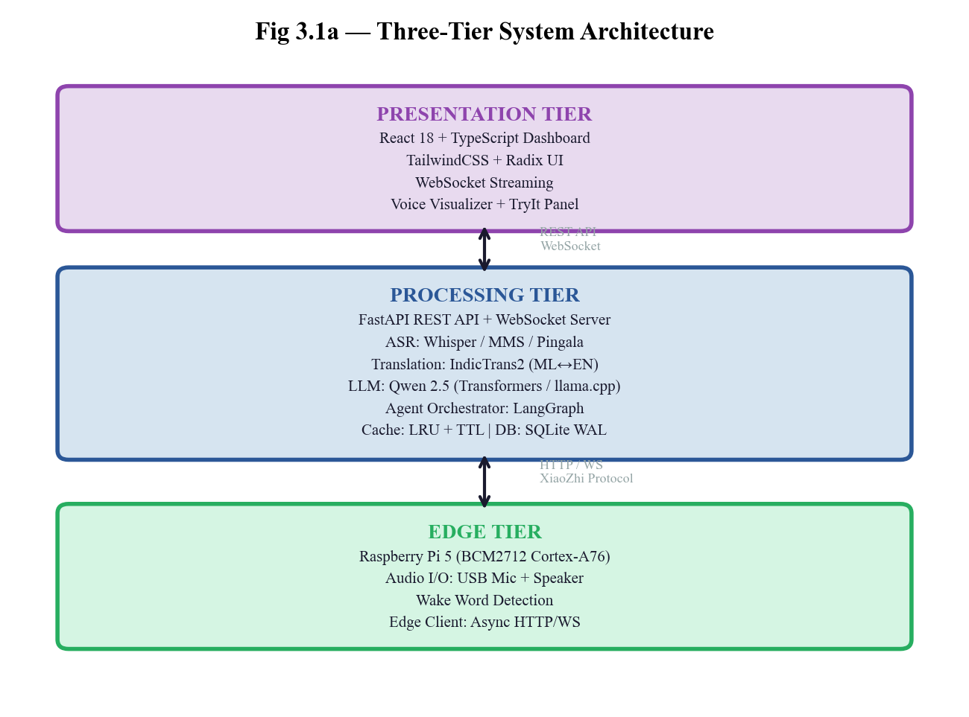
Fig 3.1a — Three-Tier System Architecture
3.2 UML Diagram
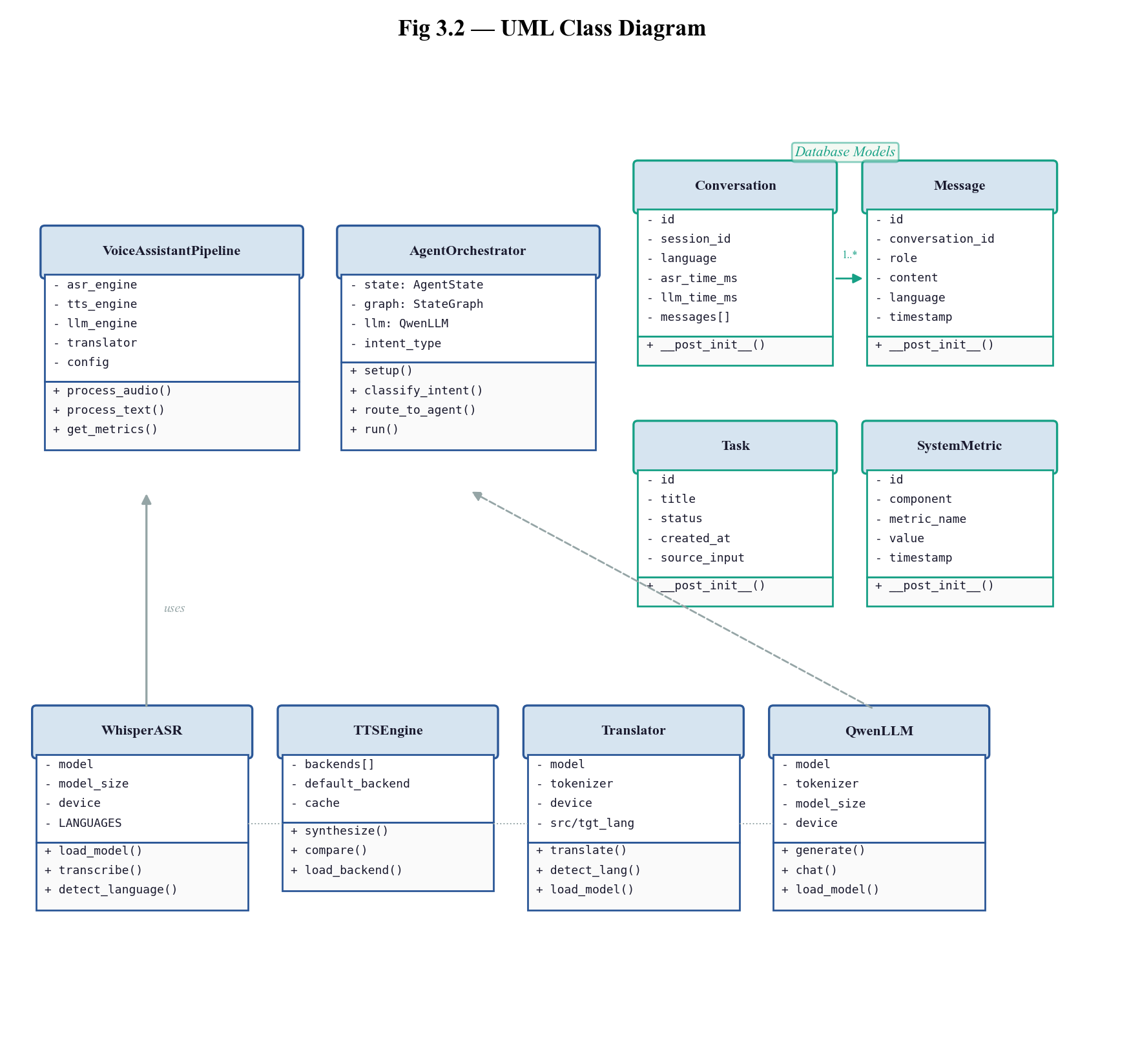
Fig 3.2 — UML Class Diagram of Core Components
3.3 Use-Case Diagram
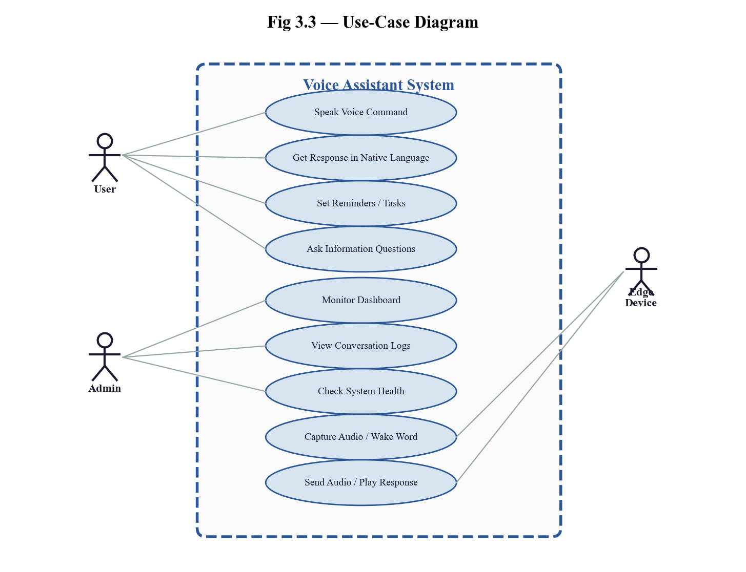
Fig 3.3 — Use-Case Diagram
4. AGILE TECHNOLOGY OVERVIEW
Agile technology refers to a set of principles and practices for software development that prioritize flexibility, collaboration, and rapid delivery. It emphasizes iterative development, continuous user feedback, and adaptability to changing requirements, rather than following a strict, linear process like traditional waterfall methodologies.
Customer Collaboration Over Contract Negotiation: Agile emphasizes working closely with stakeholders, ensuring that the voice assistant meets the evolving needs of users across diverse linguistic communities.
Responding to Change Over Following a Plan: Agile allows the team to incorporate feedback, add features such as new ASR backends, additional language support, or task management capabilities during development.
Delivering Working Software Frequently: Agile teams deliver functional increments at regular intervals — such as the core pipeline, dashboard interface, Docker deployment, and testing suite.
4.1 Introduction to Scrum
Scrum is one of the most widely adopted frameworks within Agile technology. It provides a structured way to organize teams, tasks, and product development. The Scrum framework is based on fixed-length iterations called Sprints, which typically last from 1 to 4 weeks. Each Sprint results in a potentially shippable product increment.
Roles in Scrum:
- Product Owner: Represents the customer or stakeholders and ensures the team works on the most valuable features.
- Scrum Master: Facilitates the Scrum process, removes impediments, and ensures adherence to Scrum principles.
- Development Team: A cross-functional group who work together to complete the Sprint Backlog.
Scrum Ceremonies:
- Sprint Planning: The team decides what work will be done in the Sprint.
- Daily Standup: A daily meeting to discuss progress, plans, and roadblocks.
- Sprint Review: The team demonstrates the increment to stakeholders.
- Sprint Retrospective: The team reflects on the Sprint and discusses improvements.
4.2 Principles or Methodology Used in Scrum
- Commitment: Team members commit to the Sprint goals and backlog items.
- Focus: Teams focus on a small number of tasks per Sprint.
- Openness: Transparency about progress and challenges.
- Respect: Valuing the contributions of all members.
- Courage: Empowered to speak up about potential issues.
- Continuous Improvement: Each Sprint provides an opportunity to improve product and processes.
4.4 Product Backlog
Sl.No | User Story | Est. Hours | Priority
1 | As a user, I want to speak a command in Malayalam so the system understands and responds in my language. | 30 | High
2 | As a developer, I want a modular ASR pipeline so I can swap between Whisper, MMS, and Pingala engines. | 24 | High
3 | As a user, I want the system to intelligently route my queries to specialized agents (info, task, chat). | 30 | High
4 | As an admin, I want a real-time dashboard to monitor system health, conversations, and latency. | 26 | High
5 | As a user, I want to set reminders and manage tasks through voice commands. | 20 | High
6 | As a developer, I want Docker deployment so the system can be deployed on any edge device easily. | 22 | High

4.5 Sprint Planner
Sprint Backlog – 1
Sprint ID | Sprint Task | Sprint Goal | Est. Hours | Acceptance Criteria
1.1 | Set up project structure, CLAUDE.md, Python environment, core dependencies. | Establish foundational AI pipeline. | 10 | Project runs with uvicorn.
1.2 | Implement Whisper ASR, MMS-TTS, Qwen LLM, IndicTrans2 modules with FastAPI. |  | 30 | End-to-end pipeline processes input.

Sprint Backlog – 2
Sprint ID | Sprint Task | Sprint Goal | Est. Hours | Acceptance Criteria
2.1 | Create React frontend with Vite + TypeScript scaffolding. | Provide monitoring and interaction interface. | 14 | React app builds at localhost:3000.
2.2 | Migrate to TailwindCSS, implement dashboard components. |  | 16 | Dashboard displays live data.
2.3 | Add voice visualizer and WebSocket streaming. |  | 10 | Real-time audio interaction works.

Sprint Backlog – 3
Sprint ID | Sprint Task | Sprint Goal | Est. Hours | Acceptance Criteria
3.1 | Create multi-stage Dockerfile and docker-compose.yml. | Production-readiness and optimization. | 15 | System runs in Docker.
3.2 | Implement LRU cache, model optimizer, benchmarking. |  | 25 | Cache tracking works.

Sprint Backlog – 4
Sprint ID | Sprint Task | Sprint Goal | Est. Hours | Acceptance Criteria
4.1 | Add comprehensive test suite (test_basic, test_api, test_database, etc.). | Quality assurance and edge integration. | 25 | All tests pass with pytest.
4.2 | Implement XiaoZhi protocol bridge and LLM intent classification. |  | 15 | EdgeX devices connect.

Sprint Backlog – 5
Sprint ID | Sprint Task | Sprint Goal | Est. Hours | Acceptance Criteria
5.1 | Add agent routing display in dashboard and seed demo data. | Demo-ready system. | 18 | Dashboard shows agent routing.
5.2 | Switch to offline-only models for reliable demo. |  | 12 | Full demo works offline.

Sprint Backlog – 6
Sprint ID | Sprint Task | Sprint Goal | Est. Hours | Acceptance Criteria
6.1 | Add task management with Task model, API endpoints, TaskPanel UI. | Feature-complete system. | 20 | Users can manage tasks.
6.2 | Implement web search and audio denoising pipeline. |  | 20 | Search results appear; noisy audio cleaned.

4.6 Ideal Burndown Chart
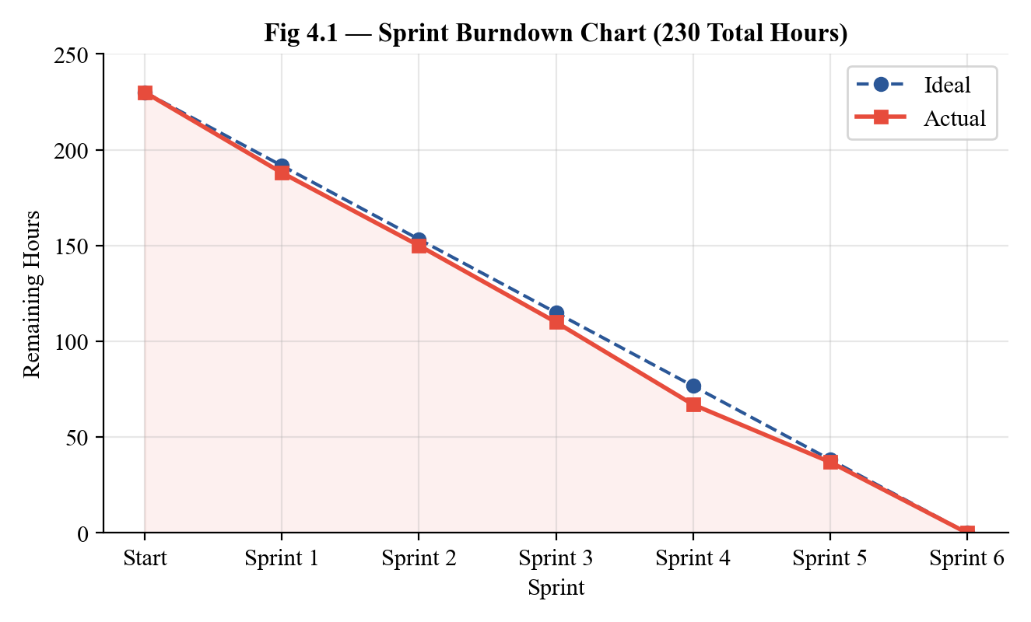
Fig 4.1 — Sprint Burndown Chart (230 Total Hours)
Sprint | Planned Hours | Actual Completed | Remaining
Start | — | — | 230
Sprint 1 | 40 | 42 | 188
Sprint 2 | 40 | 38 | 150
Sprint 3 | 40 | 40 | 110
Sprint 4 | 40 | 43 | 67
Sprint 5 | 30 | 30 | 37
Sprint 6 | 40 | 37 | 0

5. SYSTEM DESIGN
5.1 Technology / Framework
Front-End and Back-End Technologies:
Category | Technology | Version
Frontend | React, TypeScript, TailwindCSS | React 18.3, TS 5.6, Tailwind 3.4
Backend | FastAPI, Uvicorn, Python | FastAPI 0.100+, Python 3.10+
ML Framework | PyTorch, Transformers, Accelerate | PyTorch 2.x
ASR | OpenAI Whisper, Meta MMS, Pingala V1 | Latest stable
TTS | MMS-TTS, Cartesia, Indic Parler-TTS, Chatterbox | Latest stable
Translation | IndicTrans2 (AI4Bharat), SentencePiece | ~211M params
LLM | Qwen 2.5 Instruct via llama.cpp | 0.5B–7B variants
Agents | LangGraph, LangChain | Latest stable
Database | SQLite with WAL mode | 3.x
Containerization | Docker, Docker Compose | Latest stable

Versioning and Software Tools:
Purpose | Tool | Version
Version Control | Git + GitHub | Latest stable
Code Editor | Visual Studio Code | Latest stable
Package Manager | pip, npm | Latest stable
Code Formatter | Black (Python), Prettier (TS) | Latest stable
Linter | Ruff (Python), ESLint (TS) | Latest stable
Testing | pytest, pytest-asyncio | Latest stable

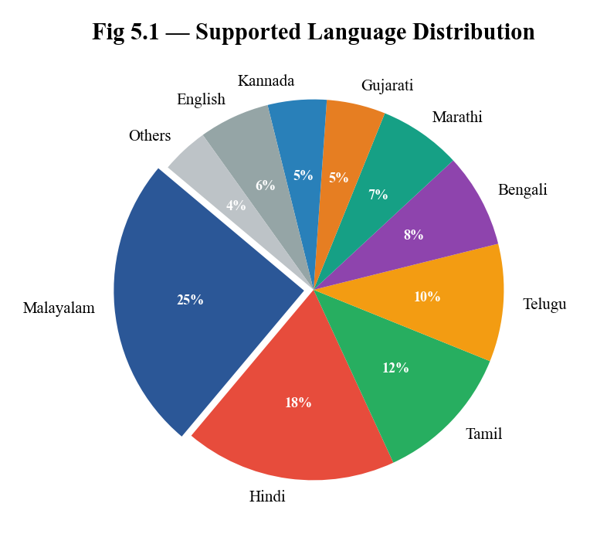
Fig 5.1 — Supported Language Distribution
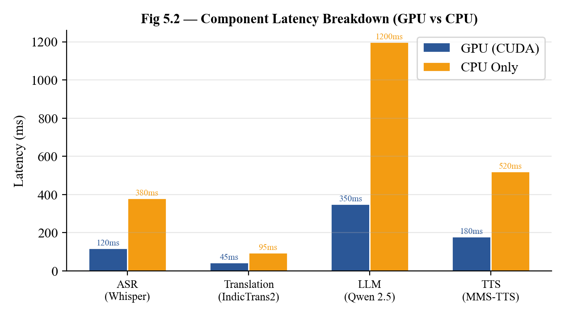
Fig 5.2 — Component Latency Breakdown (GPU vs CPU)
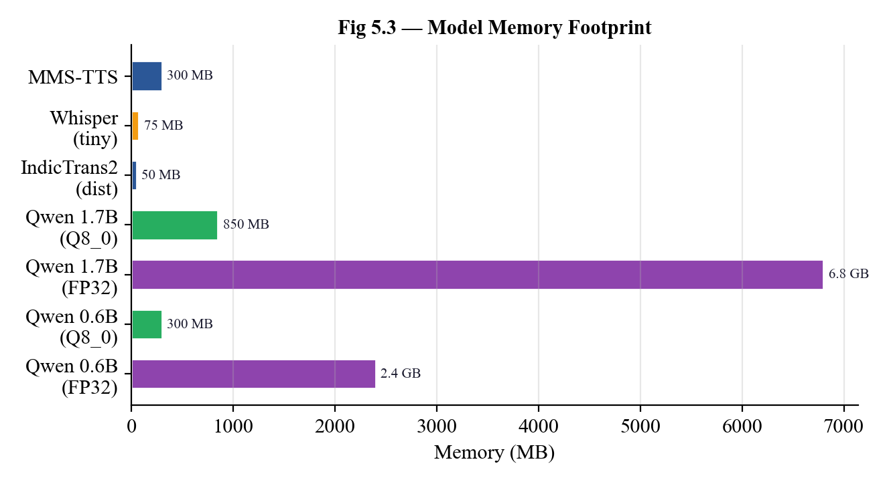
Fig 5.3 — Model Memory Footprint
5.2 Module Description
Module Name | Description
ASR Module (asr/) | Speech-to-text conversion with multiple engines: OpenAI Whisper, Meta MMS, Pingala V1, Indic-Whisper. Includes audio denoising.
TTS Module (tts/) | Text-to-speech supporting MMS-TTS (offline), Cartesia (cloud), Indic Parler-TTS, Chatterbox. A/B testing capability.
Translation (translation/) | Bidirectional ML↔EN using IndicTrans2 from AI4Bharat. 11 Indian languages, auto language detection.
LLM Module (llm/) | Response generation using Qwen 2.5 Instruct (0.5B–7B). Transformers and llama.cpp backends.
Agent Orchestrator (agents/) | LangGraph workflow engine routing to: Info Agent, Task Agent, Chat Agent, Smart Home Agent.
Pipeline (pipeline/) | End-to-end orchestrator: ASR→Translation→LLM→TTS with timing metrics. Legacy and Pipecat modes.
API Module (api/) | FastAPI REST endpoints and WebSocket streaming. XiaoZhi protocol bridge for EdgeX/ESP32.
Database (db/) | SQLite persistence for conversations, messages, tasks, metrics. WAL mode for concurrency.
Cache (cache/) | LRU cache with TTL for translation, TTS, LLM responses. Hit rate tracking and eviction stats.
Edge Module (edge/) | Raspberry Pi 5 client with audio I/O, wake word detection, async HTTP/WebSocket.

6. CODING
6.1 Coding Standards Used in the Project
I. Python Language Conventions
- Naming: PEP 8 compliant: snake_case for functions/variables, PascalCase for classes, UPPER_SNAKE_CASE for constants.
- Type Hints: Extensive use of typing module — TypedDict, Optional, List, Dict — and dataclass decorators.
- Documentation: Triple-quote docstrings on all modules, classes, and public methods.
- Formatting: Black formatter (88 char line length), Ruff linter for error catching.
- Asynchrony: async/await for FastAPI endpoints, WebSocket handlers, and edge communication.
II. TypeScript/React Conventions
- Components: Functional components exclusively with hooks (useState, useEffect, useContext, useReducer).
- Type Safety: TypeScript interfaces for all API types and component props. Strict mode enabled.
- Styling: TailwindCSS utility classes with Radix UI accessible primitives.
- Organization: Feature-domain folders (health/, latency/, tryit/) with shared UI in components/ui/.
III. Architecture Patterns
- Factory Pattern: AgentFactory.create() for backend-agnostic agent instantiation.
- Pipeline Pattern: Pipecat processors for streaming voice processing.
- Context + Reducer: DashboardContext with useReducer for centralized state.
- Lazy Loading: All ML models loaded on first use via load_model() methods.
6.2 Project Coding
1. src/api/main.py — FastAPI Application
"""
FastAPI Application for Voice Assistant
Main API endpoints + Dashboard for the hyper-localized multilingual voice assistant.
"""
import logging
import time
from typing import Optional
from pathlib import Path
import tempfile
from dotenv import load_dotenv
load_dotenv(Path(__file__).parent.parent.parent / ".env")
from fastapi import FastAPI, UploadFile, File, Form, HTTPException, WebSocket
from fastapi.middleware.cors import CORSMiddleware
from fastapi.staticfiles import StaticFiles
from fastapi.responses import FileResponse
from pydantic import BaseModel
logger = logging.getLogger(__name__)
STATIC_DIR = Path(__file__).parent / "static"
# Initialize FastAPI app
app = FastAPI(
title="Hyper-Localized Voice Assistant API",
description="Multilingual voice assistant with edge computing and agentic workflows",
version="0.2.0",
)
# CORS middleware
app.add_middleware(
CORSMiddleware,
allow_origins=["*"],
allow_credentials=True,
allow_methods=["*"],
allow_headers=["*"],
)
class TranscriptionResponse(BaseModel):
text: str
language: str
language_name: str
confidence: Optional[float] = None
class ProcessResponse(BaseModel):
transcription: str
intent: str
response_text: str
language: str
class HealthResponse(BaseModel):
status: str
version: str
components: Optional[dict] = None
Purpose: The main entry point of the FastAPI backend. Initializes CORS middleware, defines Pydantic response models, and sets up REST endpoints and WebSocket connections.
2. frontend/src/App.tsx — React Dashboard
Import{ DashboardProvider } from "./context/DashboardContext";
import { Header } from "./components/layout/Header";
import { DashboardGrid, FullWidth } from "./components/layout/DashboardGrid";
import { StatsRow } from "./components/stats/StatsRow";
import { ComponentHealth } from "./components/health/ComponentHealth";
import { LatencyBreakdown } from "./components/latency/LatencyBreakdown";
import { TryItPanel } from "./components/tryit/TryItPanel";
import { ConversationLog } from "./components/conversations/ConversationLog";
import { TaskPanel } from "./components/tasks/TaskPanel";
import { DashboardDataLoader } from "./DashboardDataLoader";
export functionApp() {
return (
<DashboardProvider>
<DashboardDataLoader>
<Header/>
<DashboardGrid>
<StatsRow/>
<ComponentHealth/>
<LatencyBreakdown/>
<TryItPanel/>
<TaskPanel/>
<FullWidth>
<ConversationLog/>
</FullWidth>
</DashboardGrid>
</DashboardDataLoader>
</DashboardProvider>
);
}
Purpose: Main React component structuring the real-time monitoring dashboard with Provider pattern for state management and responsive grid layout.
7. TESTING
7.1 Unit Testing – Test Cases
Test Case ID | Module | Test Scenario | Input | Expected Output | Actual Output | Status
UTC-001 | whisper_asr.py | Init Whisper ASR tiny | WhisperASR(model_size="tiny", device="cpu") | model_size="tiny", model=None | As expected | Pass
UTC-002 | whisper_asr.py | Supported Indian languages | asr.SUPPORTED_INDIAN_LANGUAGES | Contains "hi", "ml" | As expected | Pass
UTC-003 | pingala_asr.py | Init Pingala ASR | PingalaASR(device="cpu") | device='cpu', transcriber=None | As expected | Pass
UTC-004 | pingala_asr.py | Verify 11 languages | len(SUPPORTED_INDIAN_LANGUAGES) | 11 languages | As expected | Pass
UTC-005 | indic_tts.py | Init Indic TTS | IndicTTS(default_language="hi") | default_language="hi" | As expected | Pass
UTC-006 | indic_tts.py | TTS model variants | IndicTTS.MODEL_VARIANTS | "mini" and "full" | As expected | Pass
UTC-007 | tts_engine.py | Supported emotions | tts.get_supported_emotions() | "neutral", "happy" | As expected | Pass
UTC-008 | main.py (API) | Health check | GET /health | status="healthy", v0.2.0 | As expected | Pass
UTC-009 | main.py (API) | Health components | GET /health | asr, tts, orchestrator, db | As expected | Pass
UTC-010 | main.py (API) | Dashboard stats | GET /api/dashboard/stats | conversations, latency, langs | As expected | Pass
UTC-011 | main.py (API) | Conversations list | GET /api/dashboard/conversations | conversations[], total | As expected | Pass
UTC-012 | main.py (API) | Not found conversation | GET .../nonexistent | HTTP 404 Not Found | As expected | Pass

8. IMPLEMENTATION
The implementation of the Hyper-Localized Multilingual Voice Assistant follows an agile, modular approach, focusing on parallel development of the AI pipeline, agent system, frontend dashboard, and edge deployment.
I. Infrastructure Setup and Backend Development
Set up Python 3.10+ virtual environment with PyTorch, Transformers, and Accelerate. Implemented SQLite database with WAL mode for concurrent access. Created FastAPI application with CORS middleware, static file serving, and Pydantic response models. Developed the modular AI pipeline connecting ASR → Translation → LLM → TTS with per-component timing metrics.
II. AI/ML Pipeline Development
Integrated OpenAI Whisper for multilingual speech recognition (99+ languages). Implemented IndicTrans2 from AI4Bharat for bidirectional ML↔EN translation using the distributed variant (~211M params). Deployed Qwen 2.5 Instruct models via both Transformers and llama.cpp backends for GPU and edge inference. Added MMS-TTS for offline synthesis and an audio denoising pipeline using noisereduce.
III. Agent System Development
Designed a LangGraph orchestrator with stateful graph-based workflows. Implemented four specialized agents: Info Agent, Task Agent, Chat Agent, and Smart Home Agent. Added LLM-based intent classification with keyword fallback. Created AgentFactory for backend-agnostic agent creation (LangGraph or ClawGo).
IV. Frontend and Dashboard Development
Built a React 18 + TypeScript SPA with Vite. Implemented TailwindCSS styling with Radix UI components. Added WebSocket streaming for real-time conversation updates, voice visualizer with waveform display, and an interactive “Try It” panel with microphone recording capability.
V. Testing and Quality Assurance
Developed comprehensive test suite: unit tests for ASR, TTS, LLM, Translation initialization; API integration tests with FastAPI TestClient; database operation tests; cache functionality tests; and optimization tests. All tests run with pytest tests/ -v.
VI. Edge Deployment and Docker
Created multi-stage Dockerfile with model caching. Docker Compose includes 2 GB memory reservation with 4 GB maximum, persistent volumes for models/data, and health checks. Raspberry Pi 5 client supports audio I/O, wake word detection, and model quantization (Q8_0) for edge inference.
9. BUSINESS PERSPECTIVE
The Hyper-Localized Multilingual Voice Assistant is a strategic solution addressing a massive market gap in voice-first digital services for India’s linguistically diverse population.
I. Digital Inclusion and Accessibility
Bridging the Digital Divide: With only 10% of India’s 1.4 billion population comfortable with English, this system opens digital services to the remaining 90% via native voice interaction.
Voice-First in Rural Areas: In rural India, a voice interface eliminates the need for text-based interaction, making digital services accessible to a far wider population.
Reducing Literacy Barriers: Voice commands and audio responses enable illiterate and semi-literate users to access digital services.
II. Cost Efficiency
Open-Source AI Stack: Whisper, IndicTrans2, Qwen 2.5, MMS-TTS are all open-source, eliminating licensing fees.
Edge Deployment Economics: A Raspberry Pi 5 (~$80) runs the entire system, eliminating recurring cloud costs.
Reduced Operational Costs: Local processing eliminates bandwidth costs and cloud server provisioning.
III. Privacy and Compliance
Data Sovereignty: All audio processing happens locally. No data leaves the local network.
Regulatory Compliance: Inherently compliant with India’s DPDPA 2023 as no personal data is transmitted externally.
IV. Scalability
Modular Architecture: Adding a new language requires only a configuration change in settings.yaml.
Docker Deployment: Single-command deployment via docker-compose up enables rapid scaling.
Market Size: India’s voice assistant market is projected at $1.6B by 2026; regional languages are the primary growth driver.
10. FUTURE SCOPE OR ENHANCEMENTS
The successful implementation lays the groundwork for strategic enhancements that expand functionality, improve user experience, and increase operational intelligence.
I. Advanced Features
- Conversation Memory with RAG: Implement Retrieval-Augmented Generation (RAG) for multi-turn conversation context.
- Voice Cloning for Personalized TTS: Synthesize responses in a familiar voice using 5-second voice samples.
- Deep Learning Wake Word: Custom deep learning model for natural “Hey Assistant” activation.
II. Model Improvements
- Domain-Specific Fine-Tuning: Fine-tune IndicTrans2 on healthcare, agriculture, and education vocabulary.
- Dialect-Specific ASR: Train custom ASR for specific Indian dialects (e.g., Malabar vs. Travancore Malayalam).
- Streaming ASR: Real-time chunked audio processing for reduced perceived latency.
III. Platform Expansion
- Mobile Application: React Native mobile app communicating with edge device over local Wi-Fi.
- WhatsApp Business API: Process voice messages through India’s most popular messaging platform (500M+ users).
- Multi-Device Sync: Synchronize across multiple edge nodes in a facility.
11. APPENDIX
11.1 Git History [Sprint Wise]
Sprint 1 – Project Initialization & Core Pipeline
- Set up project structure, CLAUDE.md development guidance, and Python environment.
- Implemented core ASR (Whisper), TTS (MMS), LLM (Qwen), and Translation (IndicTrans2) modules.
- Created initial FastAPI server with REST endpoints.
- Established the end-to-end pipeline: Audio → ASR → Translation → LLM → TTS → Audio.
Sprint 2 – Frontend Dashboard & UI
- Created React frontend dashboard with Vite + TypeScript scaffolding.
- Removed node_modules from tracking and added root README.
- Migrated to TailwindCSS, added voice visualizer, updated backend pipeline.
- Implemented StatsRow, ComponentHealth, ConversationLog components.
Sprint 3 – Docker, Optimization & Documentation
- Added multi-stage Docker setup and docker-compose.yml with memory limits.
- Implemented LRU cache with TTL for response caching.
- Added model optimization utilities (quantization, memory profiling).
- Created benchmarking script and sprint documentation.
Sprint 4 – Testing, EdgeX Bridge & Agent Enhancement
- Added comprehensive test suite: test_basic, test_api, test_database, test_cache.
- Implemented XiaoZhi/EdgeX protocol bridge for ESP32 communication.
- Added LLM-based intent classification in the agent orchestrator.
Sprint 5 – Agent Routing, Seed Data & Demo
- Added agent routing display in the dashboard UI.
- Implemented seed_demo_data.py for sample conversations.
- Switched to offline-only models for reliable demonstration.
Sprint 6 – Task Management, Web Search & Audio
- Added task management with Task model, API endpoints, TaskPanel UI.
- Implemented web search integration for real-time information.
- Added audio denoising pipeline using noisereduce.
- Final UI enhancements and polish across all dashboard components.
11.2 Screenshots of Forms, Reports, Diagrams
Dashboard Overview — Stats, Component Health, and Latency Breakdown
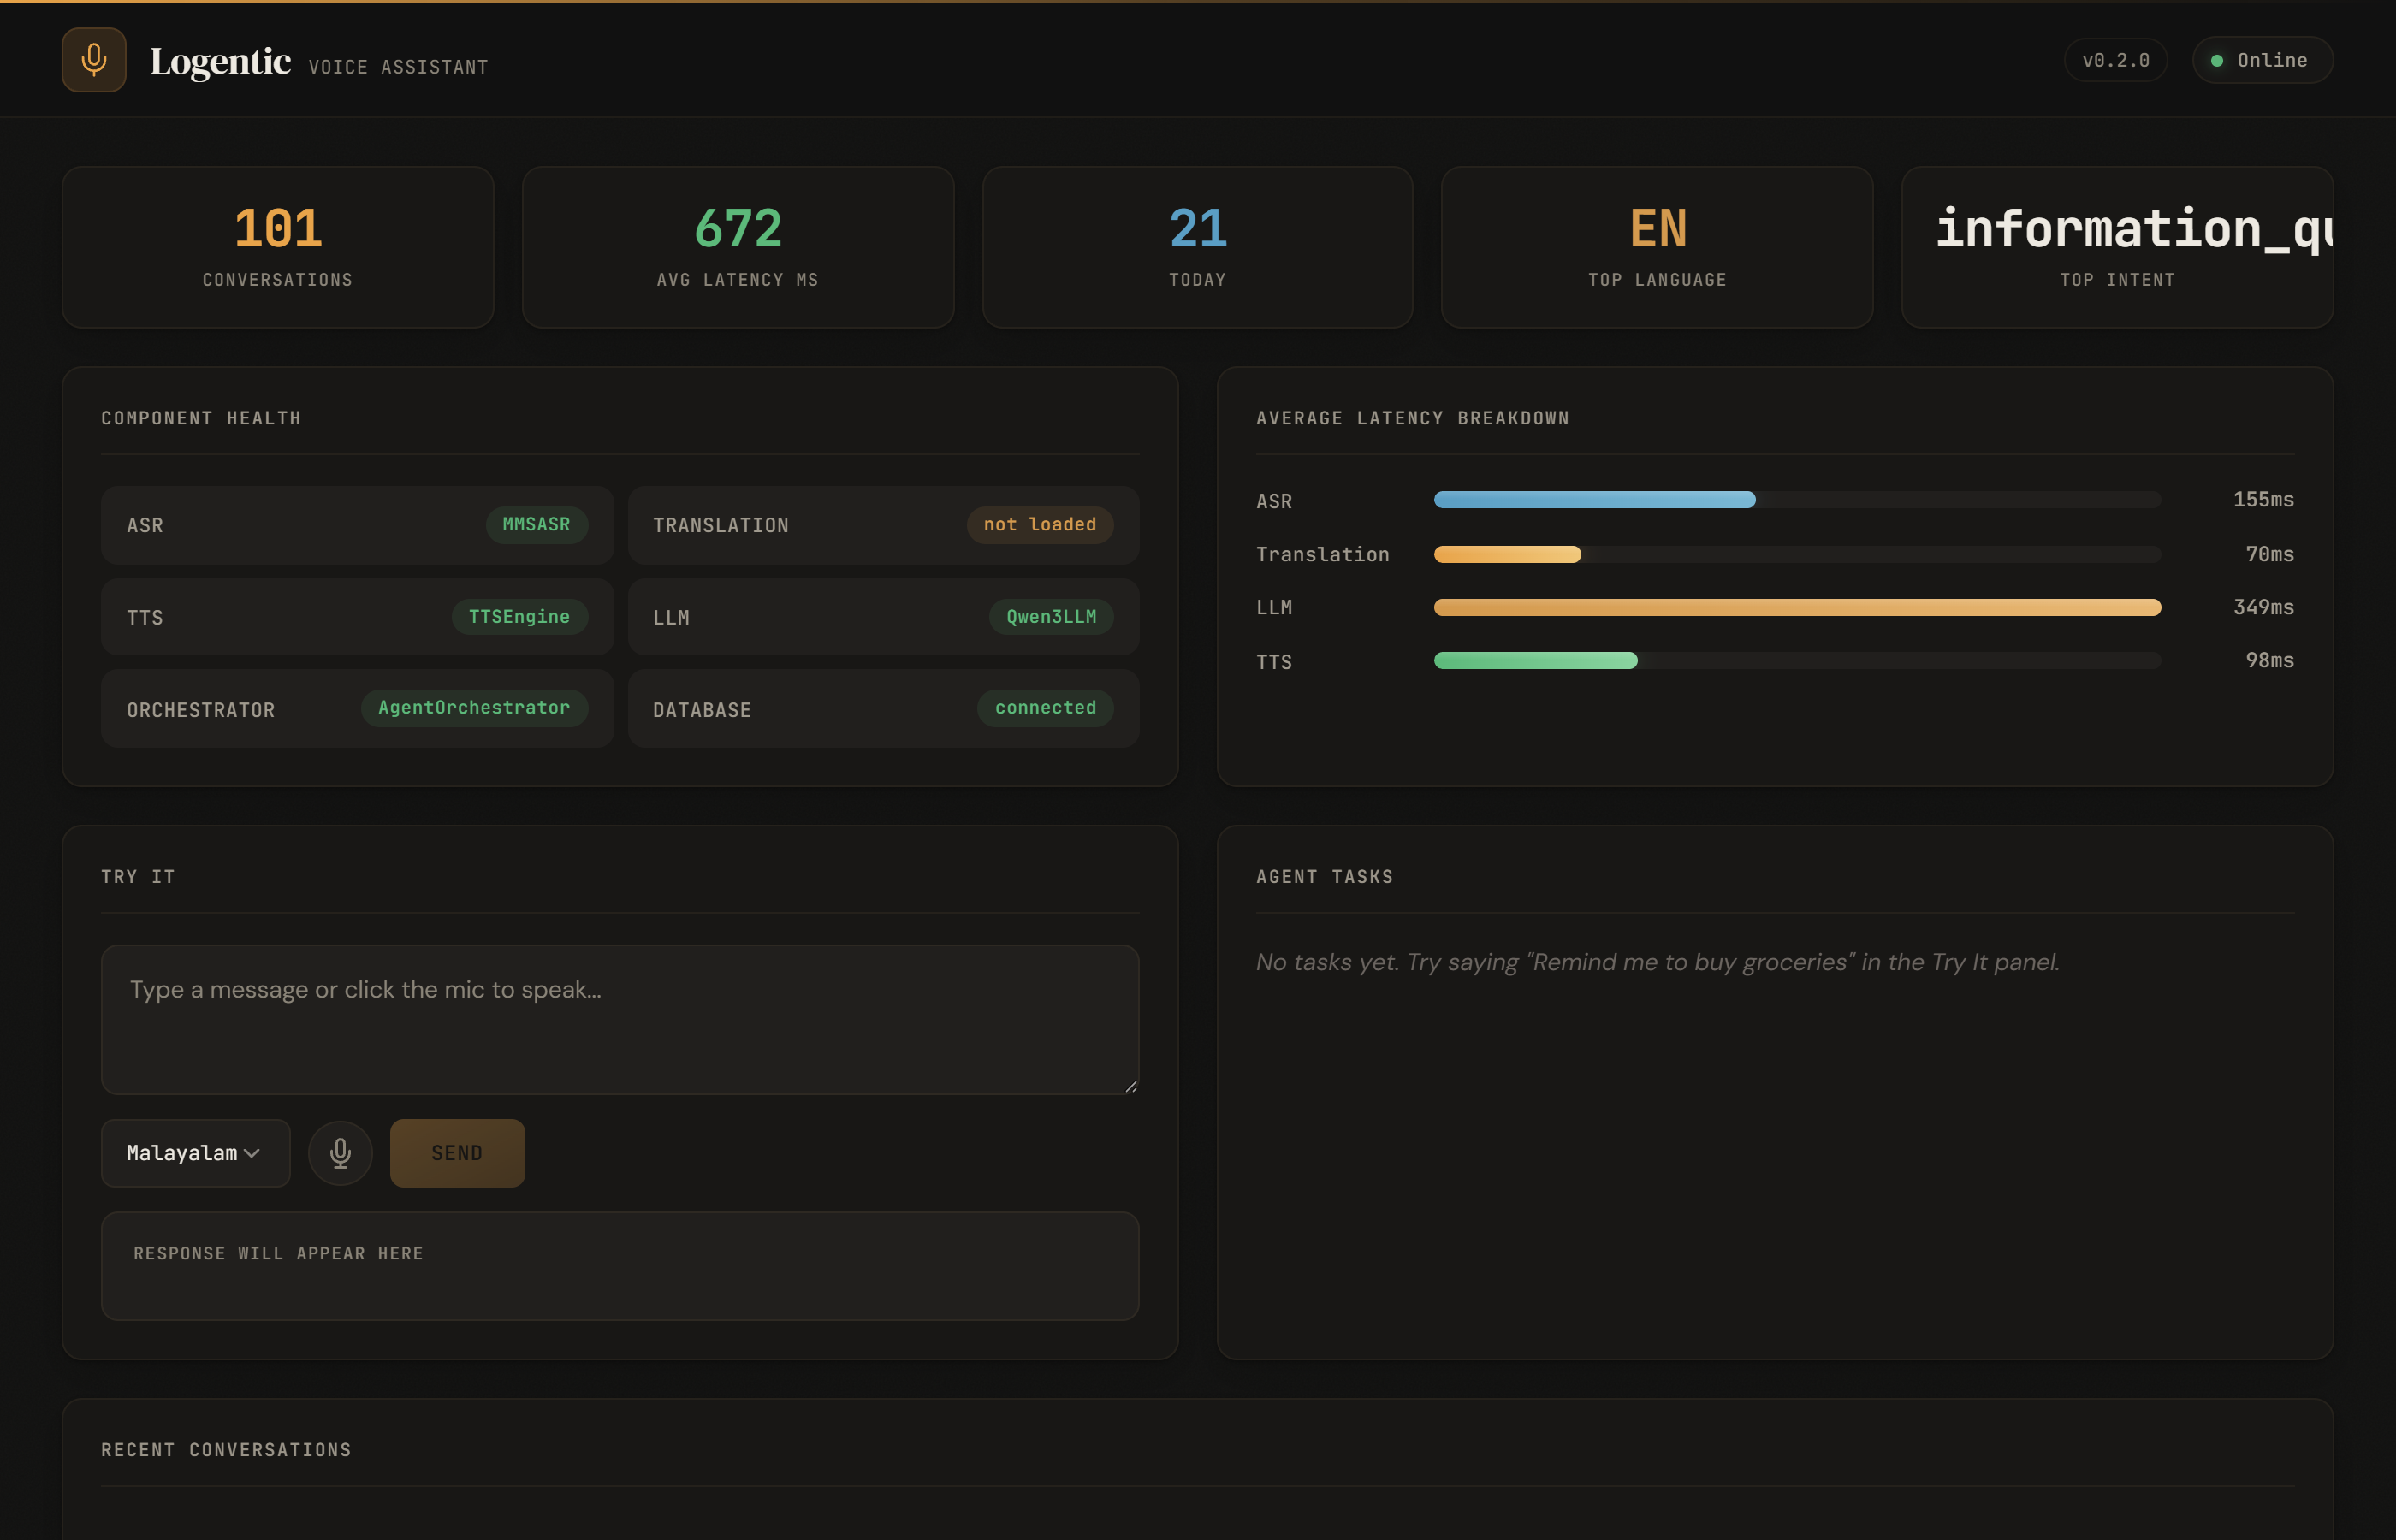
Fig 11.1 — Dashboard: Statistics Row, Component Health, and Average Latency Breakdown
Try It Panel and Conversation Log
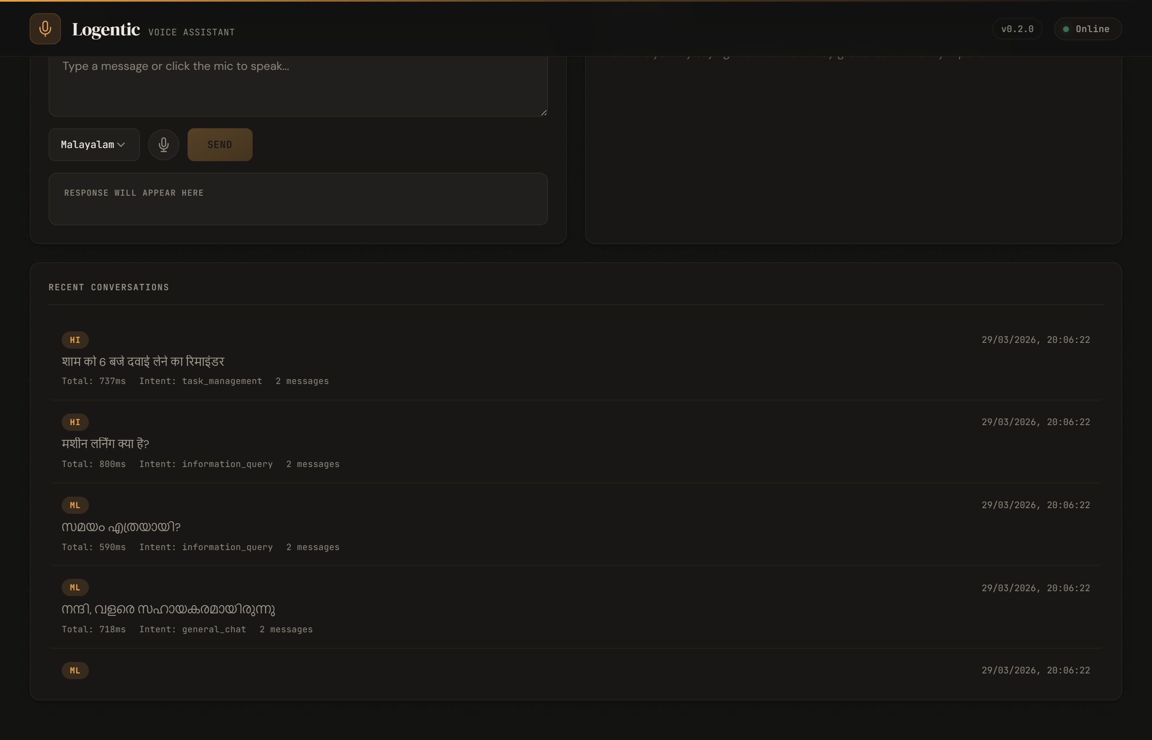
Fig 11.2 — Try It Panel (Voice Input) and Recent Conversations with Multilingual Queries
Recent Conversations — Multilingual Query History
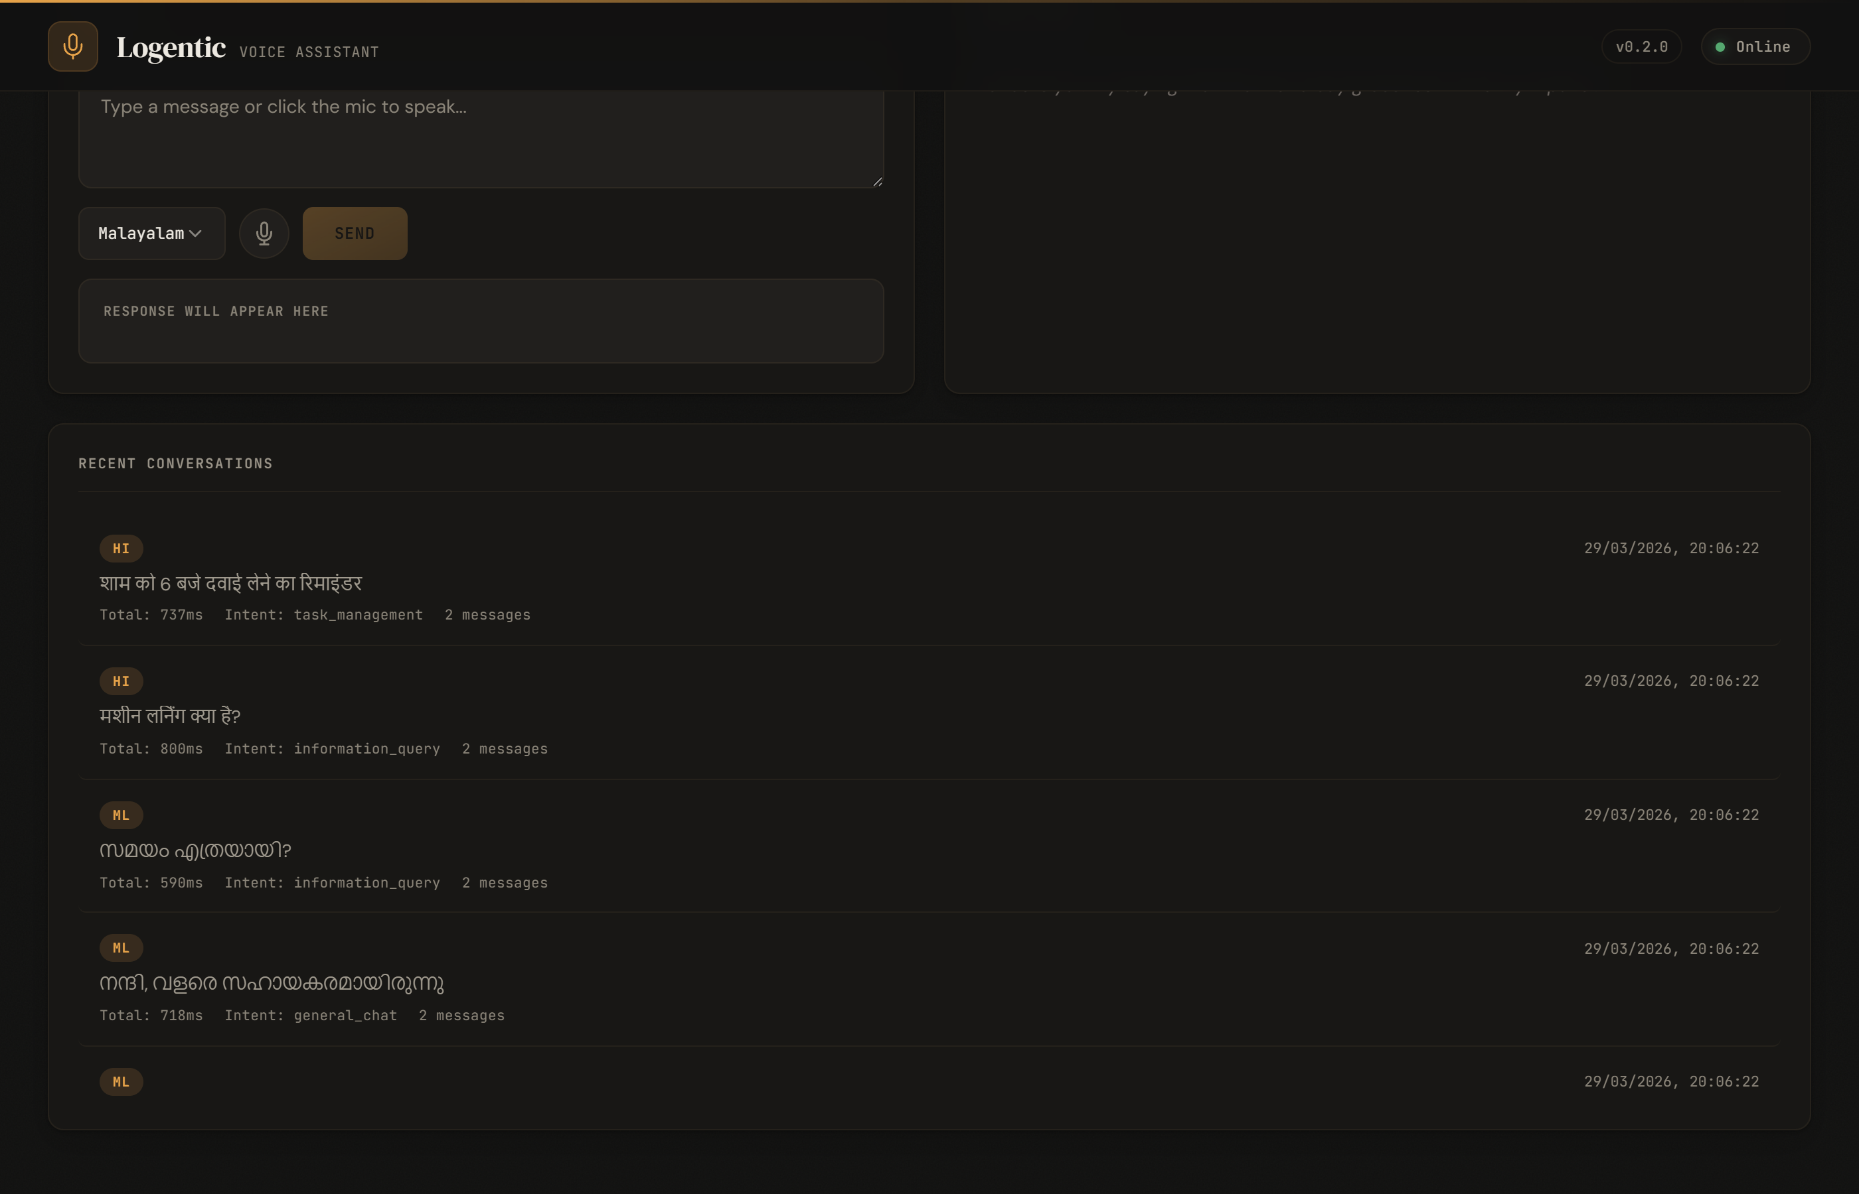
Fig 11.3 — Conversation Log with Language Tags, Intent Classification, and Timestamps
Complete Dashboard View
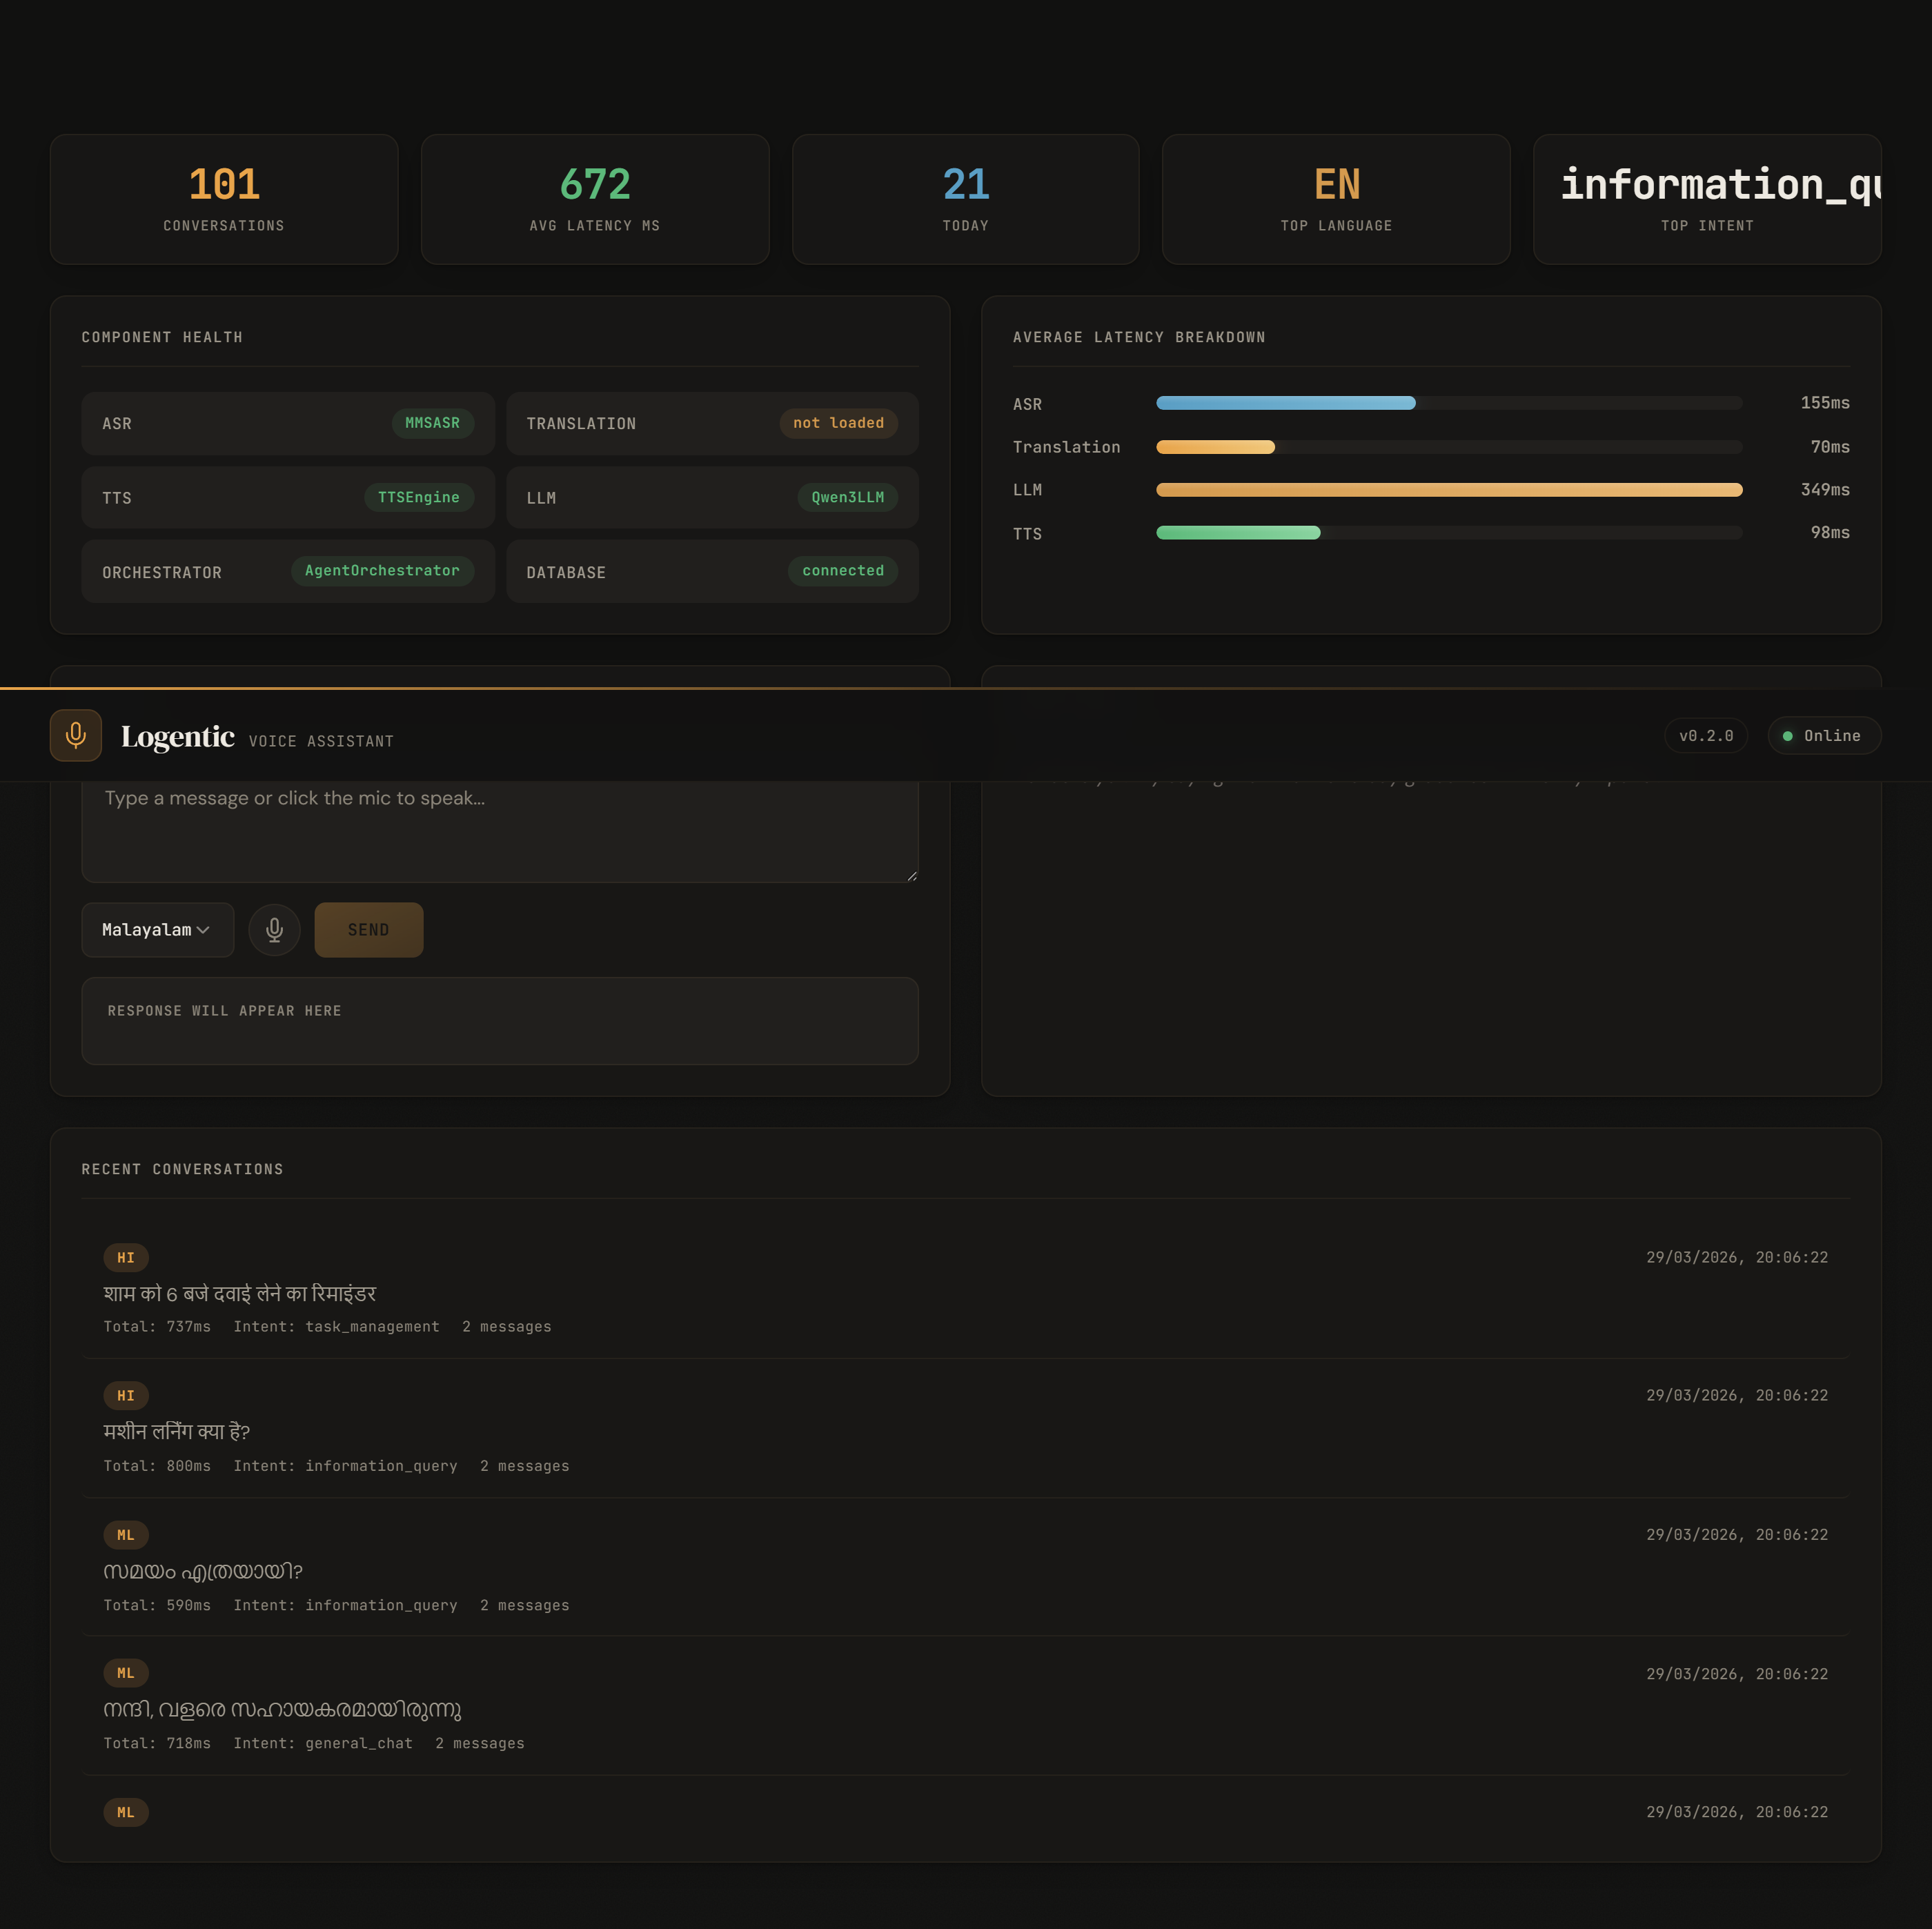
Fig 11.4 — Full-Page Dashboard: End-to-End View of All Monitoring Panels
Responsive Layout (Narrow Viewport)
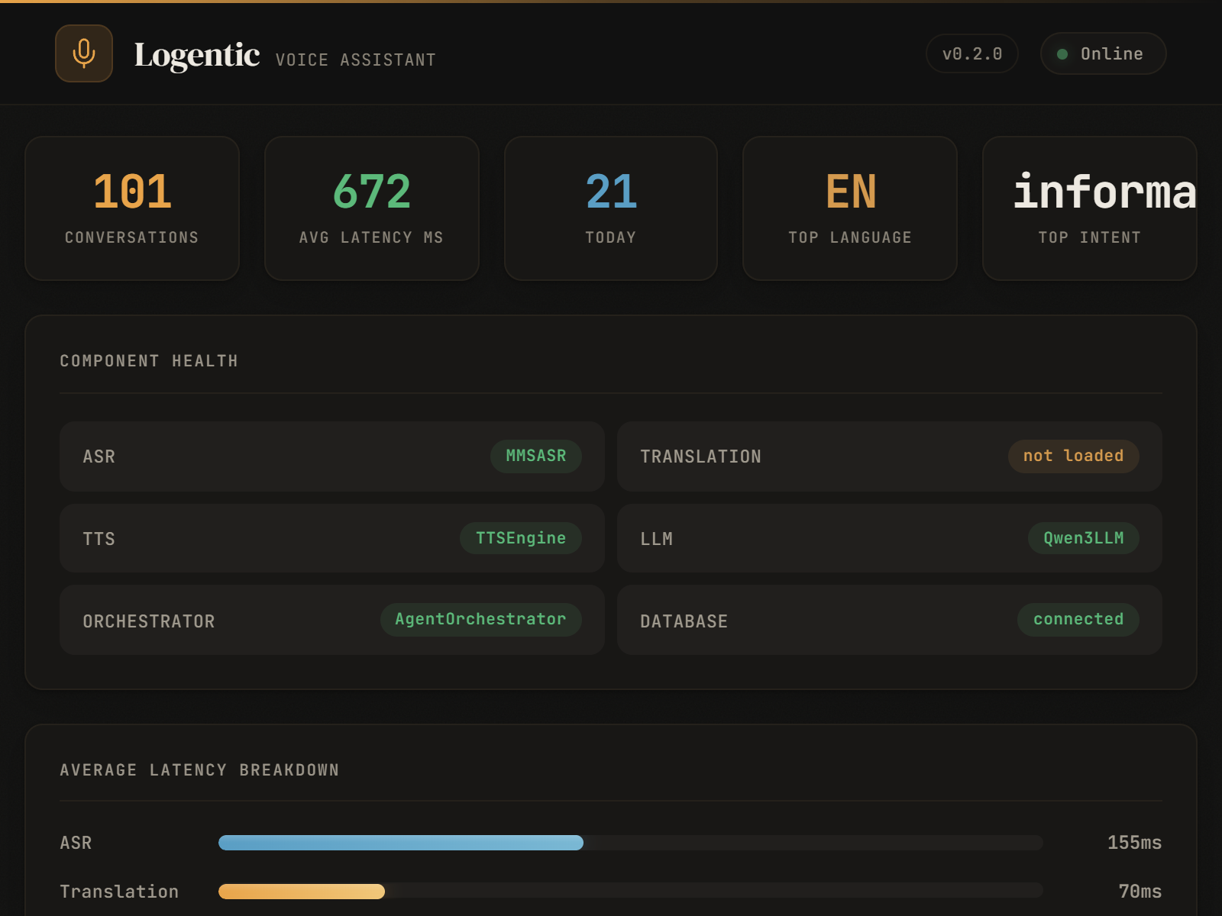
Fig 11.5 — Dashboard Responsive Layout at 800px Width
11.3 Burndown Chart
The burndown chart tracks remaining effort across six sprints. The actual line closely follows the ideal, with minor deviations in Sprint 5 (reduced scope as system approached demo-readiness).

Fig 11.6 — Burndown Chart (repeated for reference)
12. References / Bibliography
Books and Articles
Russell, S. & Norvig, P. (2021). Artificial Intelligence: A Modern Approach (4th ed.). Pearson.
Goodfellow, I., Bengio, Y., & Courville, A. (2016). Deep Learning. MIT Press.
Jurafsky, D. & Martin, J.H. (2023). Speech and Language Processing (3rd ed. draft). Stanford University.
Research Papers
Radford, A., et al. (2023). Robust Speech Recognition via Large-Scale Weak Supervision. ICML 2023. OpenAI.
Costa-jussà, M.R., et al. (2022). No Language Left Behind: Scaling Human-Centered Machine Translation. Meta AI.
Pratap, V., et al. (2023). Scaling Speech Technology to 1,000+ Languages. Meta AI.
AI4Bharat, Gala, J., et al. (2023). IndicTrans2: High-Quality MT Models for 22 Indian Languages. TACL.
Websites
https://huggingface.co — Model hosting and inference APIs.
https://pytorch.org — PyTorch deep learning framework.
https://fastapi.tiangolo.com — FastAPI web framework.
https://langchain-ai.github.io/langgraph/ — LangGraph agent framework.
https://ai4bharat.org — Indian language AI research.
Technical Documentation
OpenAI Whisper — https://github.com/openai/whisper
Meta MMS — https://github.com/facebookresearch/fairseq/tree/main/examples/mms
Qwen 2.5 — https://github.com/QwenLM/Qwen2.5
IndicTrans2 — https://github.com/AI4Bharat/IndicTrans2
React Official Docs — https://react.dev
Standards and Guidelines
ISO/IEC 25010:2011 — Systems and software quality models.
W3C WCAG 2.1 — Web Content Accessibility Guidelines.
India’s Digital Personal Data Protection Act (DPDPA) 2023.

