TAX FRAUD DETECTION SYSTEM
User Help Guide
Version 1.0
RBA Tool | April 2026

Table of Contents
Table of Contents 2
1. Introduction 4
1.1 What You Can Do 4
1.2 Supported Tax Parameters 4
2. Sidebar Navigation 5
3. Upload Sheet 6
3.1 Accessing the Upload Sheet 6
3.2 Downloading Sample Files 6
3.3 Uploading GST Data 7
Step 1 – Select Tax Parameter and Date Range 7
Step 2 – Upload the CSV File 7
Step 3 – Preview the File 7
Step 4 – Upload and Validate 8
Step 5 – Download Invalid Records (if applicable) 9
Step 6 – Process the Data 9
Step 7 – Processing Complete 11
3.4 Uploading SWT Data 12
3.5 Uploading CIT Data 15
3.6 Creating Segmentation 16
3.7 Final Merged Audit Summary 16
4. Dashboard 18
4.1 Common Dashboard 18
Key Metrics (Summary Cards) 18
Charts and Tables 18
Filtering by TIN 20
4.2 GST Dashboard 21
Summary Cards 21
Charts and Analysis 21
Fraud TIN Distribution Map 23
Fraud TINs by Province Popup 23
4.3 SWT Dashboard 25
Summary Cards 25
Charts and Analysis 25
4.4 CIT Dashboard 28
Key Sections 28
5. Analytics 31
5.1 Risk Assessment Dashboard 31
Key Widgets 31
5.2 Risk Profiling Dashboard 34
Key Widgets 34
6. Reports 37
6.1 Recent Uploads 37
Using Recent Uploads 37
Table Columns 37
Viewing Fraud Reasons 38
6.2 Taxpayer Profile 39
Table Columns 39
6.3 Risk Profiling Report 41
Report Sections 43
7. Upload History 44
7.1 Table Columns 44
7.2 Searching and Pagination 44
8. Error Handling 45
8.1 Downloading Invalid Records 45
9. Best Practices 46
9.1 Before Uploading 46
9.2 During Upload 46
9.3 Processing Order 46
9.4 General 46
10. Complete Workflow Summary 47
11. Conclusion 48

1. Introduction
The Tax Fraud Detection System (RBA Tool) is a web-based platform designed to help tax authorities identify fraudulent tax records using machine learning algorithms. It processes three types of tax data — GST, SWT, and CIT — and flags suspicious submissions automatically.

1.1 What You Can Do
- Upload tax data files in CSV format (GST, SWT, CIT)
- Preview and validate records before processing
- Detect fraudulent or suspicious entries using ML algorithms
- View analytics dashboards by tax parameter
- Perform risk assessment and taxpayer risk profiling
- Generate taxpayer segmentation reports
- Track all upload activity in Upload History

1.2 Supported Tax Parameters
- GST – Goods and Services Tax
- SWT – Salary and Wages Tax
- CIT – Company Income Tax

2. Sidebar Navigation
The left sidebar is the primary navigation element. It provides access to all modules. Click any item to navigate directly to that section.

Menu Item | Sub-Items | Purpose
Dashboard | Dashboard, GST, SWT, CIT | High-level analytics and fraud summaries per tax type
Upload Sheets | — | Upload, validate, and process GST/SWT/CIT CSV files
Analytics | Risk Assessment, Risk Profiling, Compliance | In-depth risk analytics and taxpayer profiling
Reports | Recent Uploads, Taxpayer Profile, Risk Profiling | Detailed reports on processed records and fraud findings
Upload History | — | Full log of all uploaded files with metadata
Help Centre | — | User documentation and support

3. Upload Sheet
The Upload Sheet module is the core feature of the RBA Tool. It allows analysts to upload tax data files, validate records, run ML-based fraud detection, and generate segmentation. All three tax types (GST, SWT, CIT) must be uploaded and processed before segmentation can be created.

Important:
Always upload all three tax files — GST, SWT, and CIT — before clicking Create Segmentation.

3.1 Accessing the Upload Sheet
- Log in to the RBA Tool.
- Click Upload Sheets in the left sidebar.
- The Upload Sheet page opens with GST selected as the default tax parameter.

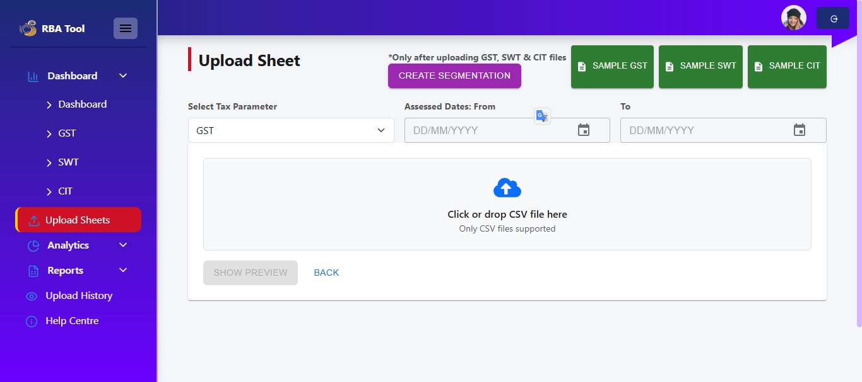
Figure 3.1 – Upload Sheet – Default View (GST selected)

3.2 Downloading Sample Files
Sample CSV templates are available at the top-right corner of the page. Download these to understand the required column structure before preparing your data.
- SAMPLE GST – Template for GST data
- SAMPLE SWT – Template for SWT data
- SAMPLE CIT – Template for CIT data

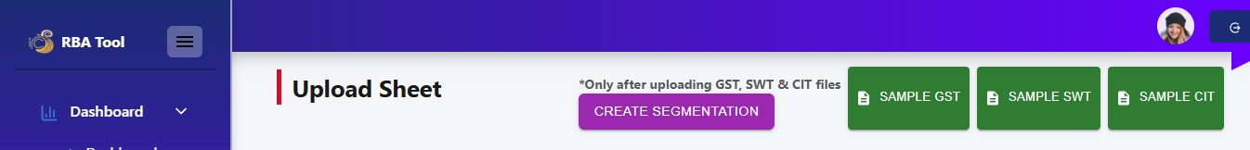
Figure 3.2 – Sample File Download Buttons

3.3 Uploading GST Data

Step 1 – Select Tax Parameter and Date Range
- From the Select Tax Parameter dropdown, choose GST (default).
- Enter the Assessed Dates From date (e.g., 01/04/2015).
- Enter the To date (e.g., 31/12/2025).

Step 2 – Upload the CSV File
- Click inside the upload area or drag and drop your GST CSV file.
- Only CSV files are accepted. Ensure your file matches the sample template format.
- The file name appears in the upload area once selected.

Step 3 – Preview the File
- Click Show Preview to see the first 10 rows of your uploaded file.
- Review column headings and data values to confirm correctness before proceeding.

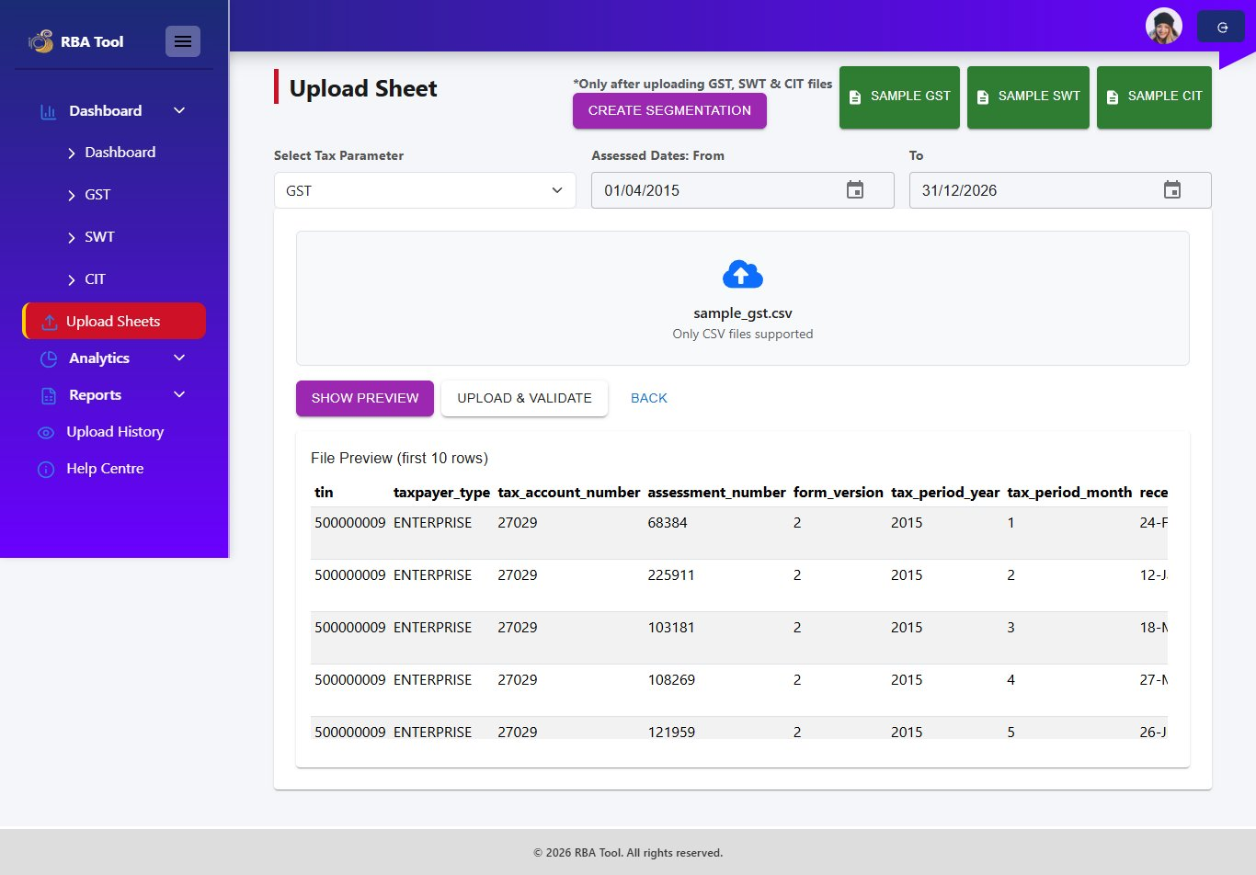
Figure 3.3 – File Preview (First 10 Rows)

Step 4 – Upload and Validate
- Click Upload & Validate.
- The system checks each record for:
- Missing TIN – Records without a Tax Identification Number
- Duplicate TIN – Same TIN with identical tax year and month
- Validation results are shown:
- Total Records – Total rows in the file
- Valid Records – Rows that passed all checks
- Invalid Records – Rows that failed (highlighted in red)
- Duplicates – Number of duplicate entries
- Missing TINs – Records with no TIN

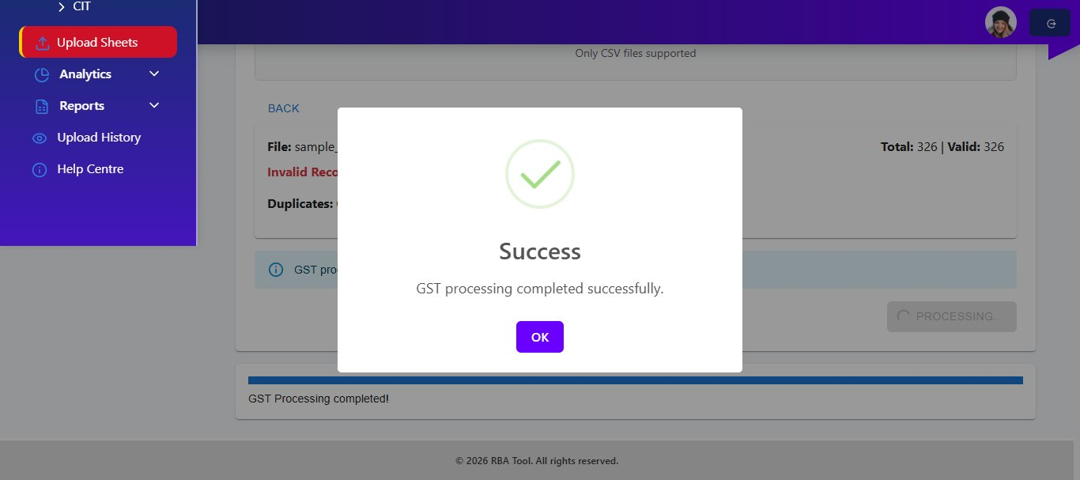
Figure 3.4 – Validation Results (Upload Success – All Records Valid)

Step 5 – Download Invalid Records (if applicable)
If invalid records are detected, a Download Invalid Records link appears next to the Invalid Records count. Click it to download a CSV of all invalid rows for correction.

Note:
Processing can proceed even with invalid records. Only valid records will be passed to the ML algorithm.

Step 6 – Process the Data
- Click the Process button at the bottom-right of the page.
- The ML algorithm runs and performs the following:
- Validates and cleans the GST data
- Detects suspicious and potentially fraudulent records
- Tags each flagged record with a fraud reason
- A progress bar shows the current processing step (e.g., Step 1: Validating & Cleaning GST).

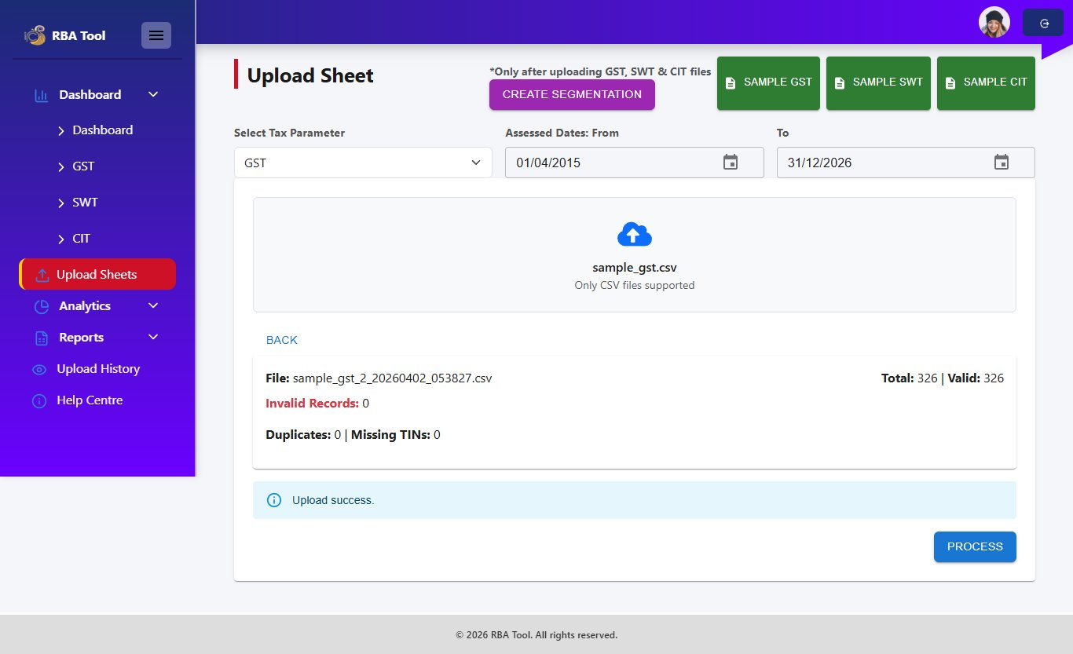
Figure 3.5 – Upload, Validate, and Process Buttons
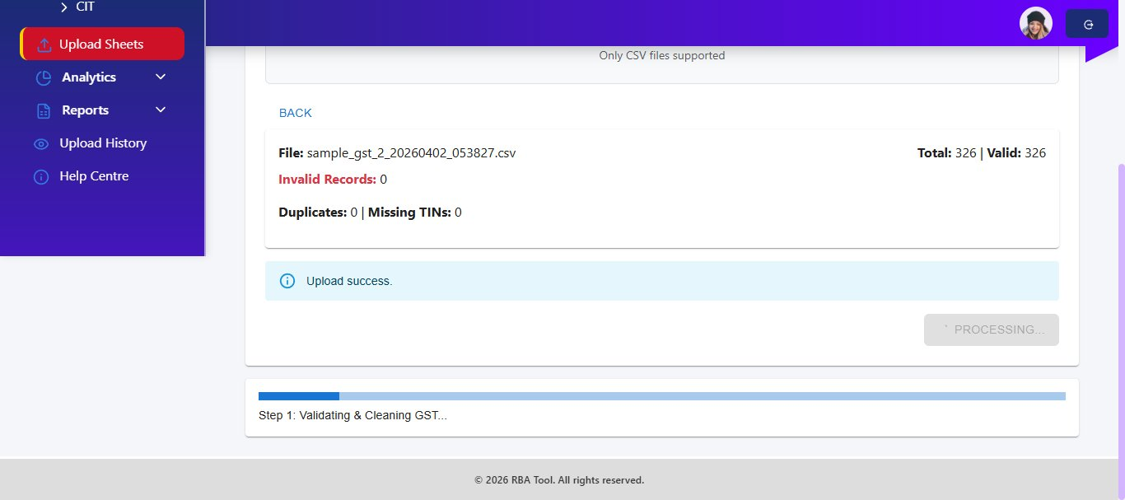
Figure 3.6 – Processing in Progress
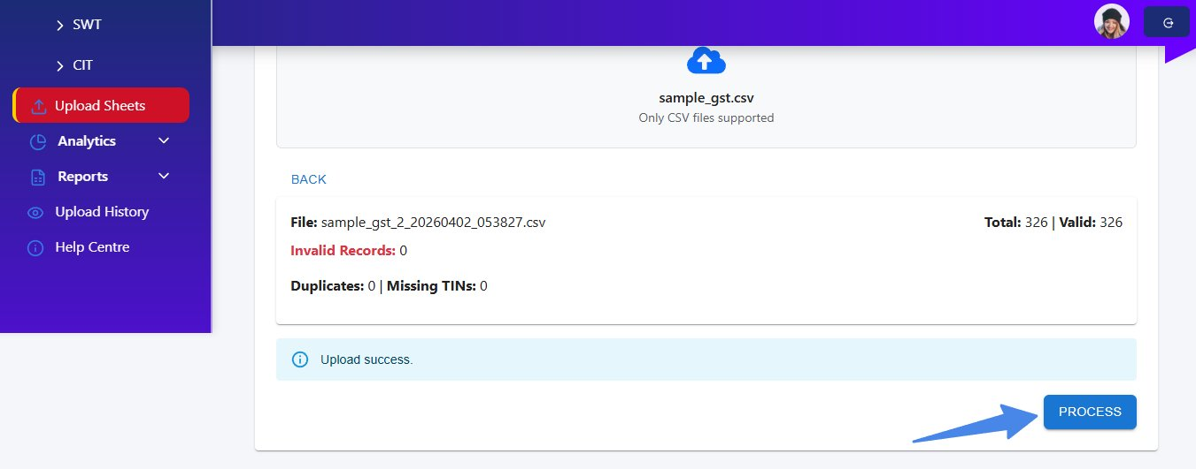
Figure 3.7 – Processing Screen Detail

Step 7 – Processing Complete
- When processing finishes, a Success dialog is displayed.
- The message reads: GST processing completed successfully.
- Click OK to dismiss and return to the Upload Sheet.


Figure 3.8 – GST Processing Completed Successfully

3.4 Uploading SWT Data
Repeat the same steps as GST but select SWT as the tax parameter.

- Select SWT from the Select Tax Parameter dropdown.
- Set the Assessed Dates (From and To).
- Upload your SWT CSV file.
- Click Show Preview to verify the first 10 rows.

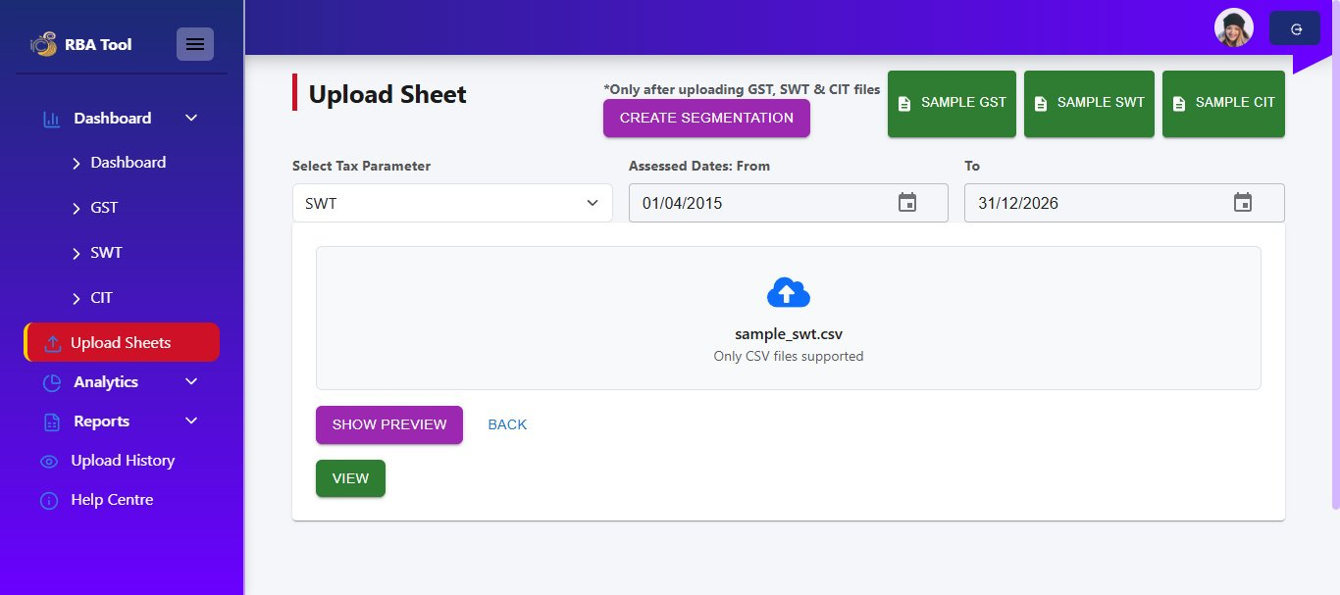
Figure 3.9 – SWT Tax Parameter Selected
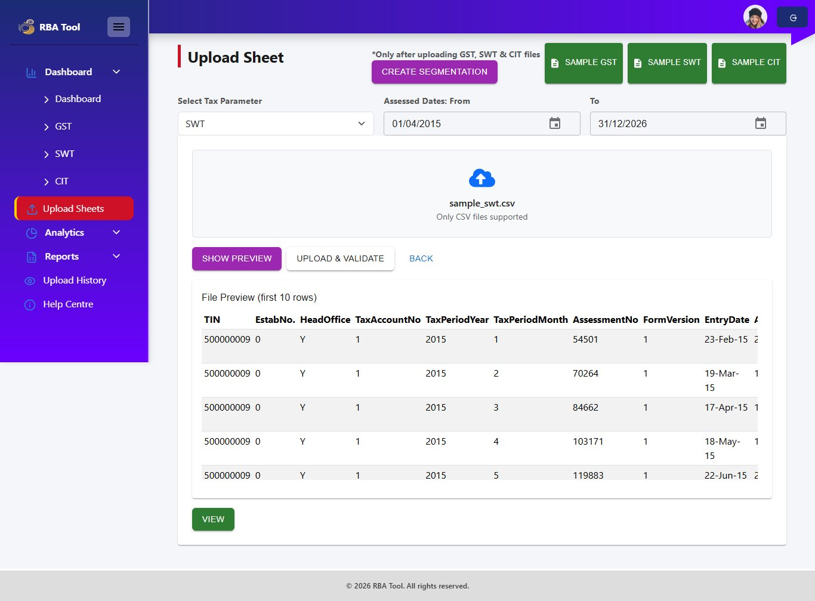
Figure 3.10 – SWT File Preview (First 10 Rows)
- Click Upload & Validate.
- Review validation results including any Invalid Records, Duplicates, and Missing TINs.

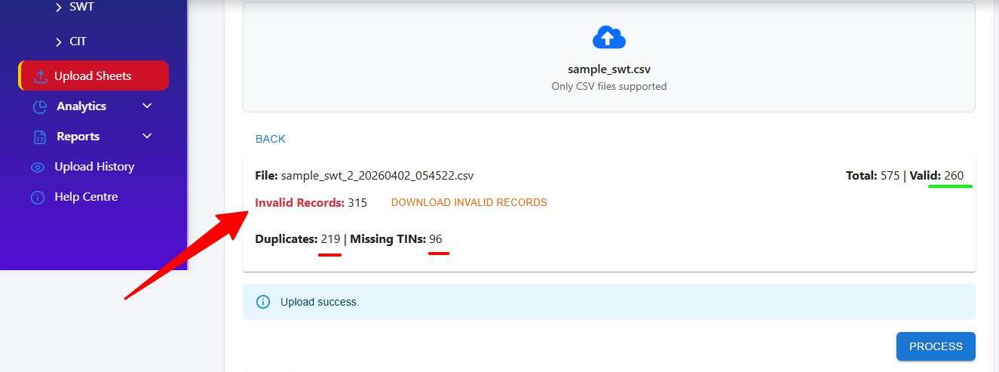
Figure 3.11 – SWT Validation Results (with Invalid Records Example)
Example:
In this example, 315 of 575 records are invalid (219 duplicates, 96 missing TINs). Only 260 valid records will be processed. A Download Invalid Records link is available.

- Click Process to run the ML algorithm on valid SWT records.

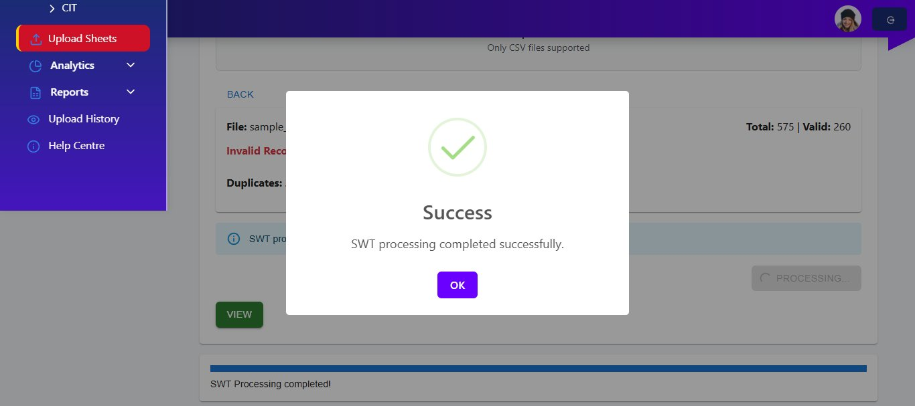
Figure 3.12 – SWT Processing in Progress

A Success dialog confirms SWT processing is complete. Click OK.

3.5 Uploading CIT Data
Follow the same upload, validation, and processing flow for CIT data.

- Select CIT from the Select Tax Parameter dropdown.
- Set the Assessed Dates.
- Upload, preview, validate, and process your CIT CSV file.

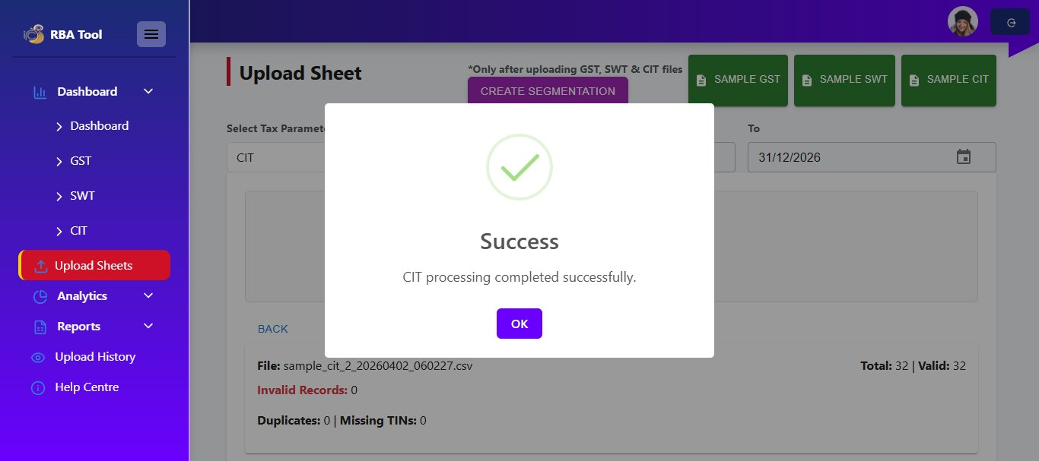
Figure 3.13 – CIT Processing Completed Successfully

3.6 Creating Segmentation
After all three tax types are uploaded and processed successfully, you can generate taxpayer segmentation.

Prerequisite:
GST, SWT, and CIT must all be processed before the Create Segmentation button becomes active.

- Click the Create Segmentation button (purple, top of the page).

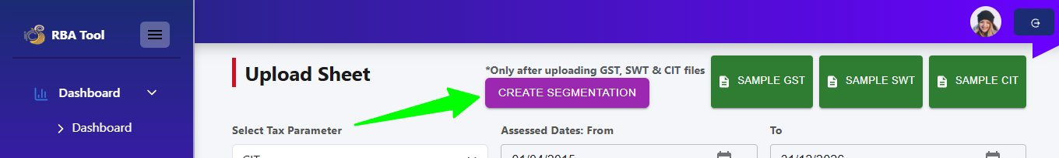
Figure 3.14 – Create Segmentation Button
- The system segments taxpayers across all three tax datasets.
- A Segmenting... spinner appears on the button while processing.
- A Success dialog confirms: Segmentation completed successfully.
- Click OK, then click the View button to open the Final Merged Audit Summary.

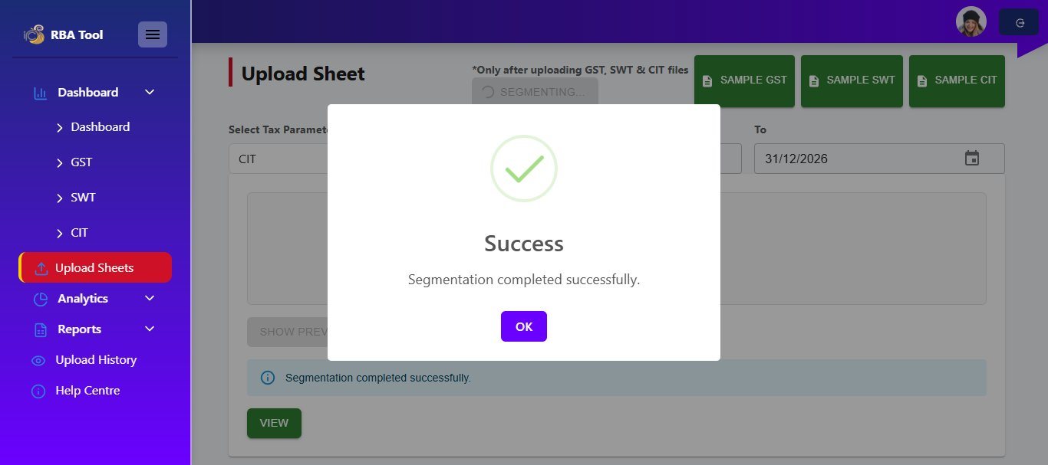
Figure 3.15 – Segmentation Completed Successfully

3.7 Final Merged Audit Summary
The Final Merged Audit Summary table displays combined fraud detection results for all processed taxpayer records across GST, SWT, and CIT.

Key columns in the table:
- TIN – Tax Identification Number
- Taxpayer Name – Name of the taxpayer entity
- Type – Taxpayer category (e.g., Enterprise)
- Segmentation – Assigned taxpayer segment (Large, Medium, Small)
- Total Sales – Reported total sales figure
- GST Payable / GST Refund – GST amounts
- Fraud – Valid (green) or Fraud Detected (red)

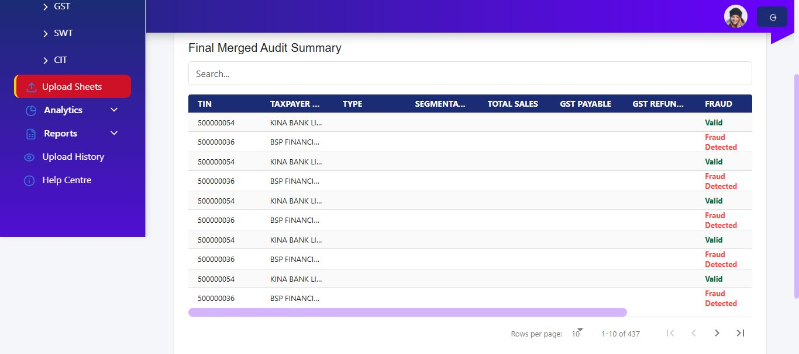
Figure 3.16 – Final Merged Audit Summary

Fraud Flags:
"Valid" records passed all ML checks. "Fraud Detected" records are flagged for investigation based on anomalies identified by the algorithm.

4. Dashboard
The Dashboard module provides analytics and fraud detection summaries. It is divided into sub-dashboards for the common overview and each tax type (GST, SWT, CIT). Access the Dashboard from the left sidebar.

4.1 Common Dashboard
The main Dashboard provides a consolidated financial overview across all taxpayers. Use the date filters and the Select TIN dropdown to drill into specific taxpayers or view all data together.

Key Metrics (Summary Cards)
- Total Income – Aggregate income across all taxpayers in the selected period
- Total Profit – Net profit reported across all entities
- Total CIT Tax – Total company income tax collected
- Effective Tax Rate – Average effective CIT rate (%)

Charts and Tables
- Tax Flow (Income vs Profit vs CIT) – Line chart showing trends from 2015–2022
- Top Sectors by Income – Bar chart ranking sectors by income with sector breakdown table
- Fraud Cases by Year – Bar chart of annual fraud case counts
- Fraud Distribution – Pie chart showing fraud spread across years
- Top Financial TINs – Table of highest-income taxpayers with their tax amounts
- Consolidated Records – Paginated table with TIN, taxpayer, year, income, profit, and tax

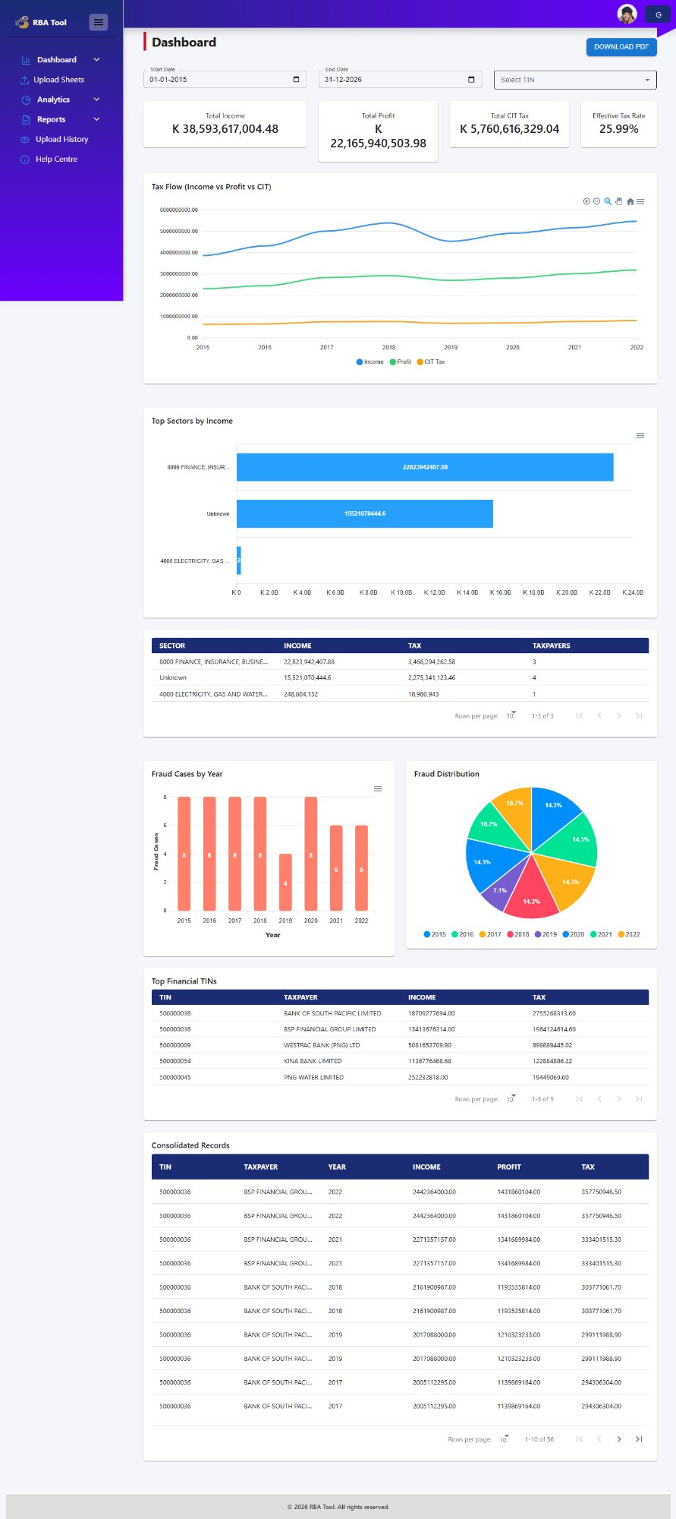
Figure 4.1 – Common Dashboard Overview

Filtering by TIN
Use the Select TIN dropdown (top-right) to filter all dashboard charts and tables to a specific taxpayer. The dropdown lists all available TINs with their company names.

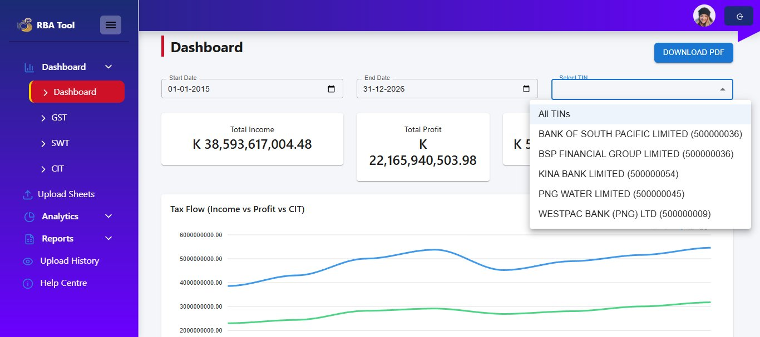
Figure 4.2 – TIN Filter Dropdown on Dashboard

Available options include:
- All TINs – View aggregate data across all taxpayers
- Individual TINs (e.g., BANK OF SOUTH PACIFIC LIMITED, BSP FINANCIAL GROUP LIMITED, KINA BANK LIMITED, PNG WATER LIMITED, WESTPAC BANK (PNG) LTD)

Click Download PDF (top-right) to export the current dashboard view as a PDF report.

4.2 GST Dashboard
The GST Dashboard provides Goods and Services Tax specific analytics. Select a Tenure (e.g., Custom Date) and set the Start and End Date to filter the view.

Summary Cards
- Total Tax Payers – Number of unique GST taxpayers in the period
- Total Sales Income (PGK) – Aggregate sales income reported
- Total GST Payable (PGK) – Total GST amount owed to the authority
- Total GST Refundable (PGK) – Total GST refund amounts due

Charts and Analysis
- Sales Comparison – Line chart showing Total Sales, Exempt Sales, Zero Rated Sales, and Taxable Sales over time
- GST Payable vs Refundable – Bar chart comparing monthly GST payable and refundable amounts
- Segmentation Distribution – Bar chart of taxpayer counts by segment (Large, Medium, Small)
- Risk Flagged vs Non-Risk – Pie chart showing the proportion of flagged vs. clean records (e.g., 27.9% Risk Flagged)
- Fraud TIN Distribution by Province – Interactive map showing geographic risk concentration using a colour-coded risk scale (0–100%)

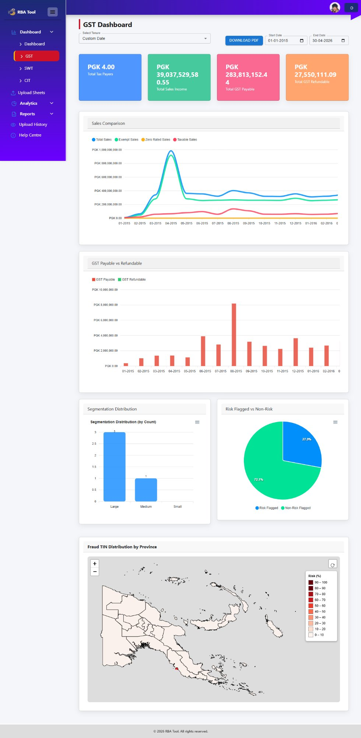
Figure 4.3 – GST Dashboard Overview

Fraud TIN Distribution Map
The interactive map displays fraud risk by province. Darker red shading indicates higher risk concentration (90–100%). Click on a highlighted province to view the Fraud TINs popup listing taxpayers flagged in that region.

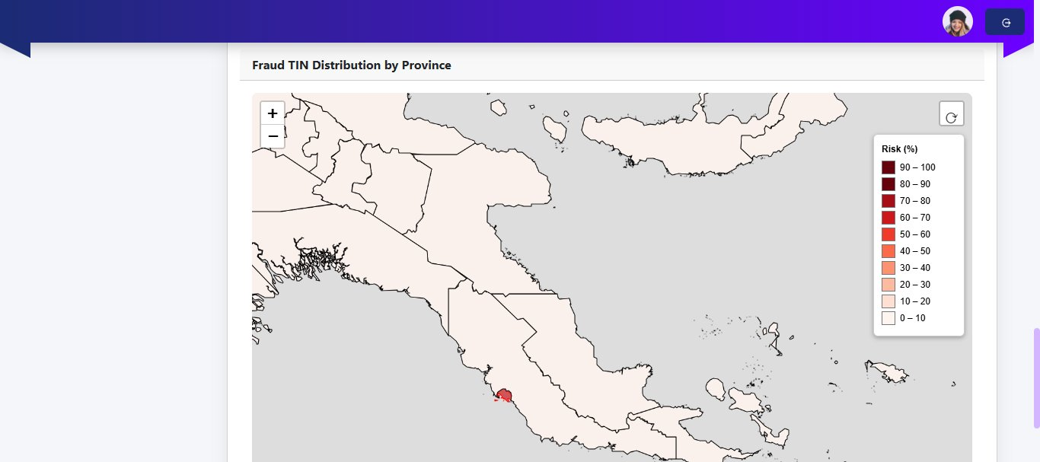
Figure 4.4 – Fraud TIN Distribution by Province (Map View)

Fraud TINs by Province Popup
Clicking a province on the map opens a popup listing all fraud-flagged TINs and their taxpayer names in that province. Click Close to dismiss.

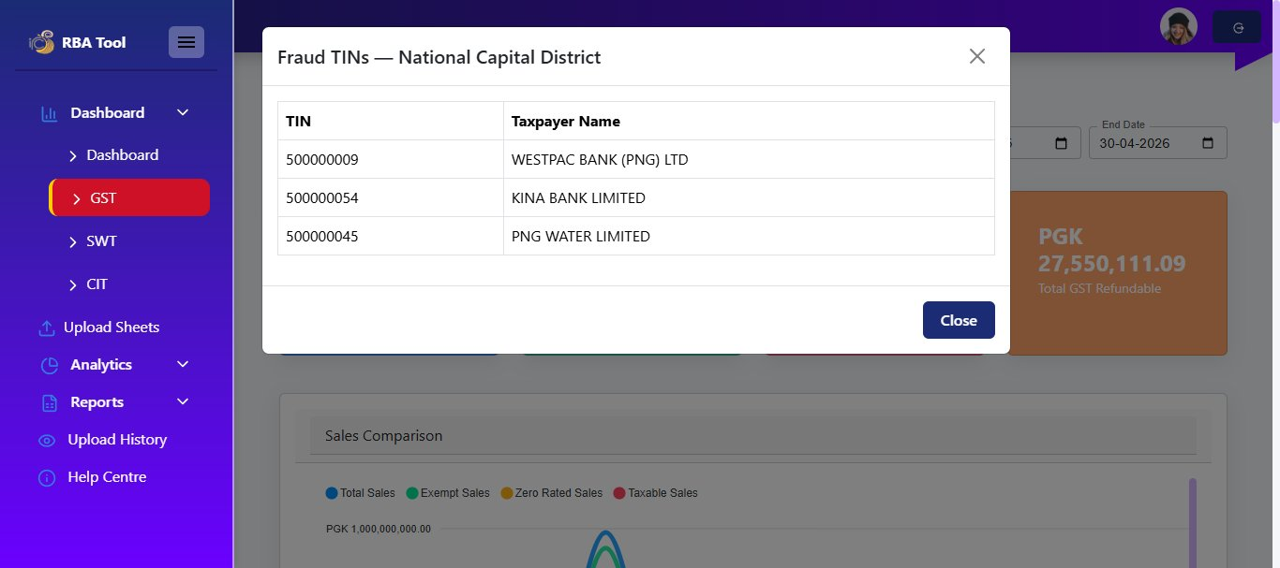
Figure 4.5 – Fraud TINs Popup – National Capital District

Click Download PDF to export the GST Dashboard as a PDF.

4.3 SWT Dashboard
The SWT Dashboard presents Salary and Wages Tax analytics. Select a Tenure and date range to filter all metrics.

Summary Cards
- Total Employers – Number of employer entities with SWT data
- Total Wages Paid (PGK) – Aggregate salary and wages paid across all employers
- Total SWT Deducted (PGK) – Total SWT withheld from employee wages
- Effective SWT Rate (%) – Average effective SWT deduction rate

Charts and Analysis
- Total Salary Wages Paid vs SWT Deducted – Line chart comparing monthly wages paid to SWT deducted amounts
- Fraud / Red Flag Cases (Monthly) – Bar chart showing monthly fraud case counts by period
- Segmentation Distribution – Pie chart showing employer breakdown by size (Large: 78.1%, Medium: 21.3%)
- Fraud TIN Distribution by Province – Interactive map with province-level risk shading
- Latest SWT Records – Paginated table showing TIN, employer, segmentation, salary, SWT deducted, and period

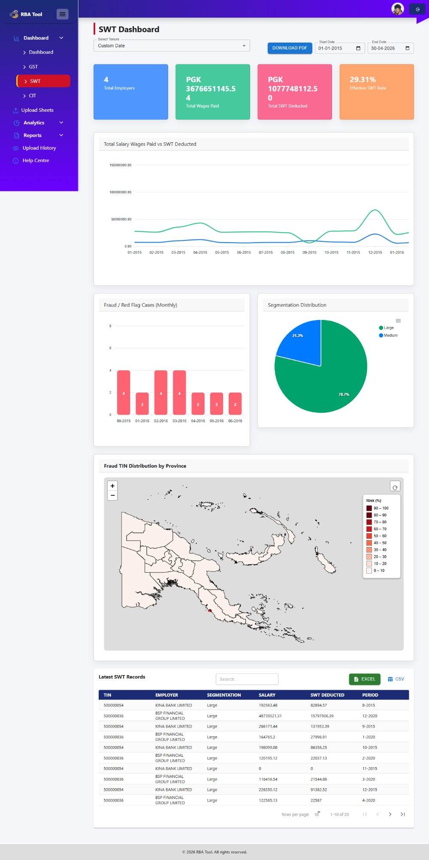
Figure 4.6 – SWT Dashboard Overview

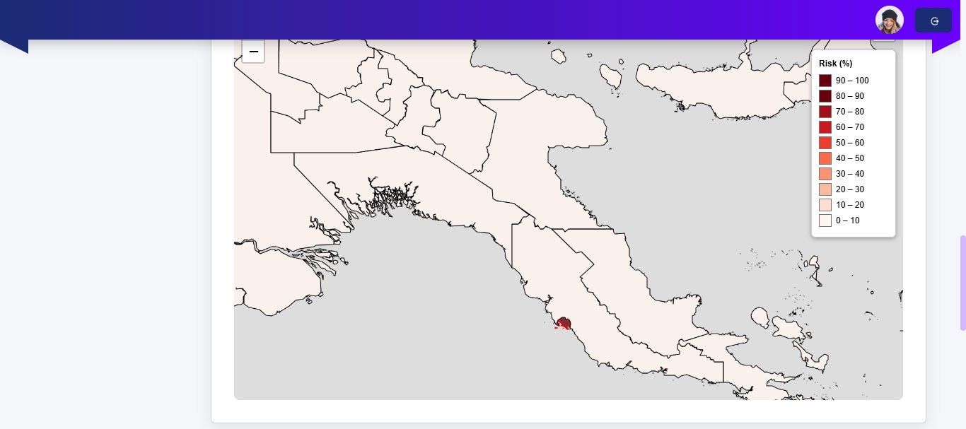
Figure 4.7 – SWT Fraud TIN Distribution by Province (Map Detail)

4.4 CIT Dashboard
The CIT Dashboard presents Company Income Tax analytics. Use the Tenure dropdown and date range to filter the displayed data.

Key Sections
- Top 50 Net Profit Taxpayers – Ranked table of highest net-profit companies with export to Excel or CSV
- Top 50 Net Loss Taxpayers – Table of companies reporting net losses
- Segmentation Distribution – Donut chart showing taxpayer size breakdown (e.g., 75% Large, 25% Medium)
- Risk Flagged vs Non-Risk – Pie chart of risk-flagged vs. non-flagged CIT records
- Superannuation PNG vs Foreign – Table comparing PNG and foreign superannuation amounts (PGK)
- Interest PNG vs Foreign – Table comparing PNG and foreign interest income
- Fraud TIN Distribution by Province – Interactive map with risk-colour coding by province
- Gross Sales vs COGS – Periodic table comparing gross sales to cost of goods sold by year

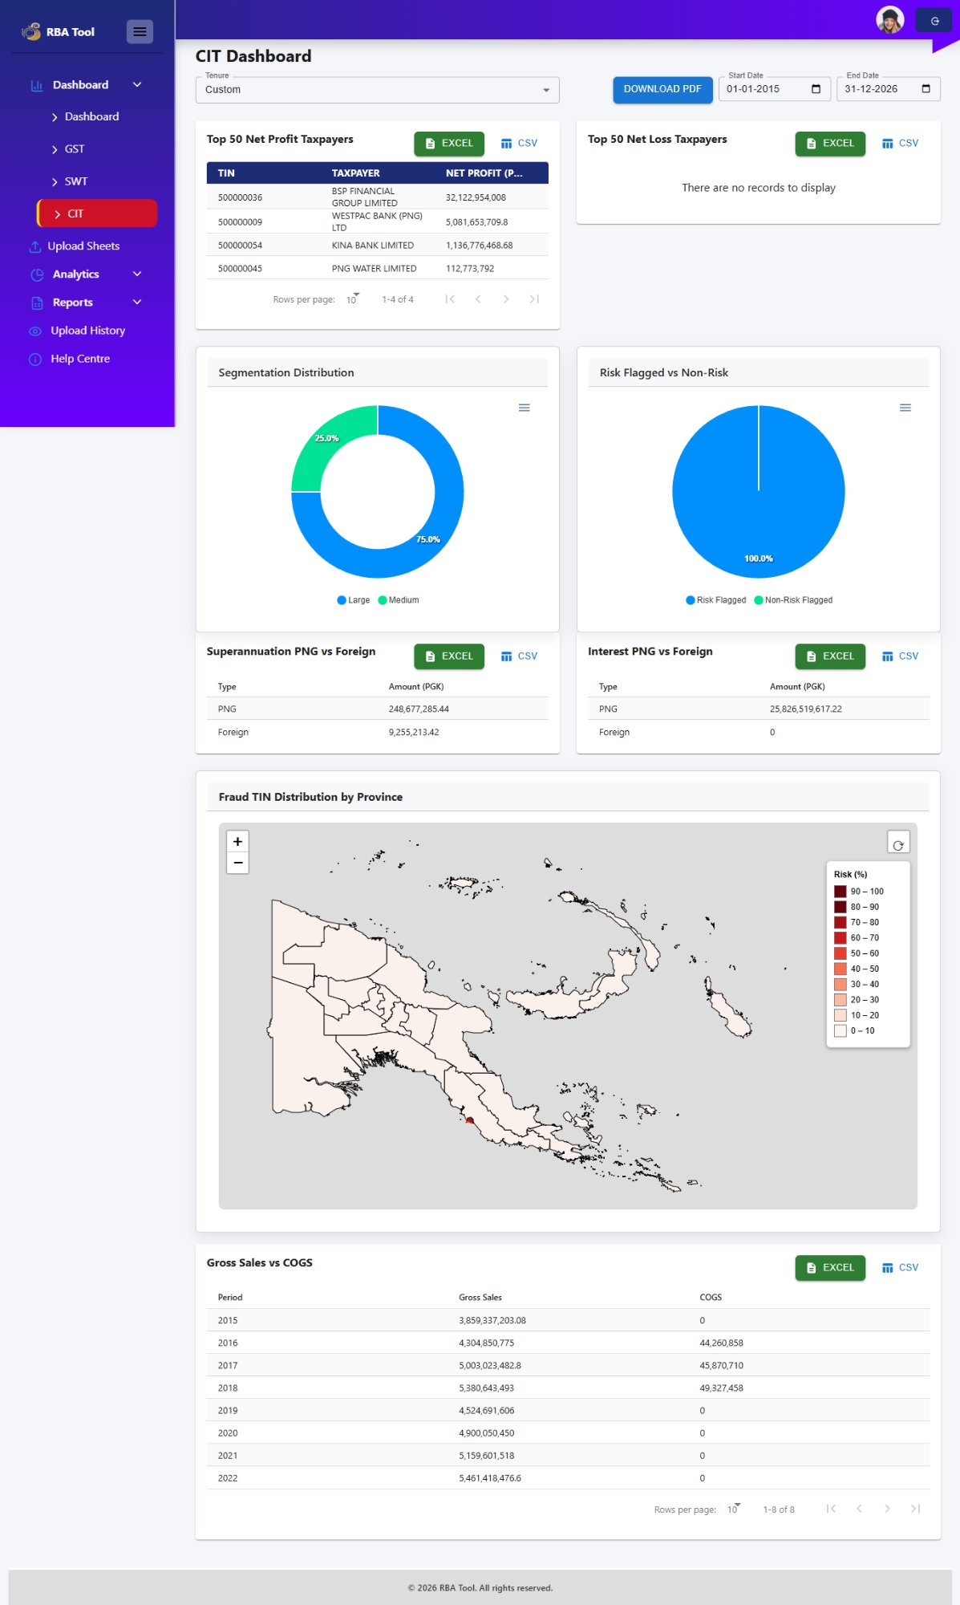
Figure 4.8 – CIT Dashboard Overview

5. Analytics
The Analytics module provides advanced risk analysis tools. It contains three sub-sections: Risk Assessment, Risk Profiling, and Compliance. Access these from the Analytics menu in the left sidebar.

5.1 Risk Assessment Dashboard
The Risk Assessment Dashboard identifies and quantifies risk across taxpayer segments and industry sectors. Select a Tax Type (GST, SWT, CIT), a Tenure, and a date range to filter results.

Key Widgets
- Risk Breakdown by Category (Segment) – Bar chart comparing Total Records vs. Flagged Records across Large, Medium, and Unknown taxpayer segments. Export data using Download CSV.
- Sector-based Risk (By Industry) – Bar chart showing Total Taxpayers vs. Risk Flagged for a selected industry sector. Use the Select Sector dropdown to change the industry.
- Total Taxpayers vs Risk Flagged – Bar chart showing the monthly count of total taxpayers vs. flagged taxpayers over time
- Frequency of Risk Anomalies – Pie chart showing the proportion of anomaly types (e.g., Excessive Exempt Sales: 42.8%, Suspiciously Low Output: 57.2%)
- List of Risk Assessment Companies – Searchable table showing Company Name, Total Sales (PGK), Total Flags, and Segments. Export via Download CSV.

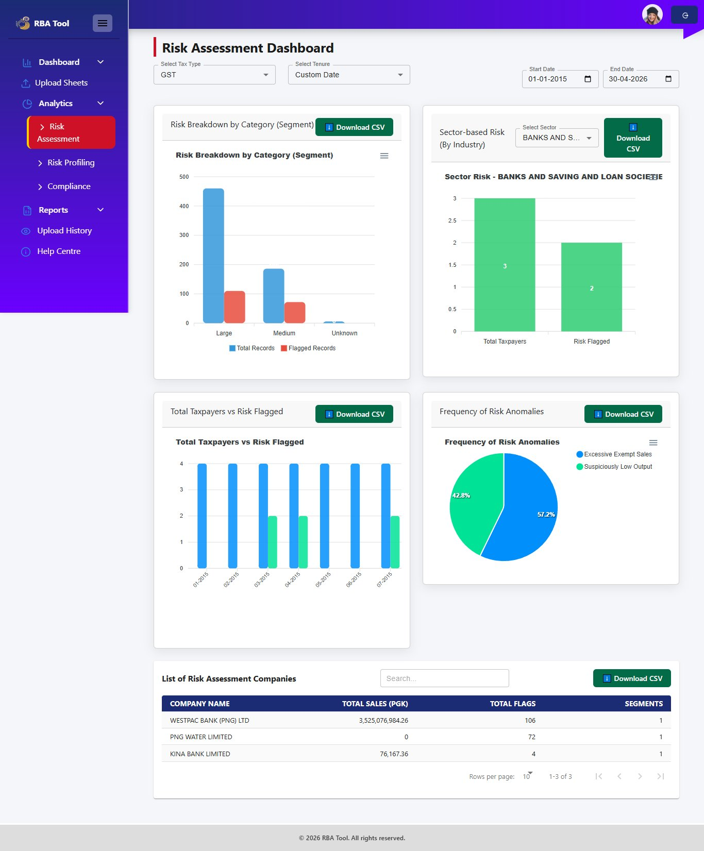
Figure 5.1 – Risk Assessment Dashboard

How to Use:
Select a sector from the Select Sector dropdown to view industry-specific risk data. Use Download CSV on each widget to export the underlying data for offline analysis.

5.2 Risk Profiling Dashboard
The Risk Profiling Dashboard provides a deep-dive view of fraud patterns and financial risk by industry. Select a Tax Type, Tenure, and date range to filter all views.

Key Widgets
- Frequency of Risk Anomalies – Pie chart showing the share of Flagged vs. Not Flagged records (e.g., 27.9% Flagged, 72.1% Not Flagged)
- Risk Breakdown by Category – Bar chart comparing Flagged vs. Total Records across taxpayer segments (Large, Medium, Unknown)
- Payable vs Refundable – Bar chart for a selected industry showing total GST payable vs. refundable amounts (PGK)
- Input Credits vs Output Debits – Bar chart comparing input credit and output debit amounts for the selected industry
- Sales Comparison Table – Paginated table showing Industry, Year, Total Sales, Taxable Sales, and Taxpayer count. Export via Excel or CSV.

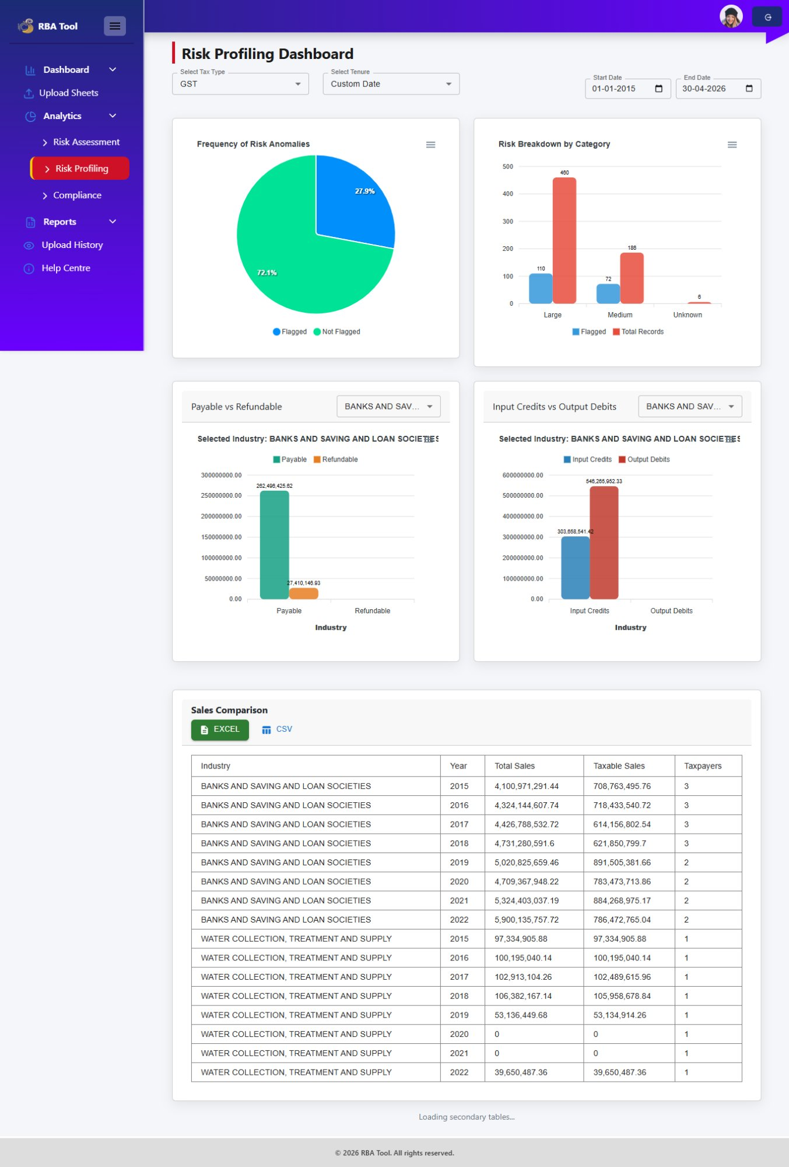
Figure 5.2 – Risk Profiling Dashboard

Industry Filtering:
Use the industry dropdown on the Payable vs Refundable and Input Credits vs Output Debits widgets to compare financial metrics across different sectors.

6. Reports
The Reports module provides detailed data tables and taxpayer-specific fraud reports. It contains three sub-sections accessible from the Reports menu in the sidebar: Recent Uploads, Taxpayer Profile, and Risk Profiling.

6.1 Recent Uploads
The Recent Uploads report displays all processed tax records from the most recent upload. Filter by tax type and search for specific taxpayers.

Using Recent Uploads
- Click Reports in the sidebar, then select Recent Uploads.
- Use the Category dropdown to filter by tax type: GST, SWT, or CIT.
- The Total Records count updates to reflect the selected category.
- Use the Search box to filter by TIN, Company Name, or Year.
- Export the full table using the Excel or CSV buttons.

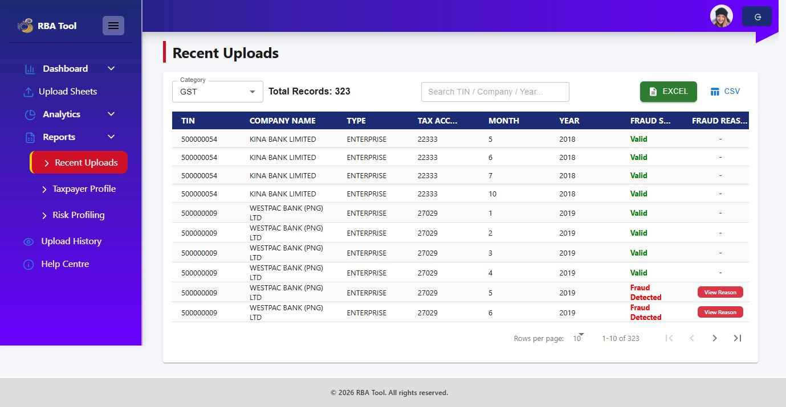
Figure 6.1 – Recent Uploads Report (GST view, 323 records)

Table Columns
- TIN – Tax Identification Number
- Company Name – Name of the taxpayer entity
- Type – Taxpayer category (e.g., Enterprise, Salary/Wage)
- Tax Account Number – Associated tax account
- Month / Year – The period of the submission
- Fraud Status – Valid (green) or Fraud Detected (red)
- Fraud Reason – View Reason button for flagged records

Viewing Fraud Reasons
For records marked Fraud Detected, click the View Reason button in the Fraud Reason column. A Fraud Reason Details popup opens with the specific reason identified by the ML algorithm (e.g., "Multiple moderate risk indicators").

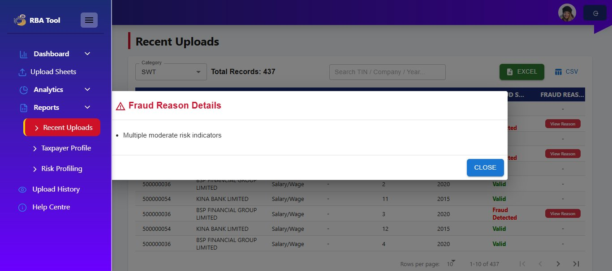
Figure 6.2 – Fraud Reason Details Popup

Note:
The Category dropdown at the top controls which tax type's records are shown. Switch between GST, SWT, and CIT to review each dataset independently.

6.2 Taxpayer Profile
The Taxpayer Profile section provides a risk profiling summary for all taxpayers. Filter by Tax Type and date range to view risk scores, risk type, and fraud flags.

- Click Reports, then select Taxpayer Profile.
- Select the Tax Type (GST, SWT, or CIT) from the dropdown.
- Set the Tenure and date range filters.
- Use the Search taxpayer box to find a specific entity.
- Click the eye icon in the Fraud Reason column to view fraud details for any flagged record.
- Export results using the Excel or CSV buttons.

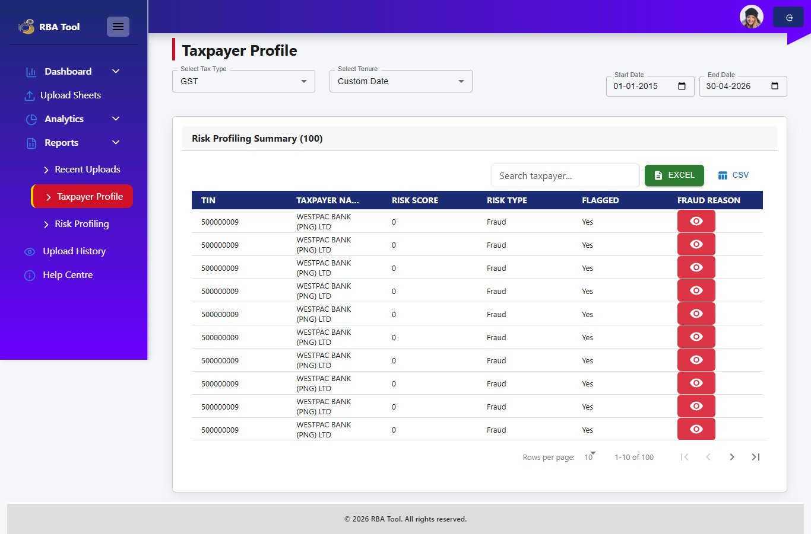
Figure 6.3 – Taxpayer Profile – Risk Profiling Summary

Table Columns
- TIN – Tax Identification Number
- Taxpayer Name – Name of the company or entity
- Risk Score – Numerical risk score assigned by the ML model
- Risk Type – Classification of risk (e.g., Fraud)
- Flagged – Whether the taxpayer is flagged (Yes/No)
- Fraud Reason – Eye icon button to view the detailed fraud reason

Pagination:
The table shows up to 100 records per page by default (e.g., 1-10 of 100). Use the pagination controls to navigate through all records.

6.3 Risk Profiling Report
The Risk Profiling report provides a comprehensive Tax Compliance Report for an individual taxpayer. Select a specific TIN to view a full breakdown of GST and SWT analysis including fraud metrics, compliance metrics, and financial ratios.

- Click Reports, then select Risk Profiling.
- Select a TIN/Taxpayer from the TIN / Taxpayer dropdown.
- Set the Tenure and date range.
- The Tax Compliance Report loads automatically for the selected taxpayer.
- Export the report using Excel, CSV, or PDF buttons.

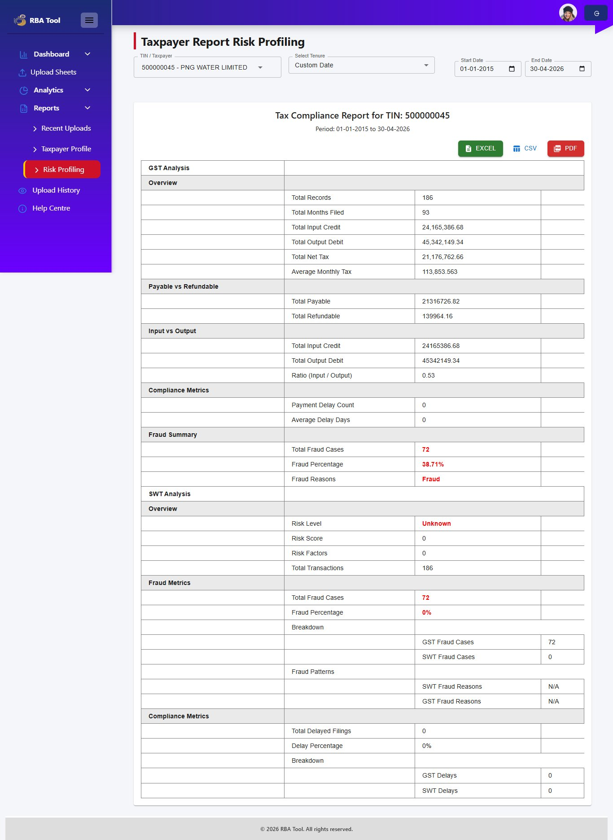
Figure 6.4 – Taxpayer Report Risk Profiling (TIN: 500000045)

Report Sections
The Tax Compliance Report is divided into two main analysis blocks:

GST Analysis
- Overview – Total Records, Total Months Filed, Total Input Credit, Total Output Debit, Net Tax, Average Monthly Tax
- Payable vs Refundable – Total GST Payable and Total GST Refundable
- Input vs Output – Input Credit and Output Debit totals with the ratio (Input / Output)
- Compliance Metrics – Payment Delay Count and Average Delay Days
- Fraud Summary – Total Fraud Cases, Fraud Percentage (%), and Fraud Reasons

SWT Analysis
- Overview – Risk Level, Risk Score, Risk Factors, Total Transactions
- Fraud Metrics – Total Fraud Cases, Fraud Percentage, Breakdown by GST and SWT fraud cases
- Fraud Patterns – SWT and GST Fraud Reasons
- Compliance Metrics – Total Delayed Filings, Delay Percentage, GST and SWT delay breakdowns

7. Upload History
The Upload History module provides a complete log of all CSV files uploaded to the system. Use this to verify past uploads, confirm the tax parameter used, and check who performed each upload.

- Click Upload History in the left sidebar.
- The table loads showing all historical upload records.

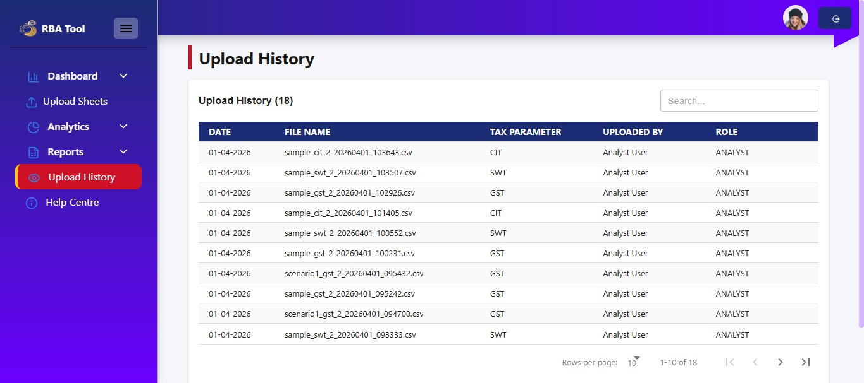
Figure 7.1 – Upload History Page

7.1 Table Columns
- Date – The date the file was uploaded (DD-MM-YYYY)
- File Name – Auto-generated name including tax type, date, and timestamp (e.g., sample_cit_2_20260401_103643.csv)
- Tax Parameter – The tax type: GST, SWT, or CIT
- Uploaded By – The user account that performed the upload
- Role – The system role of the uploader (e.g., ANALYST)

7.2 Searching and Pagination
- Use the Search box (top-right) to filter by file name, date, or tax parameter.
- The table shows 10 rows per page. Use the pagination controls at the bottom-right to navigate.
- The total upload count is shown in the heading (e.g., Upload History (18)).

8. Error Handling
The system automatically detects and reports data quality issues during validation. Resolve errors before processing to ensure maximum valid record counts.

Error Type | Description | Resolution
Missing TIN | Record has no Tax Identification Number. | Add the correct TIN to the source data and re-upload.
Duplicate TIN | Same TIN found with identical tax year and month. | Remove duplicate rows from the CSV file before re-uploading.
Invalid File Format | File is not a CSV or does not match the required column structure. | Download the sample file, use it as a template, and re-upload.
Upload Failure | File upload was interrupted or rejected by the server. | Check file size and format. Refresh and try again.
Processing Error | ML processing failed during execution. | Refresh the page and re-initiate processing. Contact admin if repeated.

8.1 Downloading Invalid Records
- After validation, if Invalid Records count is greater than 0, a Download Invalid Records link appears next to the count.
- Click the link to download a CSV listing only the invalid rows with their error details.
- Correct the errors in the source data.
- Re-upload the corrected file as a new upload.

9. Best Practices

9.1 Before Uploading
- Download and use the sample CSV template to prepare your data file correctly.
- Ensure all records contain a valid TIN.
- Remove duplicate rows (same TIN + tax year + tax month) before uploading.
- Confirm the correct financial period dates (From and To) are selected.

9.2 During Upload
- Always click Show Preview before uploading to confirm column mapping.
- Review the first 10 rows to verify data accuracy.
- Click Upload & Validate before clicking Process.
- Download and correct invalid records if the invalid count is significant.

9.3 Processing Order
- Upload and process GST first, then SWT, then CIT.
- Do not click Create Segmentation until all three are fully processed.
- Wait for each success confirmation before proceeding to the next step.

9.4 General
- Check Upload History before re-uploading to avoid duplicate submissions.
- Use the TIN filter on dashboards to investigate specific taxpayers.
- Use Download CSV and Download PDF on dashboards and reports to save evidence for audits.
- Review Fraud Reason details for all Fraud Detected records before taking action.

10. Complete Workflow Summary
The following end-to-end workflow covers the full process from data preparation to fraud review.

Step | Action | Where
1 | Log in to the RBA Tool | Login Page
2 | Download sample CSV templates | Upload Sheet – Sample GST / SWT / CIT buttons
3 | Upload and process GST data | Upload Sheet → Select GST → Upload → Validate → Process
4 | Upload and process SWT data | Upload Sheet → Select SWT → Upload → Validate → Process
5 | Upload and process CIT data | Upload Sheet → Select CIT → Upload → Validate → Process
6 | Create Segmentation | Upload Sheet → Create Segmentation button
7 | View Final Audit Summary | Upload Sheet → View button after segmentation
8 | Review dashboards | Dashboard → GST / SWT / CIT sub-dashboards
9 | Perform risk analysis | Analytics → Risk Assessment / Risk Profiling
10 | Review flagged records | Reports → Recent Uploads → View Reason
11 | Generate taxpayer reports | Reports → Taxpayer Profile / Risk Profiling
12 | Export and share findings | Dashboard / Reports → Download PDF / CSV / Excel
13 | Verify upload log | Upload History

11. Conclusion
The Tax Fraud Detection System provides a structured, ML-powered approach to identifying fraudulent tax submissions across GST, SWT, and CIT. By combining automated data validation, machine learning fraud detection, risk profiling, and geographic visualisation, the system significantly reduces manual review effort and improves detection accuracy.

The complete workflow — Upload → Validate → Process → Segmentation → Dashboard Review → Risk Analysis → Report Export — ensures all data is verified, cleaned, and analysed before findings are acted upon.

For further assistance, contact your system administrator or navigate to Help Centre from the left sidebar.

